Jenkins-1-Task Mohammed mujahed-16
1:Install Jenkins and
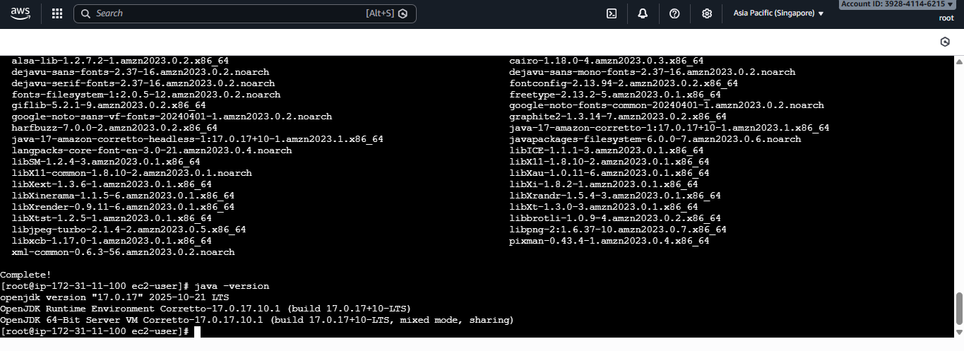
first install java <sudo yum install java-17-amazon-corretto –y>
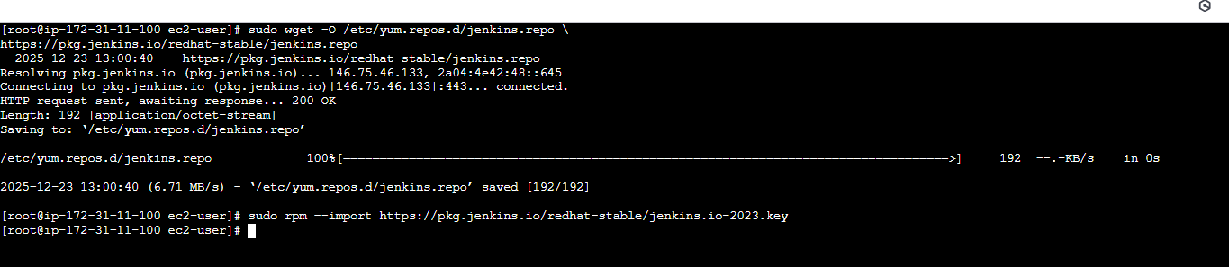
#then added repositories for Jenkins.
<sudo wget -O /etc/yum.repos.d/jenkins.repo \

https://pkg.jenkins.io/redhat-stable/jenkins.repo>
# <sudo rpm --import https://pkg.jenkins.io/redhat-stable/jenkins.io-2023.key>
--------------------------xxxxxxxxxxxxx---------xxxxxxxxxxxxxx-----------------------------------
>> Purpose (WHY we do this)
- Jenkins is a CI/CD automation tool
- It automates build, test, and deployment
- Installing Jenkins is the foundation step for CI/CD

Without Jenkins installed → nothing else is possible.
>> Steps (HOW we do it)
- Update system packages
Ensures OS has latest dependencies.
- Install Java
Jenkins is written in Java → it cannot run without Java.
- Add Jenkins repository
So the OS knows where to download Jenkins from.
- Install Jenkins package
Downloads and installs Jenkins binaries.
- Start Jenkins service
Jenkins runs as a background service.
- Enable Jenkins on boot
Jenkins starts automatically after server restart.
- Access Jenkins UI
Jenkins provides a web interface for configuration.

2: run Jenkins on port number 8081.
Purpose
- Default Jenkins port is 8080
- 8080 may already be used by applications (Tomcat, apps)
- Changing port avoids conflicts

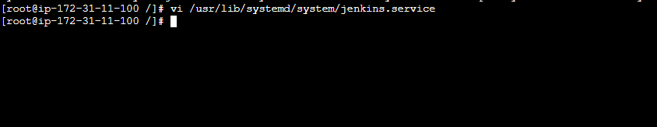
#default port config file location below.
# <vi /usr/lib/system/system/Jenkins.service>
#edit the port number from 8080 to 8081.
sed –I ‘s/8080/8081/g’ Jenkins.service
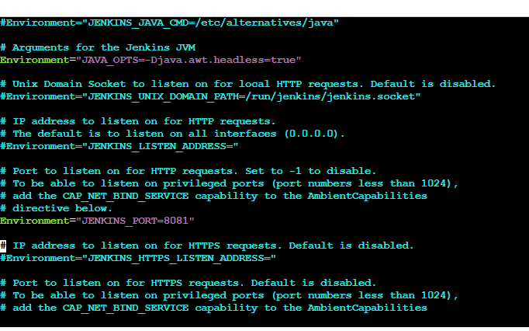
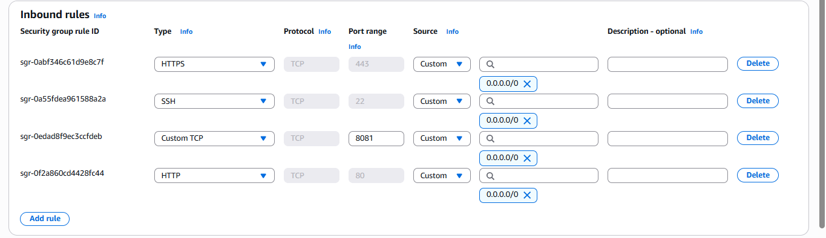
edit the security inbound rule and add 8081. Tcp.
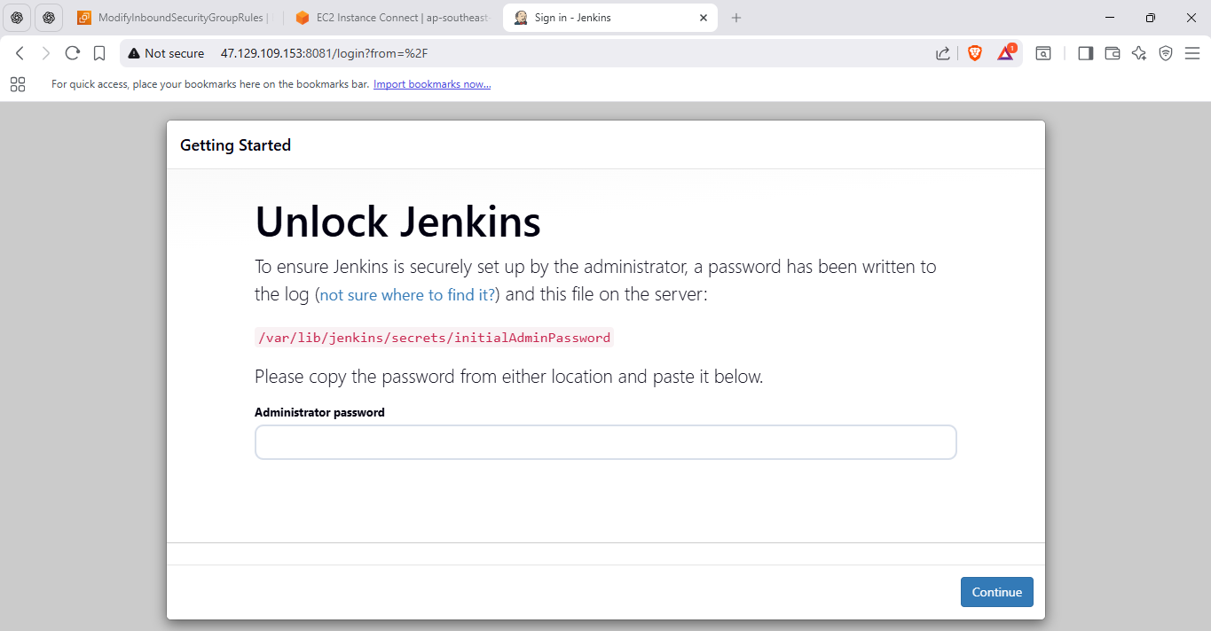
here you can see the Jenkins run on port number 8081.
3:Secure Jenkins server
>> Purpose
- Jenkins controls deployments → very sensitive
- Open Jenkins = security risk
- Security ensures only authorized users can access Jenkins

>> Steps
- Unlock Jenkins using initial admin password
- Install recommended plugins
- Create Admin user
- Configure Jenkins to use its own user database
- Disable anonymous access

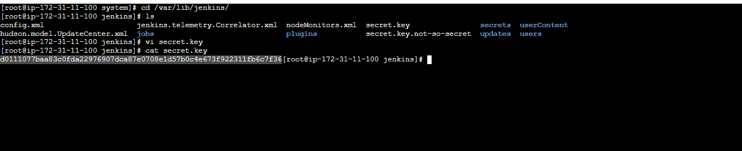
#after setuping the Jenkins login with password
# <cat /var/lib/Jenkins/secret/initialadminpass> this file contain password.
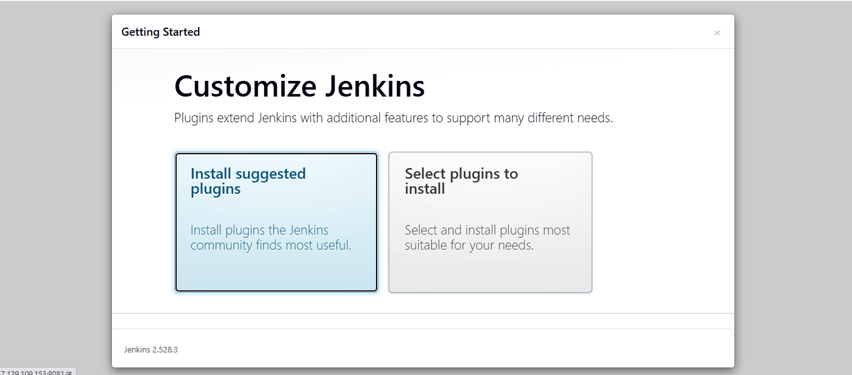
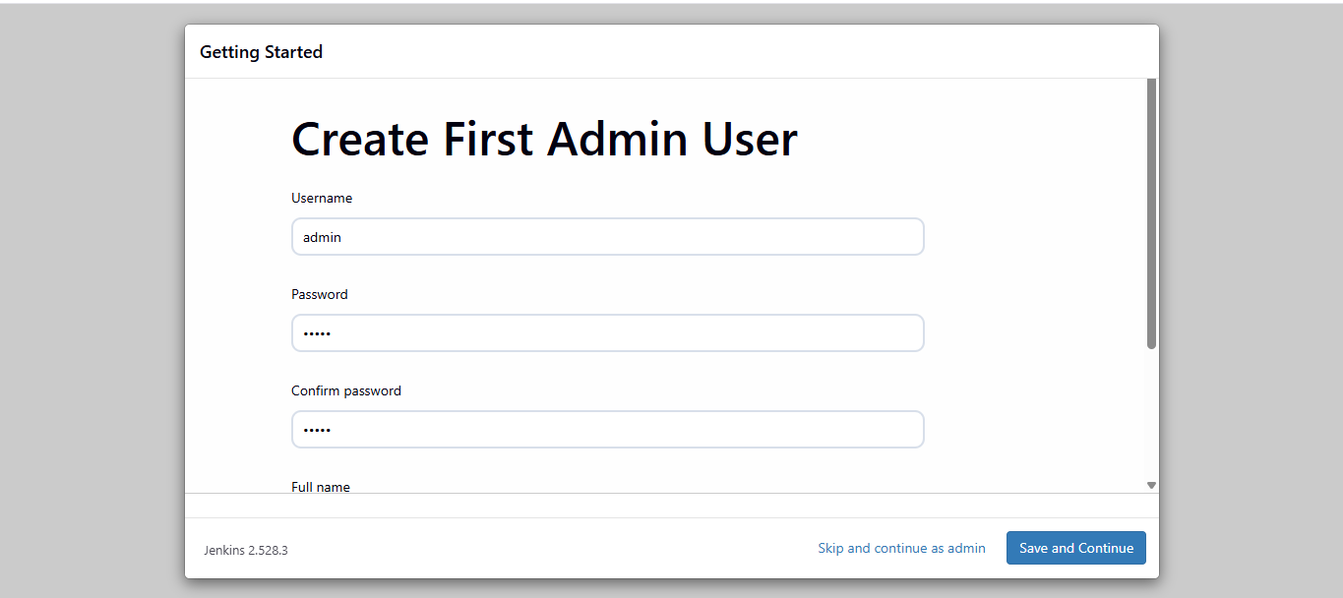
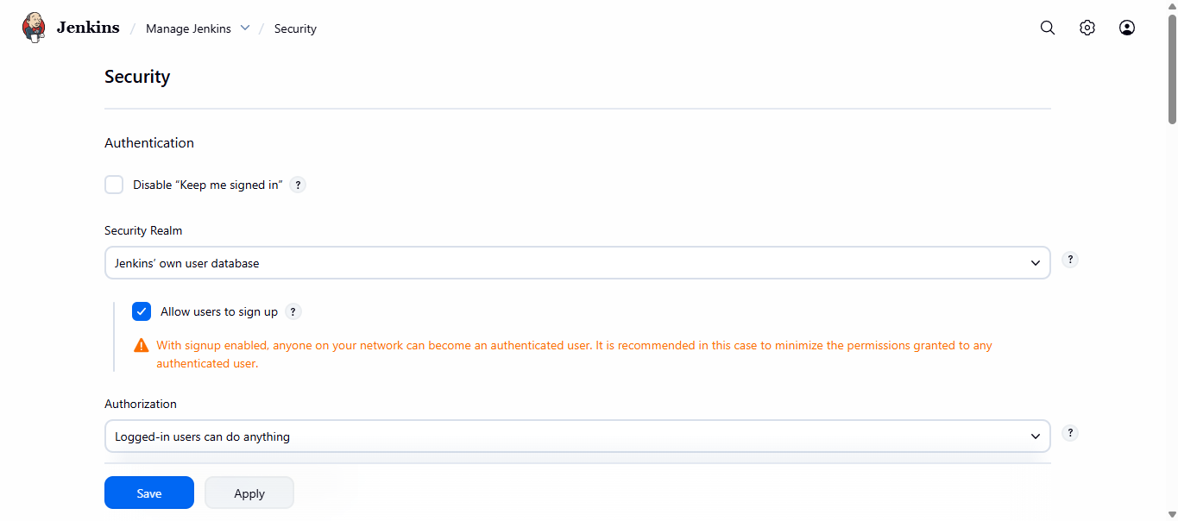
4:Create users called DevOps, Testing in Jenkins with Limited access.
>>Purpose
- In real projects, not everyone is admin
- DevOps, QA, Developers have different permissions
- This prevents accidental or malicious changes

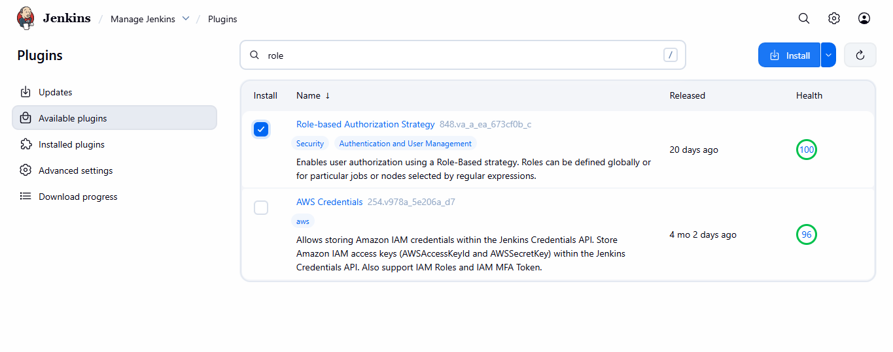
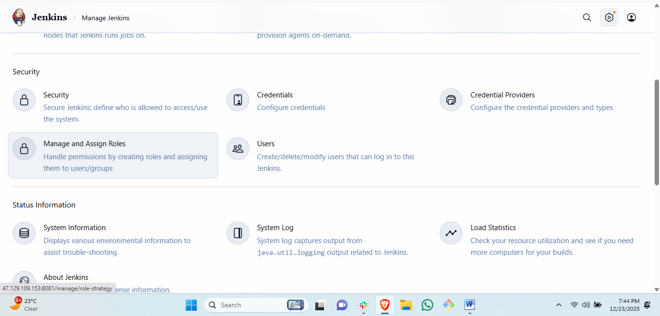
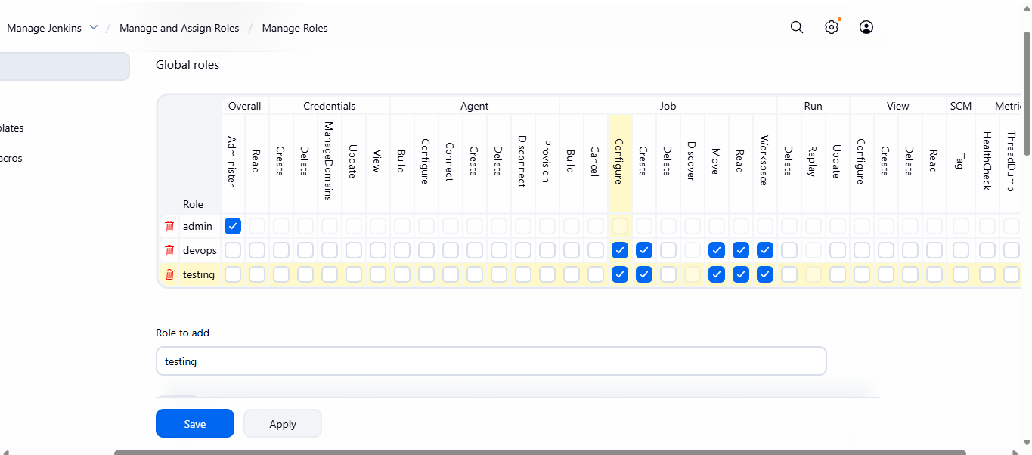
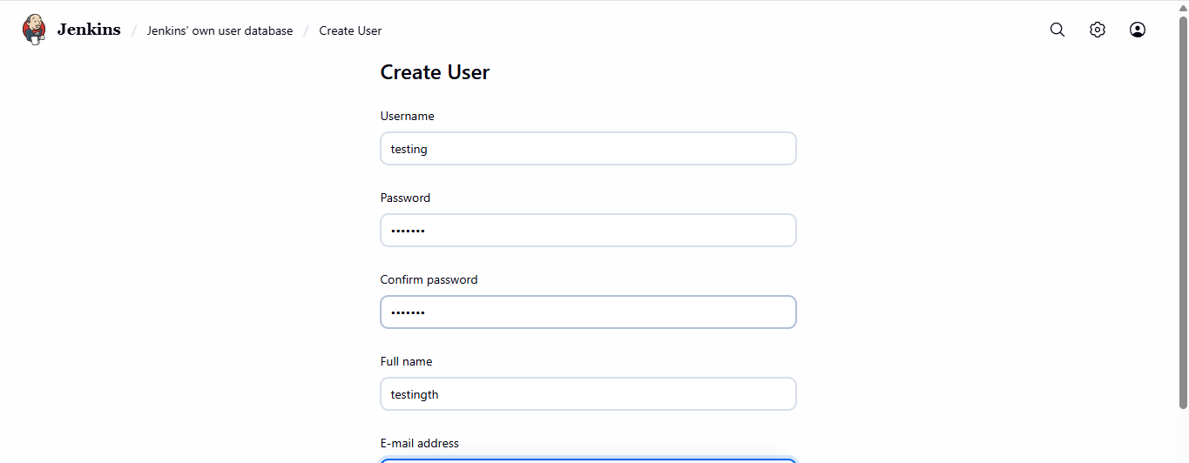
>> Steps
- Install Role-Based Authorization Strategy plugin
- Enable role-based authorization
- Create roles:
  - Admin → full access
  - DevOps → create/configure/build jobs
  - Testing → read/build only
- Create users:
  - DevOps
  - Testing
- Assign users to roles

5:Configure labels and restrict the jobs to execute based on label only.
>>Purpose
- Jenkins may have multiple nodes (agents)
- We must control where jobs run
- Labels ensure jobs run only on correct machines
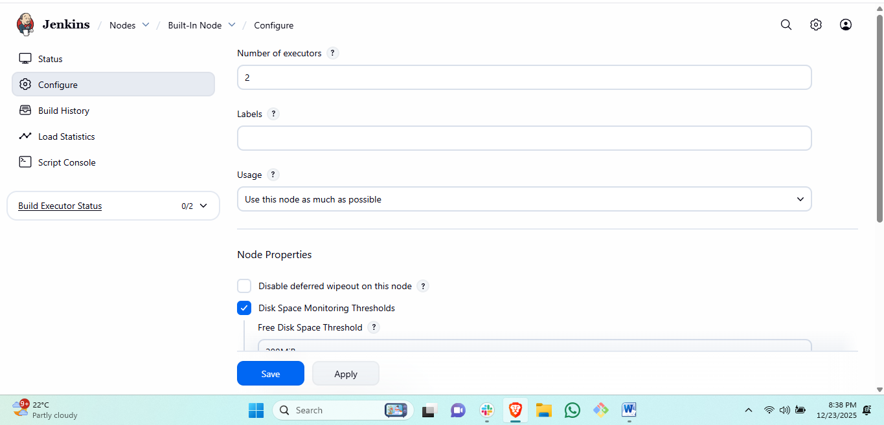
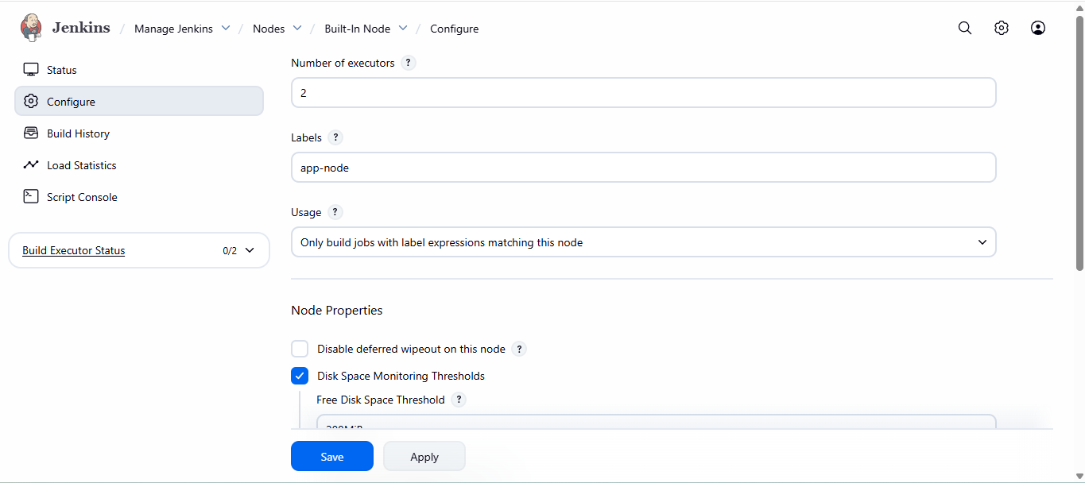
created label and save..

6:Create Three sample jobs using the below URL. https://github.com/betawins/Techie_horizon_Login_app.git
🎯 Purpose
- CI pipeline has multiple stages
- Each job represents a stage
- This teaches GitHub integration and job separation

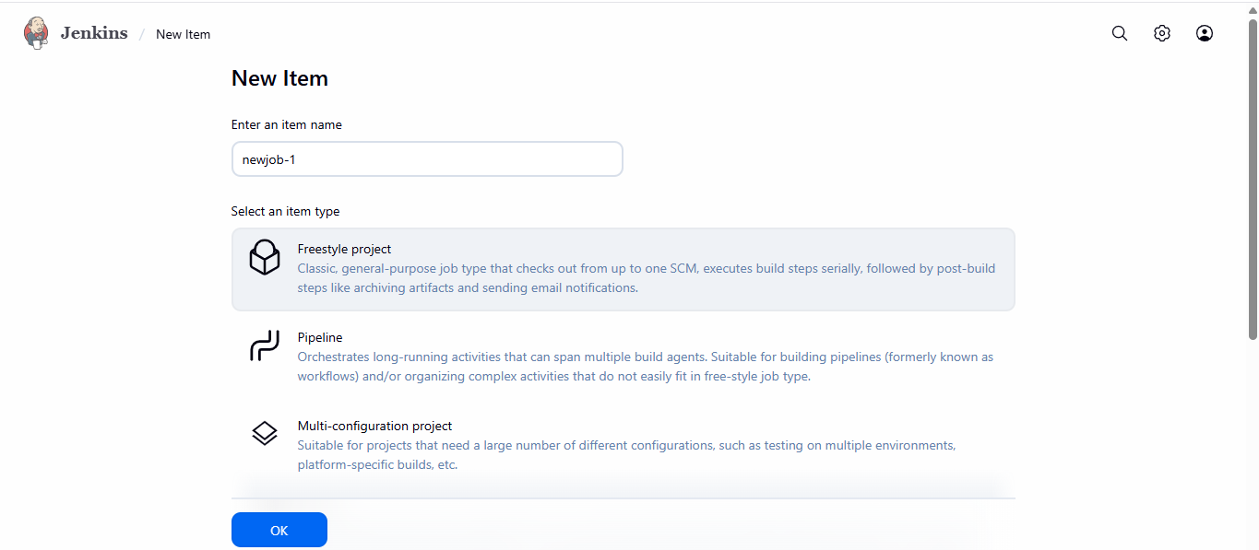
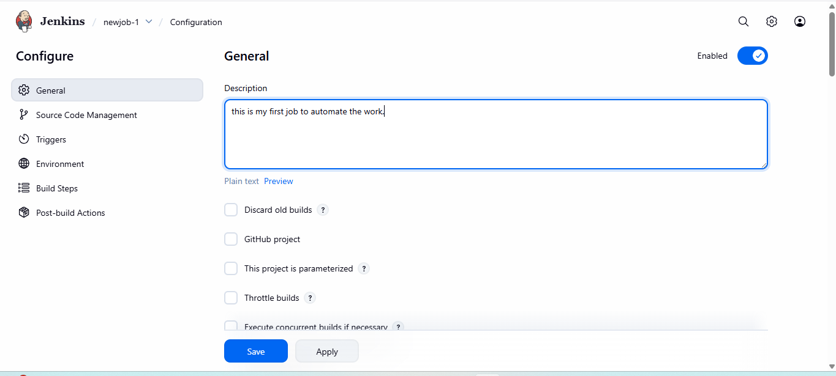
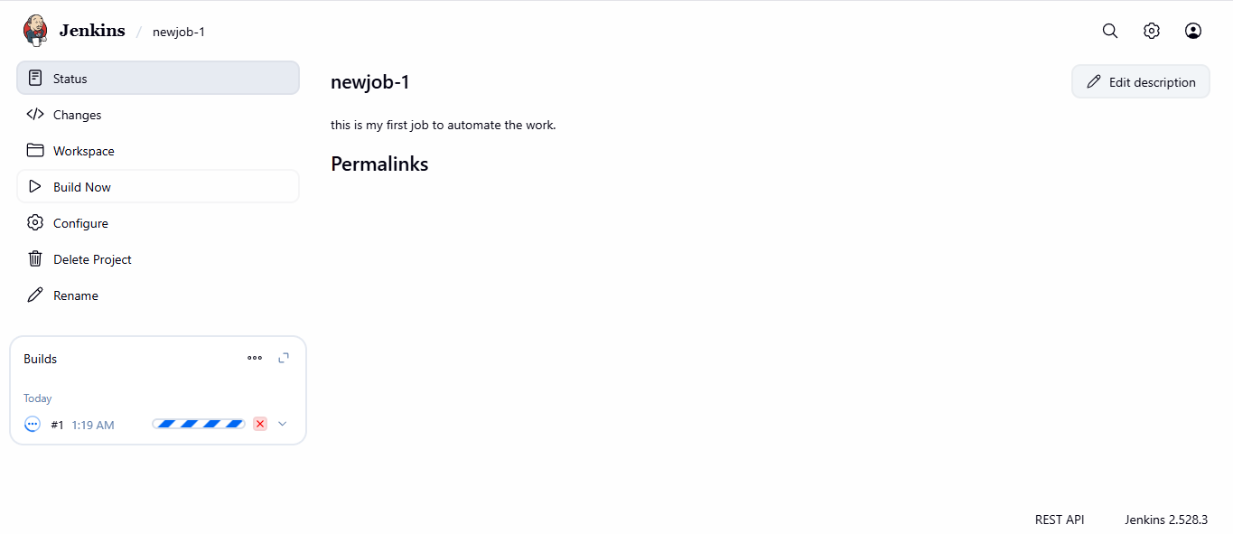
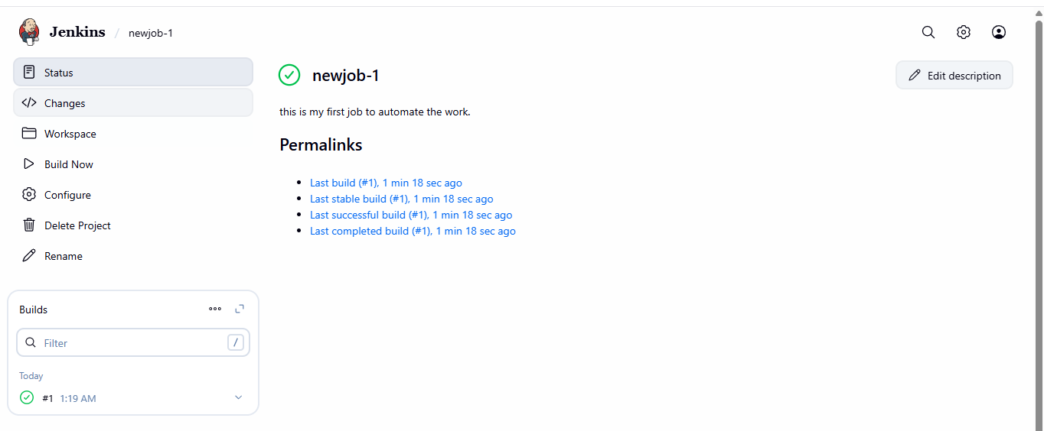
🧱 JOB-1: Clone Repository

Purpose
- Verify Jenkins can access GitHub
- Verify Git is installed and working

Steps
- Create Freestyle job
- Configure Git SCM
- Add shell step to list files
- Build and verify successful clone

Creatong 2nd job.
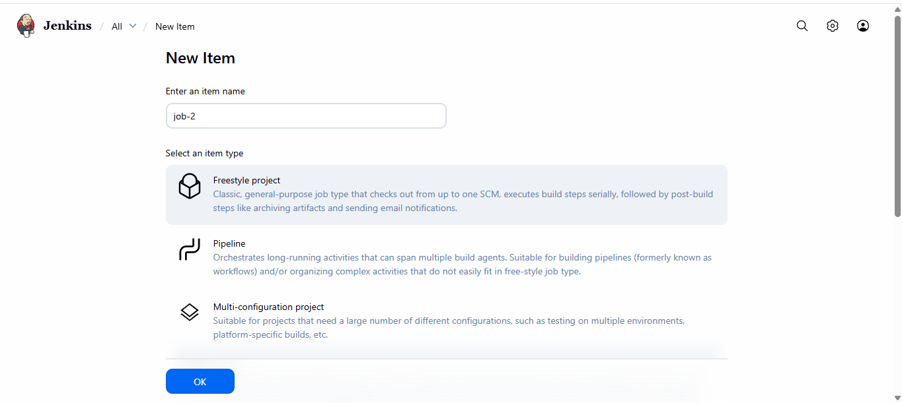
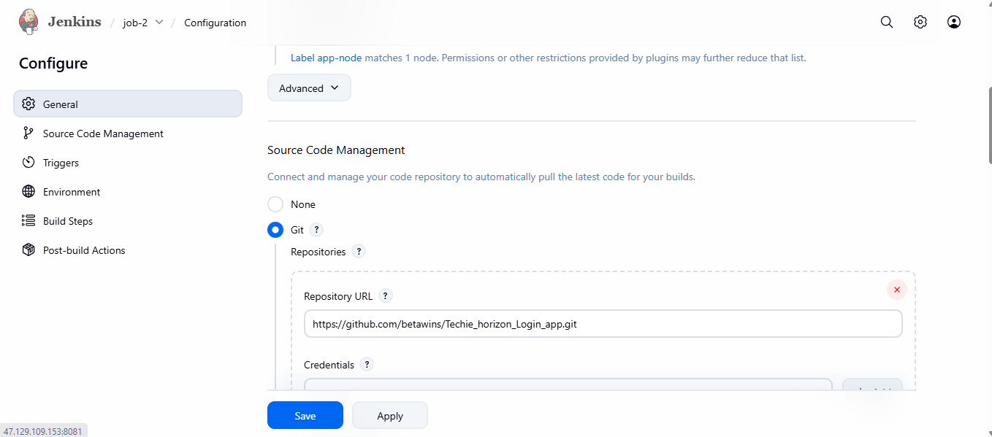
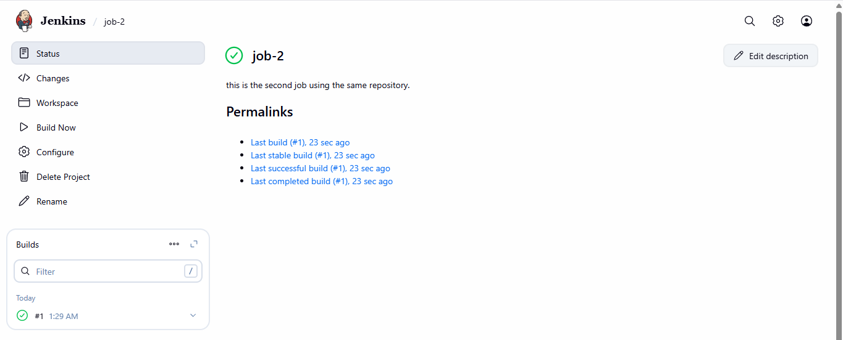
🧱 JOB-2: Build Job

Purpose
- Simulate application build process
- Represent CI build stage

Steps
- Create new Freestyle job
- Use same GitHub repository
- Add shell commands for build simulation
- Build and verify output

7:Create one Jenkins job using git hub Private repository.
Repository

Purpose of Task-7 (WHY we do this)
- In real projects, repositories are PRIVATE
- Jenkins must authenticate securely to pull code
- Passwords are unsafe → GitHub Tokens are used
- This task proves you can:
  - Handle secure credentials
  - Integrate Jenkins with private SCM

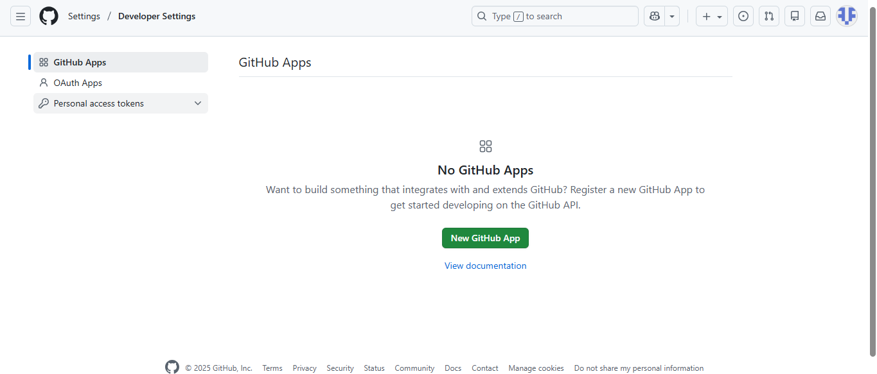
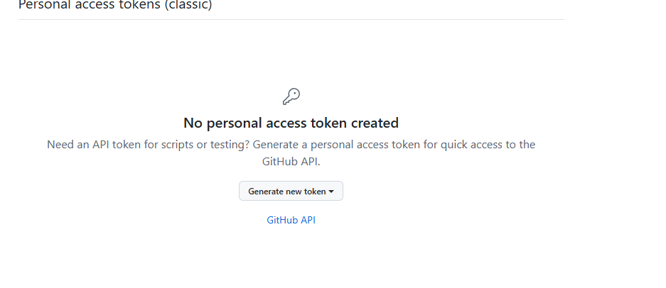
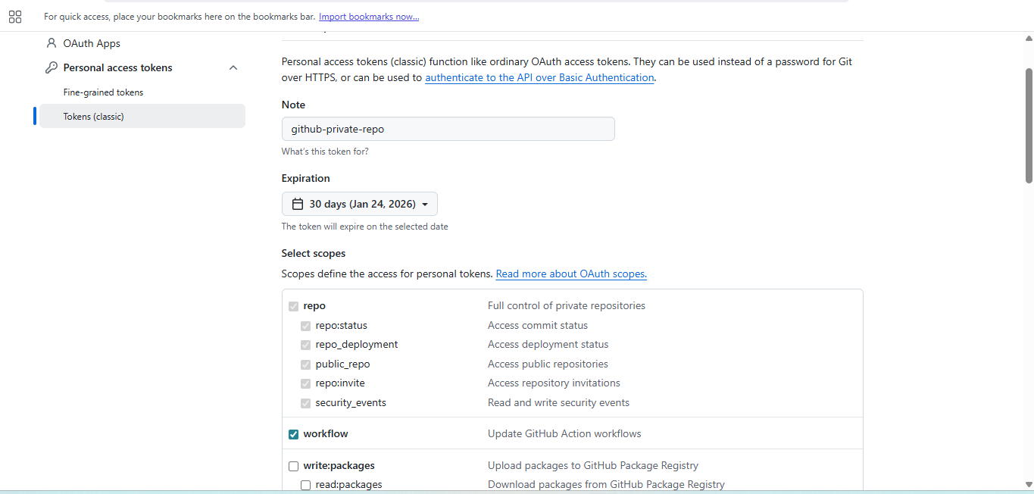
then go to Jenkins.
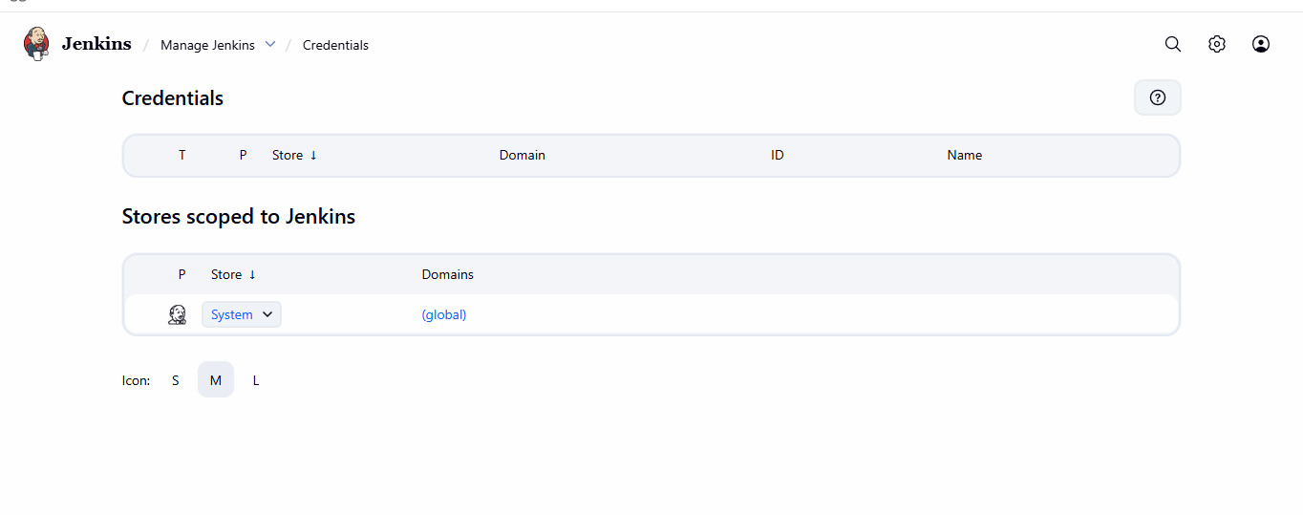
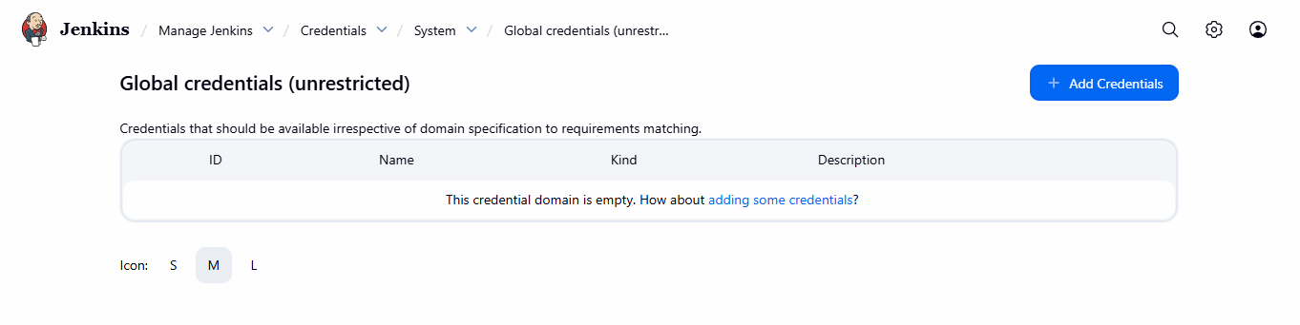
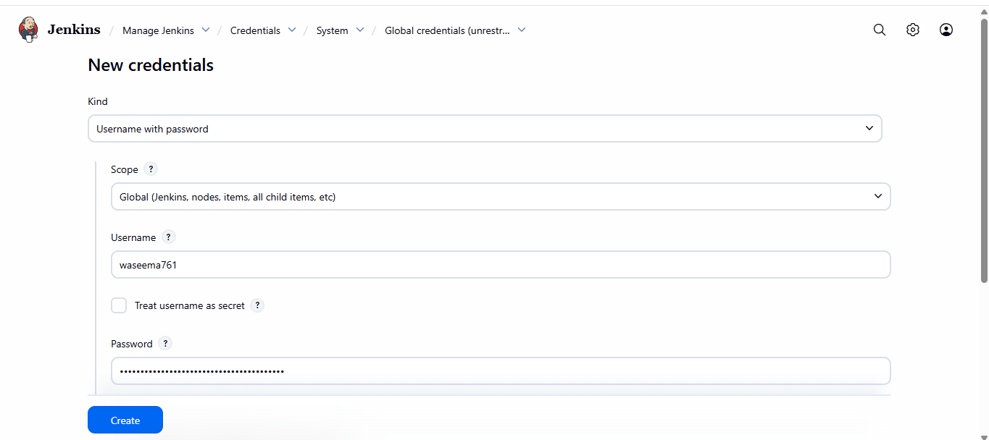
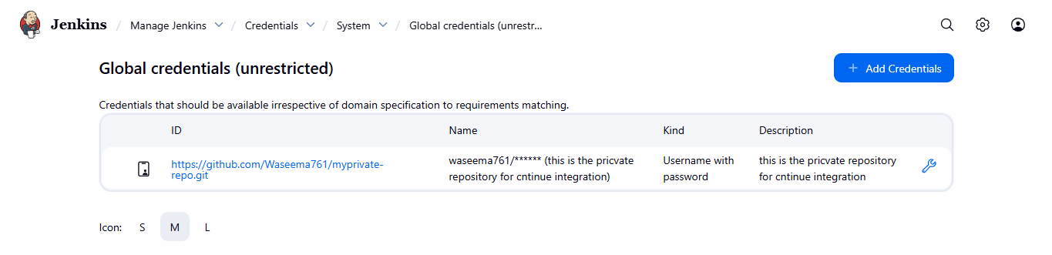
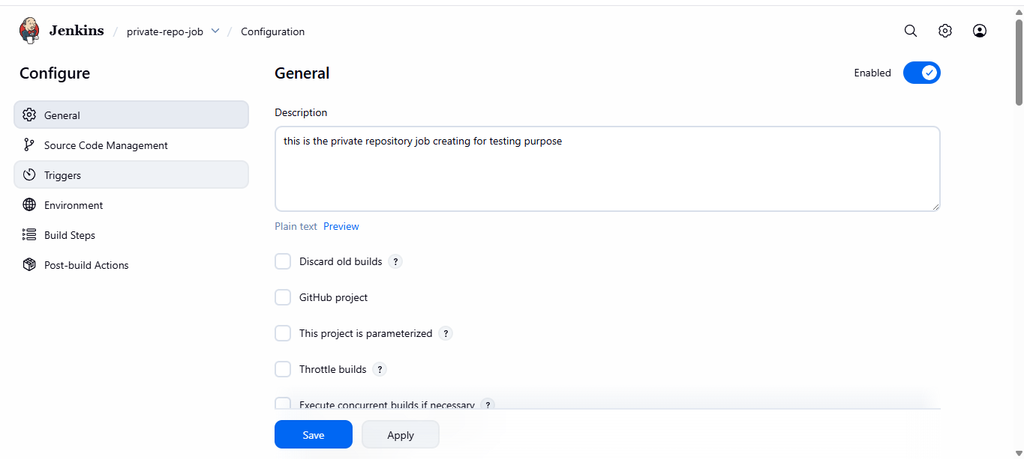
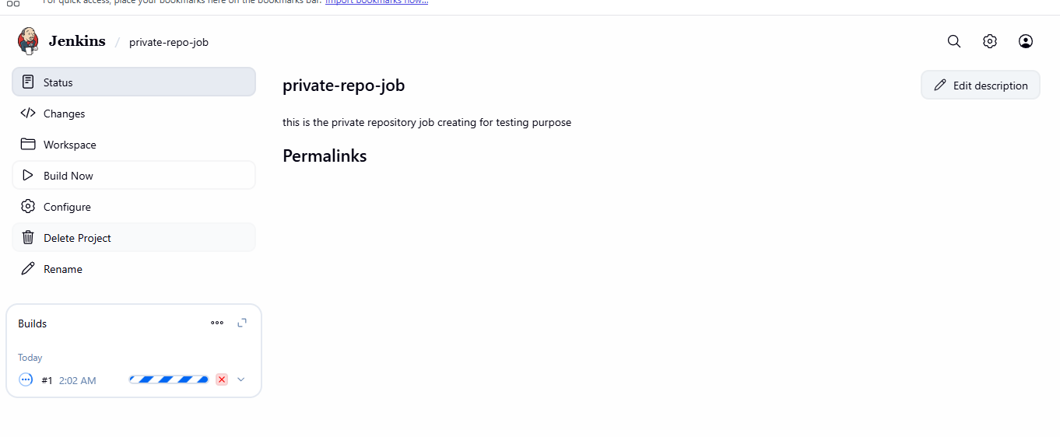
🟢 STEP-1: Generate GitHub Personal Access Token

📍 Where
GitHub website (your account)

Steps
- Login to GitHub
- Click Profile picture → Settings
- Go to:
- Developer settings → Personal access tokens → Tokens (classic)
- Click Generate new token (classic)

Token Settings
- Note: jenkins-private-repo
- Expiration: 30 days (or No expiration for lab)
- Scopes (VERY IMPORTANT):
✔ repo
✔ workflow
- Click Generate token
- COPY THE TOKEN (you will not see it again)

🟢 STEP-2: Add GitHub Credentials in Jenkins

🎯 Purpose
To securely store GitHub authentication details.

📍 Where in Jenkins
Dashboard → Manage Jenkins → Credentials
→ System → Global credentials → Add Credentials

Fill Details EXACTLY
- Kind: Username with password
- Username: your GitHub username
- Password: 👉 paste GitHub token here
- ID: github-private-creds
- Description: GitHub private repo access
Click Create
✅ Jenkins now securely stores your token

🟢 STEP-3: Create Jenkins Job (Private Repo)

📍 Jenkins Dashboard
Click New Item
- Job Name:
- private-repo-job
- Select:
👉 Freestyle project
- Click OK

🟢 STEP-4: Configure Job

🔹 General Section
✔ Restrict where this project can be run
Label:
app-node

🔹 Source Code Management
Select:
Git
Fill:
- Repository URL
- https://github.com/<your-username>/<your-private-repo>.git
- Credentials
👉 Select: github-private-creds
- Branch
- */main

🔹 Build Step
Add:
Execute shell
Command:
echo "Cloned private repository successfully"
ls -l

Click Save

🟢 STEP-5: Build & Verify
Click:
Build Now

✅ SUCCESS OUTPUT (CHECK THIS)
In Console Output, you must see:

