- Create VPC with 2 private and 2 public subnets
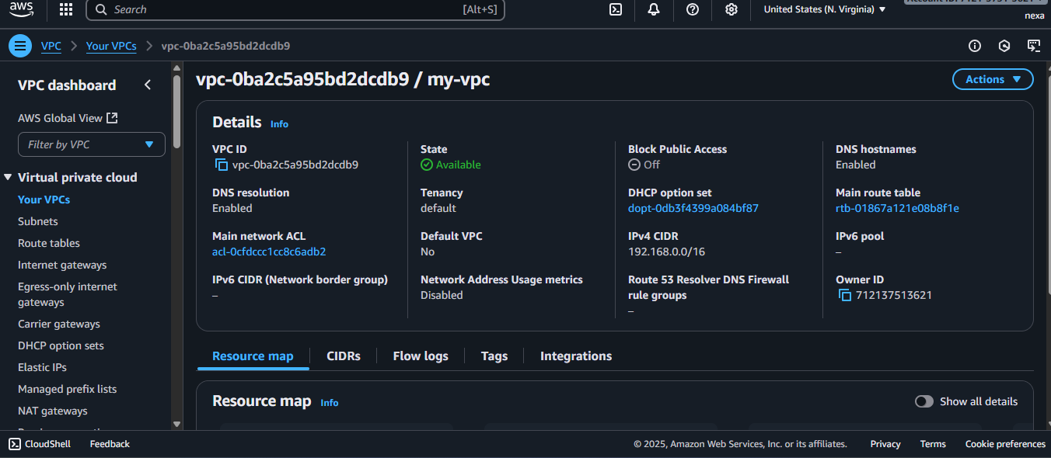
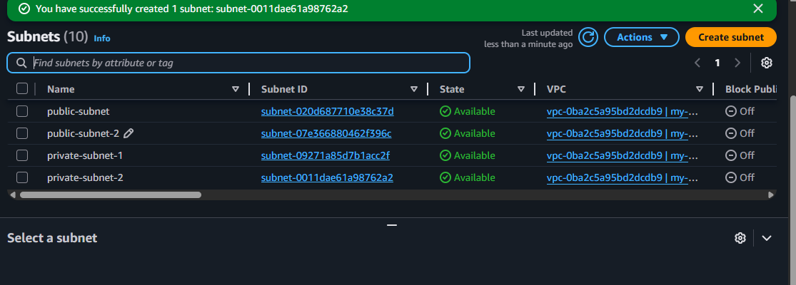
Steps: go to AWS search box and search VPC and tab on create vpc. >named your vpc and provide the ip address 192.168.0.0/16 and create vpc.
2:go to subnets and create subnet and give name with public-subnet-1 and assign the availability zone and assigh the ip range with 192.168.1.0/24
3: then create more subnets follows same steps but change ip ranges to 192.168.2.0/24 like this.

- Enable DNS Hostname in VPC.
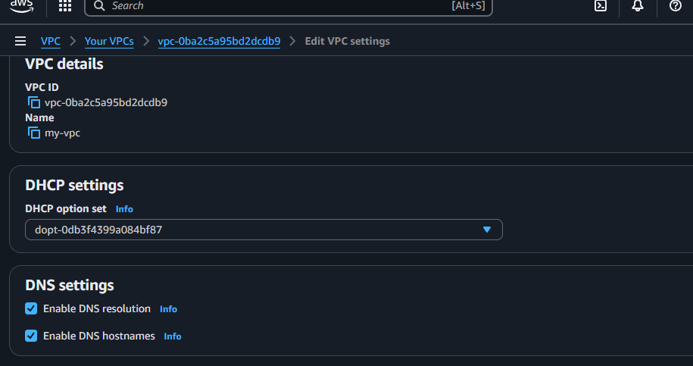
Steps:go to vpc and select your vpc and go to actions and vpc setting and enable the dns hostname.
- Enable Auto Assign Public IP in 2 public subnets.
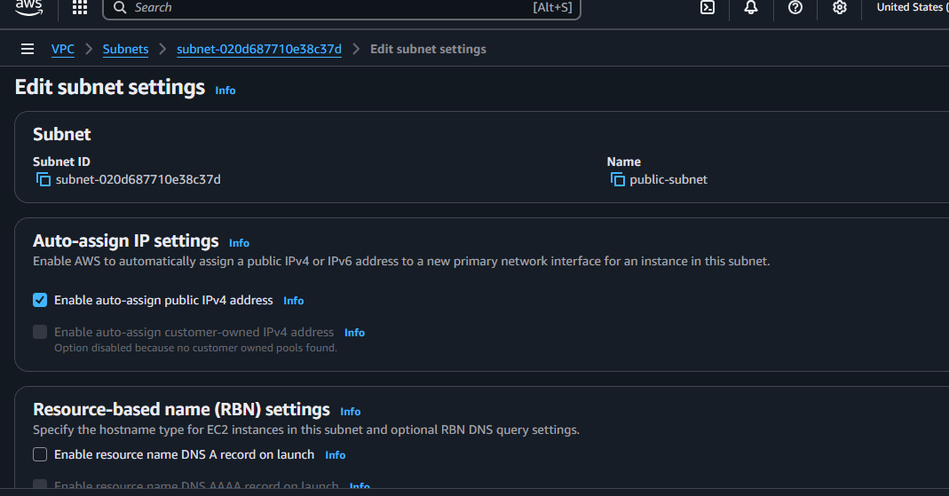
Steps to auto assigh public ip to public subnet: go to subnet and select the public subnet and go to action and click on subnet setting and enable the auto enable the auto assign public ip and save.

- Add 2 private subnets in private route table.
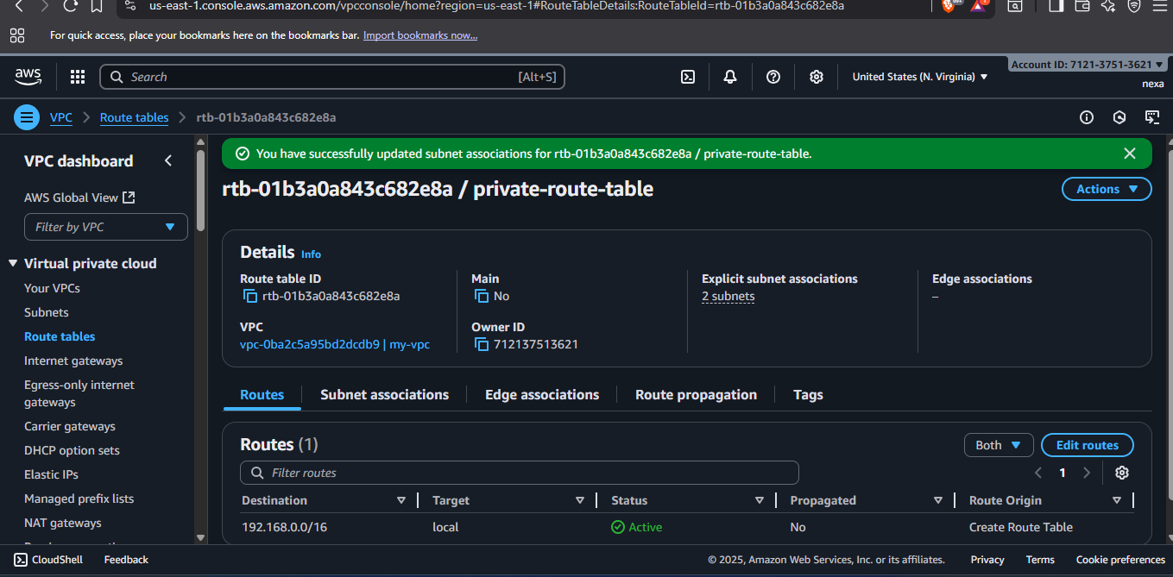
steps
Go to route table and create new route table and go to subnet association and add the private subnets to the created routin table
- Add 2 public subnets in public route table.
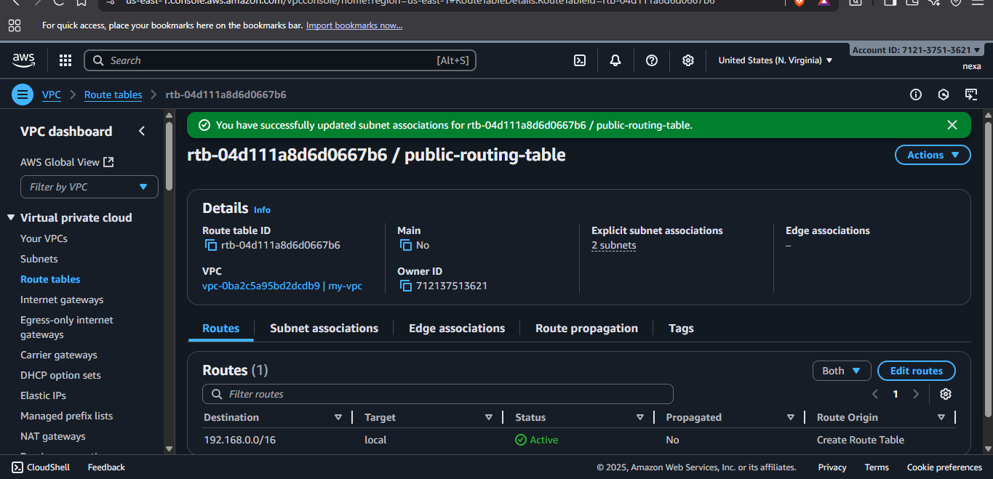
Steps: follow the same steps you did in task 4.
- Public route table will have the routes to internet and local.
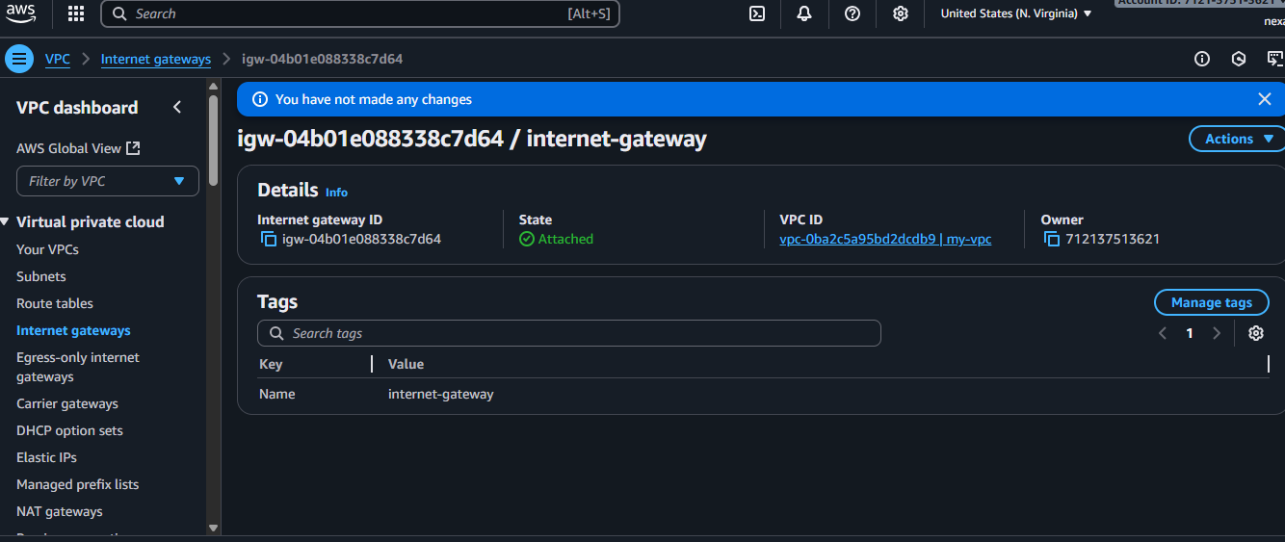
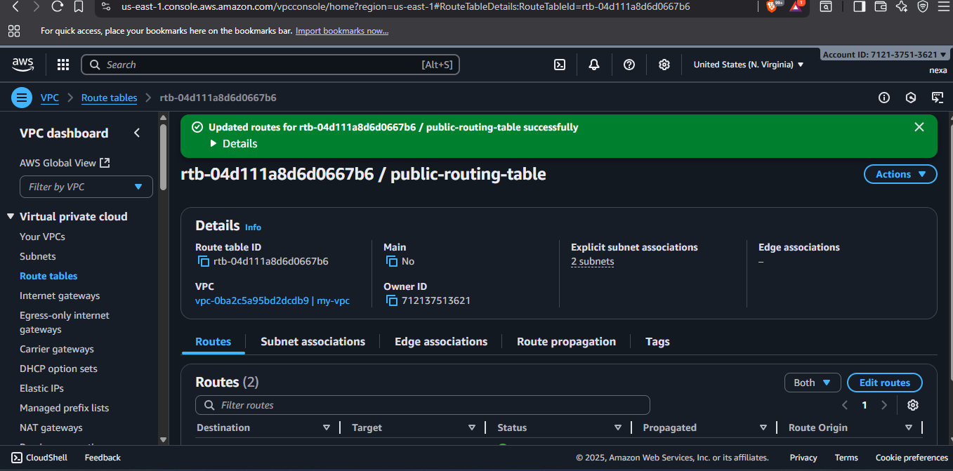
Steps: first I have created the igw and select the created intenet gateway and go to actions and attach the vpc to intenet gateway then move to public route table and select it click on to actions ad edit route and attaché the igw to that routing table.
- Create EC2 in public subnet with t2.micro and install PHP.
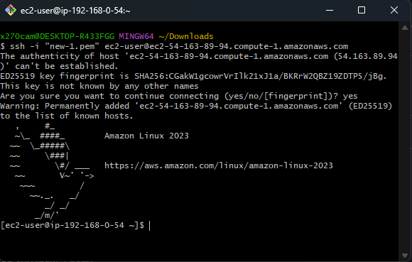
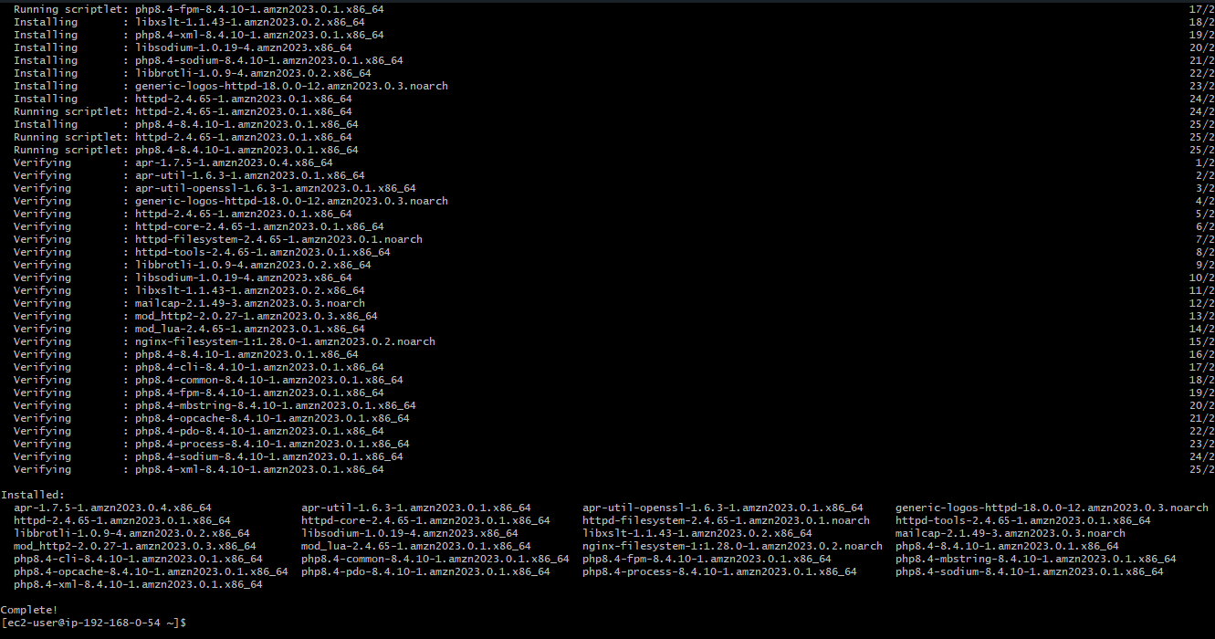
Steps: go to ec2 and lauch instance select the amazon linux ami and select the keypair and attach the created vpc and attach the public subnet and click on existiug security group add ssh and http protocol and launch the instance and connect it through remote if you wan to I connect with git bash remote connection and update the by sudo yum update and install package.
- Configure NAT gateway in public subnet and connect to private instance.
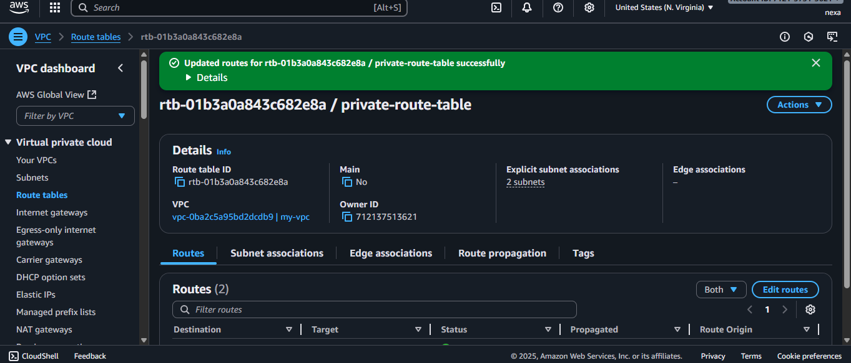
Steps: create the NAT gateway and select the public subnet add your vpc and create wait until it shows nat gateway created successfully.
2: then go to routing table select the private routing and go to actions and edit route then add 0.0.0.0/0 extention and add the NAT gateway and add your created nat gateway and save changes.
- Install Apache Tomcat in private EC2 and deploy a sample app.
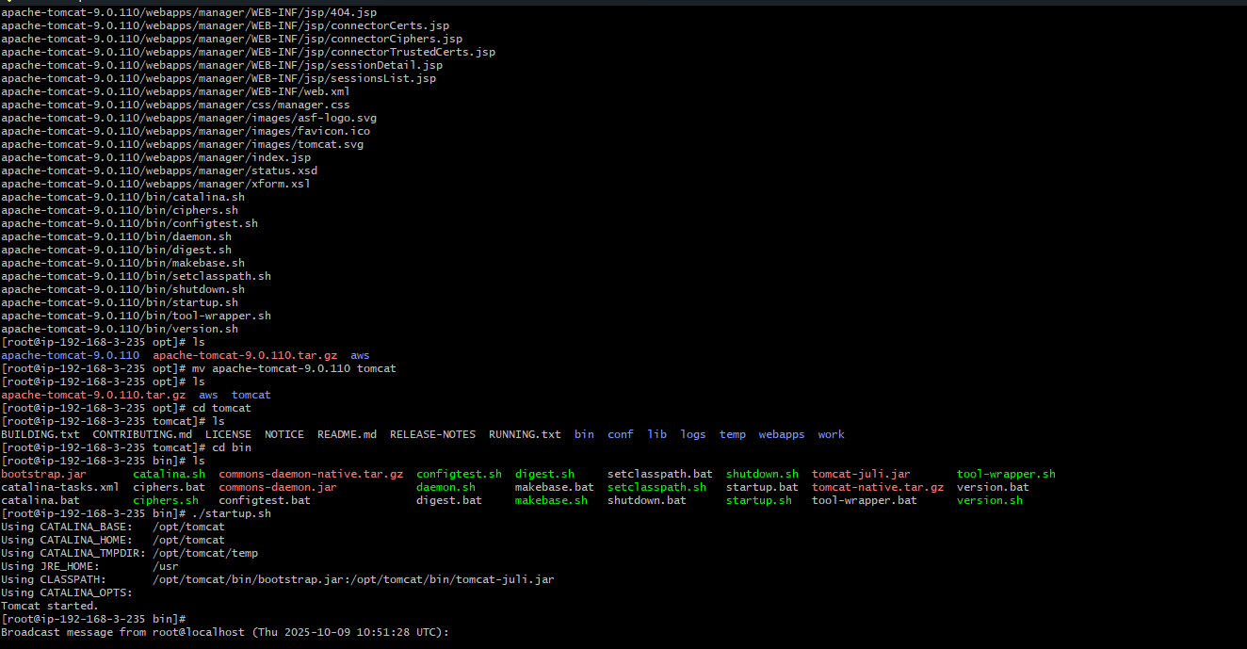

Steps: Create Private EC2 Instance
- Go to EC2 → Launch Instance
- Configure:
  - Name: Private-Tomcat-Server
  - AMI: Amazon Linux 2023 or Ubuntu
  - Instance type: t2.micro
  - Key pair: Same as public instance
  - Network settings:
    - VPC: Your VPC
    - Subnet: Private-Subnet-1
    - Auto-assign public IP: Disable
    - Security group: Select Private-SG
  - Click Launch instance

Connect to Private Instance via Public Instance (Bastion)
- Copy your private key to public instance:
- Process to connect private instance through public instance
- Connect your public instance through remote connection and open new gitbash in downloads and cat your pem key and copy your pem key and go to your public instance and create a new file name private.pem and paste the content. chmod 400 your new file.
- ssh/your-key.pem ec2-user@<private-ip>
- follow the process to install tomcat.
Steps# cd / and then cd opt
#yum update
#yum install java17* -y
#then go to browser and copy the tomcat 9 download tar link
#wget copied link
#tar xvf file name
# mv untar filename tomcat
#cd tomcat
#cd bin
#./startup.sh
The tomcat is running successfully.

- Configure VPC flow logs and store the logs in S3 and CloudWatch.

