RDS-Tasks. Mohammed Mujahed-16
- Create MariaDB DB on EC2.
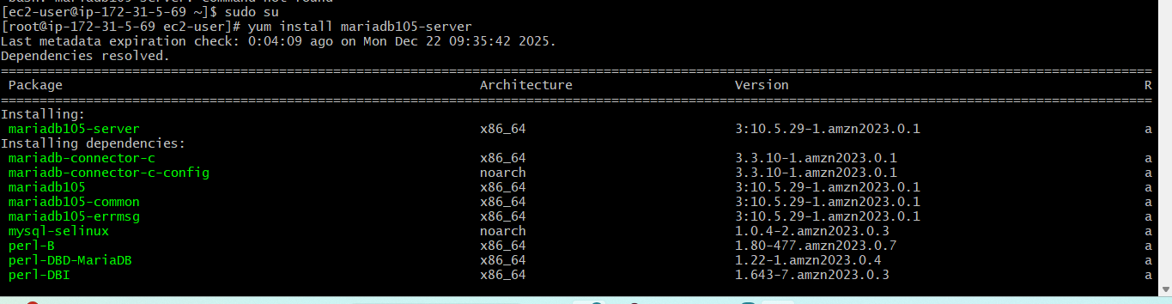
for amazon linux 2023. <Yum install mariadb105-server.>
<sudo dnf clean all> for updating.
<sudo dnf makecache> for updating.
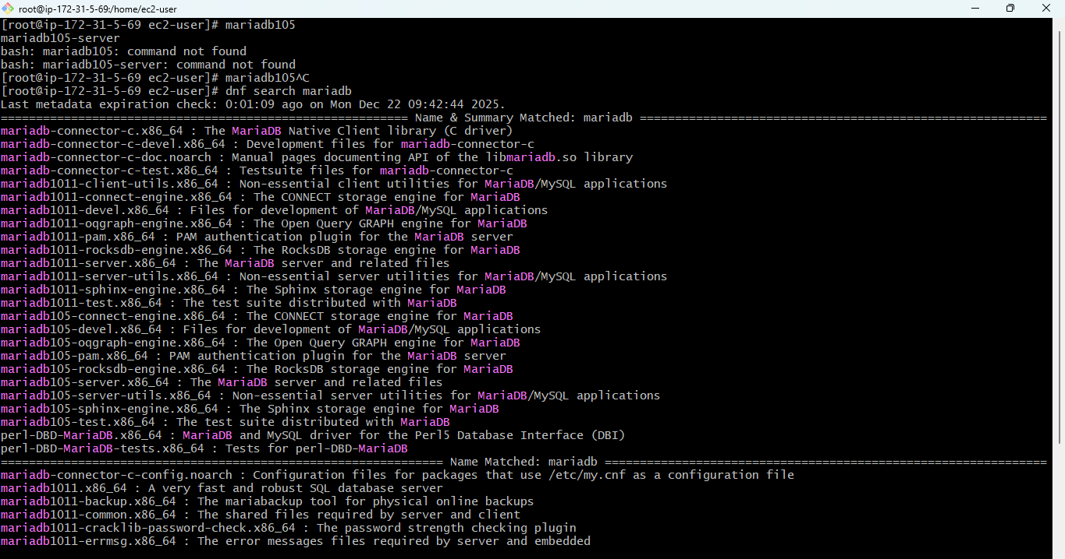
# sudo dnf install mariadb105-server –y> to install mariadb in server.
#systemctl enable mariadb
#systemctl start mariadb.
#systemctl status mariadb.
sudo mysql_secure_installation> to configure mysql
mysql -u root –p.> to switch to database.
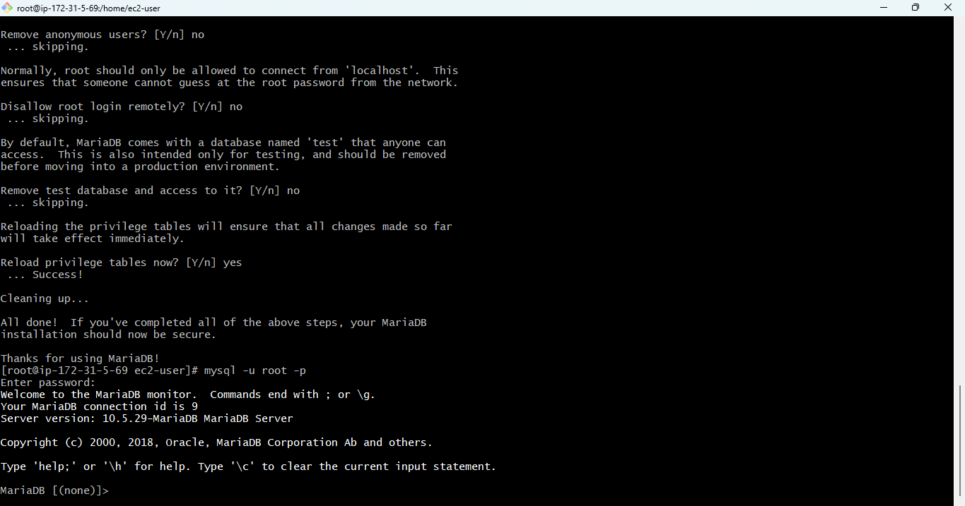

2: Insert some dummy data.
Purpose:
To simulate real application data for backup and migration testing.
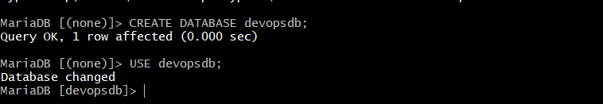
switch to devops user to create new tables. <CREATE DATABASE devopsdb;
USE devopsdb;>
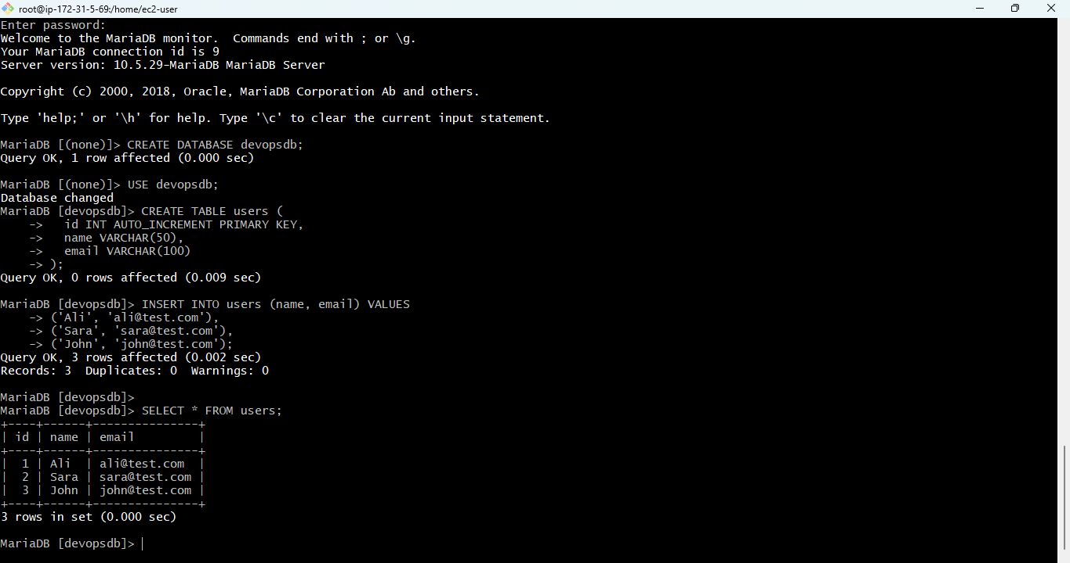
#created the devops user and insert dmmy data in this.
steps: <mysql -u root –p>
#after creatin the table and in=sterting the dummy data.
#check the result with,. SELECT * FROM users;

3:Take the backup of dummy data on EC2.
> Purpose
To learn manual backup strategy for disaster recovery.

.
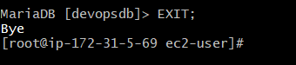
first exit from database.<exit>
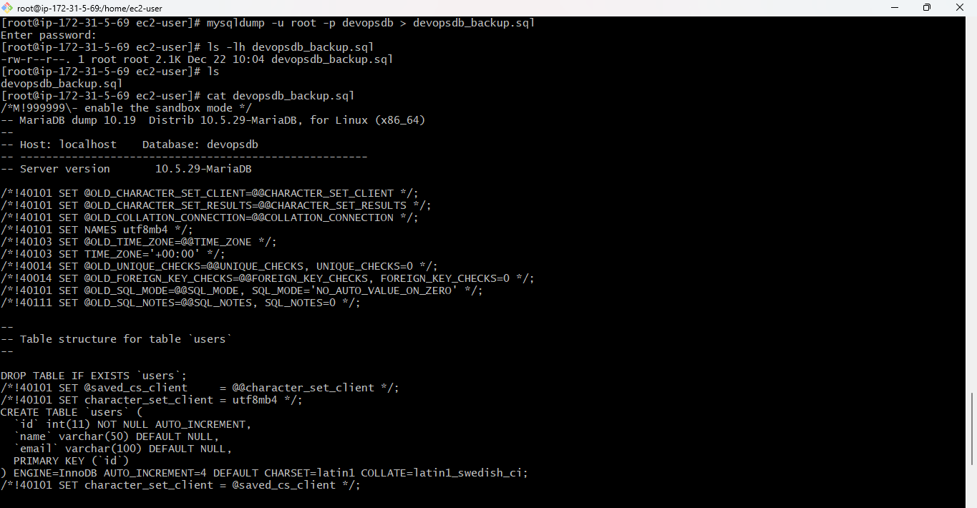
# <mysqldump -u root -p devopsdb > devopsdb_backup.sql> take backup.
# <ls -lh devopsdb_backup.sql> check status.

4:Launch MariaDB RDS instance.
> Purpose
To use AWS-managed database instead of self-managed EC2 DB.
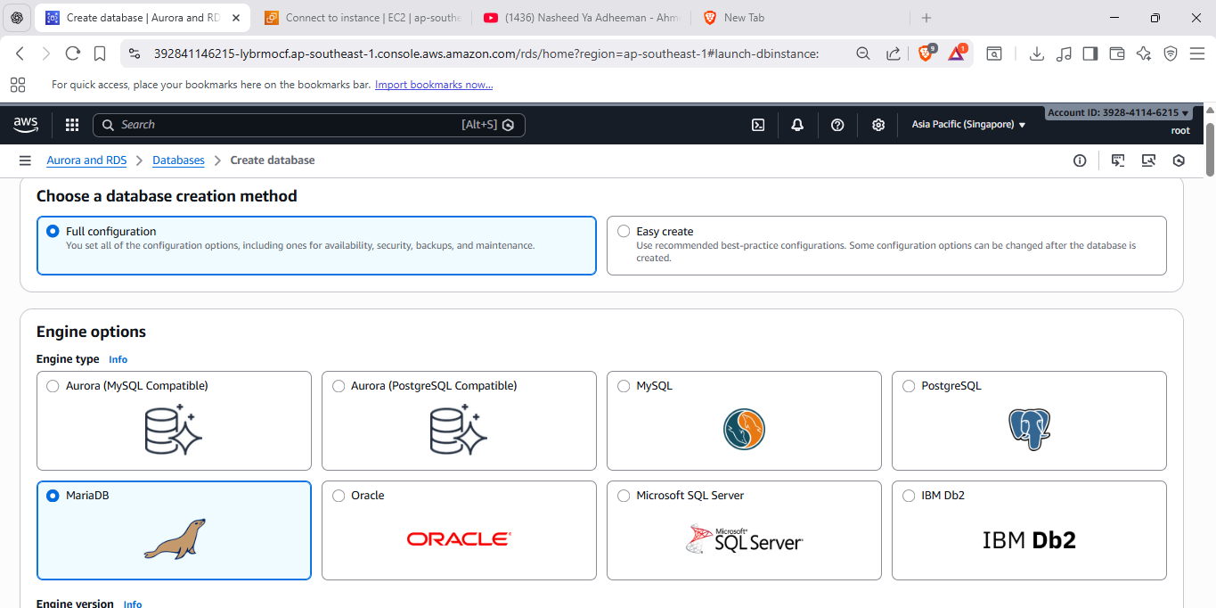
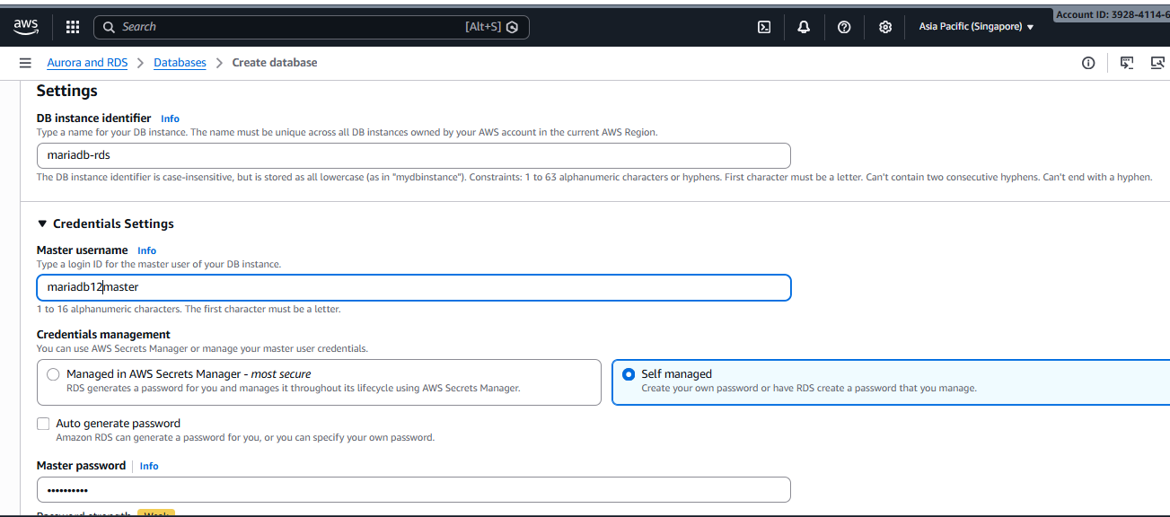

🎯 Purpose
To create a managed MariaDB database using AWS RDS instead of running it manually on EC2.

🔹 Step-by-Step (AWS Console)
- Login to AWS Console
- Go to RDS → Databases
- Click Create database

Database creation options
- Choose Standard create

Engine options
- Engine type: MariaDB
- Version: default (recommended)

Templates
- Select Dev/Test

Settings
- DB instance identifier:
- database-2
- Master username:
- admin
- Master password:
→ set and save it

Instance configuration
- DB instance class: db.t3.micro or free-tier eligible

Storage
- Default settings are fine

Connectivity
- VPC: same VPC as EC2
- Public access: Yes
- Subnet group: default
- VPC security group:
  - Allow MySQL/Aurora (3306) from EC2 security group

Additional configuration
- Initial database name: leave blank
- Click Create database
- Wait until status becomes Available

5:Migrate database from EC2 to RDS.
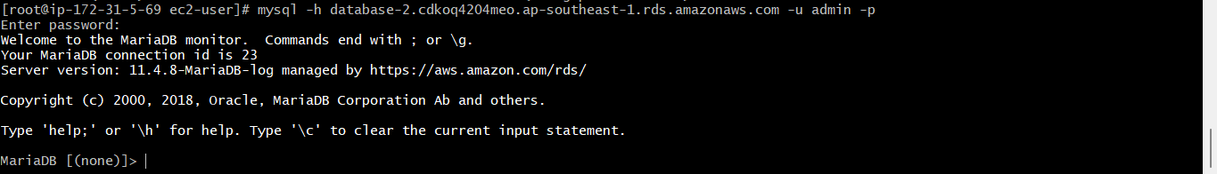
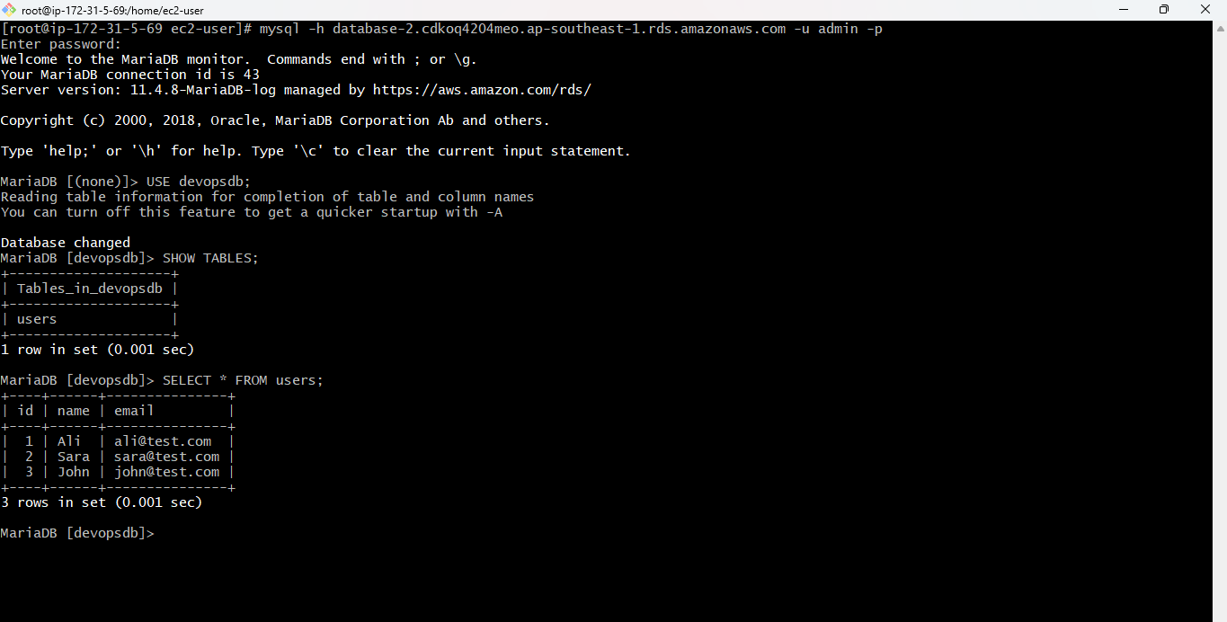
🔹 Step 1: Login to EC2
SSH into the EC2 instance where MariaDB + backup exists.
Confirm backup file:
ls -lh devopsdb_backup.sql

🔹 Step 2: Login to RDS from EC2
Run on EC2 (replace nothing except password):
mysql -h database-2.cdkoq4204meo.ap-southeast-1.rds.amazonaws.com -u admin -p
Expected output:
MariaDB [(none)]>
📸 Evidence: successful login screen

🔹 Step 3: Create Database on RDS
Inside RDS prompt:
CREATE DATABASE devopsdb;
SHOW DATABASES;
exit;

6:Install MySQL DB on EC2.
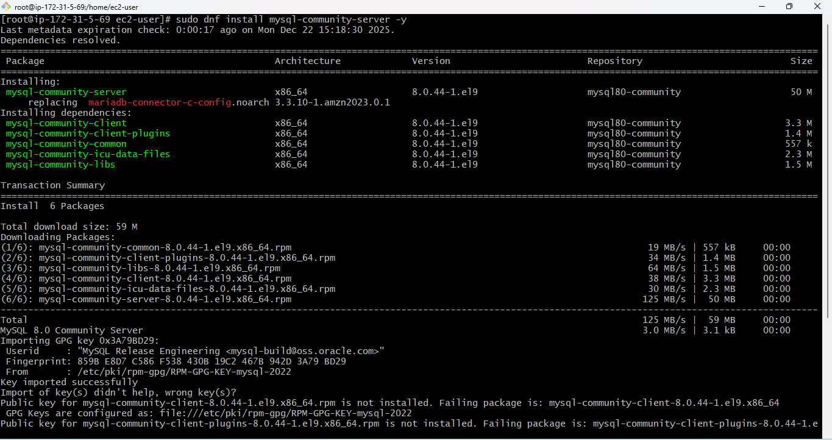
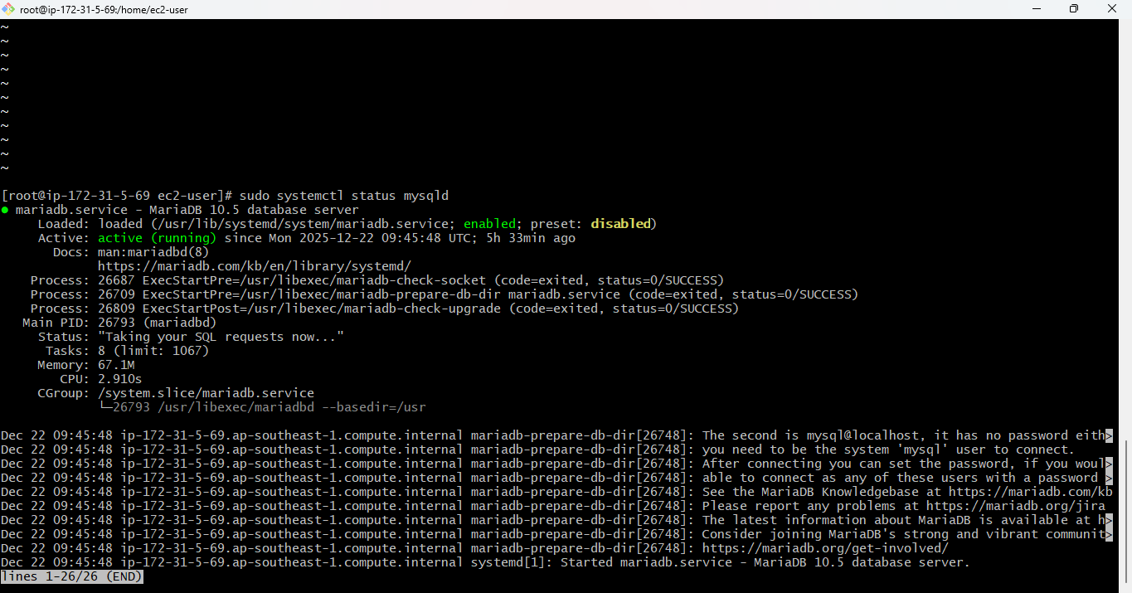
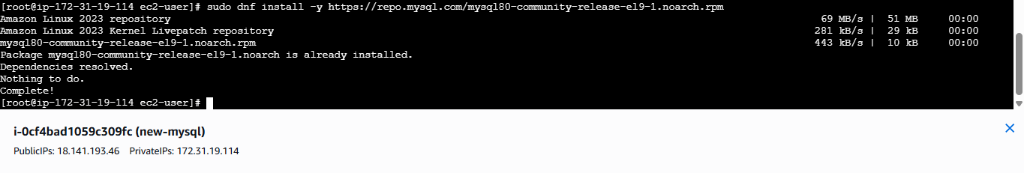
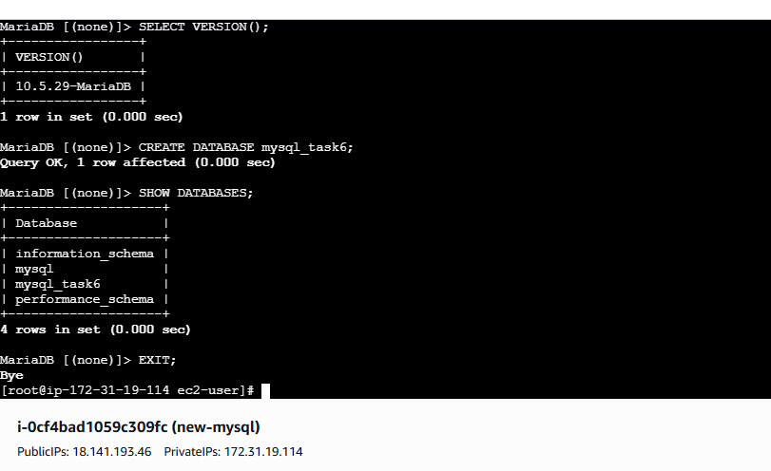
> Purpose
To set up a MySQL-compatible database on an EC2 instance and understand self-managed database installation on AWS.

>> Steps Executed (Amazon Linux 2023)

Step 1: Install MariaDB Server
sudo dnf install mariadb105-server -y

Step 2: Start and Enable MariaDB
sudo systemctl start mariadb
sudo systemctl enable mariadb
sudo systemctl status mariadb
✅ Status: active (running)

Step 3: Secure Database Installation
sudo mariadb-secure-installation
Actions taken:
- Set root password
- Removed anonymous users
- Disabled remote root login
- Removed test database
- Reloaded privileges

Step 4: Login to Database
mariadb -u root -p

Step 5: Verify MySQL Compatibility
SELECT VERSION();
Output example:
10.5.x-MariaDB

Step 6: Create Sample Database
CREATE DATABASE mysql_task6;
SHOW DATABASES;
EXIT;

7:Launch MySQL RDS image.
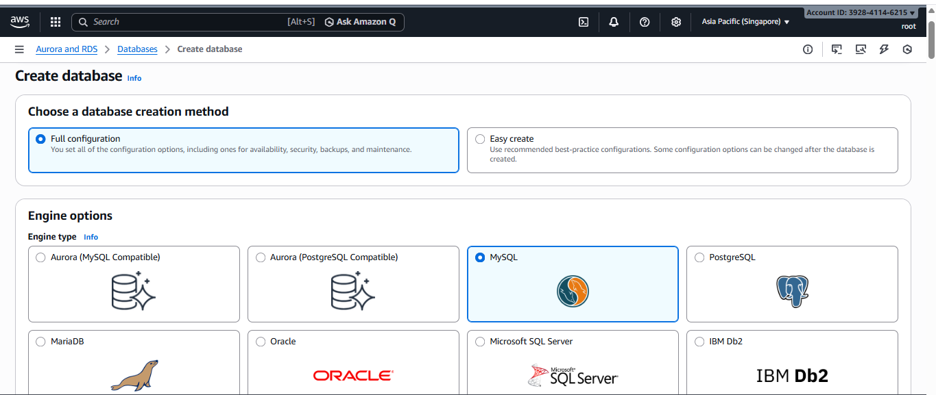
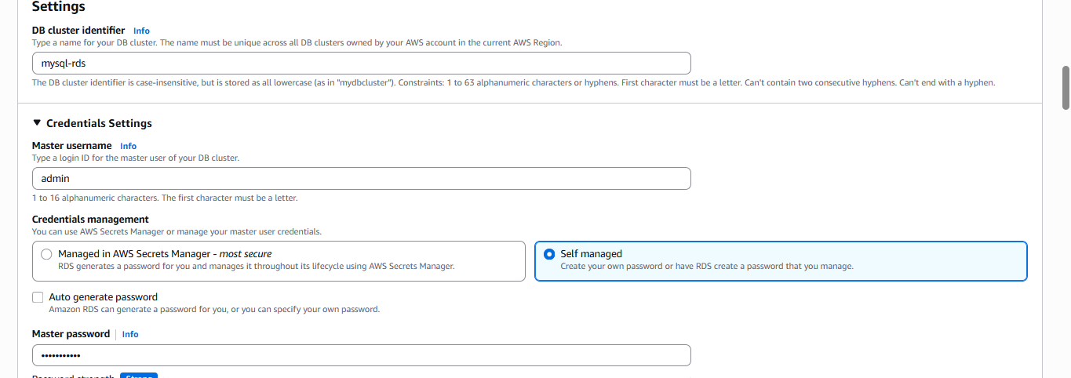
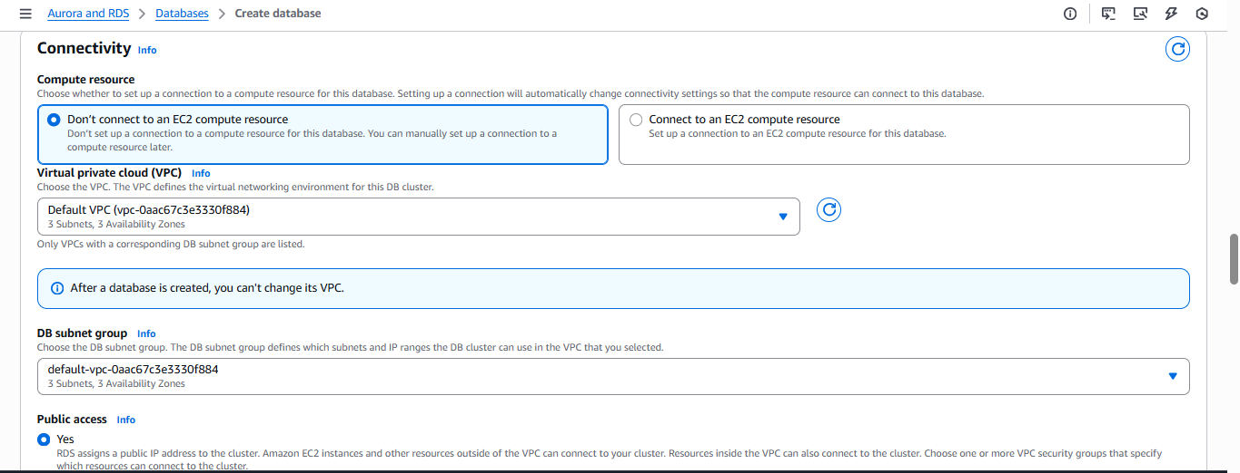
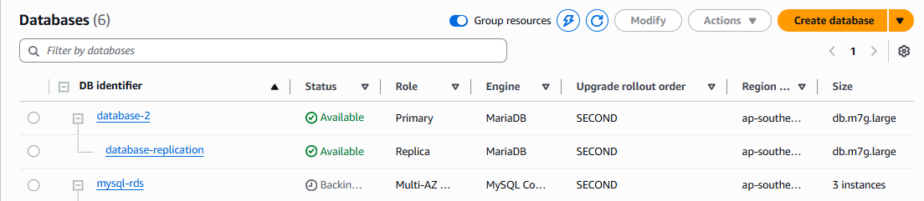
>> Purpose of Task 7
To create a managed MySQL database using AWS RDS and understand:
- Managed DB service
- Automatic patching
- Backups

High availability (used in later tasks)
🛠️ STEP-BY-STEP: Launch MySQL RDS Instance

🔹 Step 1: Open RDS Service
- AWS Console
- Search RDS
- Click Databases
- Click Create database

🔹 Step 2: Choose Database Creation Method
- Select Standard create

🔹 Step 3: Engine Selection
- Engine type: MySQL
- Engine version: Default (8.0.x)

🔹 Step 4: Templates
- Select Dev/Test
(Free tier is fine if available)

🔹 Step 5: Settings
- DB instance identifier:
- mysql-rds
- Master username:
- admin
- Master password:
  - Set a strong password
  - Save it (important)

🔹 Step 6: Instance Configuration
- DB instance class:
- db.t3.micro
(or smallest available)

🔹 Step 7: Storage
- Storage type: General Purpose (gp3)
- Allocated storage: Default (20 GB is fine)
- Disable autoscaling (optional)

🔹 Step 8: Connectivity (VERY IMPORTANT)
- VPC: Same VPC as EC2
- Public access: Yes
- Subnet group: default
- VPC security group:
  - Allow MySQL/Aurora (3306) from:
    - EC2 security group
⚠️ Do NOT use 0.0.0.0/0 unless required

🔹 Step 9: Database Authentication
- Authentication: Password authentication

🔹 Step 10: Additional Configuration
- Initial database name: leave blank
- Backup retention: Default
- Encryption: Default

🔹 Step 11: Create Database
Click Create database..

8:Configure Multi-AZ.
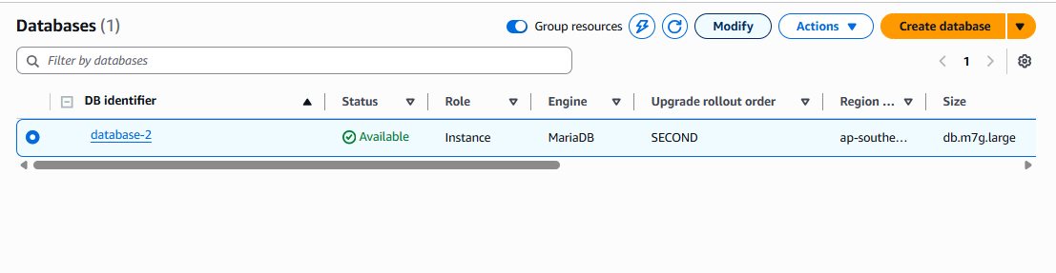
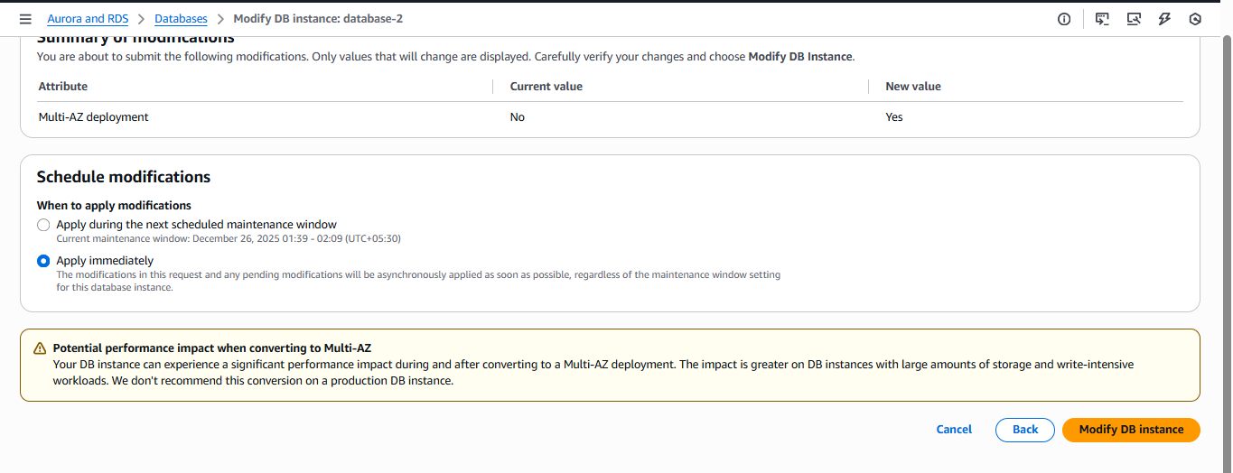

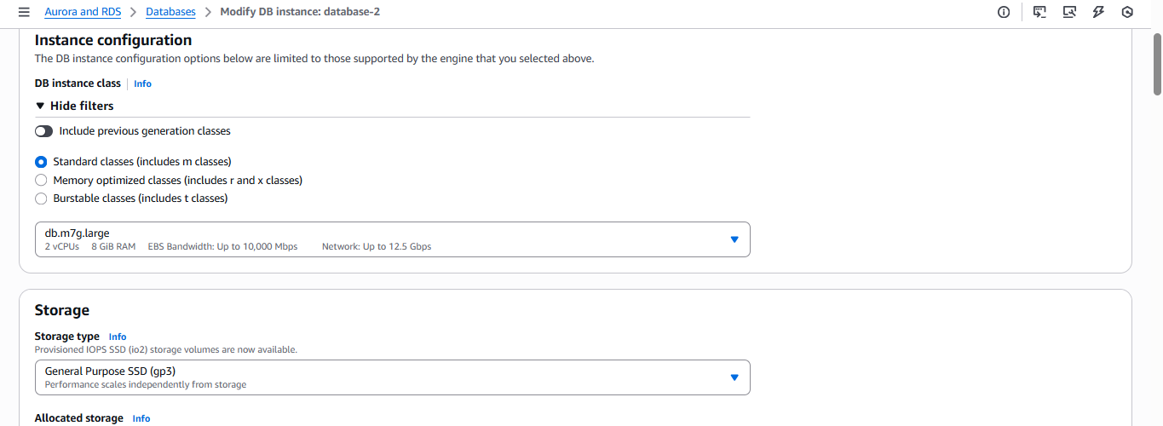
>>Purpose
To ensure high availability and automatic failover.

>> Steps
- Modify RDS instance
- Enable Multi-AZ
- Apply immediately

9:Take backup of DB and restore the DB.
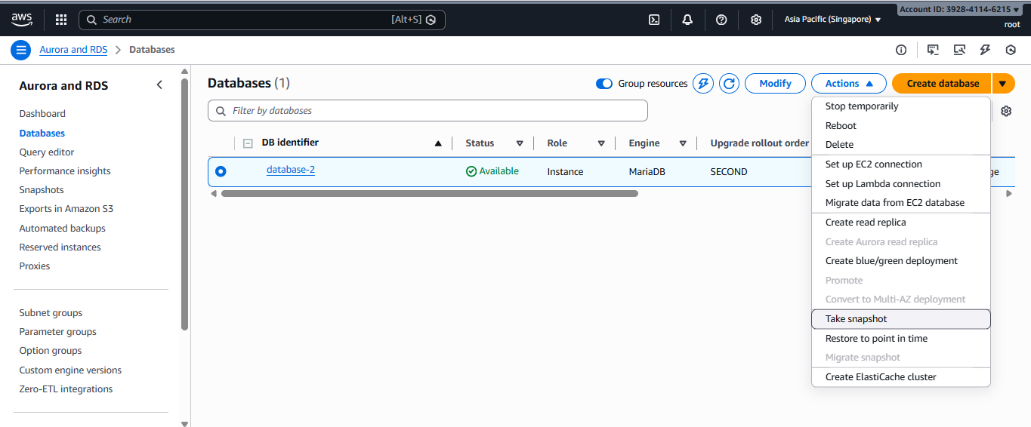
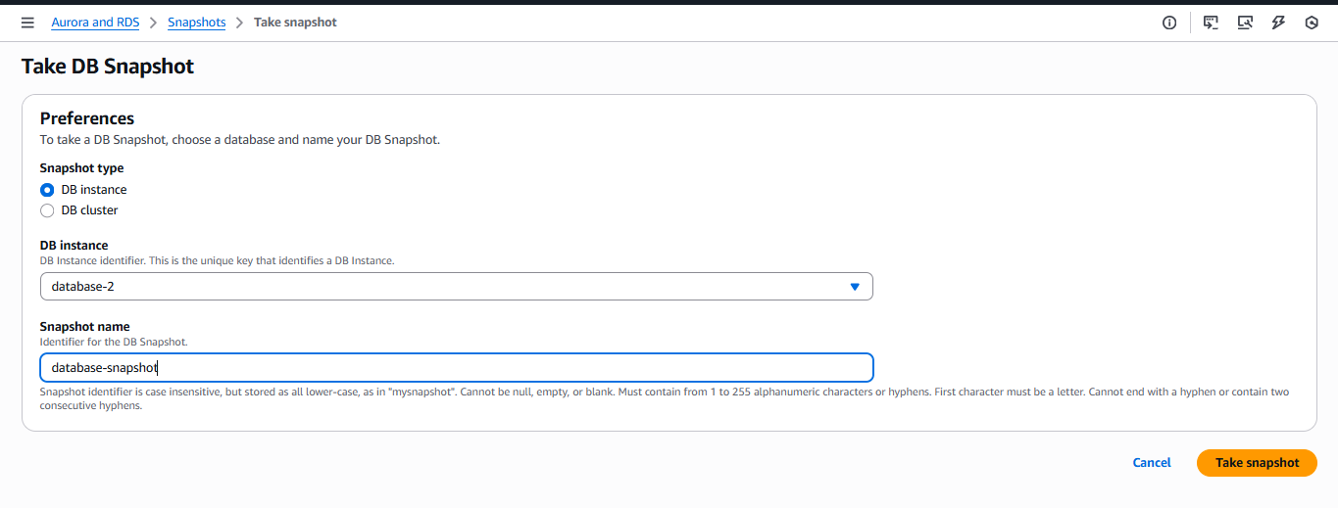
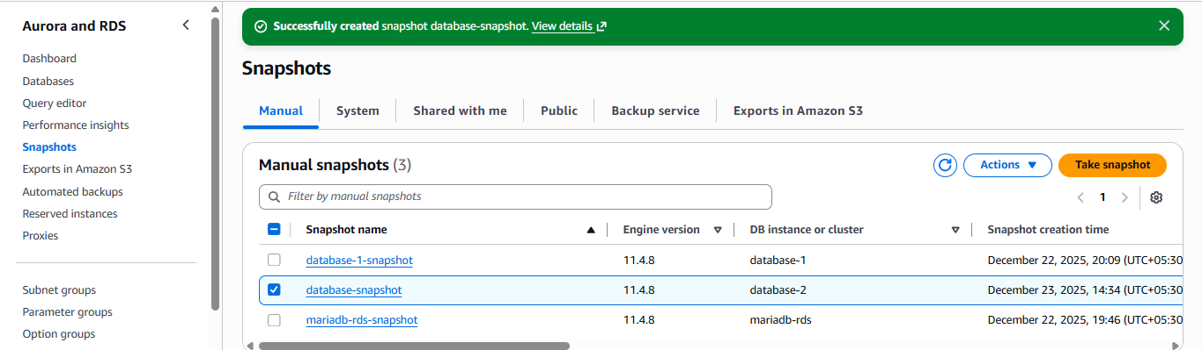
>>Purpose
To validate disaster recovery using automated snapshots.

>> Steps
- RDS → Snapshots → Take snapshot
- Restore snapshot → New DB instance

10: Create read replica.

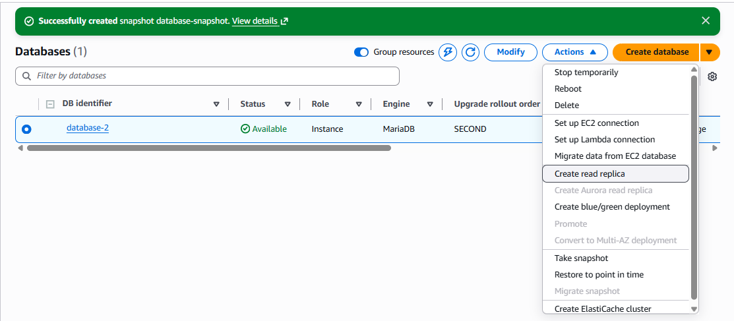
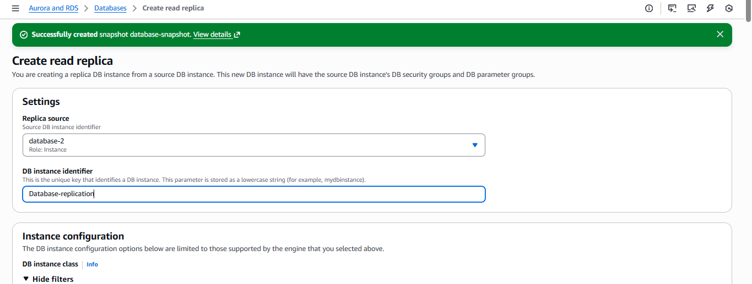
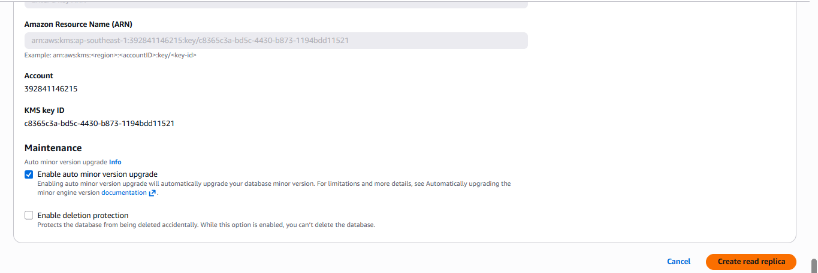
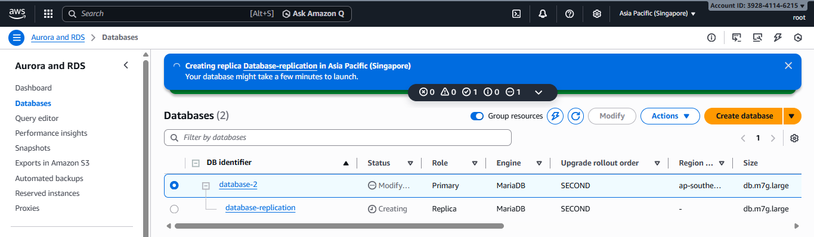
it takes some time to create replication.
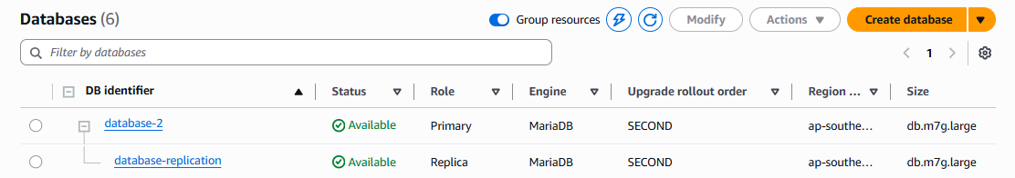
🎯 Purpose of Task 10
The purpose of creating a Read Replica is to:
- Improve read performance by offloading read queries
- Support high read traffic applications
- Enable scalability without affecting the primary database
- Use replicas for reporting, analytics, or read-only workloads
- Increase availability for read operations
A Read Replica is a read-only copy of the primary RDS database that automatically stays in sync using asynchronous replication.

🔹 Step 1: Open RDS Console
- AWS Console
- Go to RDS
- Click Databases

🔹 Step 2: Select Primary MySQL RDS
- Select your primary MySQL RDS instance
(example: mysql-rds)

🔹 Step 3: Create Read Replica
- Click Actions
- Select Create read replica

🔹 Step 4: Read Replica Settings

DB instance identifier
mysql-rds-replica

Instance configuration
- DB instance class:
db.t3.micro
(or smallest available)

Destination region
- Choose Same region (recommended for this task)

Storage
- Leave default settings

Networking
- VPC: Same as primary DB
- Public access: Optional (Yes for testing)

Monitoring & Maintenance
- Keep defaults

🔹 Step 5: Create Read Replica
Click Create read replica
⏳ Wait until status becomes:
Available…

