Design and fabrication of regenerative braking system

# Chandrakant Rahane1, Vaibhav Varpe2

Bachelor of Engineering, Mechanical, Sinhgad academy of Engineering, Pune, India1 Master of Engineering, Mechanical, Amrutvahini College of Engineering, Sangamner, India2

**Abstract**: In recent years, increased concerns over the impact of the conventional car (ICE – Internal Combustion Engine) on the environment have led to renewed interest and advancement in the Electric Vehicle (EV). While the advancements in the EV technology have been able to overcome many of its initial limitations, the need to improve overall efficiency of the vehicle has led to the design of the regenerative braking system (RBS). The RBS will be used to convert the car’s mechanical energy and also the heat that would have been lost during braking into electrical energy. The RBS would be controlled using a PWM (Pulse Width Modulation) signal generated from a microcontroller. The duty cycle of the PWM signal would in turn depend on the response to a variable resistor which will be used to model the conventional braking. A higher resistance would generate a PWM signal with a higher duty cycle and in turn, a higher braking intensity. Therefore by varying the resistor value, the braking intensity can also be varied. The motor to be used in this system will primarily be a DC Motor. We intend to switch to an induction motor later on as this is currently the norm in the BEV (Battery Electric Vehicle) industry.In other term to maximize the efficiency of the RBS, it is important that we store some of the energy that may have otherwise been wasted. To achieve this, we implement the use of large capacitors connected in parallel to store the energy. This energy could then be used to recharge the batteries of the Electric vehicle (EV).

**Keywords**: Energy, flywheel, hybrid vehicle, regenerative braking.

# INTRODUCTION

A regenerative brake is an apparatus, a device or system which allows a vehicle to recapture and store part of the kinetic energy that would otherwise be 'lost' to heat when braking.

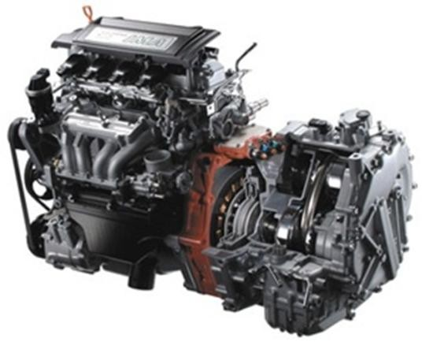

Fig.1. IMA principle

Honda's patented IMA(Integrated Motor Assist) concept is quite simple - use an efficient Otto engine supplemented by an electric motor when additional power is needed. Also referred to as a 'hybrid' system because it uses two power sources, the IMA concept allows the Civic Hybrid to use a smaller gasoline engine without any significant loss in performance.This system is especially effective due to the fact that acceleration requires a significantly higher power than needed for cruising on a level road (where vehicles spend most of their time). An engine more powerful than needed has to work under low load most of the time, condition where its efficiency is lower than under high loads, thus worsening the vehicle's fuel economy.The electric motor-generator positioned between the engine and transmission assists the engine when accelerating and recovers energy to store in batteries when braking or decelerating, allowing it to operate independently without the need for a grid power supply. When the Civic Hybrid is coasting or its brakes are applied, its electric motor becomes a generator, converting forward momentum (kinetic energy) into electrical energy, instead of wasting it as heat during conventional braking. Energy is stored in a battery pack located behind the rear seat

in the trunk. If the state of charge of the batteries is low, the motor-generator will also recharge them while the Civic Hybrid is cruising.

1. Brake

A brake is a machine element and its principle object is to absorb energy during deceleration. In vehicle brakes are used to absorb kinetic energy whereas in hoists or elevators brakes are also used to absorb potential energy. By connecting the moving member to stationary frame, normally brake converts kinetic energy to heat energy. This causes wastage of energy and also wearing of frictional lining material.

1. Regenerative Braking System

Regenerative Braking System is the way of slowing vehicle by using the motors as brakes. Instead of the surplus energy of the vehicle being wasted as unwanted heat, the motors act as generators and return some of it to the overhead wires as electricity. The vehicle is primarily powered from the electrical energy generated from the generator, which burns gasoline. This energy is stored in a large battery, and used by an electric motor that provides motive force to the wheels. The regenerative braking taking place on the vehicle is a way to obtain more efficiency; instead of converting kinetic energy to thermal energy through frictional braking, the vehicle can convert a good fraction of its kinetic energy back into charge in the battery, using the same principle as an alternator.Therefore, if you drive long distance without braking, you’ll be powering the vehicle entirely from gasoline. The Regenerative Braking System comes into its own when you’re driving in the city, and spending a good deal of your time braking. You will still use more fuel in the city for each mile you drive than on the highway, though. (Thermodynamics tells us that all inefficiency comes from heat generation. For instance, when you brake, the brake pedals heat up and a quantity of heat, or energy, is lost to the outside world. Friction in the engine produces heat in the same way. Heat energy, also, has higher entropy than, say, electric, meaning that it is less ordered.).

1. Definition

Braking method in which the mechanical energy from the load is converted into electric energy and regenerated back into the line is known as Regenerative Braking. The Motor operates as generator.

1. Regenerative Braking For Hybrid Vehicle

In most electric and hybrid electric vehicles on the road today, this is accomplished by operating the traction motor as a generator, providing braking torque to the wheels and recharging the traction batteries. The energy provided by regenerative braking can then be used for propulsion or to power vehicle accessories.

The use of a hybrid power unit is most suitable in application where:

1. The vehicle is operated in traffic with frequent stops or a highly variable speed.
2. Annual mileage is sufficient to pay off the initial investment in the hybrid system.
3. The vehicle and the driving pattern is such that acceleration resistance is dominant.

# ELEMENTS OF THE SYSTEM

There are three basic element required which are necessary for the working of regenerative braking system.

*A.* Energy Storage Unit (ESU)

The ESU performs two primary functions.

1. To recover & store braking energy.
2. To absorb excess engine energy during light load operation.

The selection criteria for an effective energy storage includes

1. High specific energy storage density
2. High energy transfer rate

The energy recaptured by regenerative braking might be stored in one of three devices: an electrochemical battery, a flywheel, in a regenerative fuel cell.Regenerative and Batteries:With this system, the electric motor of a car becomes a generator when the brake pedal is applied. The kinetic energy of the car is used to generate electricity that is then used to recharge the batteries. With this system, traditional friction brakes must also be used to ensure that the car slows down as much as necessary.

Thus, not all of the kinetic energy of the car can be harnessed for the batteries because some of it is "lost" to waste heat. Some energy is also lost to resistance as the energy travels from the wheel and axle, through the drive train and electric motor, and into the battery. For example, the Toyota Prius can only recapture about 30% of the vehicles kinetic energy.

The Honda Insight is another vehicle in addition to the Prius that is on the market and currently uses regenerative braking. In the Insight there are two deceleration modes: When the throttle is engaged, but the brake pedal is not, the vehicle slows down gradually, and the battery receives a partial charge. When the brake pedal is depressed, the battery receives a higher charge, which slows the vehicle down faster. The further the brake pedal is depressed, the more the conventional friction brakes are employed. In the Insight, the motor/generator produces AC, which is converted into DC, which is then used to charge the Battery Module. The Insight, as well as all other regenerative systems, must have an electric controller that regulates how much charge the battery receives and how much the friction brakes are used.Regenerative and Flywheels:In this system, the translational energy of the vehicle is transferred into rotational energy in the flywheel, which stores the energy until it is needed to accelerate the vehicle. The benefit of using flywheel technology is that more of the forward inertial energy of the car can be captured than in batteries, because the flywheel can be engaged even during relatively short intervals of braking and acceleration. In the case of batteries, they are not able to accept charge at these rapid intervals, and thus more energy is lost to friction. Another advantage of flywheel technology is that the additional power supplied by the flywheel during acceleration substantially supplements the power output of the small engine that hybrid vehicles are equipped with.

Flywheel

The energy of a flywheel can be described by this general energy equation, assuming the flywheel is the system: Ein-Eout= ∆Esystem

Where, Ein= the energy into the flywheel.

Eout= the energy out of the flywheel.

∆Esystem= the change in energy of the flywheel.

An assumption is made that during braking there is no change in the potential energy, enthalpy of the flywheel, pressure or volume of the flywheel, so only kinetic energy will be considered. As the car is braking, no energy is dispersed by the flywheel, and the only energy into the flywheel is the initial kinetic energy of the car.

∴The equation can be simplified to,

mv2 = ∆E

2

Where,

flywheel

m= the mass of the car.

v = the initial velocity of the car just before braking.

The flywheel collects a percentage of the initial kinetic energy of the car, and this percentage can be represented by ɳfly. The flywheel stores the energy as rotational kinetic energy. Because the energy is kept as kinetic energy and not transformed into another type of energy this process is efficient. The flywheel can only store so much energy, however, and this is limited by its maximum amount of rotational kinetic energy. This is determined based upon the inertia of the flywheel and its angular velocity. As the car sits idle, little rotational kinetic energy is lost over time so the initial amount of energy in the flywheel can be assumed to equal the final amount of energy distributed by the flywheel.

∴The amount of kinetic energy distributed by the flywheel is therefore:

KE = ɳ

× mv2

flywheel

fly 2

# WORKING MODEL

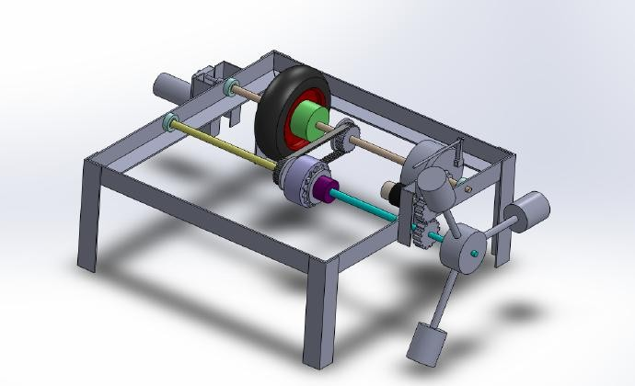

Fig. 2. Working model

1. Construction

The working model consist of an electric geared motor (Torque 12kg-cm,speed 100 RPM) which is attached to the input shaft 1.Shaft 1 consist of wheel and brake unit and it is also consist of the pulley mounted on shaft 1 which is parallel to shaft 2.

This system consists of total 3 shafts in which shaft 1 and shaft 2 is parallel to each other. While the shaft 3 is connected to the shaft 2 through the sprocket used.The second timing pulley, sprocket are mounted on the shaft 2. Shaft 2 has been cut in two parts such that the further third part is become shaft 3 and when motion is provided from input shaft and when the brake is applied only the shaft 1 and half portion of shaft 2 is stopped.The shaft 3 keeps on rotating while other the two shafts are stopped by the braking force.The shaft 3 is directly attached to the flywheel which is made of mild steel material to absorb the energy coming out from the shaft 3.A dynamo is connected to the flywheel by means of 2 gear pair for which gear ratio is 1:1. Dynamo converts the rotational mechanical energy to electrical energy. This energy we can show in the multimeter which can display the ampere and voltage generated.

The timing pulley is made of Teflon material while the timing belt is made of polymer.

Potentiometer which regulates the voltage is used for varying the speed. By regulating the voltage we can vary the input speed from which different readings are taken by connecting different load.

1. Working principle

When voltage is applied to the input shaft, wheel starts rotating in clockwise direction. This clockwise motion is also transferred to the second shaft through the timing pulley and hence the sprocket to the shaft 3.We are using Timing pulley since its efficiency is 99.99% hence, the friction losses are neglected. Motion which is transmitted to the sprocket shaft is carried to the third shaft from which flywheel is connected.Motion of the shaft is transmitted to the flywheel and it is connected to 1:1 gear ratio gear with the dynamo. The dynamo is used to convert the rotational energy to the mechanical energy. Basically its work is to store the energy.When we apply the brake the motor continues to work but the wheel gets stopped and thus the sprocket shaft also gets stopped but the flywheel keeps on rotating which stores the waste energy of the wheel lost due to friction or heat to the atmosphere.

Now this rotating mechanical energy is transferred to the dynamo from where battery or any equipment is connected which can work by taking this energy. Dyanamo connected to the flywheel means of gear pair converts rotational mechanical energy to electrical energy.Potentiometer which regulates the voltage is used for varying the speed. By regulating the voltage we can vary the input speed from which different readings are taken by connecting different load.

1. 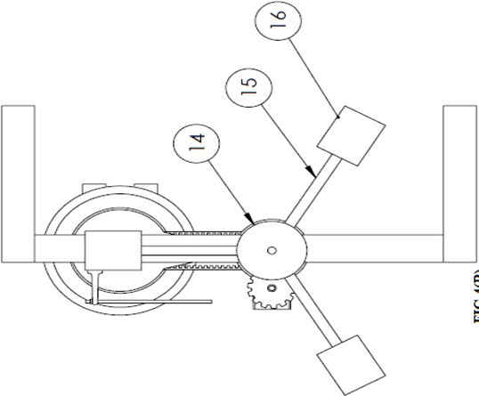Numbering of components

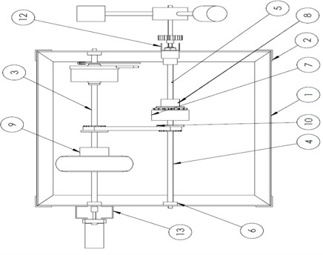

*C.* Components and material used

TABLE I: COMPONENTS, MATERIAL AND QUANTITY

|  |  |  |  |
| --- | --- | --- | --- |
| **Serial number** | **Part name** | **Material** | **Quantity** |
| 1 | 30×30 Angle | MILD STEEL | 4 |
| 2 | 30×30 Angle | MILD STEEL | 4 |
| 3 | 10mm solid bar | MILD STEEL | 1 |
| 4 | 10mm solid bar | MILD STEEL | 1 |
| 5 | 10mm solid bar | MILD STEEL | 1 |
| 6 | Hub | MILD STEEL | 4 |
| 7 | Cup | MILD STEEL | 1 |
| 8 | Bush | MILD STEEL | 1 |
| 9 | Bush | MILD STEEL | 1 |
| 10 | Pulley | TEFLON | 2 |
| 11 | Belt | POLYMER | 1 |
| 12 | Channel 38×20 | ALUMINIUM | 1 |
| 13 | Channel 50×25 | ALUMINIUM | 2 |
| 14 | MS bar dia 75 | MILD STEEL | 1 |
| 15 | 12mm solid bar | MILD STEEL | 3 |
| 16 | MS bar dia 42 | MILD STEEL | 3 |

1. Energy Calculation

# RESULTS AND DISCUSSION

TABLE IIIII: ENERGY CALCULATION

|  |  |  |  |  |
| --- | --- | --- | --- | --- |
| **Serial number** | **Speed (rpm)** | **Volt (V)** | **Ammeter (mA)** | **energy covered P=V×I (W)** |
| 1 | 50 | 6.6 | 11.28 | 0.0767 |
| 2 | 100 | 7.1 | 19.6 | 0.1352 |

1. Graph of Energy Covered(watt) vs Speed(rpm)

**Energy covered(W) vs Speed**

0.16

0.14

0.12

0.1

0.08

0.06

0.04

0.02

0

energy

covered(W)

speed 50(RPM) speed

100(RPM)

Graph 1: Energy covered vs Speed

# CONCLUSION

Theoretical investigations of a regenerative braking system show about 15% saving in fuel consumption.The lower operating and environment costs of a vehicle with regenerative braking system should make it more attractive than a conventional one. The traditional cost of the system could be recovered in the few years only.The exhaust emission of vehicle using the regenerative braking concept would be much less than equivalent conventional vehicles as less fuel are used for consumption.These systems are particularly suitable in developing countries such as India where buses are the preferred means of transportation within the cities.From the above graph it is clear that with more speed of vehicle the RBS saves more energy while with lowers the speed RBS saves energy but less compared to the more speed.At 100 rpm we got 0.1352 Watt and at 50 rpm we got 0.0767 Watt power without any load considerations while at 100 rpm we got 0.0532 Watt and at 50 rpm we got 0.0402 Watt with load consideration.

# ACKNOWLEDGMENT

It is a matter of great satisfaction and pleasure to present the paper on''Design and fabrication of regenerative braking system". We express our deep sense of gratitude to Prof.S.A.Ladkat and Dr. S.S. Kore for their valuable guidance discussion and constant encouragement for successful completion of this work.We would also like to express our deep regards to Prof. Lande Y. D.and Prof. Aher V. S. for their support.

# REFERENCES

[1]. Savitski, D., Ivanov, V., Shyrokau, B., De Smet, J. et al., "Experimental Study on Continuous ABS Operation in Pure Regenerative Mode for Full Electric Vehicle," SAE Int. J. Passeng. Cars - Mech. Syst. 8(1):364-369, 2015, doi:10.4271/2015-01-9109.

[2]. Gao, Y., Chen, L., and Ehsani, M., "Investigation of the Effectiveness of Regenerative Braking for EV and HEV," SAE Technical Paper 1999- 01-2910, 1999.

[3]. "International Journal of Automotive Technology" December 2008, Volume 9, Issue 6, pp 749-757.