EXPERIMENT-1
INSTALLATION OF GIMP AND BLENDER

Installation of GIMP:

1) Download the GIMP installer free from gimp.org/downloads
2) Run the GIMP installer. You can find this at the location you saved it to, usually your Downloads/My Downloads folder.
3) Follow the prompts to install GIMP. Most users can leave the settings at the defaults.
4) Finish the installation. After selecting the file formats, GIMP will install. This may take a few minutes.
5) Start using GIMP. Once GIMP has finished installing, you can start using it.

NOTE: GIMP comes pre-installed in Ubuntu OS distribution based on Linux. If the user is using any distribution of Linux preinstalled with GIMP then we can skip directly to launching the application and start using it.

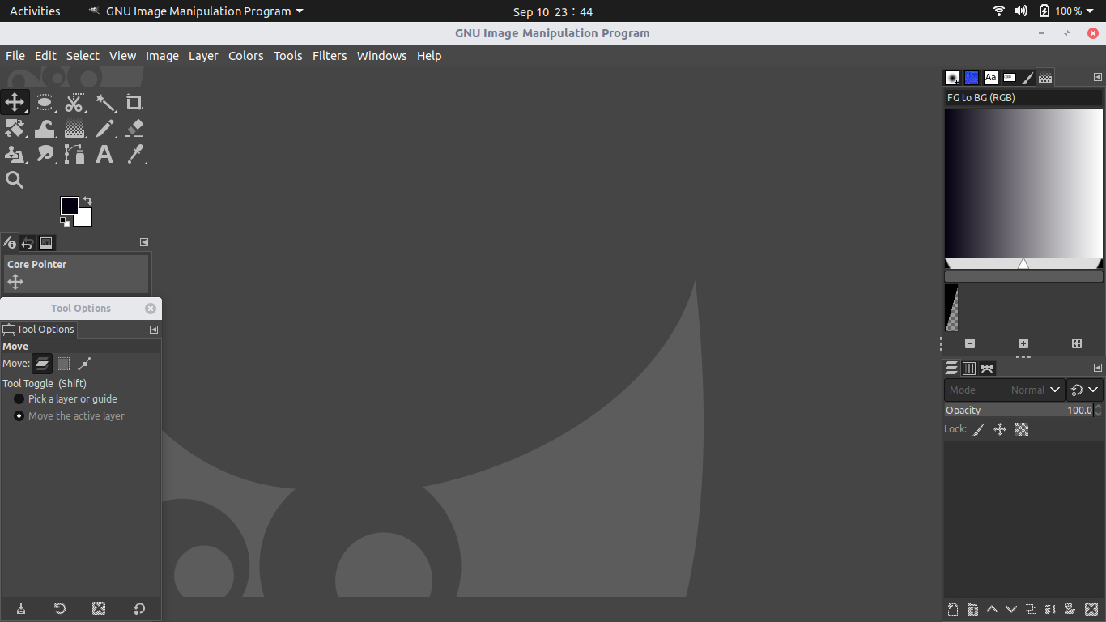

Installation of Blender:

1) Visit the Blender Website.
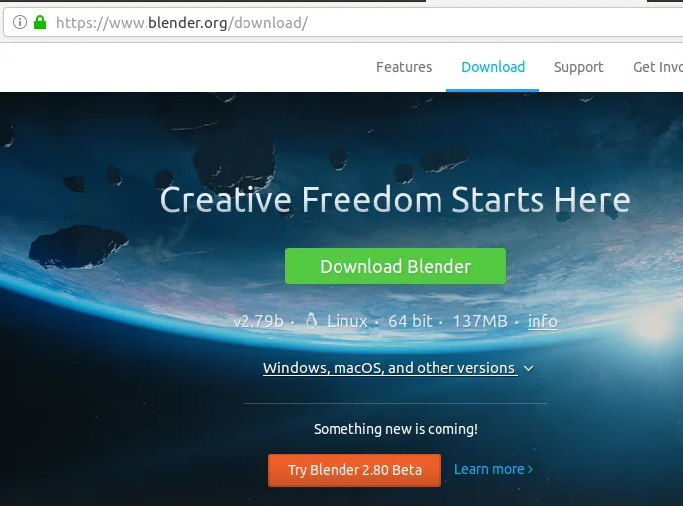
2) When you have selected a Blender version by clicking on it, the following dialog will appear:

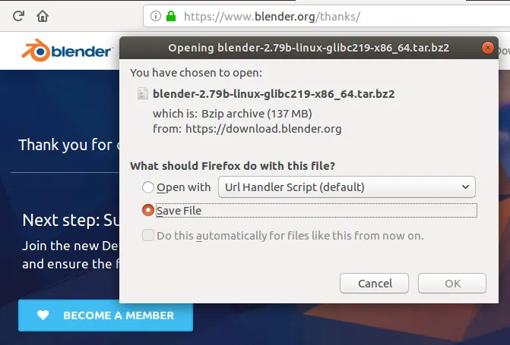

3) Select the Save File option and click OK in order to download the tar.bz2 file on your system.

4)Next, open the location where you have saved the file; it is mostly your Downloads folder by default.

5) Right-click on the Blender tar.bz2 file and select Extract Here from the options. When the files are extracted into a folder by the same name, open the folder and try to locate the “blender” executable file.

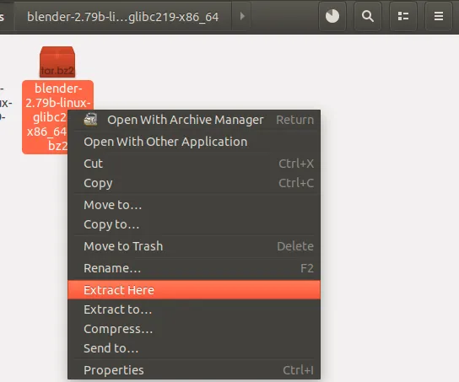
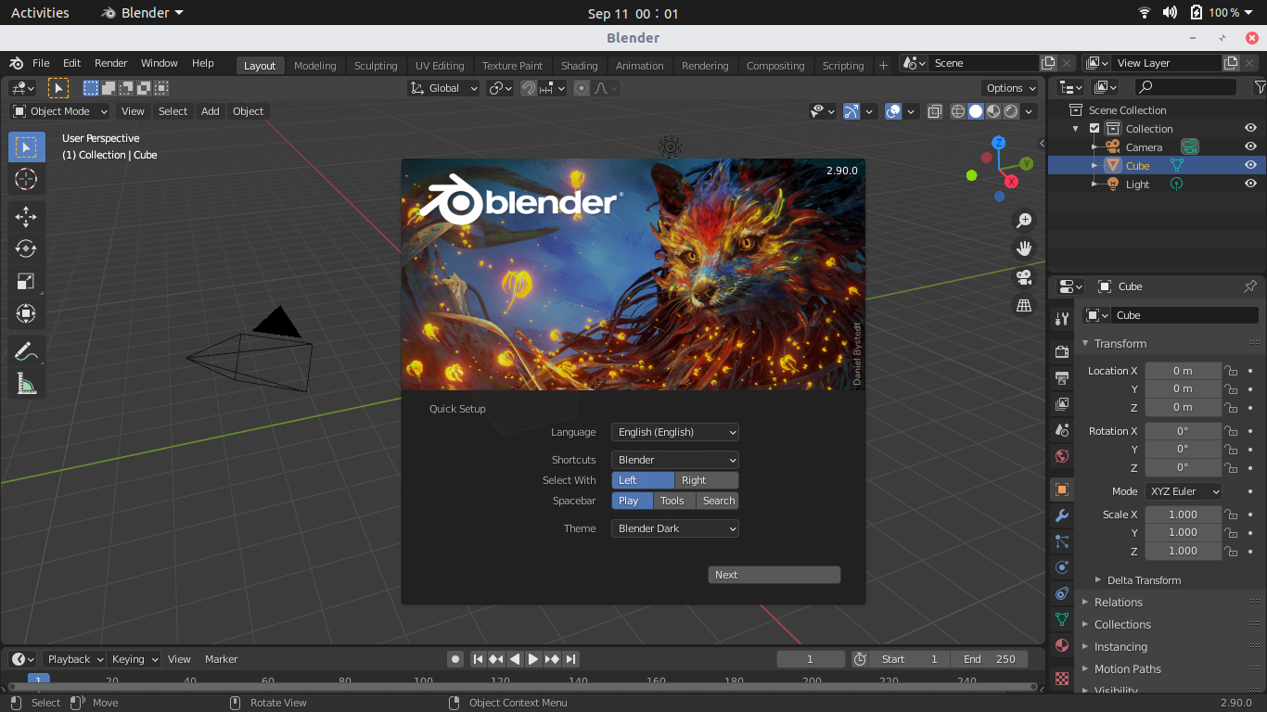
6) Right-click the ‘blender’ file and then select Run from the option

