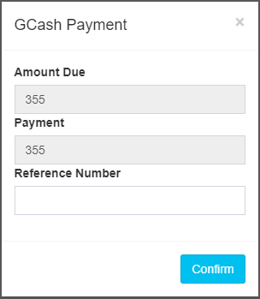

* Sales Order => New Order => Make Transaction => GCash Payment
* 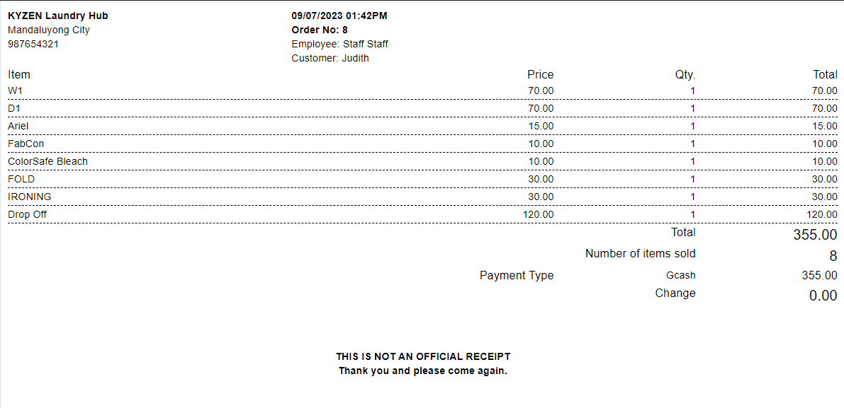 \*note: Can “Confirm” with or without the reference Number.
* Sales Order => View Orders => Action (View Receipt)
* \*note: In GCash Payment Transaction, Where the reference number is included during the payment it has not shown in the receipt.
* 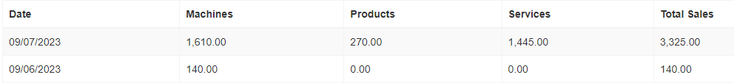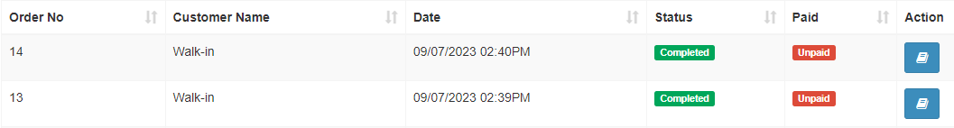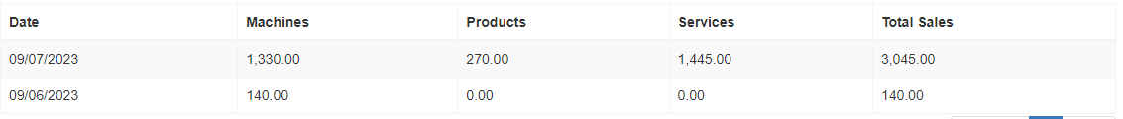Dash Board(Check Daily Sales of the Month) => Sales Order (Make Transaction) => Queing (Start & Finisih Machine Cycle) => Dash Board (Check Daily Sales of the Month) => Sales Order => View Orders
* \*note: Total Sales updated even though theres Unpaid Transaction.
* 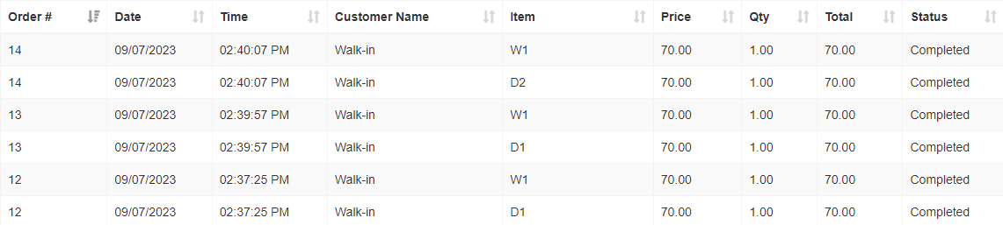Reports => Detailed Reports
* \*note: Type of Payments are not included or shown.
* 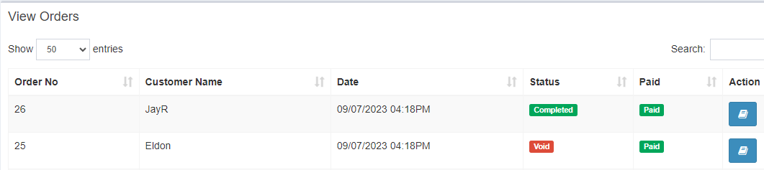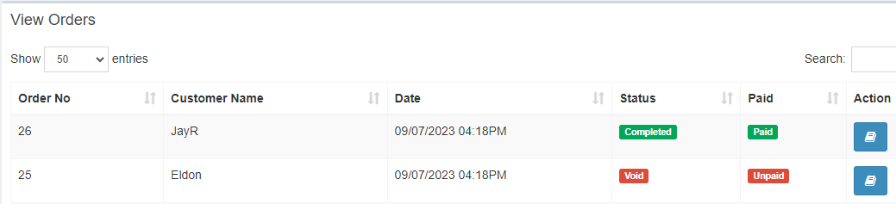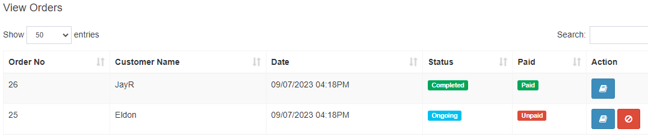Sales Order => Make Transaction => Type of Payment (Pay Later) => View Orders => Action (Voiding/Canceling Transaction) => Action (Tapping “Mark as Paid”)
* \*note: Marking the Unpaid to Paid of the Voided Transaction