AWS_KALKEESHWARA_P_LAB_04_RDS

Lab 04

Course: Working with RDS

1. Be able to create RDS DB instance

2. Learn how to log in to RDS

To create a database in AWS   
login to AWS and search for “RDS” in the Search bar  
Select the **RDS** services as shown bwlow  
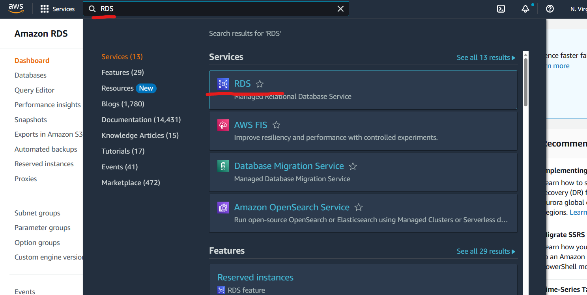

Click on **Databases** and click on **Create Database** button as shown below  
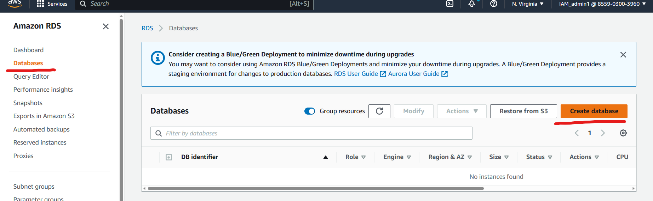

Select Database version as **Mysql** as shown below  
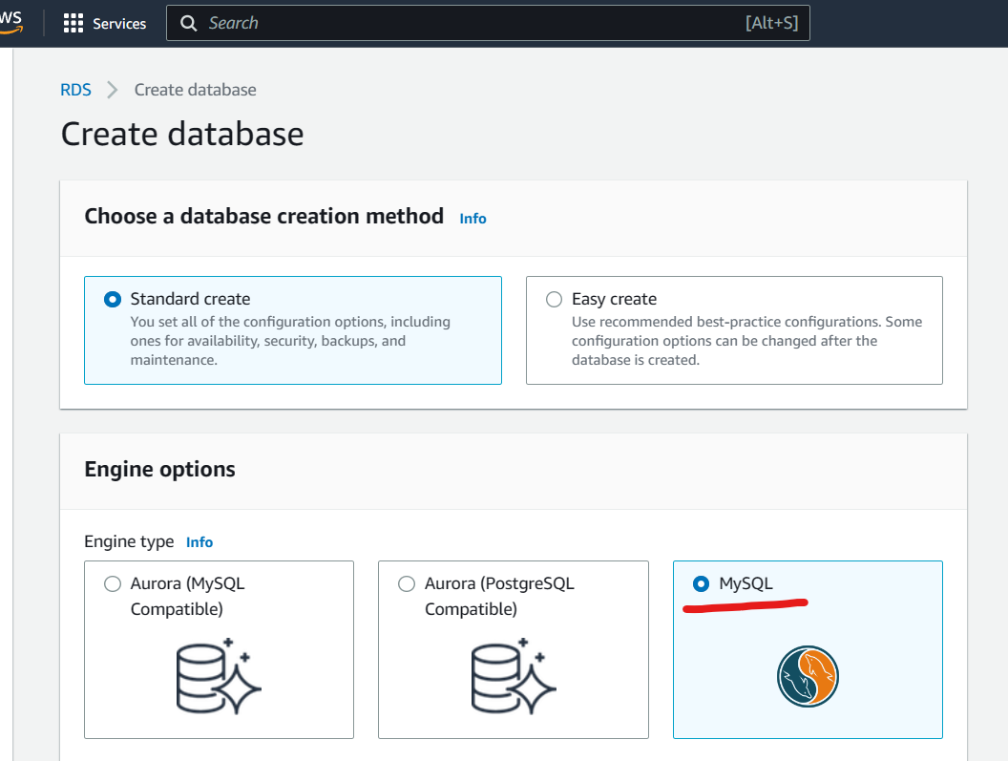

Select **Free Tier** under Temaplates  
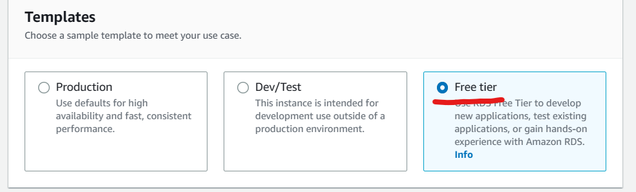

Specify a name in the name field and provide a credential in the username and password field.  
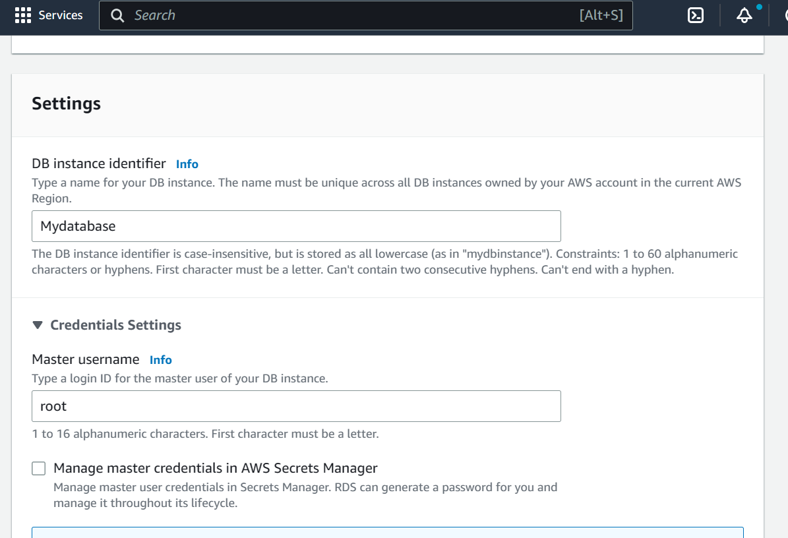

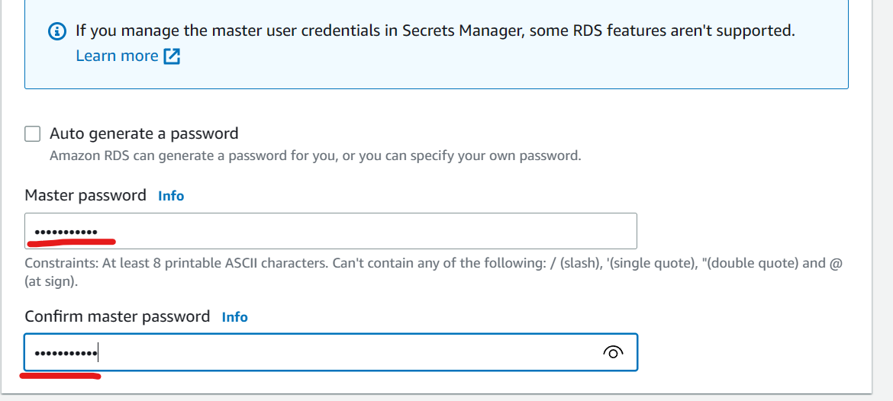  
Select instance class as t2 micros  
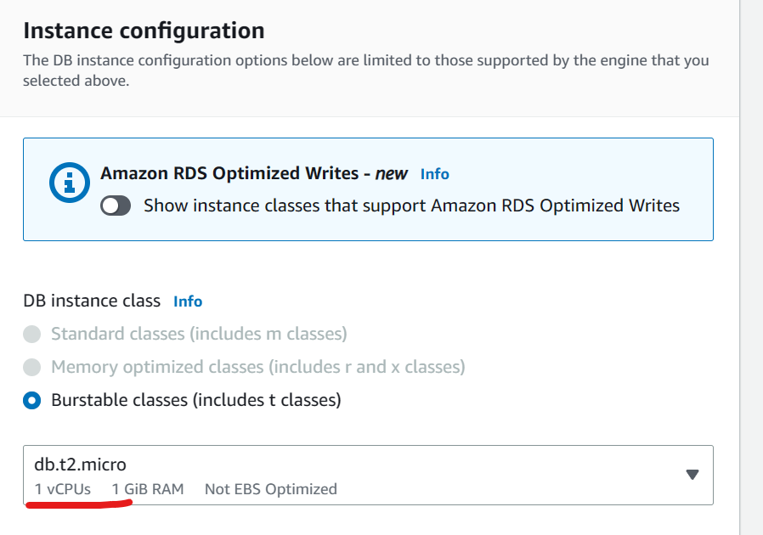  
set storage as **20** gb and uncheck Enable auto-scaling.  
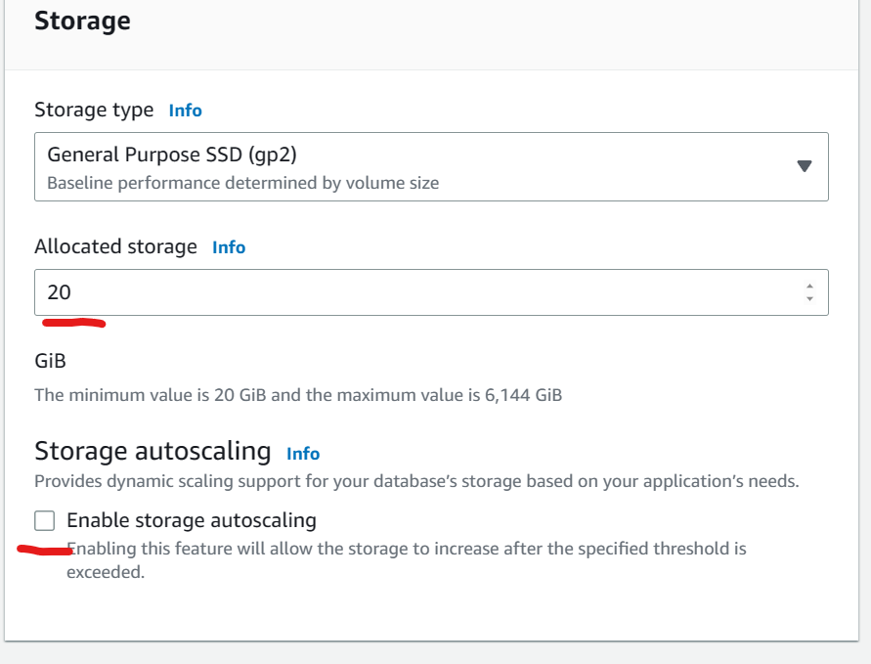

Under connectivity section set Public access as **Yes**  
Select **create Security group** and mentioned your desired Security group name as shown below.  
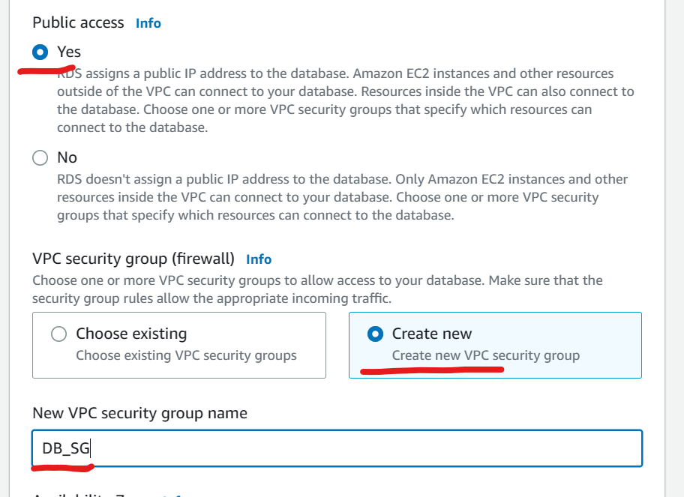  
Under additional Configuration section you can fill a Database name as shown below.  
uncheck the “enable database backup” option  
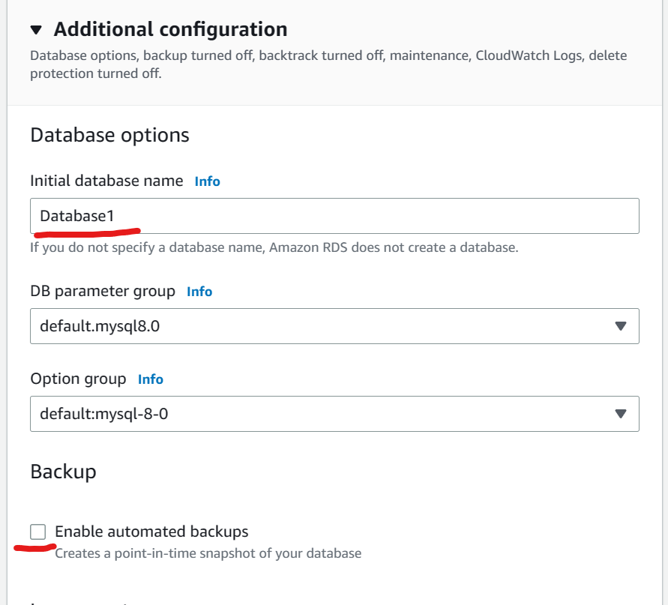  
  
Scroll down and click on create a database.  
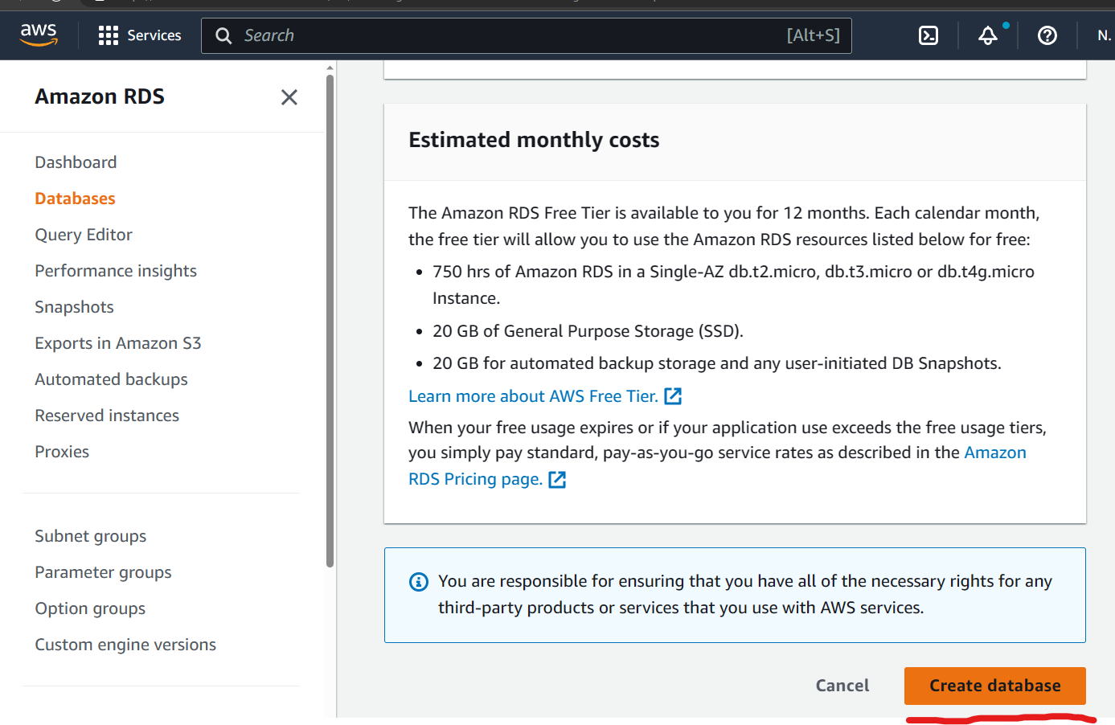

You will find a new database created as shown below  
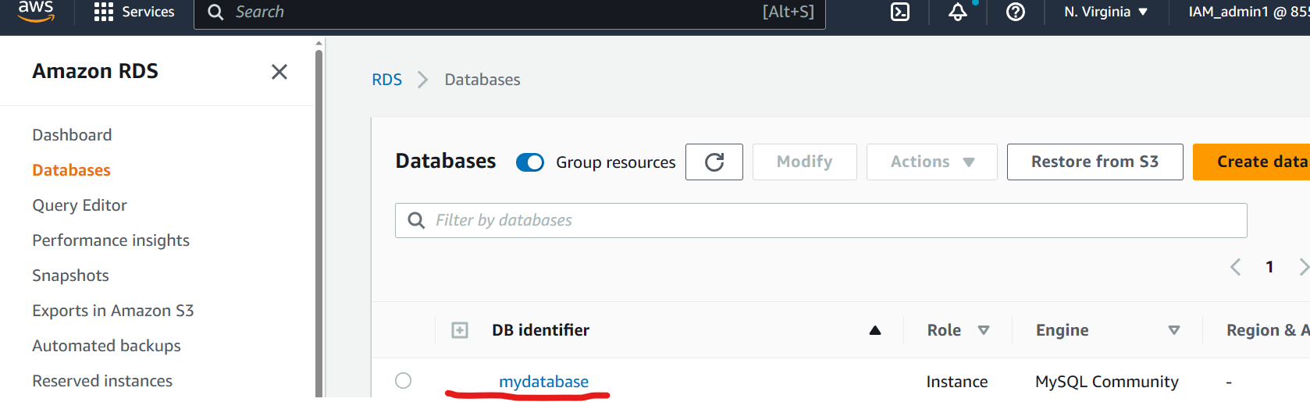

Now to setup a client application visit the link below to add Chrome MySQL admin into your chrome browser.  
<https://chrome.google.com/webstore/detail/chrome-mysql-admin/ndgnpnpakfcdjmpgmcaknimfgcldechn?pli=1&_ind=category%252Fextensions&_asi=1&source=5>

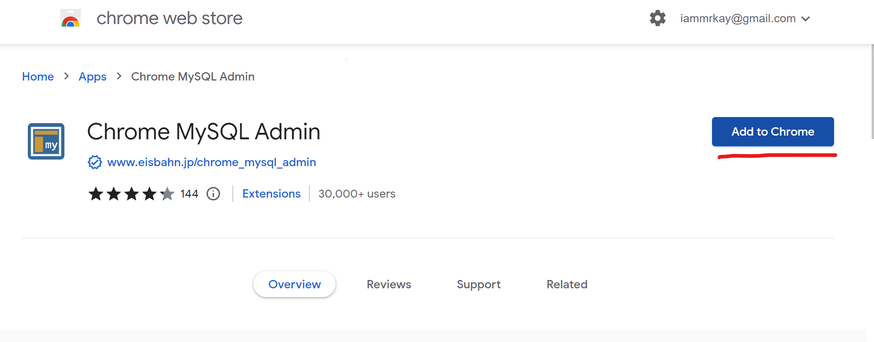  
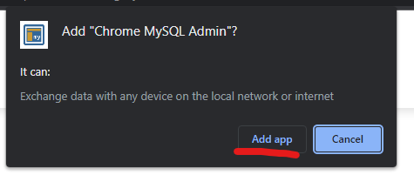  
Click on **Launch App** in the same page as shown below.  
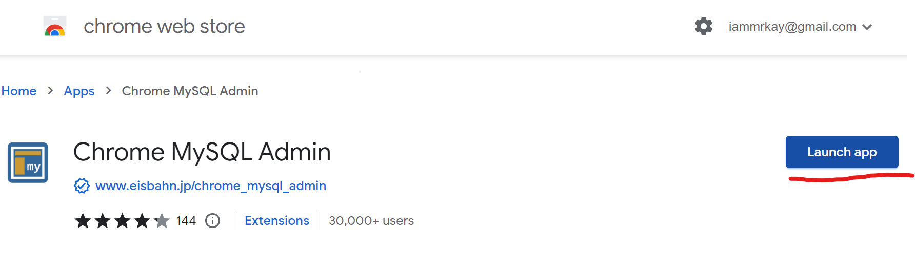

The below window will open  
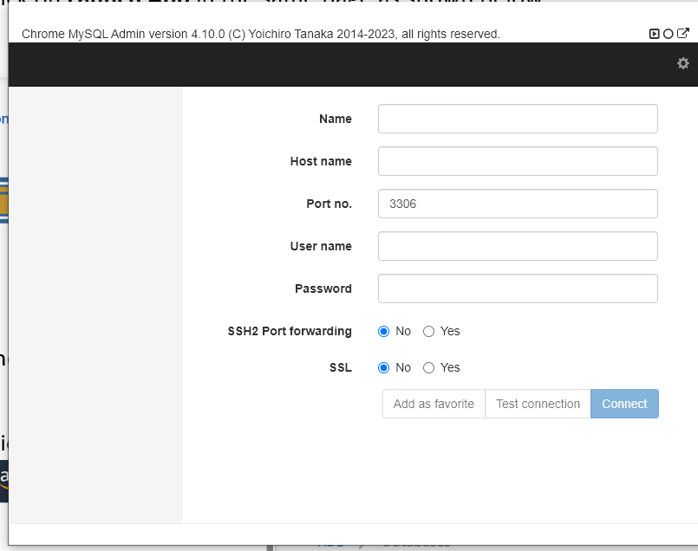

Click on the database name and collect the end point details.  
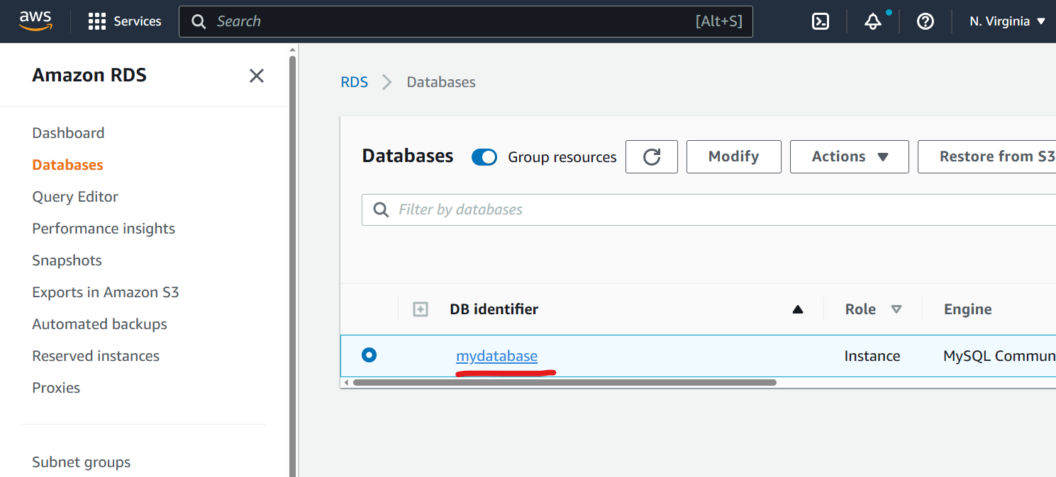

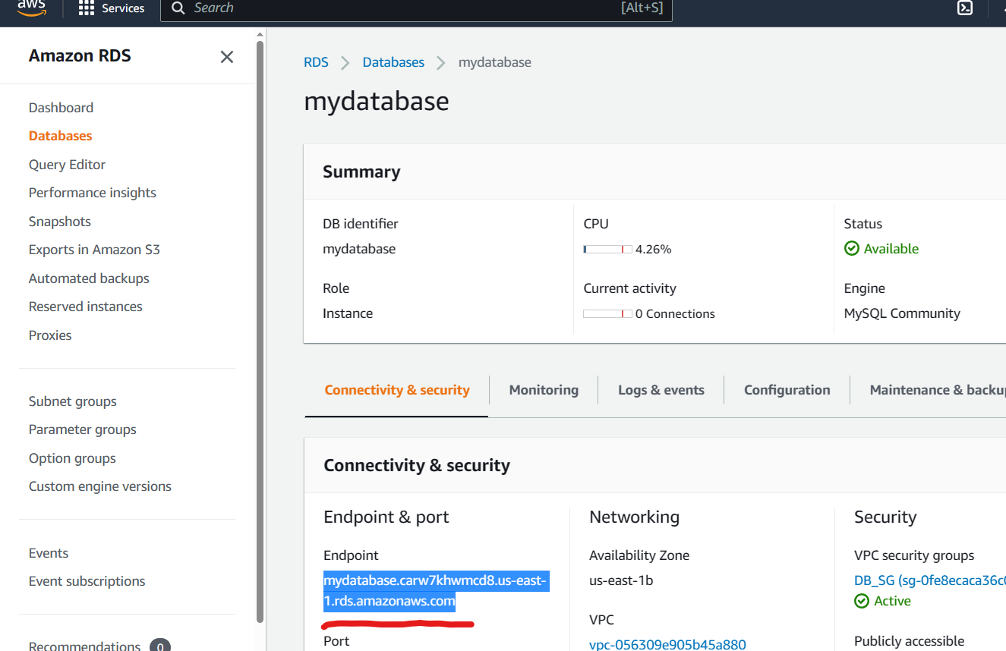

Switch back to the Chrome mysql app and fill the following details.  
Name = RDS  
Endpoint: copy paste the endpoint from the RDS details as shown wbove.  
username: root  
click on **Connect**  
password : password that you have set.  
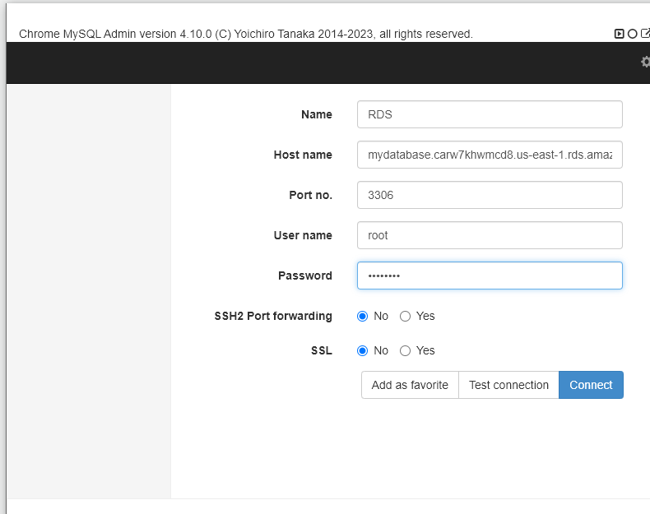

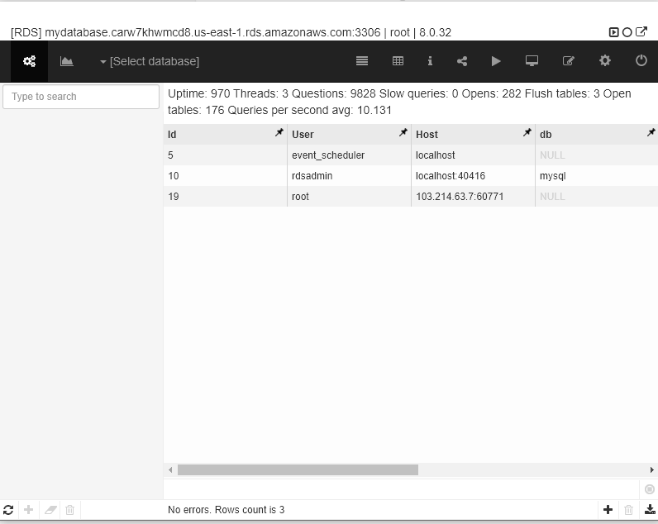

Go to Querry mode by clicking on the 3rd last icon shown bwlo.  
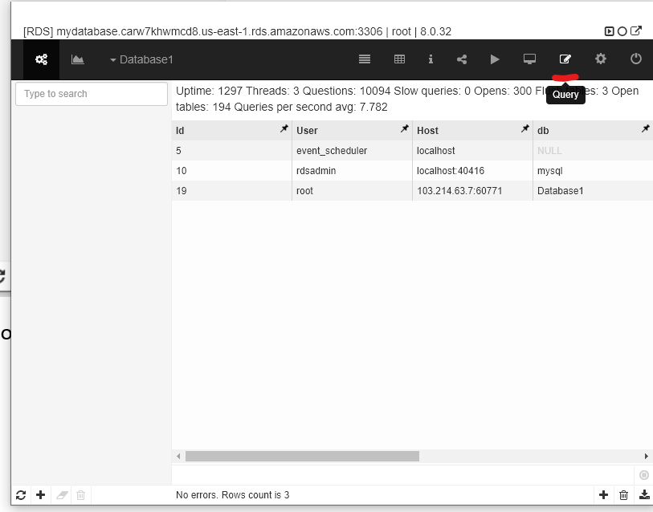

Enter the querry as shown bwlow.  
>create database RDS_DB  
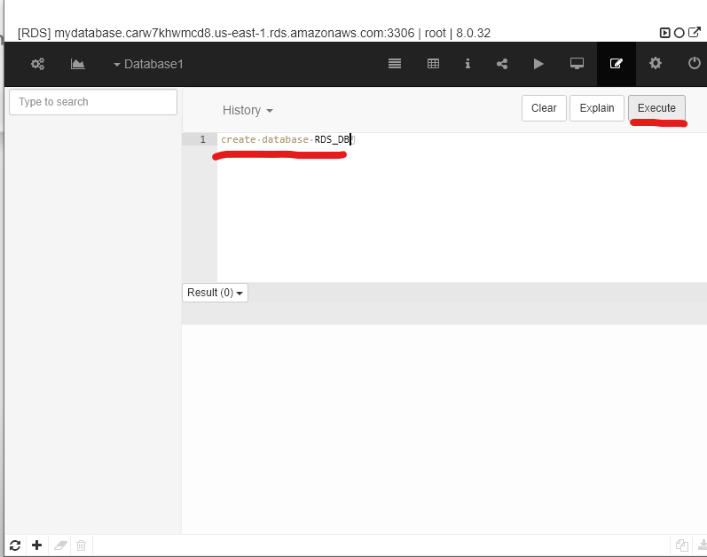

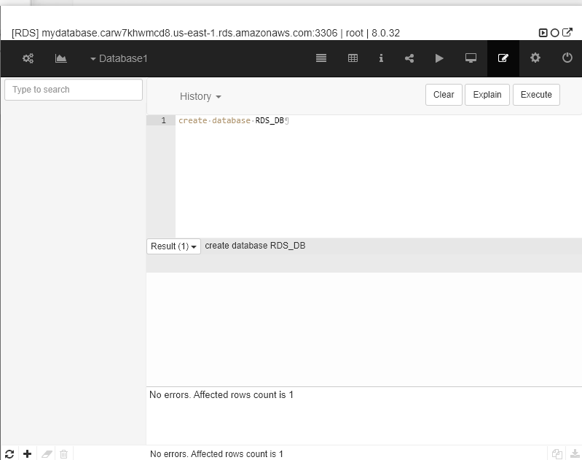

To view the Database in the server, the servier would require a relogin.  
Click on **logout** button as shown below.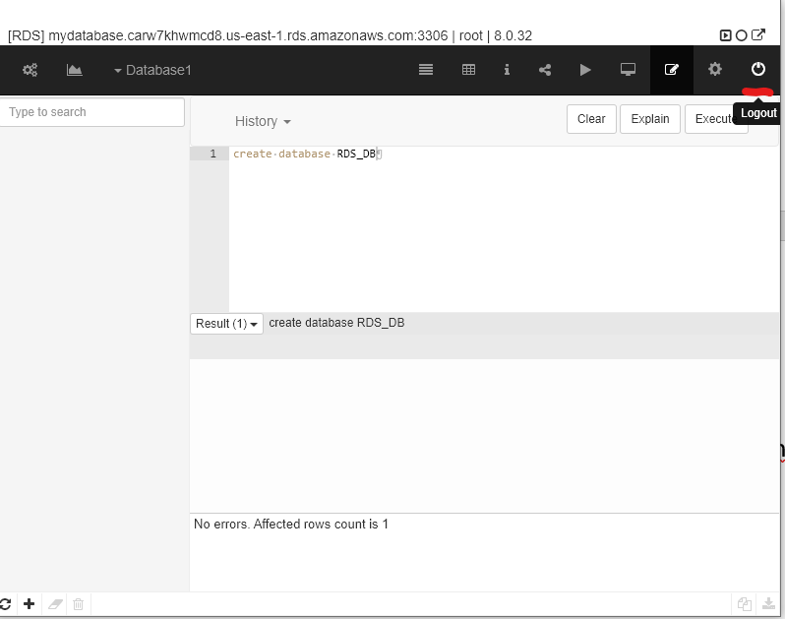  
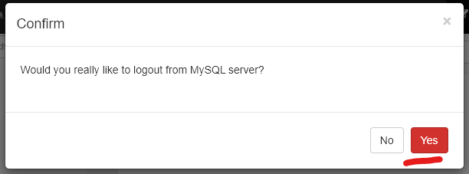  
Select **Yes** and you will be logged out successfly.  
Fill up the credentials and click on **Connect** button.  
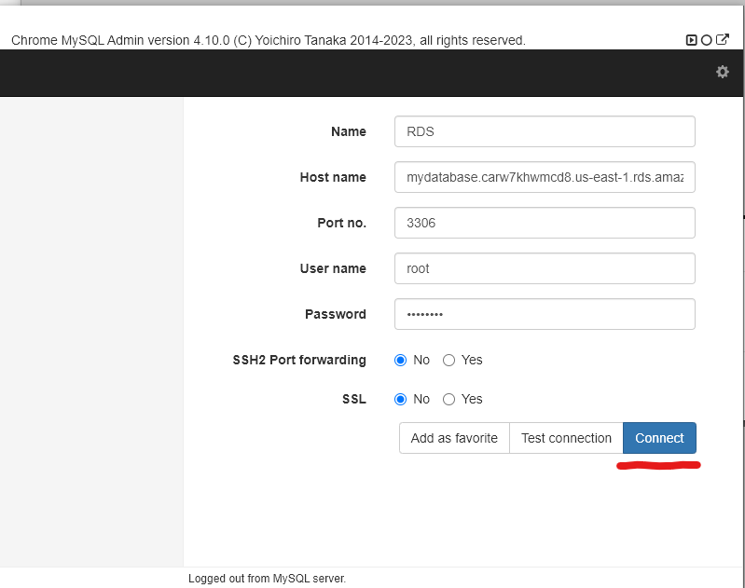

Check the Database list and you will find the newly created database as shown below.  
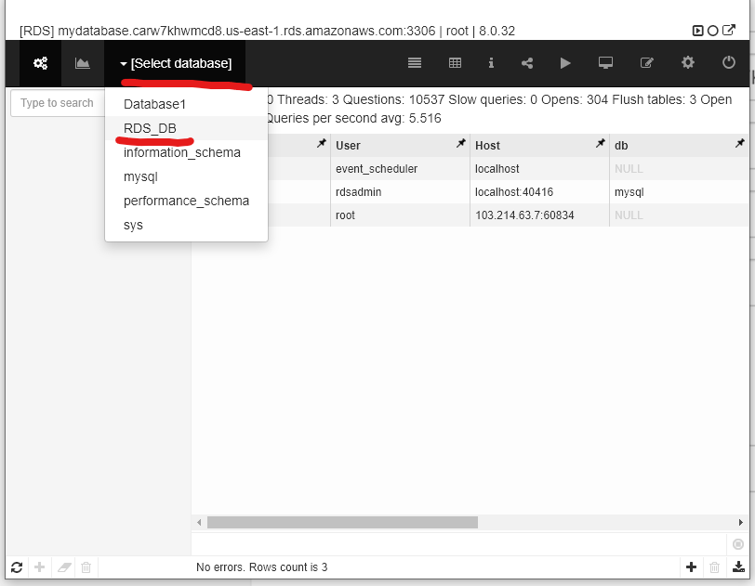

Congratulations you have successfully created a database in the RDS databse services.

Clean up.

Logout from the Chrome Mysql App by clicking on logout button.

In order to clean up, visit the Database menu and select the recently created database service.  
Click on **Actions** button and click on **Delete** as shown below.  
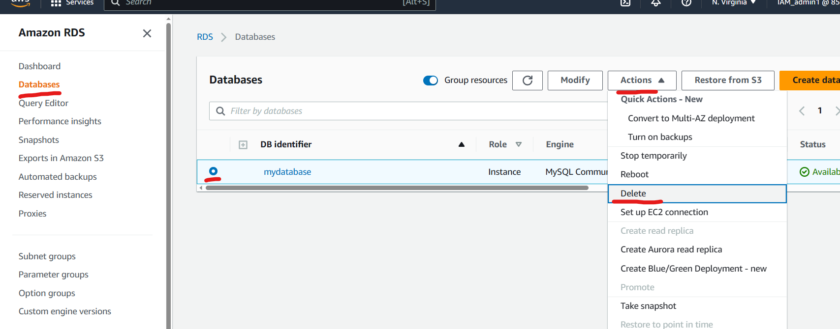  
Uncheck the “create Final snapshot”  
check mark the “I acknowledge that upon ….ect”  
Type “delete me” and click on **Delete** button as shown below>  
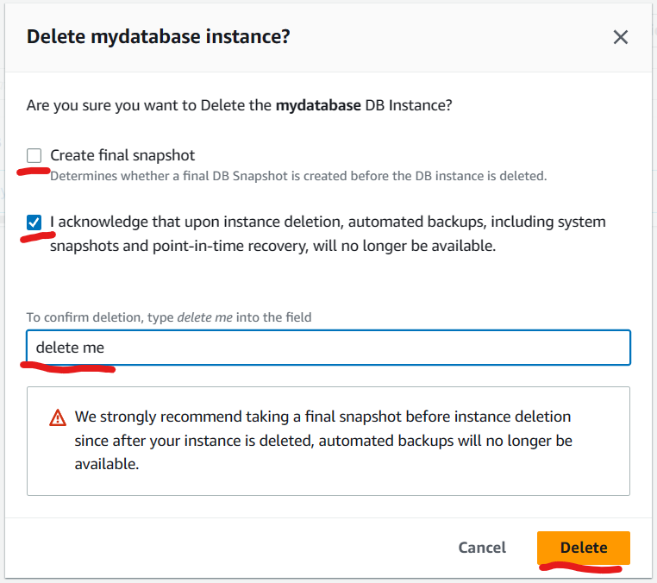  
upon successful deletion of the service you will recive the below output.  
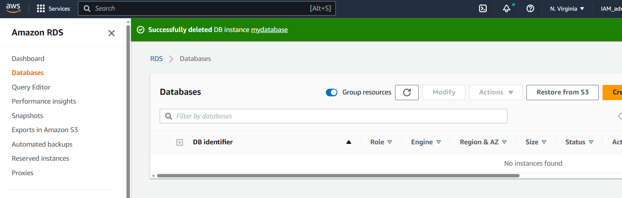

Congratulation you have successfully deleted a database in RDS service.