Write a program to print Hello World

#include <iostream>

int main() {

std::cout << "Hello world!";

return 0;

}

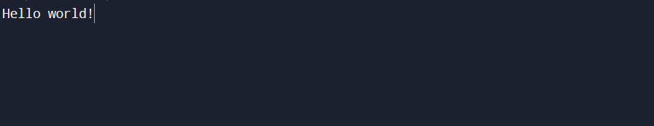

Write a program to reverse a number

#include <iostream>

int main() {

int n, rev = 0;

std::cout << "Enter number: ";

std::cin >> n;

while(n!=0){

rev = rev\*10 + n%10;

n /= 10;

}

std::cout<<"Reverse number: "<<rev;

return 0;

}

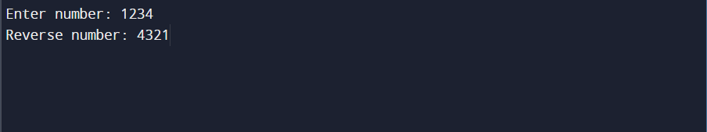

Write a program to check a number is palindrome or not

#include <iostream>

bool isPalindrome(int n){

int rev = 0, temp = n;

while(n!=0){

rev = rev \* 10 + n % 10;

n /= 10;

}

return (rev == temp) ? true : false;

}

int main() {

int num;

bool palindrome;

std::cout << "Enter number: ";

std::cin >> num;

palindrome = isPalindrome(num);

std::cout << num << (palindrome ? " is Palindrome\n" : " is not Palindrome\n");

return 0;

}

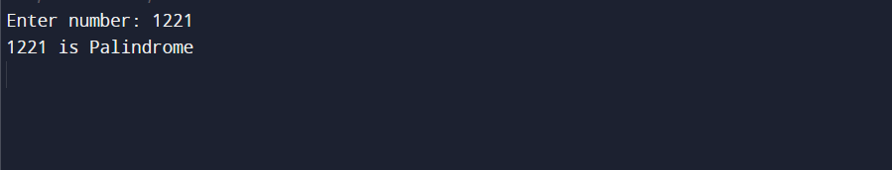

Write a program to find factorial of a number

#include <iostream>

int getFactorial(int n){

return (n==0 || n==1)? 1:n \* getFactorial(n-1);

}

int main() {

int num, factorial = 1;

std::cout << "Enter number: ";

std::cin >> num;

factorial = getFactorial(num);

std::cout << "Factorial of "<<num<<" is "<<factorial;

return 0;

}

