**DPG Degree College**

**Bachelor of Computer Applications**

**Object Oriented Programming Lab Using C++ (BCA-208)**



**Session 2022-2023**

**Submitted to: Submitted by:**

**Ms. Jasmine Raj Verma**

**(Assistant Professor) Sem - 4th**

**Dept. of Computer Science Roll No: 121832**

**MDU ROHTAK, HARYANA**

**DPG Degree College**

**Bachelor of Computer Applications**

**Certificate**

This is to certify that Mr. Raj Verma S/o Mr. Amit Kumar has submitted practical file for fulfillment of BCA 4st semester Lab. Course.

**Submitted to: Submitted By:**

**Ms. Jasmine Raj Verma**

**(Assistant Professor) Sem - 4th**

**Dept. of Computer Science Roll No: 121832**

|  |  |  |  |  |
| --- | --- | --- | --- | --- |
| **S. No** |  | **Practical name** | **Date** | **Signature** |
| **1** | **A** | WAP to print “Welcome to C++!” | 18/04/2023 |  |
|  | **B** | WAP to compute quotient & remainder(Take dividend & divisor input from user | 18/04/2023 |  |
|  | **C** | WAP to reverse a number | 18/04/2023 |  |
|  | **D** | WAP to Swap Two numbers | 18/04/2023 |  |
| **2** | **A** | WAP to check whether a character is vowel or constant | 25/01/2023 |  |
|  | **B** | WAP to find factorial of a number | 25/01/2023 |  |
|  | **C** | WAP to check whether a number is a palindrome or not | 25/01/2023 |  |
|  | **D** | WAP to find largest number among three number | 25/01/2023 |  |
| **3** |  | WAP to implement function call by value and call by reference | 01/02/2023 |  |
| **4** |  | WAP illustrating Class Declarations, Definition, and Accessing Class Members (variables & Functions | 08/02/2023 |  |
| **5** |  | Program to demonstrate default constructor, parameterized constructor, copy constructors (implicit & explicit) and Destructor | 15/02/2023 |  |
| **6** |  | WAP to demonstrate the usage of “THIS” operator. | 22/02/2023 |  |
| **7** |  | WAP to demonstrate all the significance of scope resolution operator in C++ | 01/03/2023 |  |
| **8** | **A** | WAP to implement single inheritance | 15/03/2023 |  |
|  | **B** | WAP to implement multiple inheritance | 15/03/2023 |  |
|  | **C** | WAP to implement multi-level inheritance | 15/03/2023 |  |
|  | **D** | WAP to implement hierarchical inheritance | 15/03/2023 |  |
| **9** | **A** | WAP to implement public inheritance | 22/03/2023 |  |
|  | **B** | WAP to implement private inheritance | 22/03/2023 |  |
| **10** | **A** | WAP to Demonstrate the Operator Overloading. | 29/03/2023 |  |
|  | **B** | WAP to Demonstrate the function Overloading. | 29/03/2023 |  |
| **11** | **A** | WAP for function overriding with early binding with and without using pointer | 4/04/2023 |  |
|  | **B** | WAP for function overriding with late binding | 4/04/2023 |  |
| **12** | **A** | WAP to Demonstrate Pure virtual Function | 12/04/2023 |  |
|  | **B** | WAP to Demonstrate friend function | 12/04/2023 |  |
| **13** | **A** | WAP Containing a Possible Exception. Use a Try Block to Throw it and a Catch Block to Handle it Properly. | 19/04/2023 |  |
|  | **B** | WAP to Demonstrate the use of catch all | 19/04/2023 |  |

## Practical 1

### AIM: WAP to print “Welcome to C++”.

#include <iostream>

int main() {

std::cout << "Welcome to C++!" ;

return 0;

}

Output:

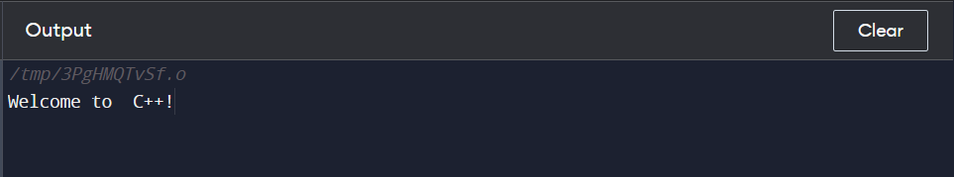

### AIM: WAP to compute quotient & remainder (Take dividend & divisor input from the user).

#include <iostream>

using namespace std;

int main() {

int dividend, divisor, quotient, remainder;

cout << "Enter the dividend: ";

cin >> dividend;

cout << "Enter the divisor: ";

cin >> divisor;

quotient = dividend / divisor;

remainder = dividend % divisor;

cout << "Quotient: " << quotient << endl;

cout << "Remainder: " << remainder << endl;

return 0;

}

Output:

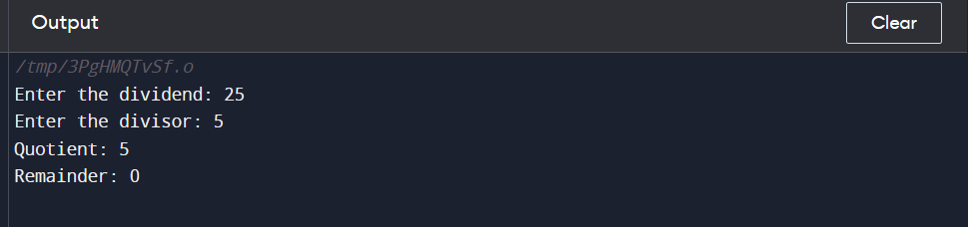

### AIM: WAP to reverse a number.

#include <iostream>

using namespace std;

int main() {

int num, reverse = 0;

cout << "Enter a number: ";

cin >> num;

while(num > 0) {

int digit = num % 10;

reverse = (reverse * 10) + digit;

num /= 10;

}

cout << "Reverse of the number: " << reverse << endl;

return 0;

}

Output:

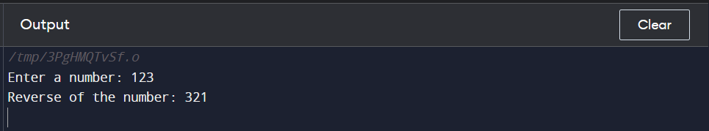

### AIM: WAP to swap two numbers

#include <iostream>

using namespace std;

int main() {

int num1, num2;

cout << "Enter two numbers: ";

cin >> num1 >> num2;

cout << "Before swapping: num1 = " << num1 << ", num2 = " << num2 << endl;

int temp = num1;

num1 = num2;

num2 = temp;

cout << "After swapping: num1 = " << num1 << ", num2 = " << num2 << endl;

return 0;

}

Output:

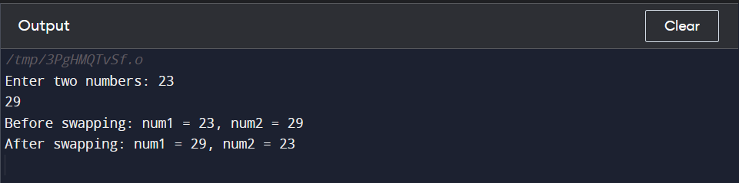

## Practical 2

### AIM: WAP to check whether a character is vowel or consonant.

#include <iostream>

using namespace std;

int main() {

char ch;

cout << "Enter a character: ";

cin >> ch;

if(ch == 'a' || ch == 'e' || ch == 'i' || ch == 'o' || ch == 'u' ||

ch == 'A' || ch == 'E' || ch == 'I' || ch == 'O' || ch == 'U') {

cout << ch << " is a vowel." << endl;

} else {

cout << ch << " is a consonant." << endl;

}

return 0;

}

Output:

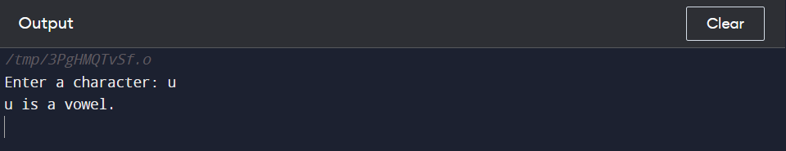

### AIM: WAP to find factorial of number.

#include <iostream>

using namespace std;

int factorial(int num) {

if (num == 0)

return 1;

else

return num * factorial(num - 1);

}

int main() {

int num;

cout << "Enter a number: ";

cin >> num;

if (num < 0)

cout << "Error: Factorial of negative numbers is undefined." << endl;

else

cout << "Factorial of " << num << " = " << factorial(num) << endl;

return 0;

}

Output:

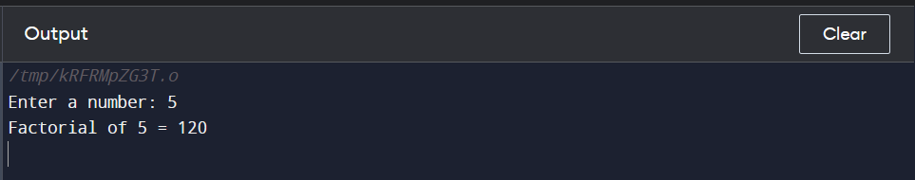

### AIM: WAP to check whether a number is palindrome or not.

#include <iostream>

using namespace std;

int reverse(int num) {

int reversedNum = 0, remainder;

while (num != 0) {

remainder = num % 10;

reversedNum = reversedNum * 10 + remainder;

num /= 10;

}

return reversedNum;

}

bool isPalindrome(int num) {

return num == reverse(num);

}

int main() {

int num;

cout << "Enter a number: ";

cin >> num;

if (isPalindrome(num))

cout << num << " is a palindrome number." << endl;

else

cout << num << " is not a palindrome number." << endl;

return 0;

}

Output:

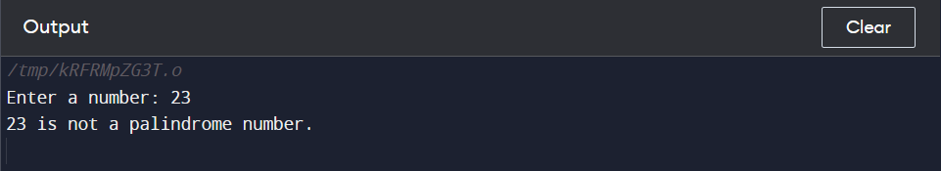

### AIM: WAP to find largest number among three number.

#include <iostream>

using namespace std;

int main() {

int num1, num2, num3, largest;

cout << "Enter three numbers: ";

cin >> num1 >> num2 >> num3;

largest = num1;

if (num2 > largest) {

largest = num2;

}

if (num3 > largest) {

largest = num3;

}

cout << "The largest number is: " << largest << endl;

return 0;

}

Output:

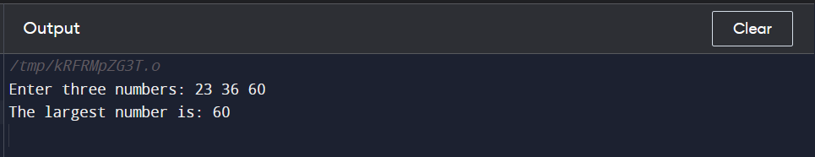

## Practical 3

### AIM: WAP to implement function call by value and call by reference.

#include <iostream>

using namespace std;

// Call by value function

void swapByValue(int num1, int num2) {

int temp = num1;

num1 = num2;

num2 = temp;

cout << "Inside swapByValue function: num1 = " << num1 << ", num2 = " << num2 << endl;

}

// Call by reference function

void swapByRef(int& num1, int& num2) {

int temp = num1;

num1 = num2;

num2 = temp;

cout << "Inside swapByRef function: num1 = " << num1 << ", num2 = " << num2 << endl;

}

int main() {

int num1 = 10, num2 = 20;

// Call by value

cout << "Before swapByValue function call: num1 = " << num1 << ", num2 = " << num2 << endl;

swapByValue(num1, num2);

cout << "After swapByValue function call: num1 = " << num1 << ", num2 = " << num2 << endl;

// Call by reference

cout << "Before swapByRef function call: num1 = " << num1 << ", num2 = " << num2 << endl;

swapByRef(num1, num2);

cout << "After swapByRef function call: num1 = " << num1 << ", num2 = " << num2 << endl;

return 0;

}

Output:

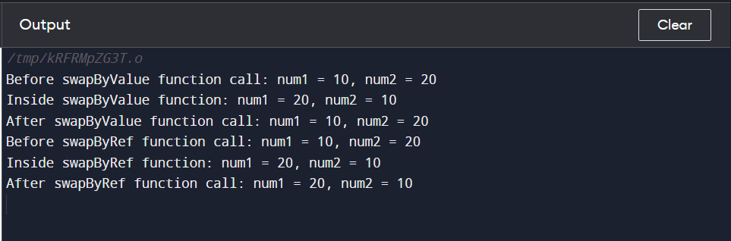

## Practical 4

### AIM: WAP for Illustrating Class Declarations, Definition, and Accessing Class Members (variables & functions).

#include <iostream>

using namespace std;

// Class declaration

class Rectangle {

public:

// Public member variables

double length;

double width;

// Public member functions

double area();

double perimeter();

};

// Class definition

double Rectangle::area() {

return length * width;

}

double Rectangle::perimeter() {

return 2 * (length + width);

}

int main() {

// Create an object of the Rectangle class

Rectangle rect;

// Assign values to the member variables

rect.length = 10;

rect.width = 5;

// Access and display the area and perimeter of the rectangle

cout << "Length = " << rect.length << endl;

cout << "Width = " << rect.width << endl;

cout << "Area = " << rect.area() << endl;

cout << "Perimeter = " << rect.perimeter() << endl;

return 0;

}

Output:

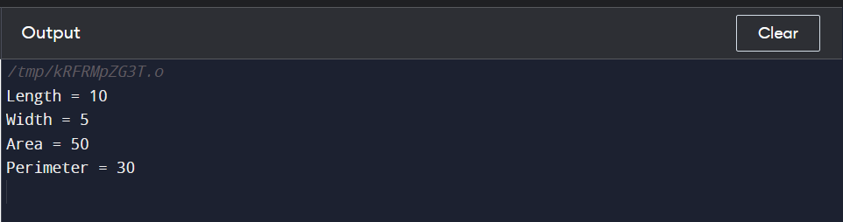

## Practical 5

### AIM: WAP to demonstrate default constructor parameterized constructor copy constructor (implicit and explicit) and destructor.

#include <iostream>

#include <string>

using namespace std;

class Person {

private:

string name;

int age;

public:

// Default constructor

Person() {

name = "";

age = 0;

}

// Parameterized constructor

Person(string n, int a) {

name = n;

age = a;

}

// Copy constructor

Person(const Person& p) {

cout << "Using explicit copy constructor" << endl;

name = p.name;

age = p.age;

}

// Destructor

~Person() {

cout << "Destructor called for " << name << endl;

}

void display() {

cout << "Name: " << name << endl;

cout << "Age: " << age << endl;

}

};

int main() {

Person p1("John", 25);

p1.display();

Person p2 = p1; // Implicit copy constructor

p2.display();

Person p3(p1); // Explicit copy constructor

p3.display();

return 0;

}

Output:

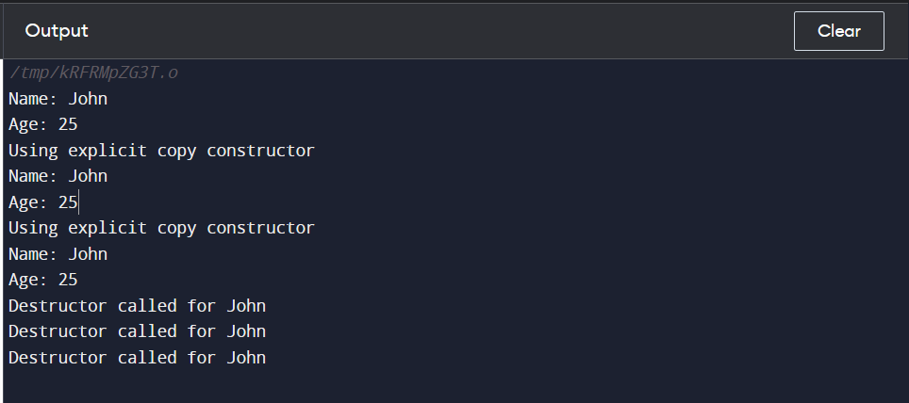

## Practical 6

### AIM: WAP to demonstrate the usage of this operator.

#include <iostream>

using namespace std;

class MyClass {

private:

int x;

public:

MyClass(int x) {

this->x = x;

}

void print() {

cout << "x = " << this->x << endl;

}

void setX(int x) {

this->x = x;

}

};

int main() {

MyClass obj(5);

obj.print();

obj.setX(10);

obj.print();

return 0;

}

Output:

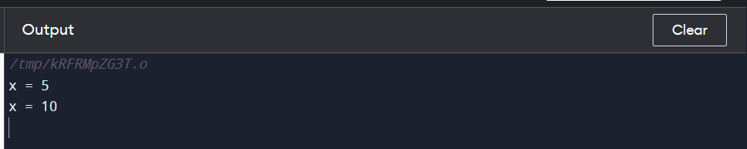

## Practical 7

### WAP to demonstrate all significance of scope resolution operator.

#include <iostream>

using namespace std;

int x = 10; // global variable

class MyClass {

public:

static int y; // static variable

int x = 20; // member variable

static void printY() { // static function

cout << "y = " << y << endl;

}

void printX() { // member function

cout << "x = " << x << endl;

}

};

int MyClass::y = 30; // static variable definition

int main() {

int x = 40; // local variable

cout << "Global variable x = " << ::x << endl;

cout << "Local variable x = " << x << endl;

cout << "Static variable y = " << MyClass::y << endl;

MyClass::printY();

MyClass obj;

cout << "Member variable x = " << obj.x << endl;

obj.printX();

return 0;

}

Output:

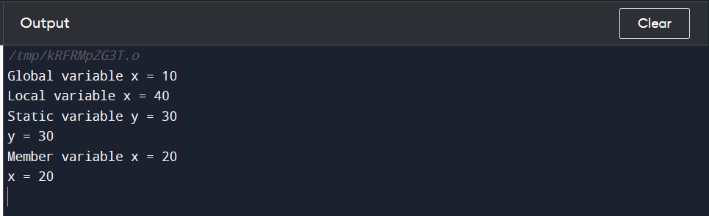

## Practical 8

### AIM: WAP to demonstrate single inheritance.

#include <iostream>

using namespace std;

// base class

class Shape {

protected:

int width;

int height;

public:

void setWidth(int w) {

width = w;

}

void setHeight(int h) {

height = h;

}

};

// derived class

class Rectangle : public Shape {

public:

int getArea() {

return width * height;

}

};

int main() {

Rectangle rect;

rect.setWidth(5);

rect.setHeight(7);

cout << "Area of rectangle = " << rect.getArea() << endl;

return 0;

}

Output:

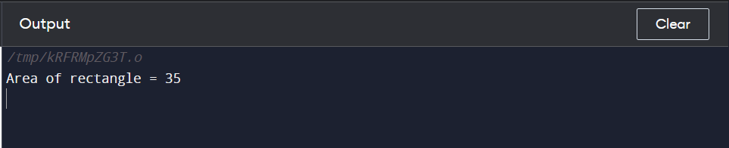

### AIM: WAP to demonstrate multiple inheritance.

#include <iostream>

using namespace std;

class A {

public:

void display() {

cout << "This is class A." << endl;

}

};

class B {

public:

void display() {

cout << "This is class B." << endl;

}

};

// derived class C that inherits from A and B

class C : public A, public B {

public:

void show() {

// resolve ambiguity by specifying which display function to use

A::display();

B::display();

}

};

int main() {

C c;

c.show();

return 0;

}

Output:

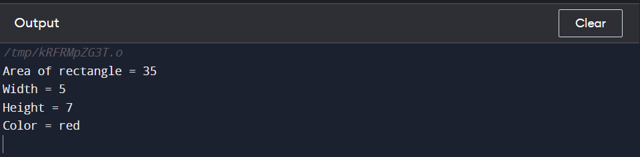

### AIM: WAP to demonstrate multi-level inheritance.

#include <iostream>

using namespace std;

// base class

class Animal {

public:

void eat() {

cout << "Eating..." << endl;

}

};

// derived class

class Dog : public Animal {

public:

void bark() {

cout << "Barking..." << endl;

}

};

// derived class from Dog

class Bulldog : public Dog {

public:

void run() {

cout << "Running..." << endl;

}

};

int main() {

Bulldog b;

b.eat();

b.bark();

b.run();

return 0;

}

Output:

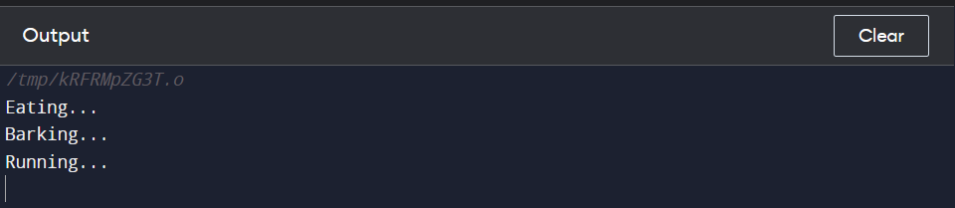

### AIM: WAP to demonstrate hierarchical inheritance.

#include <iostream>

using namespace std;

// base class

class Animal {

public:

void eat() {

cout << "Eating..." << endl;

}

};

// derived class 1

class Dog : public Animal {

public:

void bark() {

cout << "Barking..." << endl;

}

};

// derived class 2

class Cat : public Animal {

public:

void meow() {

cout << "Meowing..." << endl;

}

};

int main() {

Dog d;

Cat c;

d.eat();

d.bark();

c.eat();

c.meow();

return 0;

}

Output:

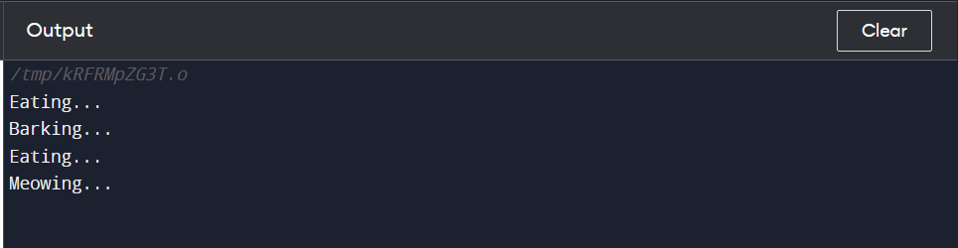

## Practical 9

### AIM: WAP to implement public inheritance

#include<iostream>

using namespace std;

class Base{

public:

int pub;

private:

int pvt;

protected:

int pro;

public:

Base(){

pub=0;

pvt=-1;

pro=1;

}

};

class Derived: public Base{

public:

void info(){

cout<<pub<<endl;

//cout<<pvt<<endl; this line gives error because pvt is private member and not accesible

cout<<pro<<endl;

}

};

int main(){

Derived obj;

obj.info();

return 0;

}

Output:

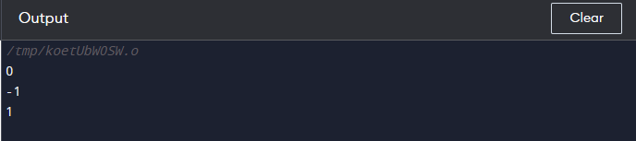

### AIM: WAP to implement private inheritance

#include <iostream>

using namespace std;

class Base{

protected:

int a = 0;

int b = -1;

int c = 1;

};

class Derived: private Base{

public:

int get_a(){

return a;

}

int get_b(){

return b;

}

int get_c(){

return c;

}

};

int main() {

Derived obj;

int a = obj.get_a();

int b = obj.get_b();

int c = obj.get_c();

cout<<a<<endl;

cout<<b<<endl;

cout<<c<<endl;

return 0;

}

Output:

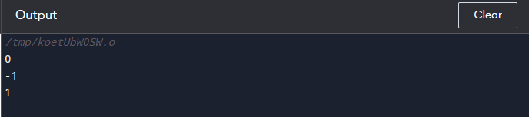

## Practical 10

### AIM: WAP to demonstrate operator overloading.

#include <iostream>

using namespace std;

class Count {

private:

int value;

public:

Count() :{

value = 5;

}

void operator ++ () {

++value;

}

void display() {

cout << "Count: " << value << endl;

}

};

int main() {

Count count1;

++count1;

count1.display();

return 0;

}

Output:

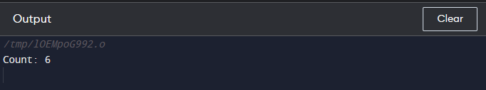

### AIM: WAP to demonstrate function overloading.

#include <iostream>

using namespace std;

// function to add two integers

int add(int a, int b) {

return a + b;

}

// function to add three integers

int add(int a, int b, int c) {

return a + b + c;

}

// function to add two doubles

double add(double a, double b) {

return a + b;

}

int main() {

int sum1 = add(5, 10);

int sum2 = add(5, 10, 15);

double sum3 = add(2.5, 3.7);

cout << "Sum of 5 and 10 is: " << sum1 << endl;

cout << "Sum of 5, 10 and 15 is: " << sum2 << endl;

cout << "Sum of 2.5 and 3.7 is: " << sum3 << endl;

return 0;

}

Output:

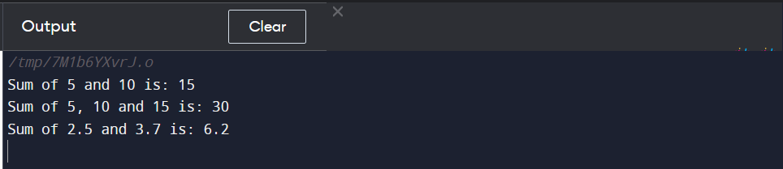

## Practical 11

### AIM: WAP to demonstrate function overriding with early binding with and without using pointer.

#include <iostream>

using namespace std;

class Animal {

public:

void speak() {

cout << "Animal speaking..." << endl;

}

};

class Dog : public Animal {

public:

void speak() {

cout << "Dog barking..." << endl;

}

};

int main() {

Animal myAnimal;

Dog myDog;

Animal* ptrAnimal = &myAnimal;

Animal* ptrDog = &myDog;

myAnimal.speak(); // Early binding without pointer

myDog.speak(); // Early binding without pointer

ptrAnimal->speak(); // Early binding with pointer

ptrDog->speak(); // Early binding with pointer

return 0;

}

Output:

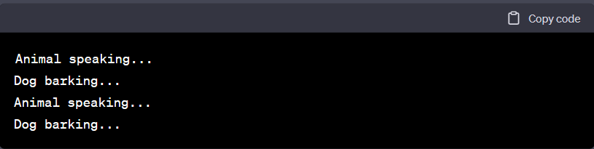

### AIM: WAP to demonstrate function overriding with late binding.

#include <iostream>

using namespace std;

class Animal {

public:

virtual void speak() {

cout << "Animal speaking..." << endl;

}

};

class Dog : public Animal {

public:

void speak() {

cout << "Dog barking..." << endl;

}

};

int main() {

Animal* animalPtr;

Dog dog;

animalPtr = &dog;

animalPtr->speak(); // late binding

return 0;

}

Output:

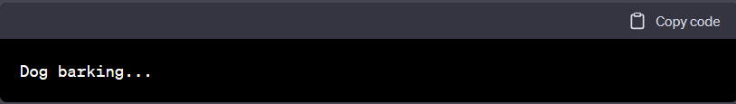

## Practical 12

### AIM: WAP to demonstrate pure virtual function.

#include <iostream>

using namespace std;

class Shape {

protected:

int width, height;

public:

Shape( int a = 0, int b = 0) {

width = a;

height = b;

}

// pure virtual function

virtual int area() = 0;

};

class Rectangle: public Shape {

public:

Rectangle( int a = 0, int b = 0):Shape(a, b) { }

int area () {

cout << "Rectangle class area :" << endl;

return (width * height);

}

};

int main() {

Shape *shape;

Rectangle rec(10,7);

shape = &rec;

// call rectangle area.

cout << shape->area() << endl;

return 0;

}

Output:

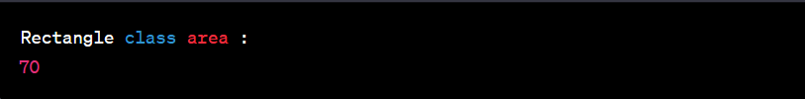

### AIM: WAP to demonstrate friend function.

#include <iostream>

using namespace std;

class MyClass {

private:

int num1, num2;

public:

MyClass(int a, int b) {

num1 = a;

num2 = b;

}

friend int sum(MyClass obj);

};

int sum(MyClass obj) {

return (obj.num1 + obj.num2);

}

int main() {

MyClass obj(10, 20);

cout << "Sum of num1 and num2 is: " << sum(obj) << endl;

return 0;

}

Output:



## Practical 13

### AIM: WAP to containing a possible exception. Use try block to throw it and catch block to handle it properly.

#include <iostream>

using namespace std;

int main() {

try {

int num1, num2, result;

cout << "Enter two numbers: ";

cin >> num1 >> num2;

if (num2 == 0) {

throw "Divide by zero error!";

}

else {

result = num1 / num2;

cout << "Result: " << result << endl;

}

}

catch (const char* msg) {

cerr << msg << endl;

}

return 0;

}

Output:

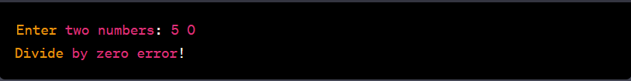

### AIM: WAP to demonstrate the use of catch-all

#include <iostream>

using namespace std;

int main() {

try {

int a, b;

cout << "Enter the values of a and b: ";

cin >> a >> b;

if (b == 0) {

throw runtime_error("Division by zero");

}

double result = a / b;

cout << "Result = " << result << endl;

}

catch (...) {

cout << "An exception occurred." << endl;

}

return 0;

}

Output:

