## AIM 1: Creating a webpage for illustrating text formatting tags.

### HTML

<!DOCTYPE html>

<html>

<head>

<title>RAJ VERMA</title>

<link rel="stylesheet" href="style.css" />

</head>

<body>

<h1>Text Formatting Tags</h1>

<p>This is an example of <strong>bold text</strong>.</p>

<p>This is an example of <em>italic text</em>.</p>

<p>This is an example of <u>underlined text</u>.</p>

<p>This is an example of <del>strikethrough text</del>.</p>

<p>

This is an example of <sup>superscript text</sup> and

<sub>subscript text</sub>.

</p>

</body>

<script src="script.js"></script>

</html>

### CSS File

body {

font-family: Arial, sans-serif;

background-color: #1d1d1d;

color: #fff;

margin: 0;

padding: 0;

}

h1 {

font-size: 36px;

font-weight: bold;

text-align: center;

margin-top: 50px;

margin-bottom: 30px;

}

p {

font-size: 18px;

line-height: 1.5;

margin-bottom: 20px;

}

strong {

font-weight: bold;

}

em {

font-style: italic;

}

u {

text-decoration: underline;

}

del {

text-decoration: line-through;

}

sup {

vertical-align: super;

font-size: 14px;

}

sub {

vertical-align: sub;

font-size: 14px;

}

### OUTPUT

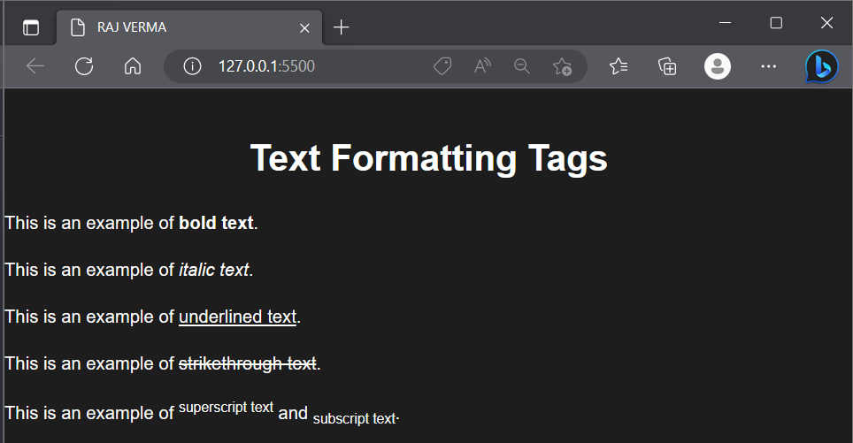

## AIM 2: Create a webpage to demonstrate font variations.

### HTML File

<!DOCTYPE html>

<html>

<head>

<title>RAJ VERMA</title>

<link rel="stylesheet" type="text/css" href="styles.css">

</head>

<body>

<h1>Font Variation </h1>

<p>This is an example of regular text.</p>

<p class="italic">This is an example of italic text.</p>

<p class="bold">This is an example of bold text.</p>

<p class="underline">This is an example of underlined text.</p>

<p class="strikethrough">This is an example of strikethrough text.</p>

<p class="smallcaps">This is an example of small caps text.</p>

</body>

</html>

### CSS File

body {

font-family: Arial, sans-serif;

background-color: #f2f2f2;

color: #333;

margin: 0;

padding: 0;

}

h1 {

font-size: 36px;

font-weight: bold;

}

.italic {

font-style: italic;

}

.bold {

font-weight: bold;

}

.underline {

text-decoration: underline;

}

.strikethrough {

text-decoration: line-through;

}

.smallcaps {

font-variant: small-caps;

}

### OUTPUT

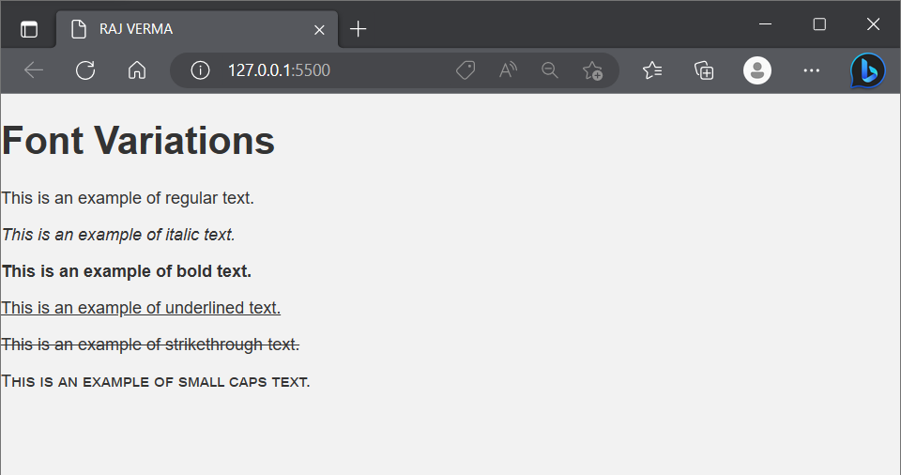

## AIM 3: Create a webpage to illustrate three types of list in html

### HTML File

<!DOCTYPE html>

<html>

<head>

<title>List Types</title>

<link rel="stylesheet" type="text/css" href="styles.css">

</head>

<body>

<h1>Types of Lists</h1>

<h2>Unordered List</h2>

<ul>

<li>Item 1</li>

<li>Item 2</li>

<li>Item 3</li>

</ul>

<h2>Ordered List</h2>

<ol>

<li>First Item</li>

<li>Second Item</li>

<li>Third Item</li>

</ol>

<h2>Definition List</h2>

<dl>

<dt>Term 1</dt>

<dd>Definition 1</dd>

<dt>Term 2</dt>

<dd>Definition 2</dd>

<dt>Term 3</dt>

<dd>Definition 3</dd>

</dl>

</body>

</html>

### CSS File

body {

font-family: Arial, sans-serif;

background-color: #f2f2f2;

color: #333;

margin: 0;

padding: 0;

}

h1 {

font-size: 36px;

font-weight: bold;

text-align: center;

margin-top: 50px;

margin-bottom: 30px;

}

ul {

list-style-type: disc;

margin-left: 30px;

}

ol {

list-style-type: decimal;

margin-left: 30px;

}

dl {

margin-left: 30px;

}

dt {

font-weight: bold;

}

dd {

margin-bottom: 10px;

margin-left: 20px;

}

### OUTPUT

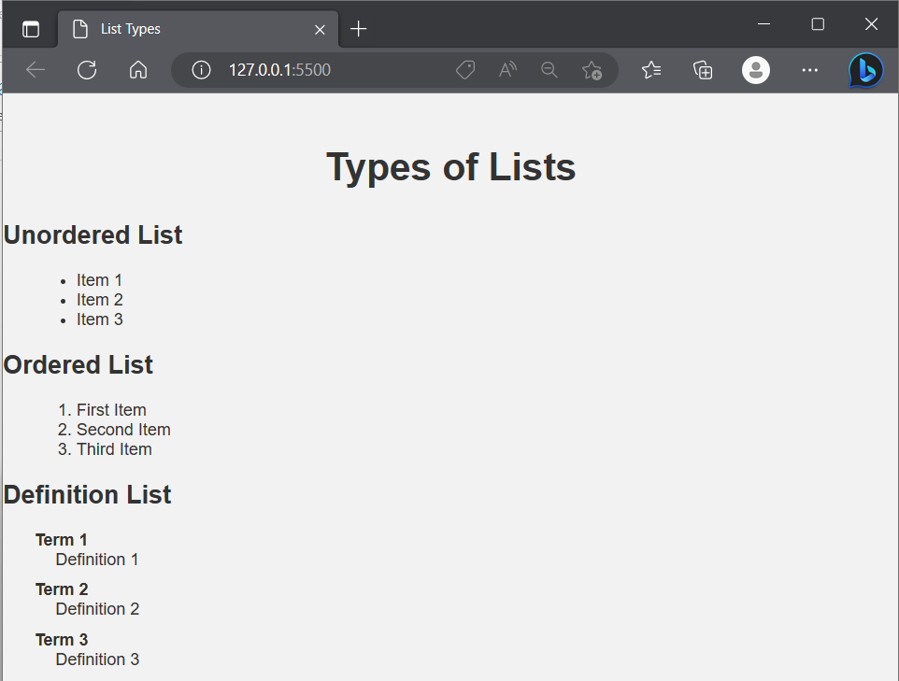

## AIM 4: Create a webpage to show your CV.

### HTML File

<!DOCTYPE html>

<html>

<head>

<title>My Curriculum Vitae</title>

<link rel="stylesheet" type="text/css" href="styles.css">

</head>

<body>

<div class="container">

<h1>My Curriculum Vitae</h1>

<table>

<tr>

<td colspan="2" class="section-heading">Personal Information</td>

</tr>

<tr>

<td>Name:</td>

<td>John Doe</td>

</tr>

<tr>

<td>Email:</td>

<td>johndoe@example.com</td>

</tr>

<tr>

<td>Phone:</td>

<td>555-1234</td>

</tr>

<tr>

<td>Address:</td>

<td>123 Main St<br>Anytown, USA</td>

</tr>

<tr>

<td colspan="2">&nbsp;</td>

</tr>

<tr>

<td colspan="2" class="section-heading">Education</td>

</tr>

<tr>

<td>2010-2014</td>

<td>Bachelor of Science in Computer Science<br>University of XYZ</td>

</tr>

<tr>

<td colspan="2">&nbsp;</td>

</tr>

<tr>

<td colspan="2" class="section-heading">Experience</td>

</tr>

<tr>

<td>2014-2016</td>

<td>Software Engineer<br>ABC Company</td>

</tr>

<tr>

<td>&nbsp;</td>

<td>Lorem ipsum dolor sit amet, consectetur adipiscing elit. Integer euismod metus sit amet arcu maximus consequat. Ut in leo quis mi lacinia tincidunt.</td>

</tr>

<tr>

<td>2016-Present</td>

<td>Senior Software Engineer<br>DEF Company</td>

</tr>

<tr>

<td>&nbsp;</td>

<td>Lorem ipsum dolor sit amet, consectetur adipiscing elit. Integer euismod metus sit amet arcu maximus consequat. Ut in leo quis mi lacinia tincidunt.</td>

</tr>

</table>

</div>

</body>

</html>

### CSS File

body {

font-family: Arial, sans-serif;

background-color: #f2f2f2;

color: #333;

margin: 0;

padding: 0;

}

.container {

max-width: 800px;

margin: 50px auto;

padding: 20px;

background-color: #fff;

box-shadow: 0 0 10px rgba(0, 0, 0, 0.1);

}

h1 {

font-size: 36px;

font-weight: bold;

text-align: center;

margin-top: 0;

margin-bottom: 30px;

}

table {

border-collapse: collapse;

width: 100%;

}

td {

padding: 10px;

border: 1px solid #ccc;

}

.section-heading {

font-weight: bold;

background-color: #f2f2f2;

}

### OUTPUT

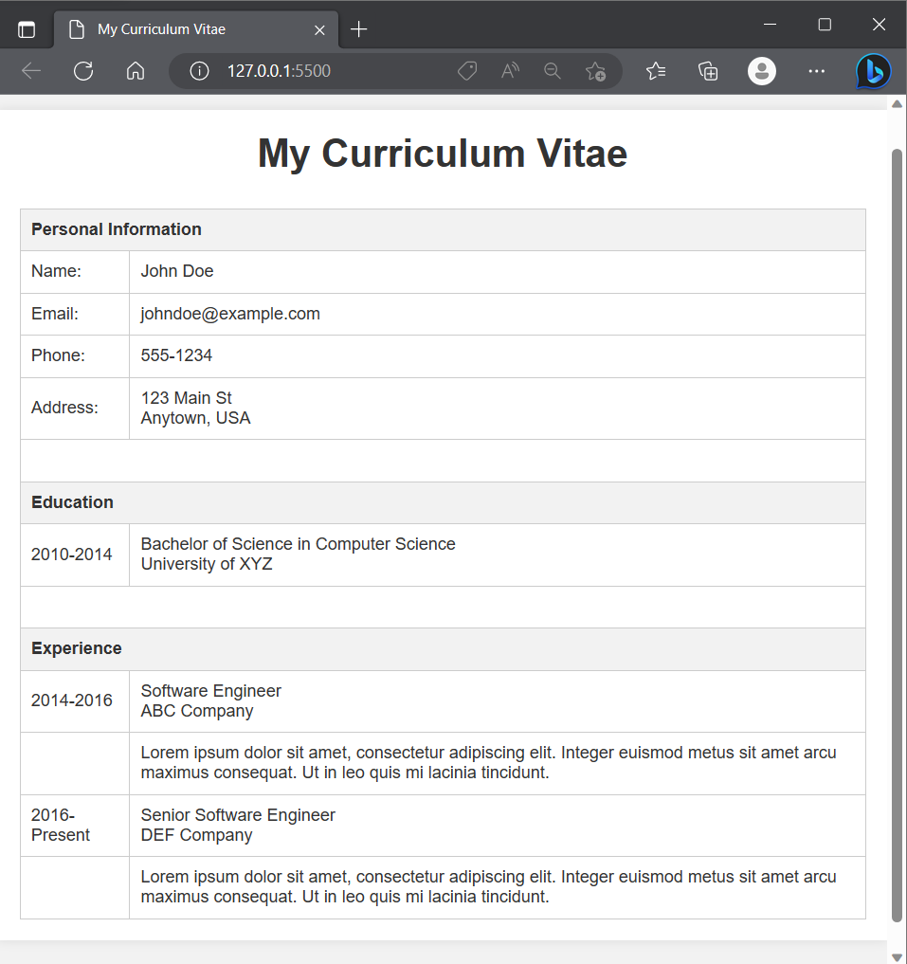

## AIM 5: Create a webpage to show your CV.

### HTML File

<!DOCTYPE html>

<html>

<head>

<title>Subscribe to our mailing list</title>

<link rel="stylesheet" type="text/css" href="styles.css">

</head>

<body>

<div class="container">

<h1>Subscribe to our mailing list</h1>

<form method="post" action="subscribe.php">

<label for="name">Name:</label>

<input type="text" id="name" name="name" required>

<label for="email">Email:</label>

<input type="email" id="email" name="email" required>

<label for="interests">Interests:</label>

<select id="interests" name="interests[]" multiple required>

<option value="technology">Technology</option>

<option value="fashion">Fashion</option>

<option value="food">Food</option>

<option value="sports">Sports</option>

</select>

<label for="message">Message:</label>

<textarea id="message" name="message"></textarea>

<input type="submit" value="Subscribe">

</form>

</div>

</body>

</html>

### CSS File

body {

font-family: Arial, sans-serif;

background-color: #f2f2f2;

color: #333;

margin: 0;

padding: 0;

}

.container {

max-width: 800px;

margin: 50px auto;

padding: 20px;

background-color: #fff;

box-shadow: 0 0 10px rgba(0, 0, 0, 0.1);

}

h1 {

font-size: 36px;

font-weight: bold;

text-align: center;

margin-top: 0;

margin-bottom: 30px;

}

form {

display: flex;

flex-direction: column;

}

label {

font-weight: bold;

margin-bottom: 5px;

}

input[type="text"],

input[type="email"],

textarea,

select {

padding: 10px;

border: 1px solid #ccc;

border-radius: 3px;

margin-bottom: 10px;

font-size: 16px;

}

input[type="submit"] {

background-color: #333;

color: #fff;

padding: 10px;

border: none;

border-radius: 3px;

cursor: pointer;

font-size: 16px;

}

input[type="submit"]:hover {

background-color: #444;

}

### OUTPUT

