Name: Muaaz Hassan Ansari

Id: DHC-107

Customer Churn Prediction Report

# 1. Introduction

This report presents the analysis and predictive modeling performed on the Telco Customer Churn dataset. The goal of this project is to identify factors that contribute to customer churn and to build a machine learning model that can predict whether a customer will churn.

# 2. Dataset Overview

The dataset contains customer demographic information, account details, and services used. The target variable is 'Churn', which indicates whether a customer has left the company.

Dataset Source: GitHub Repository ("<https://raw.githubusercontent.com/mindsdb/mindsdb-examples/master/classics/customer_churn/raw_data/WA_Fn-UseC_-Telco-Customer-Churn.csv>")

# 3. Methodology

The following steps were followed in the churn prediction task:  
1. Data loading and cleaning  
2. Exploratory Data Analysis (EDA)  
3. Feature encoding and preprocessing  
4. Splitting into training and testing sets  
5. Model training using Logistic Regression, Random Forest, and other classifiers  
6. Evaluation of models using accuracy, precision, recall, and F1-score  
7. Graphical visualization of results

# 4. Results

The performance of the models can be represented through confusion matrices, ROC curves, and bar charts of accuracy scores. These results will help visualize how well the models distinguish between churn and non-churn customers.

DATASET:

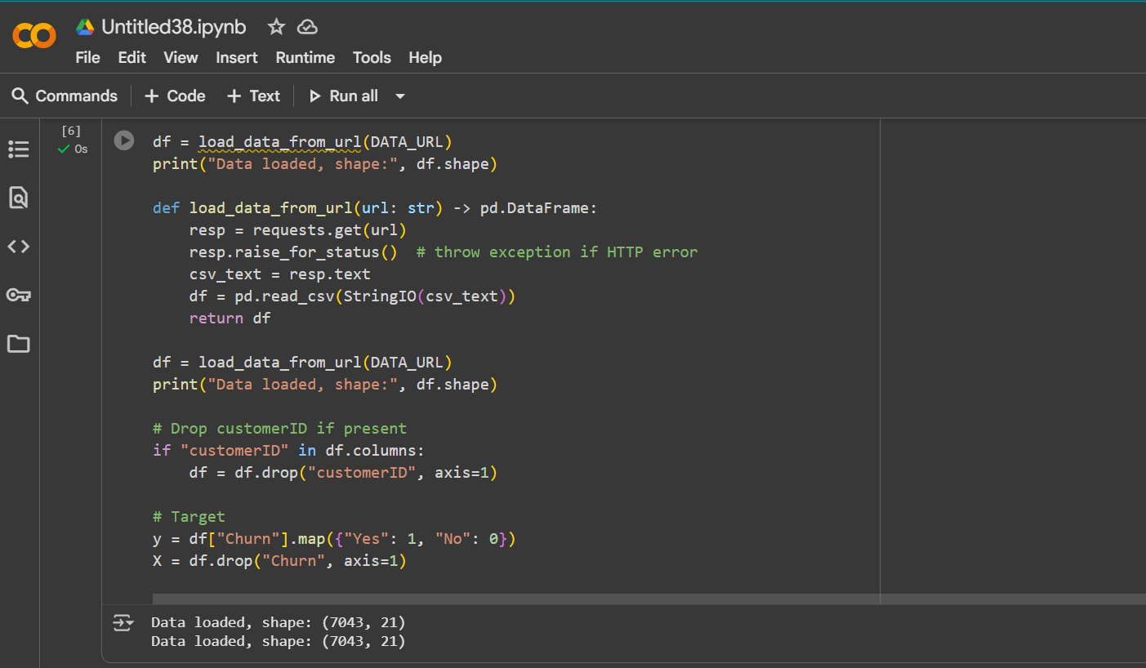

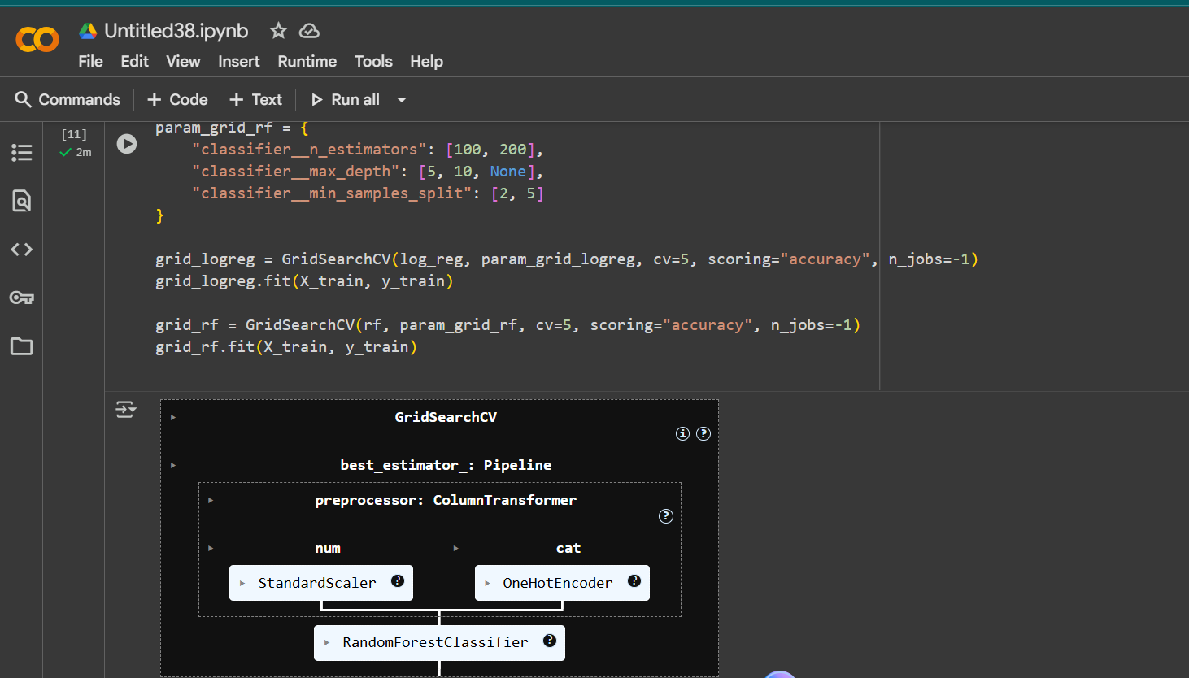

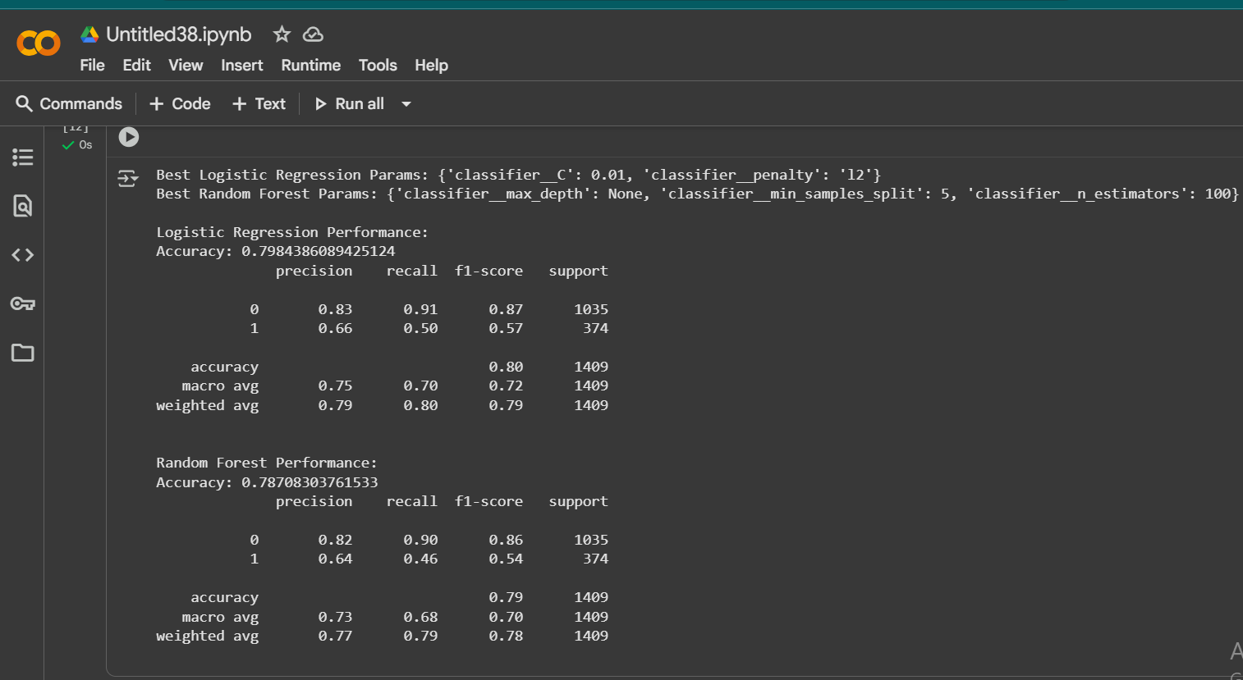

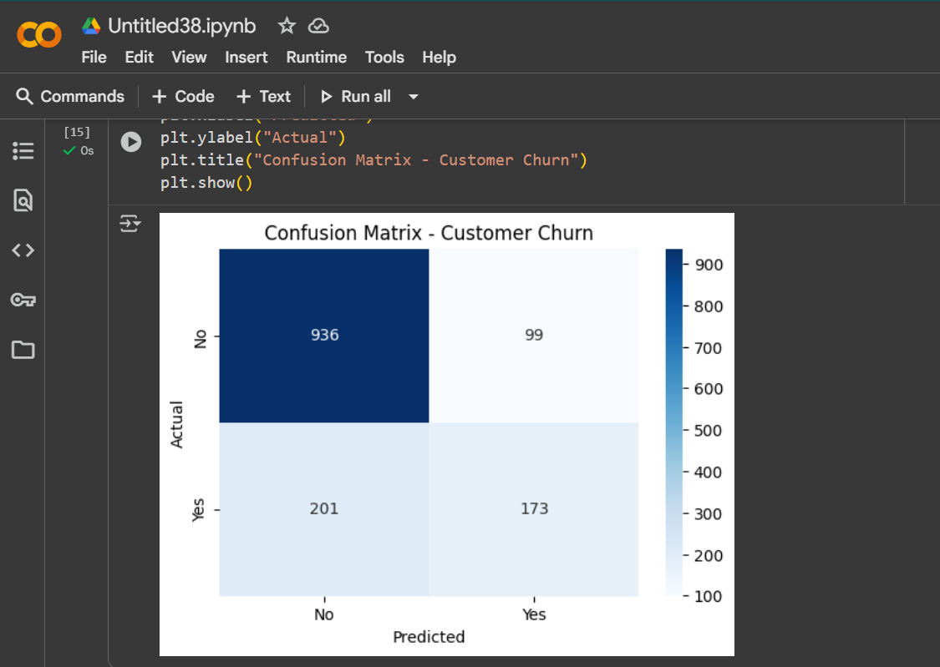

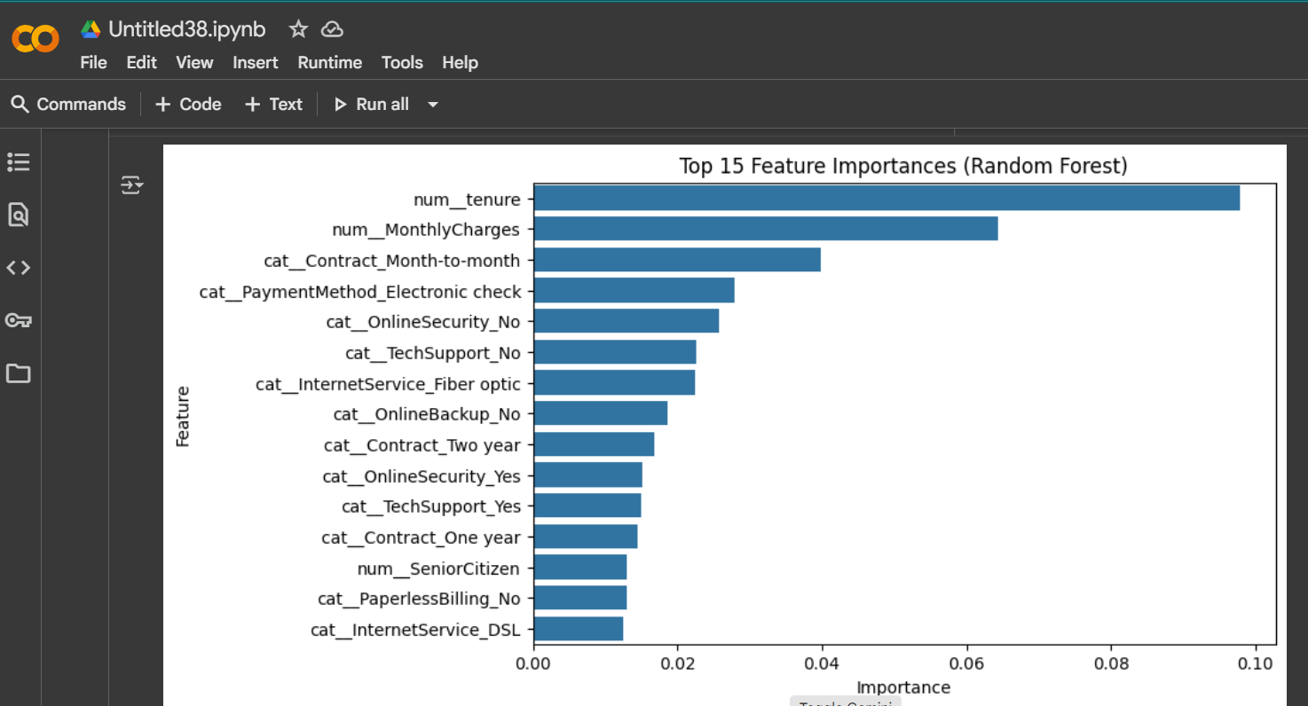

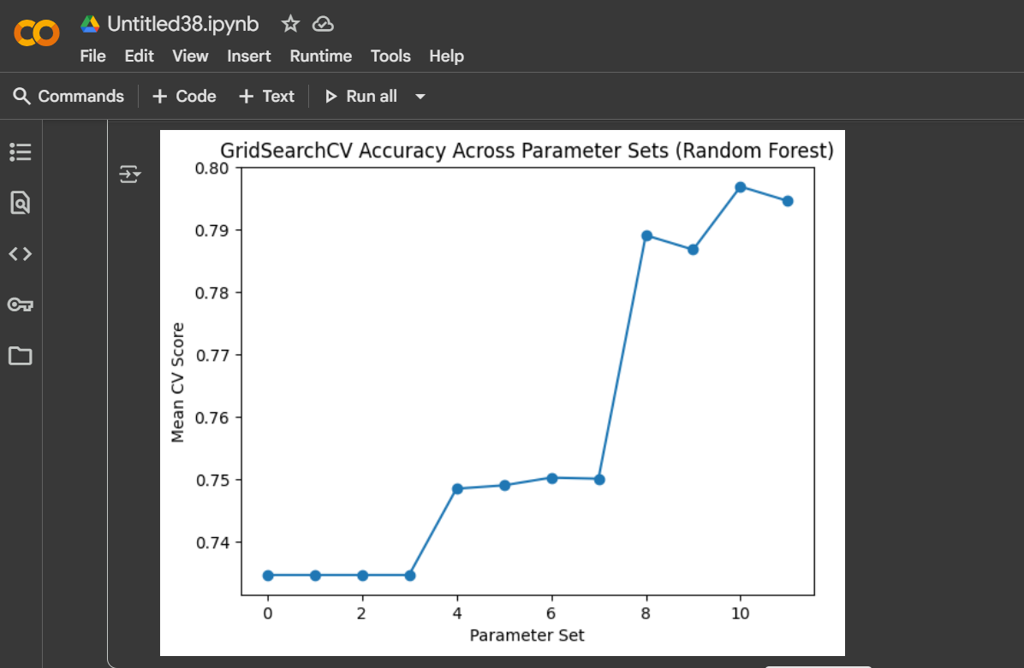

# 5. Conclusion

The predictive models provide valuable insights into the likelihood of customer churn. Business stakeholders can use these findings to design retention strategies, improve customer satisfaction, and reduce churn rates.