BPMSquare
Project Costing
How worked hours become project costs and customer invoices, step by step
Workforce Management module · screens captured from the BPMSquare demo workspace
Snapshot 6 September 2026

Contents

1. What project costing does
Every check-in and check-out an employee makes is already recorded by Workforce Management. Project costing adds one fact to each of those work sessions: which project the time belongs to. From that one fact the system can tell you where the hours went, how much of a budget is used, what the work is worth at your rates, and raise the invoice for it.
Nobody has to pick a project when they punch. The project is worked out from what a supervisor set up, in a fixed order, and stamped on the punch at the moment it happens. A later change to the setup never rewrites history.
The chain in one line: Set rates → create the project → say where its hours come from → people punch as usual → hours appear on the project → preview and raise the invoice → send it.

Each of those steps is a screen, shown below in the order you would use them.

2. Set the billing rates once
Go to Settings → Workforce → General → Project billing. This is where an hour gets its price. There are three rungs, and the most specific one wins:
- A rate on the project itself (set on the project form, under "More"). Covers its sub-projects too unless they set their own.
- A rate for the person's employment type (full-time, contractor, and any type you have added).
- The workspace default, used when nothing above applies.
Cost rates follow the same layout but have no project rung: what a person costs does not change with the job they are on. Cost stays internal. It shows as margin on the billing preview and is never printed on an invoice or exposed on the API.
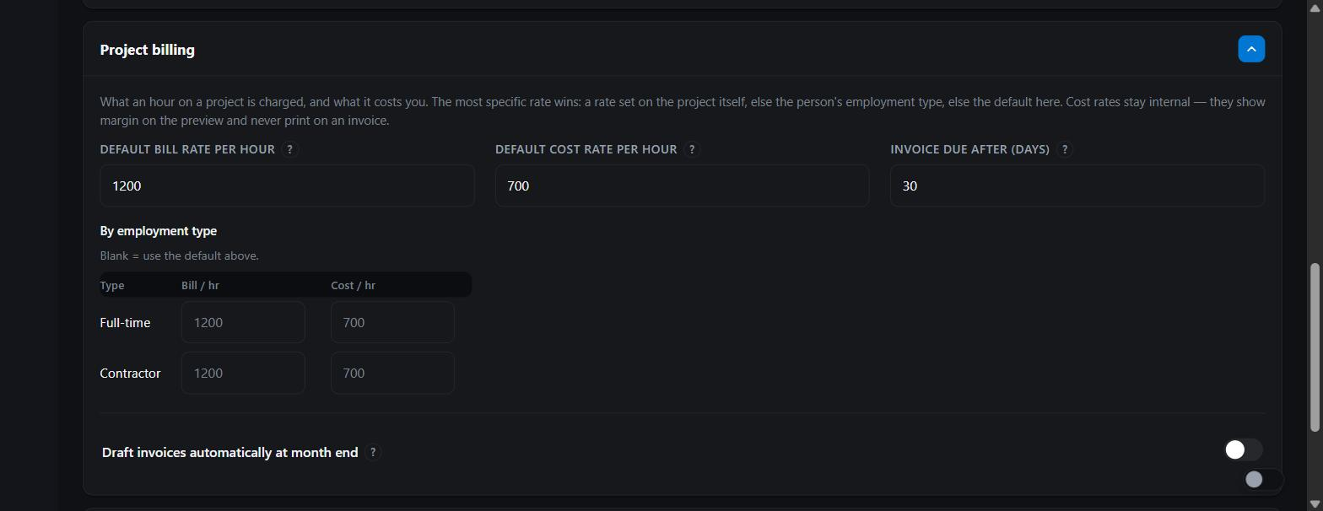
Figure 1 · Settings → Workforce → Project billing: default bill and cost rate, rates per employment type, invoice due days, and the month-end auto-draft switch.
- Enter a default bill rate per hour. Until one exists, nothing can be invoiced. A zero rate is treated as "not set", never as "free".
- Enter a default cost rate if you want margin on the preview.
- Override either per employment type where a contractor and a full-timer are charged differently.
- Set how many days after the draft the invoice falls due.
- Leave "Draft invoices automatically at month end" off until you have raised a few invoices by hand and trust the numbers. When on, the 1st of each month drafts last month for every active, account-linked project with hours. Drafts only; nothing is sent.

3. Create the project
Open Workforce → Projects and press + Add Project. The only thing a project needs is a name; its ID (PRJ-0001, PRJ-0002 …) is assigned for you.
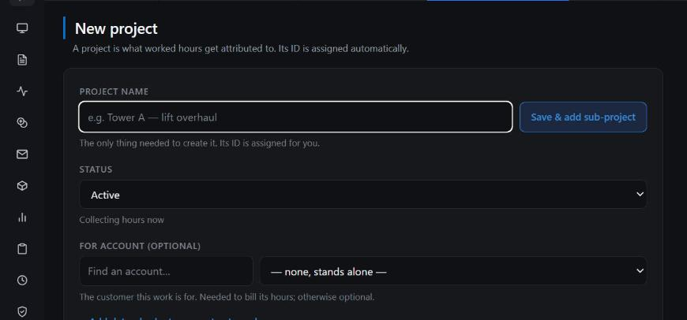
Figure 2 · New project. Name, status, and the optional account it is for. Dates, a budget in hours, a contract number and a bill rate sit behind "Add dates, budget or a contract number".
- Give it a name. If the work is for a customer, pick the account under For account. This is optional to run the project, but an invoice needs a customer, so link it before you bill.
- Add dates and a budget in hours if you want budget burn tracked. Add the client's PO or contract number if they quote one.
- Press Save, or Save & add sub-project to go straight into breaking it down.

Sub-projects and levels
A project can be broken into parts, and parts into parts, down to three levels beneath it. Every part has everything a project has: its own people, shifts, sites, dates and budget. Hours booked to a part roll up into the project above it, so the project always shows the whole picture.
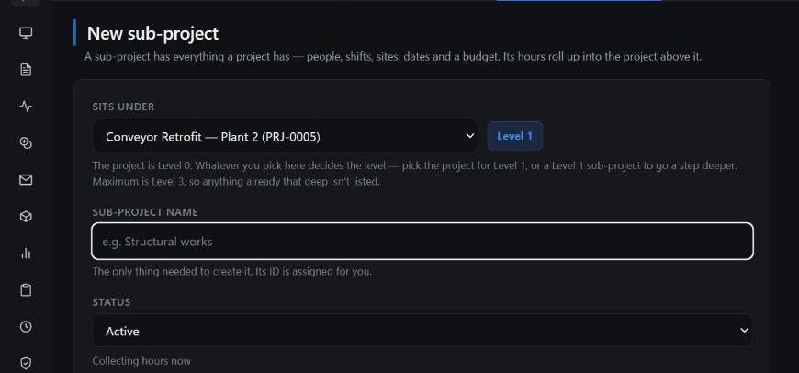
Figure 3 · New sub-project. "Sits under" decides the level: pick the project for Level 1, a Level 1 part for Level 2, and so on. Parts are numbered inside the parent (PRJ-0005.1, PRJ-0005.1.2).
- From the project page, press + next to Sub-projects, or + Create sub-project on the form.
- Name the part. The level is shown, not asked for; it follows from what you picked under "Sits under".
- Repeat for each part. The Projects list shows them as a tree beneath the project.
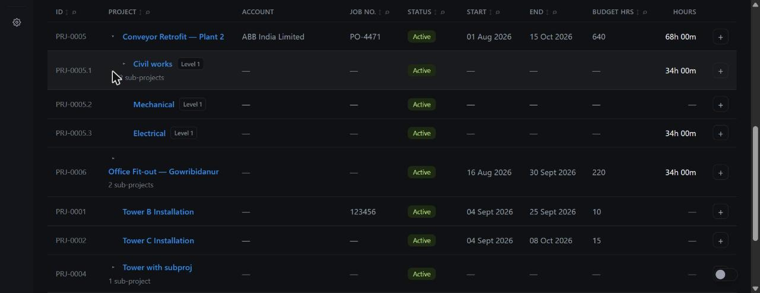
Figure 4 · The Projects list with PRJ-0005 expanded: three Level 1 parts, each with its own hours, numbered inside the parent. The + on the right adds a part in place.

4. Say where its hours come from
This is the part that makes punching effortless for employees. Instead of asking each person which project they are on, you tell the project who works on it. Four rungs are checked, top to bottom, at the moment of every check-in, and the first match is stamped on the punch:
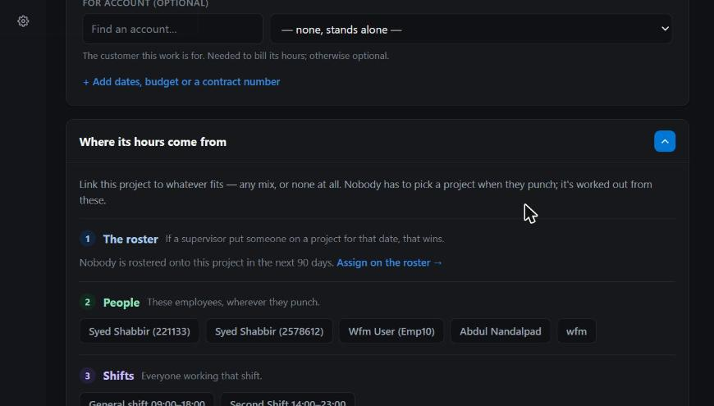
Figure 5 · "Where its hours come from" on the project form: the roster, then linked people, then shifts, then sites. First match wins.
- 1 · The roster. A supervisor put this person on this project for that date. Always wins, because it is the most deliberate.
- 2 · People. Employees linked to the project, wherever they punch.
- 3 · Shifts. Everyone working a linked shift.
- 4 · Sites. Anyone punching at a linked site, if nothing above applied.
If a step finds two projects at once the hours are left unassigned rather than guessed. Unassigned hours are shown everywhere in amber so a supervisor can settle them on the roster; they are never hidden and never billed.

Putting people on a project for specific dates
Open Workforce → Roster and use Project assignments. Pick the project, the dates, and the people. Their shift does not change; only where their hours go.
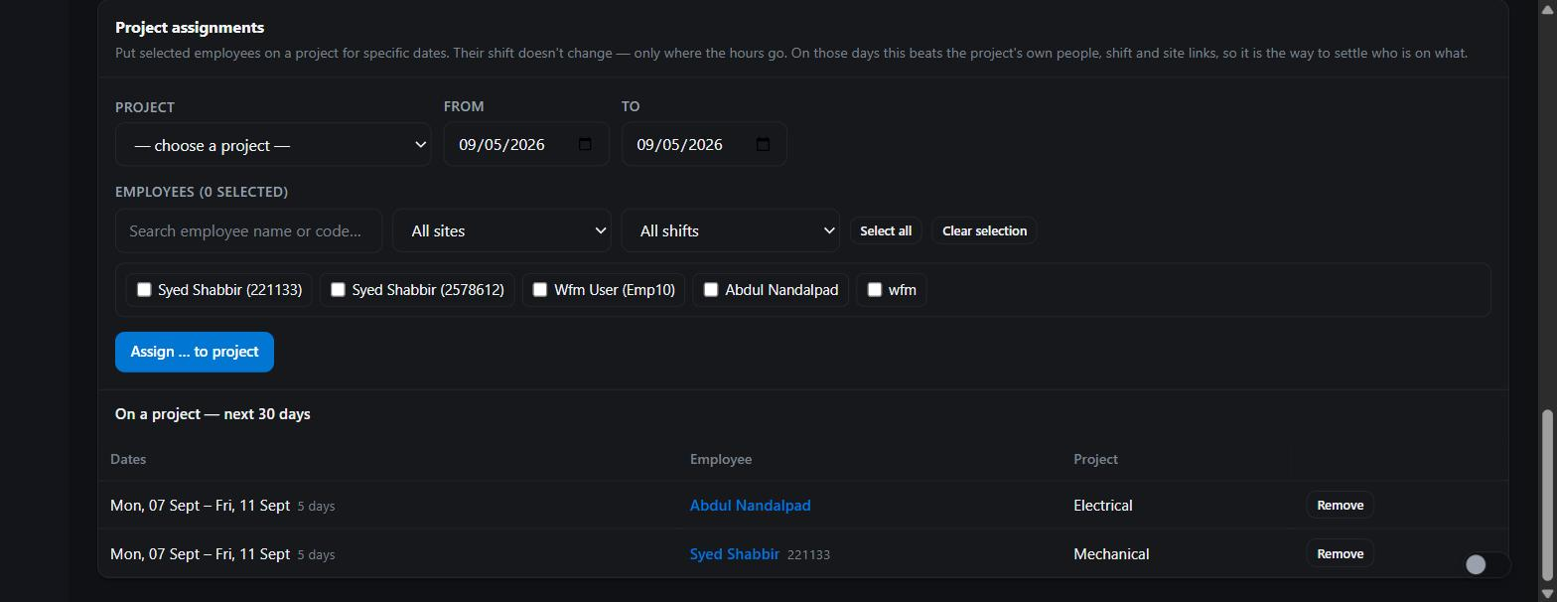
Figure 6 · Roster → Project assignments: choose a project and dates, tick people, assign. "On a project" lists who is where for the next 30 days, one row per continuous stretch, with Remove.

5. People punch as they always did
Nothing changes on the employee's phone or the kiosk. The project is resolved on the server when the check-in is recorded and shown on the punch screen so the person can see where their day is going.
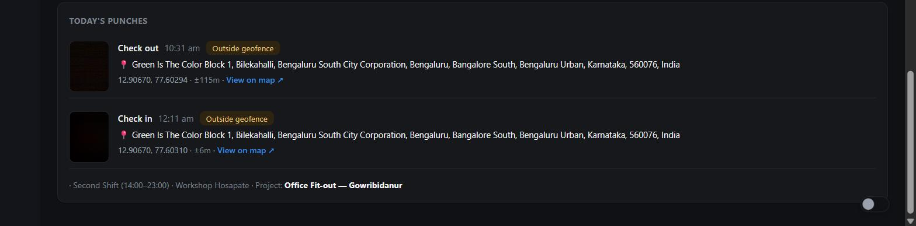
Figure 7 · My Workforce, today's punches. The line under the punches names the shift, the site and the project the day was attributed to.
Stamped, not recomputed. The project is written onto the punch at the moment it happens. Changing a link or the roster afterwards affects future punches only, so a period that has been invoiced cannot quietly change underneath the invoice.

6. Watch the hours arrive
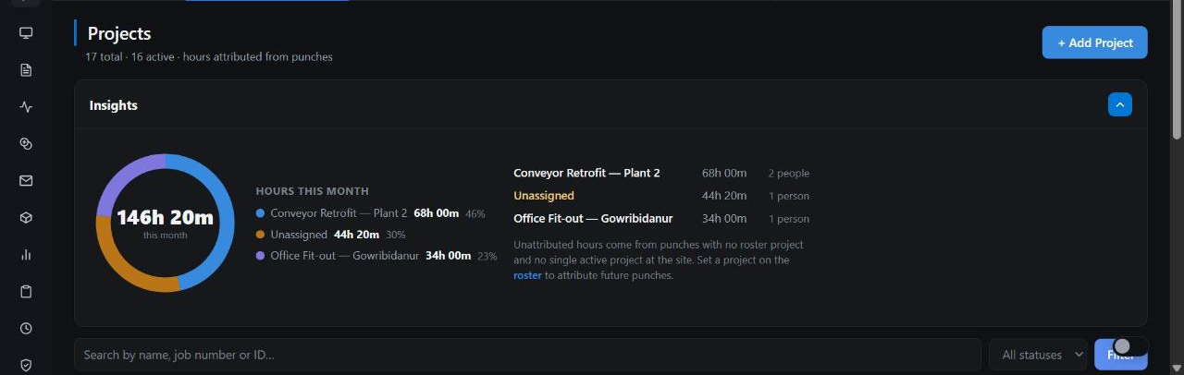
Figure 8 · Projects → Insights: hours this month by project, with Unassigned as its own amber slice and a note on how to settle it.
Every number here comes from the same calculation, so the list, the project page, the account page, the analytics and the API can never disagree:
- Projects list. Each project's hours including its parts, budget hours, account and job number.
- Project page. Hours for this month, the last 90 days or the last 12 months, headcount, budget used, and the parts beneath it.
- Account page → Projects tab. Every project for that customer, this month's hours, and how far each has been invoiced.
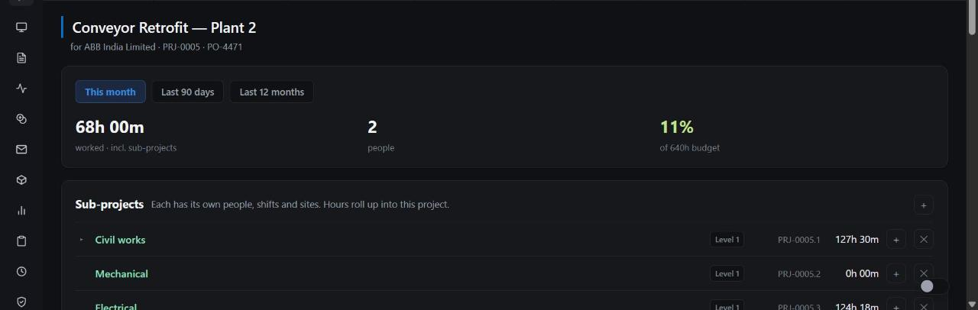
Figure 9 · A project page: hours worked including sub-projects, people, percentage of the 640-hour budget, and the parts with their own hours.
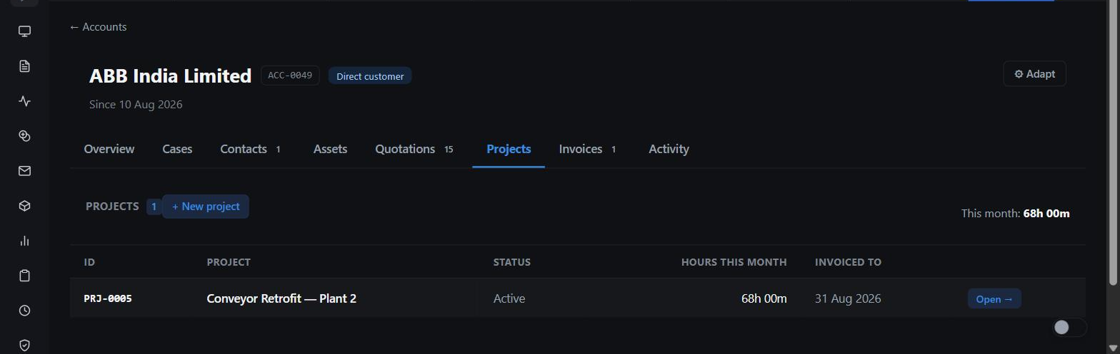
Figure 10 · The customer's account, Projects tab: hours this month and the date the project has been invoiced to.

7. Bill the hours
On the project page, the Bill hours card turns a period of hours into a draft invoice for the linked account. You always see exactly what the invoice will say before anything is created.
- Press Bill a period. Pick last month, this month so far, or any dates.
- Choose the lines: one line for the whole project, or one per sub-project. When people on one line would be charged at different rates, the line splits by employment type and says so, rather than showing a blended rate.
- Press Preview.
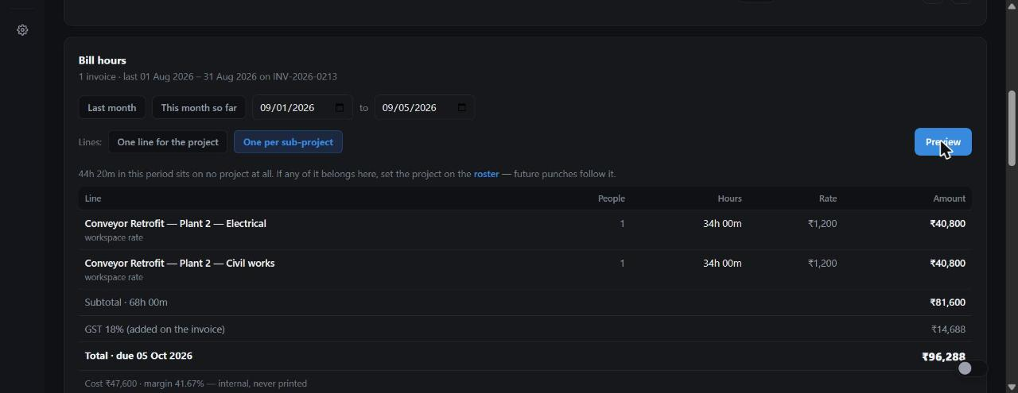
Figure 11 · The preview: one line per sub-project with people, hours, the rate that applied and why ("workspace rate"), subtotal, GST as it will print, total and due date, and the internal cost and margin line.
The preview is also where the system tells you what would make the invoice wrong, in words, instead of failing later:
- No account linked: link the customer first.
- No rate applies: set one on the project or in Settings.
- A period already invoiced on this project, a part of it, or a parent that covered it: refused, naming the invoice.
- Hours in the window on no project at all: shown as a warning so you can settle them on the roster. They are never billed.
- Press Create draft invoice. The invoice opens in the Invoices module as a draft you can still edit.
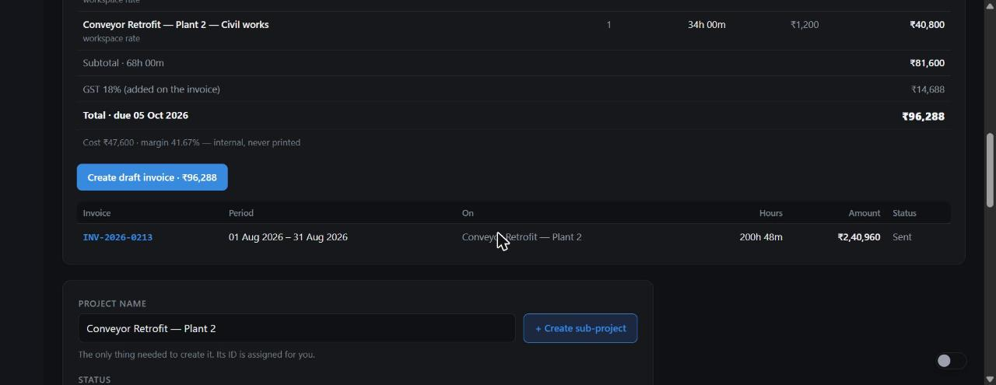
Figure 12 · Ready to create, with the invoices already raised from this project listed underneath: period, hours, amount and status.
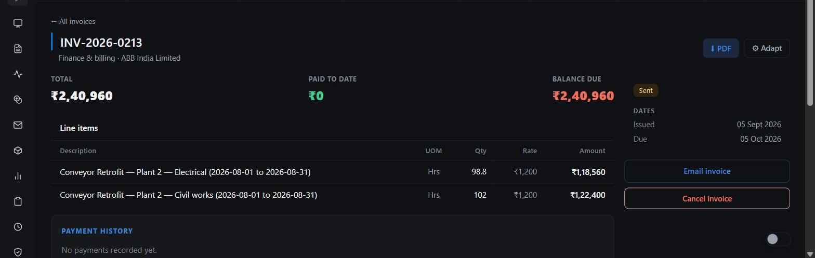
Figure 13 · The resulting invoice: one line per sub-project, quantity in hours to two decimals, the rate, and the period in each description.

Hours that arrive after invoicing
If a correction is approved after a period has been invoiced, the next preview for that same period shows how many hours were added since and offers "Bill the difference": one line for the extra hours, never a second invoice for the whole period.

Sending the invoice
On the invoice page press Email invoice. Tick the account's contacts, add any address by hand, edit the subject and message, and send. The PDF is attached automatically and is the same file the Download PDF button gives. A draft becomes Sent the first time it goes out; every recipient is logged under Administration → Outbound emails.
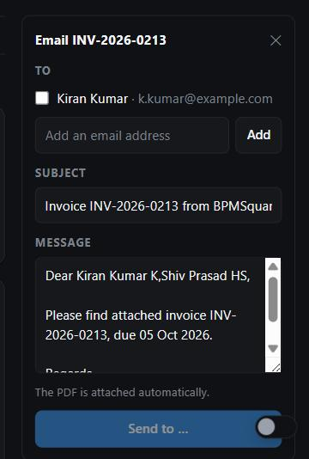
Figure 14 · Email invoice: contacts to tick, a typed address, subject and message from your invoice template.

8. Safeguard: where email really goes
Under Settings → General → Email output every workspace has one of two output channels, the same idea as SAP's Email and Fax Settings:
- Send to a specified email address. Every outbound email from any transaction goes to one internal inbox instead of the recipient on the document. The subject and the first line name who it was for, so output can still be checked end to end.
- Send to business partners. The real address on the account, contact or employee. Production only.
A demo or test workspace is locked to the first option. The second cannot be selected there, and with no inbox set the workspace sends nothing at all. No test invoice, quotation, campaign or workforce notification can reach a real customer.
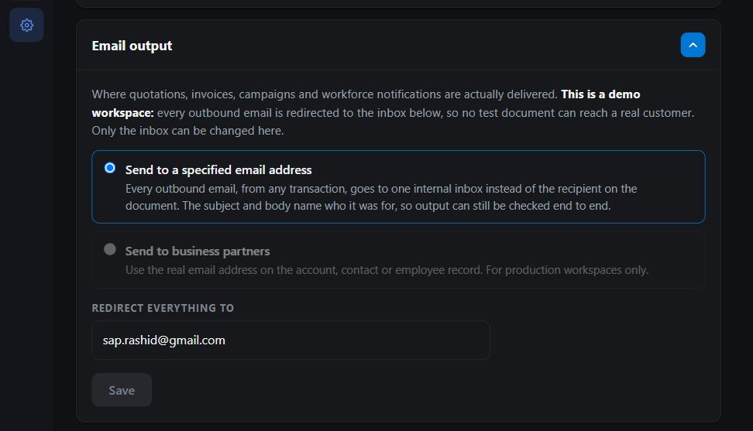
Figure 15 · Email output on the demo workspace: redirect enforced, "Send to business partners" greyed out, one inbox for everything.

9. Analytics and asking questions
The dashboard and Analytics gain a Project costing group with three widgets, scoped to what the viewer is allowed to see, like every other Workforce widget:
- Hours by project (this month). Top-level projects with Unassigned as its own bar.
- Project budget burn. Every budgeted project: hours worked against budget, amber past 80 percent, red past 100.
- Project billing (this month). What has been invoiced from hours, and hours waiting on account-linked projects that no invoice covers yet.
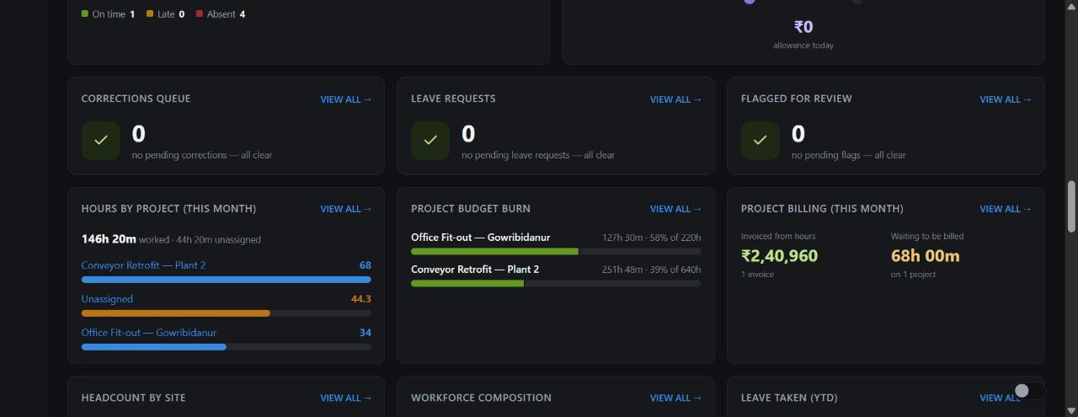
Figure 16 · Analytics: hours by project, budget burn and billing for the month, next to the existing Workforce widgets.

Talk to data
Under Analytics → Talk to data you can ask about project hours in plain English. Every work session is available as a row with its date, project, top-level project, account, employment type, hours, the rate that applied, the billable amount, and whether it has been invoiced or assigned. Questions that work well:
- Hours by project this month
- Billable amount by account last month
- Unassigned hours by month
- Who worked on Conveyor Retrofit in August
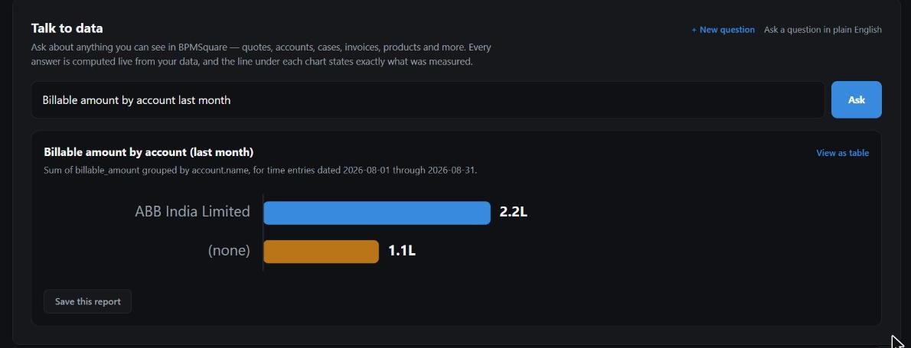
Figure 17 · Talk to data answering "Billable amount by account last month" from live rows. The line under the title states exactly what was measured.
The same object is available to the AI assistant in the side dock and to integrations through the API. The numbers are always computed by the system from live rows; the AI only chooses the query and explains it.

10. For integrators
Everything above is available on the v1 REST API with a scoped API key (Settings → General → Developer), and to AI clients through the MCP server.
Endpoint | What it gives you
GET /api/v1/projects | Projects and sub-projects with level, parent, account, dates, budget and bill rate
GET /api/v1/projects/:id/hours?from&to | Hours for a project and everything beneath it for a period, the same figure the screen shows
GET /api/v1/projects/:id/invoices | Invoices raised from the project's hours: period, hours and amount billed
POST /api/v1/projects/:id/invoices | Raise a draft invoice for a period; dry_run previews the lines; top_up bills only hours added since
GET /api/v1/project-hours | One row per work session with rate and billable amount; group_by and aggregates supported; employee columns need the employees scope
POST /api/v1/ask | A plain-English question against any of the objects above

Data Workbench imports, exports and updates projects like any other object, including the bill rate and the tenant's custom fields.

11. Rules the system enforces
- Actual minutes. Nothing is rounded to a block. Line quantity is hours to two decimals and the amount is quantity times rate, so the printed line agrees with itself.
- A session belongs to the day it started, in the workspace timezone. A night shift that crosses midnight counts on the day it began.
- Rate ladder. Project, then nearest parent project, then employment type, then workspace default. Zero means unset.
- Tax is the workspace's existing tax setting, applied on the invoice exactly as for any other invoice.
- No double billing. A period already covered by a non-cancelled invoice on the project, a part of it, or a parent that included it, is refused. Deleting a draft frees its period; cancelling an invoice frees it too.
- Unassigned hours are never billed. They are a warning to settle on the roster.
- Standalone projects are not billable. An invoice needs a customer; link the account first.
- Overtime is not billed yet. Overtime sessions carry no project, so they cannot be attributed. This is deliberate rather than guessed.
- Cost never leaves the workspace. It shows to admins on the preview and nowhere else.

