BPMSquare Pricing — Cost-based technique
Demo walkthrough and validation record · Snapshot 6 September 2026 · production, demo workspace (Al Noor Engineering)

1. What this document shows
The cost-based pricing technique was built one step at a time (engine and data, the quote line, setup and demo) and this is the walk through it on the live demo workspace. Every screenshot below is from production after the 6 September deploy. Names and addresses shown are the demo workspace's fictional ones.
The story is the one a manufacturer told us: start from what a unit really costs (ERP cost if it is fresh, else a confirmed supplier reply, else a price list, else a hand-kept rate — and never a silent guess), add freight and handling to reach landed cost, add the rep's margin, check the margin floor, then discount and tax. Where nothing answers, the quote line asks the supplier.
Owner decision during the walk: the engine demo runs on Standard Quotes. Quotations are the design partner's own object and were not touched. Standard Quote lines gained a product picker and the same Price with engine flow that day.

Outcome at a glance
Step | Result
Cost rates, source ladder, floor policy in Pricing setup | Works. Saved labour 450/h, material 850/unit, salvage credit 610/unit; ladder ERP 30d → RFQ 180d → price list 365d → manual; policy Warn.
Sample bill | Works. 690 total cost → 724.50 landed (4% freight, 1% handling) → 25% margin → 18% tax = 1,068.63. Margin 25% shown against the 15% floor.
Go live → Today's rates | Works. Version published, plain-language summary shows the rates.
Product cost sheet (PRD-0007) | Works. 18 material, 12 labour hours, 6 salvage; cost price as of 5 Sep, 1 day old.
Standard Quote line 1, PRD-0007 (made part) | Works. Priced 26,390.70 with the full why trace.
Line 2, PRD-0008 (bought-in, ERP cost 3 days old) | Works. Priced from the fresh ERP cost: 265,000 → 410,418.75.
Line 3, PRD-0009 (bought-in, ERP cost 95 days old) | Works. Engine refused to invent a cost: NEEDS RFQ, shows what it tried (PRODUCT_COST 95 days old, limit 30).
Send RFQ from the line | Works. RFQ-0001 to Meridian Door Systems, redirected to the internal inbox (demo safeguard).
Save the quote | Works. SQ-2026-0002 with the three lines.
Enter the supplier's reply | BLOCKED by a database check: fixed in code, needs migration 0115 (see §8).
Re-price line 3 from the RFQ reply, send gate on the margin floor | Not yet exercised — depends on 0114 and 0115 being applied.

2. Pricing setup — the numbers
Pricing → Pricing setup → Cost-based. The step now has three new blocks above the rate tables: your cost rates (what one unit of each input costs today), where a cost comes from (the source ladder with freshness limits), and what happens when a line falls below the minimum margin.
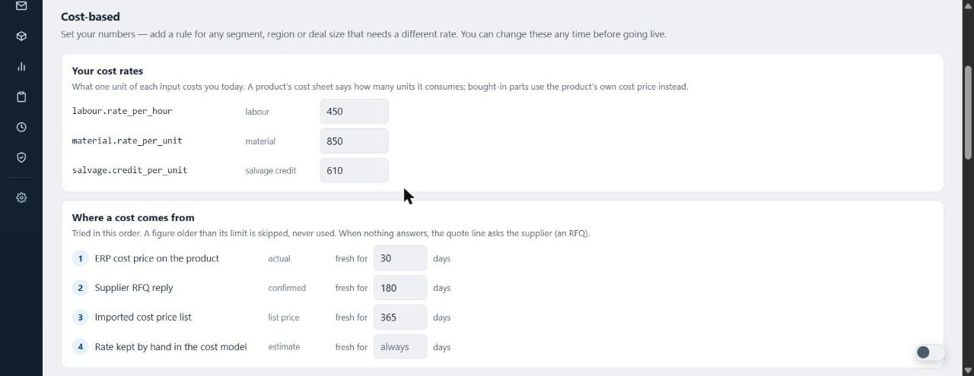
Your cost rates and the start of the source ladder
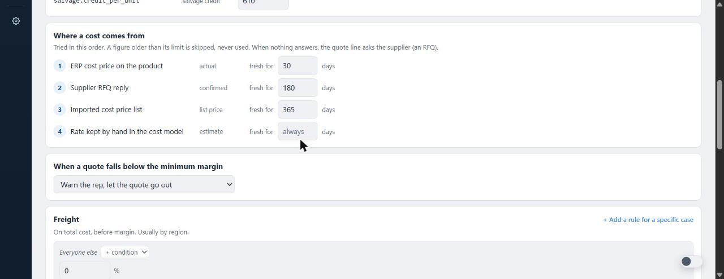
The ladder in full and the floor policy (Warn the rep, let the quote go out)
Freight was set to 4%, handling to 1%, margin 25%, minimum acceptable margin 15%, tax 18%.

3. Sample bill
Continue to sample bill prices one unit of a sample product through the live engine with the numbers just entered. The banner reads the engine's own margin flag.
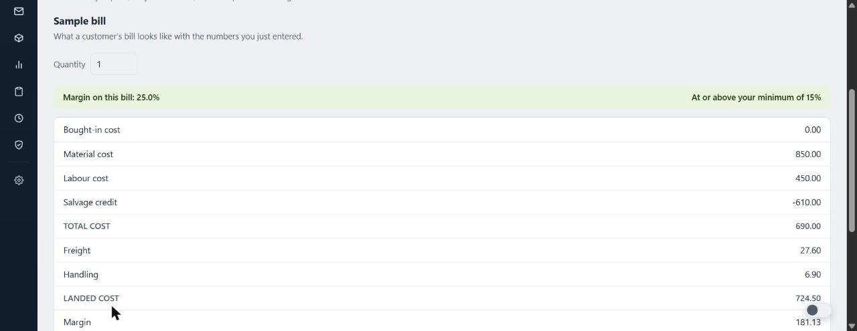
Margin on this bill 25%, at or above the 15% minimum
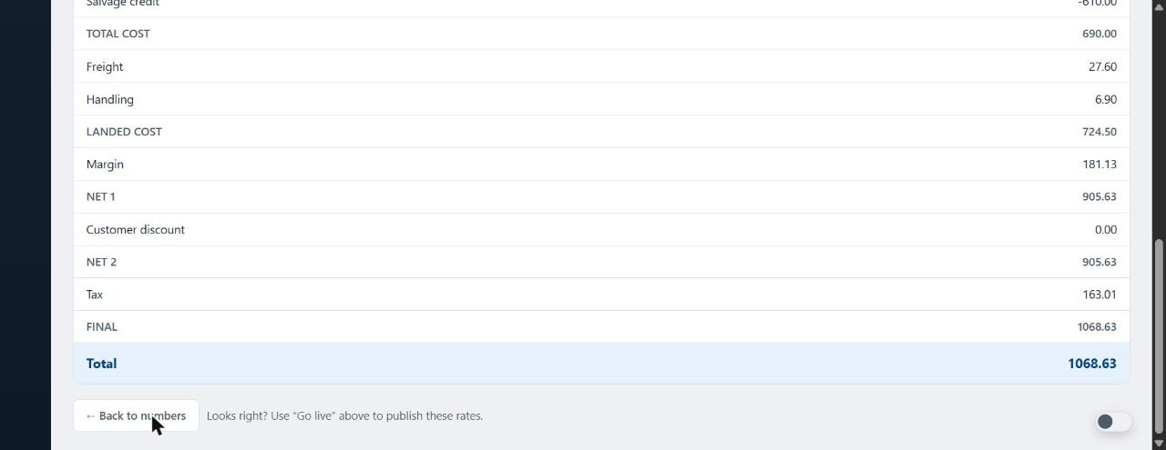
Total cost 690 → landed 724.50 → net 905.63 → tax → 1,068.63

4. Go live
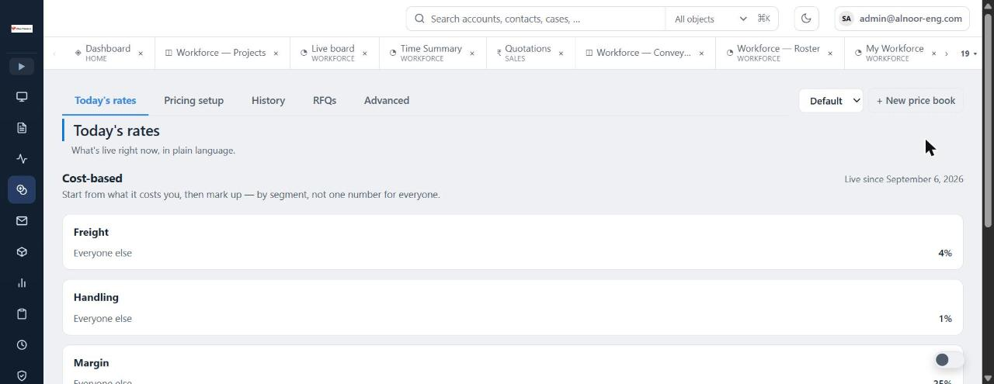
Today's rates after publishing: cost-based, live since 6 September 2026

5. Product cost sheet
A product carries what one unit consumes. PRD-0007 Motor Rewinding 45 kW: 18 units of material, 12 labour hours, 6 units of salvage credit, with the ERP cost price dated 5 September. A product with no sheet is one bought-in part at its cost price.
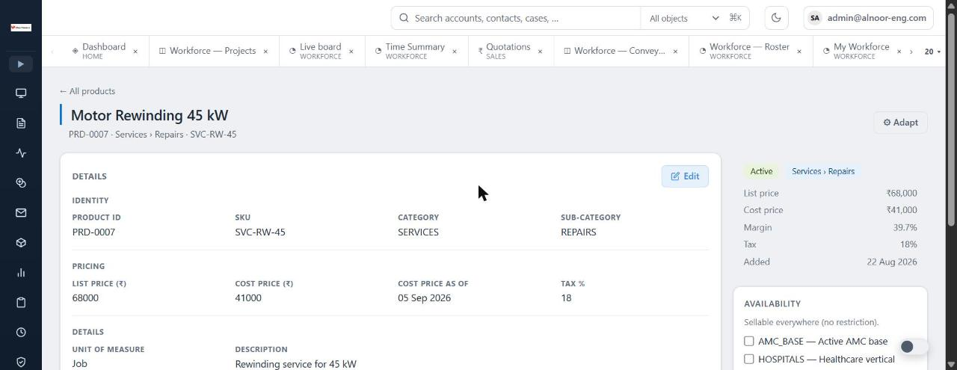
PRD-0007 with cost price and cost price as-of
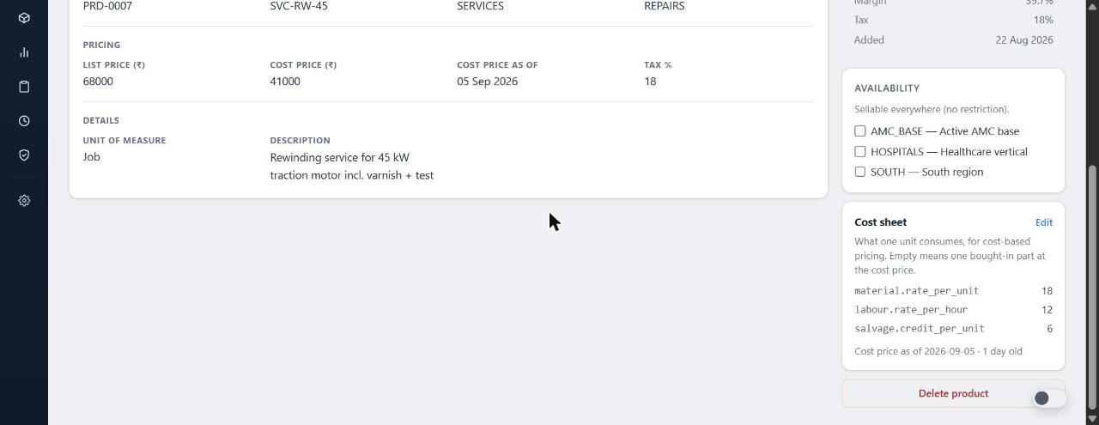
The cost sheet card, one day old

6. The Standard Quote
Sales → Standard Quotes → New, account Demo Motor Company. Each line can name a product; picking one fills the description, unit and list price without overwriting what the rep typed. Price with engine asks the engine for the line and shows the answer under the product.

Line 1 — PRD-0007, a made part
Material 18 × 850 = 15,300, labour 12 × 450 = 5,400, salvage 6 × 610 = −3,660 → total cost 17,040 → landed 17,892 → margin 4,473 → net 22,365 → tax 4,025.70 → 26,390.70.
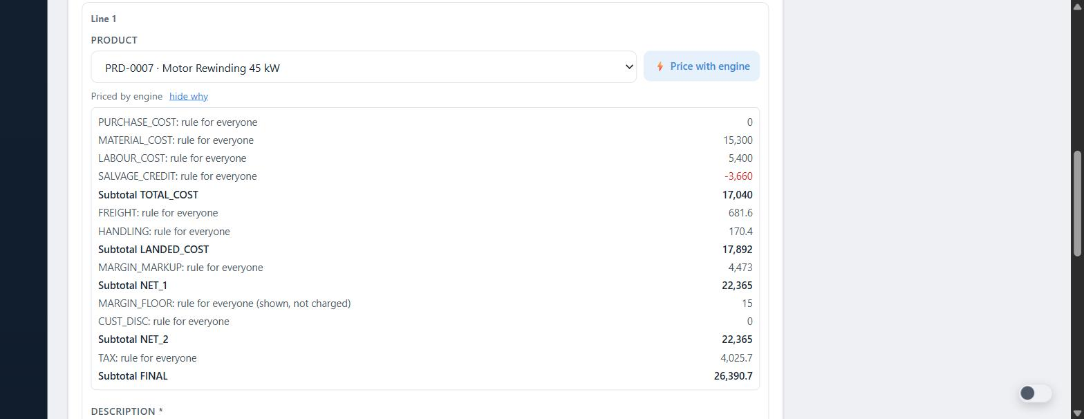
The why trace, opened from the chip under the product
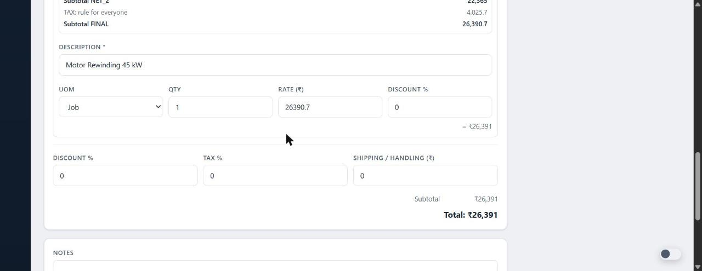
The rate landed on the line: 26,390.70

Line 2 — PRD-0008, bought-in with a fresh ERP cost
The ladder's first rung answered: ERP cost 265,000, three days old, inside the 30-day limit. Landed 278,250, net 347,812.50, final 410,418.75.
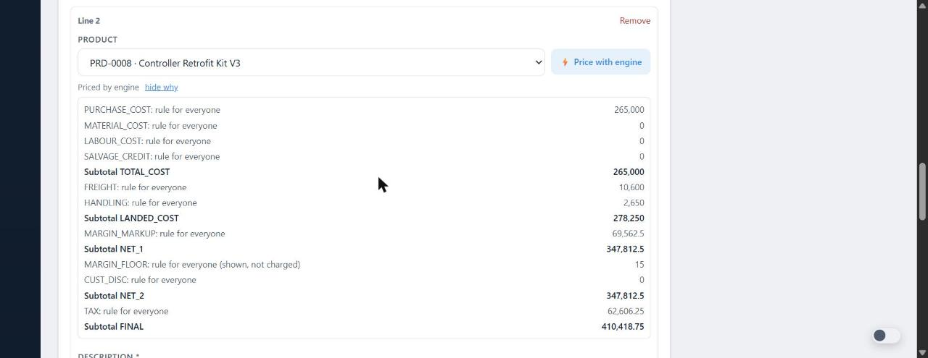
PURCHASE_COST from the product's own ERP figure

Line 3 — PRD-0009, bought-in with a stale ERP cost
The ERP cost is 95 days old, the limit is 30, and no RFQ reply or price list exists, so the engine refused to price it. The line shows what was tried and offers to ask the supplier.
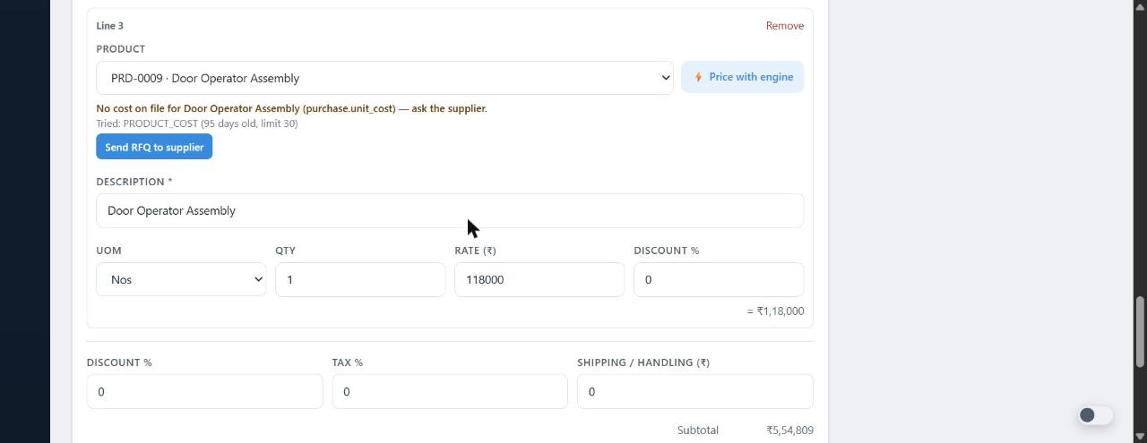
NEEDS RFQ with the ladder's verdict
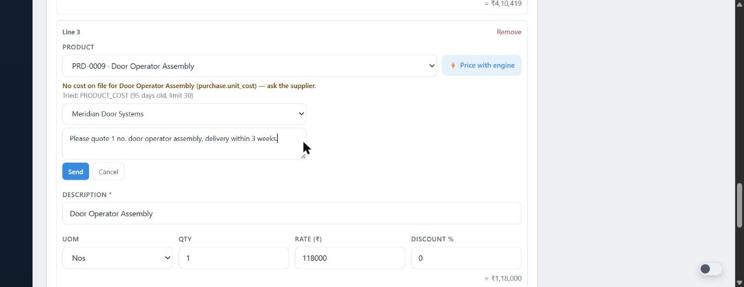
Send RFQ: supplier and a message, inline on the line
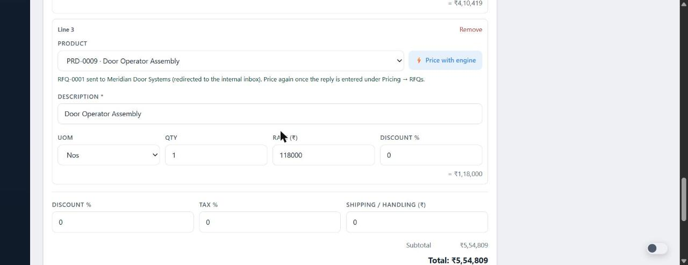
RFQ-0001 sent; the demo workspace redirects it to the internal inbox

Saved
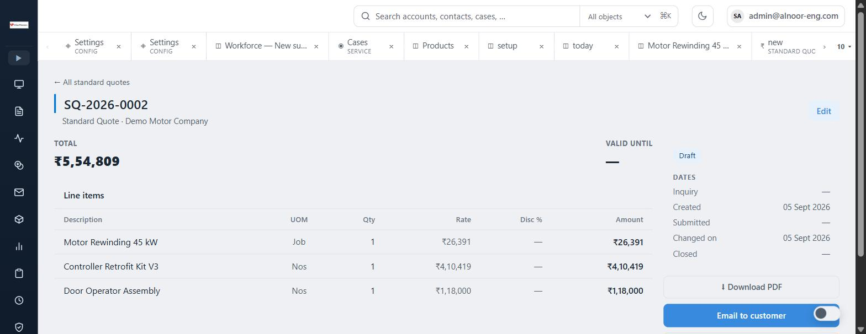
SQ-2026-0002 with the three lines

7. The supplier replies — Pricing → RFQs
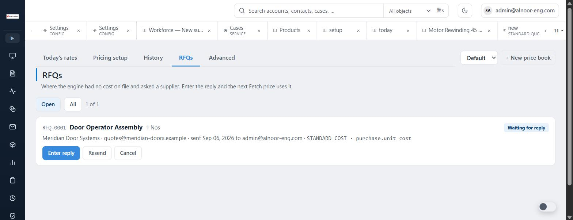
RFQ-0001 waiting for a reply
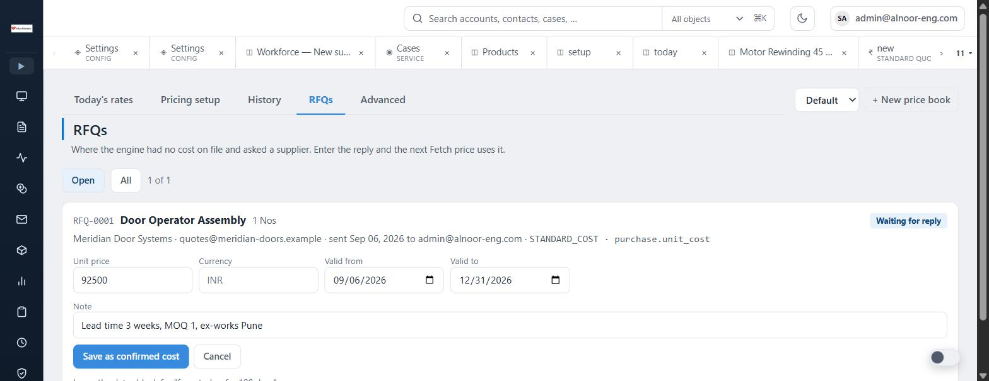
Entering the reply: 92,500 valid 6 Sep to 31 Dec, lead time note
Saving the reply failed on production with a database check constraint (below). The cause is a migration gap, not the engine: the PURCHASE cost kind was added to the engine in 0113 but the table's allowed kinds were never widened. Migration 0115 fixes it; the route now names the migration instead of the raw error.
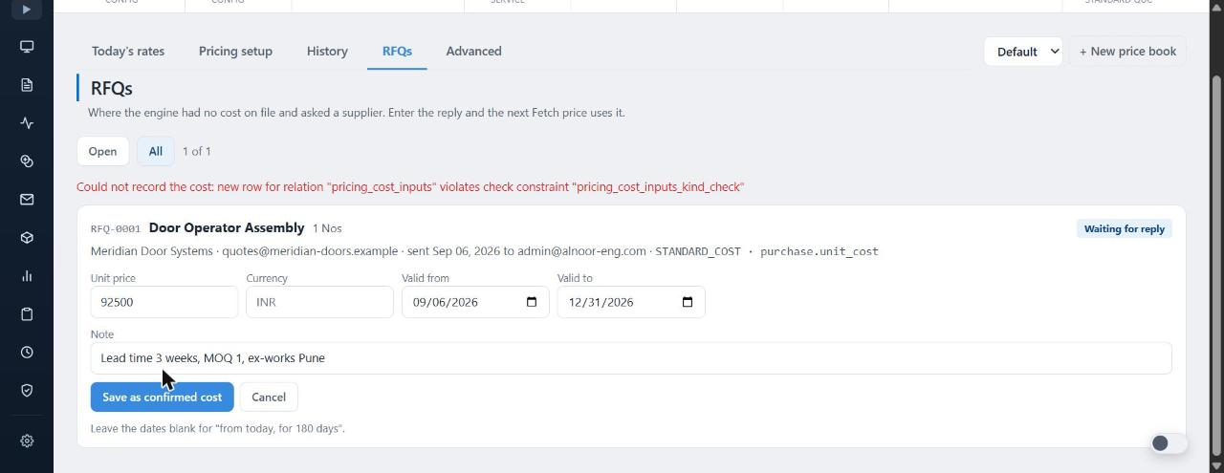
The error as seen on 6 September, before 0115

8. Findings and what is left

Fixed in code, waiting on SQL
- 0115 — RFQ reply cannot be recorded. pricing_cost_inputs rejects kind PURCHASE. Run 0115 on both databases; then the reply saves as a confirmed, product-scoped cost and the next Price with engine on line 3 uses it.
- 0114 — Standard Quote lines. Adds product, pricing document and flags to standard_quote_lines and the back-reference on RFQs. Until applied, a saved Standard Quote drops the product link and the document id, so the send gate on the margin floor and the flag on the detail page cannot fire.

Decision needed
- The engine's rate includes tax. The cost-based procedure ends with TAX → FINAL and the line rate is FINAL ÷ qty (26,390.70 includes 18% tax). Both quote forms also carry their own header Tax %. If a rep sets header tax as well, tax is charged twice. Options: the line takes NET_2 (pre-tax) and the header applies tax, or the procedure's tax step is kept and the form is told to leave header tax at 0. Recommendation: line takes NET_2.

Still to walk once 0114 and 0115 are applied
- Enter the RFQ reply, open SQ-2026-0002 → Edit, Price with engine on line 3: the why chip should show source RFQ, confirmed, dated today.
- Lower the margin below 15% on one line and save: the detail page shows the flag; with the floor policy set to Block, Email to customer refuses with the line named.
- Pricing → Advanced → Test & Trace: the three stored pricing documents with their replay.

Not in scope of this walk
- Price list, value-based and variant techniques follow the same three steps next (spec §17, Batch 1½).
- Approvals for a blocked line (Batch 3).

