KAMCO walkthrough: from tender email to contract project
Snapshot 2026-10-30. The screens after the October redesign. Every step has one picture. A red box and a red number mark where to click; the number matches the step. Pictures are from the KAMCO workspace, on TEST data only.
Labels in bold are exactly as shown on screen. An "i" icon next to a label opens a short explanation: use it instead of guessing.

What changed
Before | Now | Where
Eight tabs and no start or end | One path across the top: Received, Decision, BOQ, Costing, Bid, Submitted, Won or lost, with one Next row | Tender
Several chips always open | One Details row, closed until you open it | Tender
Source, Mk, Rate, Linked | Cost from, Markup %, Rate / unit, Product, each with an "i" | BOQ
"12 lines not priced" pill | The Priced tile: "6 of 12 · 6 to price" | BOQ
Cost could only be set from Costing | Cost / unit and Save cost in the row panel | BOQ
Estimates and RFQs cards | Cost sources, one table | Costing
Price more BOQ rows | Add rows | Costing
Create quote on a tender estimate | Back to Costing (or Back to BOQ line n) | Estimate
Bid email sent outside the tender | Send by email and Sent to client on the Bid tab | Bid
Payment terms typed by hand | Payment terms template chosen on the Bid tab | Bid
Client email outside the system | Interactions tab: one timeline and New email | Tender
One long room, open questions | Room sub-tabs Discussion, Team, Decisions, Documents; open questions removed | Room
Competitor cards | One list (Company, Expected price, Status); click a row for the evidence | Competitors
Suggest from market research | Asks three questions first, then proposes competitors with a source for every fact | Competitors
Project budget made by the system | You allocate it: Allocate by BOQ line or Work package | Contract project
Variations | Client changes | Contract project
Invoicing | Client billing | Contract project
Committed, Actual | Ordered, Spent | Budget, Buy-out
Default margin setting | Margin floor (Settings, Contract projects) | Settings
Handover | Hand over to the ERP | Contract project

A. From the email to a tender
1. Open the Inbox and click the email.
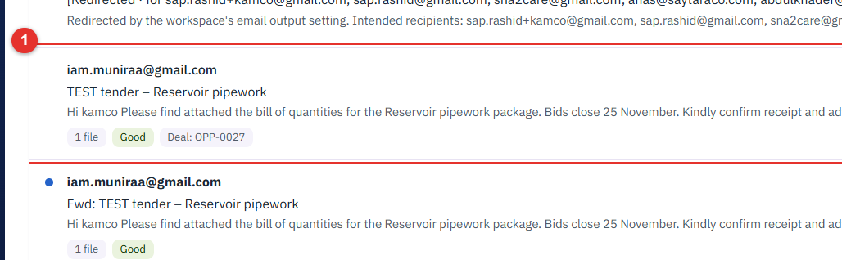
2. Click Create from this email. On a new email it offers what to create (a deal or tender). On this one it is greyed out, because the email already became a deal ("This email became Deal OPP-0027.").
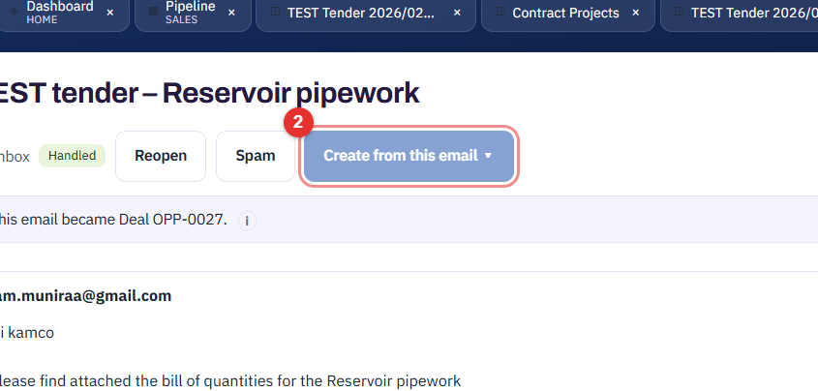
Or start a tender by hand: Pipeline, New tender.
3. In New tender, click Account and choose the issuer's account (required).
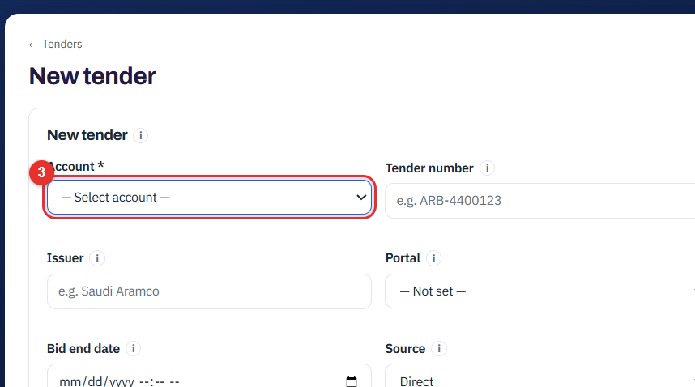
4. Click Tender number and type the client's number.
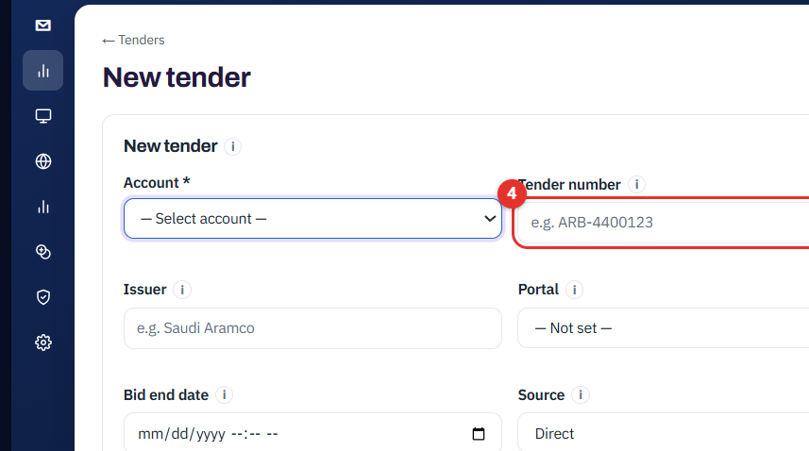
5. Click Save. The tender opens at stage Received.
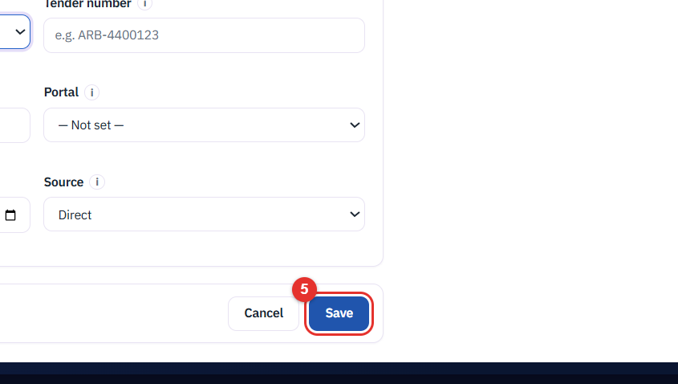

B. The tender screen
6. Read the path across the top. The dark dot is where you are.
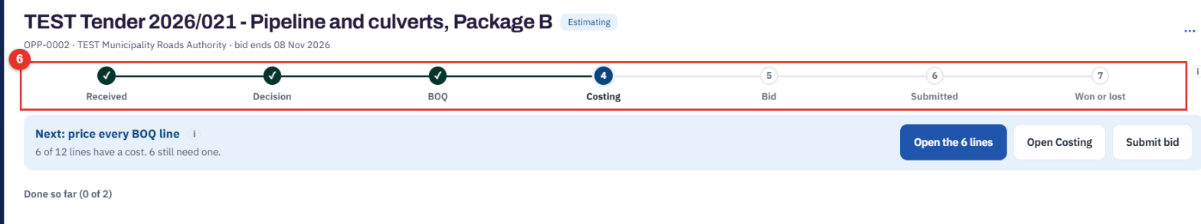
7. The blue Next row says what to do now and gives one main button. Here: Open the 6 lines opens the lines that still need a cost. At stage Received the button is Propose bid decision; an approver then approves it.
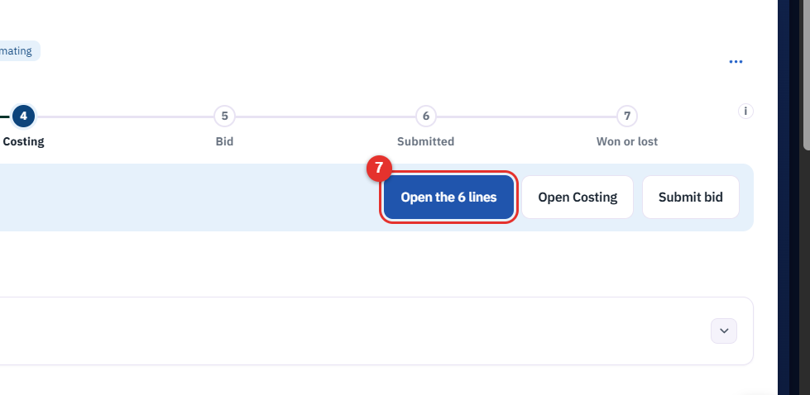
8. Click Details to open the facts: amount, stage, bid decision, bid end date, bid guarantee. It stays closed by default and remembers your choice.
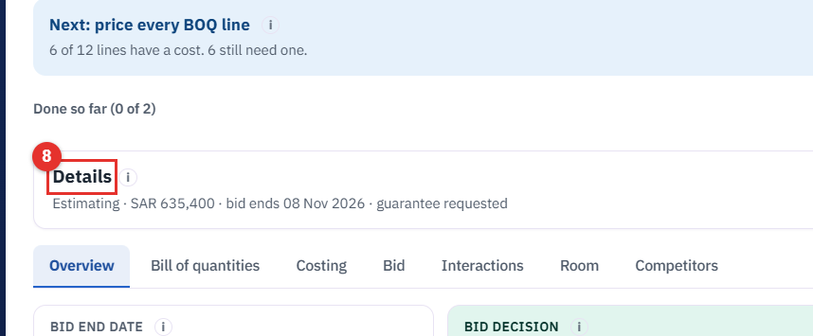
Result:
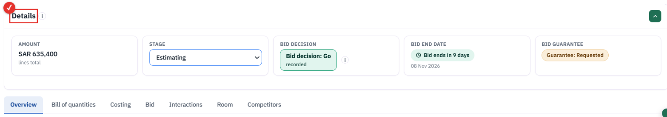

C. Bill of quantities
9. Click Bill of quantities.
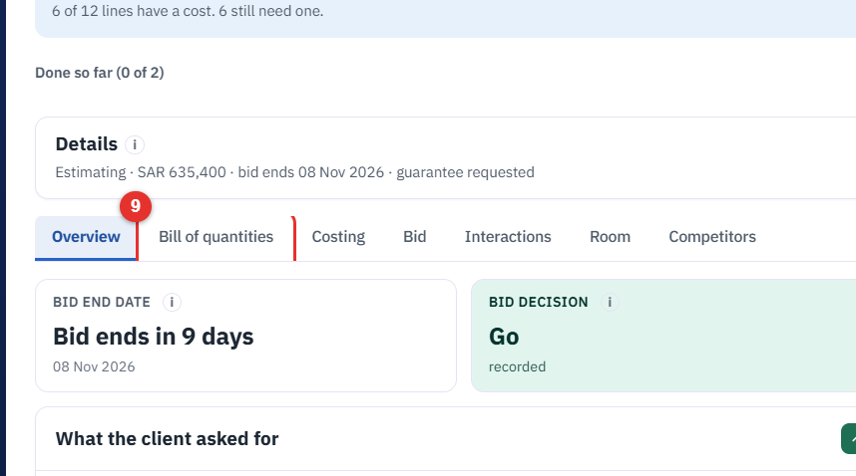
10. Click Upload revised BOQ to load the client's .xlsx. The columns are read for you; check them, then create the lines.
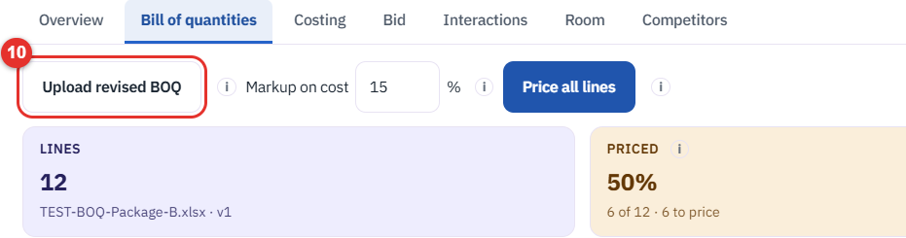
11. Set Markup on cost (%). It is added on the cost to make the rate.
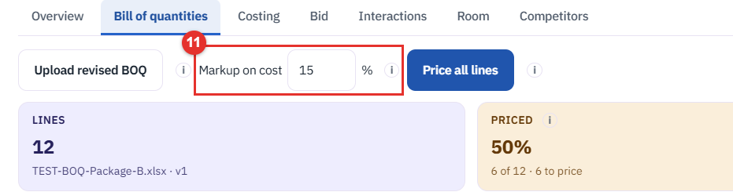
12. Click Price all lines. It uses supplier, then BOM, then past project, fresh prices only.
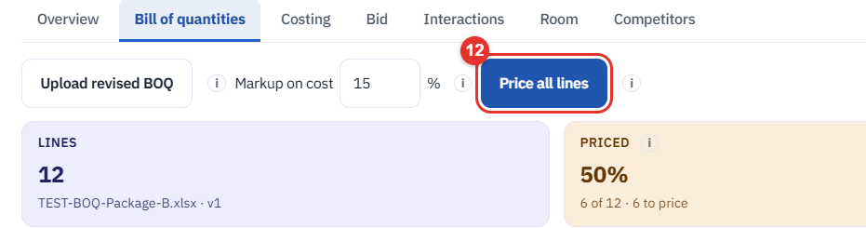
13. Read the Priced tile: "6 of 12 · 6 to price".
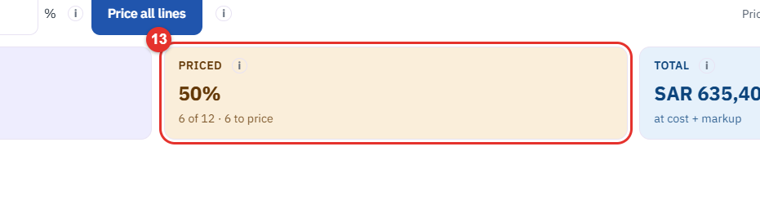
14. Click the "i" beside Cost from to see where a cost came from. Every column head has one.
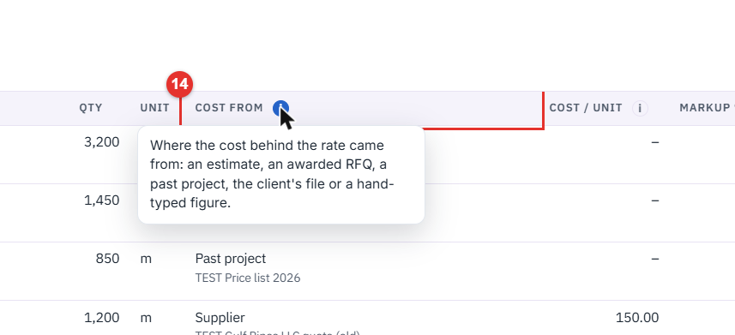
15. Click an item number (here 2.2) to open the row.
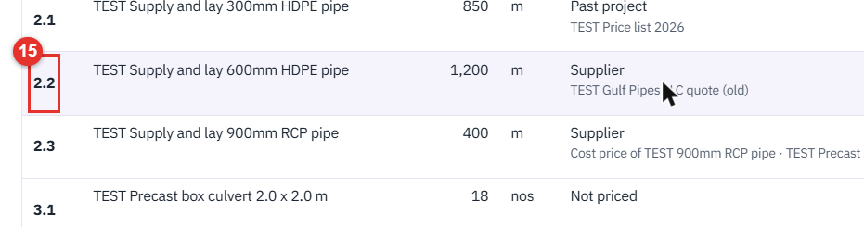
Result: the row panel with Where the cost came from.
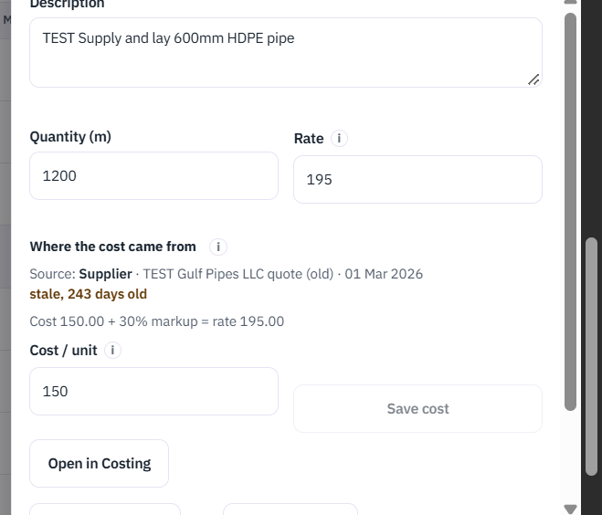
16. In the panel, click Cost / unit and type your own cost.
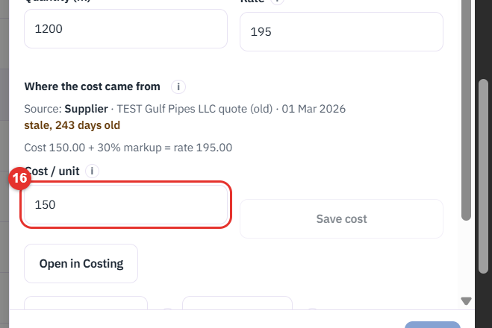
17. Click Save cost. It is saved as Manual and keeps the source it replaced. The button stays grey until the cost changes.
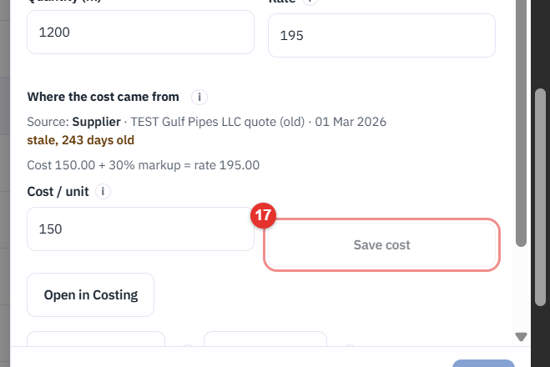

D. Costing, RFQ, estimate, award
18. Click Costing. The four tiles count rows priced, rows that still need a cost, RFQs out and replies in.
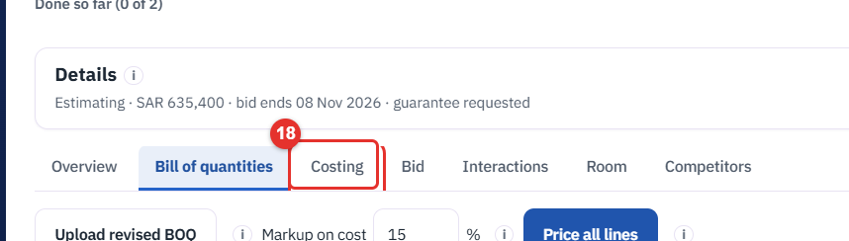
19. Read Cost sources: one table of estimates and RFQs, with the BOQ rows each one prices. Each BOQ row takes its cost from one source.
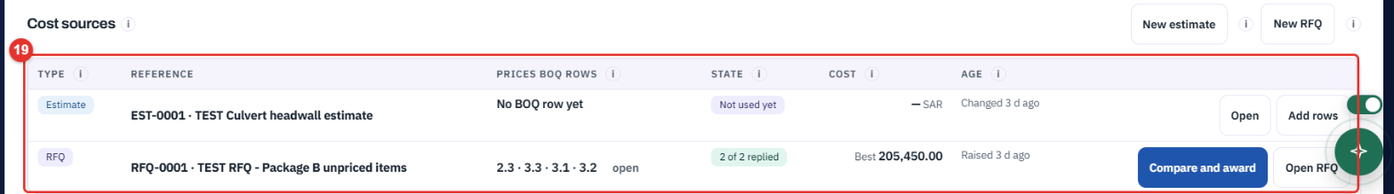
20. Click Add rows to give an estimate more BOQ rows to price.
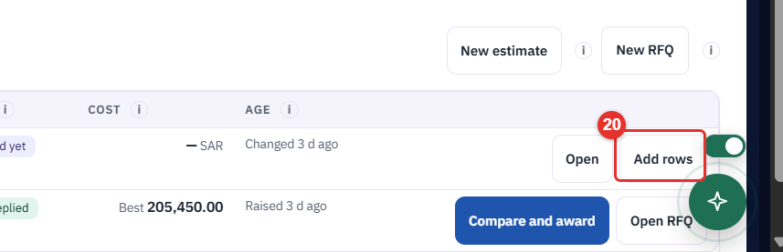
21. On a sent RFQ with replies, click Compare and award.
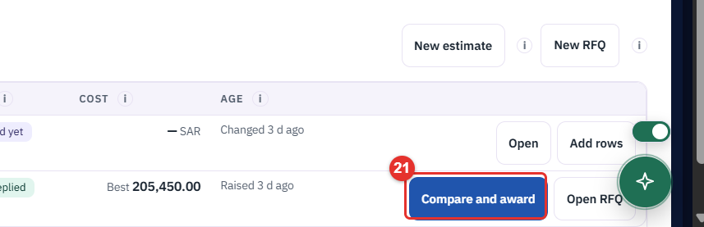
22. Suppliers appear side by side with Lowest valid marked. Award and price on a line writes cost plus markup into the BOQ rate. (Not clicked in this guide.)
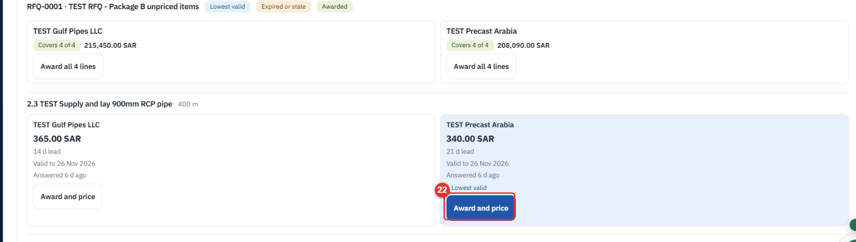
23. For an estimate, click Open.
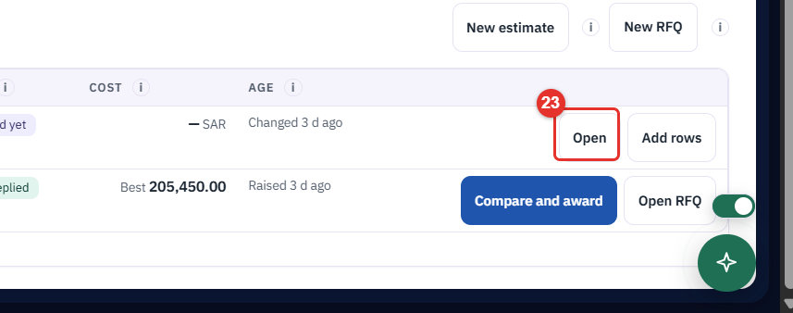
24. The estimate shows its tender at the top. Click Back to Costing to return. When the estimate prices a BOQ row the link reads Back to BOQ line n and the row panel opens. There is no Create quote on a tender estimate.
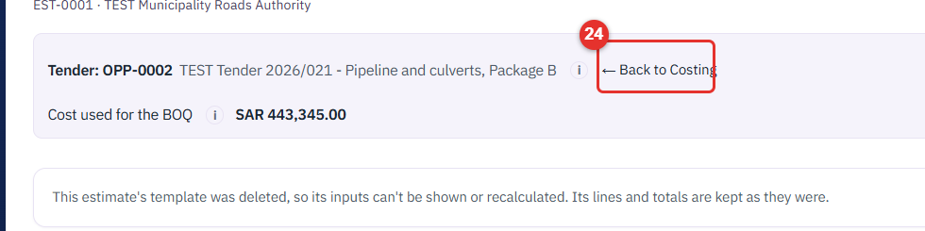

E. The bid
25. Click Bid.
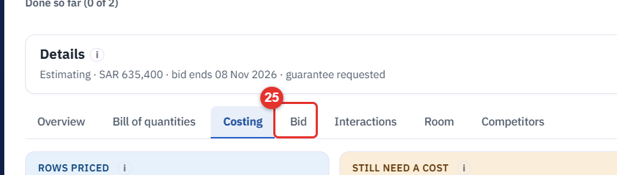
26. Read Before you submit. It lists what is missing: unpriced lines, old prices, no approved go decision, bid guarantee not marked Submitted.
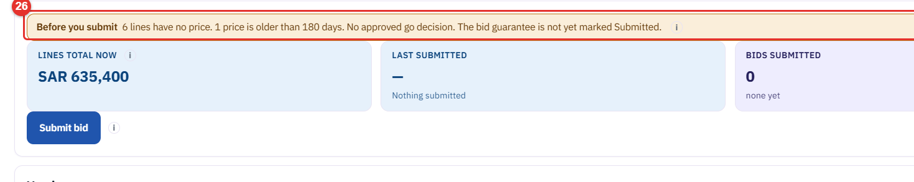
27. Choose Payment terms. The template's milestones show under it. Templates are edited in Settings. The choice prints on the bid documents and is saved on the submitted version.
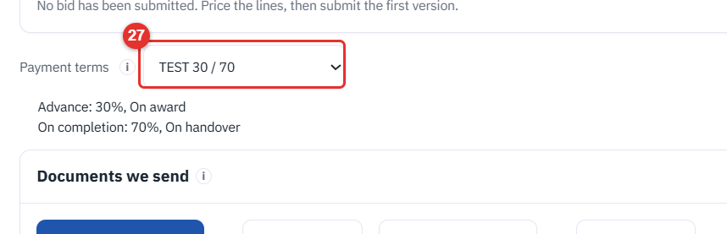
28. Under Documents we send, click Send by email next to Download priced BOQ (or next to Export answer sheet). Costs and markup are never in the file.
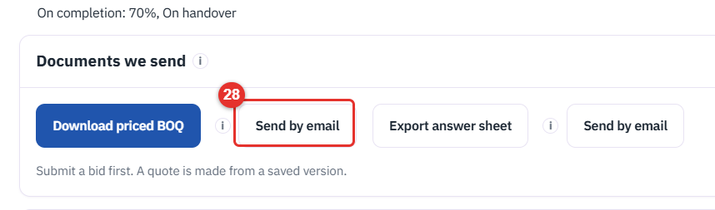
29. In the side panel, click To and type the client's address. Add a Note if you like.
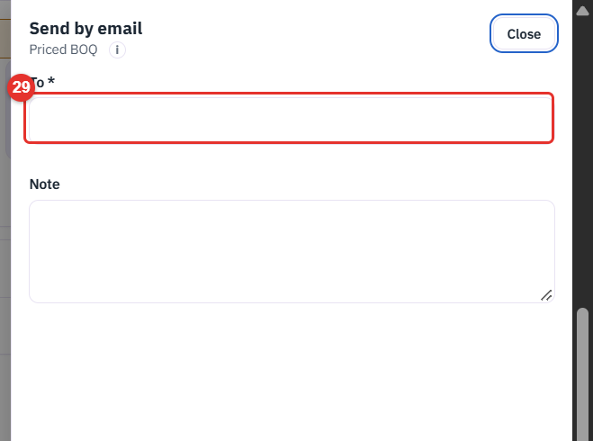
30. Click Send. The mail goes through the tender and is logged under Sent to client and in Outbound emails. (Not clicked in this guide.)
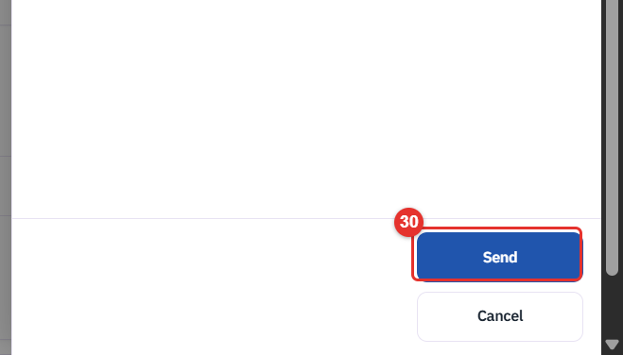
31. For a portal upload or a mail sent elsewhere, click + Record a send under Sent to client. (The panel was not opened in this guide.)
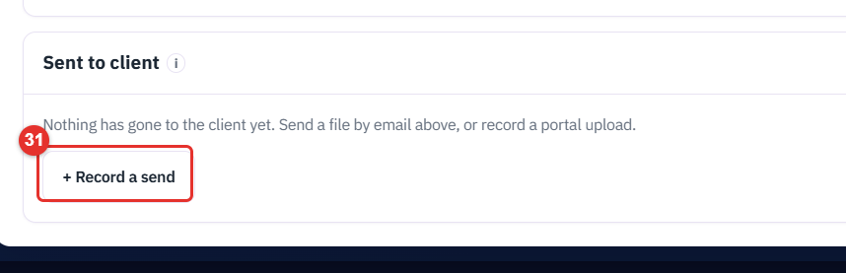
32. Click Submit bid. It saves the lines and total as the next numbered version and moves the tender to Submitted. Cost and markup are never saved in a version. To change a bid later use Revise bid; the next submit is the next version.
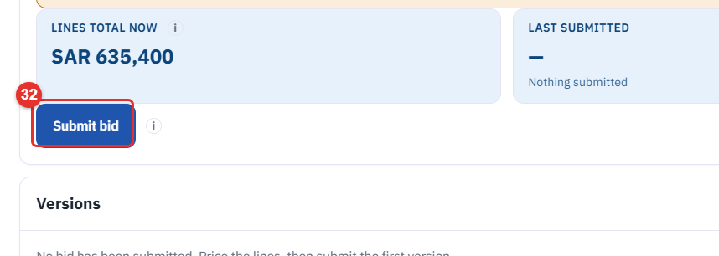

F. Talking to the client and the team
33. Click Interactions.
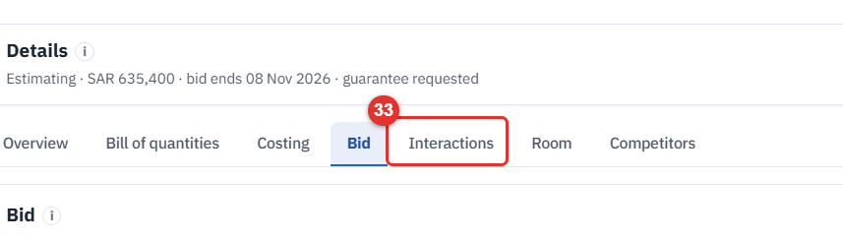
34. Click New email to write to the client from the tender. Sent mail, replies and the source email form one timeline here. This tender has none yet.
35. In the panel, click To, then write the Subject and Message. (Not sent in this guide.)
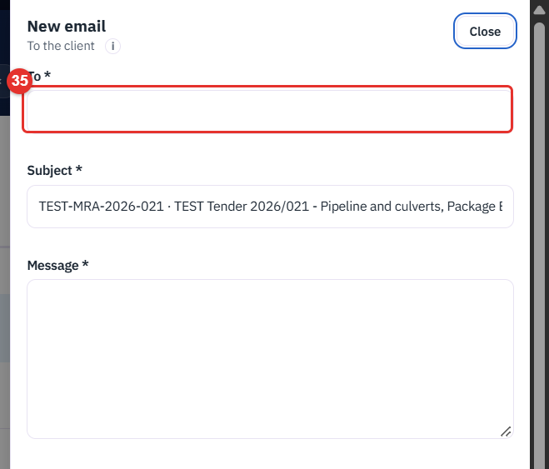
36. Click Room for the internal team room. It is never visible to the client.
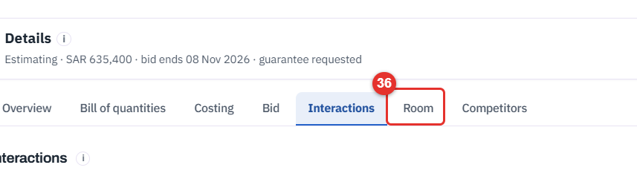
37. The room has four sub-tabs: Discussion, Team, Decisions, Documents.
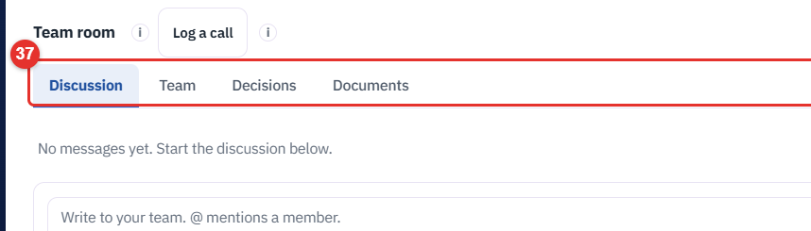
38. Team: who is in the room and Add by name....
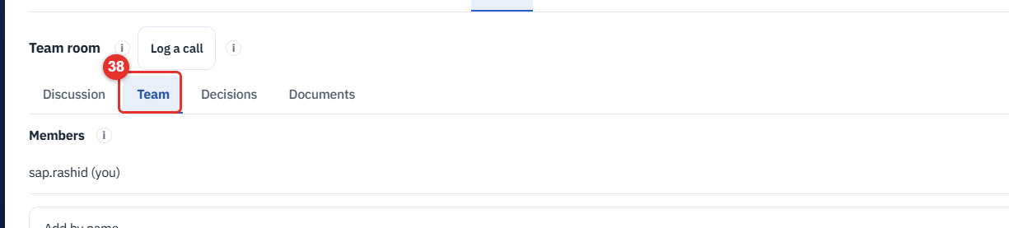
39. Decisions: pin one-line decisions ("Agreed to...").
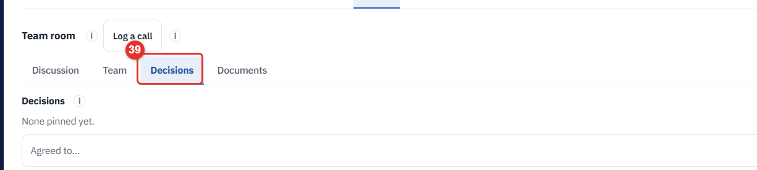
40. Documents: files attached to messages in Discussion.
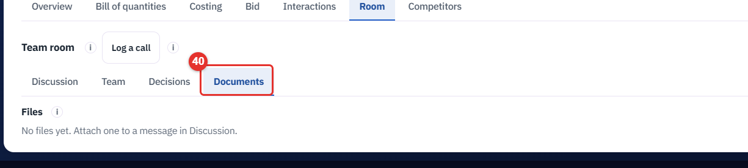

G. Competitors
41. Click Competitors.
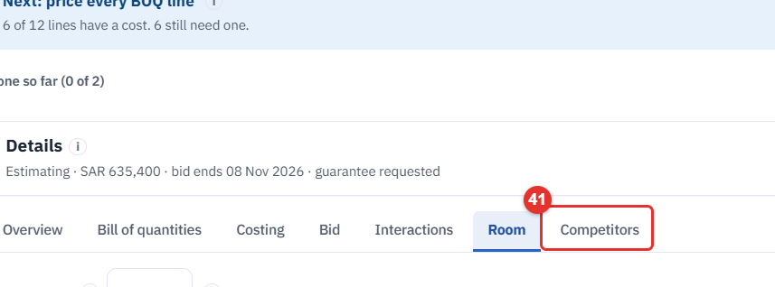
42. Click Add competitor to add one yourself.
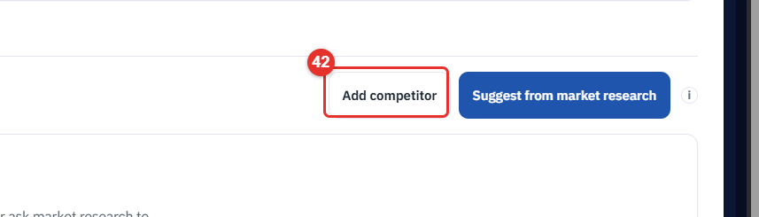
43. Click Suggest from market research for proposals with a source for every fact. It uses part of your AI allowance, so use it once per tender.
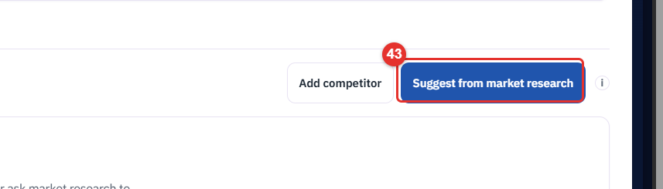
44. It first asks what it needs (supply only or supply and install, region, who issues the tender). Click an answer. Nothing runs until all three are answered.
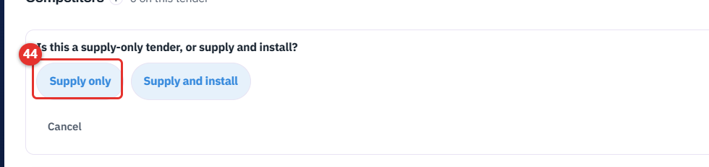
45. The Add competitor panel: Company, Website, Country, Expected price, Strengths, Note, then Save.
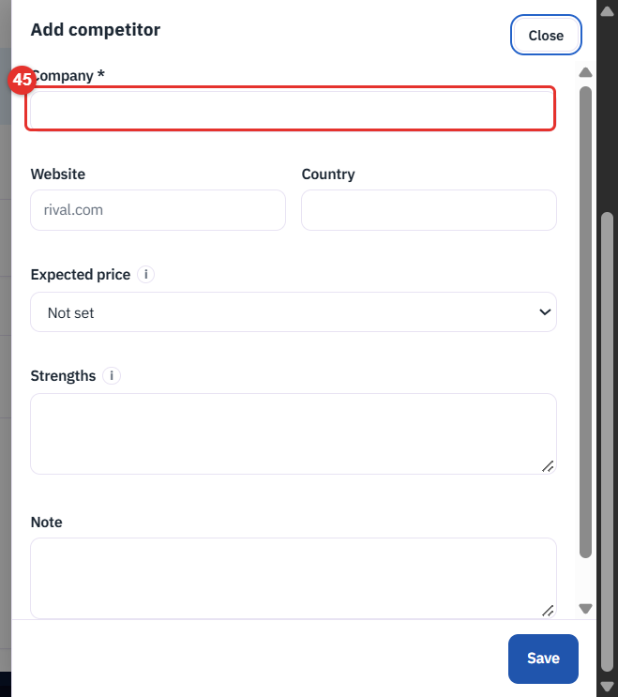
The list shows only Company, Expected price and Status (Proposed or Added by you). Click a row for the evidence, with a link to its source, and for Accept, Reject, Edit and Remove. This tender has no competitors yet, so the list was not captured.

H. The contract project
The project exists only after the tender is won. In the tender, set the outcome to Won; the Next row then offers Create contract project, and later Open contract project.
46. Open Contract Projects and click Open on a project.
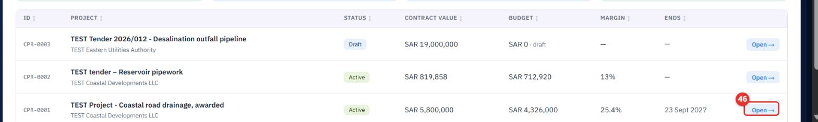
47. Click Tender OPP-0004 (top left) to go back to the tender it came from.
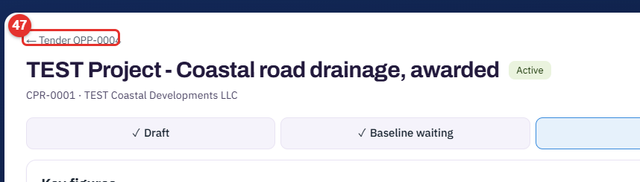
48. Read the project path: Draft, Baseline waiting, Active, Handed over, Closed.
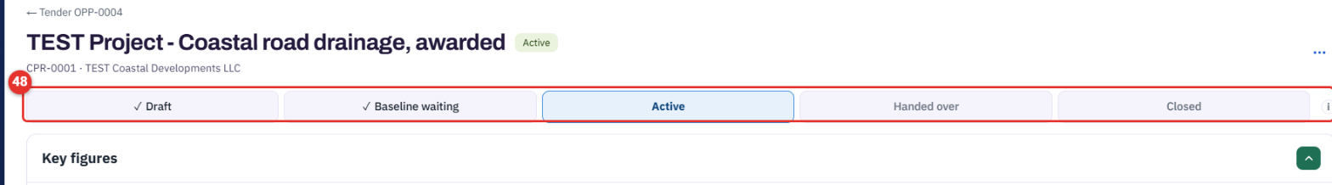
49. Key figures: Contract value, Budget, Planned margin. The section collapses.
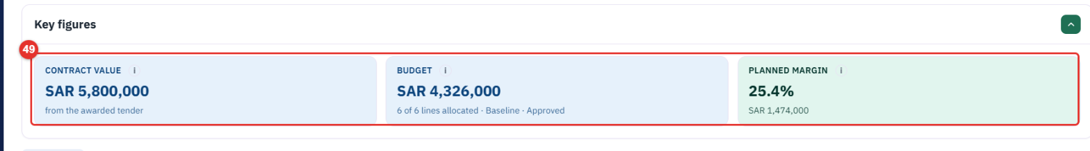
50. Needs you lists what a person must fix, each with a Fix link.
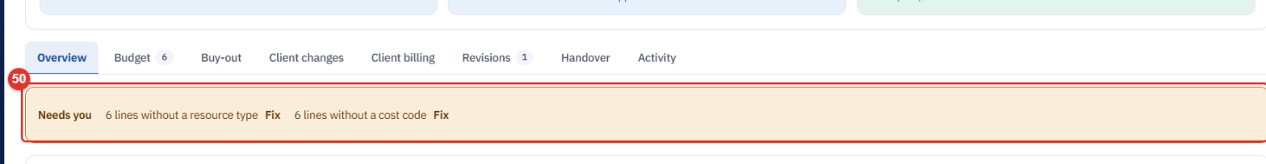
51. Where the budget goes: one bar of the contract value, the budget by cost type, the rest is your margin.
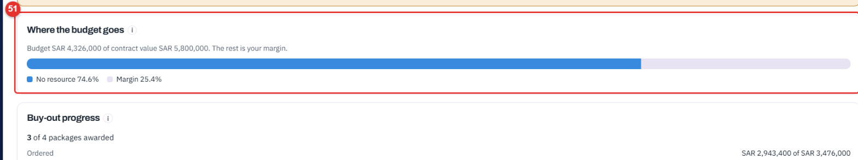
52. Click Budget.
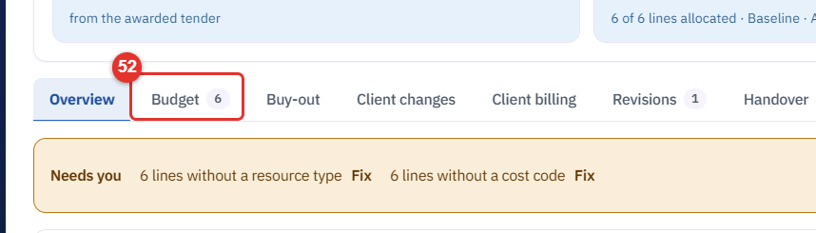
53. Allocate by: BOQ line (type a cost on each line) or Work package (type one cost per package). You can switch until the baseline is approved; switching clears typed costs after a confirmation. Here the baseline is approved, so the choice is locked.
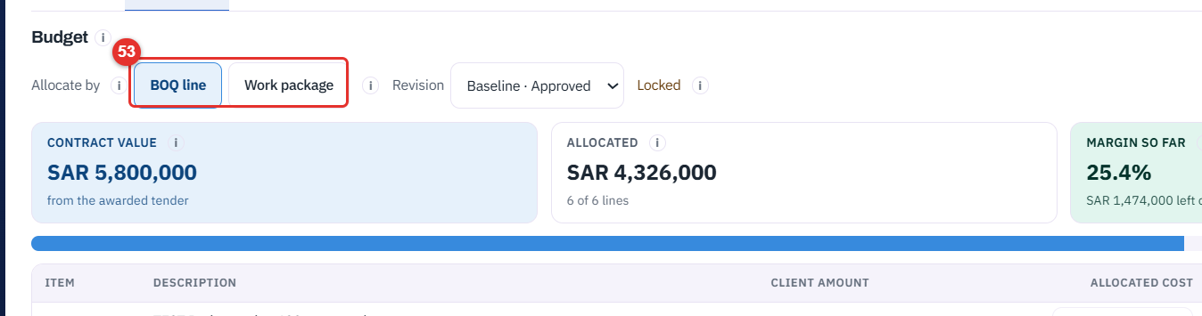
54. Three figures: Contract value, Allocated, Margin so far (contract value less what you allocated, live). It turns amber under the Margin floor and red when over-allocated.
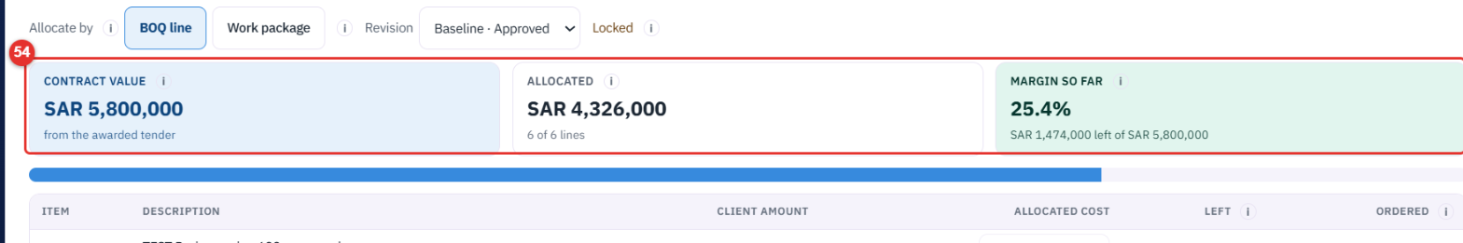
55. In the table, type a cost in Allocated cost for each line. Left is the client's amount less your cost. Fill from tender costs (next to Allocate by) copies the costs recorded on the tender once; it shows only when the project came from a tender with recorded costs.
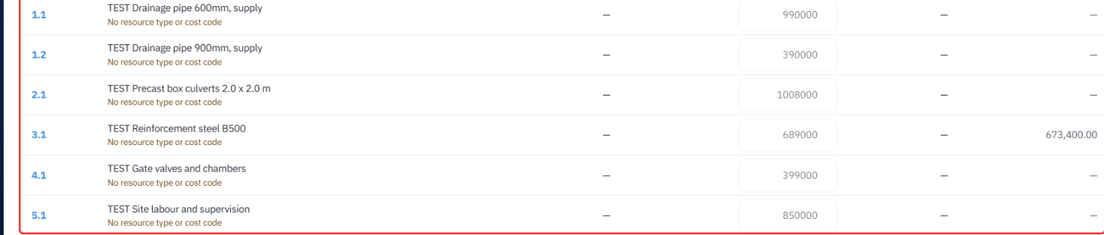
56. Click Work breakdown (WBS) to group BOQ lines into work packages, each with an owner.
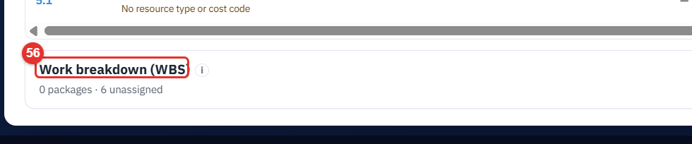
57. New work package (code, name, owner, lines). It is greyed here because the baseline is approved ("Locked"). Unassigned lines are listed in amber.
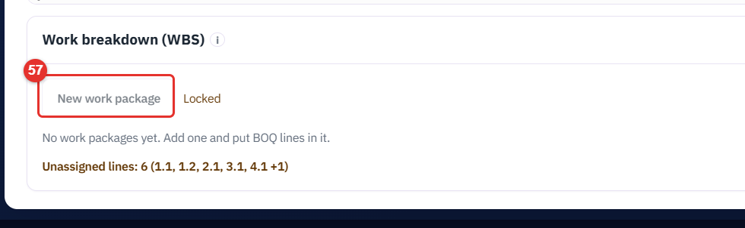
58. Click Buy-out.
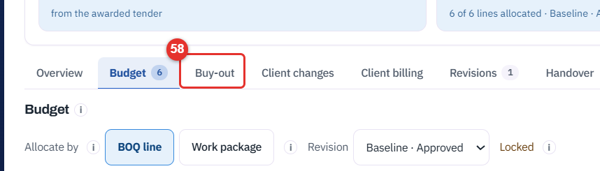
59. Three tiles: Packages, Ordered vs budget, Needs decision.
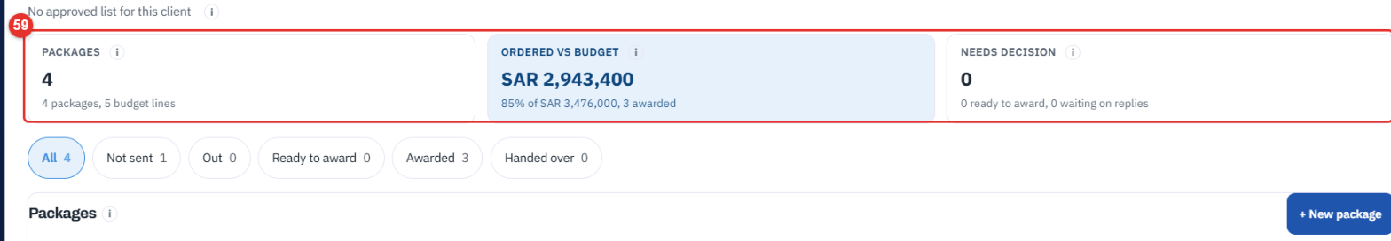
60. One row per package: Budget, Best quote, Ordered, Against budget, Status, ePROMIS.
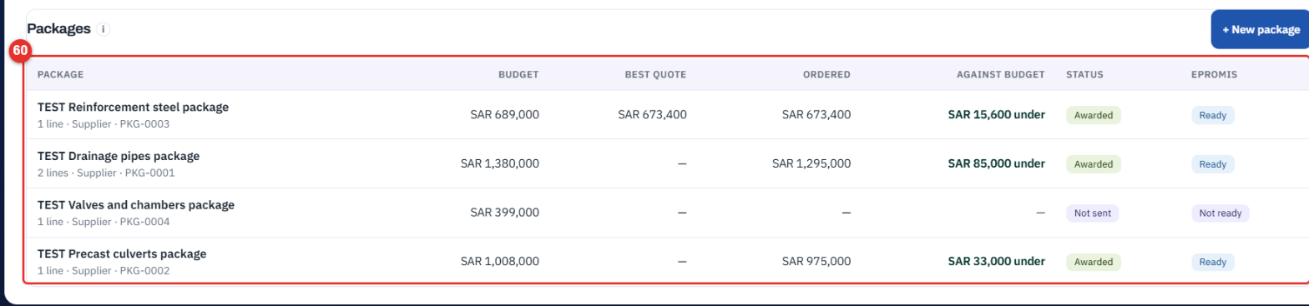
61. Click Client changes.
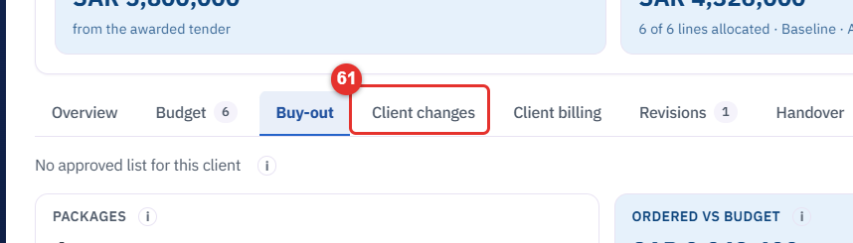
62. Client change orders: changes the client asks for after the award. An approved one moves the contract value and opens a budget revision.
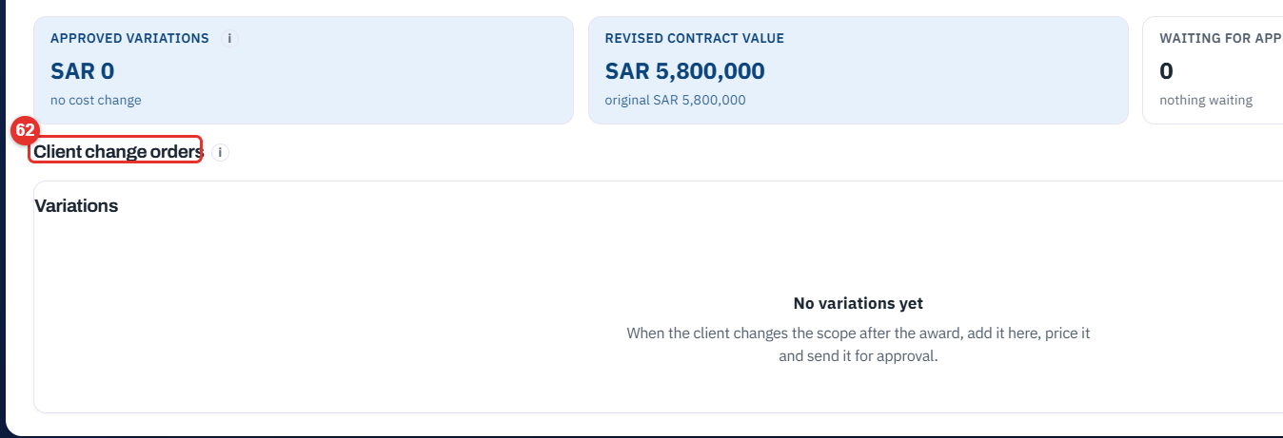
63. Click Client billing.
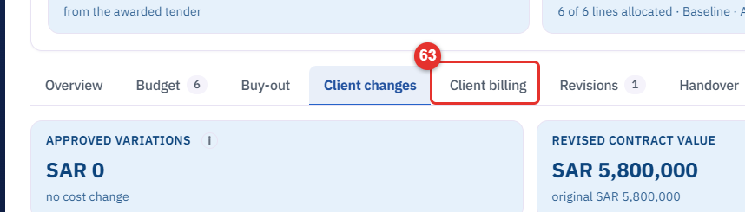
64. Click + Add milestone to build the billing schedule. If the winning bid carried a payment-terms template, Copy the tender's payment terms makes the milestones for you. It shows only when the schedule is empty.
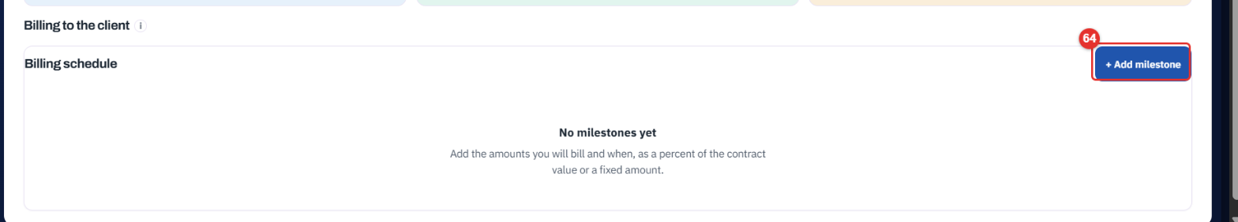
65. Click Handover.
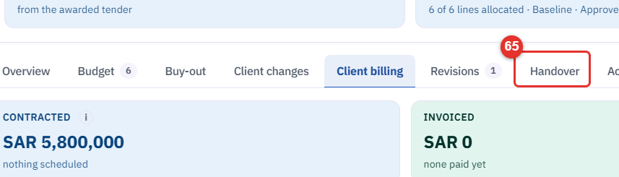
66. Hand over to the ERP: click Download Excel for the budget file.
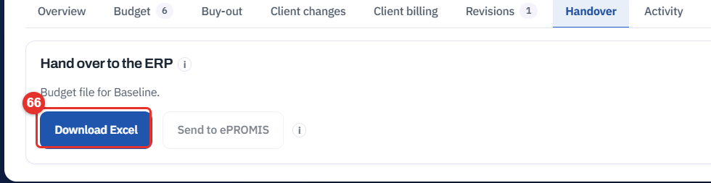

A new project: nothing allocated yet
67. A project made from a won tender starts with the client's contract lines and no costs. Margin so far reads Not allocated yet until you type a cost.
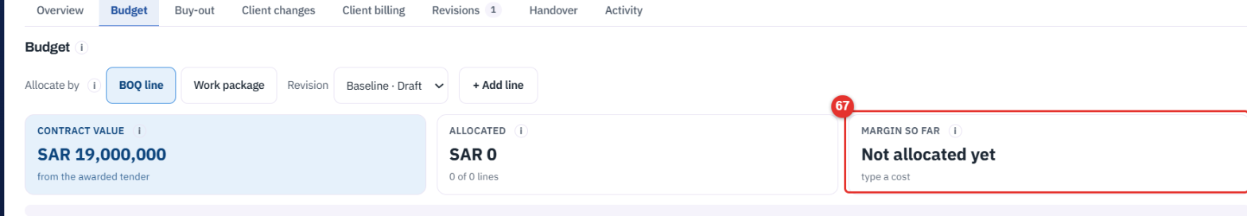

Settings, Contract projects
68. Payment terms: a few templates (name and milestones). Click + New template, or Open one.
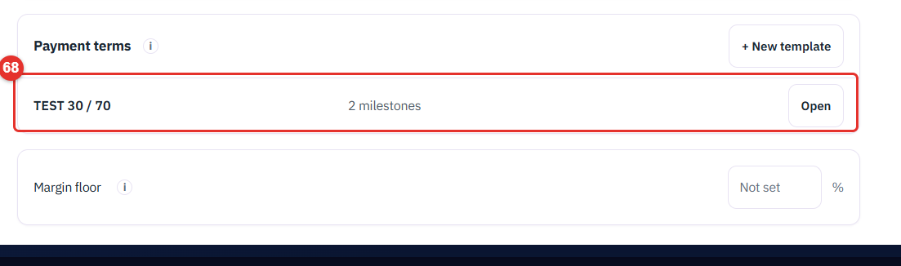
69. Margin floor: the percent under which a project's margin turns amber. It reads Not set until you type one.
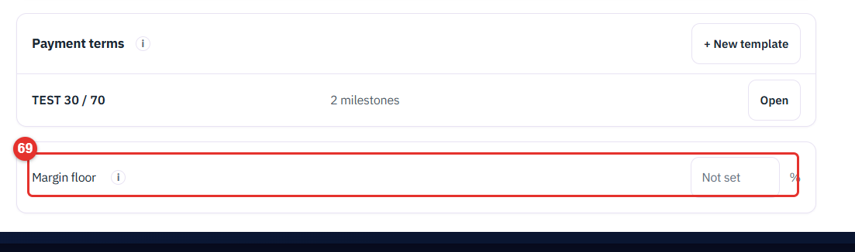

Phone view
On a phone (375 px) each screen is one column. The path scrolls sideways, the Next row stacks its buttons full width, tiles stack, and tables keep their key columns. Tap targets are 44 px.
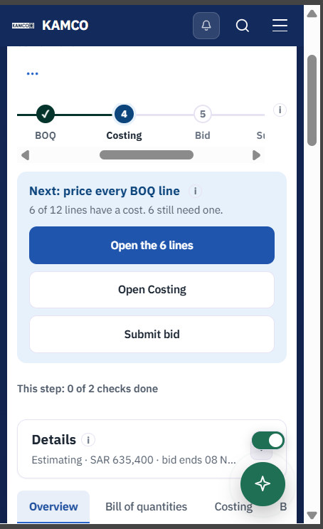
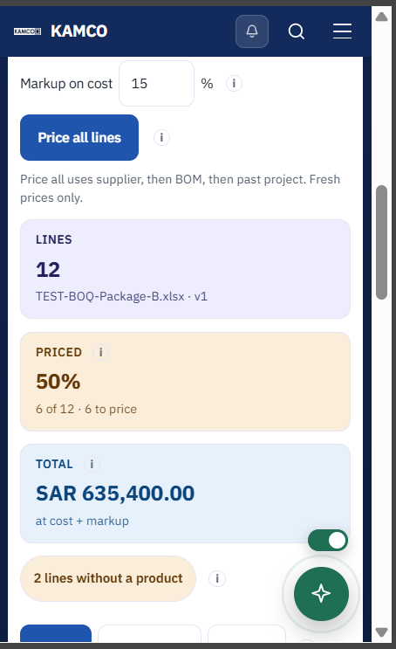
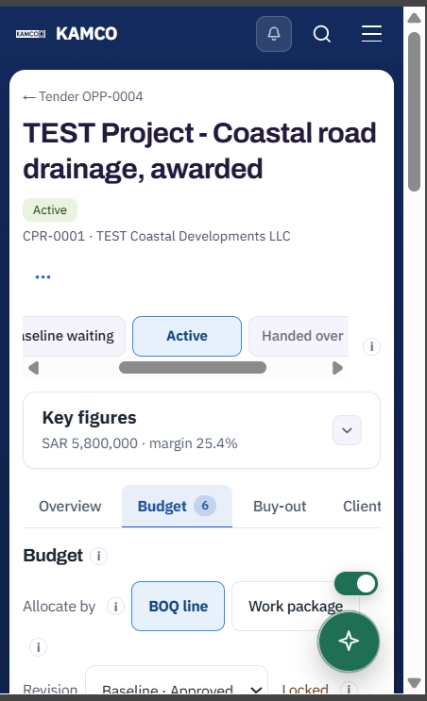

Not shown in this guide
These screens had no data on the capture workspace, or opening them would have changed data: the Propose bid decision panel, the Record a send panel, a competitor list with rows and its evidence panel, an Interactions timeline with mail in it, Fill from tender costs, Work package mode with packages, Copy the tender's payment terms, and a Won tender with its Contract project link.

