OPERATING SYSTEMS LAB
LAB 3 — Navigating the Linux File System & Directory/File Commands
Student Name | Hasnain Ali
Roll Number | F24-0597
Program / Section | BSCS-B
Semester | 5th
Date | 11th October 2026

1. Learning Objectives
- Navigate the Linux file system using the command line (pwd, cd, ls).
- Differentiate between absolute and relative pathnames and use the ".." and "~" shortcuts.
- List directory contents using options such as -l, -a and -h to view detailed, hidden and human-readable information.

2. Theoretical Background
Linux organizes its files in a hierarchical directory structure that looks like an upside-down tree. The topmost directory is the root directory, represented by a single slash (/), and it contains common subdirectories such as bin, dev, etc, home, lib and tmp.
The directory a user is currently standing in is called the current working directory and is displayed with pwd. The ls command lists the contents of a directory, while cd changes the working directory. A pathname can be absolute (starting from /) or relative (starting from the working directory). The ".." operator refers to the parent directory and "~" refers to the user's home directory.

3. Tools & Software Required
- Ubuntu Linux (VirtualBox VM)
- Terminal (Bash shell)
- Commands used: pwd, cd, ls

4. Setup / Installation
No installation is required. All commands used in this lab are built into the Bash shell and the coreutils package, which is pre-installed on Ubuntu. The terminal was opened with Ctrl + Alt + T.

5. Practical Procedure

5.1 Displaying and Changing the Working Directory (Tasks 1–4)
pwd
cd /etc
cd ..
cd /
Screenshot 1 — pwd, cd /etc, cd .. and cd / (navigation)
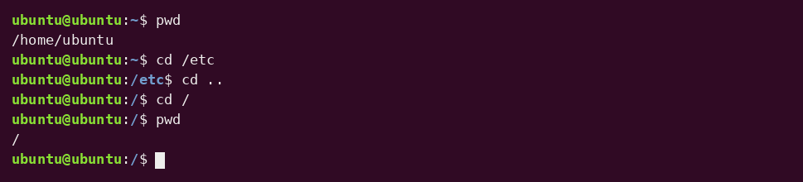

5.2 Listing the Root Directory (Tasks 5–6)
ls
ls -l
Screenshot 2 — Contents of the root directory (ls)
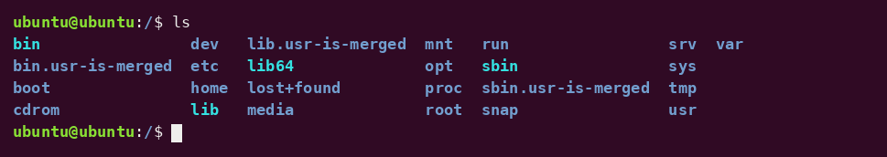

Screenshot 3 — Long listing of the root directory (ls -l)
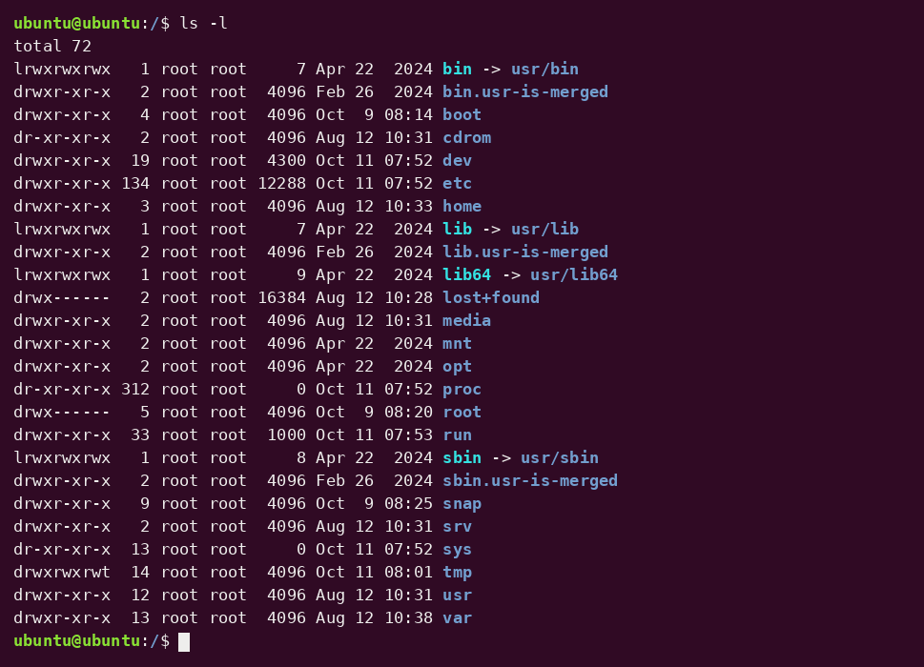

5.3 Listing Other Directories Without Leaving the Current One (Tasks 7–8)
ls /etc
ls /bin /sbin
Screenshot 4 — Contents of /etc
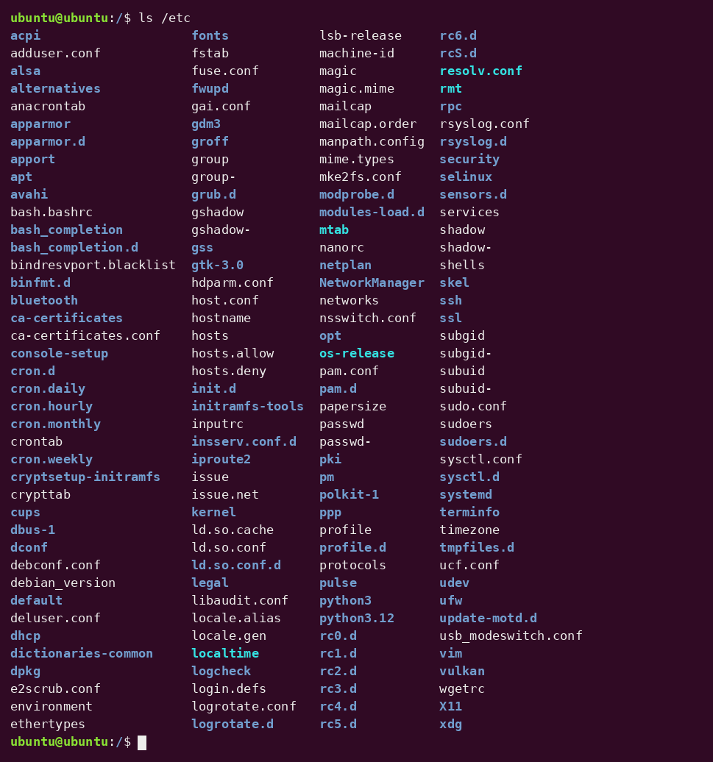

Screenshot 5 — Contents of /bin (ls /bin /sbin)
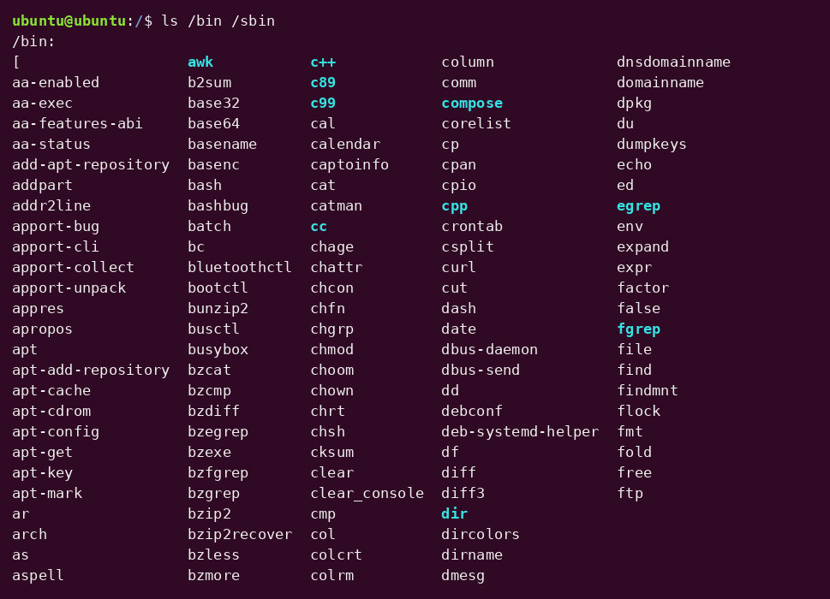

Screenshot 6 — Contents of /sbin (ls /bin /sbin)
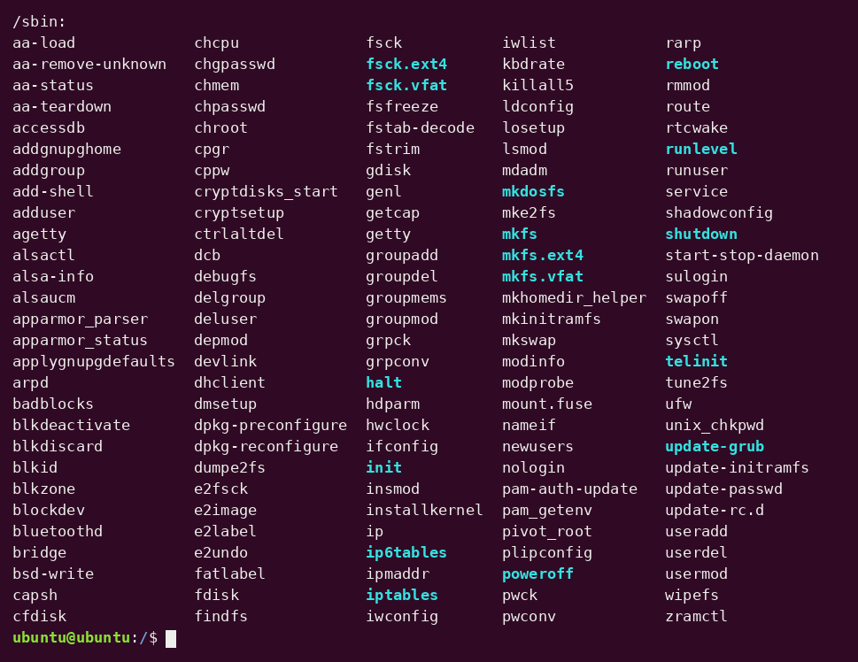

5.4 Listing the Home Directory and Hidden Files (Tasks 9–10)
ls ~
ls -a ~
Screenshot 7 — Home directory listing, with and without hidden files
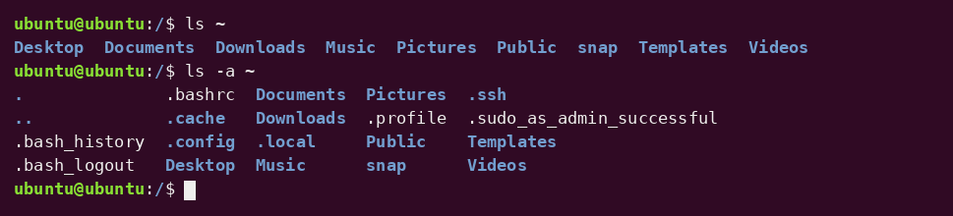

5.5 Human-Readable Listing of /boot (Task 11)
ls -lh /boot
Screenshot 8 — Long listing of /boot with human-readable sizes
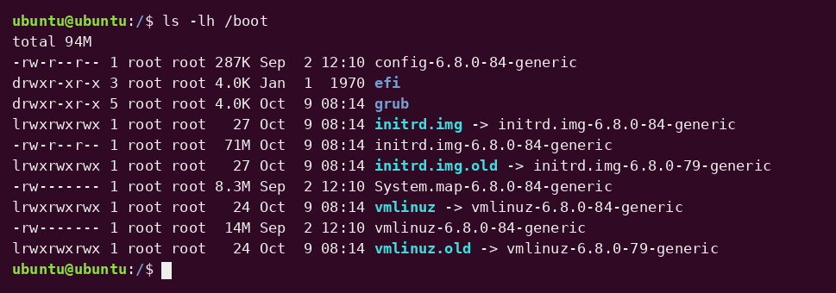

6. Expected Output / Observations
- pwd printed /home/ubuntu in the home directory, and the prompt changed to show /etc and then / as the directory was changed.
- cd .. from /etc moved to the parent directory (/), so the following cd / left the working directory unchanged.
- ls -l displayed permissions, link count, owner, group, size and modification time for each entry in the root directory. Entries such as bin, lib and sbin are symbolic links pointing into /usr.
- Using absolute paths (/etc, /bin, /sbin, ~) allowed directories to be listed without leaving /.
- ls -a ~ revealed hidden files and directories (names starting with a dot) such as .bashrc, .profile and .config, which ls ~ does not show.
- ls -lh /boot showed file sizes in readable units (K, M) instead of raw bytes.

7. Conclusion
This lab introduced the basic commands for navigating the Linux file system from the command line. Using pwd, cd and ls with the options -l, -a and -h, together with absolute and relative pathnames and the ".." and "~" shortcuts, made it possible to move around and inspect the directory tree efficiently. These skills are the foundation for the file and directory management commands and I/O redirection covered in later labs.
— End of Lab 3 —

