CHEMISTRY

- The Mole Concept

MOLE
- The mole is an SI unit used to measure the amount of any substance.
- The abbreviation for mole is mol.
- One mole is exactly 6.02214076×1023 particles.

That number of particles is Avogadro's number, which is roughly 6.02x10²³. A mole of carbon atoms is 6.02x10²³ carbon atoms. A mole of chemistry teachers is 6.02x10²³ chemistry teachers. It's a lot easier to write the word 'mole' than to write '6.02x10²³' anytime you want to refer to a large number of things.

The mole was first conceptualized by Amedeo Avogadro in 1811, with its formal adoption and numerical definition developed later through the work of several scientists.
MOLAR MASS
- Molar mass is simply the mass (g) of one mole of a substance, expressed in g/mol.
Molar mass of an element  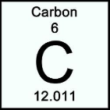  - equal to the atomic weight of the element.  - the atomic weight of carbon is 12.011 or 12. Hence, the molar mass (the mass of one mole of carbon) is 12 g/mol. | Molar mass of a compound  - calculated by summing up the atomic masses of all the elements in the compound’s formula.  - the molar mass of CO₂  C= 1 * 12= 12  O= 2 * 16= 32  (numbers in red font were taken from the subscript of the element)  12+ 32= 44  Hence, the molar mass of carbon dioxide (CO₂) is 44 g/mol. This means that the mass of 1 mole of carbon is 44 grams.
GRAMS TO MOLES AND MOLES TO GRAMS
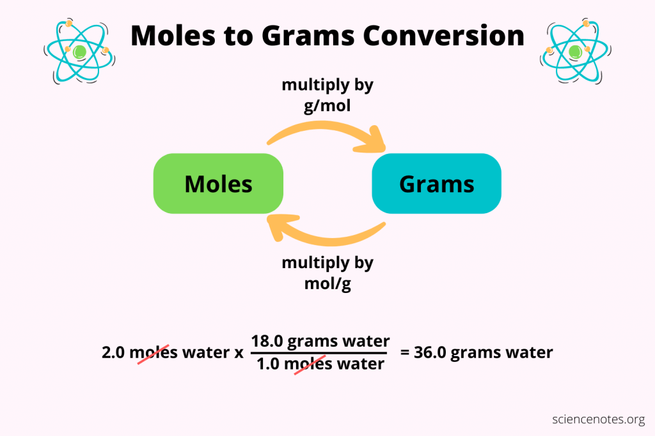
Sample Problem 01:

How many moles are there in 30 g of NaCl?

(What is asked: number of moles
What is given: 30 g of NaCl
Hence, we will convert from the given which is in grams to what is asked which is in moles. But we need to get first the molar mass of the given compound)

Solution:

Molar mass of NaCl Grams to mole

Na= 1 * 23= 23 30 g NaCl × $\frac{1 mol}{58 g}$ = 0.52 mol
Cl= 1 * 35= 35
23+35= 58 g/mol

Sample Problem 02

What is the mass in grams of 3 moles of NaCl?

(What is asked: mass in grams
What is given: 3 moles of NaCl
Hence, we will convert from the given which is in moles to what is asked which is in grams. The molar mass of NaCl, as computed from the previous problem, is 58 g/mol)

Mole to grams

3 moles NaCl × $\frac{58 g}{1 mol}$ = 174 g

(put in the numerator the unit you are trying to find)
MOLARITY | MOLALITY
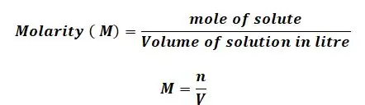  - the number of moles of solute per liter of solution  Sample Problem  A student dissolves 5.85 grams of sodium chloride (NaCl) in water and dilutes the solution to a total volume of 500 mL.  Question:  What is the molarity (M) of the NaCl solution?  Given:  - Mass of NaCl = 5.85 g  - Molar mass of NaCl = 58.5 g/mol  - Volume of solution = 500 mL = 0.5 L  Solution:  - Find the number of moles of NaCl  $$\text{moles}=\frac{\text{mass}}{\text{molar mass}} \\ \text{moles}=\frac{5.85}{58.5}=0.1\text{ mol}$$  - Use the molarity formula  $$M=\frac{\text{moles of solute}}{\text{liters of solution}} \\ M=\frac{0.1}{0.5} \\ M=0.20 M$$  Final Answer: The molarity of the NaCl solution is 0.20 M. | 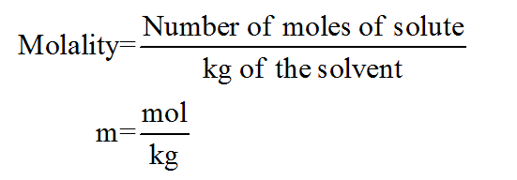  - The number of moles of solute per kilograms of a solution  Sample Problem  A chemist dissolves 11.7 grams of sodium chloride (NaCl) in 200 grams of water.  Question:  What is the molality (m) of the solution?  Given:  - Mass of NaCl = 11.7 g  - Molar mass of NaCl = 58.5 g/mol  - Mass of solvent (water) = 200 g = 0.200 kg  Solution:  - Find the number of moles of NaCl  $$\text{moles}=\frac{\text{mass}}{\text{molar mass}} \\ \text{moles}=\frac{11.7}{58.5}=0.2\text{ mol}$$  - Use the molality formula  $$m=\frac{\text{moles of solute}}{\text{kilograms of solvent}} \\ m=\frac{0.2}{0.200} \\ m=1.0 m$$  Final Answer: The molality of the NaCl solution is 1.0 m.

TEST YOURSELF

Direction. Read and analyze each question. Choose the letter of the best answer. Encircle the letter of your answer.

  - One mole of any substance contains approximately how many particles?
A. 6.02 × 10²
B. 6.02 × 10¹²
C. 6.02 × 10²³
D. 6.02 × 10³³

  - Why do chemists use the mole as a unit in measuring substances?
A. To measure the temperature of substances
B. To count extremely small particles in a practical way
C. To measure the volume of gases only
D. To determine the color of substances

  - A student needs 1 mole of carbon (C). If the molar mass of carbon is 12 g/mol, how many grams are needed?
A. 1 g
B. 6 g
C. 12 g
D. 24 g

  - If the molar mass of water (H₂O) is 18 g/mol, what does this mean?
A. One mole of water weighs 18 grams
B. Water contains 18 molecules
C. Water has 18 atoms
D. One gram of water contains 18 moles

  - What is the molar mass of calcium carbonate (CaCO₃)?
(Ca = 40 g/mol, C = 12 g/mol, O = 16 g/mol)
A. 56 g/mol
B. 84 g/mol
C. 100 g/mol
D. 116 g/mol

  - A chemist has 197 grams of gold (Au). The molar mass of gold is 197 g/mol. How many moles of gold does the chemist have?
A. 0.50 mol
B. 1.0 mol
C. 2.0 mol
D. 197 mol

  - A silversmith has 10 grams of silver (Ag). The molar mass of silver is 107.87 g/mol. Calculate how many moles of silver are in the sample.
Then, determine approximately how many silver atoms are in the sample.
Use Avogadro’s number 6.022×10^23atoms/mol.)
A. 0.093 mol; $5.60×{10}^{22}$atoms
B. 0.093 mol; $5.60×{10}^{23}$atoms
C. 0.10 mol; $6.02×{10}^{22}$atoms
D. 0.10 mol; $6.02×{10}^{23}$atoms

  - A chemist needs 0.25 moles of gold (Au) for an experiment. The molar mass of gold is 197 g/mol. How many grams of gold should the chemist use?
A. 24.6 g
B. 49.3 g
C. 98.5 g
D. 197 g

  - A student dissolves 10 grams of NaOH (molar mass = 40 g/mol) in 500 mL of water. What is the molarity of the solution?
A. 0.25 M
B. 0.50 M
C. 0.20 M
D. 0.40 M

  - A solution is prepared by dissolving 20 g of KBr (molar mass = 119 g/mol) in 250 g of water. What is the molality?
A. 0.67 m
B. 0.75 m
C. 1.50 m
D. 0.50 m

ANSWER KEY

Step 1: Write the formula for converting grams to moles
$$\text{moles}=\frac{\text{mass of substance (g)}}{\text{molar mass (g/mol)}}$$
Step 2: Substitute the values
$$\text{moles of Au}=\frac{197 \text{g}}{197 \text{g/mol}} \\ \text{moles of Au}=1.0 \text{mol}$$
✅ Answer: B. 1.0 mol

Solution (for answer key):
Step 1 – Convert grams to moles:
$$\text{moles of Ag}=\frac{\text{mass}}{\text{molar mass}}=\frac{10}{107.87}≈0.0927≈0.093 \text{mol}$$
Step 2 – Convert moles to atoms:
$$\text{atoms of Ag}=0.093×6.022×{10}^{23}≈5.60×{10}^{22} \text{atoms}$$

Step 1 – Use the formula for grams from moles:
$$\text{mass (g)}=\text{moles}×\text{molar mass (g/mol)} \\ \text{mass of Au}=0.25×197 \\ \text{mass of Au}=49.25≈49.3 \text{g}$$
✅ Answer: B

$$\text{Molarity (M)}=\frac{0.25}{0.5}=0.50\text{ M}$$
$$\text{moles of KBr}=\frac{20}{119}≈0.168\text{ mol} \\ \text{Mass of solvent in kg}=250g=0.25kg \\ \text{Molality (m)}=\frac{0.168}{0.25}≈0.672≈0.67m$$
REFERENCES

Helmenstine, A. M. (2019, October 23). What is a mole and why are moles used? ThoughtCo. https://www.thoughtco.com/what-is-a-mole-and-why-are-moles-used-602108

Science Notes and Projects. (n.d.). Moles to grams conversion examples. https://sciencenotes.org/moles-to-grams-conversion-examples/

Net Explanations. (n.d.). Molarity formula. https://www.netexplanations.com/molarity-formula/

Science Notes and Projects. (2025). Molality definition and formula [Image]. https://sciencenotes.org/wp-content/uploads/2025/12/Molality-Definition-and-Formula-1024x683.png

