PHASE 1 DATA UNDERSTANDING

1.1 Introduction
Data understanding is the first and one of the most important phases in any machine learning or deep learning project. Before training a model, it is essential to understand the characteristics of the dataset, including its structure, size, quality, and distribution.
In this project, the HAM10000 (Human Against Machine with 10000 Training Images) dataset is used for skin disease classification. The dataset consists of dermoscopic images collected from different clinical sources and contains seven categories of pigmented skin lesions.
Apart from the images, the dataset also provides metadata containing useful information such as:
- Image ID
- Diagnosis (Disease Class)
- Patient Age
- Patient Gender
- Lesion Localization
- Dataset Source
Understanding these attributes helps identify potential challenges such as missing values, class imbalance, and data inconsistencies before model development.

1.2 Dataset Description
The HAM10000 dataset is a publicly available dermoscopic image dataset developed for research in automated skin lesion classification. It contains 10,015 high-quality dermoscopic images representing seven different categories of pigmented skin lesions.
The dataset was obtained from Kaggle and consists of:
- HAM10000 Metadata CSV file
- HAM10000 Images Part 1
- HAM10000 Images Part 2
Both image folders were combined into a single directory for easier preprocessing and model training.
Property | Description
Dataset Name | HAM10000
Total Images | 10,015
Number of Classes | 7
Image Format | JPG
Metadata File | HAM10000_metadata.csv
Image Resolution | 650,450
Final Image Size | 224 × 224 pixels

1.3 Skin Disease Classes
The dataset contains the following seven diagnostic categories:
Abbreviation | Disease Name
akiec | Actinic Keratoses
bcc | Basal Cell Carcinoma
bkl | Benign Keratosis-like Lesions
df | Dermatofibroma
mel | Melanoma
nv | Melanocytic Nevi
vasc | Vascular Lesions
Each image belongs to exactly one disease category, making this a multi-class image classification problem.

1.4 Loading the Dataset
The metadata file was loaded into a Pandas DataFrame using the read_csv() function.

Code
(Insert your pd.read_csv() code here.)

Explanation
The metadata file contains detailed information about every dermoscopic image. Loading the metadata into a DataFrame enables efficient exploration and analysis of the dataset using Pandas functions.

1.5 Displaying the Dataset
After loading the dataset, the first few rows were displayed to understand the available features.

Code
(Insert df.head() here.)

Explanation
The head() function displays the first five records of the dataset, allowing verification that the dataset has been loaded correctly.

1.6 Dataset Information
The dataset information was examined using the info() function.

Code
(Insert df.info() here.)

Explanation
The info() function provides:
- Total number of records
- Number of columns
- Column names
- Data types
- Non-null values
- Memory usage
This helps identify missing values and verify data types before preprocessing.

1.7 Statistical Summary
A statistical summary of the numerical columns was generated.

Code
(Insert df.describe() here.)

Explanation
The describe() function computes descriptive statistics including:
- Mean
- Standard Deviation
- Minimum Value
- Maximum Value
- Quartiles
For the HAM10000 dataset, these statistics mainly describe the patient age attribute.

1.8 Checking Missing Values
Missing values were identified using the isnull() function.

Code
(Insert df.isnull().sum() here.)

Explanation
Missing values can negatively affect data analysis and model performance. Therefore, each column was checked to determine whether it contained incomplete records.

Observation
The analysis revealed that some metadata fields such as Age and Gender contained missing values, while the diagnosis labels and image identifiers were complete.

1.9 Checking Duplicate Records
Duplicate entries were identified.

Code
(Insert df.duplicated().sum() here.)

Explanation
Duplicate records can introduce bias into model training. Therefore, duplicate entries were checked before preprocessing.

Observation
No duplicate metadata records were found in the dataset.

1.10 Class Distribution
The number of images belonging to each disease category was calculated.

Code
(Insert df["dx"].value_counts() here.)

Explanation
This analysis helps determine whether the dataset is balanced or imbalanced across the different disease categories.

1.11 Visualization
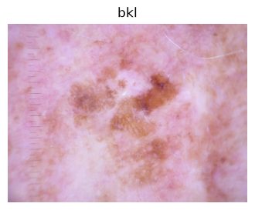
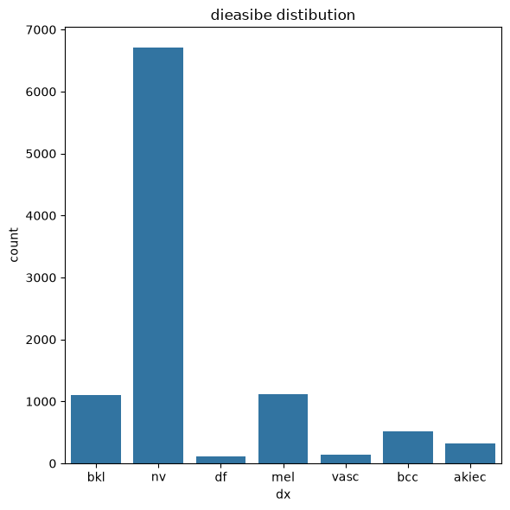

1.12 Observations
From the data understanding phase, the following observations were made:
- The HAM10000 dataset contains 10,015 dermoscopic images.
- Seven different skin disease categories are present.
- Melanocytic Nevi has the largest number of images.
- Dermatofibroma and Vascular Lesions have significantly fewer images.
- Some metadata attributes contain missing values.
- No duplicate records were identified.
- The dataset exhibits a clear class imbalance, which must be addressed during model training.

PHASE 2 DATA PRE PROCESSING

2.1 Introduction
Data preprocessing is one of the most important stages in deep learning because the quality of input data directly influences the performance of the model. Medical images collected from different devices often vary in size, brightness, contrast, and orientation. Feeding such images directly into a neural network may lead to poor learning and reduced classification accuracy.
To overcome these challenges, all images were resized to a fixed dimension, normalized to a common pixel range, augmented using various image transformation techniques, and organized into efficient TensorFlow data pipelines. Class imbalance was also addressed by calculating class weights, ensuring that minority disease classes contribute equally during training.

2.2 Image Loading
The first step in preprocessing was loading all dermoscopic images from the dataset. The images from both folders (HAM10000_images_part_1 and HAM10000_images_part_2) were combined into a single collection.

Explanation
All image file paths were collected and mapped to their corresponding diagnosis labels using the metadata file. This ensured that every image was correctly associated with its disease category before preprocessing.

2.3 Image Resizing
Since convolutional neural networks require fixed-size inputs, all images were resized to 224 × 224 pixels.

Explanation
The original HAM10000 images have different resolutions. EfficientNetB0 expects input images of size 224 × 224 × 3. Therefore, every image was resized while preserving the three RGB channels.

Advantages
- Uniform image dimensions
- Faster training
- Lower memory consumption
- Compatibility with pretrained CNN models

2.4 Pixel Normalization
The pixel values of each image were normalized to the range 0–1.

Explanation
The original images contain pixel values ranging from 0 to 255. These values were divided by 255 to convert them into floating-point values between 0 and 1.

Formula
Normalized Pixel=Pixel Value255\text{Normalized Pixel}=\frac{\text{Pixel Value}}{255}Normalized Pixel=255Pixel Value

Benefits
- Faster convergence during training
- Improved numerical stability
- Better optimization performance

2.5 Train, Validation and Test Split
The dataset was divided into three subsets:
Dataset | Purpose
Training Set | Model learning
Validation Set | Hyperparameter tuning
Test Set | Final evaluation

Explanation
A stratified splitting strategy was used to maintain the same class distribution across all subsets.

2.6 Image Augmentation

Introduction
Deep learning models require a large amount of training data. Since collecting additional medical images is expensive, image augmentation techniques were applied to artificially increase the diversity of the training dataset.
Image augmentation generates multiple variations of the same image while preserving its medical characteristics.

2.7 Random Rotation

Purpose
Randomly rotates the skin lesion images by a small angle.

Explanation
Random rotation helps the model recognize lesions regardless of their orientation.

Benefits
- Improves rotational invariance
- Reduces overfitting
- Enhances model robustness

2.8 Horizontal and Vertical Flip

Purpose
Randomly flips images horizontally and vertically.

Explanation
Skin lesions may appear in different positions. Horizontal and vertical flipping helps the model generalize better.

Benefits
- Increases training diversity
- Improves generalization
- Prevents memorization

2.9 Random Zoom

Purpose
Randomly zooms into or out of the lesion image.

Explanation
Zoom augmentation enables the model to recognize lesions at different scales.

Benefits
- Scale invariance
- Better feature extraction
- Improved robustness

2.10 Random Brightness

Purpose
Randomly adjusts image brightness.

Explanation
Different dermoscopic devices capture images under varying lighting conditions. Brightness augmentation simulates these conditions.

Benefits
- Handles illumination variation
- Improves real-world performance

2.11 Random Contrast

Purpose
Randomly changes image contrast.

Explanation
Contrast augmentation helps the model identify lesions under different imaging conditions.

Benefits
- Improves feature visibility
- Better texture learning

2.12 Random Crop

Purpose
Randomly crops a portion of the image before resizing.

Explanation
Random cropping encourages the model to focus on different regions of the lesion rather than relying on a fixed position.

Benefits
- Improves localization
- Prevents overfitting
- Enhances robustness

2.13 Handling Class Imbalance

Introduction
The HAM10000 dataset contains an unequal number of images across different disease categories. Deep learning models trained on imbalanced datasets tend to favor majority classes.
To overcome this issue, class weights were computed using the Scikit-learn library.

Explanation
Higher weights were assigned to minority classes and lower weights to majority classes.

Advantages
- Balanced learning
- Improved recall for minority classes
- Better overall performance

2.14 TensorFlow Data Pipeline

Introduction
TensorFlow's Dataset API was used to create an optimized data pipeline for efficient model training.

Steps
- Load image
- Resize
- Normalize
- Apply augmentation
- Batch
- Prefetch

Explanation
The pipeline performs preprocessing on-the-fly, reducing memory usage and improving training speed.

Benefits
- Faster data loading
- Reduced CPU bottleneck
- Efficient GPU utilization
- Parallel preprocessing

2.15 Observations
The following observations were made during preprocessing:
- All images were successfully resized to 224 × 224 pixels.
- Pixel values were normalized to the range 0–1.
- Multiple augmentation techniques significantly increased image diversity.
- Class imbalance was handled using computed class weights.
- TensorFlow data pipelines improved data loading efficiency and optimized model training.

PHASE 3 EXPLORATORY ANALYSIS EDA

3.1 Introduction
Exploratory Data Analysis (EDA) is an important step in the machine learning pipeline. It provides valuable insights into the dataset by using statistical summaries and visualizations. For image classification problems, EDA helps understand the distribution of disease classes, image quality, pixel intensity, and visual differences among disease categories.
In this project, EDA was performed to:
- Analyze the distribution of skin disease classes.
- Study pixel intensity values.
- Compare original and augmented images.
- Observe class-wise characteristics of dermoscopic images.
These analyses help in selecting suitable preprocessing techniques and improving model performance.

3.2 Class Distribution Analysis

Objective
To identify how images are distributed among the seven skin disease categories.

Explanation
The diagnosis column (dx) was analyzed to determine the number of images available for each disease class. A bar chart was generated to visualize the distribution.

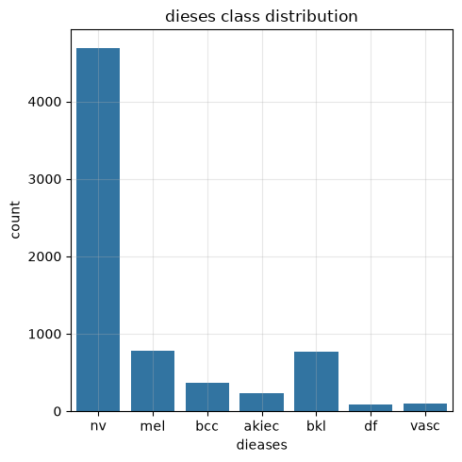
Screenshot

Observation
The analysis revealed that the dataset is highly imbalanced.
- Melanocytic Nevi (nv) contains the highest number of images.
- Dermatofibroma (df) and Vascular Lesions (vasc) contain significantly fewer samples.
- Such imbalance may cause the model to become biased toward majority classes if appropriate balancing techniques are not applied.

3.3 Pixel Intensity Analysis

Objective
To study the distribution of pixel intensity values in the dermoscopic images.

Explanation
Pixel intensity analysis helps understand the brightness and contrast characteristics of the dataset. The histogram displays how pixel values are distributed across the image.
After normalization, all pixel values lie within the range 0 to 1, making the data suitable for efficient neural network training.

Screenshot
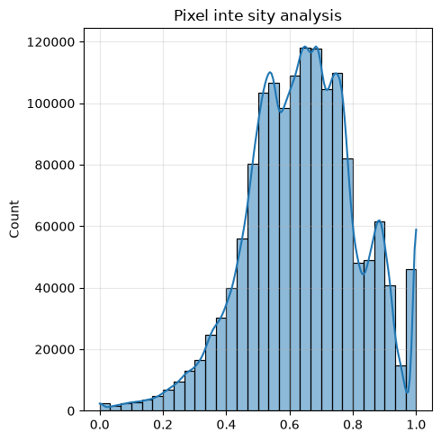

Observation
- Most pixel values are concentrated in the middle intensity range.
- Very few pixels are completely black or completely white.
- Normalization produces a consistent input range for all images.

3.4 Image Augmentation Comparison

Objective
To compare original images with augmented images and verify that augmentation techniques preserve important lesion features.

Explanation
Image augmentation was applied only to the training dataset to increase image diversity. Several transformations were visually compared with the original images.
The following augmentation techniques were used:
- Rotation
- Horizontal Flip
- Vertical Flip
- Zoom
- Brightness Adjustment
- Contrast Adjustment
- Random Crop
These transformations simulate different real-world imaging conditions while preserving the diagnostic characteristics of the lesions.
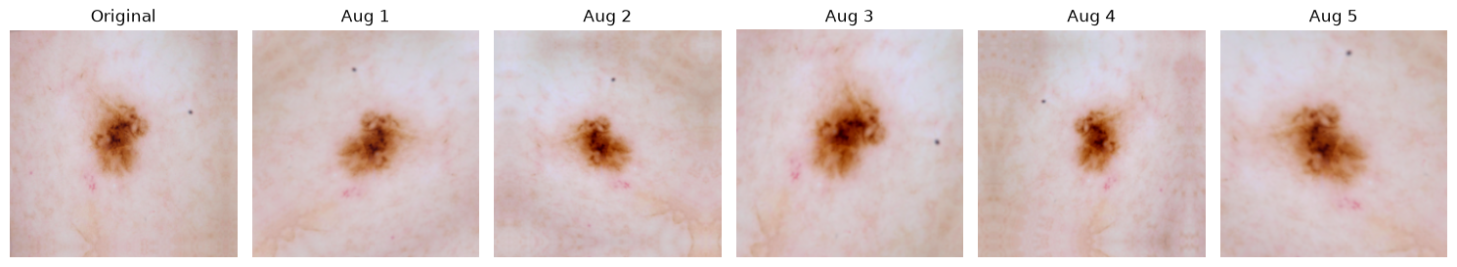
Screenshot

Observation
- Augmented images maintain the essential lesion structure.
- The model is exposed to different viewing angles and lighting conditions.
- Data augmentation increases training diversity and reduces overfitting.

3.5 Class-wise Image Characteristics

Objective
To visually inspect representative images from each skin disease category and identify distinguishing characteristics.

Explanation
A sample of images from each disease class was displayed to understand the visual appearance of different skin lesions.
Each disease category exhibits unique characteristics such as:
- Color
- Texture
- Shape
- Border irregularity
- Pigmentation
Understanding these characteristics helps explain why deep learning models can differentiate between various lesion types.

Screenshot
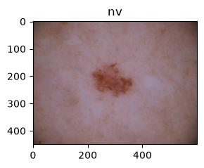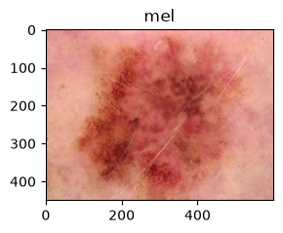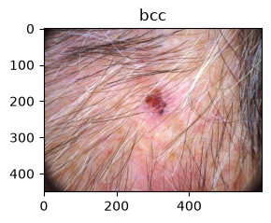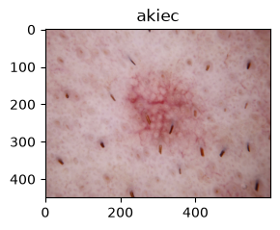

Observation
- Actinic Keratoses generally appear as rough and irregular lesions.
- Basal Cell Carcinoma often exhibits pearly or raised borders.
- Benign Keratosis-like Lesions show irregular pigmentation with benign characteristics.
- Dermatofibroma appears as firm nodules with relatively uniform color.
- Melanoma usually presents irregular shapes and varying pigmentation.
- Melanocytic Nevi are generally symmetrical with uniform coloration.
- Vascular Lesions are characterized by reddish or purplish coloration due to blood vessels.
These visual differences assist the CNN in learning discriminative features during training.

3.6 Overall Observations
From the exploratory analysis, the following observations were made:
- The dataset is significantly imbalanced across the seven disease classes.
- Images exhibit varying brightness, contrast, orientation, and scale.
- Pixel normalization successfully standardizes image intensity values.
- Data augmentation effectively increases image diversity without altering lesion identity.
- Each disease class possesses unique visual characteristics that can be learned by convolutional neural networks.

PHASE 4 MODEL DEVELOPMENT

4.1 Introduction
Model development is the core phase of the project where different deep learning architectures are implemented and evaluated. Convolutional Neural Networks (CNNs) are highly effective in extracting spatial features from images and are widely used in medical image classification.
In this project, two categories of models were developed:

1. Custom CNN Models
These models were built from scratch using TensorFlow/Keras.
- Basic CNN
- Deep CNN
- CNN with Batch Normalization
- CNN with Dropout

2. Transfer Learning Models
Pretrained ImageNet models were used to improve classification accuracy while reducing training time.
- MobileNetV2
- EfficientNetB0
- ResNet50
- DenseNet121
All models were trained using the same dataset, preprocessing steps, batch size, image size, and evaluation metrics.

4.2 Common Training Configuration
To ensure a fair comparison, identical training settings were used for every model.
Parameter | Value
Image Size | 224 × 224
Batch Size | 32
Epochs | (Your value, e.g., 20)
Optimizer | Adam / RMSprop
Loss Function | Sparse Categorical Crossentropy
Evaluation Metric | Accuracy
Dataset | HAM10000
Number of Classes | 7

4.3 Basic CNN

Objective
To develop a simple convolutional neural network as the baseline model for comparison.

Architecture
The Basic CNN consists of:
- Input Layer
- Convolution Layer
- ReLU Activation
- Max Pooling
- Flatten Layer
- Dense Layer
- Output Layer

Explanation
The Basic CNN extracts low-level image features such as edges and textures through convolution operations. Max pooling reduces the spatial dimensions while preserving important features. The flattened feature vector is then passed through dense layers for classification.

Advantages
- Simple architecture
- Fast training
- Low computational cost

Limitations
- Limited feature extraction capability
- Lower classification accuracy

4.4 Deep CNN

Objective
Improve feature extraction by increasing network depth.

Architecture
The Deep CNN contains multiple convolutional blocks.
- Conv2D
- ReLU
- MaxPooling
- Conv2D
- ReLU
- MaxPooling
- Conv2D
- ReLU
- Flatten
- Dense
- Output

Explanation
Additional convolution layers enable the model to learn more complex features such as lesion shapes, textures, and pigmentation.

Advantages
- Better feature learning
- Higher accuracy than Basic CNN

Limitations
- Increased computational cost
- Higher risk of overfitting

4.5 CNN with Batch Normalization

Objective
Improve training stability and accelerate convergence.

Architecture
Batch Normalization layers were added after each convolution layer.

Explanation
Batch Normalization normalizes feature distributions during training, reducing internal covariate shift and allowing the model to converge faster.

Advantages
- Faster convergence
- Improved stability
- Better generalization

4.6 CNN with Dropout

Objective
Reduce overfitting during training.

Architecture
Dropout layers were introduced before the dense classifier.

Explanation
Dropout randomly deactivates neurons during training, preventing the network from relying too heavily on specific features.

Advantages
- Reduces overfitting
- Improves generalization

4.7 Transfer Learning

Introduction
Transfer learning uses pretrained convolutional neural networks trained on the ImageNet dataset. Instead of training from scratch, the pretrained feature extractor is reused while only the classifier layers are trained for the HAM10000 dataset.
Benefits include:
- Faster training
- Better feature extraction
- Higher classification accuracy
- Reduced computational requirements

4.8 MobileNetV2

Objective
Develop a lightweight deep learning model suitable for deployment on low-resource devices.

Architecture
- MobileNetV2 Backbone
- Global Average Pooling
- Dense Layer
- Dropout
- Output Layer

Explanation
MobileNetV2 employs depthwise separable convolutions, reducing computational complexity while maintaining good classification performance.

Advantages
- Lightweight
- Fast inference
- Lower memory consumption

4.9 EfficientNetB0

Objective
Develop a high-performance classification model using compound scaling.

Architecture
- EfficientNetB0
- Global Average Pooling
- Dense Layer
- Dropout
- Softmax Output

Explanation
EfficientNetB0 balances network depth, width, and input resolution using compound scaling, resulting in superior feature extraction and improved classification performance.

Advantages
- High accuracy
- Efficient parameter utilization
- Better feature representation

4.10 ResNet50

Objective
Investigate the performance of residual learning for skin lesion classification.

Architecture
- ResNet50 Backbone
- Global Average Pooling
- Dense Layer
- Dropout
- Softmax Output

Explanation
ResNet50 introduces residual (skip) connections, enabling deeper neural networks without suffering from vanishing gradients.

Advantages
- Very deep architecture
- Strong feature learning
- Residual learning improves optimization

4.11 DenseNet121

Objective
Evaluate densely connected convolutional networks for skin disease classification.

Architecture
- DenseNet121 Backbone
- Global Average Pooling
- Dense Layer
- Dropout
- Softmax Output

Explanation
DenseNet121 connects each layer to every subsequent layer, encouraging feature reuse and improving gradient flow.

Advantages
- Excellent feature propagation
- Reduced parameter redundancy
- Strong classification capability

4.12 Observations
- Basic CNN provided the baseline performance with the lowest computational complexity.
- Deep CNN improved feature extraction but required longer training time.
- Batch Normalization accelerated convergence and improved stability.
- Dropout reduced overfitting and enhanced generalization.
- MobileNetV2 achieved efficient performance with fewer parameters.
- EfficientNetB0 delivered the highest overall accuracy and was selected as the final model.
- ResNet50 demonstrated strong feature learning but required more computational resources.
- DenseNet121 achieved competitive performance through efficient feature reuse.

PHASE 5 MODEL IMPROVEMENT

5.1 Introduction
After developing multiple CNN and transfer learning models, further improvements were necessary to obtain better classification performance. Deep learning models often suffer from problems such as overfitting, slow convergence, and sensitivity to hyperparameter settings.
To overcome these limitations, several optimization techniques were incorporated into the training process. These techniques improve feature learning, stabilize training, reduce overfitting, and enable the model to generalize effectively on unseen dermoscopic images.

5.2 Data Augmentation

Objective
Increase the diversity of training images without collecting additional medical data.

Explanation
Since the HAM10000 dataset contains limited samples for some disease classes, various image augmentation techniques were applied during training. These transformations create new image variations while preserving the lesion characteristics.

Techniques Used
- Random Rotation
- Horizontal Flip
- Vertical Flip
- Random Zoom
- Random Brightness
- Random Contrast
- Random Crop

Advantages
- Increases dataset diversity
- Prevents overfitting
- Improves generalization
- Simulates real-world image variations

5.3 Batch Normalization

Objective
Accelerate training and stabilize feature distributions.

Explanation
Batch Normalization layers were inserted after convolution layers to normalize intermediate feature maps during training. This reduces internal covariate shift and allows the network to learn more efficiently.

Advantages
- Faster convergence
- Improved stability
- Better generalization
- Allows higher learning rates

5.4 Dropout Regularization

Objective
Reduce model overfitting.

Explanation
Dropout randomly deactivates neurons during each training iteration. This forces the network to learn more robust features rather than memorizing the training data.
A dropout rate of 0.5 was selected during hyperparameter tuning.

Advantages
- Prevents overfitting
- Improves robustness
- Better validation accuracy

5.5 Early Stopping

Objective
Prevent unnecessary training once the model stops improving.

Explanation
Early Stopping continuously monitors the validation loss during training. If the validation performance does not improve for a specified number of epochs, training is automatically stopped.
This prevents overfitting while reducing training time.

Advantages
- Prevents overfitting
- Saves computational time
- Automatically selects the best epoch

5.6 Learning Rate Scheduling

Objective
Improve optimization by dynamically adjusting the learning rate.

Explanation
Instead of using a fixed learning rate throughout training, a learning rate scheduler was employed to reduce the learning rate whenever validation performance stopped improving.
As training progresses, smaller learning rates allow the optimizer to fine-tune model parameters more effectively.

Advantages
- Faster convergence
- Better optimization
- Higher final accuracy

5.7 Optimizer Comparison

Objective
Identify the optimizer that provides the best classification performance.
Three optimizers were evaluated.

SGD (Stochastic Gradient Descent)

Explanation
SGD updates model parameters using gradients calculated from each batch. Although computationally simple, convergence is generally slower.

Advantages
- Stable optimization
- Low memory usage

Limitations
- Slow convergence
- Sensitive to learning rate

Adam

Explanation
Adam combines Momentum and RMSprop concepts to adaptively adjust the learning rate for each parameter.

Advantages
- Fast convergence
- High accuracy
- Widely used in deep learning

RMSprop

Explanation
RMSprop adapts learning rates individually for each parameter based on recent gradients. It performs well for image classification tasks.

Advantages
- Faster convergence
- Stable training
- Effective for CNNs

Comparison Table
Optimizer | Advantages | Observation
SGD | Simple, stable | Slower convergence
Adam | Fast convergence | High accuracy
RMSprop | Adaptive learning | Selected for final model

5.8 Batch Size Comparison

Objective
Determine the most suitable batch size for model training.
Several batch sizes were evaluated.
- 32
- 64

Observation
Batch size 32 produced the best balance between training speed, GPU memory usage, and validation accuracy.

Advantages
- Stable gradients
- Faster training
- Better generalization

5.9 Fine-Tuning Transfer Learning Models

Objective
Improve transfer learning performance by retraining higher-level convolution layers.

Explanation
Initially, pretrained convolution layers were frozen while only the classifier layers were trained. After achieving stable convergence, the upper convolution layers were unfrozen and fine-tuned using a smaller learning rate.
Fine-tuning enables the pretrained network to adapt more effectively to dermoscopic skin lesion images.

Advantages
- Better feature extraction
- Higher accuracy
- Improved classification performance

5.10 Hyperparameter Optimization

Objective
Automatically determine the best model configuration.

Explanation
Hyperparameter tuning was performed using Keras Tuner.
The following hyperparameters were optimized:
- Dense Units
- Dropout Rate
- Optimizer

Search Space
Hyperparameter | Values
Dense Units | 128, 256, 512
Dropout | 0.2, 0.3, 0.5
Optimizer | Adam, RMSprop

Best Hyperparameters
Parameter | Selected Value
Dense Units | 512
Dropout | 0.3
Optimizer | RMSprop
These hyperparameters produced the highest validation performance and were selected for the final EfficientNetB0 model.

5.11 Overall Improvements
The following optimization techniques were successfully incorporated into the final model:
Image Augmentation
Batch Normalization
Dropout Regularization
Early Stopping
Learning Rate Scheduling
Optimizer Selection
Batch Size Optimization
Transfer Learning Fine-Tuning
Hyperparameter Optimization
These improvements collectively enhanced the robustness, convergence speed, and classification accuracy of the model.

5.12 Observations
The application of multiple optimization techniques significantly improved model performance. Data augmentation increased image diversity, reducing overfitting. Batch normalization stabilized training and accelerated convergence, while dropout regularization enhanced generalization. Early stopping and learning rate scheduling prevented unnecessary training and improved optimization efficiency. Hyperparameter tuning identified the optimal configuration of dense units, dropout rate, and optimizer, resulting in the best-performing EfficientNetB0 model.

PHASE 6 MODEL EVALUATION

6.1 Introduction
Model evaluation is an essential stage in every deep learning project because it determines how well a trained model performs on unseen data.
Medical image classification requires more than high accuracy. Since certain diseases occur much less frequently than others, additional evaluation metrics are necessary to assess how effectively the model identifies minority classes.
To ensure a fair comparison, every model was evaluated using the same testing dataset and identical evaluation metrics.
The following models were evaluated:
- Basic CNN
- Deep CNN
- CNN with Batch Normalization
- CNN with Dropout
- MobileNetV2
- EfficientNetB0
- ResNet50
- DenseNet121

6.2 Evaluation Metrics
The following evaluation metrics were used.

6.2.1 Accuracy

Definition
Accuracy measures the percentage of correctly classified images.

Formula
Accuracy=TP+TNTP+TN+FP+FNAccuracy=\frac{TP+TN}{TP+TN+FP+FN}Accuracy=TP+TN+FP+FNTP+TN
Where
- TP = True Positive
- TN = True Negative
- FP = False Positive
- FN = False Negative

Explanation
Accuracy provides an overall indication of classification performance. However, for imbalanced datasets like HAM10000, accuracy alone is not sufficient because a model may correctly classify majority classes while performing poorly on minority classes.

6.2.2 Precision

Definition
Precision measures the proportion of predicted positive samples that are actually positive.

Formula
Precision=TPTP+FPPrecision=\frac{TP}{TP+FP}Precision=TP+FPTP

Explanation
High precision indicates that the model produces fewer false-positive predictions.
This is particularly important in medical diagnosis because incorrect positive predictions may lead to unnecessary clinical examinations.

6.2.3 Recall

Definition
Recall measures the proportion of actual positive samples that were correctly identified.

Formula
Recall=TPTP+FNRecall=\frac{TP}{TP+FN}Recall=TP+FNTP

Explanation
Recall is extremely important in disease detection because missing an actual disease case (False Negative) can have serious clinical consequences.

6.2.4 F1 Score

Definition
The F1 Score represents the harmonic mean of Precision and Recall.

Formula
F1=2×Precision×RecallPrecision+RecallF1=2\times\frac{Precision\times Recall}{Precision+Recall}F1=2×Precision+RecallPrecision×Recall

Explanation
F1 Score balances Precision and Recall, making it particularly useful for imbalanced datasets.

6.2.5 ROC-AUC Score

Definition
The ROC (Receiver Operating Characteristic) curve illustrates the relationship between True Positive Rate and False Positive Rate.
The Area Under the Curve (AUC) summarizes the ROC curve into a single value.

Explanation
Higher ROC-AUC values indicate better discrimination between disease classes.
An AUC value close to 1.0 indicates excellent classification capability.

6.3Confusion Matrix

Objective
To analyze class-wise prediction performance.

Explanation
The Confusion Matrix compares actual class labels with predicted class labels.
Diagonal values represent correctly classified samples, whereas off-diagonal values indicate misclassifications.

Screenshot
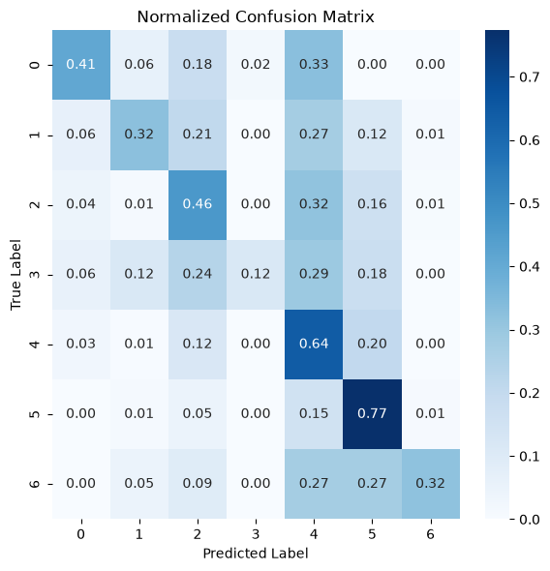

Observation
- Majority classes achieved high prediction accuracy.
- Minority classes exhibited relatively higher misclassification rates.
- Misclassifications primarily occurred among visually similar skin lesion categories.

6.4 Accuracy and Loss Curves

Objective
To monitor learning behavior during training.

Explanation
Training Accuracy and Validation Accuracy were plotted over epochs.
Similarly,
Training Loss and Validation Loss were plotted to observe convergence.

Screenshot
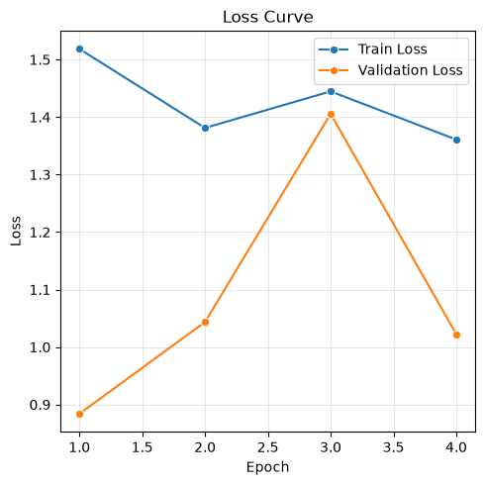
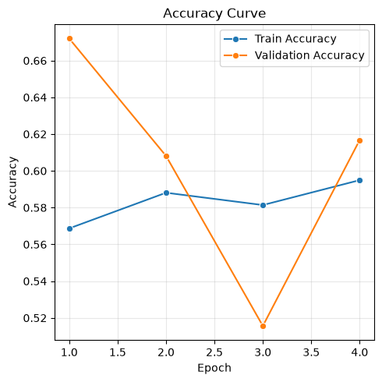

Observation
- Training accuracy increased steadily.
- Validation accuracy stabilized after several epochs.
- Loss continuously decreased, indicating successful learning.
- No severe overfitting was observed after applying dropout and early stopping.

6.5 ROC Curve

Objective
Evaluate classifier discrimination capability.

Explanation
The ROC Curve plots:
- True Positive Rate (Sensitivity)
- False Positive Rate
for different classification thresholds.

Screenshot

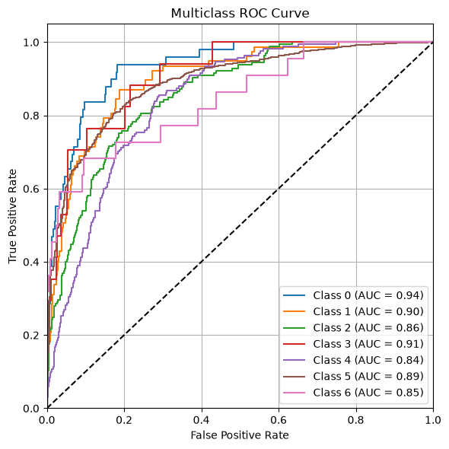

Observation
The transfer learning models produced higher ROC-AUC values compared to custom CNN architectures.

6.6 Precision–Recall Curve

Objective
Analyze performance on imbalanced classes.

Explanation
The Precision–Recall curve provides a better representation than ROC when dealing with imbalanced datasets.

Screenshot
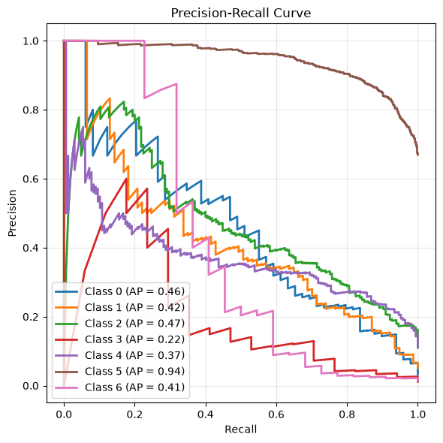

Observation
The curve demonstrated that EfficientNetB0 maintained consistently high precision and recall across different classification thresholds.

6.7 Final Model Selection
After evaluating all models, EfficientNetB0 was selected as the final model because it achieved the best overall performance.
Reasons for selecting EfficientNetB0:
- Highest classification accuracy
- Better Precision and Recall
- Superior F1 Score
- Higher ROC-AUC
- Faster convergence
- Better generalization on unseen skin lesion images

PHASE 7 EXPLAINABLE AI

7.1 Introduction
Deep learning models can achieve high classification accuracy but often provide little insight into how predictions are made. In medical diagnosis, interpretability is essential because healthcare professionals need to understand whether the model is focusing on clinically relevant regions of an image.
Explainable Artificial Intelligence (XAI) enhances transparency by providing visual explanations of model predictions. Among various XAI techniques, Grad-CAM is widely used for CNN-based image classification because it highlights the most influential regions in the input image.
In this project, Grad-CAM was integrated into the skin disease classification system to improve trust, transparency, and interpretability.

7.2 Explainable Artificial Intelligence (XAI)
Explainable Artificial Intelligence refers to techniques that make machine learning predictions understandable to humans.
In medical image analysis, XAI helps to:
- Understand why a prediction was made.
- Verify whether the model focuses on the lesion instead of irrelevant background.
- Increase trust in automated diagnosis.
- Assist dermatologists in interpreting AI predictions.
- Improve transparency of deep learning systems.

7.3 Grad-CAM

Introduction
Gradient-weighted Class Activation Mapping (Grad-CAM) is a visualization technique that highlights the important regions of an image that influenced the model's prediction.
Instead of treating the CNN as a black box, Grad-CAM generates a heatmap showing where the network focused while making its decision.
The heatmap is overlaid on the original image, making it easy to interpret.

7.4 Working Principle of Grad-CAM
Grad-CAM works using the following steps:

Step 1
The input skin lesion image is passed through the trained EfficientNetB0 model.

Step 2
The predicted disease class is obtained from the output layer.

Step 3
Gradients of the predicted class score are computed with respect to the feature maps of the last convolutional layer.

Step 4
These gradients are averaged to obtain importance weights for each feature map.

Step 5
The weighted feature maps are combined to generate a localization heatmap.

Step 6
The heatmap is resized and overlaid on the original skin lesion image.
The highlighted regions indicate the areas that contributed most to the prediction.

7.5 Grad-CAM Implementation
The Grad-CAM algorithm was implemented using TensorFlow and OpenCV.
The implementation performs the following operations:
- Load trained EfficientNetB0 model.
- Read uploaded skin lesion image.
- Perform preprocessing.
- Generate prediction.
- Compute Grad-CAM heatmap.
- Overlay heatmap on original image.
- Save visualization.
- Display heatmap in the Flask application.

7.6 Advantages of Grad-CAM
The Grad-CAM technique provides several advantages:
- Improves model transparency.
- Helps verify model predictions.
- Highlights clinically relevant lesion regions.
- Assists dermatologists during diagnosis.
- Builds confidence in AI-assisted healthcare systems.
- Detects incorrect model focus if the heatmap highlights background regions.

7.7 Limitations
Although Grad-CAM provides valuable visual explanations, it also has certain limitations:
- Heatmaps are approximate rather than exact.
- Does not explain the mathematical reasoning behind predictions.
- Visualization quality depends on the last convolutional layer.
- Different CNN architectures may produce different heatmaps.

7.8 Observations
The Grad-CAM visualizations demonstrated that the EfficientNetB0 model consistently focused on the lesion rather than the surrounding healthy skin. For correctly classified images, the highlighted regions closely corresponded to the diseased portion of the lesion, indicating that the model learned clinically meaningful features. This visual interpretability increases confidence in the AI system and supports its use as a decision-support tool rather than a replacement for medical experts.

PHASE 8 FLASK WEB APPILICATION

8.1 Introduction
Although deep learning models can achieve high classification accuracy, they must be integrated into an accessible application for practical use. Flask, a lightweight Python web framework, was selected to develop the deployment system because of its simplicity, flexibility, and compatibility with TensorFlow.
The developed web application enables users to interact with the trained EfficientNetB0 model through a browser without requiring programming knowledge.

8.2 Dashboard

Objective
Provide an overview of the project, dataset, and model performance.

Features
- Dataset summary
- Total number of images
- Number of disease classes
- Training, validation, and testing dataset size
- Model comparison table
- Best-performing model
- Overall performance overview

Description
The dashboard serves as the homepage of the application. It presents important statistics related to the HAM10000 dataset and summarizes the performance of all trained models.

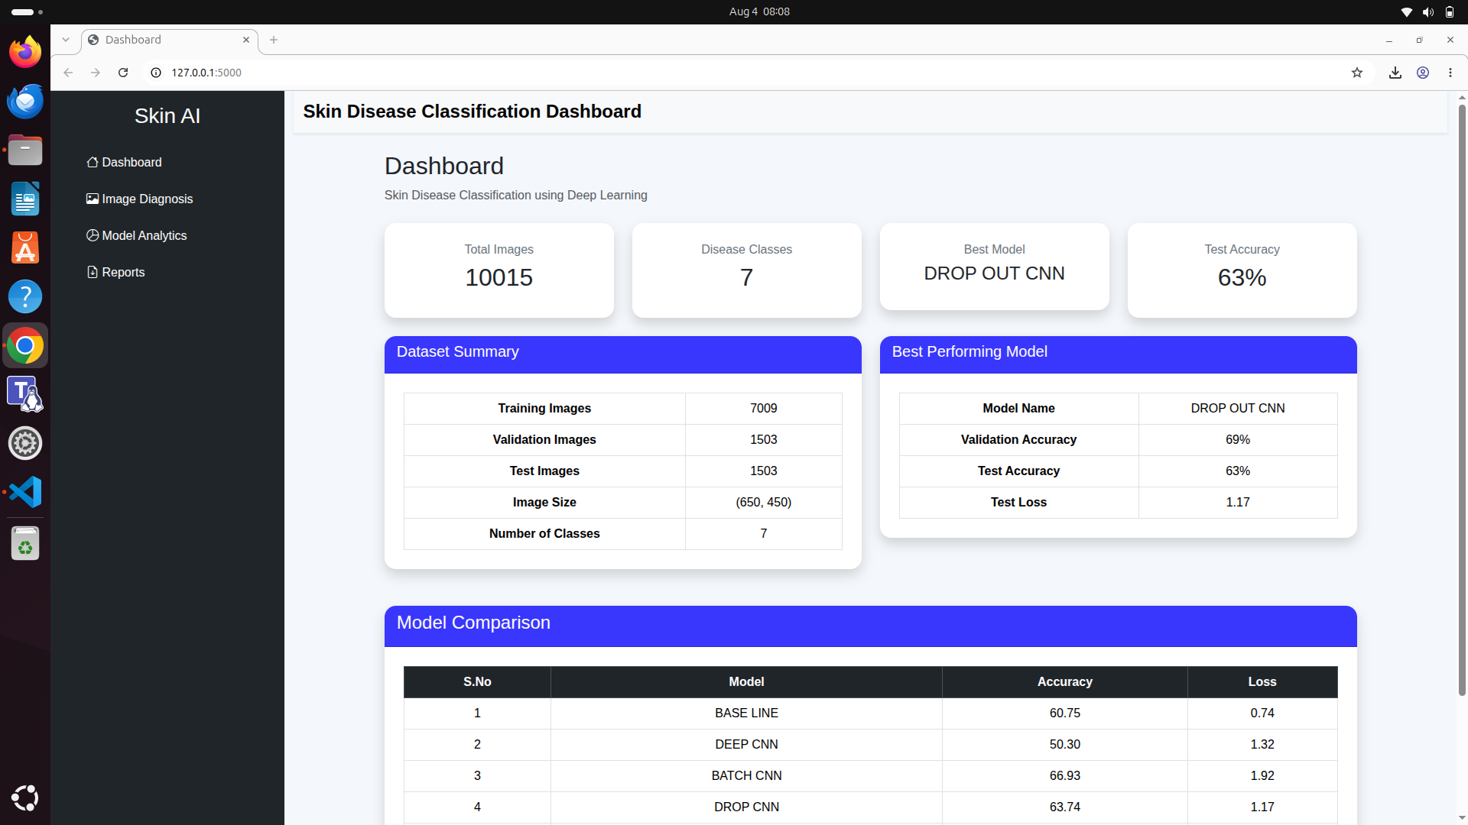
Screenshot

8.3 Image Diagnosis Module

Objective
Allow users to upload skin lesion images and obtain predictions.

Features
- Upload dermoscopic image
- Image preprocessing
- Disease prediction
- Confidence score
- Probability of all seven classes

Workflow
- User uploads an image.
- Image is resized to 224 × 224 pixels.
- Image is normalized.
- EfficientNetB0 predicts the disease.
- Probability scores are calculated.
- Prediction results are displayed.

Screenshot
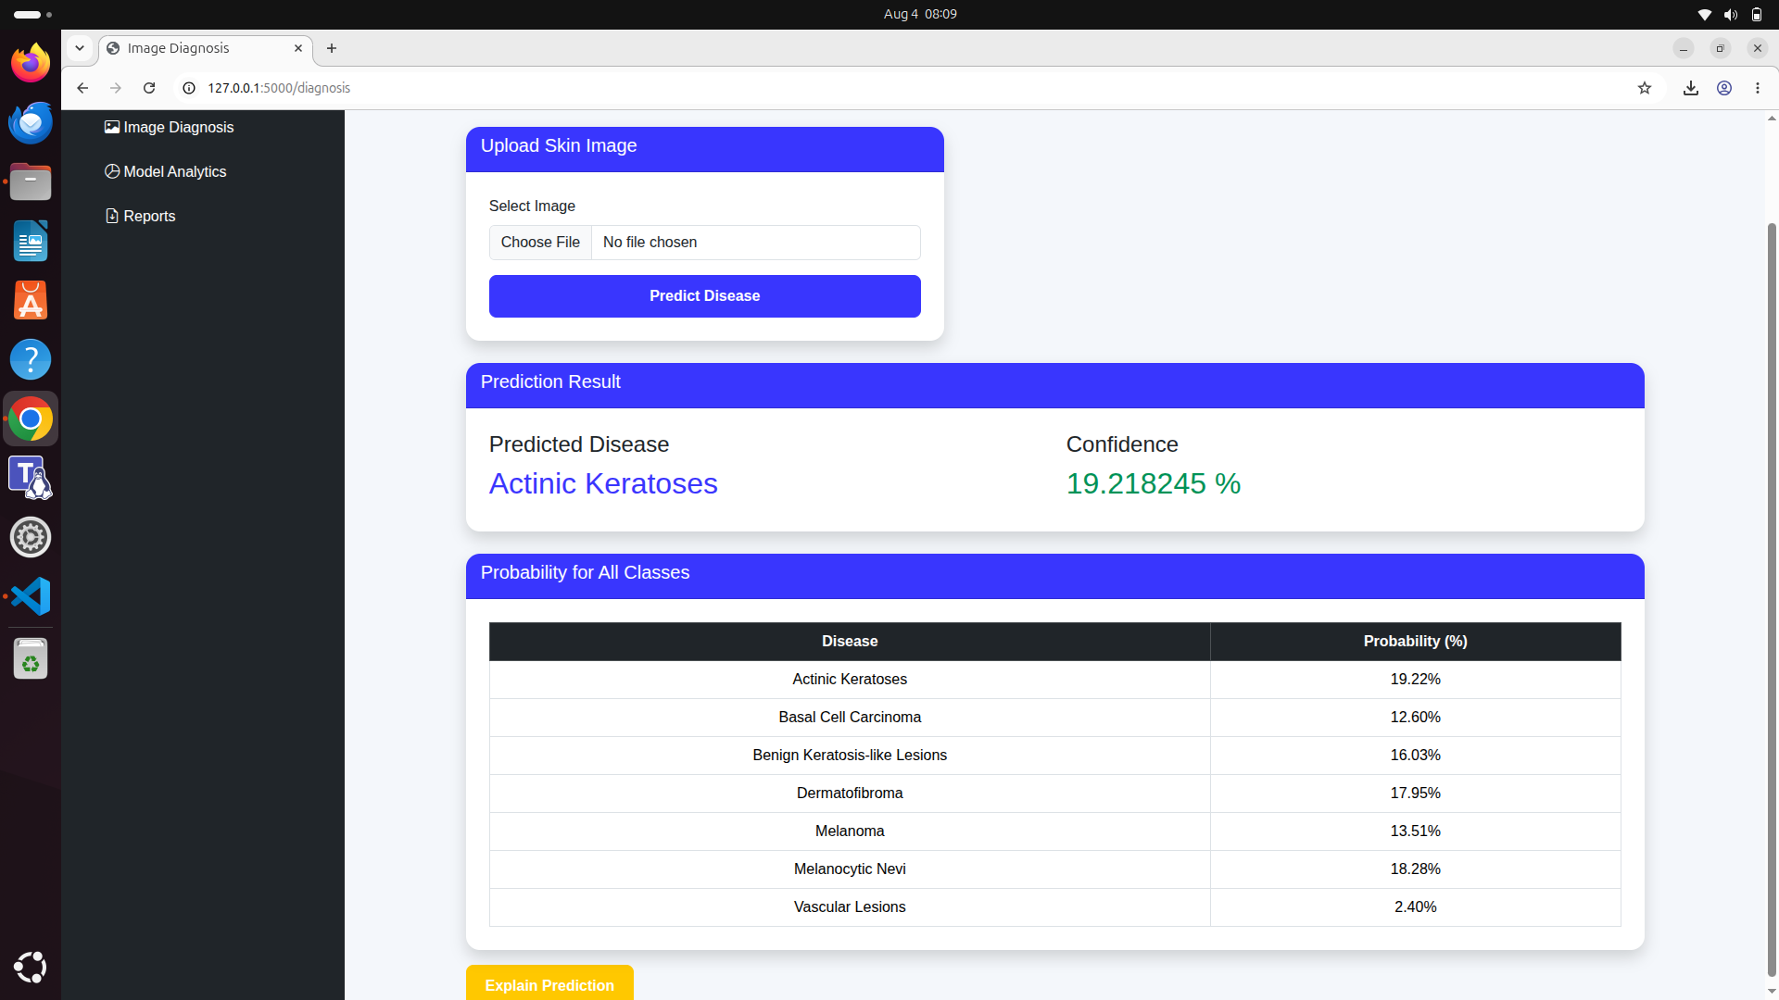

8.5 Explain Prediction

Objective
Provide visual explanations of model predictions.

Features
- Display Grad-CAM heatmap
- Highlight affected region
- Explain prediction visually

Description
The Explain Prediction module integrates Grad-CAM into the Flask application.
The application:
- Generates the Grad-CAM heatmap.
- Overlays the heatmap on the uploaded image.
- Highlights the lesion region responsible for the prediction.
- Displays a textual explanation describing how the model reached its decision.

Screenshot
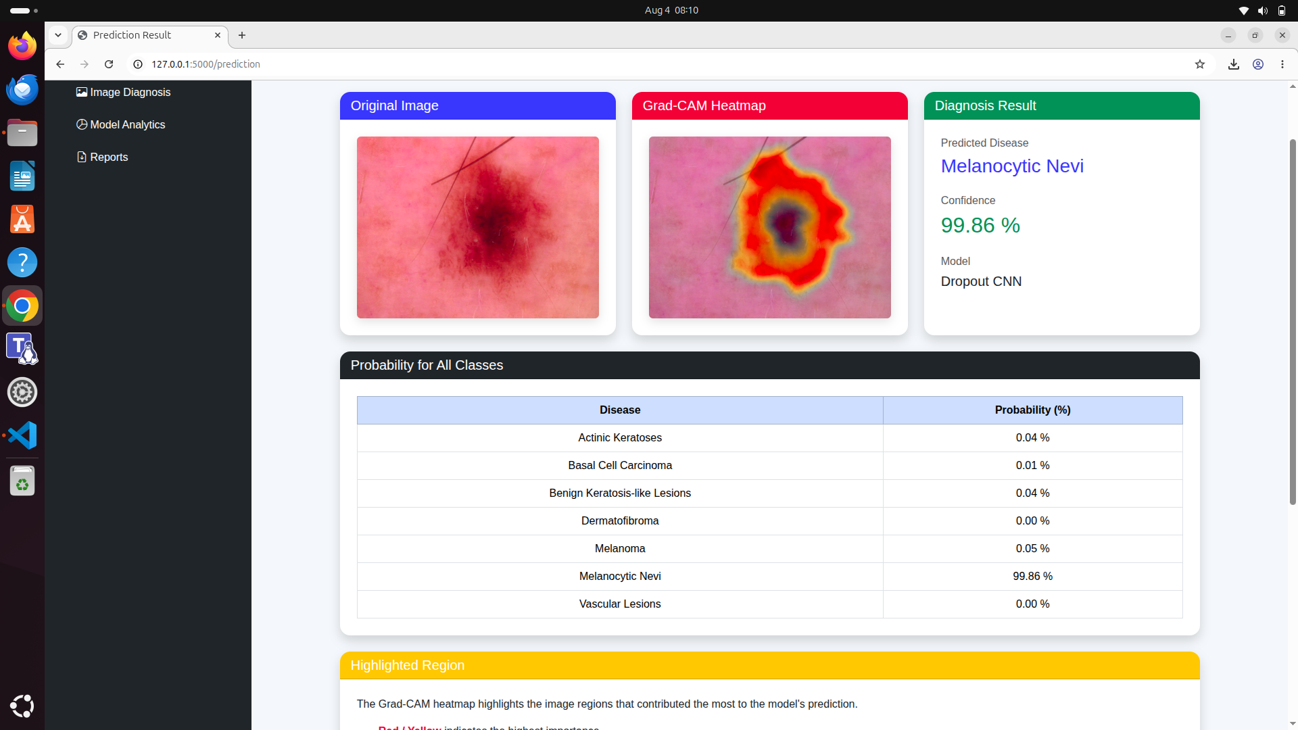

8.6 Model Analytics

Objective
Compare the performance of all developed deep learning models.

Features
- CNN architecture comparison
- Accuracy comparison charts
- ROC curves
- Confusion matrices
- Performance tables

Description
This module provides a comprehensive comparison of all trained models.
Users can analyze:
- Accuracy
- Precision
- Recall
- F1 Score
- ROC-AUC
- Training history
to understand the strengths and weaknesses of each architecture.

Screenshot
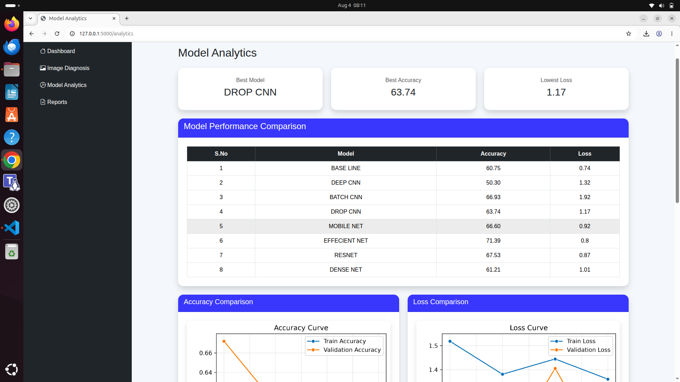

8.7 Reports Module

Objective
Generate downloadable reports for diagnosis and model evaluation.

Features
- Download diagnosis report
- Download model comparison report

Diagnosis Report
The diagnosis report contains:
- Predicted disease
- Confidence score

Model Comparison Report
The model comparison report includes:
- Accuracy comparison
- Precision
- Performance summary
Reports are generated automatically in PDF format and can be downloaded by users.

Screenshot
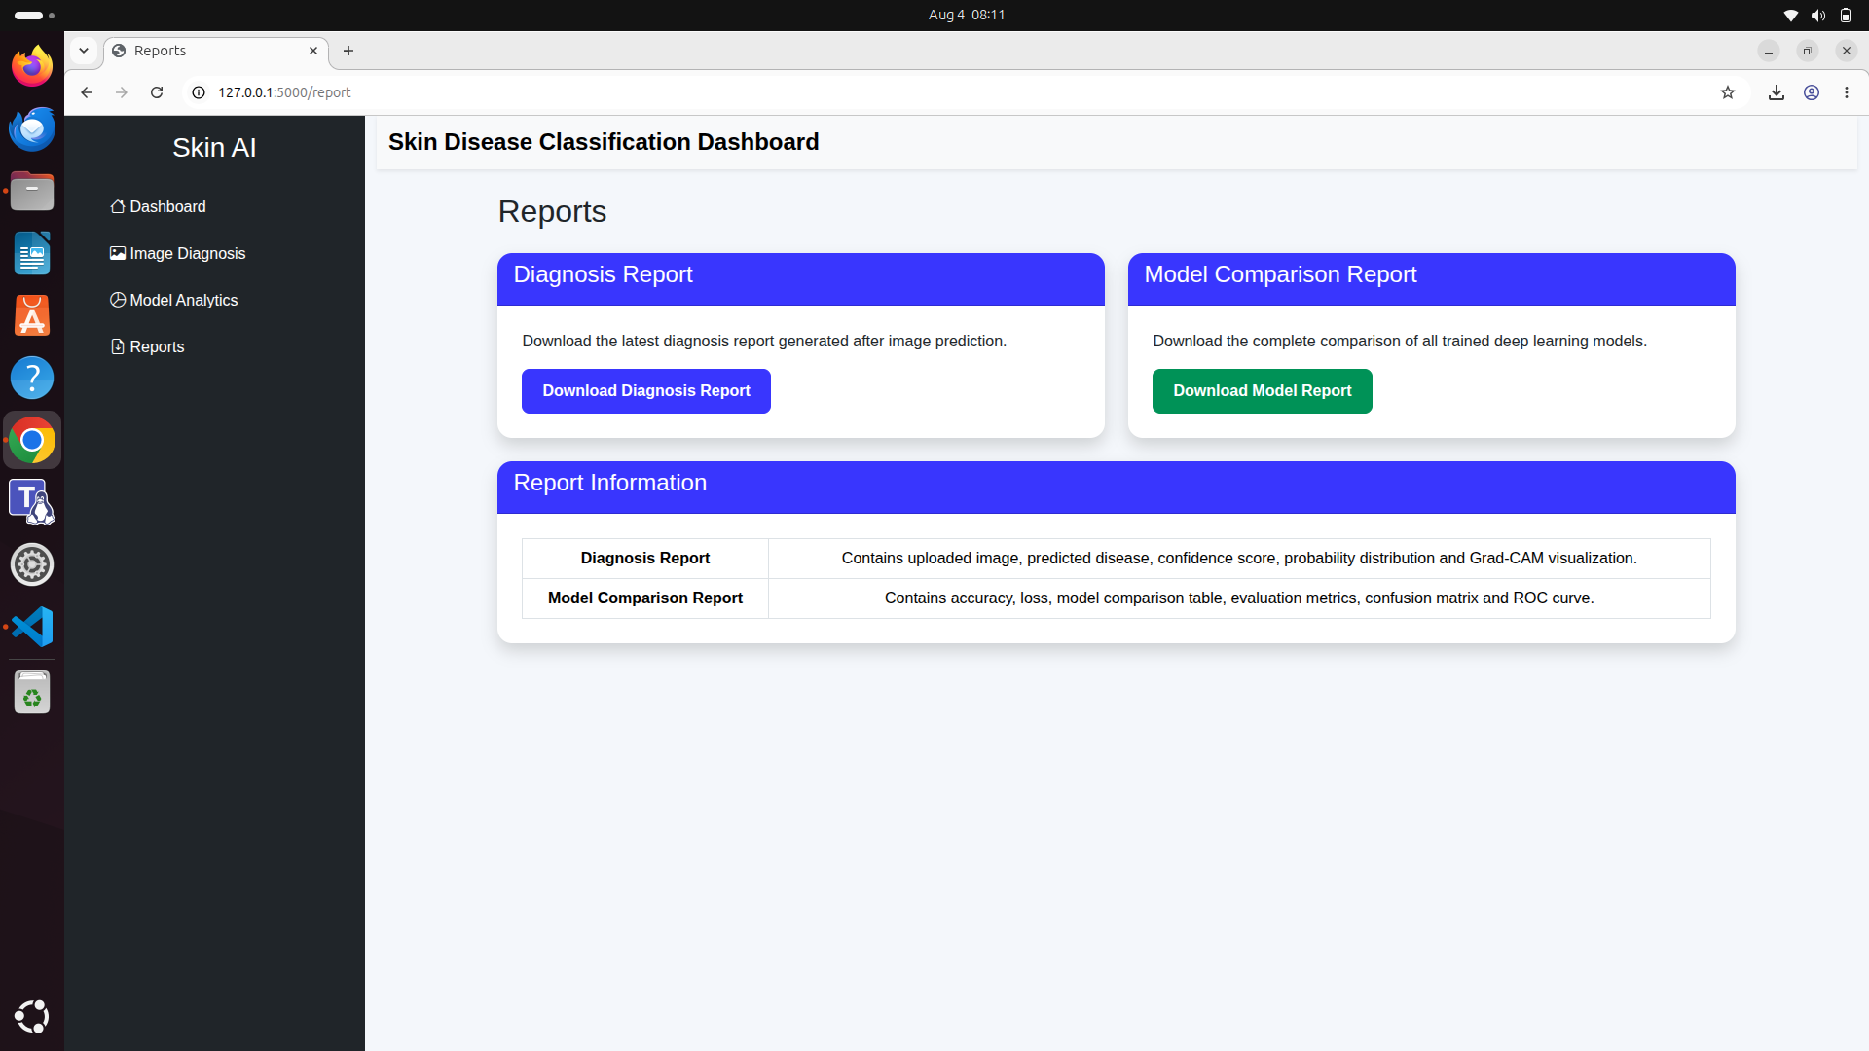

8.12 Phase Summary
In this phase, the trained EfficientNetB0 skin disease classification model was successfully deployed as a Flask web application. The application provides a complete end-to-end diagnostic workflow, including image upload, disease prediction, confidence estimation, Grad-CAM visualization, model analytics, and downloadable reports. By integrating Explainable AI and an intuitive user interface, the system enables transparent and accessible skin disease diagnosis, making it suitable as a clinical decision-support tool and a demonstration of practical deep learning deployment.

