ML MODEL DEVELOPMENT

Phase 1: Dataset Understanding and Business Understanding

1. Business Understanding
The primary objective of this project is to develop a machine learning model capable of accurately predicting the SalePrice of residential houses based on their characteristics. House price prediction helps buyers, sellers, and real estate agencies estimate the market value of a property using historical housing data.
The problem is formulated as a supervised regression problem, where SalePrice is the target variable and all remaining property attributes are used as predictor variables.

2. Dataset Understanding
The project uses the Ames Housing Dataset, which contains detailed information about residential properties.
During the initial exploration of the dataset, the following observations were made:
- Total observations: 1460 houses
- Target variable: SalePrice
- Categorical features: 43
- Numerical features: 37
- Total input features: 80

3. Missing Value Analysis
The dataset contained missing values in several columns.
A missing value analysis was performed to:
- Identify columns containing missing values.
- Measure the percentage of missing data.
- Visualize missing values using a heatmap.
This analysis helped determine appropriate strategies for handling missing values during the data preprocessing phase.

4. Numerical Feature Analysis
The distribution of all numerical features was examined to understand the characteristics of the data.

The following visualizations were used:
- Histograms
- Distribution plots
- Summary statistics

5. Correlation Analysis
A correlation analysis was conducted to measure the relationship between numerical features and the target variable (SalePrice).
This analysis helped identify features that have a strong positive or negative influence on house prices and provided an initial understanding of feature importance.

7. Pair Plot Visualization
To better understand relationships between important numerical variables, a pair plot was created using six selected features along with the target variable (SalePrice).
The pair plot helped visualize:
- Relationships between variables.
- Feature distributions.
- Trends and correlations.
- Potential linear relationships useful for regression models.

Phase 2 DATA Cleaning

1.Missing Value Handling
The training and testing datasets contained missing values in several numerical and categorical columns. Each missing value was analyzed individually instead of applying a single strategy to all columns.
Different imputation techniques were used based on the meaning of the feature.

Column name | Type of impute
LotFrontage | Zero Imputation
MasVnrArea | “None”
GarageYrBlt | “No”
BsmtFinSF1 | “No”
BsmtFinSF2 | “No”
BsmtUnfSF | “No”
TotalBsmtSF | “No”
BsmtFullBath | “No”
BsmtHalfBath | “No”
GarageCars | “No”
GarageArea | “No”

2.Categorical Encoding
Machine learning algorithms require numerical inputs; therefore, categorical variables were transformed into numerical representations.
Two encoding techniques were applied.

Ordinal Encoding
Features with an inherent order were encoded using OrdinalEncoder.
Examples include:
- LotShape
- LandSlope
- ExterQual
- ExterCond
- BsmtQual
- BsmtCond
- BsmtExposure
- BsmtFinType1
- BsmtFinType2
- HeatingQC
- KitchenQual
- Functional
- FireplaceQu
- GarageFinish
- GarageQual
- GarageCond
- PoolQC
- Fence
The ordering preserved the ranking of feature quality levels.

One-Hot Encoding
Nominal categorical features without any natural ordering were encoded using One-Hot Encoding.
Examples include:
- MSZoning
- Neighborhood
- HouseStyle
- RoofStyle
- Foundation
- Heating
- GarageType
- SaleType
- SaleCondition
- Utilities
- Exterior1st
- Exterior2nd
This approach avoids introducing artificial ordinal relationships among categories.

3.Train-Test Feature Alignment
After encoding, the training and testing datasets contained different numbers of columns because some categories appeared only in one dataset.
Training dataset column count : 228
test dataset column count : 211
To ensure consistency, both datasets were aligned so that:
- identical feature columns existed in both datasets,
- missing columns were automatically created,
- unavailable categories were filled with zero.
This guaranteed that both datasets had the same feature structure before model training.

4.Skewness Treatment
Several numerical variables exhibited high positive skewness.
The following features were transformed using the log1p() transformation:
- LotFrontage
- LotArea
- MasVnrArea
- BsmtFinSF1
- 1stFlrSF
- GrLivArea
The logarithmic transformation reduced skewness, improved feature distribution, and made the data more suitable for regression algorithms.
The same transformation was consistently applied to both training and testing datasets.
5.Feature Engineering
New features were created to improve predictive performance by combining existing attributes.
The engineered features include:

HouseAge
Calculated as:
HouseAge = Year Sold − Year Built
Represents the age of the property at the time of sale.

RemodelAge
Calculated as:
RemodelAge = Year Sold − YearRemodAdd
Measures the time elapsed since the last renovation.

Total Square Footage (TotalSf)
Calculated as the sum of:
- Basement Area
- First Floor Area
- Second Floor Area
This provides a better estimate of the overall living space.

Total Bathrooms
Computed using:
- Full Bathrooms
- Half Bathrooms
- Basement Full Bathrooms
- Basement Half Bathrooms
Half bathrooms were assigned a weight of 0.5 to reflect their relative utility.

Total Living Area
Constructed by combining major living space measurements to represent the effective usable area of the house.

6.Feature Selection
Correlation analysis was performed between every feature and the target variable (SalePrice).
Only features with an absolute correlation coefficient greater than 0.30 were selected.
This reduced the feature space from the encoded dataset to 43 highly relevant features, eliminating weak predictors and reducing model complexity.
Column selected to train the model : 43

7.Correlation Analysis
A correlation matrix was generated using the selected features and visualized through a heatmap.
The analysis helped identify:
- highly correlated predictors,
- relationships among engineered features,
- the strongest predictors of SalePrice.
- There were 43 column with greater than 0.30 of absolute corelation
This step provided insight into feature importance before model training.

8.Final Dataset Preparation
At the end of preprocessing, the following datasets were created:
- Cleaned Training Dataset
- Cleaned Testing Dataset
- Encoded Training Dataset
- Encoded Testing Dataset
- Selected Training Features
- Selected Testing Features
- Target Variable (SalePrice)
These processed datasets formed the final input for the machine learning models developed in the subsequent phase.
Data set were slipted into two :
x_train (input columns)
y_train(target column)
for test data set
x_test(input columns)
y_test(target column)
This documentation accurately reflects the work shown in your notebook while presenting it in a professional, report-ready format suitable for a final-year project

Phase 3 – Exploratory Data Analysis (EDA)

3 Overview
Exploratory Data Analysis (EDA) was performed to understand the relationships between the independent variables and the target variable (SalePrice). The objective of this phase was to discover hidden patterns, identify significant features, detect multicollinearity, and gain insights that could improve model performance.
EDA provided a better understanding of the dataset before feature selection and model development.

1.Correlation Analysis
A correlation matrix was generated using all numerical features to measure the linear relationship between the features and the target variable.
A heatmap was used to visualize the correlation coefficients.
The analysis helped identify:
- Strong positive correlations.
- Weak correlations.
- Highly correlated independent variables.
- Features influencing house prices.
Features having higher positive correlation with SalePrice were considered important candidates for model training.

2.Feature vs Target Analysis
Individual feature relationships with SalePrice were analyzed using scatter plots and regression plots.
The analysis helped understand:
- Linear relationships.
- Non-linear patterns.
- Feature importance.
- Presence of outliers.
Several important features such as OverallQual, GrLivArea, GarageArea, and Total Living Area showed a strong positive relationship with the target variable.
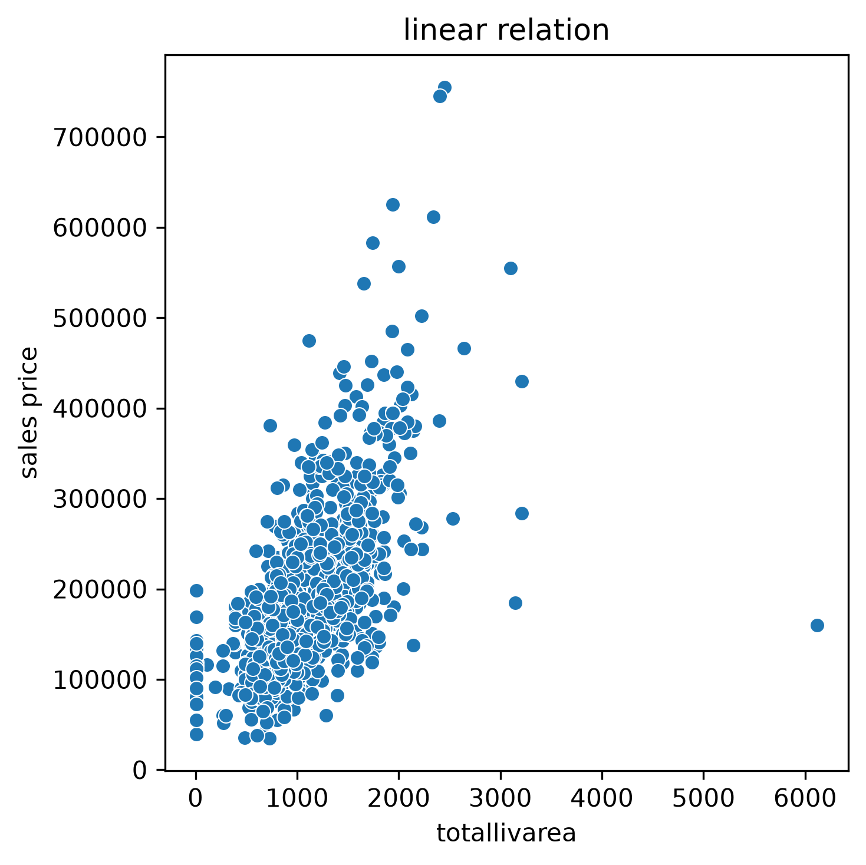
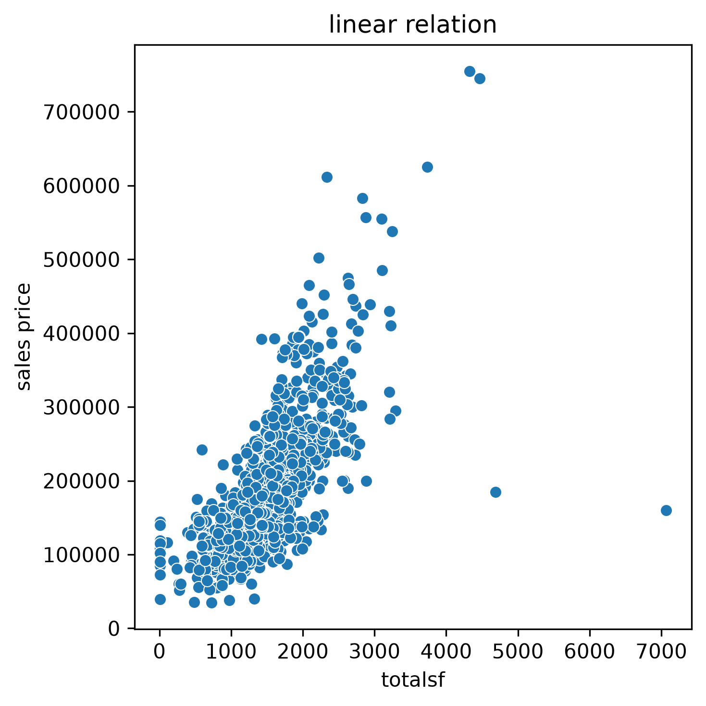

4.Pair Plot Analysis
Pair plots were created using selected numerical variables along with SalePrice.
The pair plot provided insights into:
- Pairwise relationships between variables.
- Feature distributions.
- Correlation trends.
- Possible linear relationships suitable for regression.
Only the most relevant numerical features were included to improve visualization clarity.

5.Histogram Analysis
distribution of numeric column after skewness
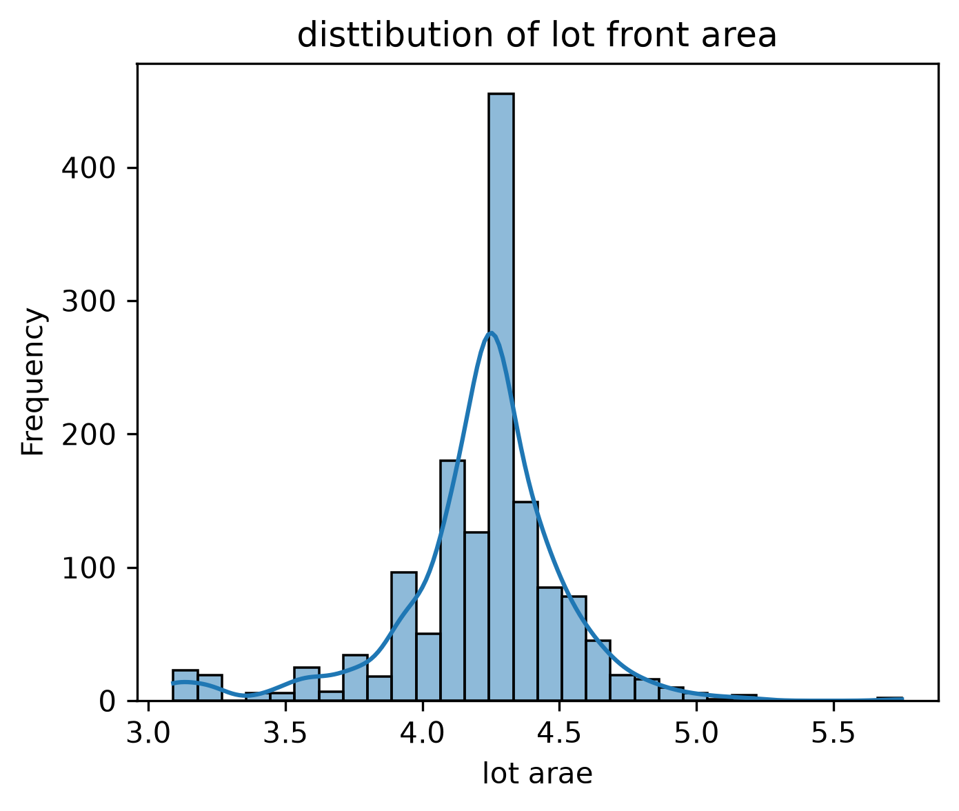
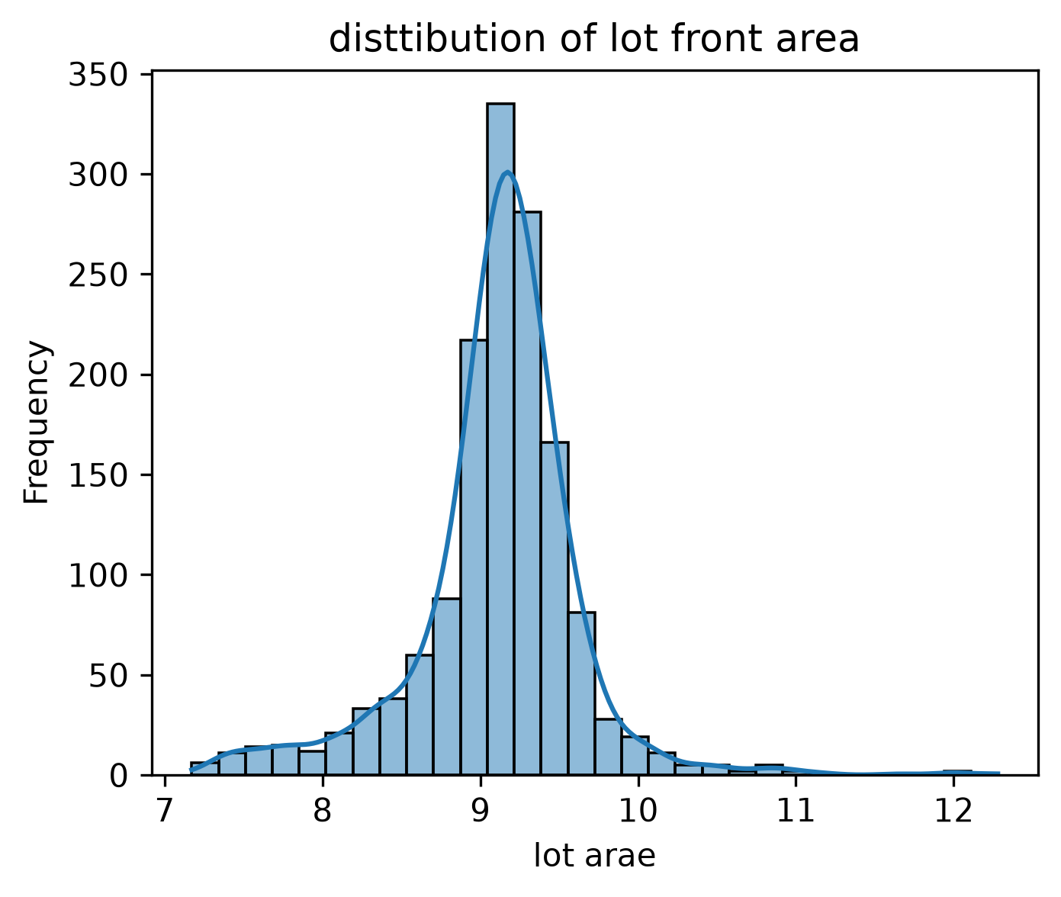

5 Insights from EDA
The following key observations were obtained:
- Overall house quality had the strongest positive relationship with SalePrice.
- Larger living areas generally resulted in higher selling prices.
- Garage size and total square footage significantly influenced property value.
- Several numerical variables exhibited positive skewness and required transformation.
- Weakly correlated variables contributed little to prediction accuracy and were excluded during feature selection.
- The selected features formed a compact and informative dataset for machine learning.

PHASE 4 Model Development and Optimization

1 Overview
After completing data preprocessing and exploratory data analysis, the prepared dataset was divided into training and testing sets for model development. Multiple regression algorithms were implemented to predict house prices, and their performances were compared using standard regression evaluation metrics.
The objective of this phase was to identify the most accurate regression model through systematic training, optimization, and evaluation.

2 Train-Test Split
The processed dataset was divided into training and testing datasets using a 70:30 ratio.
- Training Dataset: 70%
- Testing Dataset: 30%
The training dataset was used to learn the relationships between the input features and the target variable, while the testing dataset was used to evaluate the performance of each model on unseen data.
3 Machine Learning Models
Several regression algorithms were implemented and compared.
The models used in this project are:
- Linear Regression
- Decision Tree Regressor
- Random Forest Regressor
- Gradient Boosting Regressor
- XGBoost Regressor
- LightGBM Regressor
- CatBoost Regressor
Each model was trained using the same training dataset to ensure a fair comparison.

4 Model Evaluation Metrics
- Coefficient of Determination (R² Score)
- Mean Absolute Error (MAE)
- Mean Squared Error (MSE)
- Root Mean Squared Error (RMSE)

PHASE 5 Model Optimization

To improve prediction performance, different optimization techniques were applied depending on the regression algorithm.

1MODEL OPTIMIZATION TECHNIQUE

1 Linear Regression
The Linear Regression model was improved using:
- Feature Engineering
- Feature Selection
- Log Transformation
- Missing Value Treatment
- Multicollinearity Analysis using Variance Inflation Factor (VIF)
Since Linear Regression has very few tunable hyperparameters, GridSearchCV and RandomizedSearchCV were not applied.

2 Decision Tree Regressor
The Decision Tree model was optimized using:
- GridSearchCV
The following hyperparameters were tuned:
- Maximum Depth
- Minimum Samples Split
- Minimum Samples Leaf
- Criterion
- Maximum Features
Cross-validation was used during hyperparameter tuning to prevent overfitting.

3 Random Forest Regressor
The Random Forest model was optimized using:
- GridSearchCV
Important parameters include:
- Number of Trees
- Maximum Depth
- Minimum Samples Split
- Minimum Samples Leaf
- Maximum Features

4 Gradient Boosting Regressor
The Gradient Boosting model was optimized using:
- Learning Rate
- Number of Estimators
- Maximum Depth
- Subsample Ratio

5 XGBoost Regressor
The XGBoost model was optimized by tuning:
- Learning Rate
- Maximum Depth
- Number of Estimators
- Subsample
- Column Sampling

6 LightGBM Regressor
The LightGBM model was optimized by adjusting:
- Number of Leaves
- Learning Rate
- Number of Estimators
- Maximum Depth
Cross-validation was incorporated during parameter tuning.

7 CatBoost Regressor
The CatBoost model was optimized using:
- Iterations
- Learning Rate
- Tree Depth
- Random Strength
2 Model Comparison
Model | Linear | Decision | Random | Gradient | XGBoost | LightGbM | CatBoost
R2 | 0.85377 | 0.81179 | 0.9080 | 0.900180 | 0.88200 | 0.88091 | 0.91301
MAE | 20859.71 | 25017.93 | 16993.14 | 16983.67 | 19029.90 | 17305.11 | 16350.61
MSE | 102038 | 131333 | 696543 | 6418200 | 8228238 | 83100811 | 6069969
RMSE | 31943.43 | 26392 | 263922 | 25334 | 28684 | 28887 | 24637

PHASE 6 MODEL COMPARISON AND SELECTION

1 Model Selection
After training and optimizing all regression models, a comparative analysis was performed to determine the most suitable model for house price prediction.
The performance of each model was evaluated using four regression evaluation metrics:
- R² Score – Measures how well the model explains the variance in the target variable. A higher R² score indicates better predictive performance.
- Mean Absolute Error (MAE) – Measures the average absolute difference between the predicted and actual house prices. Lower values indicate better accuracy.
- Mean Squared Error (MSE) – Calculates the average squared prediction error. Lower values represent fewer large prediction errors.
- Root Mean Squared Error (RMSE) – Represents the prediction error in the same unit as the target variable. Lower RMSE indicates more accurate predictions.
The performance of all implemented regression models, including Linear Regression, Decision Tree Regressor, Random Forest Regressor, Gradient Boosting Regressor, XGBoost Regressor, LightGBM Regressor, and CatBoost Regressor, was compared using these evaluation metrics.
Among all the models, the CatBoost Regressor achieved the highest R² Score while producing the lowest MAE, MSE, and RMSE values. This indicates that CatBoost provided the most accurate predictions and the smallest prediction errors compared to the other models.
Based on the comparative evaluation, the CatBoost Regressor was selected as the final prediction model and used for deployment in the Flask-based house price prediction application.
While comparing all the model Catboost regressor have high R2 and lower mae,mse,rmse
MODEL/SCORE | R2 | MAE | MSE | RMSE | STATUS
Linear | 0.85377 | 20859.71 | 102038 | 31943.43 | LOWER
Decision | 0.81179 | 25017.93 | 131333 | 26392 | LOWER
Random | 0.9080 | 16993.14 | 696543 | 263922 | LOWER
Gradient | 0.900180 | 16983.67 | 6418200 | 25334 | LOWER
XGBoost | 0.882000 | 190299.02 | 8228238 | 28684 | LOWER
LightGbM | 0.88091 | 17305.11 | 83100811 | 28887 | LOWER
CatBoost | 0.91301 | 16350.61 | 6069969 | 24637 | HIGHER

2 Actual vs Predicted Analysis
An Actual vs Predicted scatter plot was generated to compare the model's predicted house prices with the actual sale prices.

Purpose
- Evaluate prediction accuracy.
- Identify under-predictions and over-predictions.
- Verify how closely predictions follow actual values.

Observation
Most predicted values were distributed close to the diagonal reference line, indicating that the CatBoost Regressor was able to accurately estimate house prices for the majority of properties. Small deviations from the reference line represent normal prediction errors.
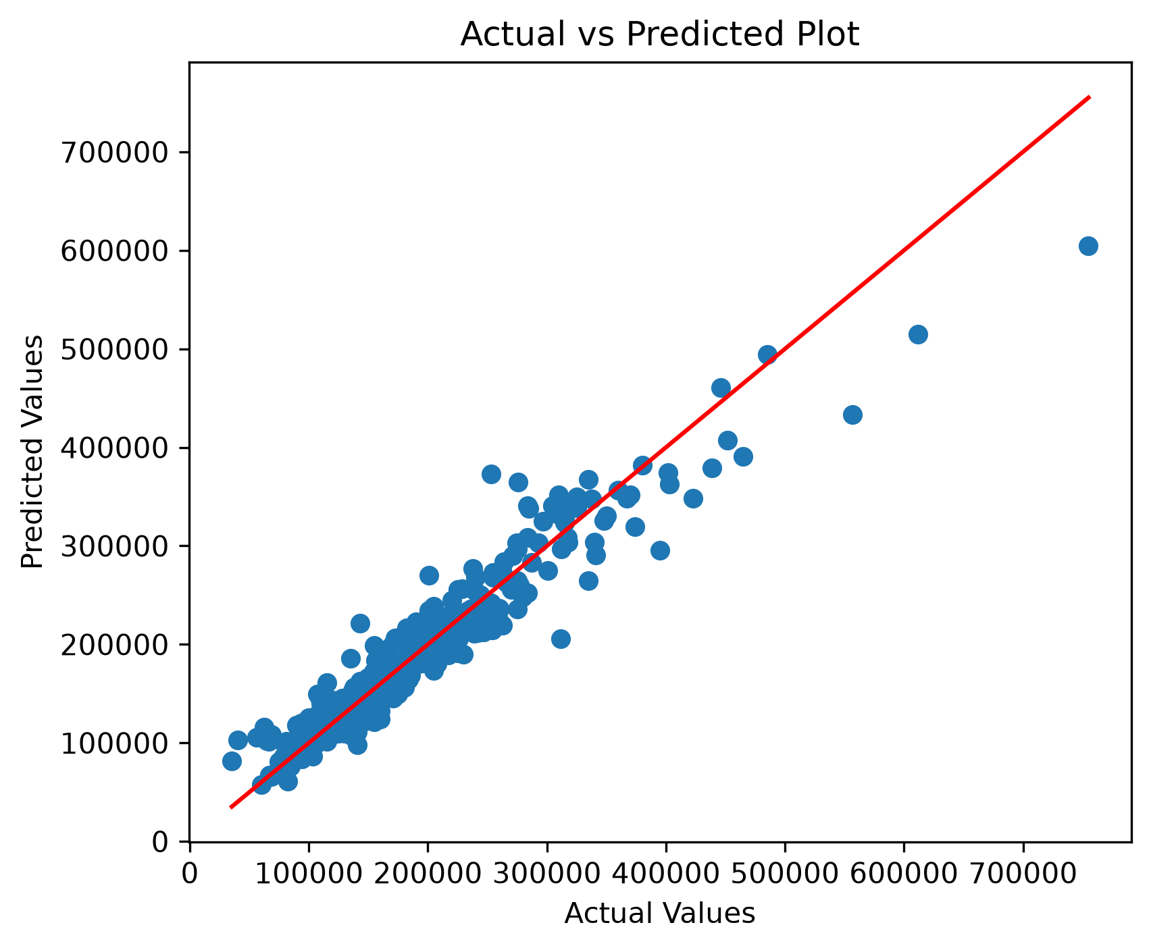

3 Residual Analysis
A Residual Plot was created using the residual values (Actual Price − Predicted Price).

Purpose
- Examine prediction errors.
- Detect systematic bias.
- Check whether residuals are randomly distributed.

Observation
The residuals were randomly scattered around zero without any noticeable pattern. This indicates that the model does not exhibit significant bias and captures the underlying relationship between the selected features and the target variable effectively.
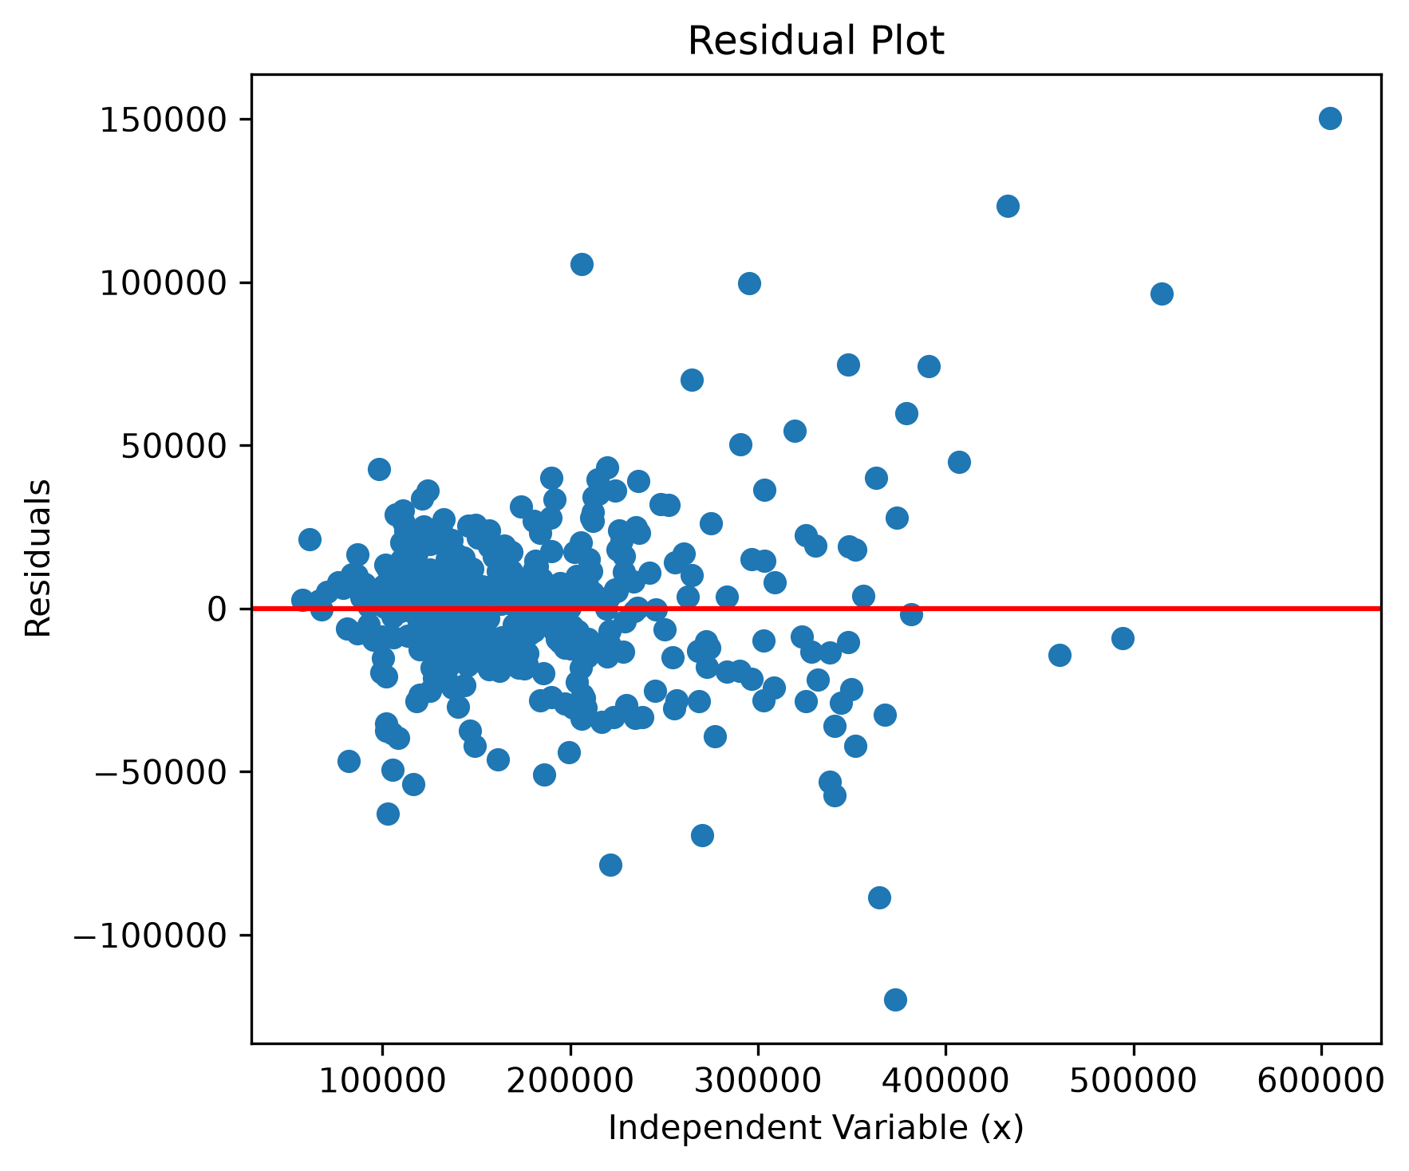

4 Feature Importance Analysis
The CatBoost model provides feature importance scores that measure the contribution of each feature toward the prediction of house prices.

Purpose
- Identify the most influential features.
- Improve model interpretability.
- Validate the feature selection process.

Observation
The analysis showed that features related to house quality, living area, total square footage, and garage size contributed most significantly to the prediction of SalePrice. Less influential features received lower importance scores, confirming that the feature selection process successfully retained the most informative predictors.

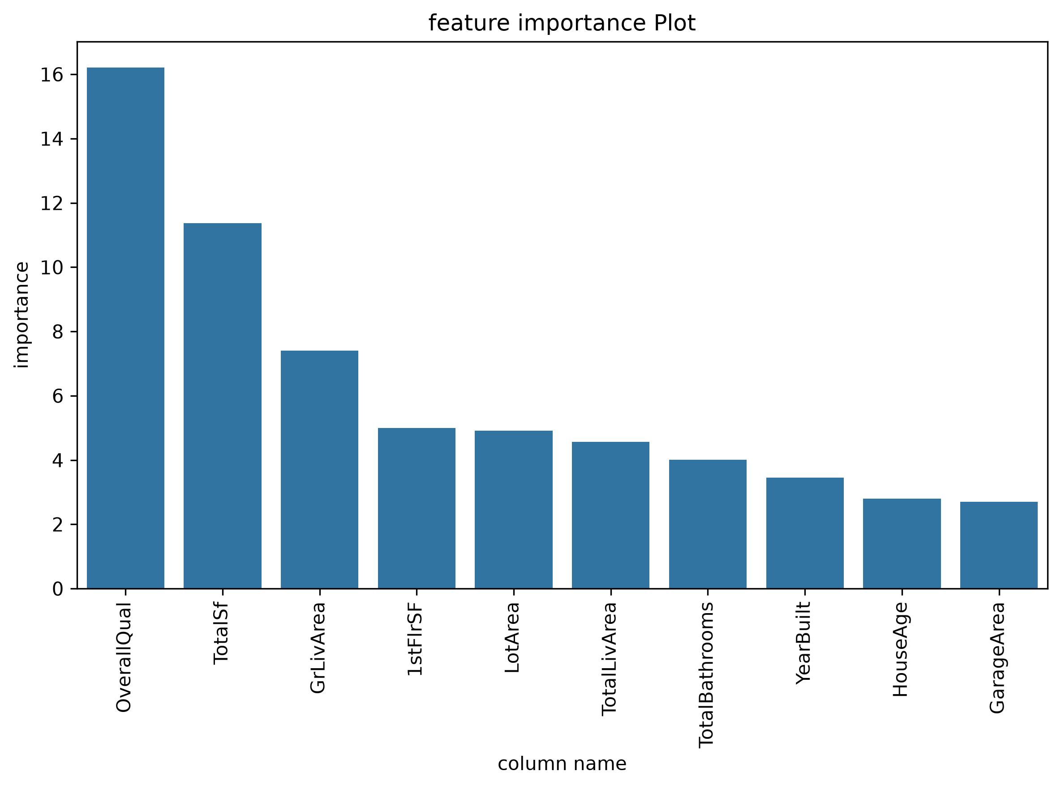

5 Model Comparison Visualization
A comparison chart was created to evaluate the performance of all implemented regression models.
The following models were compared:
- Linear Regression
- Decision Tree Regressor
- Random Forest Regressor
- Gradient Boosting Regressor
- XGBoost Regressor
- LightGBM Regressor
- CatBoost Regressor

Purpose
- Compare the performance of multiple regression algorithms.
- Identify the best-performing model.
- Provide a visual summary of evaluation metrics.

Evaluation Metrics Used
- R² Score
- Mean Absolute Error (MAE)
- Mean Squared Error (MSE)
- Root Mean Squared Error (RMSE)

Observation
The comparison chart demonstrated that the CatBoost Regressor consistently outperformed the other regression models by achieving the highest R² Score and the lowest prediction errors. This confirmed its suitability as the final model for deployment.
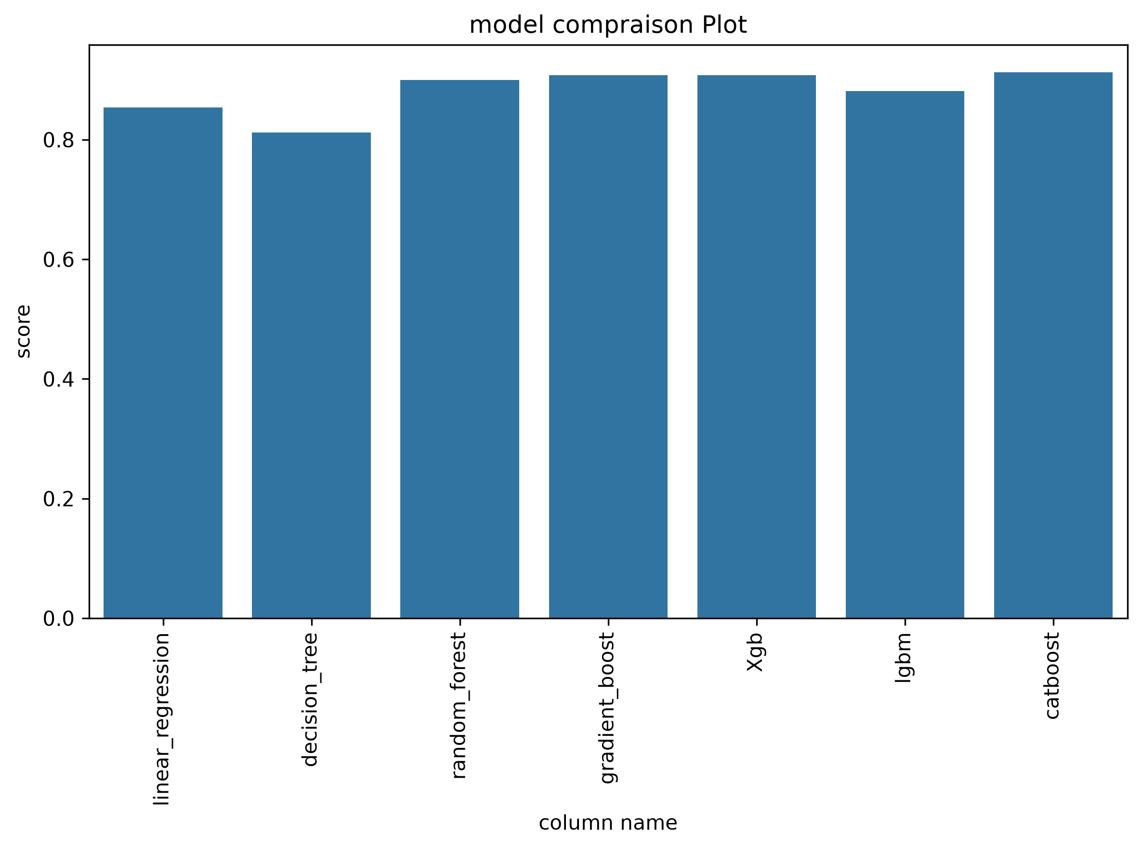
From the above observation catboost model have performed well so it was the model we choose.

Outcome of Phase 6
At the end of this phase:
- The prediction accuracy of the CatBoost model was validated using the Actual vs Predicted plot.
- Residual analysis confirmed that prediction errors were randomly distributed without significant bias.
- Feature importance analysis identified the most influential predictors contributing to house price estimation.
- A visual comparison of all regression models confirmed that the CatBoost Regressor achieved the best overall performance.
- These analyses increased confidence in the reliability and interpretability of the final deployed model.

FLASK DEVELOPMENT AND DASHBOARD

1 Overview
After selecting the CatBoost Regressor as the final prediction model, a web application was developed using the Flask framework. The objective of this phase was to provide an interactive and user-friendly interface that allows users to predict house prices and explore the complete machine learning analysis without requiring programming knowledge.
The trained CatBoost model, preprocessing pipeline, and feature selection process were integrated into the Flask application to enable real-time house price prediction.

2 Flask Framework
Flask is a lightweight Python web framework used for developing web applications.
The Flask application acts as a bridge between the trained machine learning model and the user interface by handling:
- User requests
- Data preprocessing
- Model prediction
- Result visualization
- Report generation

3 Application Architecture
The application follows a modular architecture consisting of the following components:
- Frontend
  - HTML
  - CSS
  - Bootstrap
  - JavaScript
- Backend
  - Flask
  - Pandas
  - NumPy
  - Joblib
  - Reportlab
- Machine Learning Model
  - CatBoost Regressor
- Dataset
  - Housing Dataset

4 Dashboard Module
The dashboard serves as the home page of the application and provides an overview of the project.
The dashboard displays:
- Dataset summary
- Number of records
- Number of features
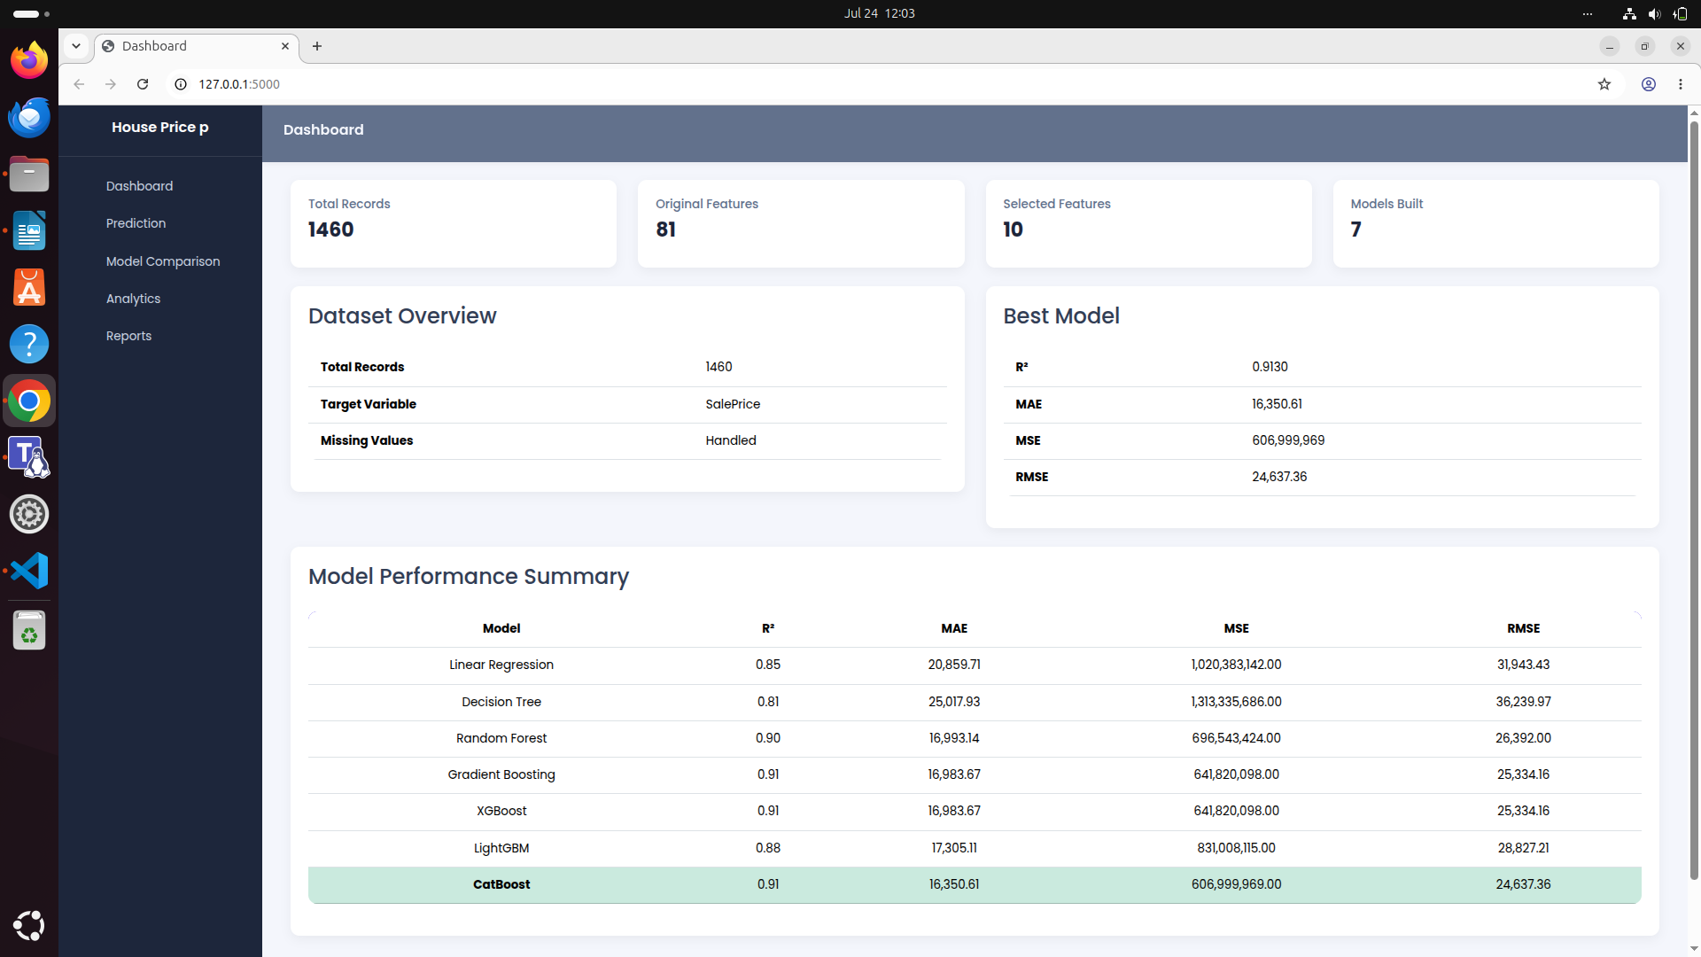
- Selected model
- Performance metrics
- Model comparison summary
The information displayed on the dashboard is dynamically loaded from the processed dataset and model evaluation results.

Fig dashboard

5 Prediction Module
The prediction module enables users to estimate the selling price of a house.
Users provide the required property details through an input form containing the selected features.
Examples include:
- Overall Quality
- Total Square Footage
- Ground Living Area
- First Floor Area
- Lot Area
- Total Living Area
- Total Bathrooms
- Year Built
- House Age
- Garage Area
Before prediction, the application automatically performs the same preprocessing steps that were applied during model training, including feature transformation and logarithmic scaling where required.
The processed input is then passed to the trained CatBoost model to generate the predicted house price.
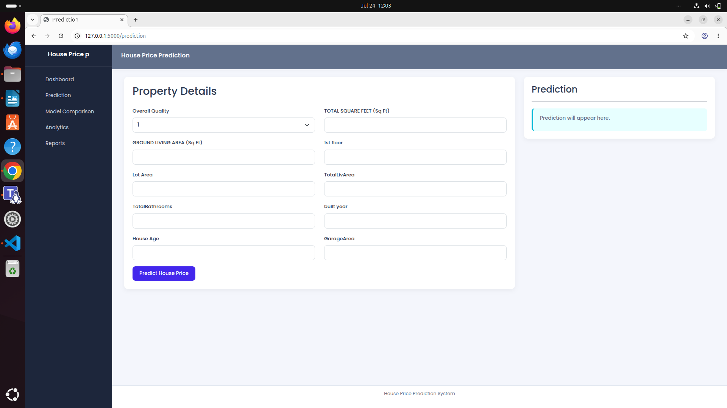
The predicted value is displayed in a readable currency format.

Fig prediction page

6 Model Comparison Dashboard
A dedicated dashboard was developed to compare the performance of all implemented regression models.
The comparison includes:
- Linear Regression
- Decision Tree Regressor
- Random Forest Regressor
- Gradient Boosting Regressor
- XGBoost Regressor
- LightGBM Regressor
- CatBoost Regressor
The dashboard presents evaluation metrics including:
- R² Score
- Mean Absolute Error (MAE)
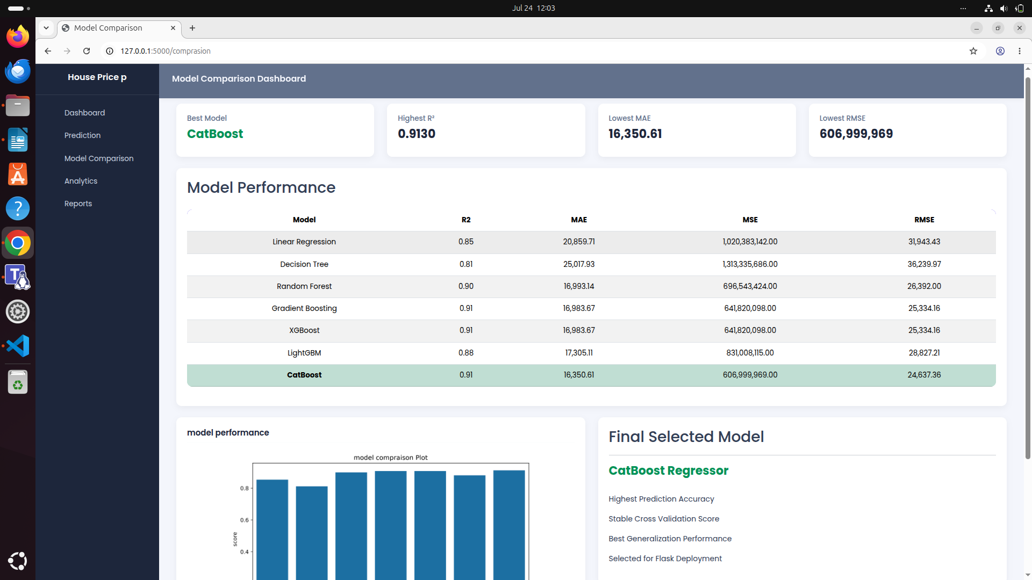
- Mean Squared Error (MSE)
- Root Mean Squared Error (RMSE)
This module helps users understand why the CatBoost Regressor was selected as the final prediction model.

Fig comparison page

7 Analytics Dashboard
The analytics dashboard provides visual insights into the dataset and model performance.
The dashboard includes:
- Correlation Heatmap
- Feature Distribution Plots
- Feature Importance Chart
- Actual vs Predicted Plot
- Residual Plot
- Model Comparison Chart
These visualizations help users understand the relationships between features and evaluate the effectiveness of the prediction model.

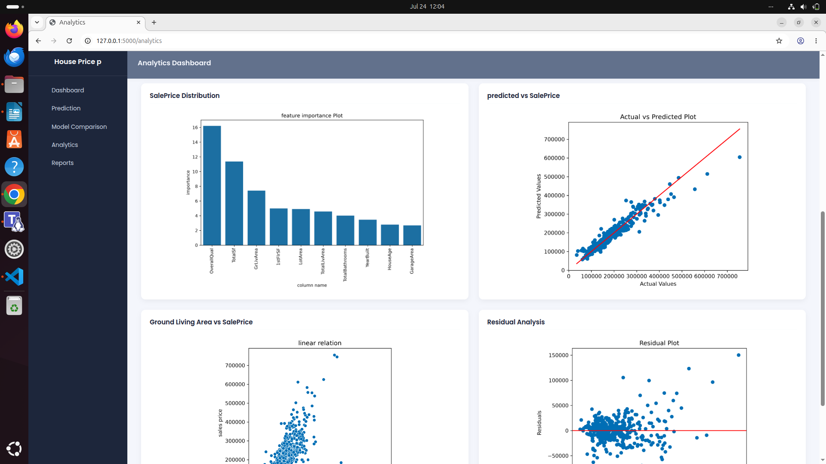
Fig analytic page

8 Report Generation
The application includes an automated report generation feature.
Users can download:
- Prediction Report
- Model Evaluation Report
- Model Comparison Report
he reports are generated dynamically in PDF format and include prediction results, evaluation metrics, and model performance summaries.

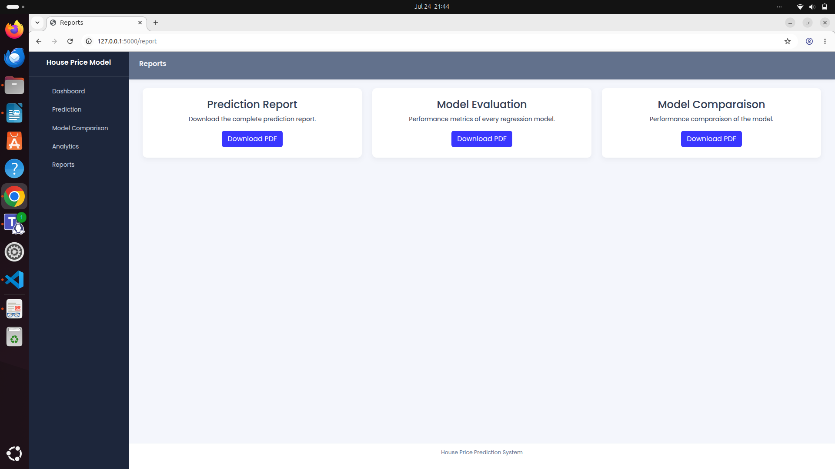
Fig Report page

