Phase 1 – Data Understanding
1.1 Overview
The first phase of the project focuses on understanding the available electricity-demand datasets, examining their structure and quality, selecting the dataset to be used for forecasting, and identifying important temporal patterns in electricity consumption.
Several electricity-demand datasets were initially examined, including:
- AEP
- COMED
- DAYTON
- DEOK
- DOM
- DUQ
- EKPC
- FE
- NI
- PJM
- PJME
- PJMW
The analysis was performed using Pandas, NumPy, Matplotlib, and Seaborn.
1.2 Dataset Exploration
The datasets were loaded individually and examined using operations such as: df.info()
df.describe()
df.isnull().sum()
df[df.duplicated()]
df.head()
This was done to understand:
- Number of observations
- Number of columns
- Data types
- Missing values
- Duplicate records
- Statistical distribution of electricity demand
The initial combined PJM dataset contained 178,262 rows and 13 columns, but the individual regional datasets were also investigated separately.
1.3 Dataset Selection
After examining the available datasets, PJME_hourly.csv was selected for the forecasting project.
The selected dataset contains two main columns:
Column | Description
Datetime | Timestamp of the electricity-demand observation
PJME_MW | Electricity demand in megawatts

The selected PJME dataset contains 145,366 observations.
The dataset was loaded using:
df = pd.read_csv(r'../data/raw/PJME_hourly.csv')
Statistic | Value
Count | 145,366
Mean | 32,080.22 MW
Standard Deviation | 6,464.01 MW
Minimum | 14,544 MW
25% | 27,573 MW
Median | 31,421 MW
75% | 35,650 MW
Maximum | 62,009 MW

1.4 Duplicate and Missing Value Analysis
Duplicate records and missing values were checked for the selected PJME dataset.
The duplicate check returned:
Empty DataFrame

Therefore, no duplicate records were identified in the PJME dataset during this analysis.
The dataset was also checked for missing values using:
df.isnull().sum()
The analysis did not identify missing values in the selected PJME demand data.
1.5 Datetime Conversion
The Datetime column was initially read as a string and was converted into a datetime datatype:
df['Datetime'] = df['Datetime'].astype('datetime64[ms]')
This conversion allowed temporal information to be extracted from the timestamp.
The following features were then created:
df['year'] = df['Datetime'].dt.year
df['month'] = df['Datetime'].dt.month
df['day_name'] = df['Datetime'].dt.day_name()
df['hour'] = df['Datetime'].dt.hour
The dataset covers the years:
2002 – 2018
1.6 Hourly Demand Analysis
The average electricity demand was calculated for each hour of the day.
df.groupby('hour')['PJME_MW'].mean()
The results show a clear hourly demand pattern.
Hour | Average Demand (MW)
0 | 29,523.61
4 | 25,414.92
8 | 31,490.83
12 | 34,588.62
16 | 35,065.39
18 | 36,421.93
19 | 36,426.63
23 | 32,047.50

The lowest average demand occurs around the early morning hours, while demand increases during the daytime and reaches higher levels during the evening.
This demonstrates that hour of the day is an important factor for electricity demand forecasting.

1.7 Monthly Demand Analysis
Monthly average demand was calculated using:
df.groupby('month')['PJME_MW'].mean()
Month | Average Demand (MW)
January | 34,343.25
February | 33,434.97
March | 30,514.90
April | 27,863.34
May | 28,695.36
June | 33,811.80
July | 37,881.97
August | 36,595.96
September | 31,484.05
October | 28,119.23
November | 29,328.73
December | 32,676.25

The highest average demand occurs in July, while the lowest average demand occurs in April.
This indicates that seasonal/monthly patterns exist in electricity consumption.
1.8 Day-of-Week Analysis
Average electricity demand was also calculated according to the day of the week.
df.groupby('day_name')['PJME_MW'].mean()
Day | Average Demand (MW)
Monday | 32,672.03
Tuesday | 33,272.27
Wednesday | 33,261.50
Thursday | 33,085.86
Friday | 32,688.10
Saturday | 30,162.88
Sunday | 29,411.87

The analysis shows that weekday demand is generally higher than weekend demand.
In particular, Sunday has the lowest average demand, while Tuesday has the highest average demand among the days of the week.
This indicates that day-of-week information can also be useful for forecasting.
1.9 Yearly Demand Analysis
Average demand was also examined by year:
df.groupby('year')['PJME_MW'].mean()
The dataset contains observations from 2002 through 2018.
The yearly averages vary over time, indicating that electricity demand does not remain constant throughout the entire period.
This provides evidence of longer-term changes in the demand pattern.
1.10 Time Interval Analysis
The difference between consecutive timestamps was examined using:
time_diffs = df['Datetime'].diff()
print(time_diffs.value_counts())
The most common interval was:
0 days 01:00:00 → 139,275 observations
This confirms that the dataset is primarily composed of hourly observations.
Some larger or negative time differences were also observed, indicating irregularities in the timestamp sequence.
This is important because the forecasting models depend on the chronological ordering of observations.
1.11 Weekly Feature
A week-of-year feature was created:
df['week_of_year'] = df['Datetime'].dt.isocalendar().week
This feature provides information about the position of each observation within the year and can help represent weekly/seasonal patterns.
1.12 Visual Analysis
Several visualizations were created to understand the demand patterns.
Hourly Consumption
A line plot was created to visualize demand across different hours of the day.
Daily Consumption
A visualization was created using day_name to compare demand across the days of the week.
The resulting figure was saved as:
static/images/day.png
Monthly Consumption
A monthly demand visualization was created and saved as:
static/images/monthly.png
Weekly Consumption
A weekly demand visualization based on week_of_year was created and saved as:
static/images/weekly.png
Demand Distribution
A histogram was also created to examine the distribution of PJME_MW.
1.13 Dataset Prepared for Next Phase
After the initial analysis and feature creation, the resulting dataframe was saved as:
df.to_csv(
r'../data/cleaned/timestap_pjme.csv',
index=False
)
This prepared dataset can then be used in the subsequent preprocessing and feature-engineering stages.
1.14 Phase 1 Conclusion
In Phase 1, multiple electricity-demand datasets were initially explored and compared. The PJME hourly dataset was selected as the primary dataset for the forecasting project.
The selected dataset contains 145,366 hourly observations covering the period from 2002 to 2018, with electricity demand represented by PJME_MW.
The analysis identified several important demand patterns:
- Hourly patterns — demand changes significantly throughout the day.
- Monthly/seasonal patterns — demand varies considerably between months.
- Weekly patterns — weekday and weekend demand differ.
- Yearly variations — average demand changes across years.
- Hourly temporal structure — most observations are one hour apart.
These findings establish the basis for creating temporal features and developing forecasting models in the following phases.

Phase 2 – Data Preprocessing
2.1 Introduction
The objective of this phase is to transform the electricity demand dataset into a clean and structured format suitable for time-series forecasting. The raw dataset was processed to ensure chronological consistency, handle missing observations, and create the features required by the forecasting models.
2.2 Data Cleaning
The dataset obtained from Phase 1 was first examined for timestamp inconsistencies and duplicate observations.
The data was sorted according to the Datetime column to maintain the chronological order of electricity demand observations. Duplicate timestamps were removed to ensure that each timestamp represented a single demand observation.
Since the forecasting models depend on the temporal sequence of the data, maintaining the correct chronological order was essential.
2.3 Handling Missing Time Intervals
The electricity demand data was expected to contain hourly observations. Therefore, the timestamps were examined to identify missing hourly intervals.
A continuous hourly time index was created between the minimum and maximum timestamps. This allowed missing timestamps to be identified.
Where demand observations were missing, the missing demand values were estimated using linear interpolation based on neighboring observations.
This produced a continuous hourly demand series that could be used for subsequent feature engineering.
2.4 Temporal Feature Engineering
Datetime information was used to create additional features that describe the temporal behavior of electricity consumption.
The following features were created:
Feature | Purpose
Year | Captures long-term yearly variation
Month | Captures seasonal variation
Hour | Captures daily consumption patterns
Day Number | Represents the day of the week
Day of Month | Represents position within a month
Week of Year | Captures weekly/annual patterns
Weekend | Distinguishes weekdays from weekends

The day_name categorical feature was removed after creating the numerical day_num representation.
2.5 Lag Features
Historical electricity demand is highly relevant for forecasting. Therefore, lag features were introduced to provide the models with information from previous time periods.
Three lag variables were created:
Lag 1
Represents electricity demand from the previous hour.
Lag 24
Represents electricity demand from 24 hours earlier and helps capture daily demand patterns.
Lag 168
Represents electricity demand from 168 hours earlier, equivalent to 7 days, and helps capture weekly demand patterns.
These lag features allow the forecasting models to learn relationships between current demand and previous demand observations.
2.6 Rolling Statistics
Rolling statistical features were created using a 24-hour window.
Rolling Mean
The 24-hour rolling mean represents the average demand over the previous day.
It helps smooth short-term fluctuations and provides information about the recent demand level.
Rolling Standard Deviation
The 24-hour rolling standard deviation represents the variation in demand during the previous 24 hours.
It provides information about recent demand volatility.
The rolling calculations were based on previous observations so that future information was not introduced into the model inputs.
2.7 Handling Rows Generated by Feature Engineering
Creating lag and rolling features naturally produces missing values at the beginning of the dataset because sufficient historical observations are not available for the first records.
These incomplete rows were removed after the feature-engineering process.
The resulting dataset therefore contained complete observations for all features required by the forecasting models.
2.8 Final Feature Set
After preprocessing and feature engineering, the model input consisted of the following features:
- Year
- PJME_MW
- Month
- Hour
- Day Number
- Day of Month
- Week of Year
- Weekend Indicator
- Lag 1
- Lag 24
- Lag 168
- 24-Hour Rolling Mean
- 24-Hour Rolling Standard Deviation
The electricity demand variable PJME_MW was retained as the target variable.
2.9 Train, Validation and Test Split
The processed time-series dataset was divided into three chronological subsets:
Dataset | Percentage
Training | 70%
Validation | 15%
Testing | 15%

Unlike a conventional machine-learning dataset, the data was not randomly shuffled before splitting.
The chronological split was used because future observations must not be available to the model during training.
The three datasets were saved separately for use during model development and evaluation.
2.10 Feature Scaling
Min-Max normalization was applied to the input features.
The scaler was fitted using only the training data. The same fitted scaler was then applied to the validation and test datasets.
This approach prevents information from the validation and test sets from leaking into the training process.
The target variable PJME_MW was scaled separately using another Min-Max scaler.
Keeping a separate target scaler allows the model's predictions to later be converted back from the normalized range to the original MW scale.

2.11 Saved Preprocessed Data
The preprocessing stage produced the following important files:
File | Purpose
cleaned.csv | Complete processed dataset
train.csv | Training dataset
val.csv | Validation dataset
test.csv | Testing dataset
scaler.pkl | Saved feature scaler
target_scaler.pkl | Saved target scaler
These files were subsequently used for sequence preparation and model development.
2.13 Phase 2 Conclusion
Phase 2 transformed the electricity demand data into a structured dataset suitable for time-series forecasting.
The preprocessing stage ensured that the data was chronologically consistent and free from incomplete feature records. Temporal, lag, and rolling features were introduced to capture daily, weekly, and seasonal demand behavior.
The data was then divided into training, validation, and testing sets and normalized using Min-Max scaling. The fitted scalers were saved so that the same preprocessing procedure could be applied during model evaluation and deployment.

Phase 3 – Exploratory Data Analysis (EDA)
3.1 Introduction
The objective of this phase is to perform Exploratory Data Analysis (EDA) on the cleaned electricity demand dataset.
EDA is used to understand the distribution of electricity demand, identify patterns and trends, examine relationships between variables, and detect unusual observations before developing forecasting models.
The analysis focuses mainly on the temporal behavior of PJME_MW, since electricity demand is a time-dependent variable
3.2 Objectives of EDA
The main objectives of this phase are:
- Understand the distribution of electricity demand.
- Analyze hourly demand patterns.
- Analyze daily demand patterns.
- Analyze weekly demand patterns.
- Analyze monthly and seasonal demand patterns.
- Examine yearly demand trends.
- Identify peak and minimum demand periods.
- Study relationships between demand and engineered features.
- Identify unusual demand behavior and outliers.
- Understand the characteristics that should be considered during model development.
3.3 Distribution of Electricity Demand
The distribution of PJME_MW was analyzed to understand the typical electricity consumption range and the spread of demand values.
A histogram was used to visualize the distribution of electricity demand.
The analysis shows that electricity demand is concentrated around its typical operating range, while higher and lower demand values occur less frequently.
This analysis is useful for understanding the scale and variability of the target variable before training the forecasting models.
3.4 Hourly Demand Pattern
Electricity demand was analyzed according to the hour of the day.
The analysis shows that demand is not constant throughout a 24-hour period.
Demand is generally lower during the early morning hours and increases during the daytime. Higher demand is observed during the evening period.
This demonstrates that hour of the day is an important predictor of electricity consumption.
The hourly pattern provides justification for including the hour feature in the forecasting models.
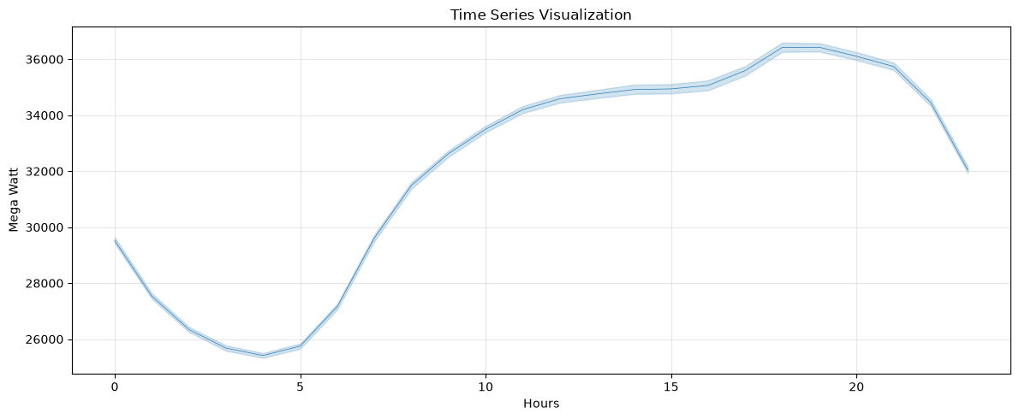

3.5 Daily Demand Pattern
The average electricity demand was analyzed for each day of the week.
The analysis shows a clear difference between weekday and weekend electricity consumption.
Weekdays generally have higher electricity demand compared with weekends, while Sunday records comparatively lower demand.
This indicates that electricity consumption is influenced by human activity and weekly routines.
Therefore, the day_num and is_weekend features are useful for capturing these patterns.
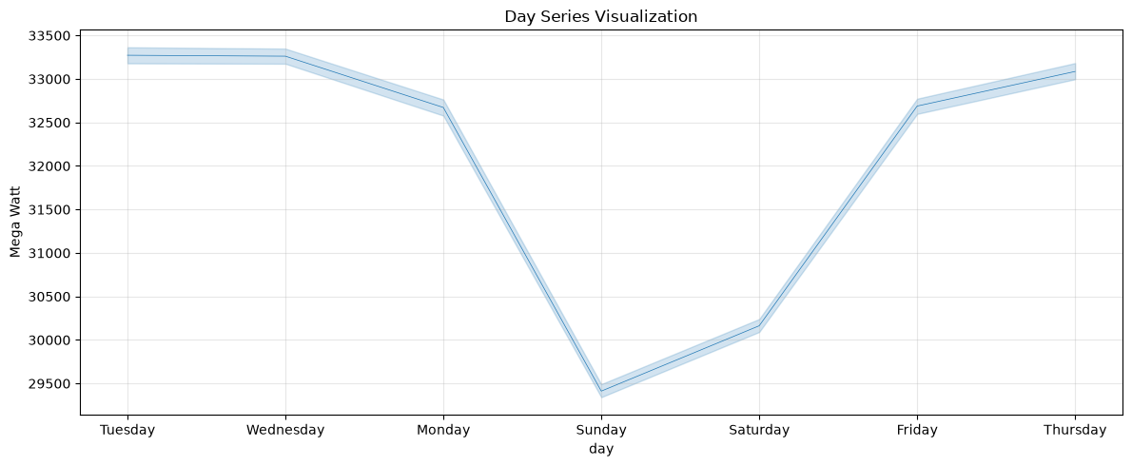
3.6 Weekly Demand Pattern
Weekly demand behavior was analyzed to identify recurring patterns across weeks of the year.
The analysis demonstrates that electricity demand changes throughout the year rather than remaining constant.
The weekly pattern can be influenced by seasonal conditions, working days, weekends, and changes in electricity usage.
This supports the use of historical lag features such as the 168-hour lag, which represents demand from the same hour approximately one week earlier.
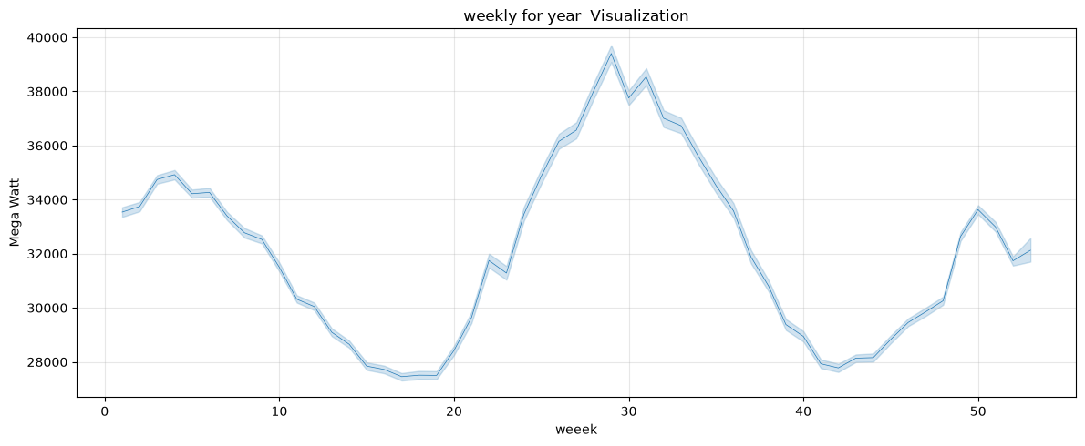

3.7 Monthly Demand Pattern
Monthly electricity demand was analyzed to identify seasonal variations.
The analysis showed noticeable differences in average electricity consumption between months.
Higher demand occurs during certain months, while other months have comparatively lower consumption.
This demonstrates the presence of seasonality in electricity demand.
The month feature was therefore retained as an important temporal variable for forecasting.
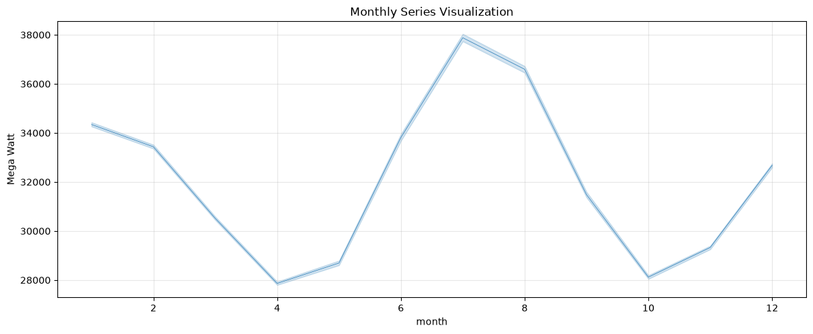
3.8 Correlation Analysis
Relationships between the numerical variables and electricity demand were examined using correlation analysis.
A correlation matrix/heatmap was used to visually investigate relationships between the available features.
The analysis helps determine which variables have stronger relationships with PJME_MW.
In particular, lag-based and rolling features are expected to provide useful information because previous electricity demand is strongly related to future demand.
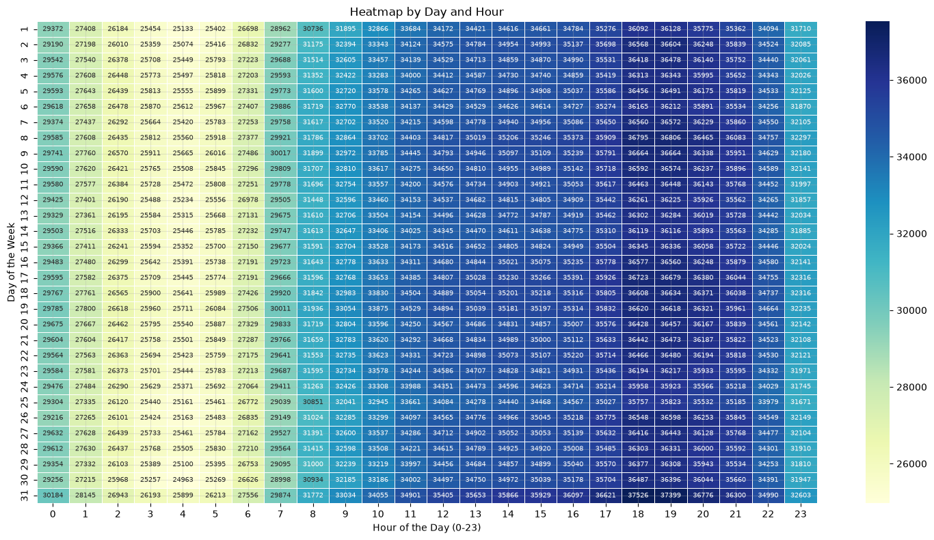
3.9 Importance of EDA for Model Development
The EDA findings directly influenced the feature engineering and model-development stages.
The observed temporal patterns justify the use of:
- hour for daily demand patterns
- month for seasonal patterns
- day_num for weekly patterns
- is_weekend for weekday/weekend differences
- lag_1 for short-term dependency
- lag_24 for daily dependency
- lag_168 for weekly dependency
- rolling_mean_24 for recent demand level
- rolling_std_24 for recent demand variability
Therefore, EDA provided the foundation for selecting meaningful forecasting features.

Phase 4 – Baseline Models
4.1 Introduction
The objective of this phase is to establish baseline forecasting models for electricity demand.
Baseline models provide a simple reference point against which the more advanced deep learning models can later be compared. Before developing RNN, LSTM, GRU, and Bi-LSTM models, simple forecasting techniques were implemented using historical demand values.
The baseline approaches used in this phase are based entirely on previously observed electricity demand.
4.2 Dataset
The preprocessed training, validation, and testing datasets were loaded for the forecasting workflow.
The baseline models were evaluated using the test dataset.
The target variable used for forecasting was:
PJME_MW – Electricity Demand in MW
4.3 Evaluation Metrics
A common evaluation function was created to evaluate all baseline forecasting methods consistently.
The predictions and actual values were converted back to their original MW scale using the previously saved target scaler.
The following metrics were calculated:
- MAE – Mean Absolute Error
- MSE – Mean Squared Error
- RMSE – Root Mean Squared Error
- MAPE – Mean Absolute Percentage Error
- R² – Coefficient of Determination
Using the inverse-transformed values ensures that the error metrics are represented in meaningful electricity-demand units such as MW.
4.4 Naive Forecast
The first baseline is the Naive Forecast.
The basic assumption is that the most recent demand value can be used as the prediction for the next observation.
In this project, the lag_1 feature was used as the naive prediction.
Therefore:
Current forecast = Previous-hour demand
This provides a very simple benchmark for determining whether more sophisticated models can improve upon a basic historical-value prediction.

4.5 Previous-Day Forecast
The second baseline uses the electricity demand from 24 hours earlier.
The lag_24 feature was used for this forecast.
Therefore:
Forecast = Demand from the same hour on the previous day
This approach attempts to capture the daily recurring pattern in electricity consumption.
4.6 Previous-Week Forecast
The third baseline uses the demand from 168 hours earlier.
Since:
168 hours = 7 days
the method predicts demand using the value from approximately the same hour one week earlier.
Therefore:
Forecast = Demand from the previous week
This provides a simple way of capturing weekly demand patterns.
4.7 24-Hour Moving Average
The fourth baseline uses the 24-hour rolling mean as the prediction.
The rolling_mean_24 feature was used as the forecast.
This method predicts demand based on the average electricity consumption over the previous 24 hours.
Compared with the Naive method, the moving average reduces the effect of individual short-term fluctuations.
4.8 Baseline Models Used
Baseline Model | Input Used | Forecasting Idea
Naive | lag_1 | Previous-hour demand
Previous-Day | lag_24 | Same hour from previous day
Previous-Week | lag_168 | Same hour from previous week
24-Hour Moving Average | rolling_mean_24 | Average demand over previous 24 hours

4.9 Purpose of Baseline Models
The baseline models establish a reference level of forecasting performance.
For example, if a deep learning model produces a lower MAE and RMSE than the Naive baseline, it indicates that the deep learning model is learning useful patterns beyond simply relying on the most recent observation.
Similarly, comparison with the previous-day, previous-week, and moving-average approaches helps determine whether the advanced models provide meaningful improvements over simpler forecasting strategies.
4.10 Phase 4 Conclusion
In this phase, four baseline forecasting approaches were implemented using historical electricity demand:
- Naive Forecast
- Previous-Day Forecast
- Previous-Week Forecast
- 24-Hour Moving Average
All models were evaluated using the same set of regression metrics after converting the predictions back to the original MW scale.
These baseline results provide the reference point for evaluating the more advanced deep learning forecasting models developed in the subsequent phase.

Phase 5 – Model Development
5.1 Introduction
The objective of Phase 5 is to develop deep learning models for electricity demand forecasting.
Since electricity demand is a time-series problem, recurrent neural network architectures were selected because they are designed to learn relationships between observations across time.
The models developed in this phase are:
- RNN
- LSTM
- GRU
- Bi-LSTM
The models were trained using historical electricity-demand sequences and evaluated on unseen test data.
5.2 Sequence Configuration
The forecasting problem was formulated as a multi-step forecasting problem.
The model uses:
- 24 historical hourly observations as input.
- 24 future hourly observations as the prediction target.
Therefore, the model learns the relationship between the previous 24 hours and the following 24 hours of electricity demand.
The input sequence has the general structure:
24 time steps × available features
while the output contains:
24 future demand values
This configuration allows the models to perform 24-hour electricity demand forecasting.
5.3 Recurrent Neural Network (RNN)
A basic Simple RNN model was developed as the first deep learning architecture.
The architecture consists of:
- Simple RNN layer with 64 units
- Dropout layer with a rate of 0.2
- Dense layer with 32 neurons and ReLU activation
- Output Dense layer with 24 neurons
The final layer produces 24 demand predictions corresponding to the 24-hour forecasting horizon.
The model was trained using:
- Optimizer: Adam
- Loss function: Mean Squared Error (MSE)
- Metric: Mean Absolute Error (MAE)
- Epochs: 20
- Batch size: 64
Validation data was provided during training to monitor model performance on unseen validation sequences.
5.4 LSTM Model
An LSTM model was developed to better capture long-term dependencies in the electricity-demand sequence.
The architecture consists of:
- LSTM layer with 64 units
- Dropout layer with a rate of 0.2
- Dense layer with 32 neurons and ReLU activation
- Output Dense layer with 24 neurons
The LSTM model was trained using:
- Adam optimizer
- MSE loss
- MAE metric
- 10 epochs
- Batch size of 64
LSTM is particularly suitable for time-series forecasting because its memory mechanism allows it to retain useful information from earlier time steps.
5.5 GRU Model
A GRU model was developed as another recurrent architecture.
The architecture consists of:
- GRU layer with 64 units
- Dropout layer with a rate of 0.2
- Dense layer with 32 neurons and ReLU activation
- Output Dense layer with 24 neurons
The model was trained using:
- Adam optimizer
- MSE loss
- MAE metric
- 10 epochs
- Batch size of 64
The GRU architecture provides a simpler recurrent mechanism compared with LSTM while still being capable of learning temporal dependencies.
5.6 Bi-LSTM Model
A Bidirectional LSTM model was also developed.
The architecture consists of:
- Bidirectional LSTM layer with 64 LSTM units
- Dropout layer with a rate of 0.2
- Dense layer with 32 neurons and ReLU activation
- Output Dense layer with 24 neurons
The model was trained using:
- Adam optimizer
- MSE loss
- MAE metric
- 10 epochs
- Batch size of 64
The Bidirectional LSTM processes the sequence in both directions, allowing the network to learn richer relationships within the input sequence.
5.7 Common Model Architecture
The deep learning models follow a similar overall structure:
Input Sequence
↓
Recurrent Layer
↓
Dropout
↓
Dense Layer
↓
24-Hour Output Layer
The main difference is the recurrent layer used:
Model | Recurrent Layer | Units
RNN | SimpleRNN | 64
LSTM | LSTM | 64
GRU | GRU | 64
Bi-LSTM | Bidirectional LSTM | 64

5.8 Model Training
The models were trained using the prepared training sequences.
Validation sequences were supplied during training so that the model's performance could be monitored on data that was not used for updating the model weights.
The training process used a batch size of 64.
The RNN model was trained for 20 epochs, while the LSTM, GRU, and Bi-LSTM models were trained for 10 epochs in the primary 24-hour forecasting configuration.
5.9 Prediction
After training, each model was used to generate predictions on the test sequences.
The model outputs were initially in the scaled form because the target variable had been normalized during preprocessing.
The predictions were therefore inverse-transformed using the saved target scaler to convert them back to the original electricity-demand unit:
MW (Megawatts).
This allowed the final evaluation metrics to be interpreted in the original demand scale
5.10 Model Evaluation
The developed models were evaluated using:
- MAE
- RMSE
- MAPE
- R²
These metrics were calculated by comparing the predicted electricity demand with the actual test demand.
MAE
Measures the average absolute difference between actual and predicted demand.
RMSE
Measures the square root of the average squared prediction error and gives greater importance to larger errors.
MAPE
Measures the average percentage difference between actual and predicted demand.
R²
Measures how well the model explains the variation in electricity demand.
5.11 Additional Forecasting Horizons
The notebook also contains model-development experiments using longer historical input sequences.
Experiments were performed using different sequence lengths, including configurations corresponding to:
- 24 hours
- 48 hours
- 168 hours
This was done to investigate how different historical windows affect the forecasting model.
The primary forecasting configuration used for the project was the 24-hour sequence / 24-hour horizon setup.
5.12 Comparison of Deep Learning Models
The final model comparison obtained during the project was:
Based on the evaluation results, GRU was selected as the best-performing deep learning model.
Its performance was:
- MAE: 1338.70 MW
- MSE: 3,669,936.61
- RMSE: 1915.71 MW
- MAPE: 4.18%
- R²: 91.16%
The GRU model therefore provided the most accurate predictions among the RNN, LSTM, GRU, and Bi-LSTM models evaluated in this phase.
5.13 Phase 5 Conclusion
In Phase 5, four recurrent deep learning architectures were developed for multi-step electricity demand forecasting: RNN, LSTM, GRU, and Bi-LSTM.
Each model used historical electricity-demand sequences to predict the next 24 hours of demand. The models were trained using the Adam optimizer and MSE loss and evaluated using MAE, RMSE, MAPE, and R².
Among the deep learning approaches, the GRU model achieved the best performance, with an MAE of 1338.70 MW, RMSE of 1915.71 MW, MAPE of 4.18%, and R² of 91.16%.
The trained GRU model was subsequently used as the selected forecasting model for the later evaluation and Flask dashboard stages.

Phase 6 – Model Improvement and Hyperparameter Tuning
6.1 Introduction
The objective of Phase 6 is to improve the performance of the deep learning forecasting models developed in Phase 5.
Different model configurations and training parameters were experimented with to determine their effect on electricity-demand forecasting performance.
The experiments included:
- Dropout
- Batch Normalization
- Optimizers
- Learning-rate adjustment
- Early stopping
- Batch size
- Number of recurrent layers
- Hyperparameter tuning
The models were evaluated using MAE, RMSE, MAPE, and R².
6.2 Dropout Experiment
Dropout was tested to reduce overfitting by randomly disabling a portion of neurons during training.
Different dropout values were experimented with, including:
- 0.2
- 0.3
- 0.5
The experiments were performed on the recurrent models, including LSTM and Bi-LSTM.
For example, the Bi-LSTM results showed:
Dropout | MAE (MW) | RMSE (MW) | MAPE (%) | R²
0.2 | 1483.72 | 2104.47 | 4.57 | 0.8932
0.3 | 1469.83 | 2007.76 | 4.66 | 0.9028
0.5 | 1500.72 | 2065.52 | 4.72 | 0.8971

The results show that changing the dropout rate affected the generalization performance of the model.

6.3 Batch Normalization
Batch Normalization was introduced into the model architecture to investigate whether normalizing intermediate activations could improve training.
The experiment was performed with recurrent layers followed by Batch Normalization and Dropout.
The results were compared with the corresponding models without Batch Normalization.
This experiment demonstrated that adding Batch Normalization does not automatically improve forecasting performance; its effect depends on the model architecture and other hyperparameters.
6.4 Optimizer Experiment
Different optimizers were tested to determine their effect on model training.
The main optimizers investigated were:
- Adam
- SGD
- RMSprop
For the GRU model, the results were:
Optimizer | MAE (MW) | RMSE (MW) | MAPE (%) | R²
Adam | 1388.34 | 1954.88 | 4.40 | 0.9079
SGD | 3627.66 | 4637.41 | 12.06 | 0.4819
RMSprop | 1527.82 | 2132.19 | 4.80 | 0.8905

Adam performed considerably better than SGD and RMSprop for this GRU configuration.
6.5 Learning Rate Adjustment
Learning-rate scheduling was also investigated.
A ReduceLROnPlateau strategy was used so that the learning rate could be reduced when validation performance stopped improving.
This allows the model to make smaller updates when it approaches a better solution.
The experiment was performed on the recurrent models and the resulting performance was compared with the standard optimizer configuration.
6.6 Early Stopping
Early stopping was introduced to prevent unnecessary training after validation performance stopped improving.
The model monitored validation loss and restored the weights from the best-performing epoch.
For example, the RNN experiment using early stopping produced:
- MAE: 1463.41 MW
- RMSE: 2034.92 MW
- MAPE: 4.67%
- R²: 0.9002
This was slightly better than the corresponding standard RNN configuration.
6.7 Batch Size Experiment
Different batch sizes were tested to investigate their effect on training and forecasting performance.
The experiments included:
- Batch size 16
- Batch size 32
- Batch size 64
For the GRU model, the batch-size comparison showed:
Batch Size | MAE (MW) | RMSE (MW) | MAPE (%) | R²
16 | 1338.70 | 1915.71 | 4.18 | 0.9116
32 | 1386.11 | 1943.91 | 4.42 | 0.9090
The batch-size 16 configuration achieved the best GRU performance among the tested configurations.
6.8 Number of Layers
Multiple recurrent layers were tested to determine whether increasing model depth could improve the forecasting results.
For example, a deeper GRU configuration used two GRU layers instead of a single recurrent layer.
However, increasing the number of layers did not necessarily improve performance.
The deeper GRU configuration achieved:
- MAE: 1622.88 MW
- RMSE: 2196.55 MW
- MAPE: 5.05%
- R²: 0.8838
This was worse than the best single-layer GRU configuration.
Therefore, increasing the model depth was not beneficial for the selected configuration.

6.9 Hyperparameter Tuning
Automated hyperparameter tuning was performed using Keras Tuner Random Search.
The tuning process explored different combinations of:
- Recurrent units
- Dense-layer units
- Dropout rate
- Optimizer
For the RNN tuning experiment, the search space included:
Hyperparameter | Values Tested
RNN units | 32, 64, 128
Dense units | 16, 32, 64
Dropout | 0.2, 0.3, 0.5
Optimizer | Adam, RMSprop, SGD
A maximum of 5 trials was performed.
The best RNN configuration found was:
Hyperparameter | Selected Value
RNN units | 32
Dense units | 64
Dropout | 0.3
The tuning process was based on validation loss.
6.10 GRU Improvement
The GRU experiments produced the strongest improvement among the tested configurations.
The best configuration used:
- GRU: 64 units
- Dense layer: 32 units
- Adam optimizer
- Batch size: 16
- 24-hour forecasting horizon
The resulting performance was:
Metric | Performance
MAE | 1338.70 MW
RMSE | 1915.71 MW
MAPE | 4.18%
R² | 0.9116
This configuration was saved as the improved GRU model and later used as the selected model for deployment.
6.11 Bi-LSTM Improvement
Several Bi-LSTM configurations were also evaluated by changing dropout, learning-rate scheduling, batch size, and model depth.
The best reported Bi-LSTM configuration achieved:
- MAE: 1457.88 MW
- RMSE: 2001.02 MW
- MAPE: 4.64%
- R²: 0.9035
Although the Bi-LSTM showed improvement over some of its initial configurations, it did not outperform the best GRU model.
6.12 LSTM Improvement
The LSTM model was also evaluated under different configurations, including:
- Different dropout rates
- Batch Normalization
- Different optimizers
- Early stopping
- Learning-rate scheduling
- Different batch sizes
- Multiple LSTM layers
- Hyperparameter tuning
These experiments were used to determine which configuration provided the best generalization performance.
6.13 Improvement Summary
The experiments demonstrated that model performance is strongly affected by training configuration.
The most important observations were:
- Adam performed better than SGD for the tested GRU configuration.
- A smaller batch size of 16 produced the best GRU result.
- Increasing the number of recurrent layers did not improve the GRU model.
- Early stopping provided a small improvement for the RNN.
- Dropout affected the generalization performance of LSTM and Bi-LSTM models.
- Hyperparameter tuning was useful for exploring different model configurations.
- The GRU model achieved the best overall performance among the tested improved configurations.

6.14 Final Selected Model
Based on the experiments, the GRU model was selected as the final forecasting model.
Its final configuration was:
Parameter | Value
Recurrent layer | GRU
GRU units | 64
Dense units | 32
Forecast horizon | 24 hours
Optimizer | Adam
Loss | MSE
Batch size | 16
Its final performance was:
MAE: 1338.70 MW
RMSE: 1915.71 MW
MAPE: 4.18%
R²: 91.16%
6.15 Phase 6 Conclusion
Phase 6 focused on improving the forecasting models through systematic experimentation with model architecture and training hyperparameters.
Dropout, Batch Normalization, optimizers, learning-rate scheduling, early stopping, batch size, number of layers, and automated hyperparameter tuning were investigated.
Among the tested configurations, the GRU model with Adam optimizer and batch size 16 achieved the best performance, with an MAE of 1338.70 MW, RMSE of 1915.71 MW, MAPE of 4.18%, and R² of 91.16%.
This improved GRU model was selected as the final model for the subsequent model evaluation and forecasting dashboard phases.

Phase 7 – Model Validation & Forecast Analysis
7.1 Objective
The objective of this phase is to validate the trained GRU forecasting model using unseen validation data and analyze how well it predicts electricity demand over different time periods.
Both 30-day and 60-day validation were performed to evaluate the consistency of the model.
7.2 Validation Setup
The trained GRU model uses:
- Input sequence: 24 hours
- Forecast horizon: 24 hours
- Validation period: 60 days
- 30-day validation: 720 hourly observations
The validation data was scaled using the same feature and target scalers used during model development.
After prediction, the values were inverse-transformed back to the original MW scale.
7.3 Evaluation Metrics
The GRU model was evaluated using:
- MAE – Measures the average absolute forecasting error in MW.
- RMSE – Measures the magnitude of prediction errors and gives more importance to larger errors.
- MAPE – Represents the forecasting error as a percentage.
- R² – Measures how well the model explains the variation in electricity demand.
These metrics were calculated using the actual and predicted demand values.
7.4 Forecast Analysis
Several visual analyses were performed to understand the model's forecasting behavior:
Actual vs Predicted Demand
The actual electricity demand was compared with the GRU predictions to determine how closely the model follows the real demand pattern.
Daily Forecast Error
Forecast errors were calculated for each day to identify days where the model performed better or worse.
Peak Demand Analysis
Actual and predicted daily peak demand were compared to evaluate the model's ability to capture high-demand periods.
Forecast Error Distribution
The distribution of prediction errors was analyzed to understand the spread and behavior of the model's forecasting errors.
7.5 Validation Results
The validation predictions were saved in:
validation_predictions.csv
The generated plots were also saved and later used in the Flask forecasting dashboard for displaying validation and forecasting performance.
Visualizations:
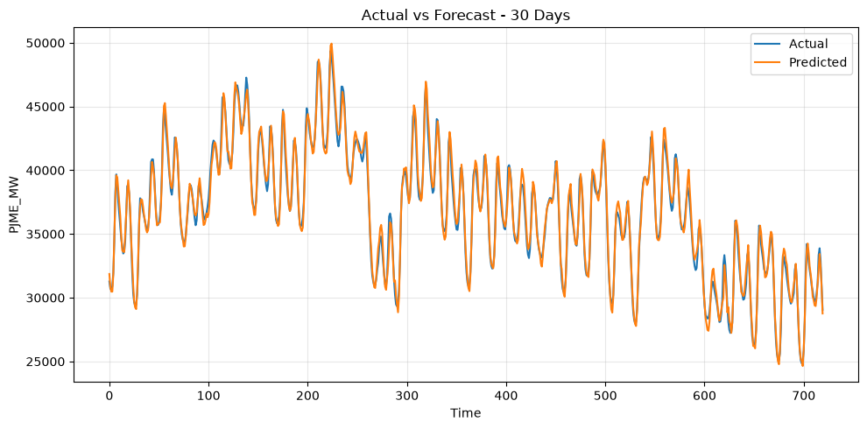

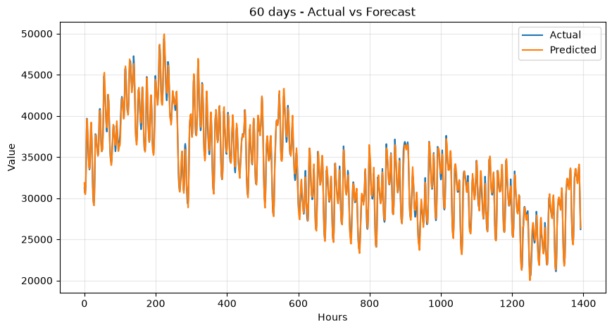
30 days forecast

60 days forecast
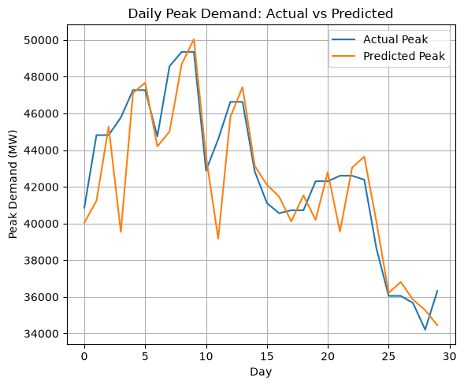

Actual vs predicted demand
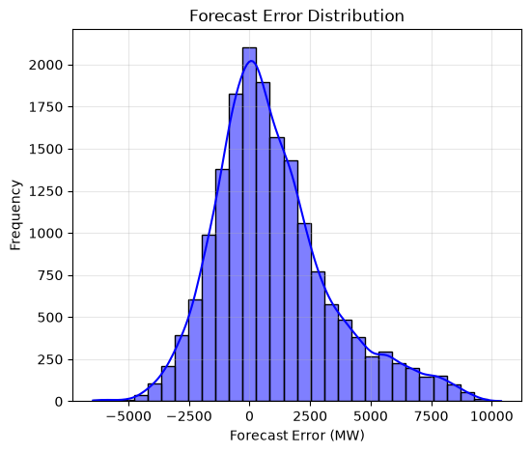

Error distribution
7.6 Conclusion
The GRU model was successfully validated using 30-day and 60-day periods. The evaluation metrics and visual analyses provided a detailed understanding of the model's forecasting accuracy, daily errors, peak-demand prediction, and overall prediction behavior.

Phase 8 – Model Evaluation and Comparison
8.1 Introduction
The objective of Phase 7 is to evaluate and compare the forecasting models developed in the previous phases.
The trained models were evaluated using the same test dataset and a common set of performance metrics. This provides a consistent basis for determining which model performs best for electricity demand forecasting.
The models compared in this phase are:
- Naive
- Moving Average
- RNN
- LSTM
- GRU
- Bi-LSTM
8.2 Evaluation Setup
The evaluation was performed using a 24-hour input sequence and a 24-hour forecasting horizon for the main model comparison.
The sequence configuration was:
Parameter | Value
Sequence length | 24 hours
Forecast horizon | 24 hours
Evaluation dataset | Test dataset
Target variable | PJME_MW
The test data was converted into sequences before being passed to the trained models.
The target values and model predictions were inverse-transformed back to the original MW scale before calculating the evaluation metrics.
8.3 Models Evaluated
The following trained models were loaded and evaluated:
Model | Model File
RNN | lr_rnn.keras
LSTM | lstm_early.keras
GRU | gru_16.keras
Bi-LSTM | bilstm_lr.keras
The Naive and Moving Average approaches were included as baseline references.
8.4 Evaluation Metrics
Five metrics were used to compare the forecasting performance.
Mean Absolute Error (MAE)
MAE measures the average absolute difference between the actual and predicted electricity demand.
A lower MAE indicates better forecasting accuracy.
Unit: MW
Mean Squared Error (MSE)
MSE calculates the average squared prediction error.
Because the errors are squared, larger forecasting errors have a greater influence on the metric.
A lower MSE indicates better performance.
Root Mean Squared Error (RMSE)
RMSE is the square root of MSE.
It provides an error measure in the same unit as the target variable, making it easier to interpret than MSE.
Unit: MW
A lower RMSE indicates better performance.
Mean Absolute Percentage Error (MAPE)
MAPE represents the average forecasting error as a percentage of the actual demand.
A lower MAPE indicates better forecasting accuracy.
Unit: %
R² Score
R² measures how well the model explains the variation in electricity demand.
A higher R² indicates better model performance.
In the comparison table, R² is represented as a percentage.
8.5 Model Comparison
The final comparison obtained from the evaluation process is

Model | MAE (MW) | MSE | RMSE (MW) | MAPE (%) | R² (%)
Naive | 1054.66 | 1,834,852.83 | 1354.57 | 3.43 | 96.00
Moving Average | 3946.08 | 25,384,046.61 | 5038.26 | 13.13 | 39.00
RNN | 1464.36 | 4,151,167.52 | 2037.44 | 4.68 | 90.00
LSTM | 1395.00 | 3,831,021.71 | 1957.30 | 4.40 | 90.77
GRU | 1338.70 | 3,669,936.61 | 1915.71 | 4.18 | 91.16
Bi-LSTM | 1457.88 | 4,004,100.32 | 2001.02 | 4.64 | 90.35
8.6 Naive Model Performance
The Naive model achieved the lowest error values among all models in this particular test comparison.
Its performance was:
- MAE: 1054.66 MW
- MSE: 1,834,852.83
- RMSE: 1354.57 MW
- MAPE: 3.43%
- R²: 96.00%
This is an important observation because it demonstrates that the most recent historical demand is already a strong predictor of future demand for this dataset.
Therefore, the deep learning models must be evaluated not only against each other but also against this strong baseline.
8.7 Moving Average Performance
The Moving Average model performed considerably worse than the other approaches.
Its performance was:
- MAE: 3946.08 MW
- RMSE: 5038.26 MW
- MAPE: 13.13%
- R²: 39.00%
The results indicate that averaging the previous demand values removes some of the short-term variation that is important for accurate electricity-demand forecasting.
8.8 RNN Performance
The RNN model achieved:
- MAE: 1464.36 MW
- MSE: 4,151,167.52
- RMSE: 2037.44 MW
- MAPE: 4.68%
- R²: 90.00%
The model successfully captured a large portion of the demand variation, achieving an R² of approximately 90%.
However, its error values were higher than those of the LSTM and GRU models.

8.9 LSTM Performance
The LSTM model achieved:
- MAE: 1395.00 MW
- MSE: 3,831,021.71
- RMSE: 1957.30 MW
- MAPE: 4.40%
- R²: 90.77%
The LSTM improved upon the basic RNN model across the major error metrics.
This indicates that the LSTM architecture was able to capture temporal dependencies more effectively than the basic RNN configuration.
8.10 GRU Performance
The GRU model achieved:
- MAE: 1338.70 MW
- MSE: 3,669,936.61
- RMSE: 1915.71 MW
- MAPE: 4.18%
- R²: 91.16%
Among the deep learning models, GRU achieved the best performance.
It produced lower MAE, MSE, RMSE, and MAPE than RNN, LSTM, and Bi-LSTM, while also achieving the highest R² among the deep learning models.
8.11 Bi-LSTM Performance
The Bi-LSTM model achieved:
- MAE: 1457.88 MW
- MSE: 4,004,100.32
- RMSE: 2001.02 MW
- MAPE: 4.64%
- R²: 90.35%
Although the Bi-LSTM achieved good forecasting performance, it did not outperform the GRU model in this experiment.

8.12 Deep Learning Model Ranking
Considering the main error metrics, the deep learning models can be ranked as follows:
Rank | Model | MAE (MW) | RMSE (MW) | MAPE (%) | R² (%)
1 | GRU | 1338.70 | 1915.71 | 4.18 | 91.16
2 | LSTM | 1395.00 | 1957.30 | 4.40 | 90.77
3 | Bi-LSTM | 1457.88 | 2001.02 | 4.64 | 90.35
4 | RNN | 1464.36 | 2037.44 | 4.68 | 90.00

Therefore, GRU was the best-performing deep learning model.
8.13 Baseline vs Deep Learning
An important finding from the evaluation is that the Naive baseline achieved better numerical performance than the deep learning models on this particular test comparison.
The Naive model achieved:
MAE = 1054.66 MW
while the best deep learning model, GRU, achieved:
MAE = 1338.70 MW
Therefore, although GRU is the best deep learning model, it does not outperform the Naive baseline based on these evaluation results.
This is an important result and should be reported honestly rather than selecting GRU as the overall best model solely because it is a deep learning model.
8.14 Forecasting Model Selection
Two conclusions can be made from the comparison:
Best Overall Forecasting Method
Naive
It achieved the lowest MAE, RMSE and MAPE and the highest R² among all evaluated methods.
Best Deep Learning Model
GRU
It achieved the best performance among RNN, LSTM, GRU and Bi-LSTM.
Therefore, the GRU model was selected as the primary deep-learning forecasting model for the forecasting dashboard, while the Naive method provides an important benchmark.

8.15 Performance Results Storage
After evaluation, the results were combined into a Pandas DataFrame containing:
- Model
- MAE
- MSE
- RMSE
- MAPE
- R²
The resulting performance table was saved as:
data/cleaned/performance.csv
This performance file was later used by the Flask application to display the model comparison results in the Analytics section.

8.16 Phase 8 Conclusion
Phase 7 evaluated the baseline and deep learning forecasting models using a common test dataset and five evaluation metrics.
The Naive model achieved the best overall numerical performance, demonstrating that recent electricity demand is a very strong predictor for this dataset.
Among the deep learning models, GRU achieved the best performance, with an MAE of 1338.70 MW, RMSE of 1915.71 MW, MAPE of 4.18%, and R² of 91.16%.
The evaluation results were stored in performance.csv and subsequently used for the model-comparison component of the forecasting dashboard.

Phase 9 – Forecasting Dashboard
9.1 Objective
The objective of Phase 9 is to develop an interactive electricity demand forecasting dashboard using Flask.
The dashboard provides different sections for viewing the latest demand, generating forecasts, analyzing model performance, and validating predictions.
9.2 Dashboard
The main dashboard displays:
- Latest electricity demand
- Selected forecasting model
- Best model performance
- Forecast information
The GRU model is selected as the primary deep learning model, with its performance displayed using MAE, RMSE, MAPE, and R².
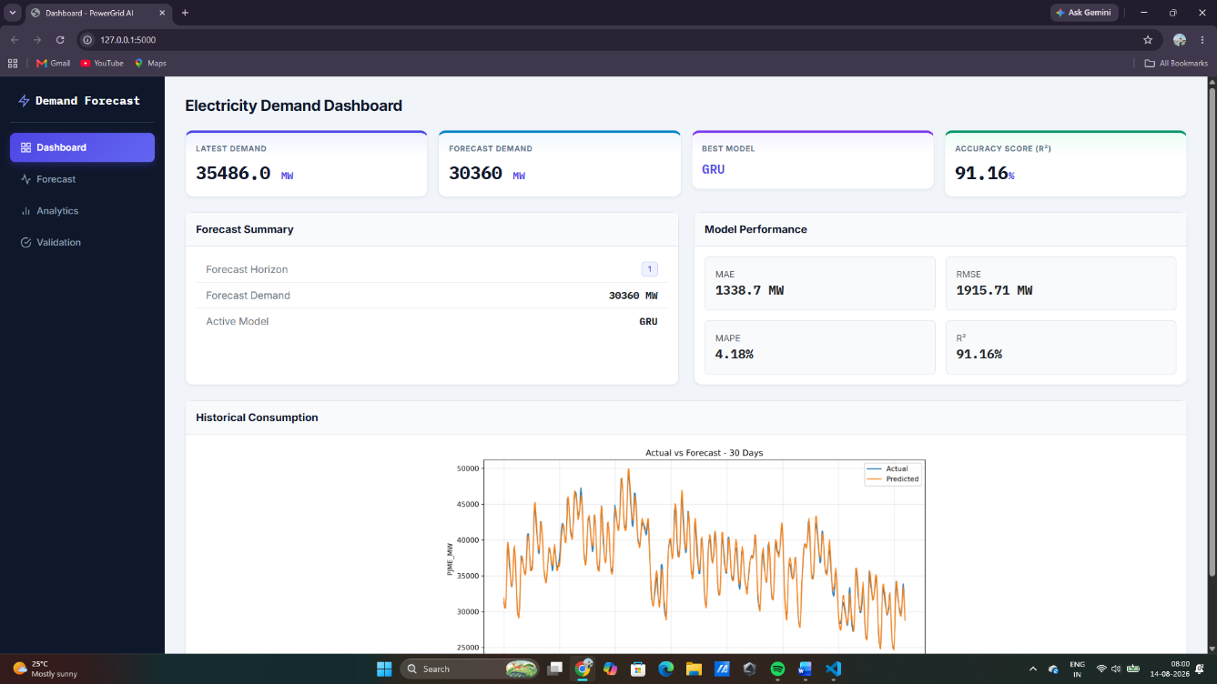

9.3 Forecast Page
The Forecast page allows the user to select a forecasting horizon.
Currently, the application supports 24-hour forecasting.
The latest 24 hours of data are passed through the feature scaler and GRU model. The model generates 24 future demand predictions, which are then converted back to MW using the target scaler.
The forecast page displays:
- Forecast date and time
- Predicted demand
- Lower forecast bound
- Upper forecast bound
Forecast intervals are calculated using the 5th and 95th percentiles of the forecast errors.
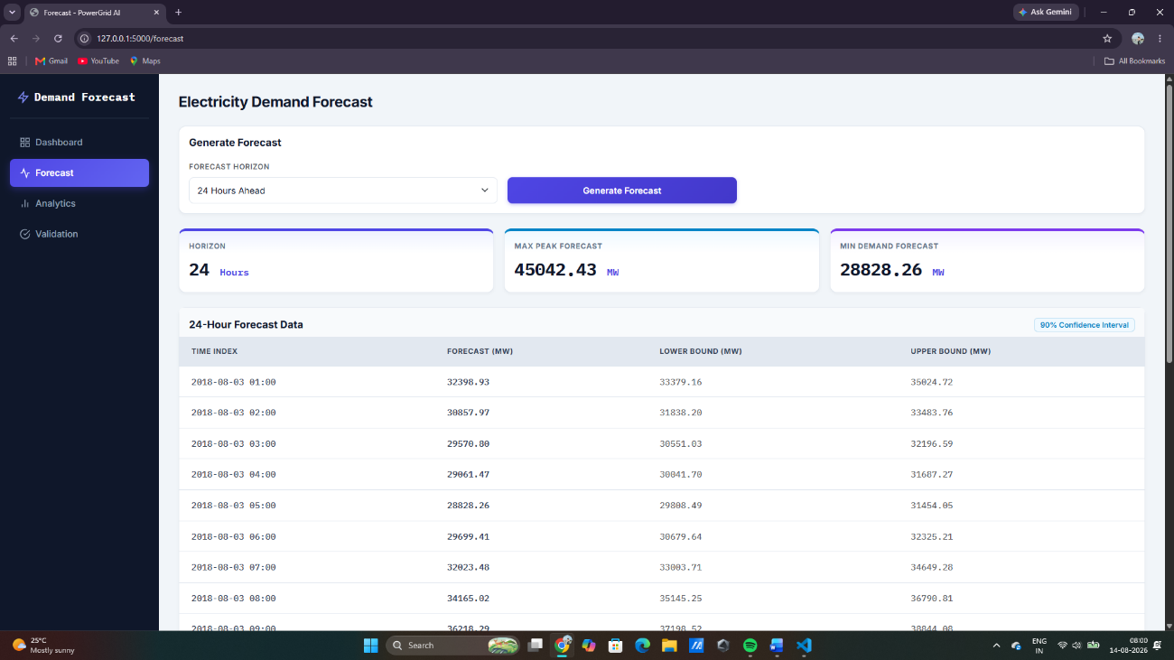

9.4 Analytics
The Analytics page provides an overall analysis of the forecasting models.
It displays the model comparison data stored in performance.csv.
The comparison includes:
- MAE
- MSE
- RMSE
- MAPE
- R²
The GRU model and its performance are also highlighted in the analytics section.

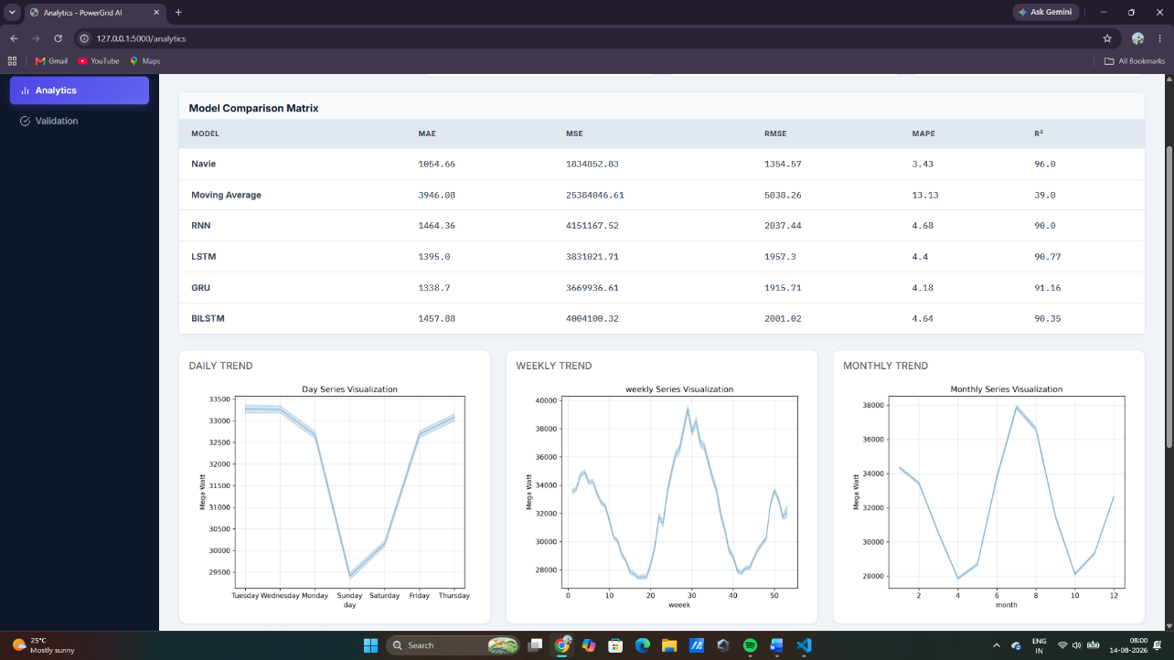

9.5 Validation
The Validation page allows the user to select either:
- 30 days
- 60 days
The application calculates the required number of hourly observations and retrieves the corresponding actual and predicted values from validation_predictions.csv.
The following metrics are calculated:
- MAE
- RMSE
- MAPE
The page also displays the actual and predicted demand values for the selected validation period.
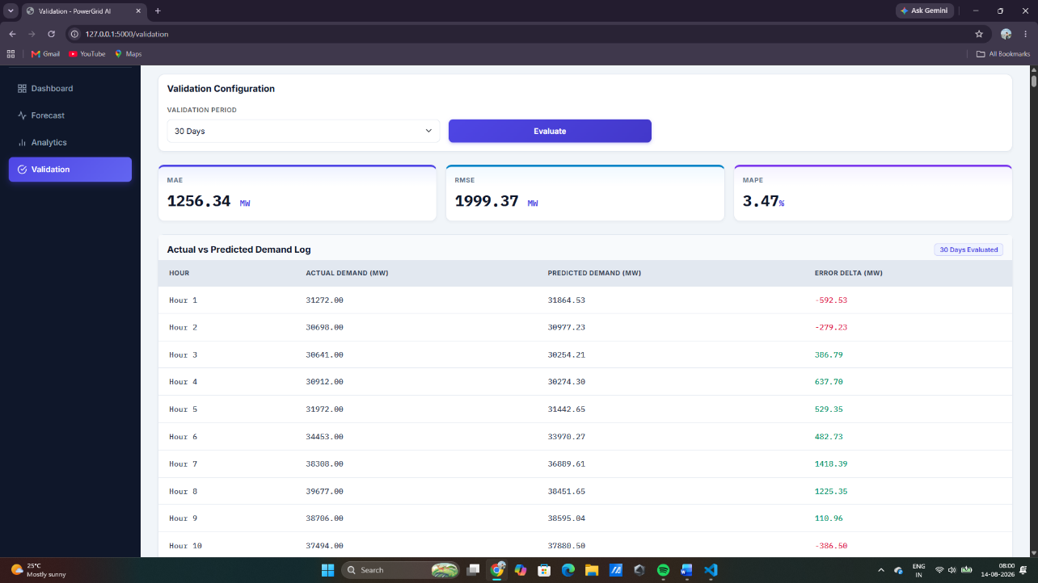

9.6 Flask Integration
Flask is used to connect the trained GRU model, processed datasets, performance results, and HTML templates.
The application loads:
- Cleaned electricity-demand data
- Feature scaler
- Target scaler
- Trained GRU model
- Model performance data
- Validation prediction data
The main application routes are:
Route | Purpose
/ | Dashboard
/forecast | Generate future demand
/analytics | Model and forecast analytics
/validation | Validate predictions for 30/60 days

9.7 Conclusion
Phase 9 successfully integrates the forecasting system into a Flask-based web dashboard.
The application allows users to:
- View current demand and model performance
- Generate a 24-hour electricity demand forecast
- View forecast intervals
- Compare model performance
- Validate predictions over 30 or 60 days
- View MAE, RMSE, and MAPE

