ClaimRoute AI
Solution Architecture Document
Cost-Governed Healthcare Claims Extraction Engine
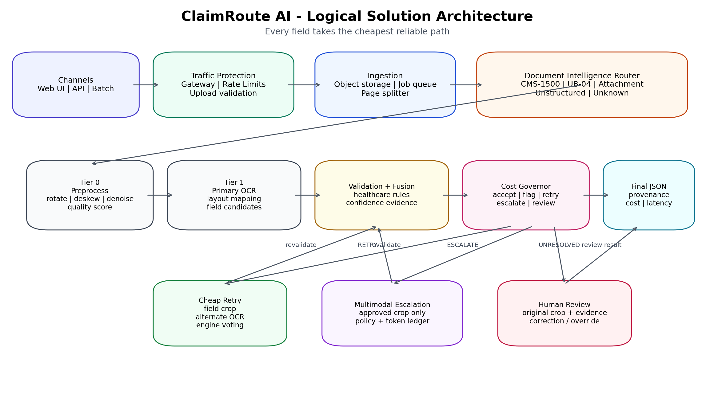
Hackathon: Datamatics AI Engineering Hackathon 2026
Version 1.0 | Architecture baseline through Day 7 | 29 July 2026

1. Executive Summary
ClaimRoute AI is a field-level, confidence-driven healthcare claims extraction engine designed to maximize verified extraction accuracy while minimizing processing cost per page. Its central principle is simple: deterministic and local methods resolve the majority of fields, while expensive multimodal intelligence is treated as a budgeted resource and used only for unresolved, policy-approved field crops.
The system is not positioned as a generic OCR wrapper or a full-page LLM parser. It combines document routing, image preprocessing, template-aware extraction, healthcare validation, confidence fusion, cheap retry, selective multimodal escalation, human review, and a complete provenance and cost ledger.
Architecture objective | Design response
Highest possible verified accuracy | Validation after every extraction attempt; critical-field policies; human review for unresolved fields.
Lowest cost per page | Single primary OCR pass; field-crop retry; selective paid escalation; per-page and per-tenant budgets.
Innovation | Cost Governor optimizes expected verified accuracy per unit cost at field level.
Scalability | Queue-based workers, independent scaling by workload, load balancing and rate limits in production topology.
Maintainability | Adapter interfaces, configuration-driven thresholds, typed field schema, modular validators and model policies.

2. Scope, Status and Architecture Boundaries

2.1 Current hackathon status
The architecture baseline reflects work completed or designed through Day 7. The current emphasis is the local extraction path and cheap retry rung. Paid multimodal escalation, mode calibration, full UI, final frozen benchmark, and production-grade traffic infrastructure remain later activities.
Area | Status | Interpretation
Synthetic claim generation and ground truth | Completed / established | Repeatable benchmark inputs with known answers.
Preprocessing and rotation recovery | Completed / established | Restores degraded-page routing and extraction viability.
Document routing and layout mapping | Completed / established | Structured forms follow form-specific field maps.
Primary OCR path | Completed / established | One primary engine on first pass to preserve the cost story.
Healthcare validators and confidence fusion | Completed / in refinement | Validators influence routing but do not silently overwrite evidence.
Cheap field-crop retry | Day 7 focus | Alternate OCR resolves failures before paid AI.
Multimodal escalation | Day 8 | Only unresolved approved crops; actual token and cost telemetry required.
Economy/Balanced/Accuracy calibration | Day 9 | Operating policies control thresholds and budget.
Streamlit experience | Day 10 | Visualize routing, field evidence, cost, latency and benchmark comparisons.
Production load balancer and enterprise rate limiting | Roadmap / architecture only | Show scale readiness; do not distract the hackathon MVP.

2.2 MVP versus production architecture
MVP build | Production-scale extension
Local Streamlit or lightweight API | Highly available API services behind a managed load balancer.
Local/small queue or controlled job runner | Durable priority queue with visibility timeouts and dead-letter queues.
Process-level concurrency limits | Tenant, provider, worker and global distributed rate limits.
Single-region object storage | Encrypted regional storage, retention policy, backup and disaster recovery.
One multimodal provider adapter | Provider pool, circuit breakers, fallback routing and regional policy enforcement.
Single review screen | Role-based review service with assignments, SLAs and audit trails.

3. Architectural Drivers and Quality Attributes
Quality attribute | Architectural requirement | Primary mechanism
Accuracy | Do not accept fields solely because OCR confidence is high. | Healthcare validators, cross-field consistency, evidence fusion.
Cost efficiency | Avoid full-page premium-model processing by default. | Crop isolation, local retry, cost governor and budget caps.
Throughput | Process pages independently and parallelize safely. | Page splitting, queue-based orchestration, stateless workers.
Reliability | A provider or worker failure must not corrupt final output. | Idempotency, retries, timeout, circuit breaker, DLQ.
Auditability | Every value must have traceable origin and decision history. | Bounding box, raw candidates, validations, processing path and ledger.
Security and privacy | Minimize PHI exposure and control external model use. | Model policy engine, crop-only calls, encryption and PHI-safe logs.
Maintainability | Engines and providers should be replaceable. | Adapters, registries, configuration and typed interfaces.
Scalability | Handle enterprise volumes without redesigning extraction logic. | API/load balancing, queue, autoscaled worker pools, partitioned storage.

4. Logical Solution Architecture

Figure 1. Logical architecture showing the deterministic path, decision layer and controlled exception routes.

4.1 Architectural layers

Experience and API layer
Accepts browser uploads, API requests and batch jobs. Returns a job ID for long-running documents instead of holding the HTTP connection open.

Traffic and ingestion layer
Validates file type and size, applies basic request limits, persists the original input, computes a checksum and creates page-level work items.

Document Intelligence Router
Classifies CMS-1500, UB-04, attachment, custom, unstructured or unknown pages using low-cost anchors, geometry and layout signatures.

Tier 0 preprocessing
Performs rotation correction, deskewing, denoising, contrast enhancement, blank/duplicate detection and quality scoring.

Tier 1 extraction
Runs one primary OCR engine, maps text to known regions, and emits field candidates with confidence and bounding boxes.

Healthcare validation
Checks NPI structure/checksum, CPT/HCPCS/ICD formats, date logic, arithmetic, claim-line totals and cross-field consistency.

Confidence fusion
Combines OCR confidence, assignment/layout evidence, page quality, field criticality and validator outcomes without collapsing the evidence into an opaque score.

Cost Governor
Chooses ACCEPT, ACCEPT_WITH_FLAG, RETRY, ESCALATE or HUMAN_REVIEW according to policy, evidence, attempt history and budget.

Cheap retry rung
Runs an alternate low-cost OCR strategy on a field crop, then returns the result to validation.

Multimodal escalation rung
Sends only the unresolved field crop to an approved provider, requests concise structured output, grounds the response and revalidates it.

Human review
Presents source crop, candidates, failed rules and route history. Review can correct, accept, reject or override with reason.

Finalization and evidence
Produces structured JSON plus validation stamp, page/box provenance, route history, cost, latency and review status.

5. Field-Level Routing and Decision Logic
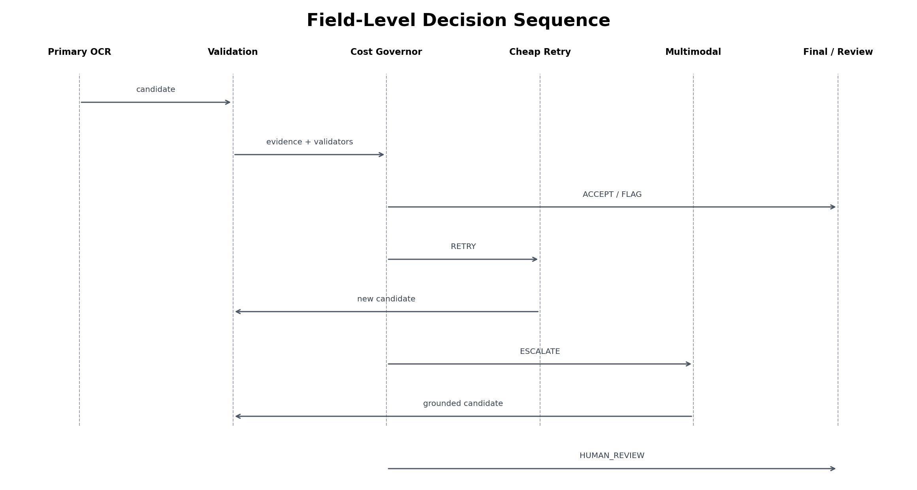
Figure 2. Every generated candidate returns to the same validation boundary before finalization.
Decision | Typical condition | Next action
ACCEPT | High evidence, validation passed, required value present. | Finalize field with provenance and cost.
ACCEPT_WITH_FLAG | Non-critical field has tolerable uncertainty and policy permits it. | Finalize with warning; do not spend expensive AI.
RETRY | Likely OCR/layout error and retry budget remains. | Crop field, run alternate OCR, revalidate.
ESCALATE | Critical or valuable unresolved field; external processing allowed; budget remains. | Send approved crop, ground response, revalidate.
HUMAN_REVIEW | Conflicting evidence, policy blocks external model, or attempts exhausted. | Create review task with all evidence.

5.1 Suggested governor inputs
- Field criticality and required/optional status
- OCR confidence and text geometry
- Layout/assignment confidence
- Page quality score
- Validator results and severity
- Agreement or disagreement between candidates
- Attempt count and route history
- External-model policy for the field
- Remaining per-page, per-job and daily budget
- Operating mode: Economy, Balanced or Accuracy

5.2 Example policy configuration
fields:
provider_npi:
criticality: high
allow_accept_with_flag: false
required_validators: [npi_checksum]
external_model_allowed: true
max_retry_attempts: 1
patient_middle_initial:
criticality: low
allow_accept_with_flag: true
external_model_allowed: false
budgets:
max_api_cost_per_page_usd: 0.002
max_escalated_fields_per_page: 5
max_multimodal_attempts_per_field: 1

6. Data and Evidence Architecture
Entity | Purpose | Key data
DocumentJob | Top-level processing request. | tenant, source URI, checksum, page count, status, mode, budget.
PageResult | Page classification and quality record. | document type, rotation, quality score, route, latency.
FieldResult | Current final field state. | name, value, confidence, page, box, source engine, status.
FieldCandidate | Immutable candidate from one attempt. | raw value, normalized value, engine/model, confidence, prompt/version.
ValidationResult | Independent domain-rule evidence. | validator, pass/fail/warn, severity, reason, reference version.
ProcessingEvent | Ordered route history. | stage, decision, timestamp, input/output identifiers, duration.
CostLedgerEntry | Measured cost evidence. | local compute estimate, input/output tokens, provider rates, total cost.
ReviewTask | Unresolved human action. | crop, candidates, reason, assignment, correction, override rationale.

6.1 Example field output
{
"field_name": "provider_npi",
"value": "1234567893",
"status": "accepted",
"confidence": 0.97,
"page": 1,
"bounding_box": [121, 340, 424, 390],
"source_engine": "tesseract_retry",
"validations": [{"name": "npi_checksum", "result": "pass"}],
"processing_path": ["primary_ocr", "validation", "retry", "validation", "accept"],
"estimated_cost_usd": 0.000014,
"latency_ms": 182
}

7. Component Design

7.1 Ingestion and page orchestration
- Accept PDF/image and create a durable job record.
- Validate MIME type, extension, size and page count.
- Calculate a document checksum to prevent duplicate processing.
- Persist the source before asynchronous processing.
- Split multipage PDFs and preserve page ordering.
- Return job status instead of blocking long requests.

7.2 Document router
- Use anchor keywords, form dimensions, fixed line geometry and page signatures first.
- Avoid a multimodal call at the front door.
- Classify attachments separately so irrelevant pages do not consume extraction or escalation cost.
- Route unknown pages to generic extraction plus review instead of forcing a wrong template.

7.3 Preprocessor
- Auto-rotate and deskew.
- Denoise and adjust contrast only when quality policy requires it.
- Detect blank or duplicate pages.
- Preserve original image and produce a transformed derivative with transformation metadata.
- Record whether preprocessing restored routing viability.

7.4 OCR and layout mapper
- Use one primary OCR pass.
- Map candidates using template coordinates and anchor relationships.
- Extract field crops from the original or corrected page at sufficient resolution.
- Keep raw OCR spans and mapping scores for evidence.

7.5 Validators
- Keep validators deterministic and independently testable.
- Version code dictionaries and reference data.
- Distinguish structural validity from real-world identity or eligibility.
- Treat validator failures as evidence, not automatic correction authority.

7.6 Retry service
- Use crop-level alternate OCR or preprocessing variants.
- Permit a small bounded number of attempts.
- Measure retry resolution rate and avoided paid calls.
- Return the retry result to the same validator chain.

7.7 Multimodal adapter
- Use provider-neutral adapters.
- Send crop, field definition, expected type, candidate values and JSON schema.
- Require JSON-only response.
- Capture actual provider usage metadata and latency.
- Apply policy, grounding and validators before acceptance.

7.8 Cost ledger
- Record local compute separately from external API charges.
- Calculate both input-token and output-token costs.
- Report estimated human-review cost separately from automated cost.
- Project measured per-page cost to 1M, 10M and 100M pages.

8. Security, Privacy and PHI Controls
The architecture uses PHI minimization rather than claiming that an extraction target can be masked before it is read. External processing is governed at field level and must be explicitly allowed.
Control area | Architecture control
Data minimization | Crop-only external requests; exclude unrelated page context.
Provider policy | Approved provider/model list, region restrictions, zero-retention requirement and contractual controls.
Encryption | TLS in transit; encryption at rest for documents, crops, results and backups.
Access | Authentication, tenant isolation, role-based review permissions and least privilege.
Logging | No raw PHI in normal application logs; use identifiers and redacted summaries.
Retention | Configurable expiration and deletion for original documents, derivatives and crops.
Secrets | Use environment/secret manager; never store API keys in source or config files.
Audit | External requests, reviewer actions, overrides and configuration versions are immutable events.
Synthetic hackathon mode | Default benchmark and demonstration dataset contains no real PHI.

9. Scalability, Traffic Management and Reliability
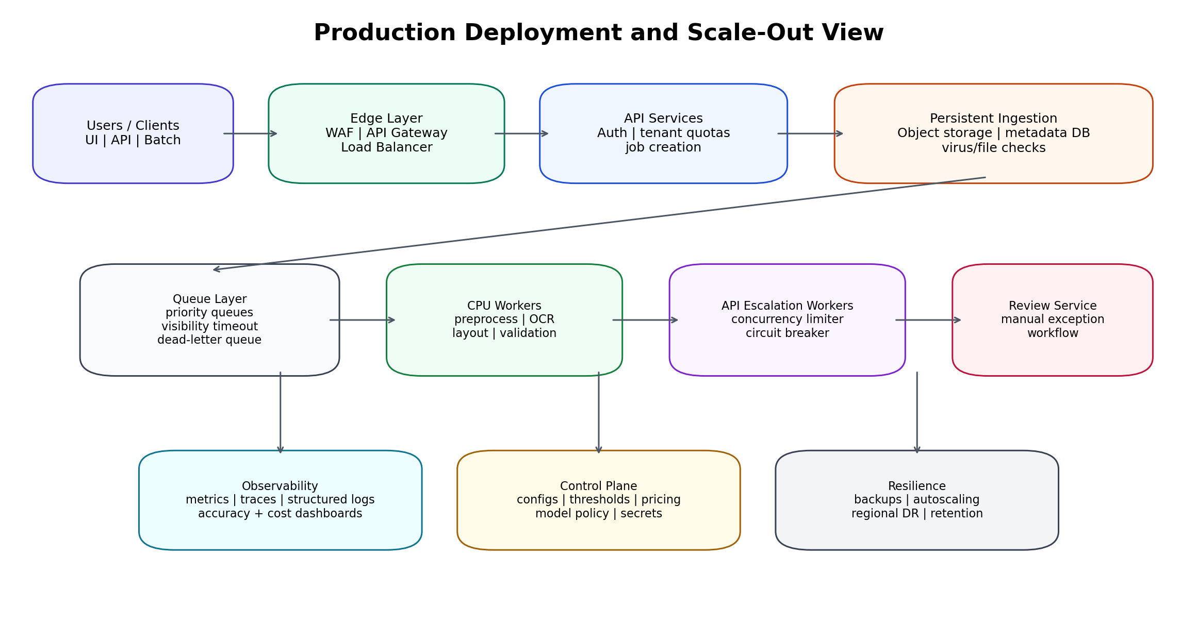
Figure 3. Production scale-out topology. Most elements are roadmap architecture, while budget and concurrency guards begin with the Day 8 API integration.

9.1 Load balancer
A production load balancer distributes incoming API traffic across stateless API instances, performs health checks, supports failover and can terminate TLS. It is included in the final architecture but is not necessary to implement in the Day 7 local prototype.

9.2 Rate limiting and quotas
Limit | Reason | Suggested scope
Requests per minute | Protect API instances from bursts. | Per user/API key and per tenant.
Pages per day | Control workload and commercial entitlement. | Per tenant or subscription tier.
File size/page count | Prevent oversized or malicious uploads. | Per request/job.
Concurrent OCR pages | Prevent one job from starving workers. | Per job and global worker pool.
Concurrent multimodal calls | Respect provider limits and cost exposure. | Per provider, tenant and system.
Escalations per page | Bound expensive exception handling. | Per operating mode and field policy.
Cost per page/job/day | Prevent runaway spend. | Governor and centralized budget service.

9.3 Reliability patterns
- Idempotency key and document checksum to prevent duplicate work and duplicate spending.
- Exponential backoff for transient provider/network failures.
- Circuit breaker when an external provider becomes unhealthy.
- Dead-letter queue for jobs that repeatedly fail.
- Timeouts at document, page, field and provider-call levels.
- Stateless workers with durable job state in storage.
- Graceful fallback to alternate provider or human review.
- Autoscaling based on queue depth, worker utilization and provider concurrency.

10. Cost Governance and Operating Modes
Cost is treated as a first-class output. Every route decision consumes a finite attempt and spending budget. The architecture reports measured and assumed costs separately.
Cost category | Measurement approach
Local preprocessing/OCR | Measured runtime and configured compute rate; described as local compute, not zero cost.
Multimodal API | Actual usage metadata: input tokens, output tokens, cached/reasoning/image usage where exposed.
Storage and queue | Configured infrastructure estimate per page/job; separated from model usage.
Human review | Configurable illustrative assumption, reported separately from automated processing.

10.1 Operating modes
Mode | Policy objective | Routing behavior
Economy | Lowest automated cost. | Higher accept thresholds for paid escalation; flags low-risk uncertainty; API mostly for critical fields.
Balanced | Best cost-accuracy frontier. | Local first, retry uncertain fields, selectively escalate important unresolved fields.
Accuracy | Maximum automated accuracy. | Lower escalation threshold, fewer flagged accepts, more model calls and potentially provider voting.

10.2 Core cost formulas
API call cost = (input tokens x input rate) + (output tokens x output rate).
Cost per correctly resolved escalated field = total escalation cost / correctly resolved escalated fields.
Projected monthly cost = measured average automated cost per page x projected page volume. Human-review estimates are shown as a separate line item.

11. Benchmark and Evidence Architecture
The benchmark harness is part of the solution, not an afterthought. It must produce reproducible evidence for accuracy, cost, throughput, routing and ablation results.
Metric | Definition / evidence
Normalized field accuracy | Comparison after approved normalization rules.
Critical-field accuracy | Accuracy restricted to high-risk fields.
Criticality-weighted accuracy | Weighted score reflecting business risk.
Primary resolution rate | Percentage finalized after first local extraction and validation.
Retry resolution rate | Percentage resolved by cheap retry without paid AI.
Multimodal resolution rate | Percentage of escalated fields resolved correctly by API.
Human-review rate | Percentage of fields/pages needing manual action.
Cost per page | Ledger-derived automated cost; human estimate separate.
Cost per correct field | Total cost divided by correctly resolved fields.
Throughput | Pages per minute/hour and p50/p95 page latency.
Escalation rate | Fields/pages sent to paid models.

11.1 Required ablations
- OCR only
- OCR plus preprocessing
- OCR plus preprocessing plus healthcare validators
- Add cheap retry
- Add selective crop-level multimodal escalation
- Full-page multimodal baseline
- Full system without healthcare validators versus with validators

12. Implementation Roadmap
Phase / Day | Primary outcome | Infrastructure notes
Days 1-5 | Dataset, preprocessing, routing, primary OCR, layout mapping and baseline evidence. | No production traffic infrastructure.
Day 6 | Focused healthcare validation and confidence evidence. | Configuration-driven field policies.
Day 7 | Cheap field-crop retry and retry resolution benchmark. | Bounded attempts, timeout and duplicate retry prevention.
Day 8 | Real crop-level multimodal escalation and actual cost ledger. | Add provider concurrency limits, timeout, backoff and cost cap.
Day 9 | Threshold calibration and Economy/Balanced/Accuracy modes. | Centralize mode and budget configuration.
Day 10 | Streamlit UI and review experience. | Add file-size, page-count and session throttles.
Day 11 | Frozen benchmark, cost projection, throughput and demo. | Document scale-out architecture; do not overbuild it.
Production roadmap | Highly available service and governance. | Load balancer, distributed rate limiting, durable queues, autoscaling, circuit breakers, DR.

13. External Interface Sketch
Endpoint | Purpose | Typical response
POST /v1/jobs | Upload or reference a document and select operating mode. | 202 Accepted with job_id.
GET /v1/jobs/{job_id} | Read job status and progress. | queued, processing, review_required, completed, failed.
GET /v1/jobs/{job_id}/result | Retrieve final structured JSON and summary metrics. | Fields, provenance, cost and latency.
GET /v1/jobs/{job_id}/events | Retrieve processing timeline for audit/demo. | Ordered route decisions and stage results.
GET /v1/review/tasks | List unresolved fields. | Review tasks filtered by tenant/user.
POST /v1/review/tasks/{id}/resolve | Correct, accept or override a field. | Updated field and audit event.

14. Architecture Risks and Mitigations
Risk | Impact | Mitigation
Synthetic dataset bias | Inflated accuracy and template overfitting. | Frozen holdout set and small external sanity set; disclose limitations.
Wrong document classification | Extraction fails before OCR mapping. | Quality-aware retry, unknown route and router-specific benchmark.
Confidence miscalibration | Incorrect fields accepted or too many escalations. | Calibrate on holdout data; separate evidence dimensions; monitor reliability curves.
External provider outage | Escalations stall. | Timeout, circuit breaker, fallback provider or human review.
Runaway API spend | Hackathon or production budget exceeded. | Per-field/page/job/day caps and concurrency quotas.
Validator false rejection | Legitimate values repeatedly escalate. | Severity levels, override workflow and versioned reference data.
PHI leakage | Security/compliance breach. | Synthetic demo data, crop minimization, policy controls and safe logging.
Scope creep | Prototype incomplete despite rich architecture. | Keep production components in roadmap; finish CMS-1500 proof first.

15. Suggested Technology Mapping
Capability | MVP option | Production option
UI | Streamlit | React/Next.js plus dedicated review application.
API | FastAPI | Containerized FastAPI services behind managed gateway/load balancer.
Queue | Local runner / Redis + Celery | SQS, Service Bus, Pub/Sub, RabbitMQ or managed queue.
Storage | Local filesystem for synthetic demo | Encrypted object storage plus PostgreSQL metadata.
Preprocessing | OpenCV / Pillow | Same libraries in autoscaled CPU workers.
OCR | PaddleOCR primary, Tesseract retry | Pluggable local/managed engine pool.
Validation | Python rules and versioned dictionaries | Rules service with controlled reference-data releases.
Multimodal | One provider adapter | Provider-neutral adapters with policy and fallback.
Observability | Structured logs and benchmark CSV/JSON | Metrics, traces, dashboards, cost/accuracy alerts.

16. Recommended Repository Structure
claims-engine/
├── engine/
│ ├── pipeline.py
│ ├── models.py
│ ├── preprocess.py
│ ├── classify.py
│ ├── ocr/
│ ├── layout/
│ ├── validators/
│ ├── escalation/
│ ├── governor.py
│ ├── ledger.py
│ ├── provenance.py
│ └── review_queue.py
├── data_factory/
├── eval/
├── app/
├── configs/
├── tests/
├── docs/
└── scripts/

17. Final Architecture Position
ClaimRoute AI should be presented as a cost-governed document intelligence system, not merely an OCR application and not an agent spectacle. The differentiator is the disciplined routing of each field through the cheapest reliable path, backed by healthcare validation, complete provenance, measurable cost, and explicit failure handling.
The operator sets the cost. The engine finds the accuracy.

Appendix A. Key Architecture Decisions
Decision | Rationale
One primary OCR engine on first pass | Preserves low cost and allows retry value to be measured.
Field-level rather than page-level escalation | Reduces tokens, PHI exposure and irrelevant context.
Validation after every attempt | Prevents OCR retry or multimodal output from bypassing domain checks.
Separate evidence dimensions | Avoids opaque confidence and supports explainability.
Config-driven criticality and budgets | Makes governor decisions reproducible and adjustable.
Queue-based production processing | Improves throughput, resilience and independent scaling.
Load balancing and distributed rate limits as roadmap | Demonstrates enterprise readiness without derailing the MVP.

Appendix B. Source Basis
This document consolidates the Datamatics AI Engineering Hackathon 2026 problem statement and the ClaimRoute architecture discussions through Day 7, including the document router, preprocessing recovery, single-pass primary OCR, healthcare validation, cheap retry, selective multimodal escalation, cost ledger, benchmark strategy, and production traffic-management notes.

