CTOL

   [Team B1JA06]

APplication Design

Contents

Architecture Diagram 2

Database Design 3

UX Design 4

Functionality 1 – Login Page 4

Functionality 2 – Sign Up Page 5

Application Design 6

Class Diagram 6

Functional 1 – Admin Side 7

Functional 2 – User side 8

# Architecture Diagram

Logical View

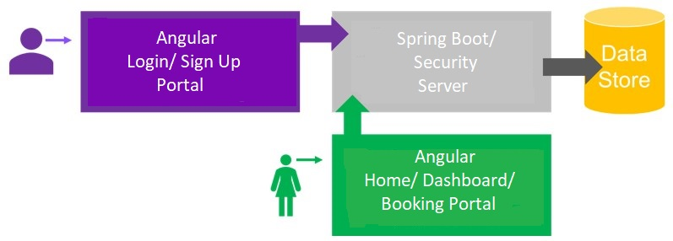

Technical Architecture

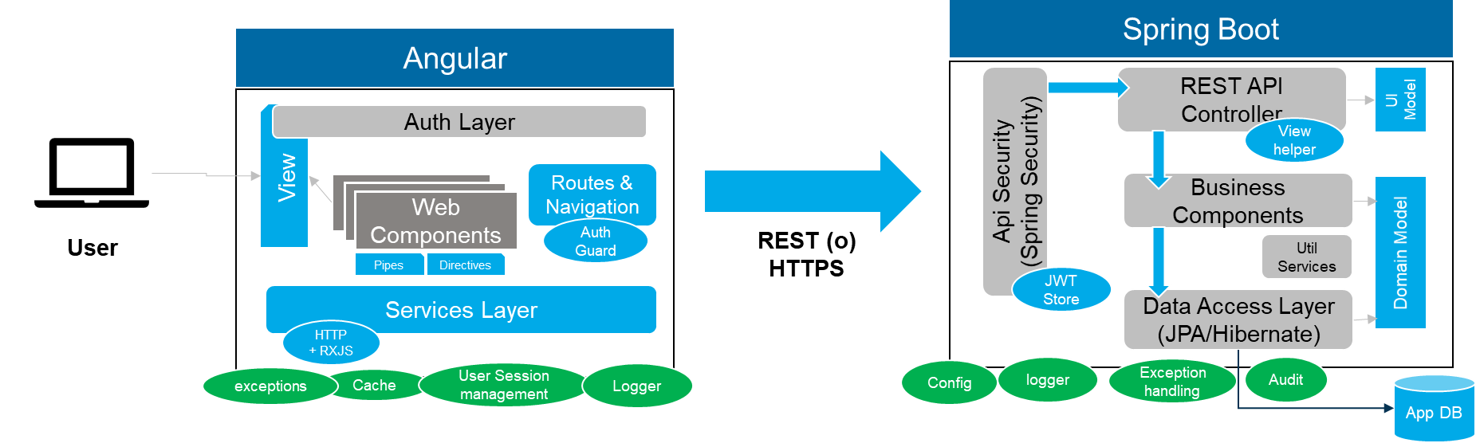

# Database Design

ER Diagram

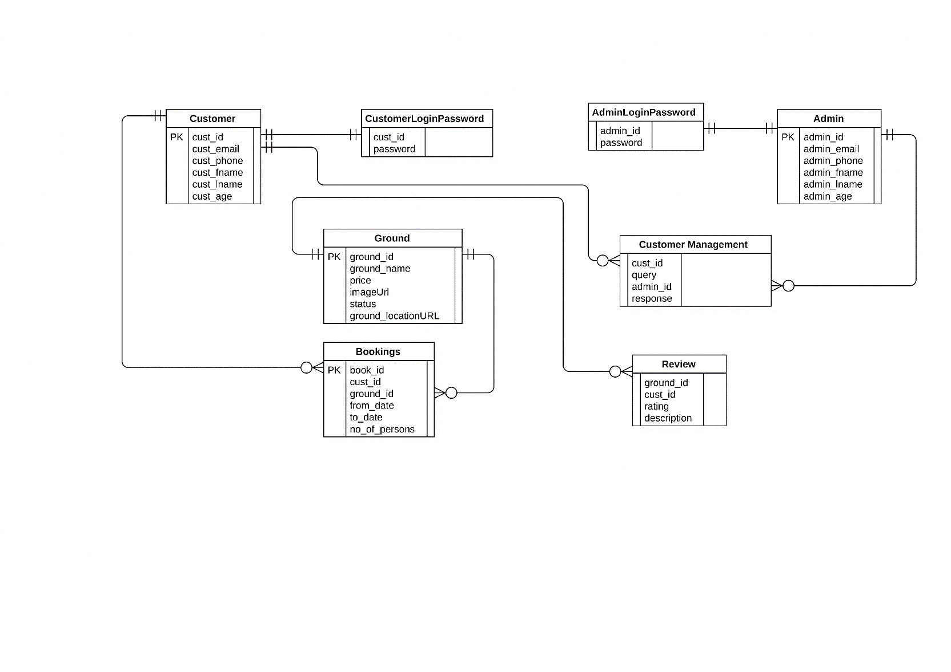

# UX Design

## Functionality 1 – Login Page

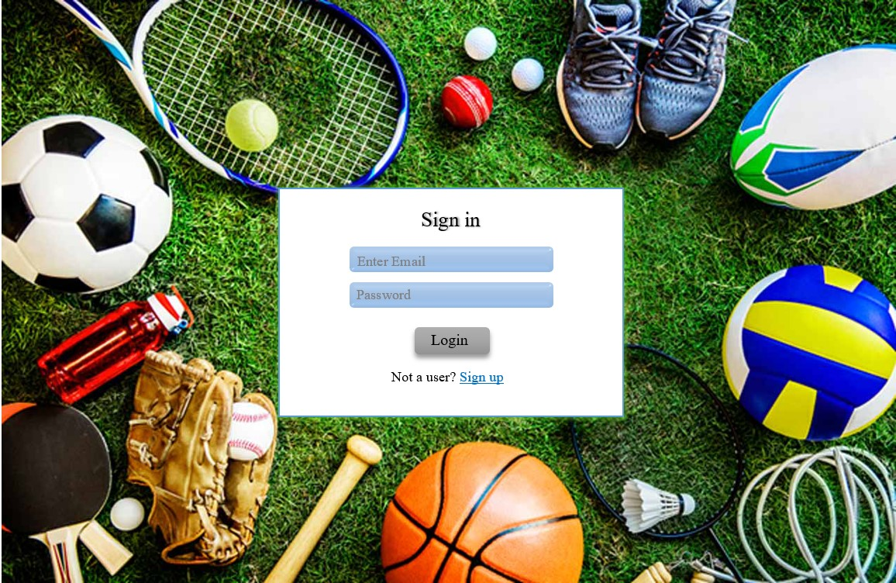

## Functionality 2 – Sign Up Page

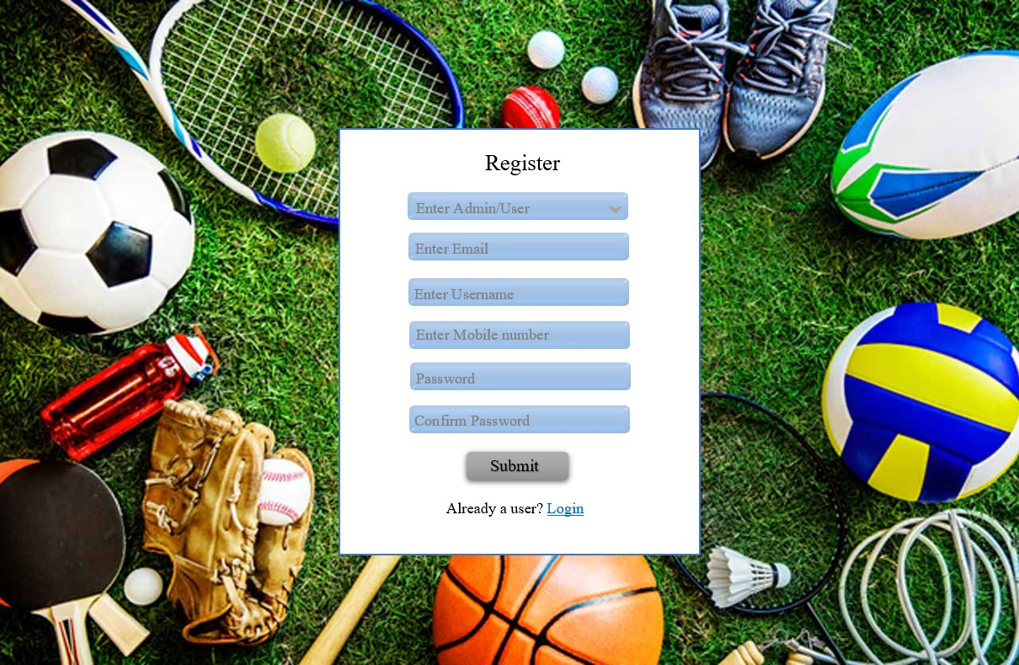

# Application Design

## Class Diagram

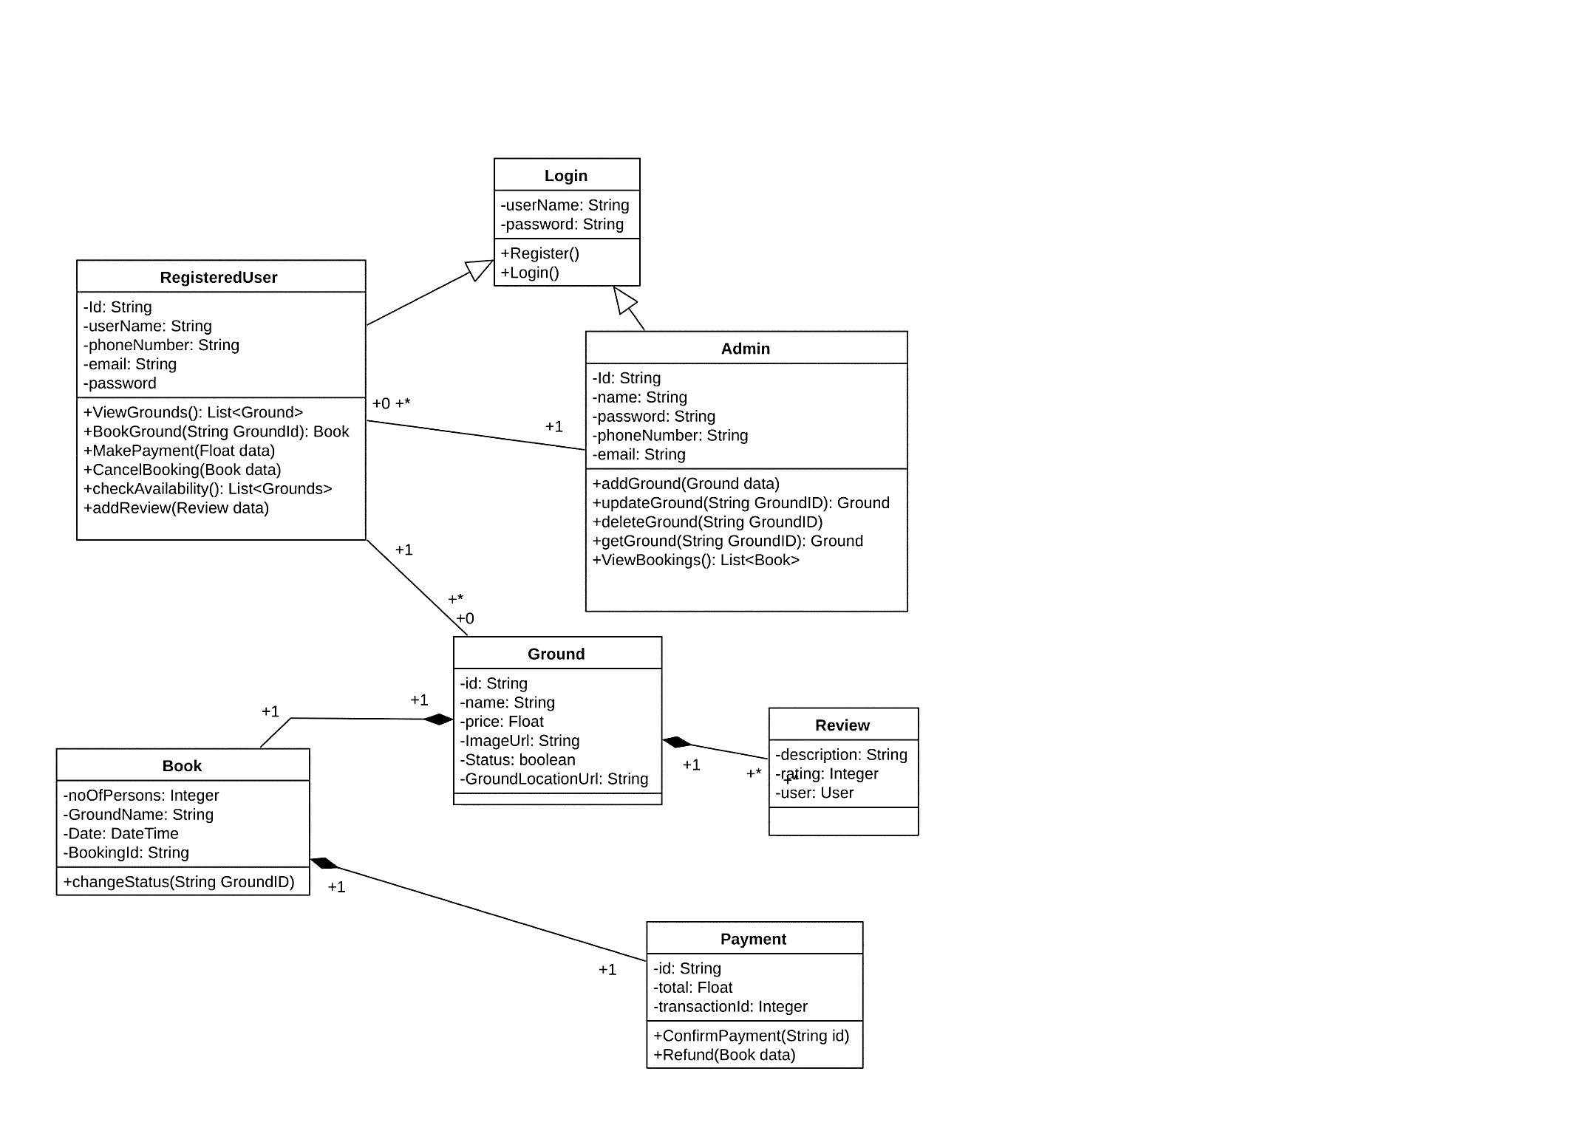

## Functional 1 – Admin Side

Sequence Diagram

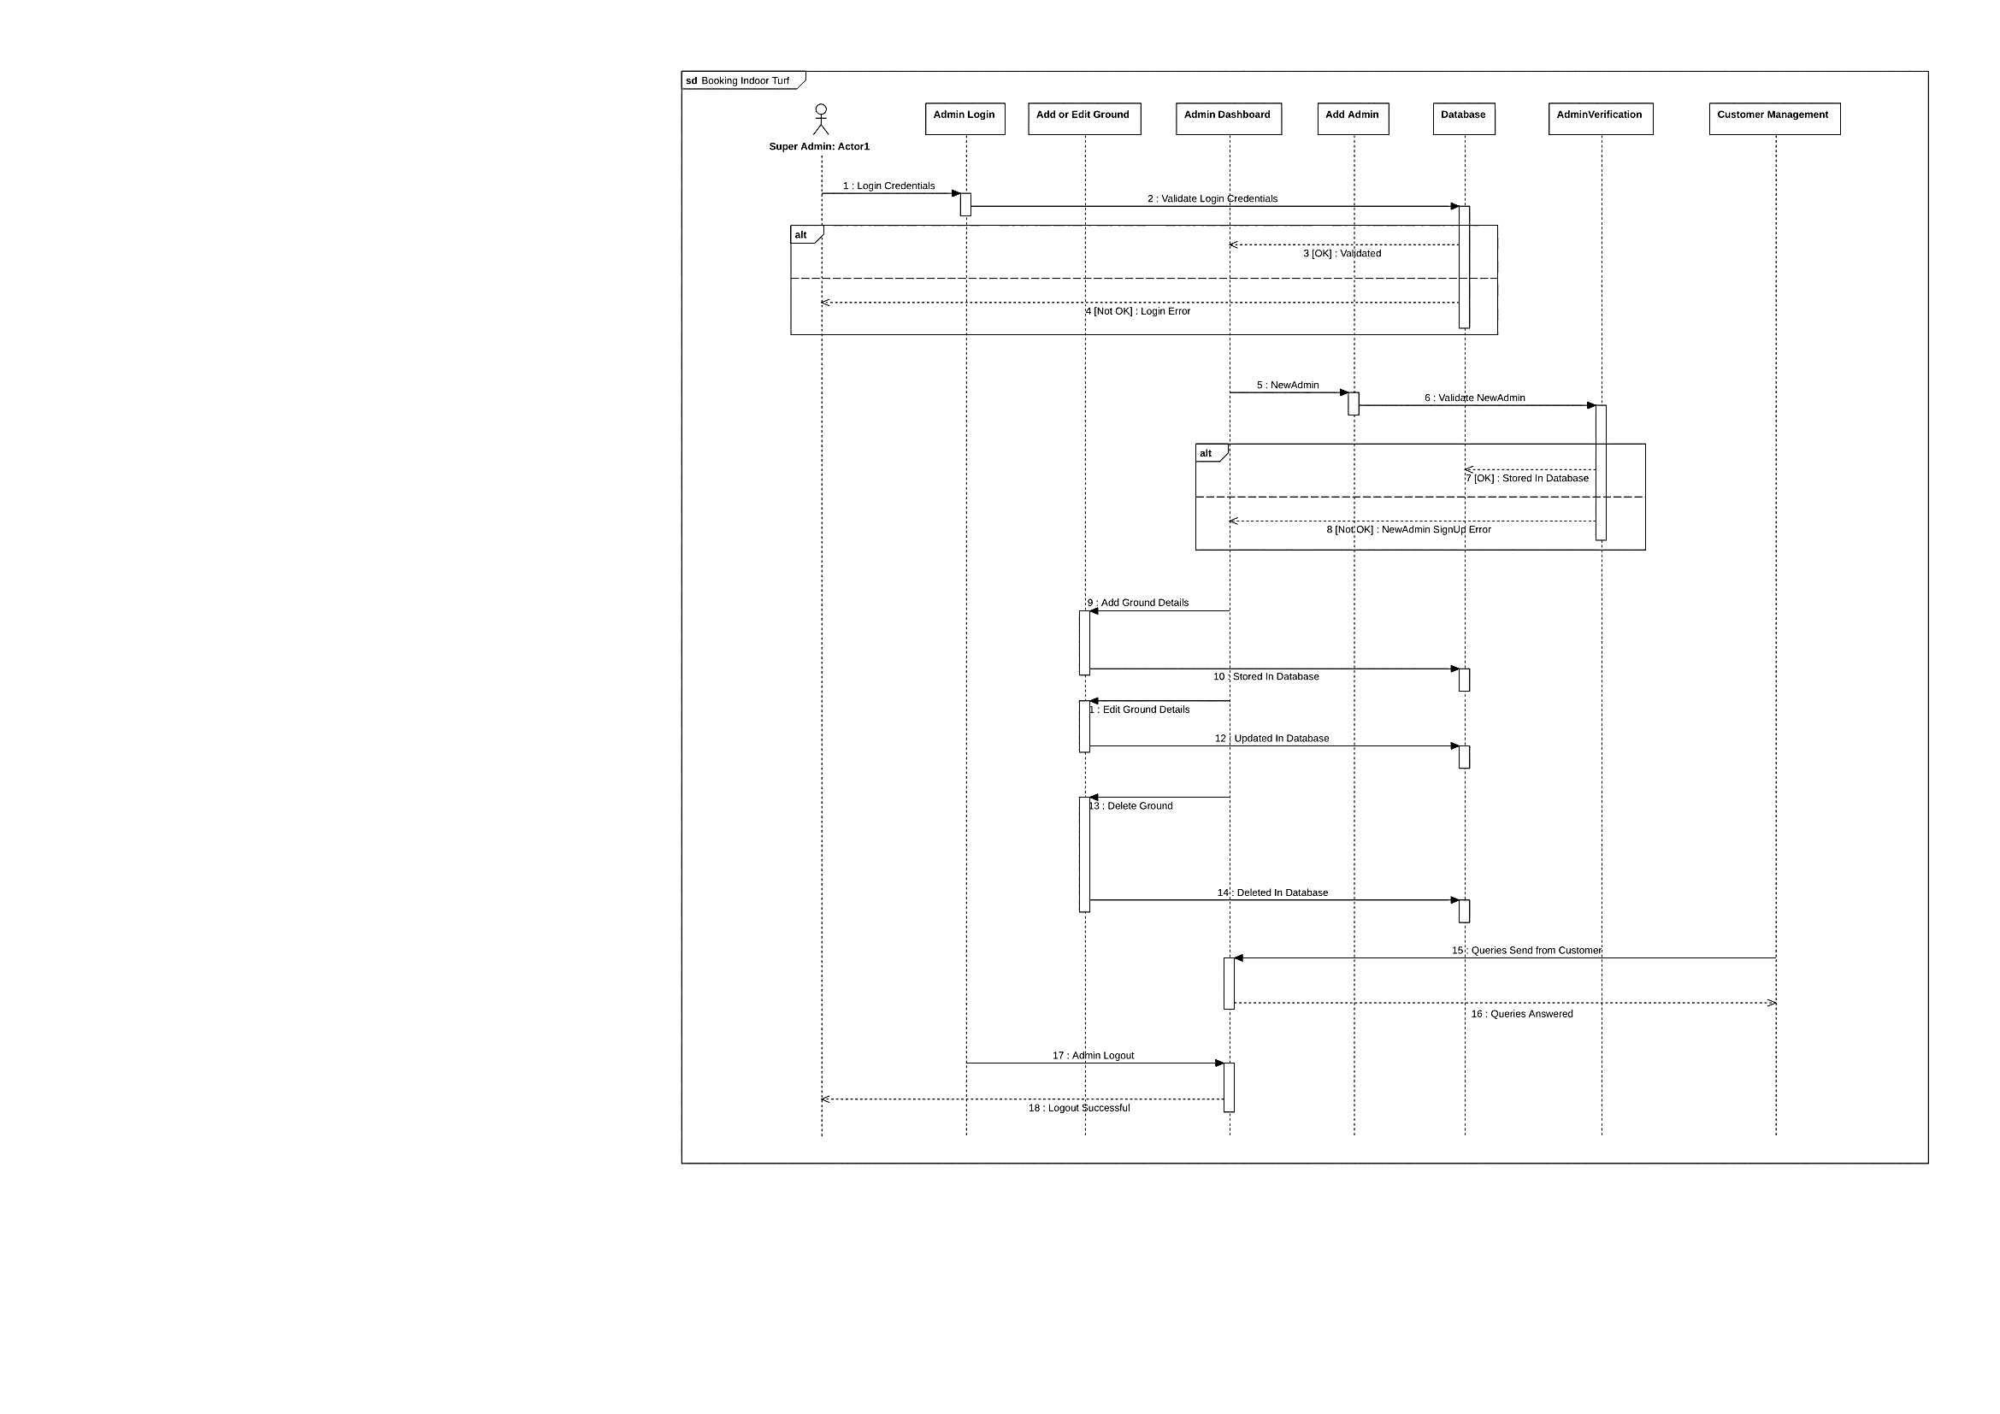

## Functional 2 – User side

Sequence Diagram

