**Problem Statement:**

To build a pure-play futuristic digital bank which is highly available, integrates with modern technology built on top of Web 3.0 and enable customers to bank wherever and whenever.

**Objectives:**

It allows the customers to:

* Open savings and checking accounts through digital resources.
* Manage transactions, which also includes KYC and other mandatory actions.
* And other value-added features like view usage patterns using AI, UPI, and real-time payments

**In-Scope:**

* AI for insurance, loans, usage patterns and investments
* KYC background verification by using test aadhar number for the purpose of this project.
* Computation for interests, loans, and other bank operations.
* Security and Privacy for the user.

**Out-of-Scope:**

* Aadhar Link (Aadhar number is required to perform bank services automatically without user intervention.)
* The different customer schemes provided by individual banks (Test Schemes would be used)
* Third-party identity provider or verification
* Service side or bank operation.

**Necessary Resources:**

* HTML
* Python
* PHP
* Database

**Design:**

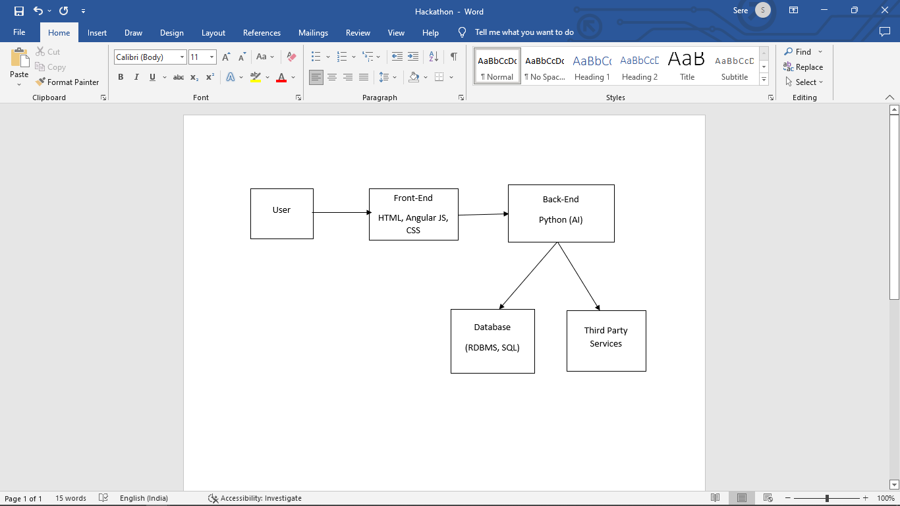

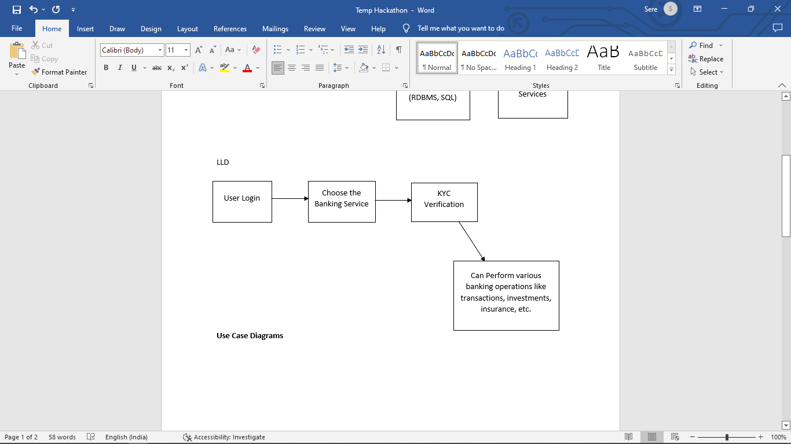

**Deployment plan:**

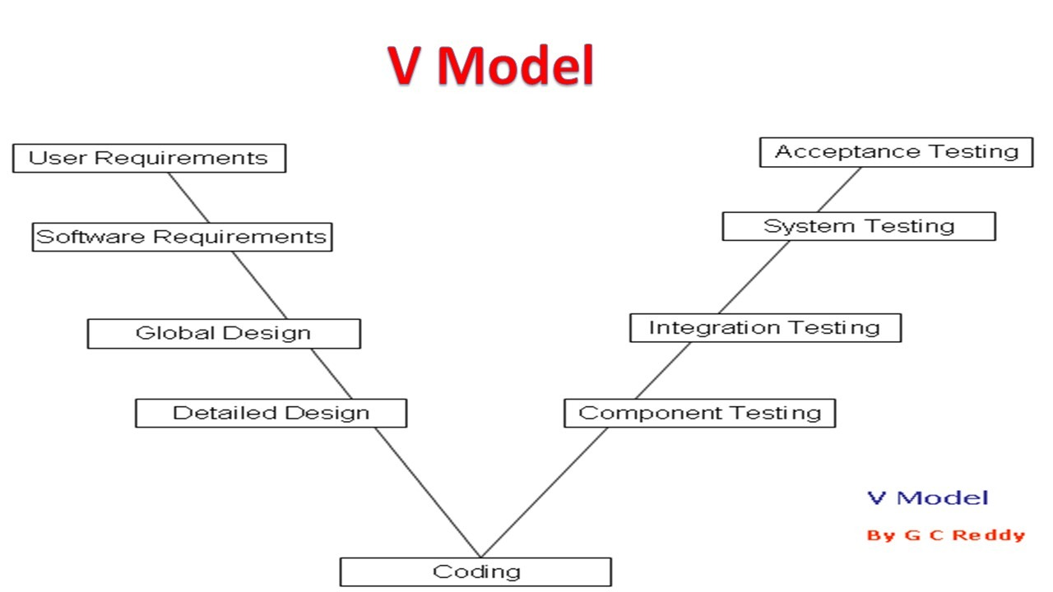

**Database Design**

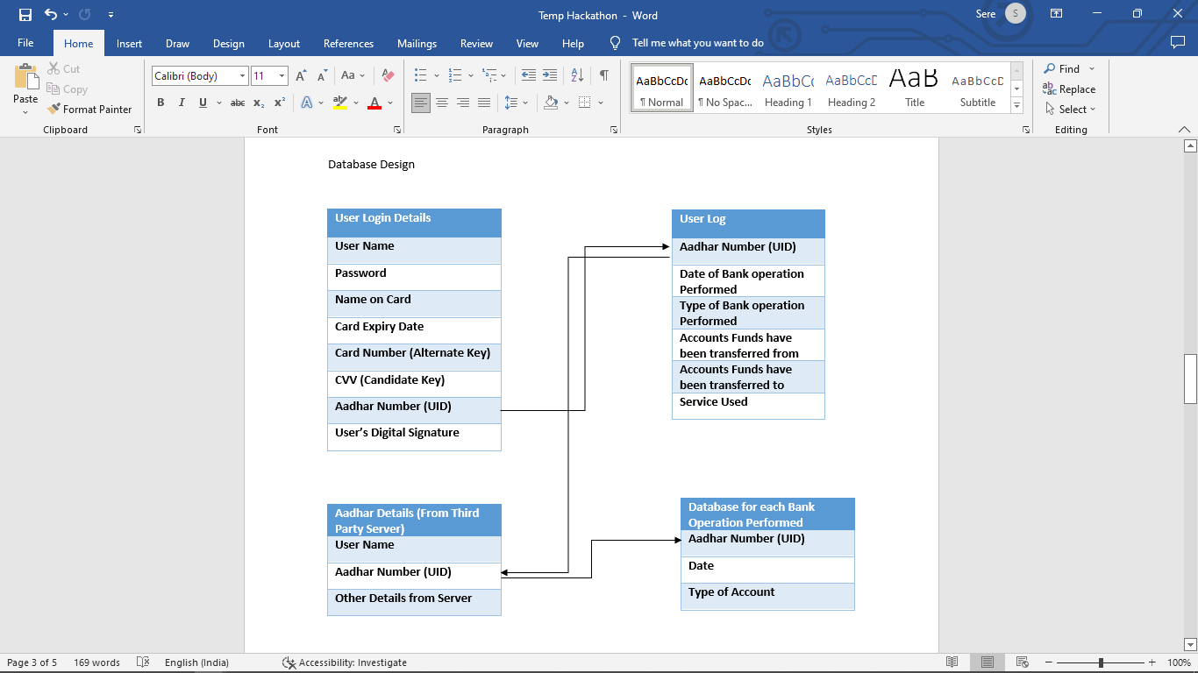

**Success Criteria:**

1. Scalable and extensible
2. Defined Feature Set
3. Innovation of the solution
4. Well defined API and UX
5. Choosing the right tools
6. Web 3.0 technologies used.

**Features to add:**

***Note: These features could not be included as it mostly depends on the bank processes***

**Registration:**

On clicking this tab, it can direct the customer to a page which takes their Aadhar number as input. The Bank must link the accounts of the customers with their Aadhar card. The customer can also be required to give the same E-mail ID and Phone number as provided in the Aadhar Card by the respective individual. Then an OTP can be sent to the customer to the E-mail ID or Phone number (SMS) provided by the customer. This way we can verify the user’s identity. It is also important to maintain the privacy of the user therefore the Aadhar number entered can be stored in the database using encryption methods and every time the person wants to perform any money-based bank operations it can provide the user with an OTP.

Once their identity is verified the user can be directed to the registration process. Here the certain fields of the form can auto-filled based on the Aadhar card details and the rest can be filled by the user

Along with the Aadhar card number the customer can also provide other proofs that may also be linked to the Aadhar card for example Voters ID, and So on

**Accounts:**

Here, a form can be provided for creating an Opening Account and a Checking Account. This can be based on the procedures of the respective banks

**Usage Patterns:**

Based on the transactions and other bank operations performed by the user, we can use Data Analysis to compute their user patterns. However, security being the utmost priority, we can give the user the choice of whether they would want to compute their usage pattern or not. If not, then their bank operation details should also not be collected for this purpose (that is, it may still need to be stored in the server for security reasons but there is no need to perform data analysis on the information)

**Chatbots:**

Chatbot can assist the users through the entire process of registration and it can also be used for assisting them in other bank operations. Necessary dataset can be provided to train the model. The chatbot is created using CNN.

**Future improvements:**

1. In the Accounts tab, apart from Opening Account and Checking Account, other accounts like Demat Account, Savings Account, CDs and so on can also be added
2. It can be made more secure by using encryption methods and OTP wherever necessary
3. The interface can be improved to make it more pleasing to the eyes

**GitHub Link:**

[**https://github.com/iamneo-production/d3cbeb54-8a1c-4a6c-8a4c-b6785bf05c8f**](https://github.com/iamneo-production/d3cbeb54-8a1c-4a6c-8a4c-b6785bf05c8f)