Name: Honey Sinha   
Sap id:500121977  
Roll no. R2142230332

Run App.py in terminal:

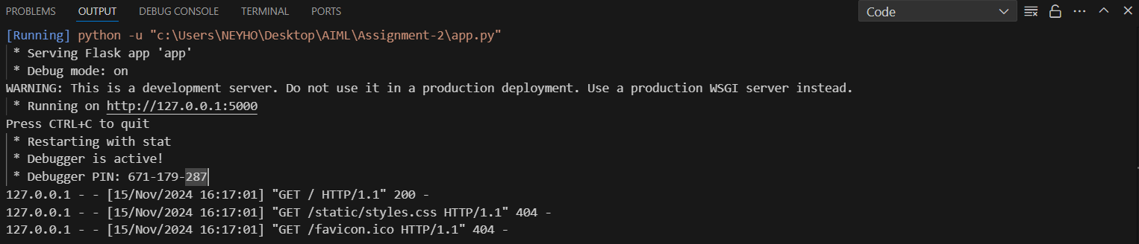  
  
Homepage:  
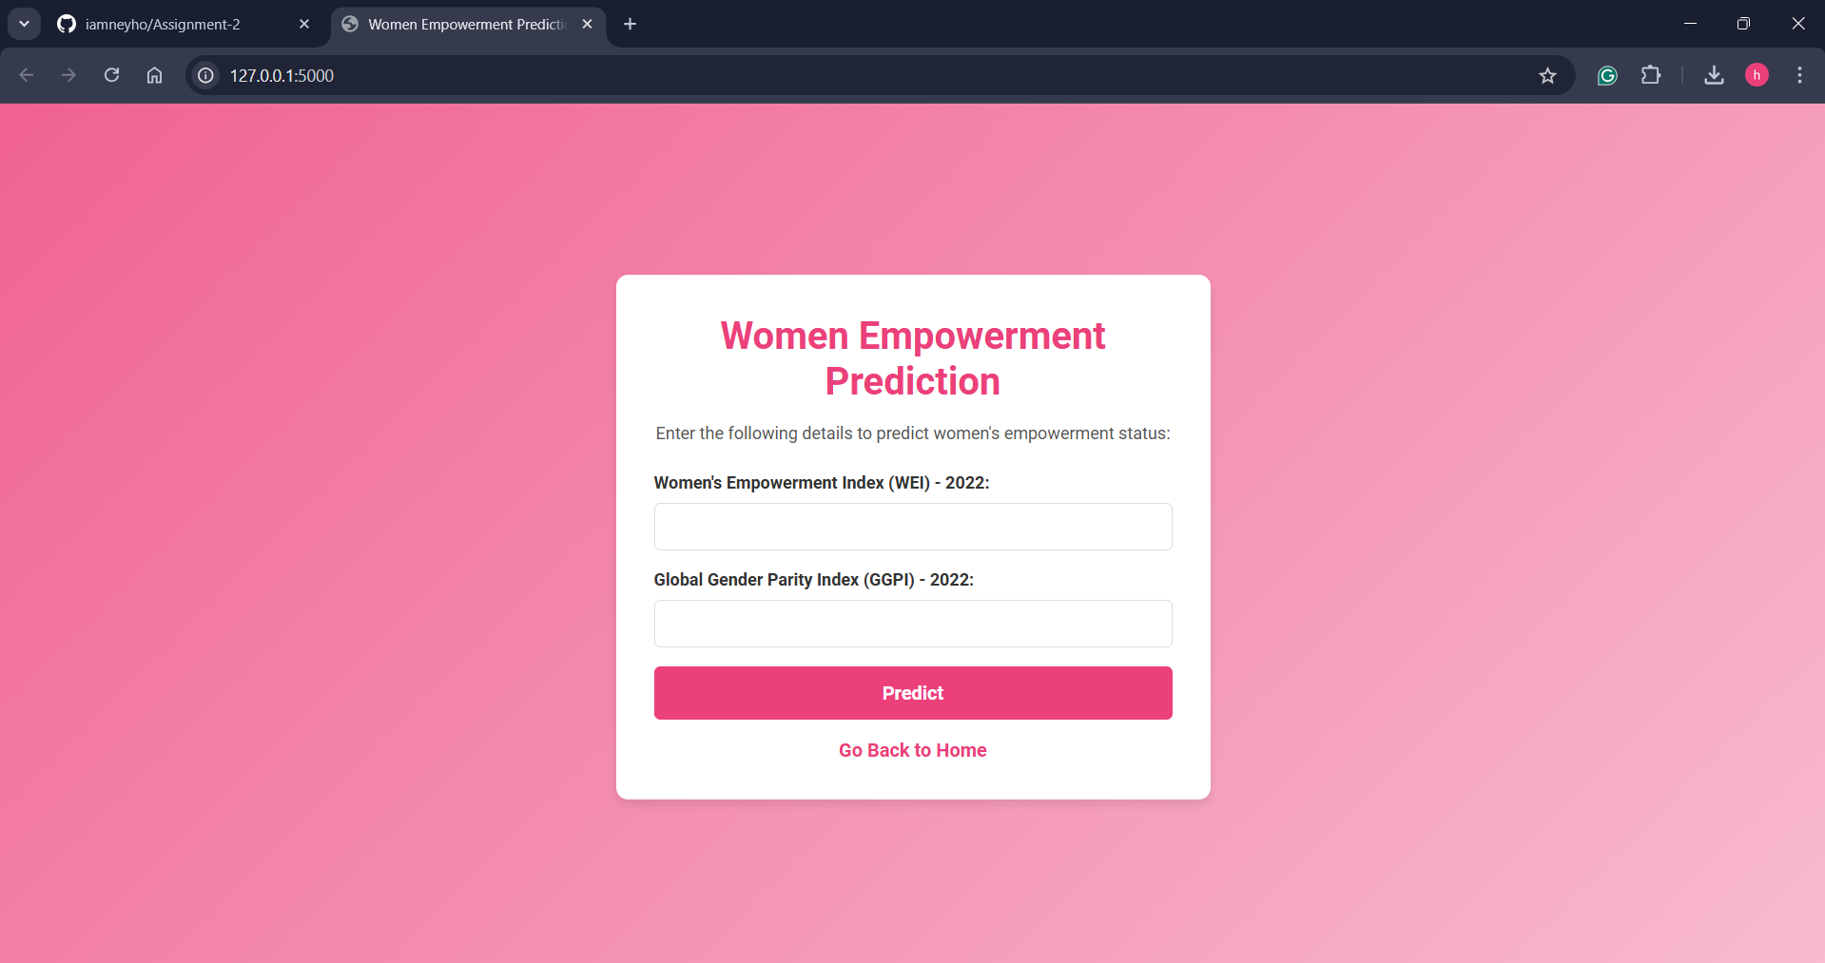  
  
Adding example values to test:  
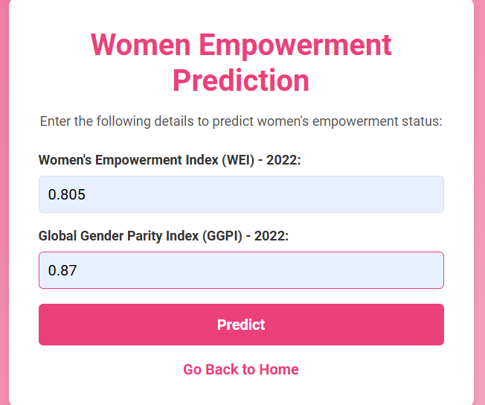

Viewing the result:

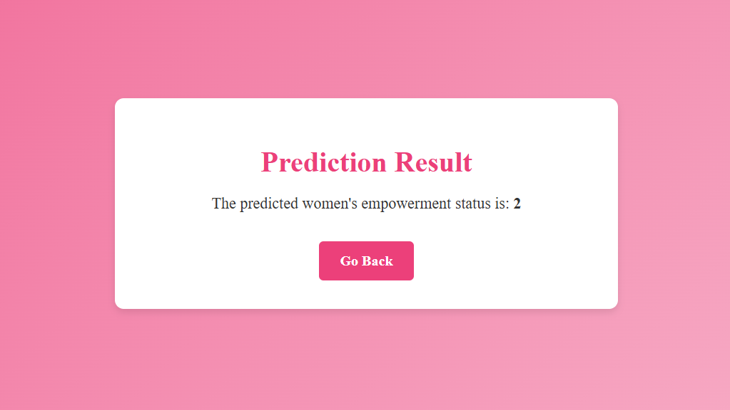

Going back to Home page:

