Non-uniform Zooming with Multi-touch Technology

Md. Nazmul Haque Khan
Interactive System course
Department of Computer Science
University of Helsinki

Date: 21 December, 2011

Contents

- Introduction………………………………………………………………….2
- Related Studies…………………………………………………………........2
- Overview of the System
  - Planning and Design…………………………………………………..4
  - Prototype………………………………………………………………6
  - Implementation………………………………………………………..7
- User Guide…………………………………………………………………...9
- Evaluation…………………………………………………………………..12
- Conclusion and Future work………………………………………………12
- Team Member Grades……………………………………………………..13
- Reference …………………………………………………………………...14

Introduction
With the increasing popularity of mobile technology and handheld devices information visualization in small screen has become a challenge for the developers and researchers. However, it is extremely difficult to display all the information a person requires at the same time in the small screen as it has the limited size of display. Switching frequently from parts to parts is some what trivial and niggling, particularly when we are doing comparison, searching and so forth. So, a new mechanism that enables people to zoom parts of components without covering other parts is crucial to be development to meet people’s demands. It will ease our labour and improve working efficiency and entertainment. By the help of this “Non-uniform zooming with multi-touch technology” project we can do the works as we required in reasonable responding time.

In our project, we developed an android application android tablet to facilitate the zooming capability in an image in a non-uniform ways by different kinds of natural finger-gestures. The finger-gestures are well-designed to understand and manipulate easily. During our project, we learned to put the design theories presented in the lectures of Interactive System course into practice. Figured out the practical problems of interactive system design and solve them by cooperation. The interactive system design theorems mainly include: User Centric Design, Information Visualization, Input Technologies, Multimodality and Evaluation.

Related Studies:
In many cases, people want to see as much information and interface components as the screen can present at one time, especially for on handheld devices. Dealing with this problem, there are many techniques have been examined to allow users to work at and move around the focused and contextual views of visual information. The traditional interface techniques remove some parts of the context to leave more space for zooming on the focused area. The overview+detail technology makes use of a spatial separation between focused and contextual views for zooming. The focus+context minimize the layer between views by displaying the focus within the context while cue-based techniques selectively highlights or suppresses items within the information space. There are three techniques for using large interfaces on small screens: a panning system similar to what is in current use, a two-level zoom system, and a fisheye view. The study also proves that people were able to carry out a web navigation task significantly faster with the fisheye view while the two-level zoom was significantly better for a monitoring task, and the panning system was significantly slow in terms of user experience [1].

The term Non-uniform Zooming has been used also in JPsEffects. It has been described in different meaning and in stretching of a video. Parameters to this effect are margins of the input video (in %). These margins are cut away and the rest of the input is stretched to fit the original size [2].

In our project, we developed the non-uniform zooming based on fisheye view. There are several lens types such as full-screen pyramid lens, constrained hemispherical lens, constrained flat-hemisphere lens [3]. In our implementation in order to get the fisheye view we have used Barrel Distortion Correction Algorithm with Bilinear Interpolation [4]. It solves the “too small screen to display information” problem, by keeping background visible while zooming only focused areas. The algorithm also provides good response time than other existing fisheye zooming software.

Overview of the System
Planning and Design
User Centric Design (UCD) concept is a recent design method to create the products with high efficiency and effectiveness and easy to use. In order to satisfy users, in the every phase of design, users should be well researched.
 | Phase 1 | Phase 2 | Phase 3 | Phase 4
Period | 05.09-14.10 | 15.10 - 06. 11 | 07. 11- 02. 12 | 02. 12 - 05.12
Design | Information collection & define initial concept | Brainstorm & detailed design  Vertical prototype &  evaluation | Redesign  &  Horizontal prototype & evaluation | Final-version concept  Prototype & evaluation

In the first phase of our project, we collected the information on non-uniform zooming algorithms and multi-touch technology through internet, learn about a candidate platform “Corner stone Multi-touch screen”, collected suggestions for our project from classmates and teachers, according to which we analyzed the user’s demands of non-uniform zooming display mechanism. After that, we made the initial off-line prototype design of our project:

“Imagine the display as the surface of flexible material. If one moves her/his hands together on the surface, the surface will bend and zoom in a 3D form. More than one zoomed areas can exist on one screen. A similar metaphor could be applied to a touch-screen display”

In phase 2, we discuss in group periodically to make more detailed designs. We defined the targeted users as people elder than 12-year old and understanding English. This project is to develop a method to solving the problem that limited screens cannot display that much visual information as people need and to provide a new entertaining display mechanism with multi-touch technology. So the features of our application should include short response time; ability of maintaining several zooming areas synchronously on a screen; interactively controllable zooming size; onion zooming; the function of to reset each zooming. Considering about the portability and time limitation, we decide to build our project on Android platform, which is optimized for mobile devices and powered by a custom 2D, 3D graphics library.

We divide our tasks into two aspects: Fish algorithm implementation and gesture detection functions implementation. Based on the Android multi-touch SDK, we designed several common gestures and zooming functions, and then, prototyped and evaluated several basic functions on Eclipse.

In phase 3, we finalized our project concept as:
“Imagine the Android tablet multi-touch screen as the surface of flexible material. If one pinches her/his fingers together on the surface, the surface will bend and zoom like a 3D bubble. Moving the fingers towards each other will reset the corresponding bubble. The feature of our system include: several bubbles can be hold on the screen; onion zooming (hierarchical bubbles) can be made on identical part of the screen; the size of bubbles are decided by distance of two fingers. A similar metaphor could be applied to a touch-screen screen of an Android tablet.”

We integrated gesture code and zooming function code, add some new functions, prototyped on an Android tablet and evaluated the prototype with some users. Finally, in the last phase, we mainly revised of concept with feedback from evaluation, conducted final version of prototype and prepared for the demo session.

Prototype

 | Prototypes
Phase 1 | Paper stretches  - Offline prototype  - Scenario-based prototype  - Rapid prototype
Phase 2 | Prototype on Eclipse  - Online prototype  - Vertical prototype  - Task-oriented prototype  - Iterative prototype
Phase 3 | Eclipse & Android tablet  - Online prototype  - Horizontal prototype  - Evolutionary prototype
Phase 4 | Android tablet & demo  - Online prototype  - Horizontal prototype  - Evolutionary prototype

The objective of our project is to exploit the available screen space. In many conditions, what people want to see on the screen are more than the screen can display. In our project, we utilize non-uniform zooming method based on Barrel Distortion Correction Algorithm with Bilinear Interpolation to visualize the overmuch information.

Implementation
The system is built on Android platform which makes it easy to deploy into any Android devices with greater than Android version 2.2. Based on the android multi-touch SDK, our system is able to detect different finger gestures correctly. Our application is implemented on a multi-touch screen on an Android tablet. It is a direct input device that has a unified input and display surface that can detect fingers’ positions and motions, and provide graphical feedback, corresponding to the direction that the user moves the fingers. We use the Keystroke-Level Model (KLM) to estimate the time needed for experts to complete a routine task: keystrokes, homing times to acquire input devices, pauses for mental preparation, and pointing at targets.

Image magnification in barrel distortion decreases with respect to the distance from the optical axis. The obvious effect is like an image which has been mapped around a sphere. Barrel distortion is in fact a diminished radius mapping for large radii in comparison with small radii. Mathematically, barrel distortion is quadratic and increases as the square of distance from the centre. So the fisheye effect with barrel distortion works well with square images. That’s why we have limited our zooming effect in a square area within an image. In our implementation we can have several zoom in different area of the image with different size of square. The barrel distortion model [4] is:
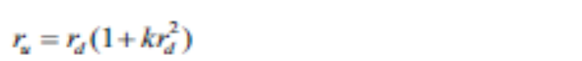
Here r_{u} and r_{d} are the distance from the centre of distortion in the undistorted and distorted images respectively, and k is the distortion parameter, which is specific to the lens. The figure below shows the effect of the distortion.

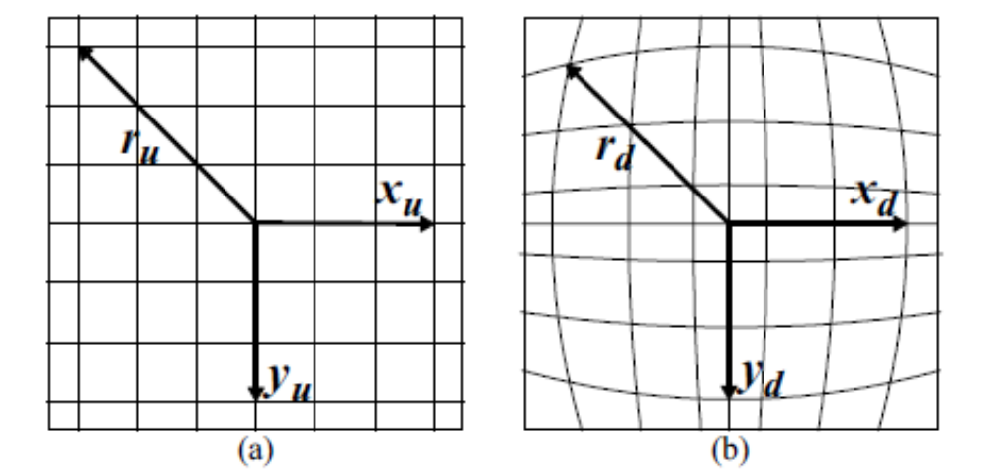
Figure1: Illustration of barrel distortion model

The difficulty of implementing the algorithm was the runtime of the function and making it run in real-time. In the beginning of our implementation we tried to run the algorithms in the whole image while it was taking almost 3 to 4 minutes for an image size of 1300 X 720 resolution. Then we have tried to run our algorithm with some modifications and enhancements and cropping only part of the image to be zoomed by using pinch zoom gestures and that worked pretty good and the run time significantly reduced from minutes to maximum of 5 seconds. The application has still some bugs which we could not handle in short time. The application can not handle very large size of image. It shows memory out of bound exception in the device. We are considering to remove these bugs in future.

User Guide
In our application there are four different features which have been implemented: zoom in, zoom out, zooming in different area and onion zooming (hierarchical zoom). We have used the pinch zoom gesture to implement the touch gesture. For zoom in the following figure shows the “zoom in” gesture.

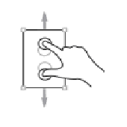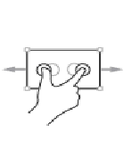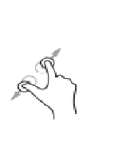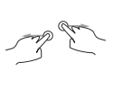
Figure 2: Finger gestures for “zoom in”

After zooming the effect will be as follows:

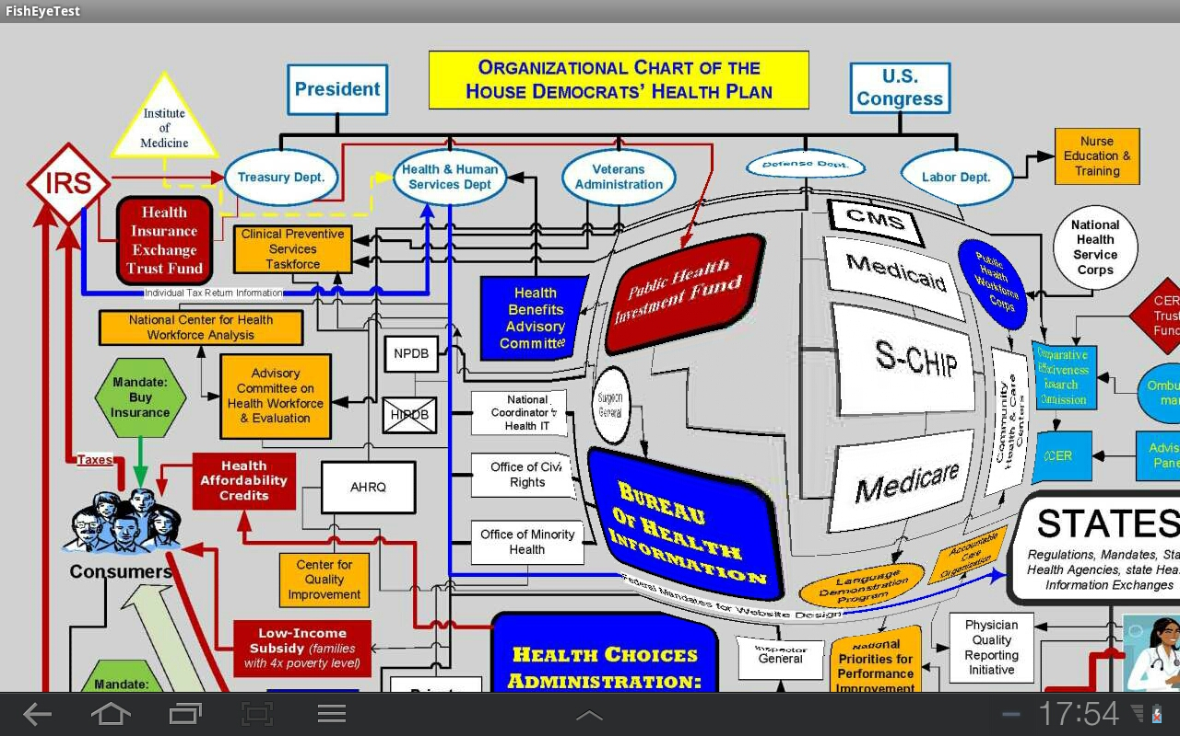
Figure 3: Zoom in of an image.
The user can have several zoom in the image in different areas using the same gestures and the effect will be as follows:

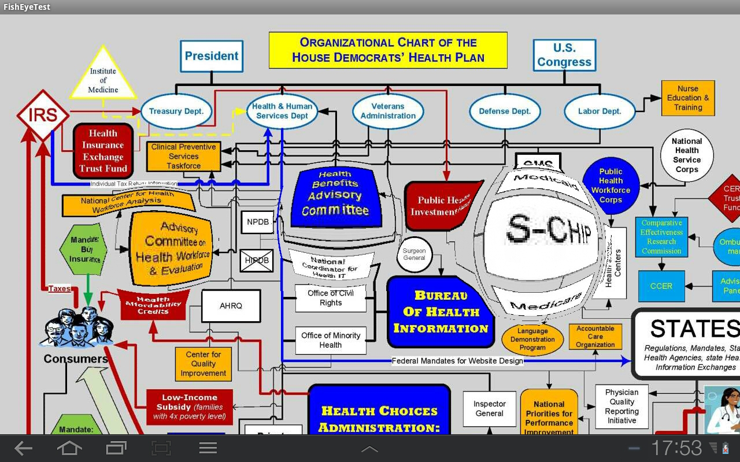

Figure 4: Multiple zooming in an image.

For “zooms out” the user need to drag two fingers towards each other. The “zoom out” feature takes the user to the previous state of the zoomed image. If the user want get the original undistorted image he or she needs to do the “zoom out” gesture repeatedly. The “zoom out” gesture for the Figure 4 will take it to its previous state as follows:
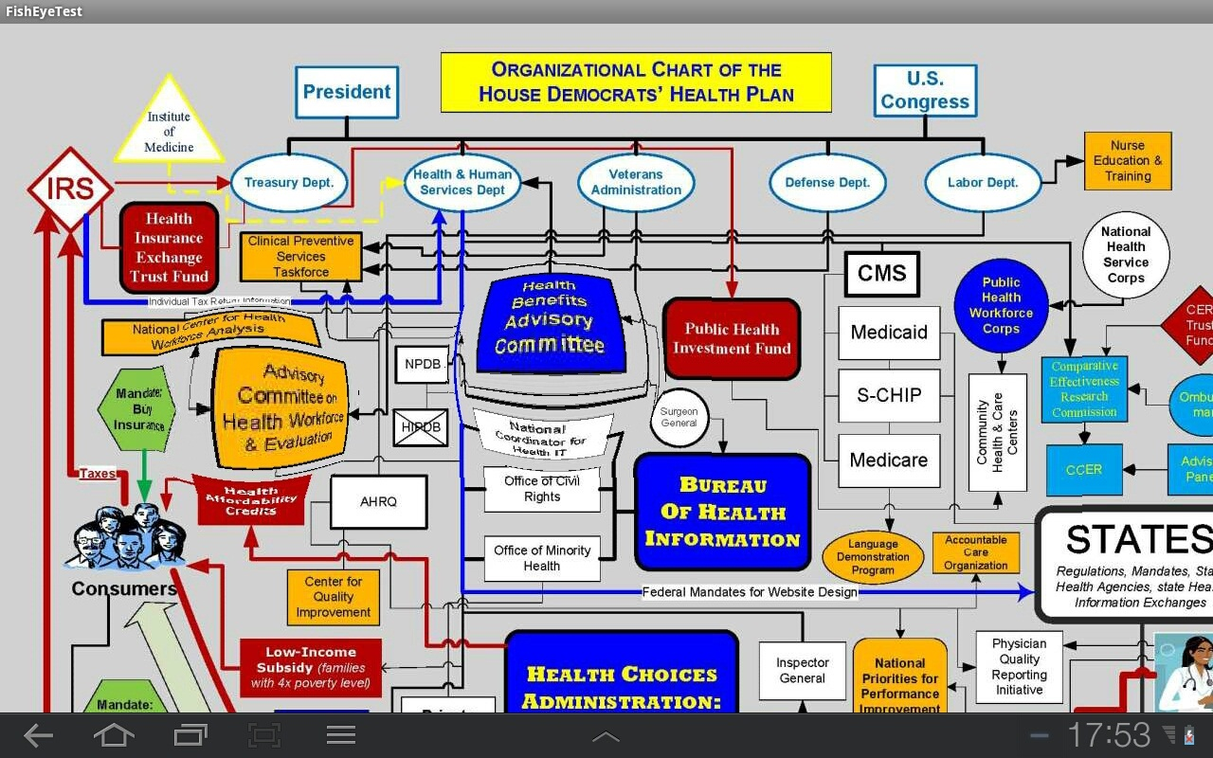
Figure 5: Zoom out of Figure 4.

For onion zooming or hierarchical zooming the user needs to use the zoom in gesture one the previously zoomed area. The effect will be as follows:

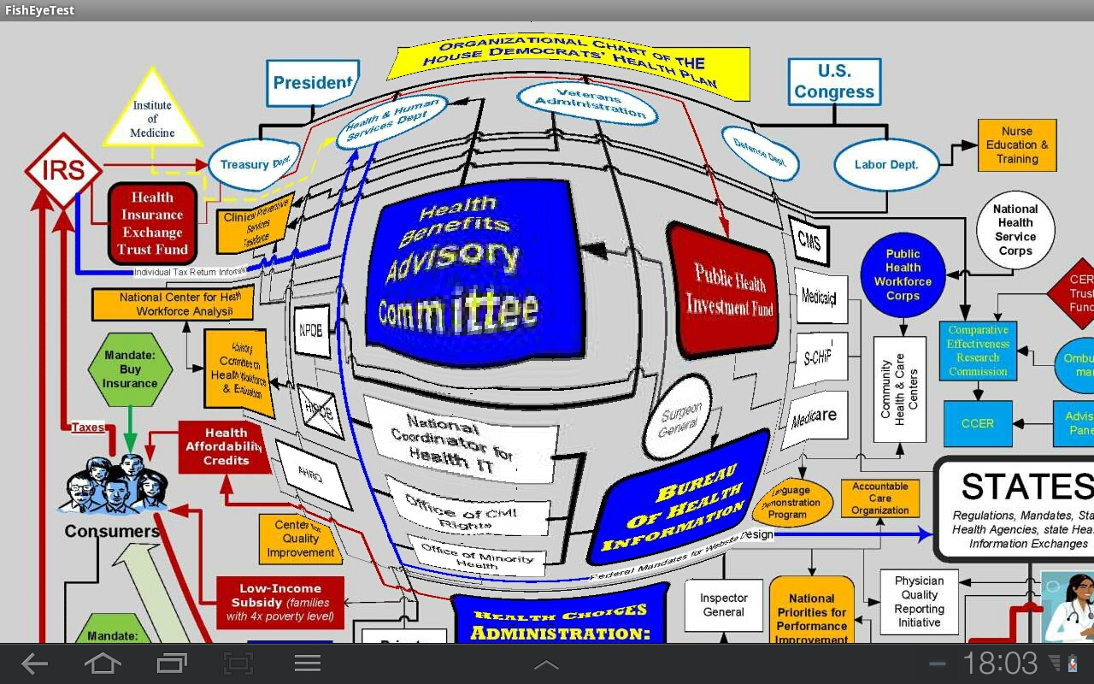
Figure 6: Onion (Hierarchical) zooming.
Zoom out for onion zooming is the same as normal zooming and it takes the user to its previous state.

Evaluation
Usability testing is a crucial tool for interactive system design to examine who is using the system and detect and identify how interaction problems happens in the design process.
In our project, we utilized Participatory Observation testing method. That means while observing the users operating the system, the observer also takes an interactive part in the setting. It is an effective way to make formative and summative evaluations of our progresses and to improve current provision.

Conclusion and Future works:
The project in deed turned out to be a challenging in many ways. It also helped us explore different techniques regarding multi-touch technologies and handheld devices. It also helped me learn and understand image processing and its difficulties with the hardware limitation in many ways for small devices. I have learned a lot of thing regarding zooming specially about fisheye lens effects. I have also learned how to handle the multi-touch functionalities in android devices.
Finally, we are also considering to extend the functionalities of our application near future. Our application still has some bugs till the writing of this report. It can not handle very large size of image which we are considering to remove near future. It has also some difficulty with touch events: it only handles two fingers at a time and shows unexpected errors if we use multiple fingers. It shows another problem if the user do not wait for the response of his zooming effect for the “zoom in” gesture and tries to repeat his action again and again before responding. It creates a memory out of bound error. We are considering to remove these bugs. In terms of functionality we are considering to add the functionality to move the fisheye lens by a one finger drag gesture so that the user can create several lenses with different sizes on the image and move over the image. Although moving a fisheye lens or viewfinder is more difficult and our techniques may require modification and some advanced studies to implement this feature.
Team Member Grades
Mohsen Koolaji: 4
Zinat Rasooli Mavini : 4
Yina Ye: 4

References:
- Carl Gutwin, Chris Fedak. Interacting with Big Interfaces on Small Screens: a Comparison of Fisheye, Zoom, and Panning Techniques.
- http://www.jpseffects.de/JPEZoom2_EN.html
- Carl Gutwin, Chris Fedak. A Comparison of Fisheye Lenses for Interactive Layout Tasks.
- K.T. Gribbon, C.T. Johnston, and D.G. Bailey. A Real-time FPGA Implementation of a Barrel Distortion Correction Algorithm with Bilinear Interpolation.

