**Data:**

Reference: <https://cdn.shopifycdn.net/s/files/1/0027/2708/4144/files/DT1206-KV4500.jpg?v=1608892470>

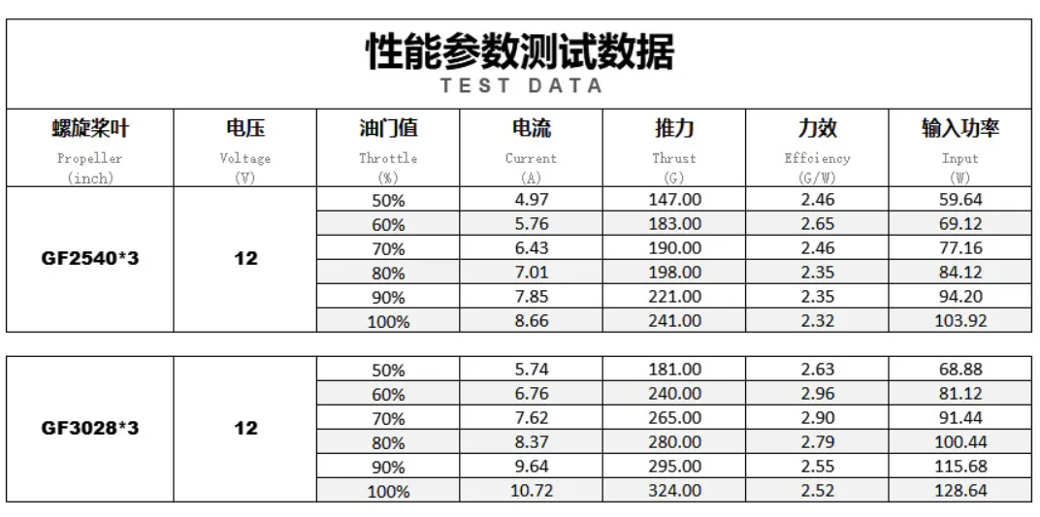

**Step 1: Define the System and Requirements**

| **Table 8: Drone Specification** | |
| --- | --- |
| **Property** | **Specification** |
| **Frame** | 5-inch (diagonal motor-to-motor distance ~200–250mm) |
| **Props** | 3×3×3 (3-inch diameter, 3-inch pitch, 3 blades) |
| **Motors** | Diatone Mamba Toka 1206 2450KV, 4 motors |
| **Battery** | 4S1P Samsung 50S 21700 |
| **Voltage** | 14.4V nominal, 16.8V fully charged |
| **Capacity** | 5000mAh |
| **Max discharge current** | 25A (5C) |
| **Internal resistance (IR)** | 60 mΩ (15 mΩ per cell × 4) |
| **Total Weight** | 600g (including battery, motors, frame, and electronics) |

| **Table 9: Motor Datasheet** | |
| --- | --- |
| **Property** | **Specification** |
| **Model** | Diatone Mamba Toka 1206 2450KV |
| **Support Battery** | 3×3×3 (3-inch diameter, 3-inch pitch, 3 blades) |
| **Max Power** | 140W |
| **Propeller Recommendation** | 2–3 inches (datasheet tests with CF2540×3 props: 2.5×4×3) |

*Load Performance (6S, 24V, CF2540×3 props):*

* 50% Throttle: 3.14A, 184g thrust, 2.44 g/W efficiency
* 60% Throttle: 3.64A, 237g thrust, 2.35 g/W
* 70% Throttle: 4.22A, 287g thrust, 2.24 g/W
* 80% Throttle: 4.59A, 321g thrust, 2.17 g/W
* 90% Throttle: 5.21A, 371g thrust, 2.25 g/W
* 100% Throttle: 5.76A, 418g thrust, 2.38 g/W

*Security Drone Requirements:*

* Flight Time: 45–60 minutes (mixed: 80% patrol, 20% burst)
* Stability: Thrust-to-weight ratio 1.1–1.5 for active surveillance
* Reliability: Minimal voltage sag and heat generation for sustained operation
* Flight Modes:
  + Patrol (50% Throttle): Low-throttle, efficient flight for routine area monitoring
  + Landing Hover (55% Throttle): Hover over docking station during alignment, followed by descent
  + Active Surveillance (75% Throttle): Moderate-throttle flight for tracking or active observation
  + Burst/Repositioning (100% Throttle): High-throttle mode for quick repositioning or emergency response

**Step 2: Adjust Motor Performance for 4S and 3×3×3 Props**

We’ll scale the datasheet performance data (for 2.5×4×3 props on 6S, 24V) to 4S (16.8V) and adjust for 3×3×3 props, using established propeller scaling laws and motor theory. References include *Anderson, J.D., Fundamentals of Aerodynamics* for propeller performance and *Heywood, J.B., Internal Combustion Engine Fundamentals* for motor scaling principles.

Scale Performance from 6S to 4S

* KV Rating: 2450KV (RPM per volt, unloaded)
* RPM:
  + On 6S (24V): Unloaded RPM = 2450×24 = 58800 RPM
  + On 4S (16.8V): Unloaded RPM=2450×16.8 = 41160 RPM
  + RPM ratio: 4116058800 ≈ 0.7

We started by defining the drone’s requirements, using the Diatone Mamba Toka 1206 2450KV motors with 3x3x3 propellers on a 4S battery setup (16.8V fully charged). The first step was to scale the motor’s performance from the datasheet, which provided thrust and current data for 6S (24V) with 2.5x4x3 props, to our 4S configuration and prop size.

Using the scaling laws from Anderson’s *Fundamentals of Aerodynamics* [A], we adjusted thrust and power based on RPM differences, where thrust scales with the square of RPM (Thrust ∝ (RPM)²) and power with the cube (Power ∝ (RPM)³). This gave us a baseline thrust of 294.94g per motor at 100% throttle, totaling 1179.76g for the quadcopter, and a corresponding current draw of 13.64A, well within our battery’s limits.

Adjust Thrust and Current for 4S

* Thrust Scaling: Thrust ∝ (RPM)2
* Thrust ratio: (0.7)2 = 0.49
  + At 100% throttle on 6S: 418g thrust
  + On 4S: 418g×0.49 = 204.82g per motor

Power Scaling: Power ∝ (RPM)3

Power ratio: (0.7)3 = 0.343

* Power on 6S at 100% throttle: 5.76A×24V = 138.24W 5.76A
* On 4S: 138.24W×0.343 = 47.42W per motor
* Current Scaling: Current = PowerVoltage
* On 4S: 47.42W16.8V ≈ 2.82A per motor
* Total current: 2.82A×4 = 11.28A
* Real-world (30–40% efficiency losses): 11.28A×(0.6 to 0.7) = 6.77A to 7.90A

Adjust for 3×3×3 Props

The datasheet uses 2.5×4×3 props (2.5-inch diameter, 4-inch pitch). The 3×3×3 props (3-inch diameter, 3-inch pitch) have a larger diameter but lower pitch.

* Diameter Ratio: 3 $÷$ 2.5 =1.2
* Thrust Adjustment: Thrust ratio = (1.2)2 = 1.44
* Thrust on 4S: 204.82g×1.44 = 294.94g per motor
* Total thrust: 294.94g×4 = 1179.76g

| (1) | $Total Thrust at 100\% Throttle=1179.76g$ |
| --- | --- |

Current Adjustment: Current ratio = (1.2)3 = 1.728

Current on 4S: 2.82A×1.728 = 4.87A per motor

Total current: 4.87A×4 = 19.48A; Real-world: 19.48A×(0.6 to 0.7) = 11.69A to 13.64A

| (2) | $Total Current at 100\% Throttle=13.64A$ |
| --- | --- |

Power Check

* Power per Motor: Power = 4.87A×16.8V ≈ 81.82W

This is within the motor’s 140W limit, confirming the suitability of 3×3×3 props

**Step 3: Flight Scenarios at Different Throttle Configurations**

Scenario 1: Patrol Mode (50% Throttle)

* Thrust: 294.94g×0.5 = 147.47g per motor; 147.47g×4 = 589.88g
* Thrust-to-Weight Ratio: 589.88g $÷$ 600g ≈ 0.98. This is slightly below 1, indicating minor throttle adjustments are needed to maintain altitude.
* Current: 4.87A×(0.5)3 = 4.87A×0.125 ≈ 0.61A per motor

Total: 0.61A×4=2.44A; Real-world: 2.44A×0.7 ≈ 1.71A

| (3) | $Total Current at 50\% Throttle (Patrol)=1.71A$ |
| --- | --- |

Voltage Sag: Vdrop = 1.71A×0.06Ω = 0.103V (Ohm’s Law)

Sags to: 16.8V−0.103V = 16.697V

Heat Generation: Pheat= I2×R = 1.712×0.06 = 0.18W

Per cell: 0.18W÷4 = 0.045W, negligible

Flight Time = $\frac{4 Ah}{1.71 A}×60≈ 140.4 minutes (80\% capacity)$. Theoretical, as the drone requires slight throttle adjustments to hover.

Scenario 2: Landing Hover (55% Throttle, Descent to 0%)

* Hover at 55% Throttle:
  + Thrust: 294.94 g×0.55 = 162.22 g per motor; 162.22g×4 = 648.88g

Thrust-to-Weight Ratio: $\frac{648.88 g}{600 g} ≈$ 1.08

Current = 4.87A×(0.55)3 = 4.87A × 0.1664 ≈ 0.81A per motor

Total: 0.81A×4 = 3.24A; Real World: 3.24A × 0.7 ≈ 2.27

| (4) | $Total Current at 55\% Throttle (Landing Hover)=2.27A$ |
| --- | --- |

Voltage Sag: Vdrop =2.27A×0.06Ω = 0.136V

Sags to: 16.8V - 0.136V = 16.664V

| (5) | $Voltage Sag at 55\% Throttle=16.664V$ |
| --- | --- |

Pheat = 2.272 ×0.06 = 0.31W; Per cell: 0.31𝑊 ÷ 4 = 0.078𝑊, negligible

Flight Time (Hover) = $\frac{4Ah}{2.27A}×60≈105.7 minutes$

Descent to Landing (55% to 0% over 10 seconds):

Average Throttle = $\frac{55\% + 0\%}{2} = 27.5\%$

Average Thrust: 294.94g × 0.275 = 81.11g per motor, 81.11g × 4 = 324.44g

Average Current: 4.87A × (0.275)3 = 4.87A × 0.0208 ≈ 0.10A per motor

Total: 0.10A × 4 = 0.40A; Real-world: 0.40A × 0.7 ≈ 0.28A

Vdrop = 0.28A × 0.06Ω = 0.017V

Sags to: 16.8V − 0.017V = 16.783V

Pheat = 0.282 × 0.06 = 0.005W; Per cell: 0.005W ÷ 4 = 0.001W, negligible

Energy Consumption (10 seconds):

Energy = $0.28 × \frac{10}{3600} hours=0.00078Ah$

*Scenario 3: Active Surveillance (75% Throttle)*

Thrust: 294.94g×0.75 = 221.21g per motor; 221.21g×4=884.84g

Thrust-to-Weight Ratio: $\frac{884.84g}{600g}≈1.47$

Current: 4.87A×(0.75)3 =4.87A×0.4219≈2.05A per motor

Total: 2.05A×4=8.20A; Real-world: 8.20A×0.7 ≈ 5.74A

| (6) | $Total Current at 75\% Throttle (Active Surveillance)=5.74A$ |
| --- | --- |

𝑉drop = 5.74A × 0.06Ω = 0.344V

Sags to: 16.8V − 0.344V = 16.456V

Pheat = 5.742×0.06 = 1.98W; Per cell: 1.98W÷4 = 0.495W, negligible

Flight Time = $\frac{4Ah}{5.74A} × 60≈41.8 minutes$

Scenario 4: Burst/Repositioning (100% Throttle)

**Thrust**: 1179.76g (ratio 1.97)

**Current**: 11.69A–13.64A

Voltage Sag: Vdrop =13.64A×0.06Ω = 0.818V

Sags to: 16.8V−0.818V=15.982V

| (7) | $Voltage Sag at 100\% Throttle=15.982V$ |
| --- | --- |

Heat Generation: Pheat=13.642×0.06 = 11.16W

Per cell: 11.16W÷4 = 2.79W, manageable for short bursts

Flight Time = $\frac{4Ah}{13.64A}× 60≈17.6 minutes$

**Step 4: Mixed Flight Time (80% Patrol, 20% Burst)**

Average Current: (0.8×1.71A)+(0.2×13.64A) = 1.37A+2.73A = 4.10A

| (8) | $Mixed Flight Current (80\% Patrol, 20\% Burst)=4.10A$ |
| --- | --- |

$⇒$ Mixed Flight Time = $\frac{4Ah}{4.10A}×60≈ 58.5 minutes$

| (9) | $Mixed Flight Time=58.5 minutes$ |
| --- | --- |

**Step 5: Battery Capability**

* Max Current: 25A
* Patrol (1.71A): Within 25A limit
* Landing Hover (2.27A): Within 25A limit
* Active Surveillance (5.74A): Within 25A limit
* Burst (13.64A): Within 25A limit
* Mixed Flight (4.10A): Within 25A limit

***Hence the chosen battery is suitable for powering our security drone as it meets all the flight requirements.***

**Step 6: Charging with iSDT 608AC**

* Max Current (DC): 8A (1.6C), reduced to 5A (1C) for safety
* Max Current (AC): 3.57A (0.714C), safe
* Charging Time (1C, 5A) = $\frac{5000mAh}{5000mA}$ $×60=60 minutes$

| (10) | $Charging Time at 1C (5A)=60 minutes$ |
| --- | --- |