- CREATE DATABASE niloy_2414032042_SCHOOL;
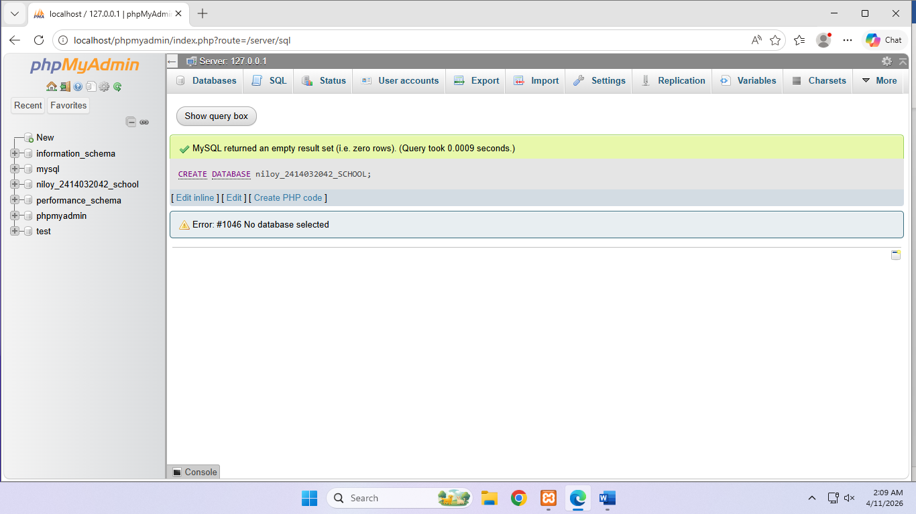

- A.
CREATE TABLE student(
SID int(20),
Name varchar(255),
Semester int(20),
Cr_Complete decimal(5,2),

PRIMARY KEY(SID)
)
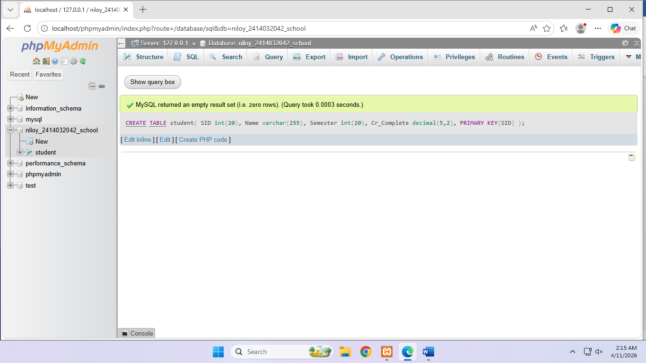

CREATE TABLE Stu_Status(
SID int(20) PRIMARY KEY,
CGPA decimal (3,2)
)

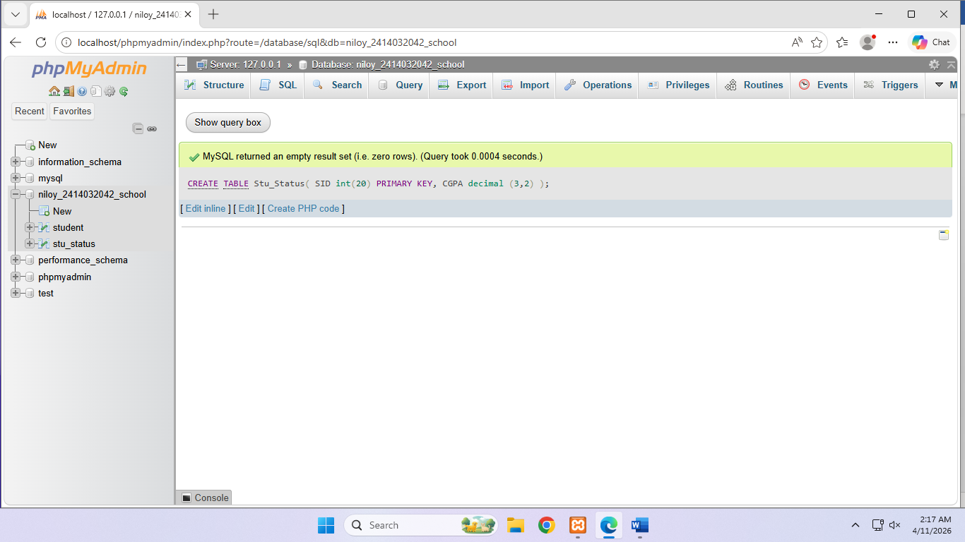

B.
INSERT INTO student
VALUES (2122, 'Joy', 10, 100.5),
(2133, 'Mick', 9, 83),
(2421, 'Mew', 5, 45),
(2532, 'Gulu ll', 2, 22),
(2618, 'Musi Jr.', 1, 9)
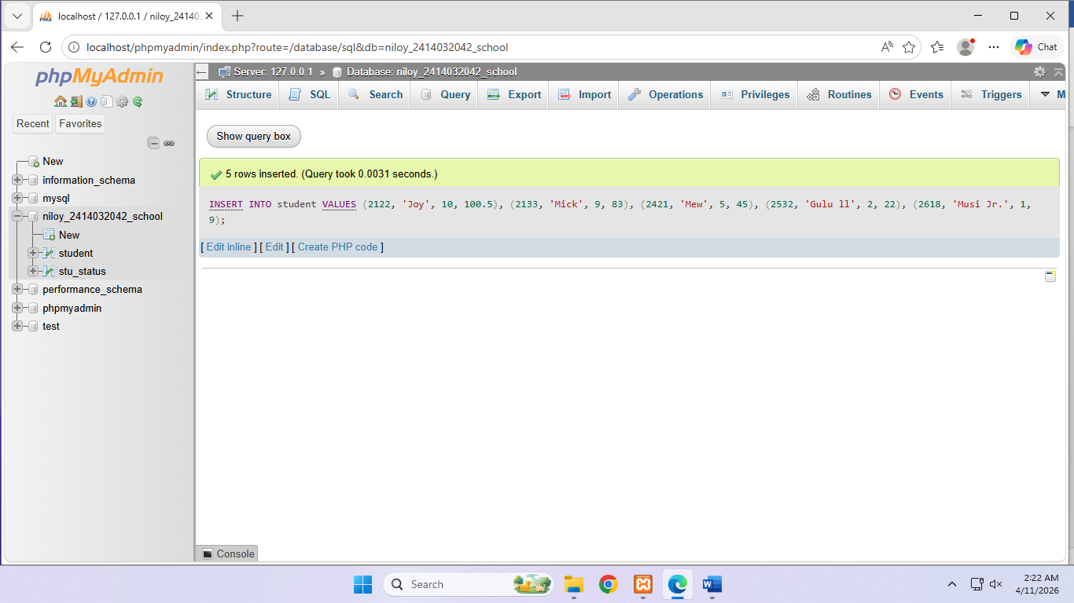

INSERT INTO stu_status (SID, CGPA)
VALUES(2122, 3.12),
(2133, 3.29),
(2421, 3.89),
(2534, 3.69),
(2618, 2.78)

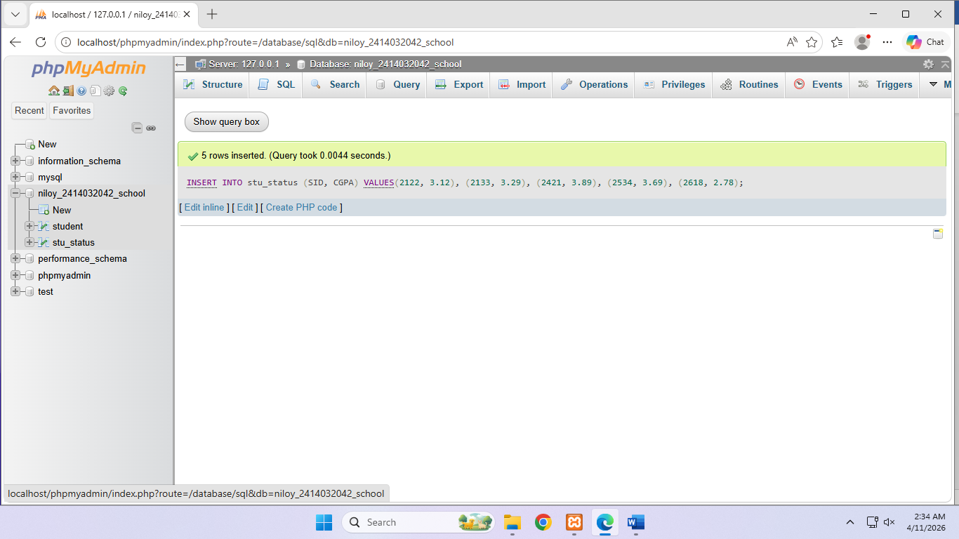

3.
ALTER TABLE stu_status
ADD COLUMN Status varchar(255);
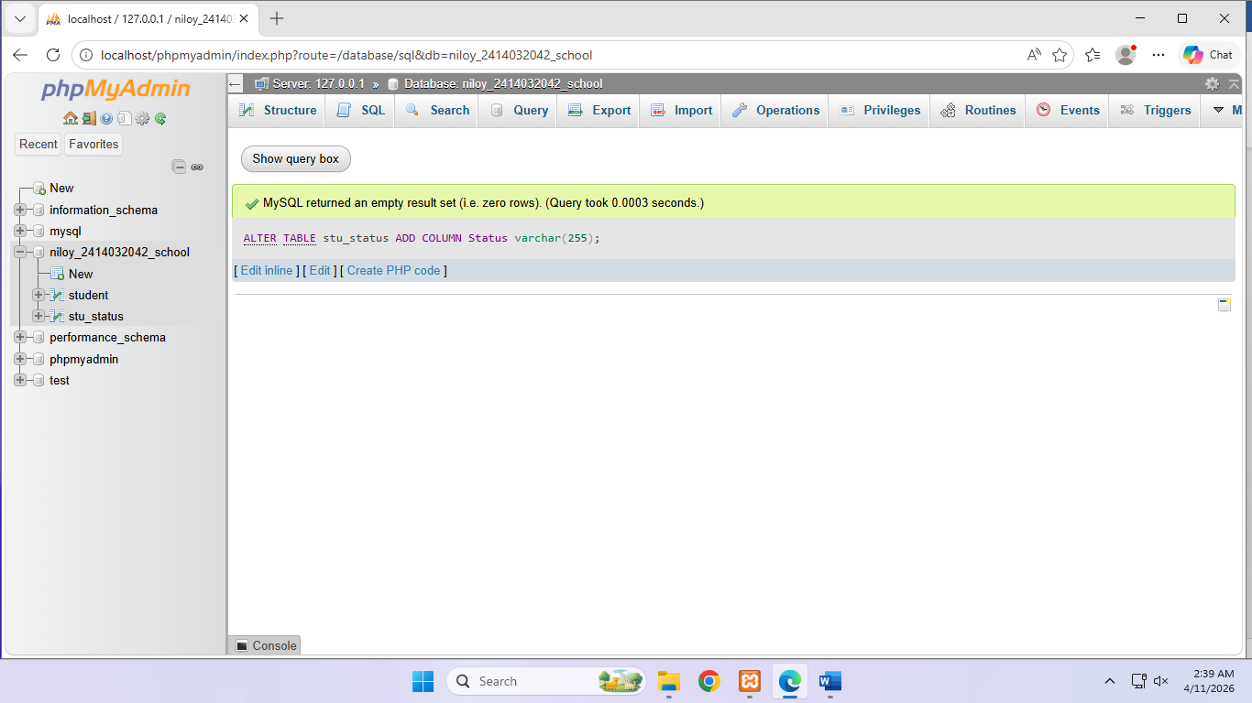

UPDATE stu_status
SET STATUS = 'Enrolled'
WHERE Status is NULL;

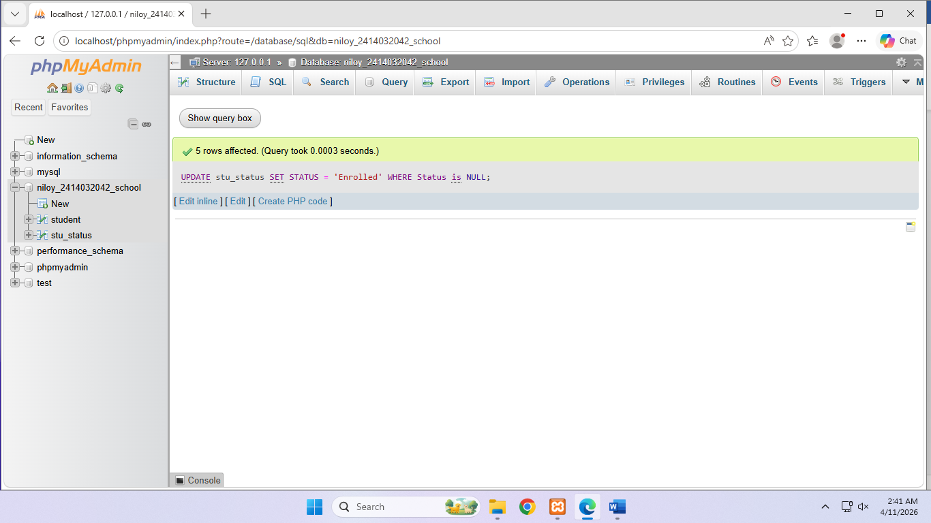

4.
SELECT s.SID, s.Name, s.Semester, s.Cr_Complete, t.CGPA
FROM student s
LEFT JOIN stu_status t
ON(s.SID = t.SID)
AND t.CGPA IS NOT NULL;

Correct:
SELECT s.SID, s.Name, s.Semester, s.Cr_Complete, t.CGPA
FROM student s
LEFT JOIN stu_status t
ON(s.SID = t.SID)
WHERE t.CGPA IS NOT NULL;
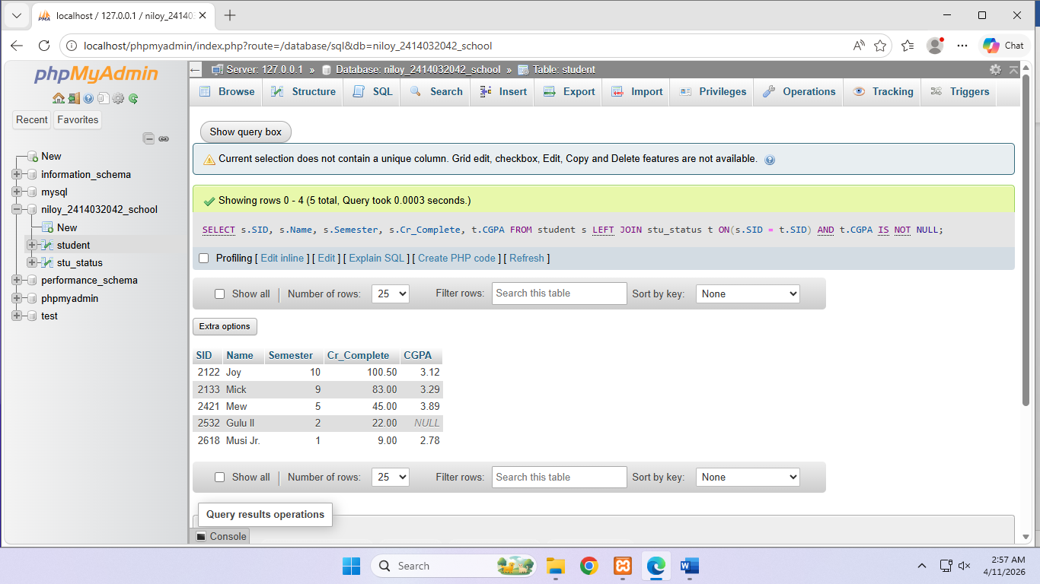

5.
SELECT l.Country_ID, l.State_Province, COUNT(*) AS Total_Employee
FROM emps e
JOIN depts d
ON (e.Department_Id = d.Department_id)
JOIN locs l
ON (d.Location_id = l.Location_id)
GROUP BY l.State_Province
HAVING (l.State_Province = 'Texas' OR l.State_Province = 'Washington');

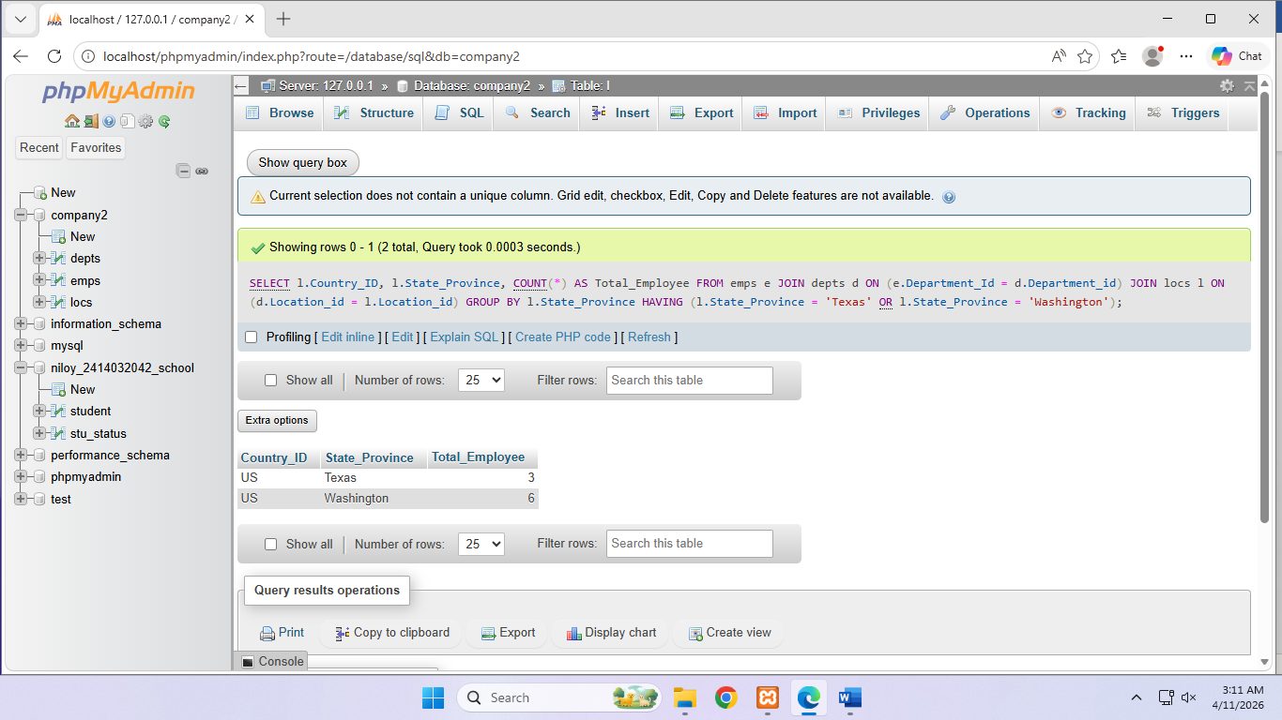

6.
SELECT l.City, e.Department_Id, MAX(e.Salary) AS Highest_Salary
FROM emps e
JOIN depts d
ON (e.Department_Id = d.Department_id)
JOIN locs l
ON (d.Location_id = l.Location_id)
GROUP BY l.City
HAVING(l.City = 'South San Francisco' OR l.City = 'Southlake');

Correct:
SELECT l.City, e.Department_Id, MAX(e.Salary) AS Highest_Salary
FROM emps e
JOIN depts d
ON (e.Department_Id = d.Department_id)
JOIN locs l
ON (d.Location_id = l.Location_id)
WHERE l.City LIKE "South%"
GROUP BY l.City;
