**Colorful fabrics casual bags handmade patch word clutch bag ...**

[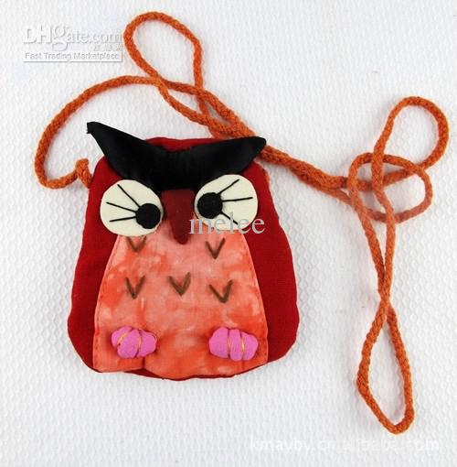](http://www.google.com.pk/url?sa=i&rct=j&q=&esrc=s&frm=1&source=images&cd=&cad=rja&uact=8&ved=0CAcQjRw&url=http://www.dhgate.com/product/christmas-baby-owl-bags-baby-crochet-handbag/145562529.html&ei=QIOxVPi2NYvmaKW0gqgJ&bvm=bv.83339334,d.d2s&psig=AFQjCNEFS72rjQIP8JEfr0Urc8U5Hspwxg&ust=1421005497813423)

**Cute owl bag style hand bag for girls and boys**

[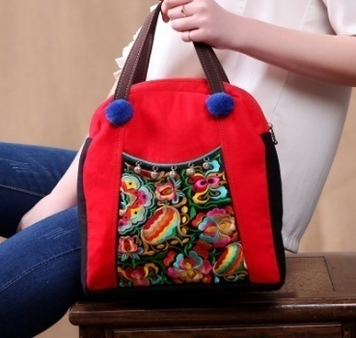](http://www.google.com.pk/url?sa=i&rct=j&q=&esrc=s&frm=1&source=images&cd=&cad=rja&uact=8&ved=0CAcQjRw&url=http://www.aliexpress.com/price/cloth-handbag-patterns_price.html&ei=SYexVKpRyuBqsomA4Aw&bvm=bv.83339334,d.d2s&psig=AFQjCNFoSo8IMnfypZfM5Rmb7urCV5FYaQ&ust=1421006978245194)

**Graphic patterns bags with cell phone pocket**

**Cell phone hand bag.. For girl**

[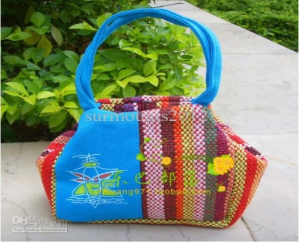](http://www.google.com.pk/url?sa=i&rct=j&q=&esrc=s&frm=1&source=images&cd=&ved=0CAcQjRw&url=http://www.dhgate.com/product/colorful-bag-girls-fabrics-casual-bags-handmade/153295655.html&ei=TYGxVNr6Monmati5gZAM&bvm=bv.83339334,d.d2s&psig=AFQjCNEFS72rjQIP8JEfr0Urc8U5Hspwxg&ust=1421005497813423)

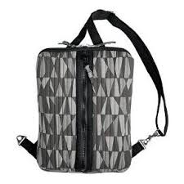 **New style bag for boys**

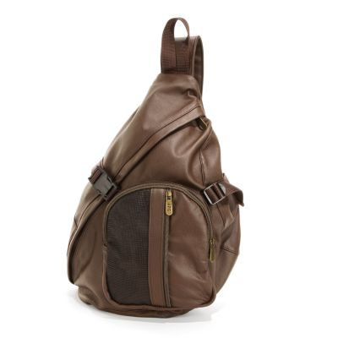

**Stylish bag for boys...**

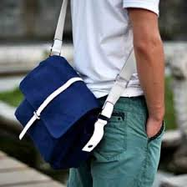

**Blue color bag for boys**

[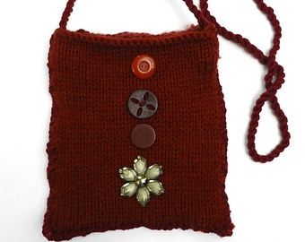](https://www.etsy.com/listing/213827112/rusty-red-and-heathered-red-hand-knit?ref=sc_3&plkey=b9caea656d613677533d69955556a88631acaeda:213827112&ga_search_query=Bags+and+Purses&ga_page=7&ga_search_type=all&ga_view_type=gallery)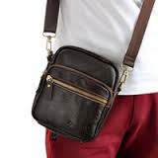

**Leather made bag..**

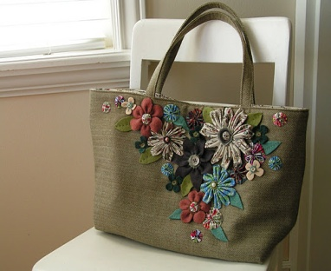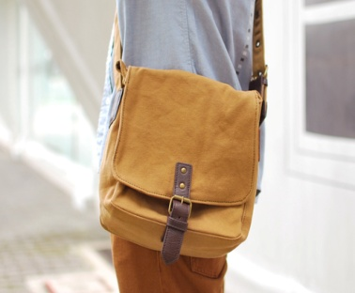

**Simple bag for boys**

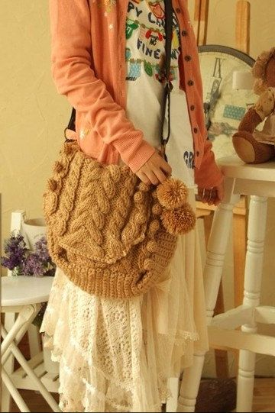

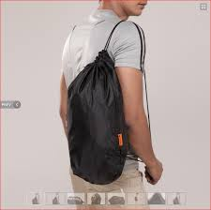

11