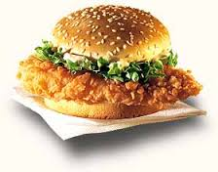**Ingredients**

* Chicken 1/2kg flay (breast boneless piece)
* Black pepper 1tsp
* Salt 1tsp
* Ajinomoto 1 1/2tsp
* Worcestershire sauce 2tbsp
* Oil for fry

**Marinate all spices else oil24 hours**

**For batter**

* Flour 2tsp
* Baking powder 1/44tsp
* Corn flour 2tbsp
* Egg 1
* Rice flour 2tbsp
* Chilled water as required
* Salt 1/2tsp

**Mix all together and make thick batter**

**For coating**

* Corn flakes 1cup
* Bread crumbs 1cup
* Chips 1cup

**Mix all spices and slightly grind(not in powered form)**

* Bun, cheese, slice, lettuce, mayonnaise

**Cooking directions**

* Dip marinated chicken in batter then coat in prepared coating

And deep fry till chicken become golden.

* Cut bun, spread mayonnaise on both pieces put lettuce, chicken

And cheese slice.

* Serve hot with chili sauce, ketchup and close law.

13