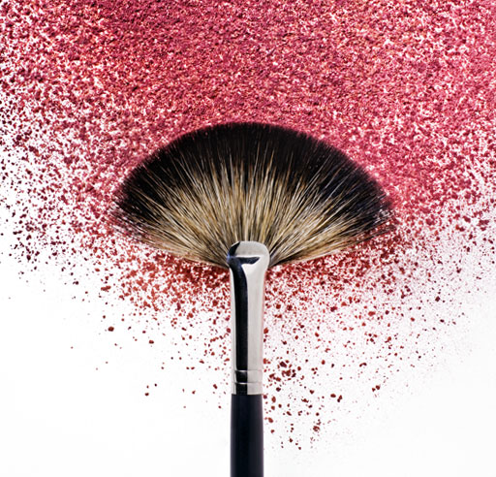

**01 INTERVIEW**

**03 BEAUTY TIPS FOR GIRLS**

**05 DRESSES**

**07 HOROSCOPE**

**09 STORY**

**11 BAGS**

**12 BOYS SHOES AND GIRLS HEELS**

**13 RECIPE CORNER**

**14 IMPORTANT FACTS**