1.What is SD-WAN?

SD-WAN – refers to Software-Defined WAN network is a technology to manage wide area networks using software-based approaches.

2.Advantages of SD-WANs:

SD-WANs provide improved performance in applications, cost savings, enhanced security and improved scalability in networks and makes its management easier.

3.How is IP assigned to devices?

IP addressing can be done using two approaches:

Static IP assignment: The IP address assigned doesn’t change over time.

Dynamic IP Assignment: Used by networking protocols like DHCP, the server automatically assigns an IP address from a pool of available address to a device when it connects to a network.

4.What are DNS servers, where it is configured?

DNS Servers – translate domain names of websites into IP addresses. DNS Servers have the following hierarchical levels:

Root Name Servers

TLD-(Top-Level Domain) Servers

Authoritative Name Servers

Recursive Name Servers

DNS servers is configured in the client devices(using the networking settings in the OS)

5.Why VLAN are required?

VLAN- Virtual LANs have the below mentioned benefits:

Better network management and security

Improved Network Segmentation

Better Network Performance

Flexible and Adaptable

6.At which place a traffic will get VLAN tagged in the network?

Traffic in a VLAN generally gets tagged at switches and routers.

**Access Port**: Connects to a single device, carries traffic for one VLAN, and sends/receives untagged frames.

**Trunk Port**: Connects to other switches/routers, carries traffic for multiple VLANs, and sends/receives tagged frames.

7.What is NAT and how does it work?

NAT – a networking technique to modify network address information – used for mapping Private IP addresses to Public IP addresses.

**NAT with Port Translation (NAPT/PAT)**: Maps multiple private IP addresses to a single public IP address using different ports.

Iptables command is used for configuring NAT/NAPT in Linux.

8.How a traffic get routed from LAN to WAN in a router / SD-WAN device?

The process:

Device 🡪 sends packet to router

Router performs NAT and forwards packet to ISP

ISP🡪 forwards to destination

Response follows the reverse path

9.What is a firewall, what all parameters does firewall have?

Firewall – Network security device that monitors and controls incoming and outgoing network traffic based on predetermined rules.

Parameters: IP addresses, Port numbers, Protocol, Action, Direction, Application Layer Filtering, Time-based rules, Stateful Inspection.

10.What is a public IP and private IP?

Public IP – A public IP address is an IP address that is globally unique and can be accessed over the Internet. Assigned by ISP and is used to identify a device or a network on the global internet.

Private IP – Used within LANs or private networks and not routable over the internet.

On Ops unit:

1. Create a VLAN with 100, IP range 192.168.55.1/24

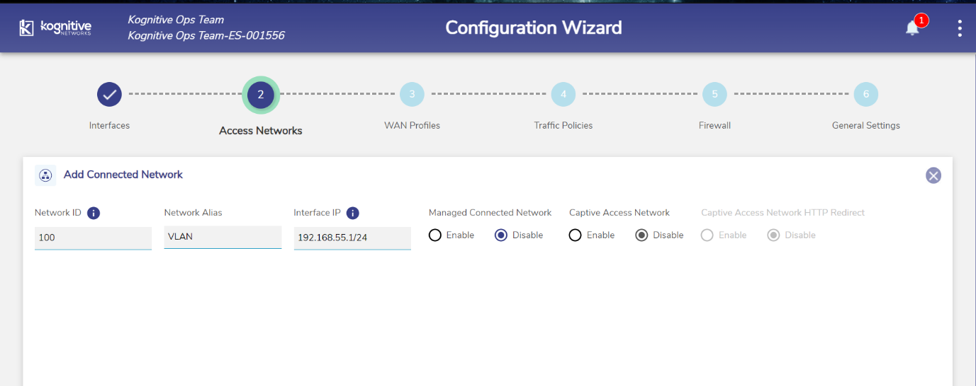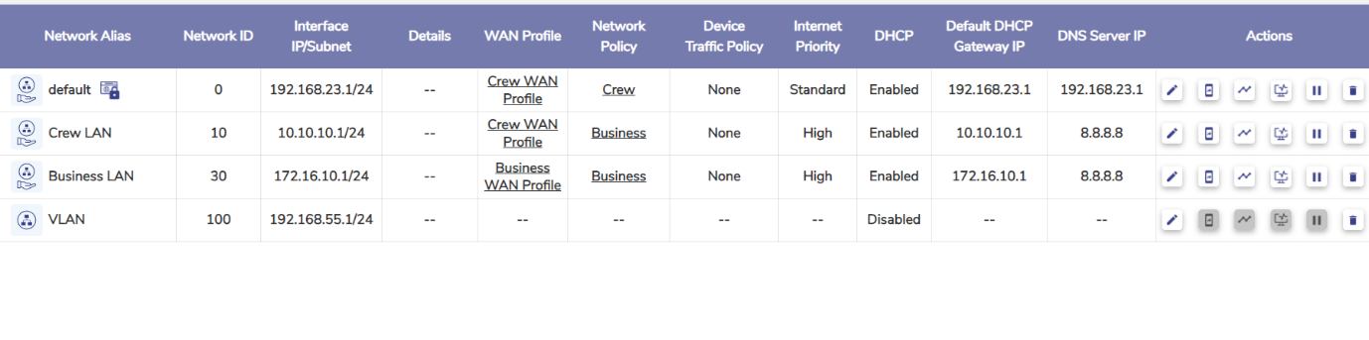

1. Assign a network traffic policy – which denies traffic to yahoo.com

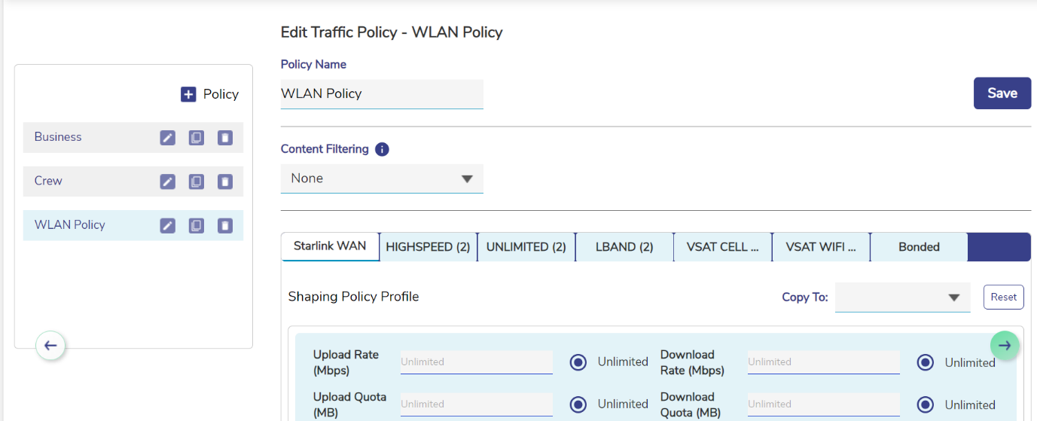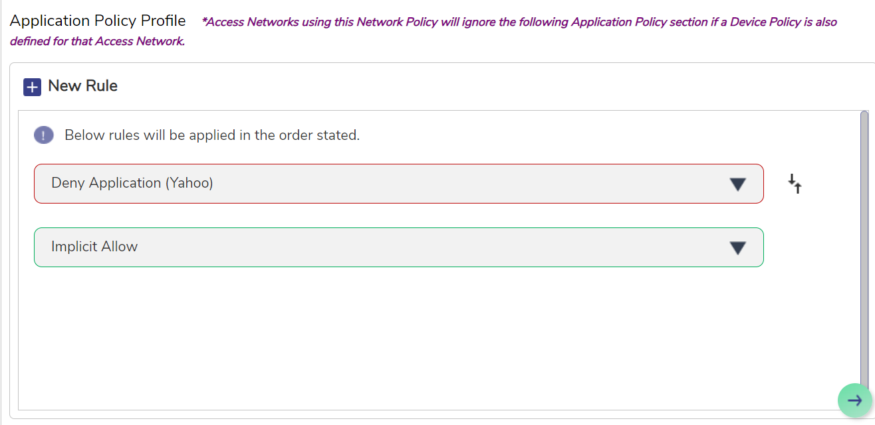

1. Configure a bandwidth for the network to 4 Mbps up and down.

