Output:
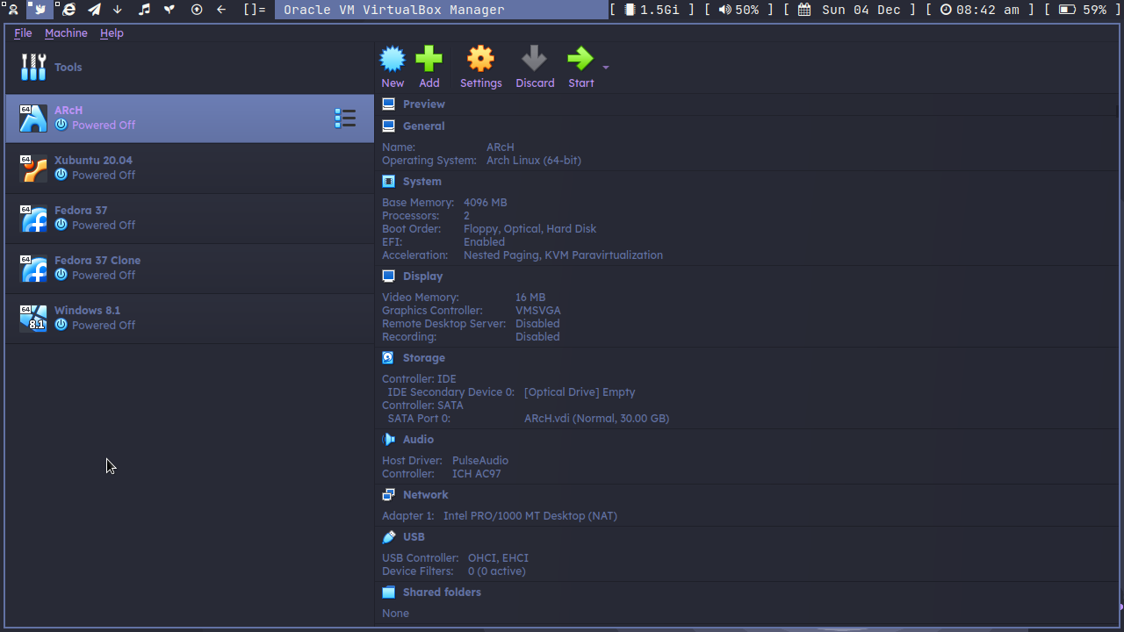
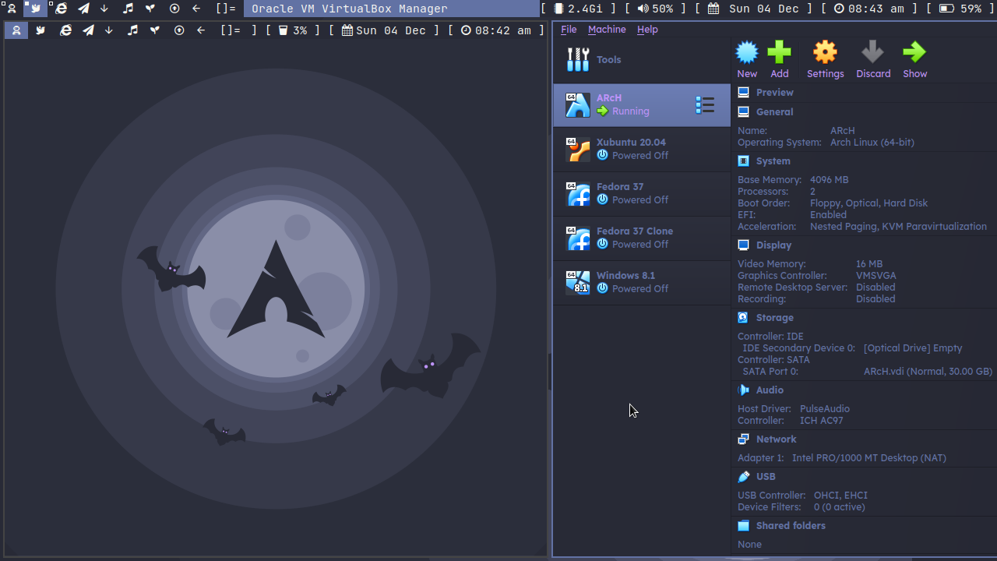

Output:
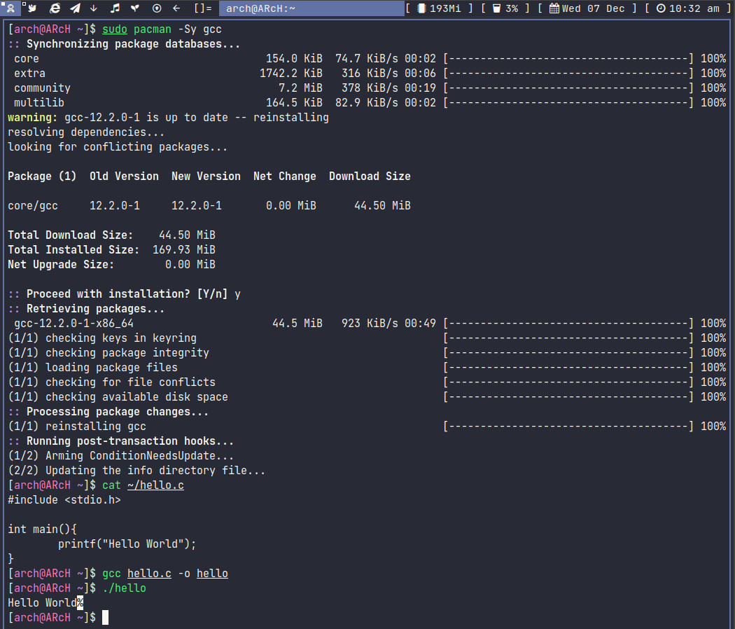

Output:
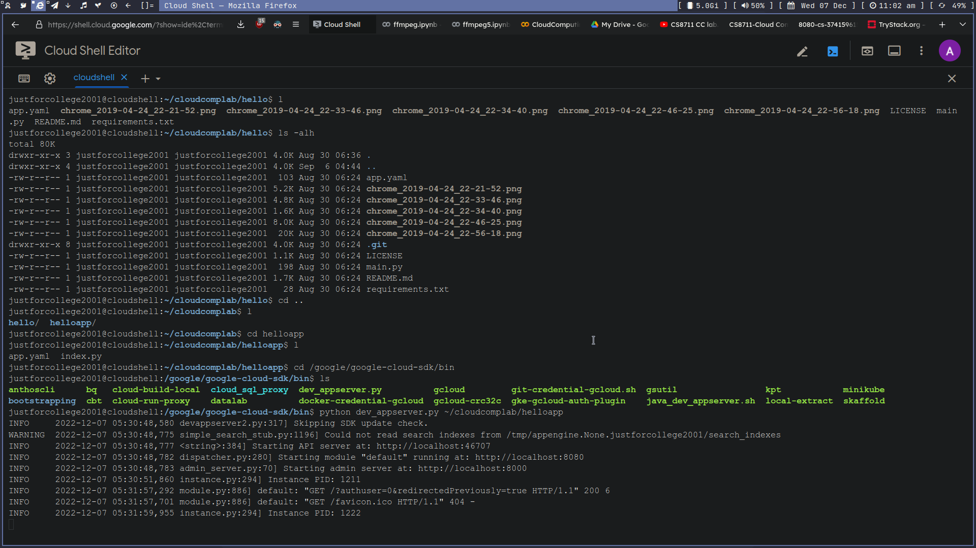
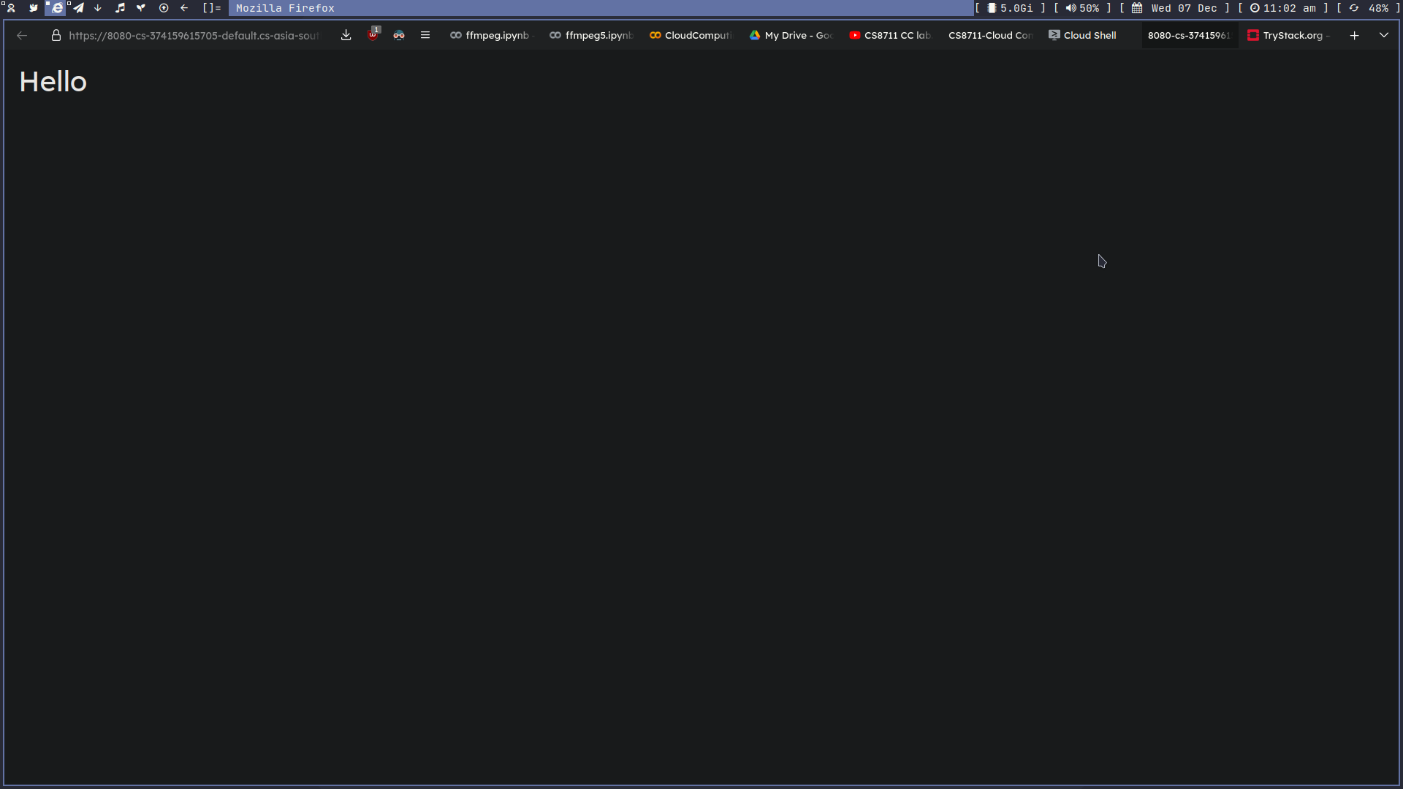

Program:

app.yaml
runtime: python27
threadsafe: false

handlers:
- url: /
script: index.py

index.py

print("Hello")

Output:

Program:

SJF.java
//https://raw.githubusercontent.com/kritidubey/Scheduling-Algorithms-Using-CloudSim/main/SJF.java
package myapp;

import java.text.DecimalFormat;
import java.util.ArrayList;
import java.util.Calendar;
import java.util.LinkedList;
import java.util.List;

import org.cloudbus.cloudsim.Cloudlet;
import org.cloudbus.cloudsim.CloudletSchedulerSpaceShared;
import org.cloudbus.cloudsim.CloudletSchedulerTimeShared;
import org.cloudbus.cloudsim.Datacenter;
import org.cloudbus.cloudsim.DatacenterBroker;
import org.cloudbus.cloudsim.DatacenterCharacteristics;
import org.cloudbus.cloudsim.Host;
import org.cloudbus.cloudsim.Log;
import org.cloudbus.cloudsim.Pe;
import org.cloudbus.cloudsim.Storage;
import org.cloudbus.cloudsim.UtilizationModel;
import org.cloudbus.cloudsim.UtilizationModelFull;
import org.cloudbus.cloudsim.Vm;
import org.cloudbus.cloudsim.VmAllocationPolicySimple;
import org.cloudbus.cloudsim.VmSchedulerTimeShared;
import org.cloudbus.cloudsim.core.CloudSim;
import org.cloudbus.cloudsim.provisioners.BwProvisionerSimple;
import org.cloudbus.cloudsim.provisioners.PeProvisionerSimple;
import org.cloudbus.cloudsim.provisioners.RamProvisionerSimple;

public class Myapp {
private static List<Cloudlet> cloudletList,cloudletListSJF;
private static List<Vm> vmlist;
private static List<Vm> createVM(int userId, int vms, int idShift) {
LinkedList<Vm> list = new LinkedList<Vm>();
long size = 1000;
int ram = 512;
int mips = 250;
long bw = 1000;
int pesNumber = 1;
String vmm = "Xen";
int jk=1;
Vm[] vm = new Vm[vms];
for(int i=0;i<vms;i++){
if (i%2==0 )
mips += jk;
else
mips -= jk;
vm[i] = new Vm(idShift + i, userId, mips, pesNumber, ram, bw, size, vmm, new CloudletSchedulerSpaceShared());
jk+=2;
list.add(vm[i]);
}
return list;
}
private static List<Cloudlet> createCloudlet(int userId, int cloudlets, int idShift){
LinkedList<Cloudlet> list = new LinkedList<Cloudlet>();
long length = 4000;
long fileSize = 300;
long outputSize = 300;
int pesNumber = 1;
UtilizationModel utilizationModel = new UtilizationModelFull();
Cloudlet[] cloudlet = new Cloudlet[cloudlets];
for(int i=0;i<cloudlets;i++){
if (i%2==0 || i<2)
length += 6500;
else
length -= 3277;
cloudlet[i] = new Cloudlet(idShift + i, length, pesNumber, fileSize, outputSize, utilizationModel, utilizationModel, utilizationModel);
cloudlet[i].setUserId(userId);
list.add(cloudlet[i]);
Log.printLine("cloudletlist size = " +cloudlet[i].getCloudletTotalLength());
}
return list;
}
private static void getCloudletListSJF(List<Cloudlet> clist)
{
int min=0;
for (int i=0; i<clist.size();i++)
if (clist.get(i).getCloudletLength() < clist.get(min).getCloudletLength())
min=i;
cloudletListSJF.add(clist.get(min));
clist.remove(min);
if (clist.size()!=0)
getCloudletListSJF(clist);
}

@SuppressWarnings("unused")
private static void sortCloudletList(List<Cloudlet> clist){
Cloudlet c;
for (int i=0; i<clist.size()-1; i++)
if (clist.get(i).getCloudletLength() < clist.get(i+1).getCloudletLength()){
c=clist.get(i);
clist.add(i, clist.get(i+1));
clist.add(i+1,c);
c=null;
}
}
private static double VmArt(List<Cloudlet> list, int VmId){
int c = 0;
double art = 0;
for(int i=0;i<list.size();i++)
if (list.get(i).getVmId() == VmId)
{
art = art + list.get(i).getExecStartTime(); c++;
}
art = art / c;
return art;
}
private static double VmMakespane(List<Cloudlet> list, int VmId){
double mkspane = 0;
for(int i=0;i<list.size();i++)
if (list.get(i).getVmId() == VmId)
if (list.get(i).getFinishTime() > mkspane)
mkspane = list.get(i).getFinishTime();
return mkspane;
}
public static void main(String[] args) {
Log.printLine("Starting CloudSimTestSJF...");
try {
int num_user = 1;
Calendar calendar = Calendar.getInstance();
boolean trace_flag = false;
CloudSim.init(num_user, calendar, trace_flag);
Datacenter datacenter0 = createDatacenter("Datacenter_0");
int vms = 50;
int cloudlets=100;
DatacenterBroker broker = createBroker("Broker_0");
int brokerId = broker.getId();
vmlist = createVM(brokerId, vms, 0);
broker.submitVmList(vmlist);
cloudletList = createCloudlet(brokerId, cloudlets, 0);
Log.printLine("cloudletlist size = " + cloudletList.size());
cloudletListSJF = new LinkedList<Cloudlet>();
getCloudletListSJF(cloudletList);
broker.submitCloudletList(cloudletListSJF);
CloudSim.startSimulation();
List<Cloudlet> newList = broker.getCloudletReceivedList();
CloudSim.stopSimulation();
printCloudletList(newList);
Log.printLine("CloudSimTestSJF finished!");
}
catch (Exception e) {
e.printStackTrace();
Log.printLine("The simulation has been terminated due to an unexpected error");
}
}
private static Datacenter createDatacenter(String name){
List<Host> hostList = new ArrayList<Host>();
List<Pe> peList1 = new ArrayList<Pe>();
int mips = 102400;
peList1.add(new Pe(0, new PeProvisionerSimple(mips)));
peList1.add(new Pe(1, new PeProvisionerSimple(mips)));
peList1.add(new Pe(2, new PeProvisionerSimple(mips)));
peList1.add(new Pe(3, new PeProvisionerSimple(mips)));
List<Pe> peList2 = new ArrayList<Pe>();
peList2.add(new Pe(0, new PeProvisionerSimple(mips)));
peList2.add(new Pe(1, new PeProvisionerSimple(mips)));
int hostId=0;
int ram = 102400;
long storage = 1000000;
int bw = 200000;
hostList.add(
new Host(
hostId,
new RamProvisionerSimple(ram),
new BwProvisionerSimple(bw),
storage,
peList1,
new VmSchedulerTimeShared(peList1)
)
);
hostId++;
String arch = "x86";
String os = "Linux";
String vmm = "Xen";
double time_zone = 10.0;
double cost = 3.0;
double costPerMem = 0.05;
double costPerStorage = 0.1;
double costPerBw = 0.1;
LinkedList<Storage> storageList = new LinkedList<Storage>();

DatacenterCharacteristics characteristics = new DatacenterCharacteristics(
arch, os, vmm, hostList, time_zone, cost, costPerMem, costPerStorage, costPerBw);
Datacenter datacenter = null;
try {
datacenter = new Datacenter(name, characteristics, new VmAllocationPolicySimple(hostList), storageList, 0);
} catch (Exception e) {
e.printStackTrace();
}

return datacenter;
}
private static DatacenterBroker createBroker(String name){

DatacenterBroker broker = null;
try {
broker = new DatacenterBroker(name);
} catch (Exception e) {
e.printStackTrace();
return null;
}
return broker;
}
private static void printCloudletList(List<Cloudlet> list) {
int size = list.size();
Cloudlet cloudlet;

double avrt=0;

String indent = " ";
Log.printLine();
Log.printLine("========== OUTPUT ==========");
Log.printLine("Cloudlet ID" + indent + "STATUS" + indent +
"Data center ID" + indent + "VM ID" + indent + indent + "Time" + indent + "Start Time" + indent + "Finish Time");

DecimalFormat dft = new DecimalFormat("###.##");
for (int i = 0; i < size; i++) {
cloudlet = list.get(i);
Log.print(indent + cloudlet.getCloudletId() + indent + indent);

if (cloudlet.getCloudletStatus() == Cloudlet.SUCCESS){
Log.print("SUCCESS");
avrt += cloudlet.getActualCPUTime();
Log.printLine( indent + indent + cloudlet.getResourceId() + indent + indent + indent + cloudlet.getVmId() +
indent + indent + indent + dft.format(cloudlet.getActualCPUTime()) +
indent + indent + dft.format(cloudlet.getExecStartTime())+ indent + indent + indent + dft.format(cloudlet.getFinishTime()));

}
else{
Log.print("Failure");
}
}
}
}

Output:
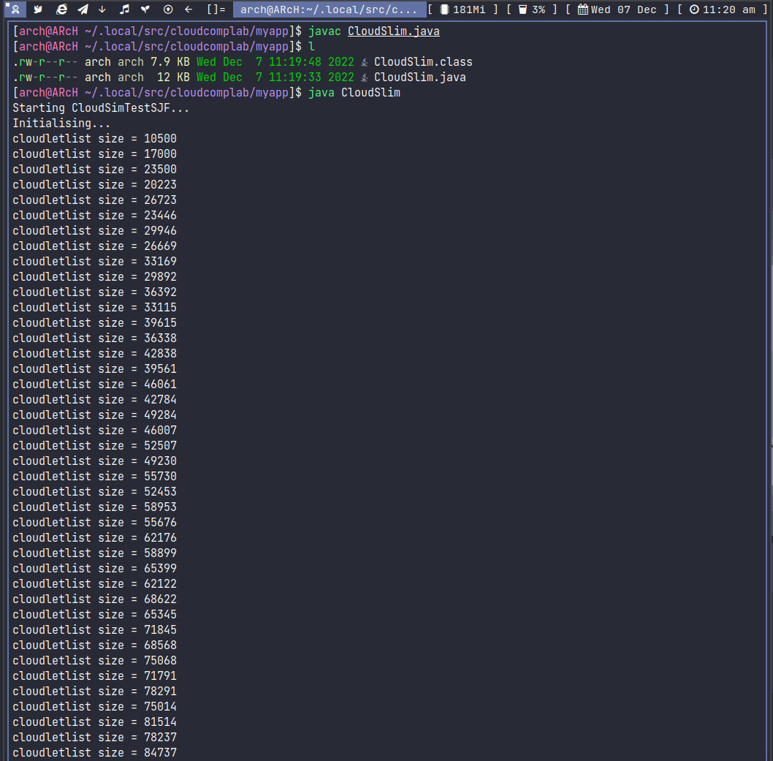

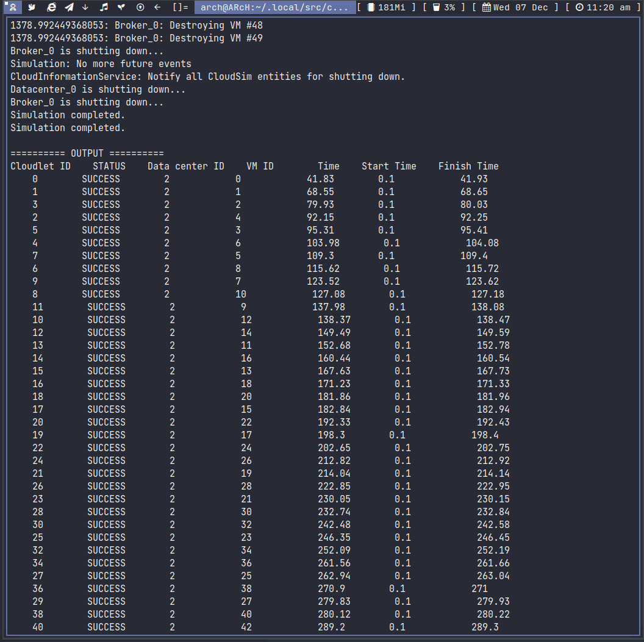

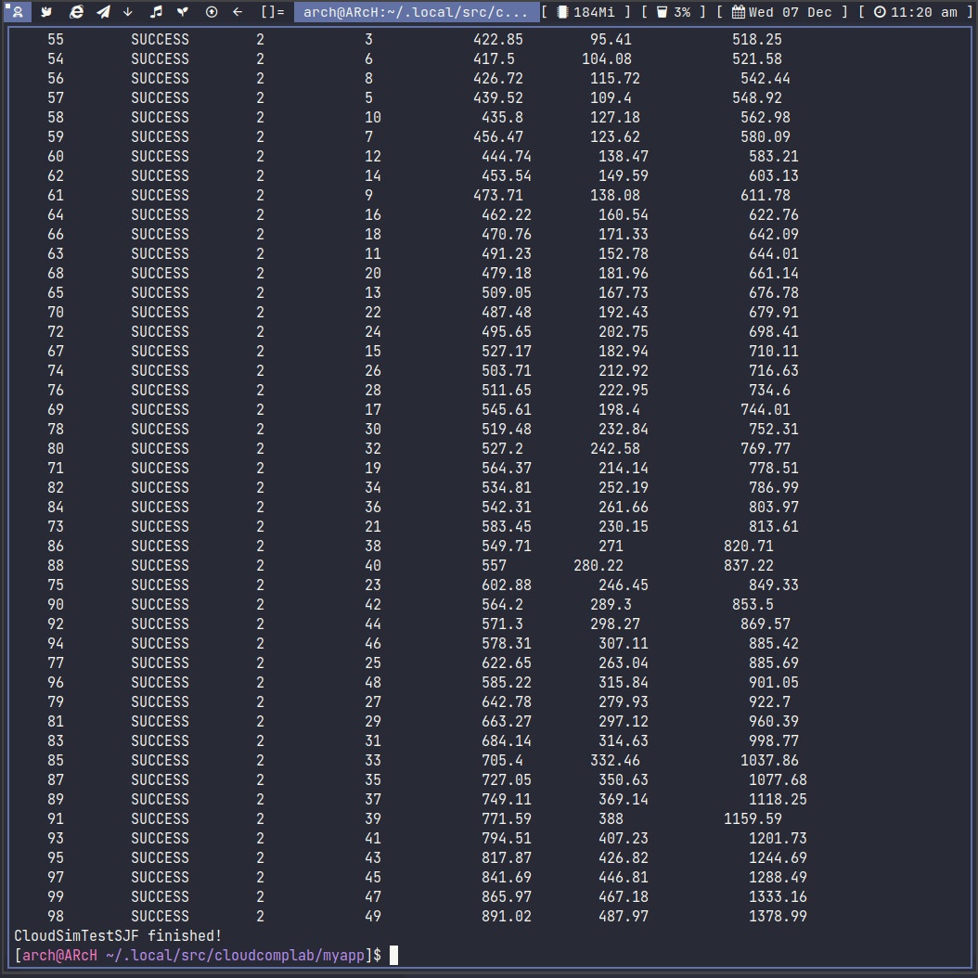

Output:
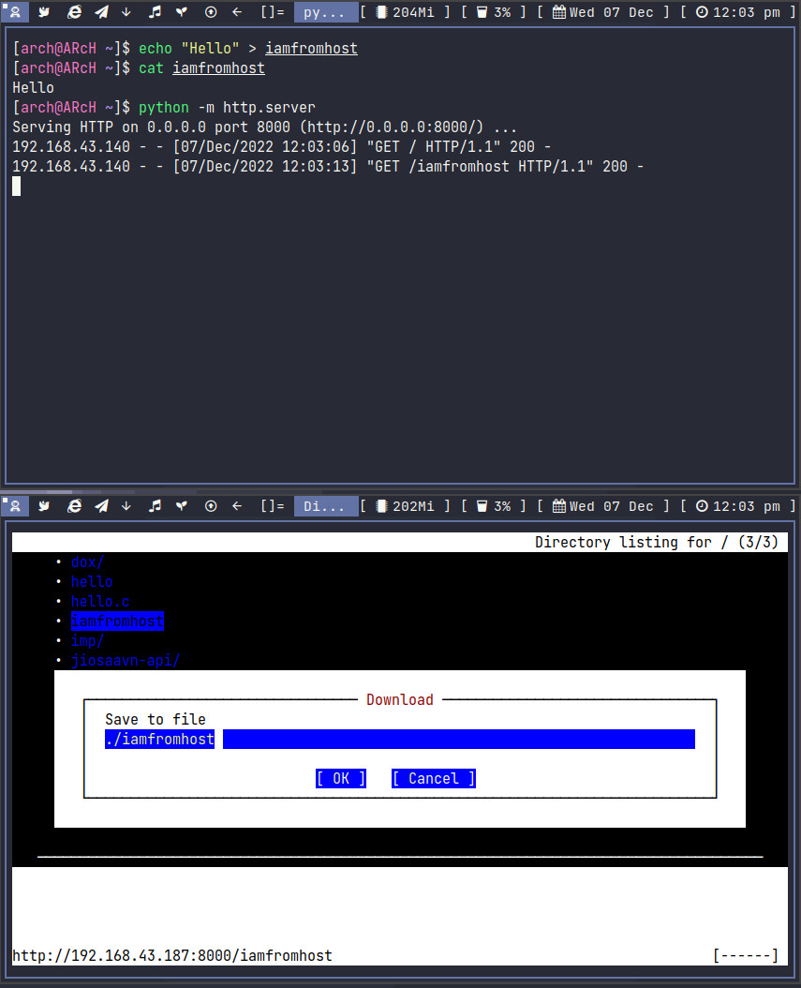

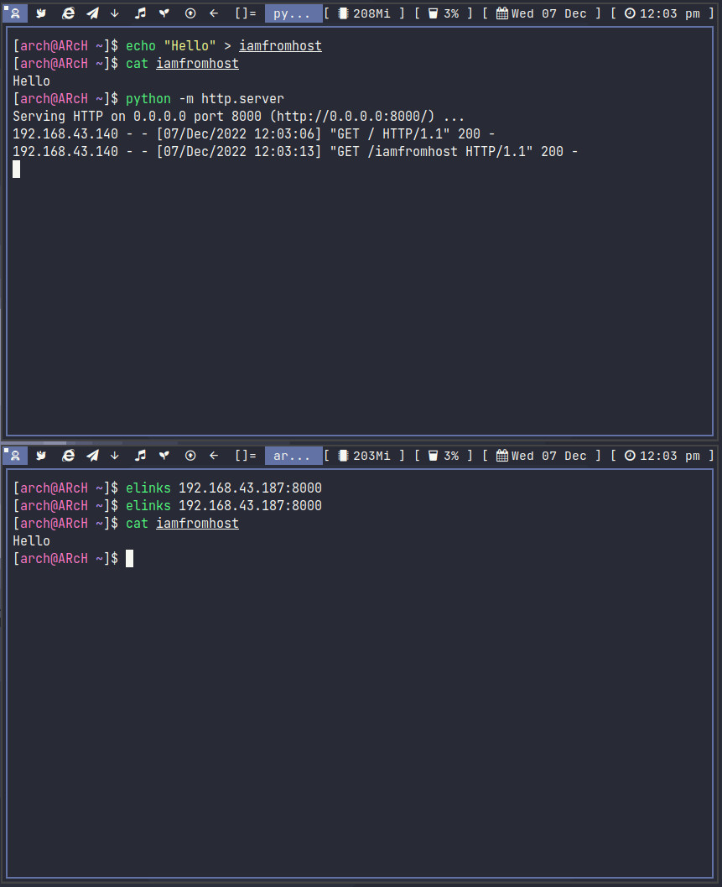

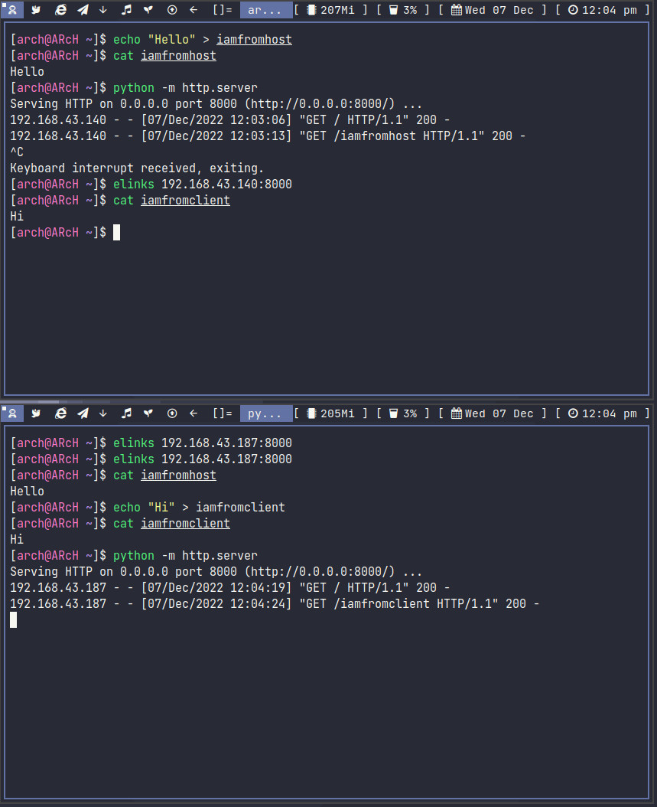

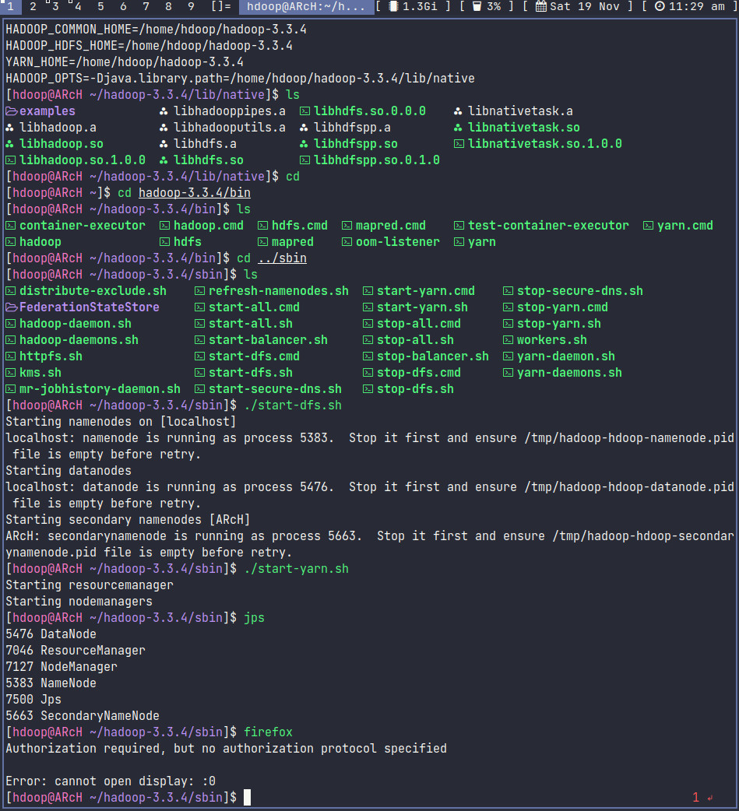
Output:

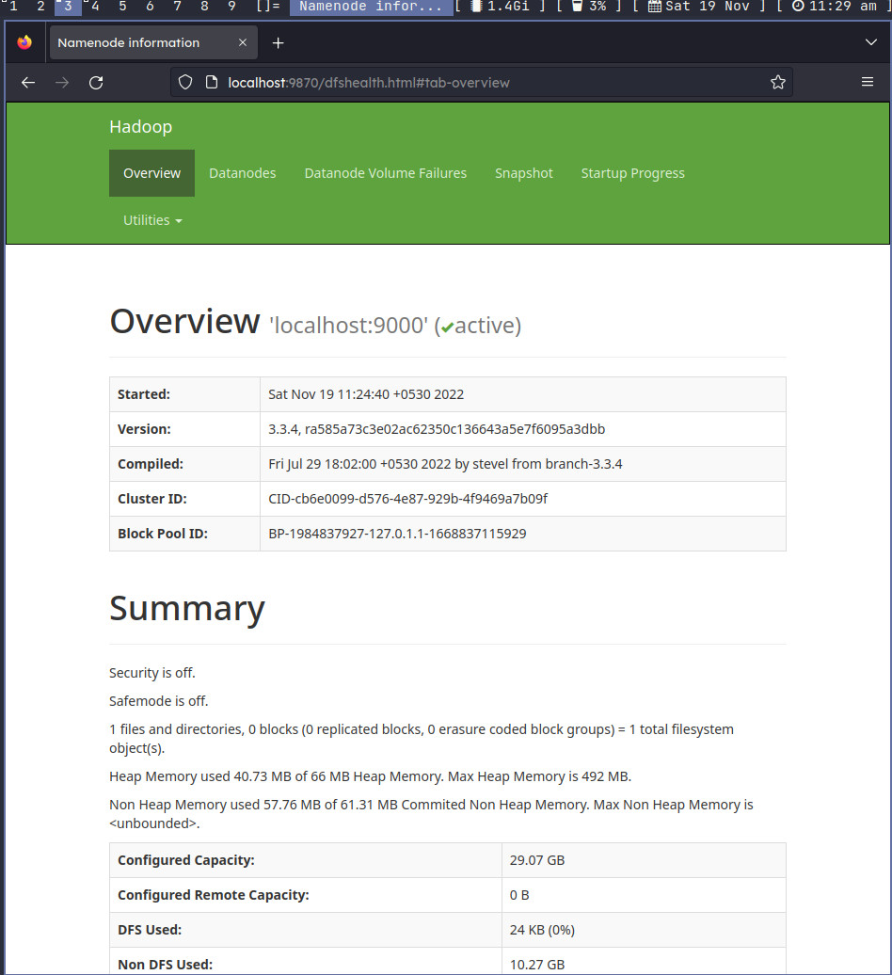

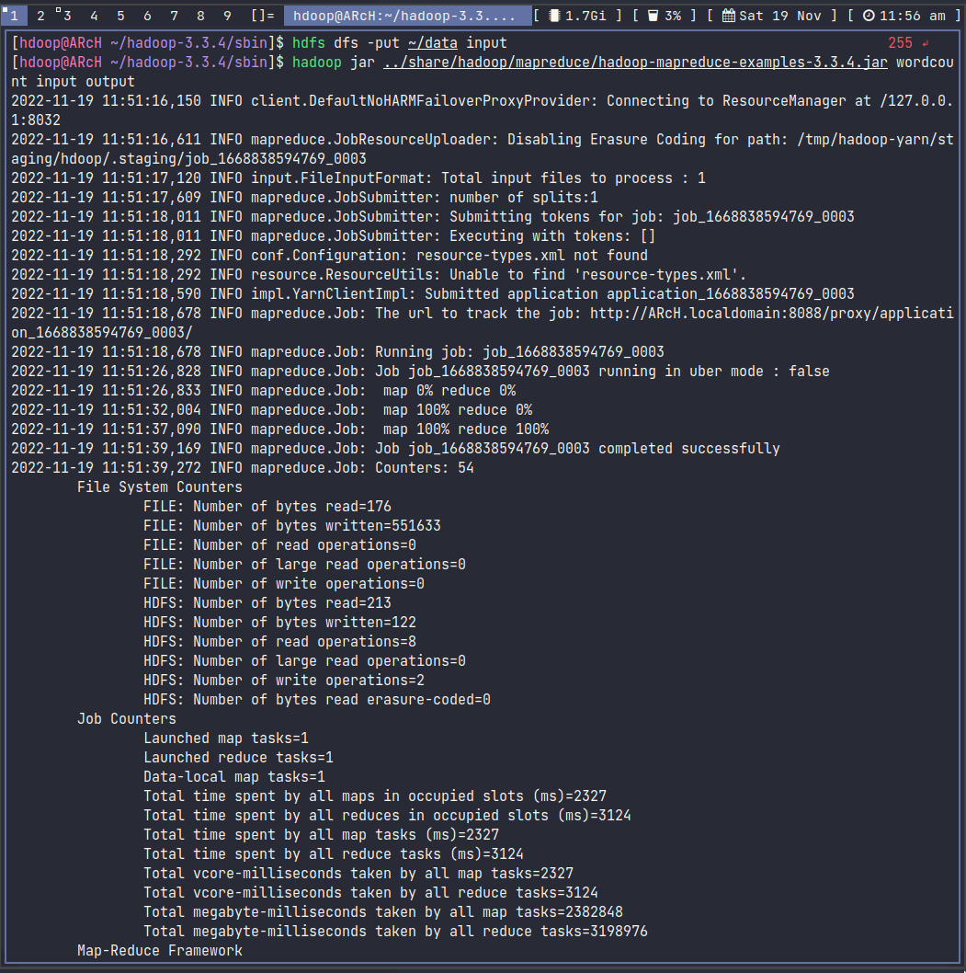

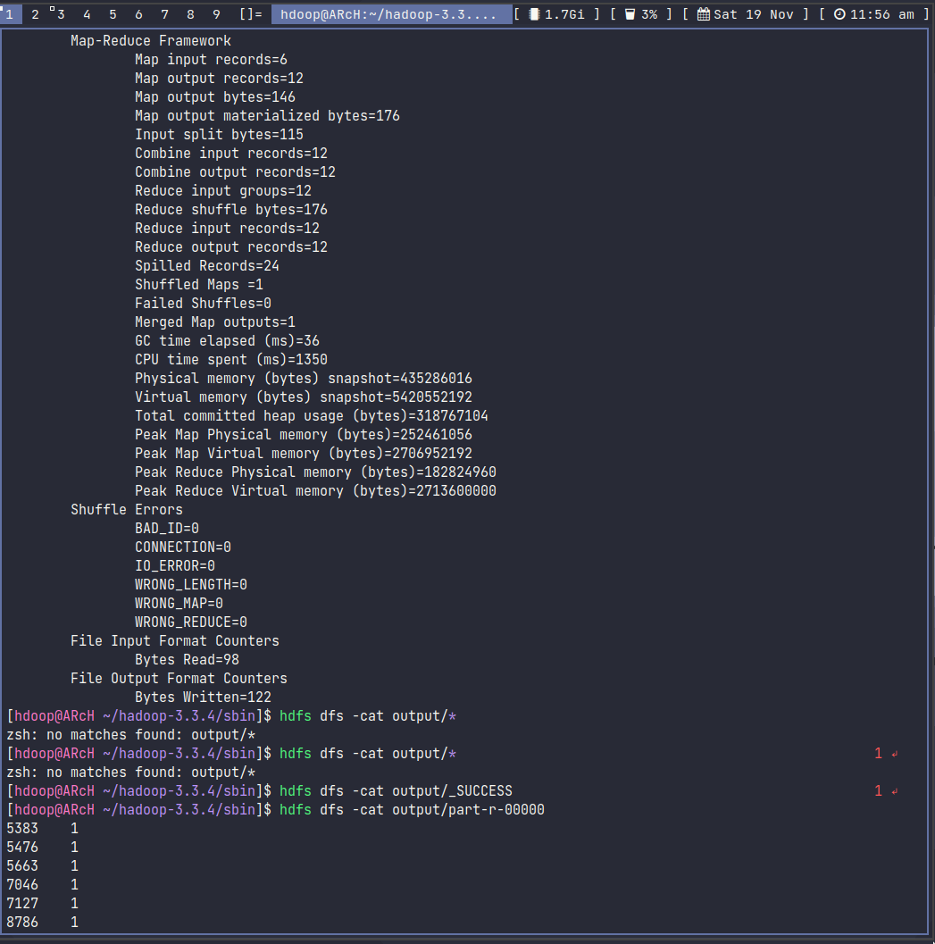

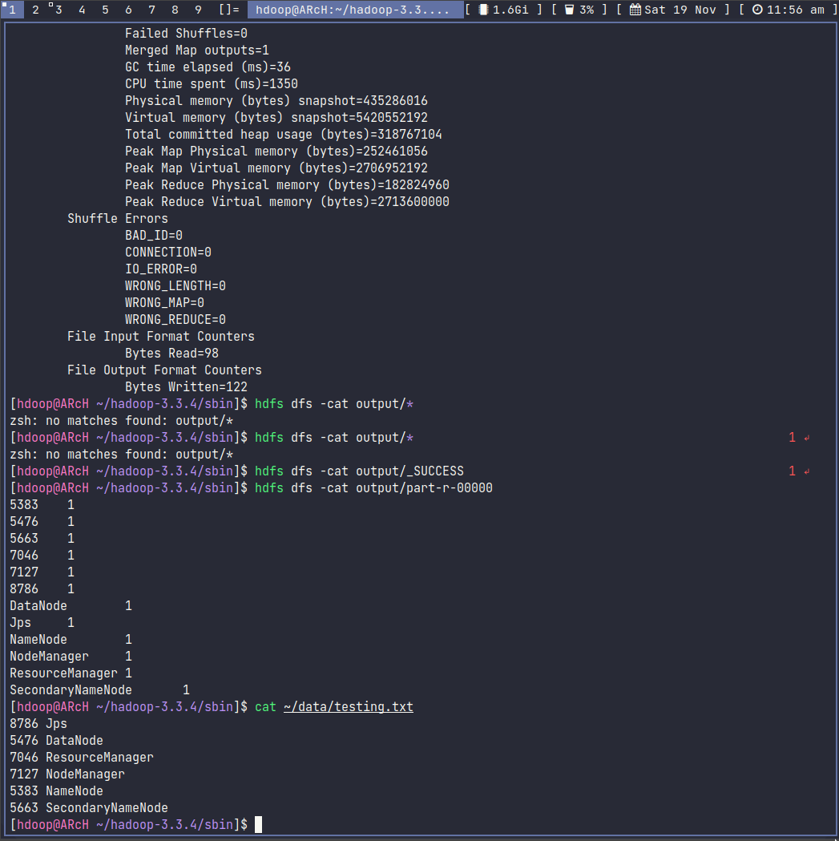

Output:

