A Deep Transfer Learning-based Edge Computing Method for Home Health Monitoring

All countries were suffered a lot during covid19 pandemic due to insufficient medical facilities such as beds, doctors and other medical equipment’s. In India per 1000 peoples we have only 1.4 beds available and to fight such situation author of this paper is combining advance technologies such as IOT sensors, edge cloud computing servers and AI (artificial intelligence) deep learning algorithms to monitor patient condition in home only. IOT sensors will be equipped with AI programs which capture RGB images of home members like children’s and elderly peoples and then extract important features from images such as sneezing, emotion expression of pain, fall detection and many more. If AI program predict any above describe symptoms then it will report to medical staff using IOT internet connection and cloud computing servers.

In propose paper in home IOT sensors only monitor patient condition so data will be stored at senor only so no privacy or internet traffic problem arises.

To implement this project author has used AI transfer learning pre-trained model and this model is re-trained with fall detection, facial expression and sneezing images and after training this model can predict such symptoms from new test images.

IOT sensors will capture RGB images and then input to AI algorithms and AI algorithm will predict patient condition from image and report to cloud server using EDGE connectivity.

We don’t find any images related to sneezing or pain facial images so we have used Fall Detection images to train AI algorithms and we used VGG16 pre-trained model to train fall detection model.

We don’t have any servers or cloud or sensors so we designed one dummy cloud and CLIENT application where user can upload test image and then client will used AI algorithm to predict condition from uploaded image and then send to cloud server.

To train this AI algorithm we have used below dataset images

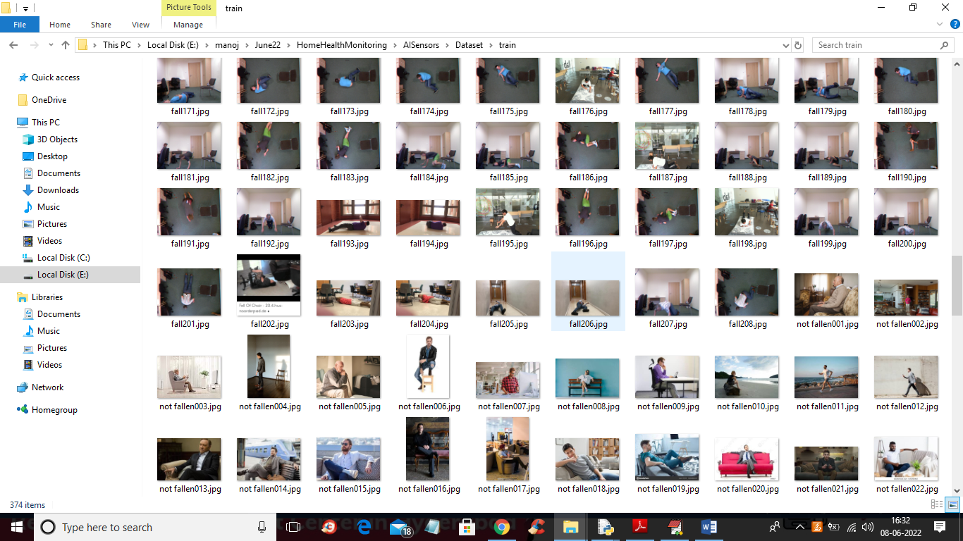

In above screen we have FALL and NO-FALL images and we are using this images to train our AI model

To implement this project we have designed following modules

1. Edge Cloud Server: this is a cloud application which received images from client and display to medical peoples for monitoring
2. AI Sensor Client Application: this module we will upload dataset to train AI model and then load the model and whenever user upload any images then it will predict condition and report to cloud server.

SCREEN SHOTS

To run project first double click on ‘run.bat’ from ‘EdgeCloudServer’ folder to start cloud server and get below screen

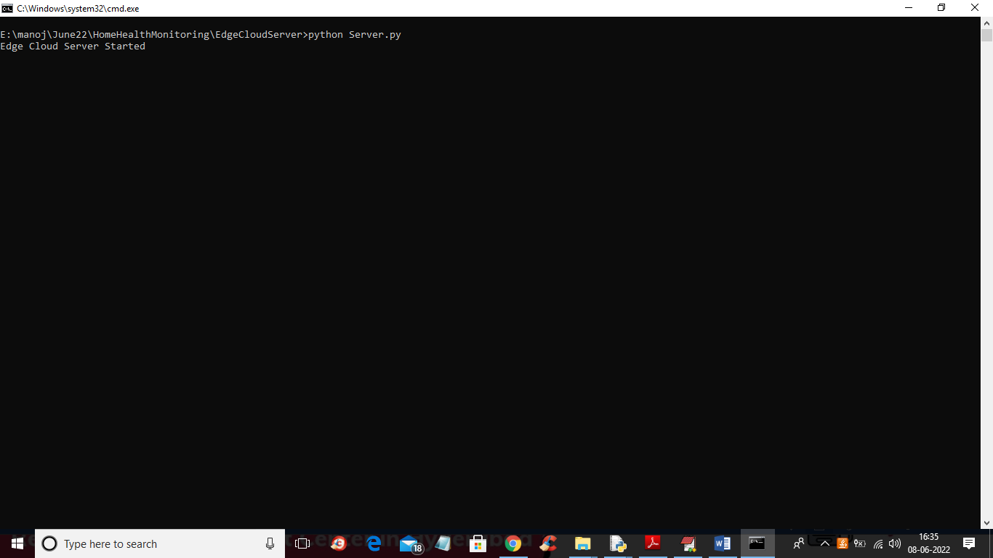

In above screen we can see edge cloud server started and now double click on ‘run.bat’ file from ‘AISensors’ folder to start client sensor application and get below output

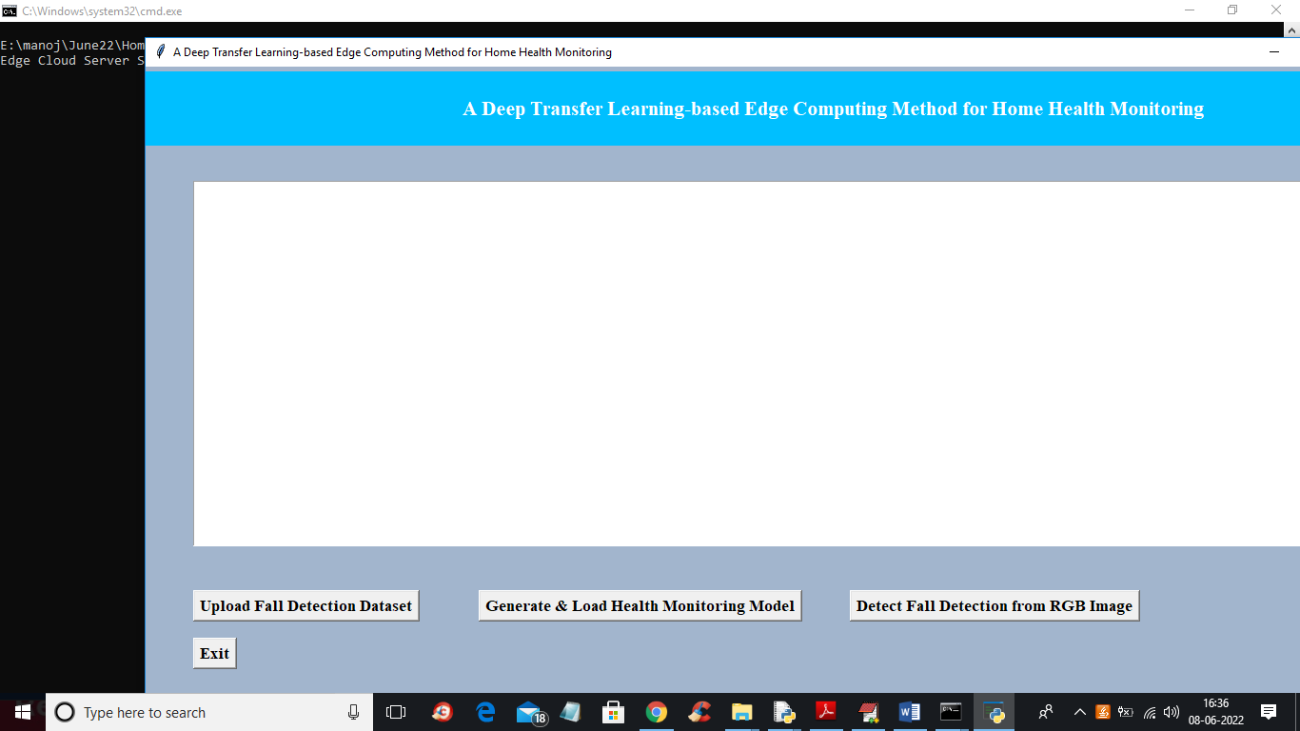

In above client application user can click on ‘Upload Fall Detection Dataset’ button to upload dataset and get below output

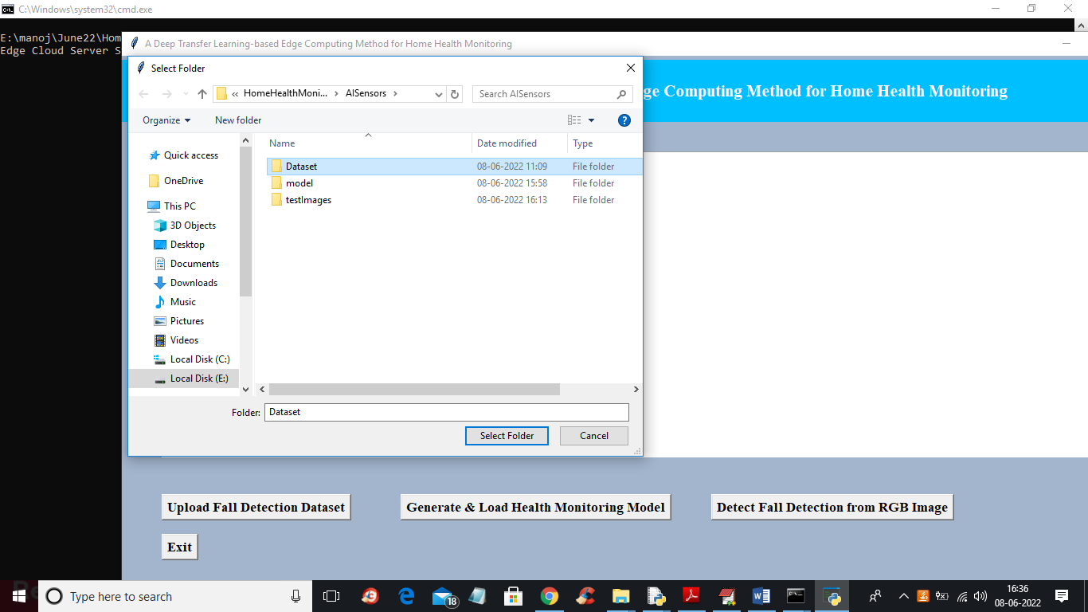

In above screen selecting and uploading ‘Dataset’ folder and then click on ‘Select Folder’ button to load dataset and get below output

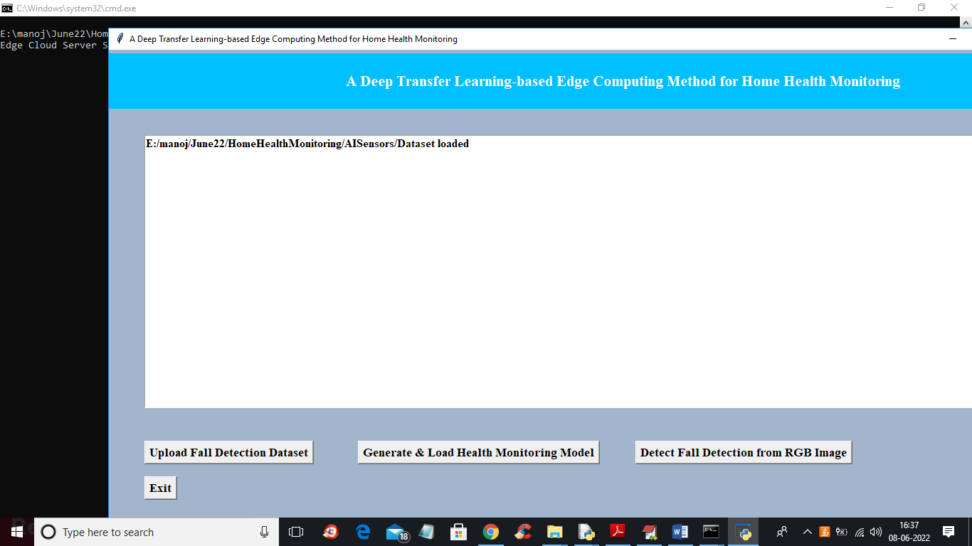

In above screen dataset loaded and now click on ‘Generate & Load Health Monitoring Model’ button to load model and get below output

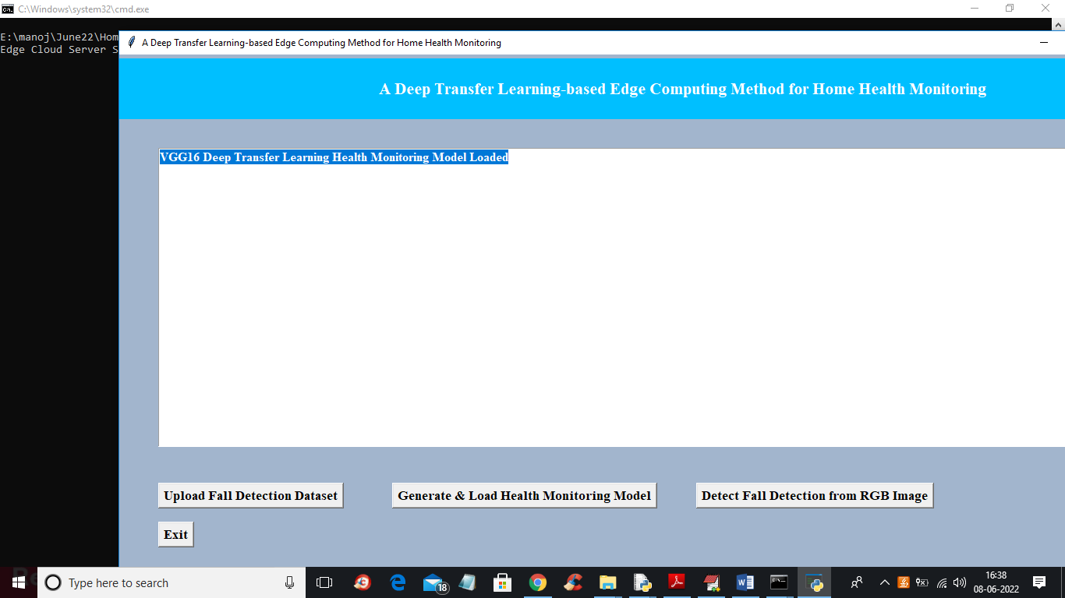

In above screen VGG16 transfer learning model loaded and now click on ‘Detect Fall Detection from RGB image’ button to upload image and get below output

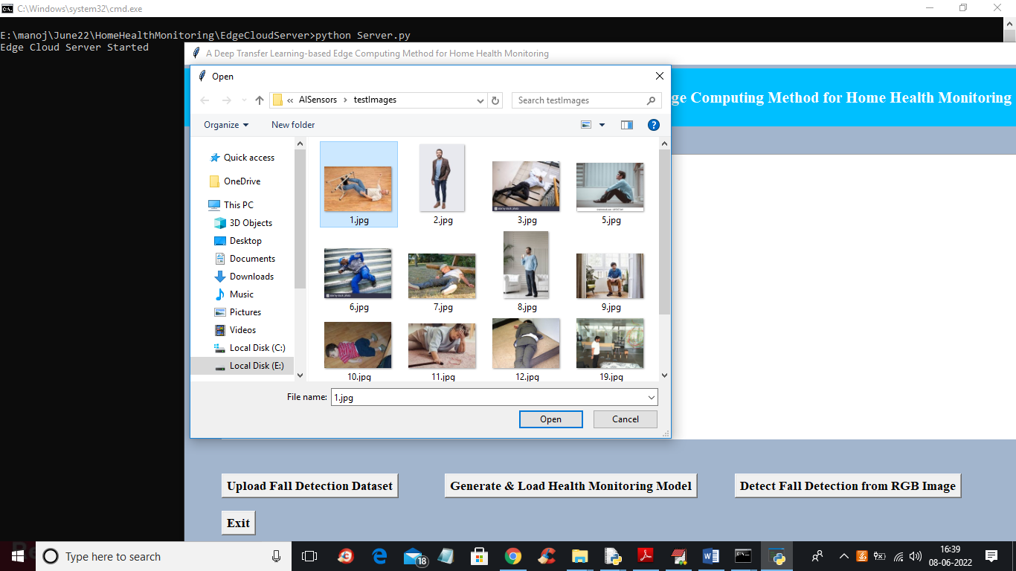

In above screen selecting and uploading ‘1.jpg’ file and then click on ‘Open’ button to get below prediction result

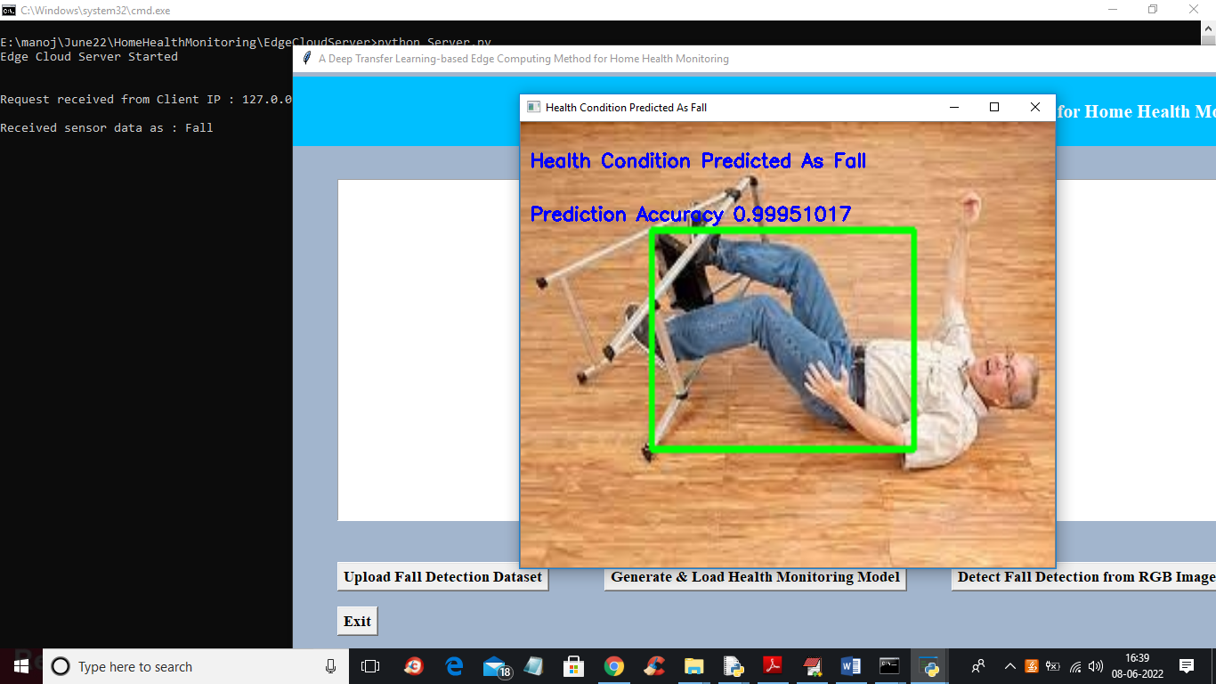

In above screen in uploaded image in blue colour text we can see patient in image condition predicted as Fall with accuracy 0.99 and the same output is report to cloud server which we can see in black console and now test other image

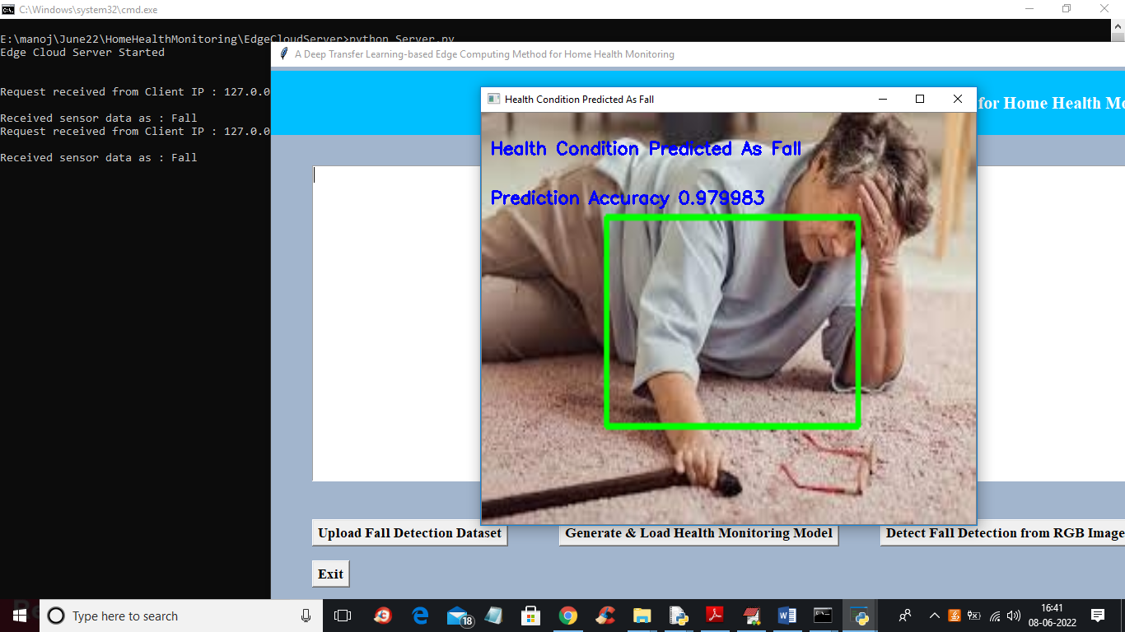

In above image also AI predicted as FALL and now test other images

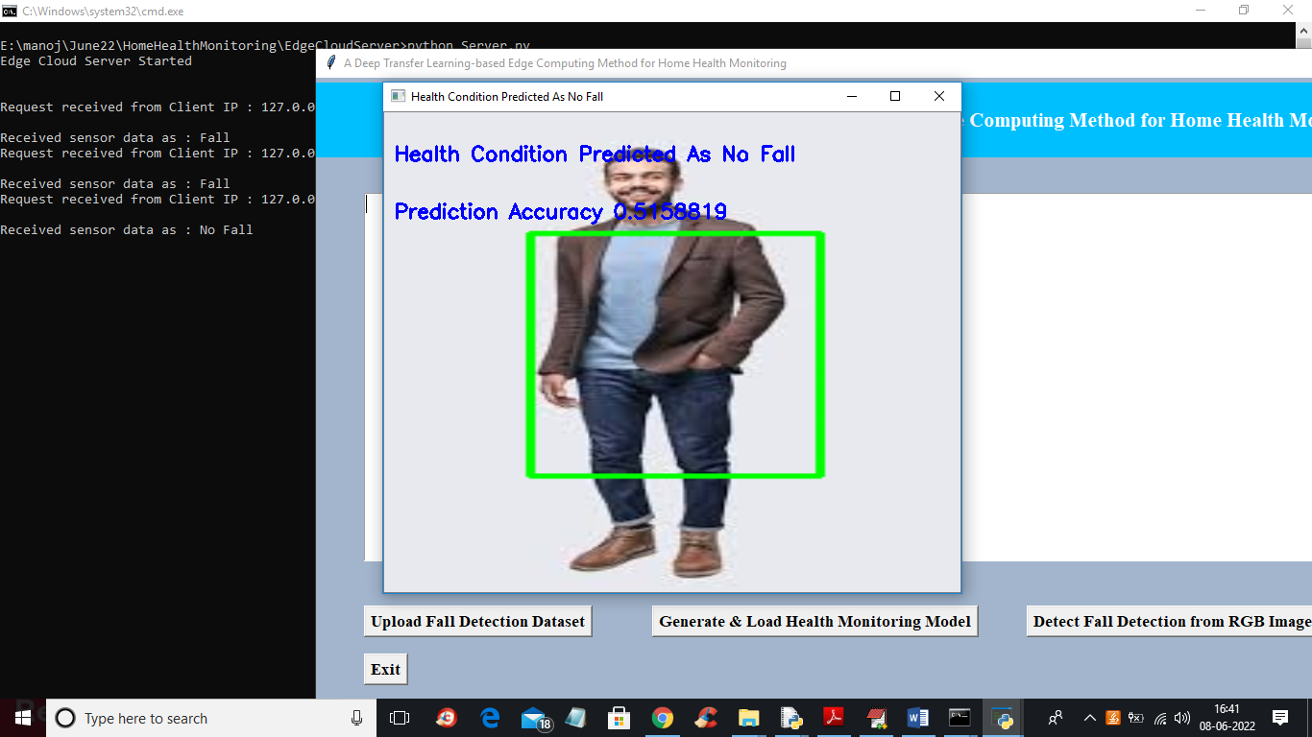

In above screen patient condition predicted as NO FALL and similarly you can upload and test other images.

All the above uploaded image we can see inside cloud ‘files’ folder with result for future monitoring

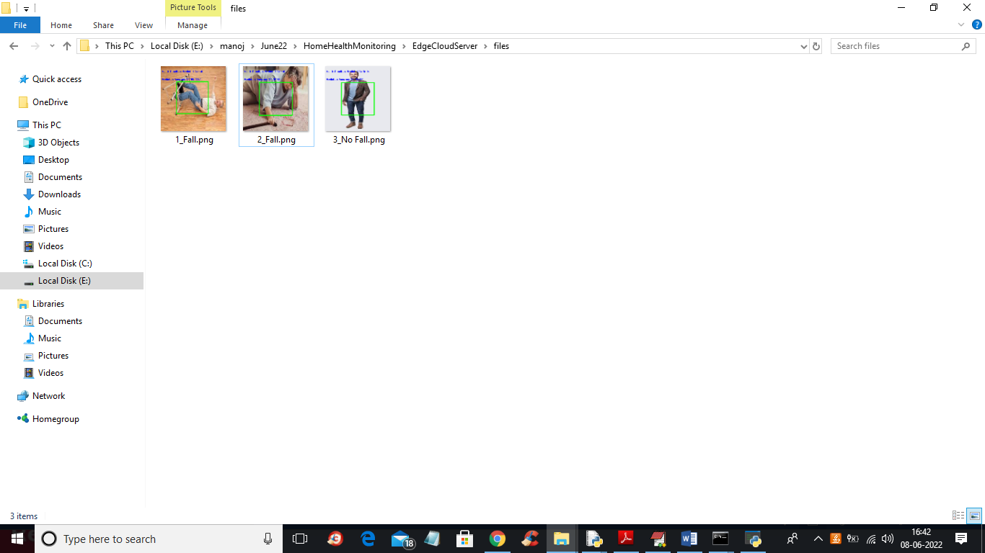

In above cloud hospital folder all uploaded images from sensors will be saved.

So by using this application patient can be monitored from home and not require any resources from hospital