Experiment No: 1

Name: Abhijeet Amrut Bhivase PRN No:2024079054 Subject: RDBMS Date:22/12/2025

- Perform DDL operations on database tables.

  - Create the table supplier, Part, Supplies.

*Program:
CREATE TABLE Supplier ( Sid INT PRIMARY KEY, Sname VARCHAR (50),
City VARCHAR (50)
);

*Output:

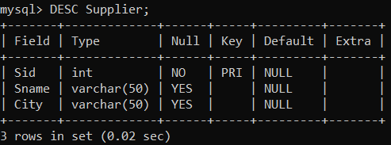

*Program:
CREATE TABLE Part( Pid INT PRIMARY KEY, Pname VARCHAR(50), Color VARCHAR(20)
);

*Output:
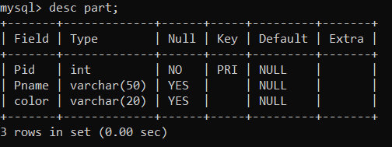

*Program:
CREATE TABLE Supplies ( Sid INT,
Pid INT,
Quantity INT, PRIMARY KEY(sid,pid),
FOREIGN KEY (sid)REFERENCES Supplier(sid) FOREIGN KEY (pid)REFERENCES Supplier(pid)
);

*Output :
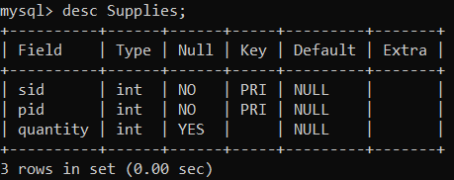

Add a new attribute state in supplier table.

*Program:
ALTER TABLE Supplier ADD state VARCHAR(30);

*Output :
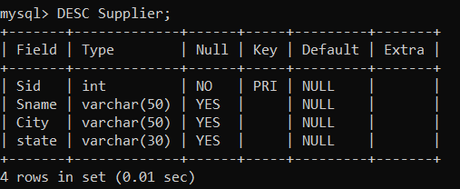

Remove attribute city from supplier table.

*Program:
ALTER TABLE Supplier DROP COLUMN City;

*Output :
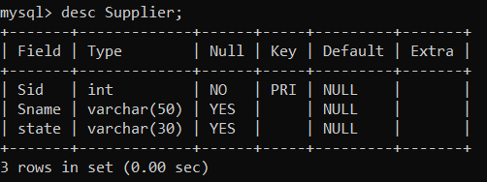

Modify the data type of phone attribute.

*Program:
ALTER TABLE Supplier MODIFY Phone VARCHAR(15);

*Output :
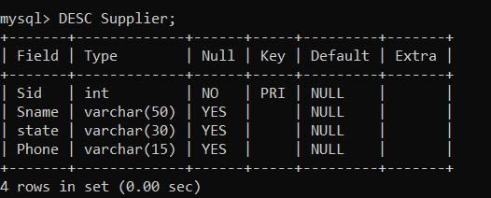

Rename attribute city to address.

*Program:
ALTER TABLE Supplier
CHANGE City address VARCHAR(100);

*Output :
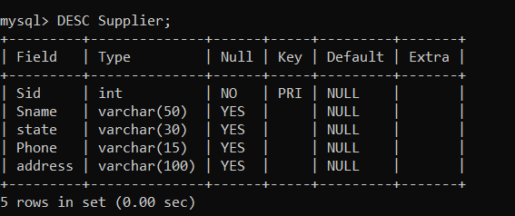

Rename table supplier to sup.

*Program:
ALTER TABLE Supplier RENAME To Sup;

*Output :
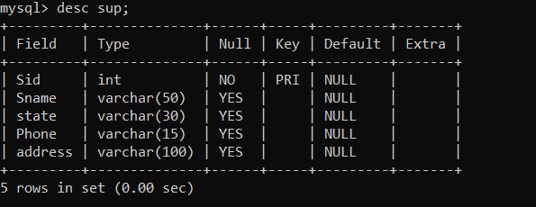

Truncate table supplies.

*Program:
TRUNCATE TABLE Supplies;

*Output :
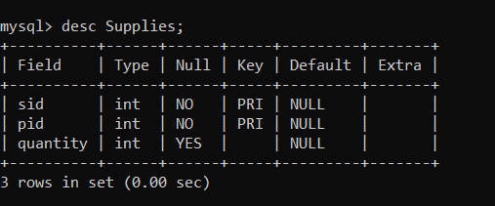

Drop table part.

*Program:
DROP TABLE Part;

*Output :
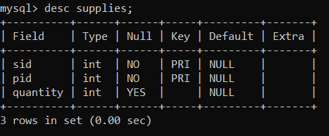

Experiment No: 2

Name: Abhijeet Amrut Bhivase PRN No:2024079054Class : BCA II Subject: RDBMS Date:24/12/2025

- Perform DML operations on tables.

Insert at least 10 records.

*Program:
INSERT INTO Supplier (sid, Sname,branch,city,phone)VALUES (204001, 'Rahul','Local','Delhi','9845671255'),
(204002, 'Vikas','Global','Mumbai','9564123870'),
(204003, 'Amit','Local','Pune','9658471235'),
(204004, 'Kiran','Global','Delhi','9874563210'),
(204005, 'Vijay','Local','Nagpur','9123547890'),
(204006, 'Anita','Global', 'Goa','9745681235'),
(204007, 'Rakesh','Local','Delhi','9235416870'),
(204008, 'Kavita','Global','Mumbai','9321456912'),
(204009, 'Vinay','Local','Pune','9452136205'),
(204010, 'Arun','Global','Nashik','9765412380');

*Output :
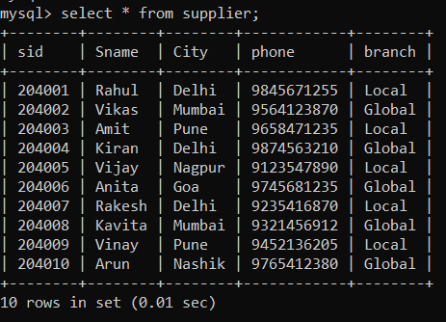

*Program:
INSERT INTO Part (pid, pname, color)VALUES (101, 'Nut', 'Red'),
(102, 'Bolt', 'Green'),
(103, 'Screw', 'Blue'),
(104, 'Hammer', 'Black'),
(105, 'Gear', 'Silver'),
(106, 'Wheel', 'White'),
(107, 'Pipe', 'Grey'),
(108, 'Wire', 'Yellow'),
(109, 'Plate', 'Bronze'),
(110, 'Handle', 'Red');

*Output :
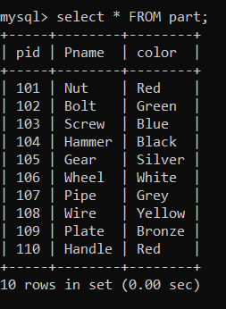

*Program:
INSERT INTO Supplies VALUES (204001,101, 1, 50,'2026-01-10'),
(204002,102, 2, 30,'2026-01-12'),
(204003,103, 1, 100,'2026-01-15'),
(204004,104, 3, 20,'2026-01-18'),
(204005,105, 2, 75,'2026-01-20'),
(204006,106, 4, 10,'2026-01-22'),
(204007,107, 1, 200,'2026-01-25'),
(204008,108, 5, 40,'2026-01-28'),
(204009,109, 3, 60,'2026-02-01'),
(204010,110, 4, 15,'2026-02-05');

*Output :
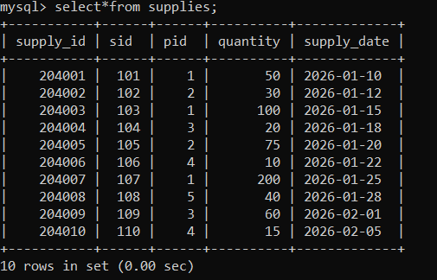

Display all records.

*Program:
SELECT * FROM supplier;

*Output :
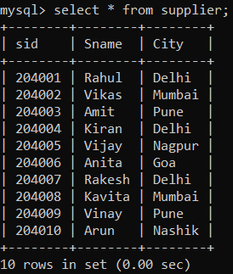

*Program:
SELECT * FROM part;

*Output :
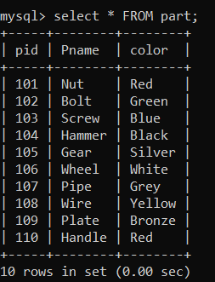

*Program:
SELECT * FROM supplies;

*Output :
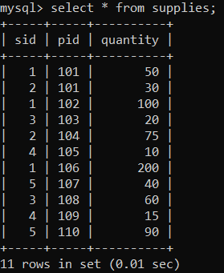

Find the name and city of all suppliers.

*Program:
SELECT Sname, city FROM supplier;

*Output :
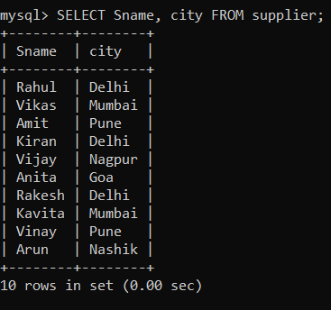

Find suppliers from ‘Delhi’.

*Program:
SELECT Sname, phone FROM supplier WHERE city='Delhi';

*Output :
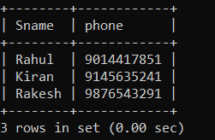

Find distinct branches.

*Program:
SELECT DISTINCT city
FROM supplier;

*Output :
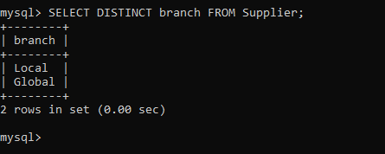

  - Delete supplier with SID = 204001.

*Program:
DELETE FROM supplier WHERE sid =204001;

*Output :
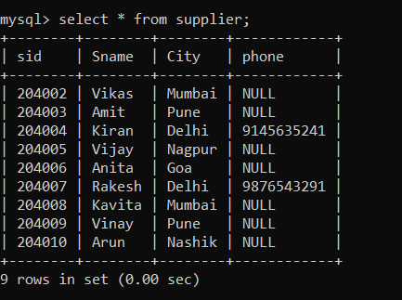

Delete all record.

*Program:
DELETE FROM supplier;

*Output :
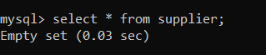

Delete suppliers whose city starts with ‘A’.

*Program:
DELETE FROM supplier WHERE city LIKE 'A%';

*Output :
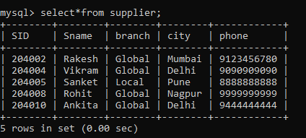

Find names containing ‘lk’.

*Program:
SELECT Sname FROM Supplier
WHERE Sname LIKE 'Ik%';

*Output :

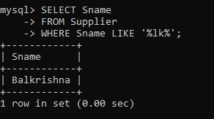

Find names with ‘R’ as second letter.

*Program:
SELECT name
FROM supplier
WHERE name LIKE ‘_R%’;

*Output :
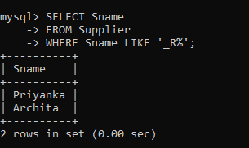

Find names starting with ‘V’ and ending with ‘A’.

*Program:
SELECT Sname FROM supplier
WHERE Sname LIKE 'V%A';

*Output :
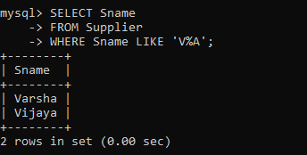

Update city to ‘BOMBAY’.

*Program:
UPDATE supplier SET city='BOMBAY';

*Output :
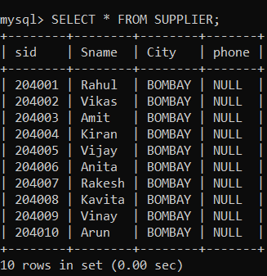

Update city of ‘Vandana’ to ‘Goa’.

*Program: UPDATE supplier SET city ='Goa'
WHERE Sname ='Vandana';

*Output :
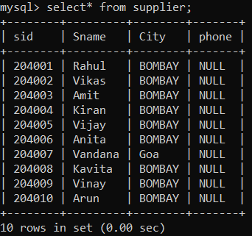

Experiment No: 3

Name: Abhijeet Amrut Bhivase PRN No:2024079054Class : BCA II Subject: RDBMS Date:02/01/2026

- Apply constraints on tables.

  - Primary key

*Program:
CREATE TABLE Supplier( Supplier_ID INT PRIMARY KEY, Supplier_Name VARCHAR(100), City VARCHAR(50)
);

*Output :
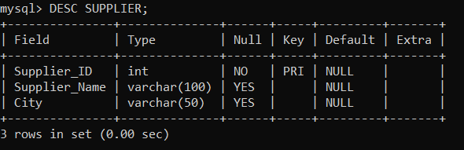

Foregin key

*Program:
CREATE TABLE supplies ( Supply_ID INT PRIMARY KEY,
Part_ID INT, Supplier_ID INT,
FOREIGN KEY (Supplier_ID)REFERENCES Supplier(supplier_ID)
);

*Output :
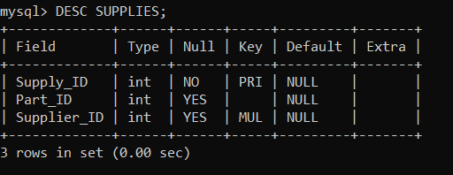

Unique Constraint

*Program:
CREATE TABLE Part( Part_ID INT PRIMARY KEY,
Part_Name VARCHAR(100)UNIQUE, Color VARCHAR(20)
);

*Output :
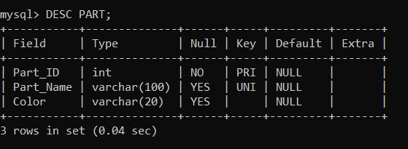

check constraints

*Program:
CREATE TABLE Supplier_Check ( SID INT PRIMARY KEY,
Sname VARCHAR(50),
branch VARCHAR(50), city VARCHAR(50), phone VARCHAR(15), CHECK (SID > 0),
CHECK (phone LIKE '9%')
);

*Output :
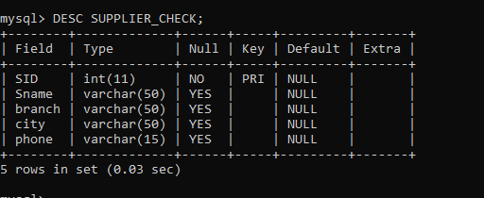

Default constraints

*Program:
CREATE TABLE Supplier_Default ( SID INT PRIMARY KEY, Sname VARCHAR(50),
branch VARCHAR(50) DEFAULT 'Local', city VARCHAR(50) DEFAULT 'Pune',
phone VARCHAR(15)
);

*Output :
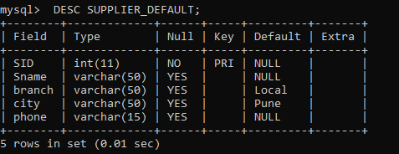

Experiment No: 4

Name: Abhijeet Amrut Bhivase PRN No:2024079054Class : BCA II Subject: RDBMS Date:03/01/2026

- Perform TCL operations and use aggregate functions.

  - Create Savepoint

*Program:
START TRANSACTION;
INSERT INTO student VALUES(1,’Ram’);
SAVEPOINT sp1;
INSERT INTO student VALUES(2,’Shyam’);

*Output :
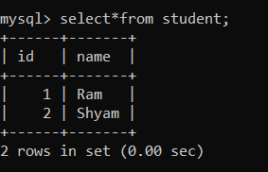

Rollback

*Program:
ROLLBACK TO sp1;

*Output :
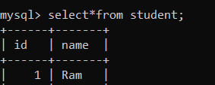

Commit

*Program:
CREATE TABLE employees( Id INT,
Name VARCHAR(20),
Salary INT
);
INSERT INTO employees VALUES(1,’Amit’,20000); INSERT INTO employees VALUES(2,’Neha’,30000); COMMIT;

*Output :
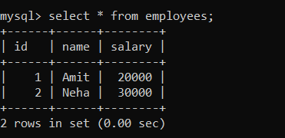

MIN, MAX, AVG, SUM

*Program:
Select MIN(cost), MAX(cost), AVG(cost), SUM(cost) from part;

*Output :
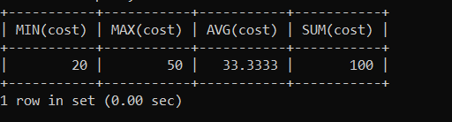

COUNT

*Program:
SELECT COUNT (*) FROM parts;

*Output :
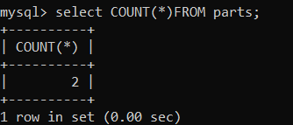

Average cost by ‘Mike’

*Program:
SELECT part_name,AVG(price)
FROM parts
where part_name='Mike' GROUP BY part_name;

*Output :
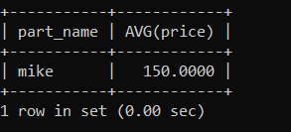

Experiment No: 5

Name: Abhijeet Amrut Bhivase PRN No:2024079054Class : BCA II Subject: RDBMS Date:13/01/2026

- Use HAVING AND ORDER BY CLAUSES

  - Total price by color

*Program:
INSERT INTO parts(part_id,part_name,price,color)
Values
(1, 'Bolt', 100,'Red'),
(2, 'Nut', 50, 'Blue'),
(3, 'Screw', 200, 'Red'),
(4, 'Washer', 150, 'Green');
select color,sum(price)as total_price from parts
group by color;

*Output :
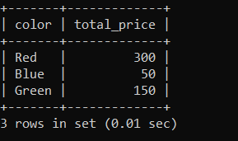

Branches with more than 2 suppliers

*Program:
select city, count(*)as num_suppliers from supplier
group by branch having count(*)>2;

*Output :
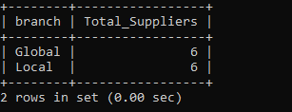

Sort pname (ASC) and cost (DESC)

*Program:
select* from parts
order by part_name ASC,price desc;

*Output :
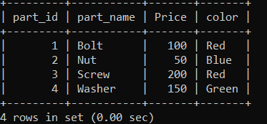

Branch-wise supplier count

*Program:
select distinct city as branch,
count(SID)OVER(PARTITION BY CITY)
AS num_suppliers from supplier;

*Output :
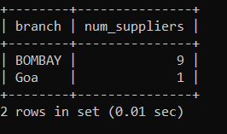

Experiment No: 6

Name: Abhijeet Amrut Bhivase PRN No:2024079054Class : BCA II Subject: RDBMS Date:21/01/2026

- Perform queries using operators.

  - Cost between 200–600

*Program:
SELECT part_name, price,color
-> from parts
-> where price between 200 and 600;

*Output :
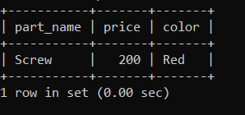

Suppliers in ‘local’ or ‘global’

*Program: Select Sname,
sid,
city, CASE
WHEN city = 'Goa' THEN 'Local' WHEN city = 'Bombay' THEN 'Global' END AS branch
FROM supplier
WHERE city IN ('Goa' , 'Bombay');

*Output :
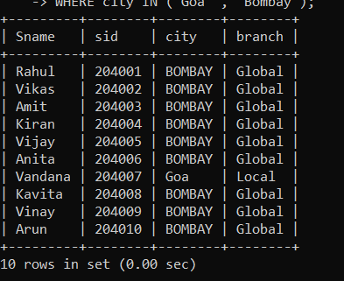

BETWEEN operator

*Program:
Select
parts.part_name AS Pname,parts.price AS cost,supplier.phone AS phoneno from parts
join supplies on parts.part_id=supplies.pid join supplier on supplies.sid=supplier.sid where parts.price between 200 and 600;

*Output :
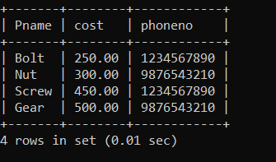

pname with ‘NET’

*Program:
INSERT INTO parts(part_id,part_name,price,color)values (106,'InternetCable',700,'White'), (107,'Magnet',150,'Silver');
select part_name AS Pname,color from parts
where part_name LIKE '%NET%';

*Output :
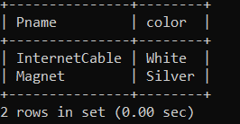

pname ‘NUT’ or ‘BOLT’

*Program:
select part_id,part_name from parts
where part_name in ('NUT' , 'BOLT');

*Output :
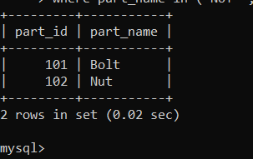

Specific dates

*Program:
CREATE TABLE SP (
sid INT, pid INT,
quantity INT, supply_date DATE
);
INSERT INTO SP VALUES (1, 101, 50, '2000-05-01'),
(1, 103, 30, '2021-01-12'),
(2, 102, 60, '2000-12-17'),
(2, 104, 20, '2021-01-10'); SELECT DISTINCT sid FROM SP
WHERE supply_date IN ( '2000-05-01',
'2021-01-12',
'2000-12-17',
'2021-01-10'
);

*Output :
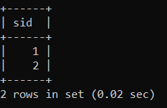

Distinct costs

*Program:
SELECT DISTINCT price
-> FROM parts;

*Output :
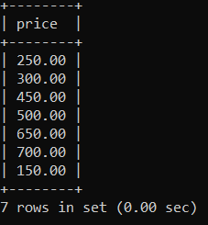

Experiment No: 7

Name: Abhijeet Amrut Bhivase PRN No:2024079054Class : BCA II Subject: RDBMS Date:23/01/2026

- Perform join and set operations.

  - Inner join

*Program:
SELECT sp.sid, parts.part_name, sp.quantity, sp.supply_date FROM sp
INNER JOIN parts ON sp.pid = parts.part_id;

*Output :
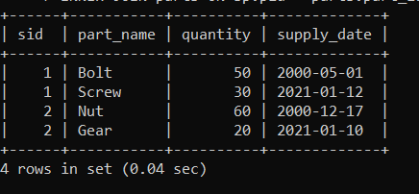

Natural Join

*Program:
SELECT *
FROM sp
NATURAL JOIN (SELECT part_id AS pid, part_name, price, color FROM parts) AS p;

*Output :
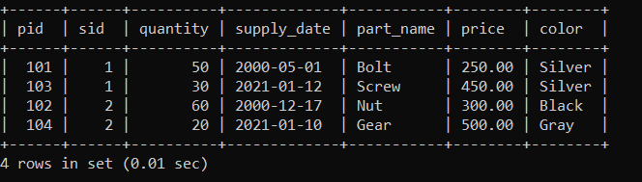

Left Outer Join

*Program:
SELECT sp.sid, sp.pid, sp.quantity, sp.supply_date, parts.part_name, parts.price, parts.color
FROM sp
LEFT JOIN parts ON sp.pid = parts.part_id;

*Output :
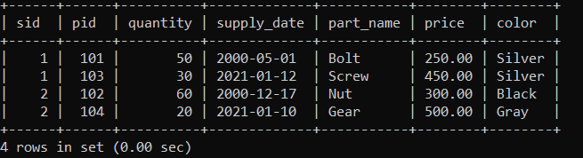

Right Outer join

*Program:
SELECT sp.sid, sp.pid, sp.quantity, sp.supply_date, parts.part_name, parts.price, parts.color
FROM sp
RIGHT JOIN parts ON sp.pid = parts.part_id;

*Output :
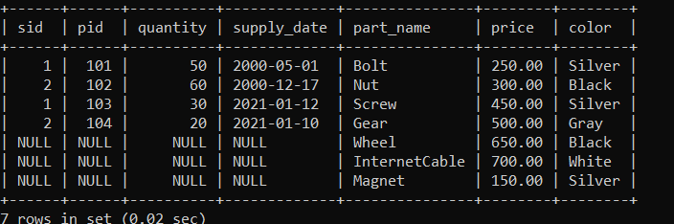

Full Outer Join

*Program:
INSERT INTO TableA VALUES (1, 'Ram'),
(2, 'Shyam'),
(3, 'Amit');

INSERT INTO TableB VALUES (2, 'Pune'),
(3, 'Mumbai'),
(4, 'Delhi');
SELECT A.ID, A.Name, B.City
FROM TableA A LEFT JOIN TableB B ON A.ID = B.ID UNION
SELECT A.ID, A.Name, B.City
FROM TableA A RIGHT JOIN TableB B ON A.ID = B.ID;

*Output :
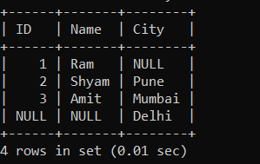

UNION

*Program:
CREATE TABLE Students_A ( ID INT,
Name VARCHAR(50)
);
CREATE TABLE Students_B ( ID INT,
Name VARCHAR(50)
);
INSERT INTO Students_A VALUES (1, 'Amit'), (2, 'Neha');
INSERT INTO Students_B VALUES (3, 'Rahul'), (4, 'Sneha'); SELECT ID, Name FROM Students_A
UNION
SELECT ID, Name FROM Students_B;

*Output :
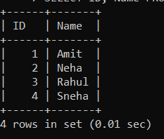

INTERSECT

*Program:
SELECT DISTINCT a.ID, a.Name
FROM Students_A a INNER JOIN Students_B b
ON a.ID = b.ID AND a.Name = b.Name;

*Output :
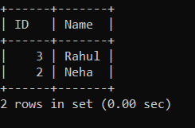

MINUS

*Program:
SELECT DISTINCT a.ID, a.Name
FROM Students_A a LEFT JOIN Students_B b
ON a.ID = b.ID AND a.Name = b.Name WHERE b.ID IS NULL;

*Output :
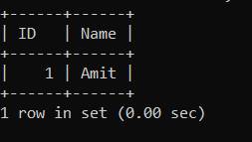

Cartesian product

*Program:
SELECT a.ID, a.Name, b.Course_ID, b.Course_Name FROM Students_A a
CROSS JOIN Students_B b;

*Output :
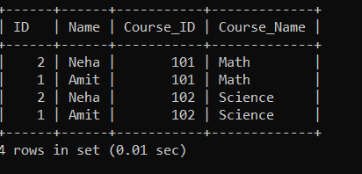

Experiment No: 8

Name: Abhijeet Amrut Bhivase PRN No:2024079054Class : BCA II Subject: RDBMS Date:30/01/2026

- Demonstration on PL/SQL block, cursor, trigger, functions and stored procedure.

  - PL/SQL block

*Program:
DECLARE
a NUMBER := 10;
b NUMBER := 20;
c NUMBER; BEGIN
c := a + b; DBMS_OUTPUT.PUT_LINE('Sum is: ' || c);
END;
/

*Output :
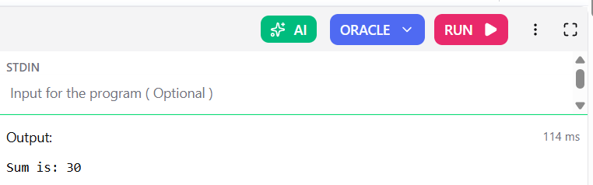

Cursor

*Program:
SET SERVEROUTPUT ON;

-- Step 1: Table create CREATE TABLE emp_demo (
id NUMBER,
name VARCHAR2(50),
salary NUMBER
);

-- Step 2: Insert data
INSERT INTO emp_demo VALUES (1, 'Amit', 30000); INSERT INTO emp_demo VALUES (2, 'Ravi', 40000); INSERT INTO emp_demo VALUES (3, 'Neha', 50000);

COMMIT;

-- Step 3: Cursor block DECLARE
CURSOR emp_cursor IS SELECT name, salary FROM emp_demo; v_name emp_demo.name%TYPE;
v_salary emp_demo.salary%TYPE; BEGIN
FOR rec IN emp_cursor LOOP DBMS_OUTPUT.PUT_LINE(rec.name || ' earns ' || rec.salary);
END LOOP; END;
/

*Output :
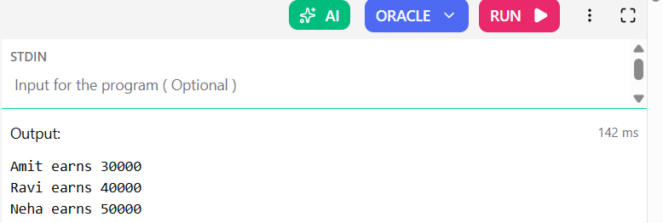

Trigger

*Program:
CREATE OR REPLACE TRIGGER emp_before_insert BEFORE INSERT ON emp
FOR EACH ROW BEGIN
:NEW.hiredate := SYSDATE; END;
/
INSERT INTO emp(emp_id, ename, sal) VALUES(4, 'JOHN', 2000);

SELECT ename, hiredate FROM emp WHERE emp_id = 4;

*Output :
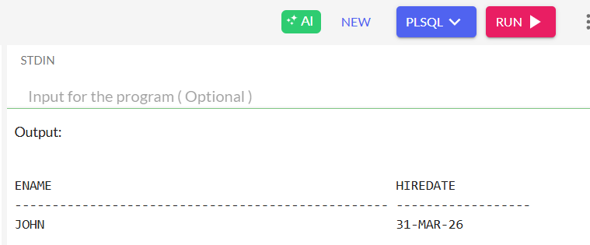

Functions

*Program:
CREATE TABLE employees ( employee_id NUMBER PRIMARY KEY, first_name VARCHAR2(50),
salary NUMBER
);

INSERT INTO employees VALUES (100, 'Steven', 5000); INSERT INTO employees VALUES (101, 'Neena', 4500);

COMMIT;
CREATE OR REPLACE FUNCTION calc_bonus(p_salary NUMBER) RETURN NUMBER
IS
v_bonus NUMBER; BEGIN
v_bonus := p_salary * 0.10; RETURN v_bonus;
END;
/
SHOW ERRORS;
SELECT first_name, salary, calc_bonus(salary) AS bonus FROM employees;

*Output :
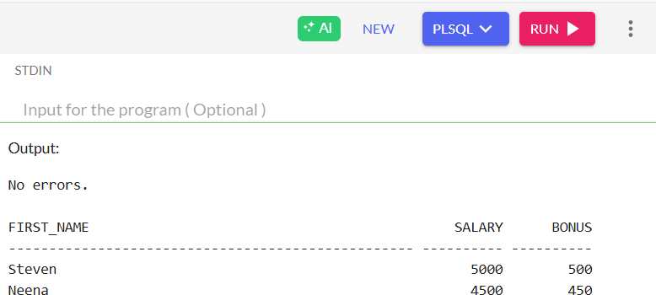

Stored procedure

*Program:
CREATE TABLE employees ( employee_id NUMBER PRIMARY KEY, first_name VARCHAR2(50),
salary NUMBER
);
INSERT INTO employees VALUES (100, 'Steven', 5000); INSERT INTO employees VALUES (101, 'Neena', 4500); INSERT INTO employees VALUES (102, 'Lex', 4000);

COMMIT;
CREATE OR REPLACE PROCEDURE increase_salary( p_emp_id IN NUMBER, -- Employee ID to update p_increase IN NUMBER -- Amount to increase salary
) IS
BEGIN
UPDATE employees
SET salary = salary + p_increase WHERE employee_id = p_emp_id;

-- Optional message
DBMS_OUTPUT.PUT_LINE('Salary updated for Employee ID ' || p_emp_id);
END;
/ BEGIN
increase_salary(101, 500); -- Increase Neena's salary by 500 END;
/

*Output :

