Lab 1.1 — RAG Fundamentals & Naive RAG
Topic: RAG Architecture, End-to-End | Lab 1 of 6
You will run this yourself. Review the code logic, then run it on your machine.

Environment Setup
Recommended Python version: Python 3.11 — it has full, stable wheel support for every package used across this lab series (sentence-transformers, faiss-cpu, together, networkx). Python 3.12 can still have gaps with some ML packages; 3.9/3.10 work but 3.11 is the current sweet spot.
Use whichever setup below matches your tooling. Keep the same environment across all upcoming labs in this series — no need to recreate it each time, just activate it and pip install any new package a later lab needs.

Option A — Using Conda
# 1. Create a new environment named "rag-labs" with Python 3.11
conda create -n rag-labs python=3.11 -y

# 2. Activate it
conda activate rag-labs

# 3. Verify the Python version
python --version
# should print: Python 3.11.x

# 4. Install all packages needed for Lab 1.1 (and upcoming labs)
pip install sentence-transformers faiss-cpu together python-dotenv numpy networkx

# 5. (Optional) verify everything imports cleanly
python -c "import sentence_transformers, faiss, together, dotenv, numpy, networkx; print('All good')"
If conda activate rag-labs doesn't work in a fresh terminal, run conda init once and restart the terminal.

Option B — Using venv (no conda required)
Step 1: Check you have Python 3.11 installed
python3 --version
# or on Windows: python --version
If it's not 3.11, download it from python.org/downloads first — venv can't install a different Python version for you, it only creates isolated environments using whatever Python you already have.
Step 2: Create the virtual environment
macOS / Linux:
python3.11 -m venv rag-labs-env
source rag-labs-env/bin/activate
Windows (Command Prompt):
py -3.11 -m venv rag-labs-env
rag-labs-env\Scripts\activate.bat
Windows (PowerShell):
py -3.11 -m venv rag-labs-env
rag-labs-env\Scripts\Activate.ps1
If Activate.ps1 gets blocked by a script-execution policy error, run this once, then retry:
Set-ExecutionPolicy -Scope CurrentUser -ExecutionPolicy RemoteSigned
Step 3: Verify you're inside the environment
python --version
# should print: Python 3.11.x
Your terminal prompt should also now show (rag-labs-env) at the start of the line.
Step 4: Install the packages
pip install sentence-transformers faiss-cpu together python-dotenv numpy networkx
Step 5: Deactivate when done for the day
deactivate
Next time, just cd back into the folder and run the activate command from Step 2 again — no need to recreate the environment.

Option C — PostgreSQL + pgvector (Production-Style Vector Store)
From this lab onward, every example ships in two versions — one using FAISS (an in-memory library, fast for learning) and one using PostgreSQL + pgvector (a real production-style database). If you already have PostgreSQL and pgAdmin installed, here's how to add vector search to it. This is optional but recommended — running both versions side by side is what proves a retrieval bug is caused by chunking, not by which vector store you happened to pick.
Step 1: Check your Postgres version — open pgAdmin, right-click your server → Properties, or run in the Query Tool:
SELECT version();
Step 2: Install Visual Studio Build Tools (needed to compile the extension on Windows). Download from visualstudio.microsoft.com/downloads and select the "Desktop development with C++" workload during install.
Step 3: Build and install pgvector. Open the "x64 Native Tools Command Prompt for VS" — search for it in the Start menu — and run it as Administrator (right-click → Run as administrator). This matters: the install step copies a file into a protected Program Files folder and will fail with "Access is denied" otherwise.
set "PGROOT=C:\Program Files\PostgreSQL\<your_version>"
cd %TEMP%
git clone --branch v0.8.6 https://github.com/pgvector/pgvector.git
cd pgvector
nmake /F Makefile.win
nmake /F Makefile.win install
Replace <your_version> with the number from Step 1 (e.g. 18). If "nmake install" still fails with Access is denied even from an elevated prompt, copy the files manually with an elevated File Explorer: vector.dll into ...\lib\, and vector.control plus everything in the sql\ folder into ...\share\extension\.
Step 4: Enable the extension in your database — in pgAdmin's Query Tool, connected to the database you'll use for these labs (e.g. a new database named rag_labs):
CREATE EXTENSION vector;
Step 5: Verify it worked
SELECT extversion FROM pg_extension WHERE extname = 'vector';
Should return a version number, e.g. 0.8.6, not an empty result.
Step 6: Quick sanity test
CREATE TABLE test_items (
id serial PRIMARY KEY,
embedding vector(3)
);

INSERT INTO test_items (embedding) VALUES ('[1,2,3]'), ('[4,5,6]');

SELECT * FROM test_items ORDER BY embedding <-> '[1,2,4]' LIMIT 5;

-- clean up once confirmed working:
DROP TABLE test_items;
Step 7: Python packages for pgvector
pip install psycopg2-binary pgvector
Step 8: Add Postgres connection details to your .env file, alongside your Together API key:
PG_HOST=localhost
PG_PORT=5432
PG_DB=rag_labs
PG_USER=postgres
PG_PASSWORD=your_postgres_password_here

Part 1: Concept — What RAG Actually Is
Retrieval-Augmented Generation (RAG) solves a simple problem: an LLM only knows what it was trained on, and it was never trained on your private documents, your company's policies, or last week's data. RAG fixes this without fine-tuning by doing four things at answer time:
- Index — split your documents into chunks, convert each chunk into a vector embedding, store them in a vector database.
- Retrieve — embed the user's question, find the most similar chunks by vector similarity.
- Augment — insert those chunks into the LLM's prompt as context.
- Generate — ask the LLM to answer using only that context.
The entire discipline of "RAG engineering" is really about making steps 1 and 2 reliable — because if the wrong chunk gets retrieved, no amount of prompt engineering in step 4 saves you. This is the single most important idea to carry into an interview: retrieval quality is the ceiling on generation quality.
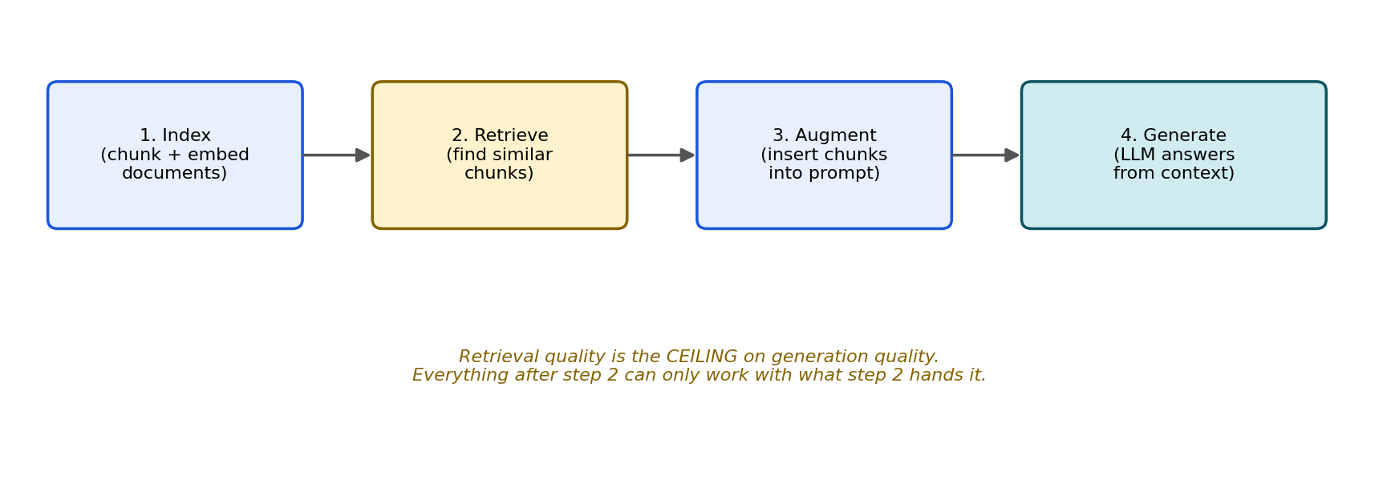
Figure 1: The whole system's quality lives or dies at the "Retrieve" step (yellow). Everything downstream can only work with what retrieval hands it.

Types of RAG (know these — you'll build several across this lab series)
Type | How it works | When it's used
Naive RAG | Fixed-size chunking, single vector search, stuff top-k chunks into the prompt | Prototypes, simple FAQ bots — this lab
Hybrid RAG | Vector search + keyword/BM25 search combined, results merged | Domains with codes/acronyms/exact terms (Lab 1.2)
Parent-Child RAG | Small chunks embedded for precise matching, larger parent chunk returned for context | Production default when context loss is a problem (Lab 1.3)
Re-ranked RAG | Vector search retrieves broadly (top-20), a cross-encoder re-ranker narrows to the true top-3 | When initial retrieval is noisy at scale (Lab 1.2)
Agentic RAG | The LLM itself decides whether to retrieve, what to search for, and whether to retrieve again | Multi-hop / compositional questions (Lab 1.5)
Graph RAG | Retrieval over a knowledge graph (entities + relationships) instead of flat text chunks | Highly relational data — covered as a bonus in this lab

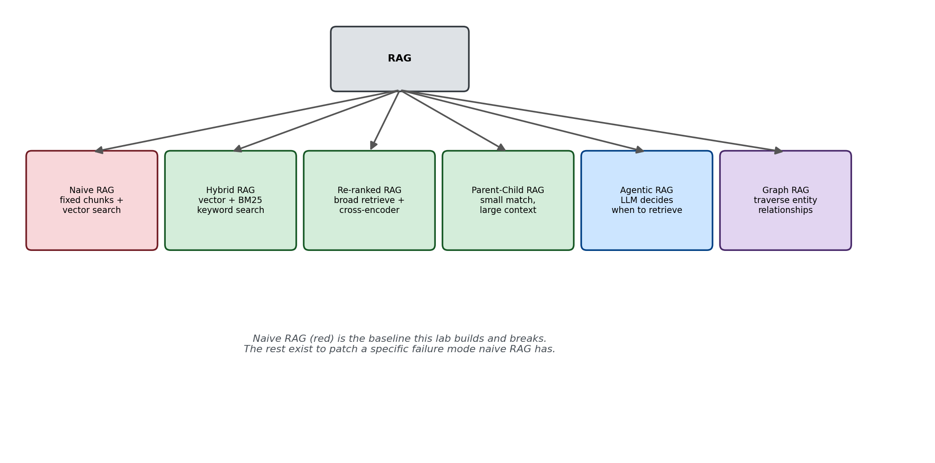
Figure 2: Naive RAG (red) is the baseline this lab builds and breaks. The rest exist to patch a specific failure mode naive RAG has.
This lab builds the first one — Naive RAG — and then deliberately breaks it, so you can feel exactly why the more advanced types exist.

Part 2: The Runnable Pipeline
This lab builds a working naive RAG system over a small "leave policy" document, using real production-grade components: sentence-transformers for embeddings, Together AI for generation, and — starting with this lab — every example ships in two versions of the vector store: FAISS (in-memory, fast for learning) and PostgreSQL + pgvector (production-style). Both versions use identical chunking, identical embeddings, and identical prompts — only the storage/retrieval layer differs — so any difference in the output is proof of something real, not an artifact of the store you picked.
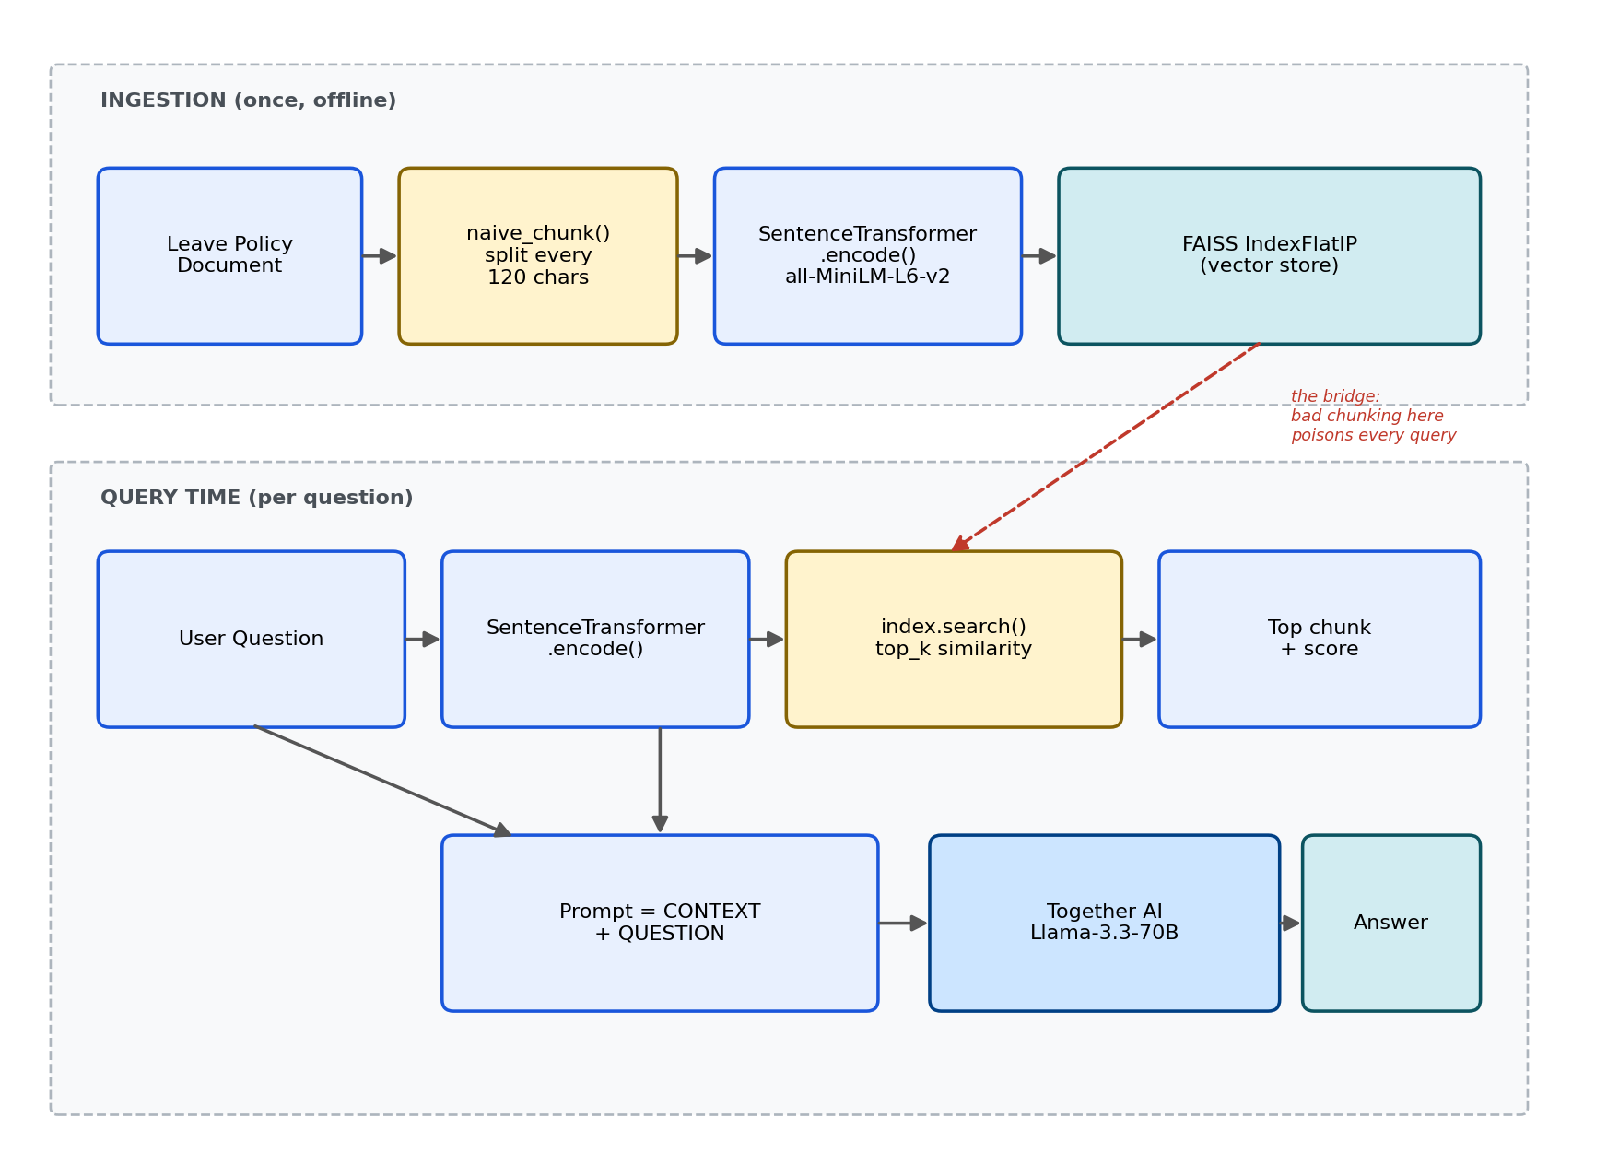
Figure 3: Ingestion happens once; query time happens on every question. The vector store (FAISS or pgvector) is the bridge between the two — everything that goes wrong in ingestion (like bad chunking) silently poisons every single query afterward, regardless of which store holds the vectors.

Setup before running
pip install sentence-transformers faiss-cpu psycopg2-binary pgvector together python-dotenv numpy
Create a .env file in the same folder (see Environment Setup, Option C, for the Postgres values):
TOGETHER_STUDY_API_KEY=your_together_key_here
PG_HOST=localhost
PG_PORT=5432
PG_DB=rag_labs
PG_USER=postgres
PG_PASSWORD=your_postgres_password_here
Every script in this lab prints the SAME four sections to the console, in this order, so FAISS and pgvector runs are directly comparable line-for-line: all chunks created, the query, the retrieved chunk(s) with similarity scores, and the LLM's answer. That standard format is defined once in a shared module and reused by every script below.

lab1_1_common.py — shared by every script in this lab
"""
lab1_1_common.py
==================
Shared code used by all FAISS/pgvector lab variants: the document,
both chunking strategies, the LLM call, and the standardized console
output format every lab script in this series uses.
"""

import os
import re
from dotenv import load_dotenv
from together import Together

load_dotenv()
client = Together(api_key=os.environ.get("TOGETHER_STUDY_API_KEY"))
MODEL = "openai/gpt-oss-20b"

# ---------------------------------------------------------------------------
# The document we're building RAG over. Small and readable on purpose --
# you should be able to read the whole thing and know the "correct" answer
# to any question before the LLM tells you, so you can judge it honestly.
# ---------------------------------------------------------------------------
DOCUMENT = """
Leave Policy Section 3: Annual Leave Entitlement. Employees are entitled to 18 days
of annual leave per calendar year, accrued monthly at 1.5 days per month. Unused
leave can be carried forward up to a maximum of 10 days into the next calendar year.
Any leave beyond the 10-day carry-forward cap is forfeited and will not be paid out.

Leave Policy Section 4: Sick Leave. Employees are entitled to 12 days of sick leave
per year. Sick leave does not carry forward and lapses at the end of the calendar year.
A medical certificate is required for sick leave exceeding 2 consecutive days.

Leave Policy Section 5: Work From Home. Employees may work from home up to 2 days
per week, subject to manager approval. Employees in probation period are NOT eligible
for work from home and must work from office for the first 6 months of employment.

Leave Policy Section 6: Notice Period. The standard notice period for resignation is
60 days for employees above 2 years of tenure, and 30 days for employees below 2 years
of tenure. The company reserves the right to waive the notice period at its discretion.
"""

# ---------------------------------------------------------------------------
# BROKEN chunker: splits by raw character count, no sentence awareness.
# Used in Part 3 to reproduce the failure.
# ---------------------------------------------------------------------------
def naive_chunk(text, chunk_size=120):
text = text.strip().replace("\n", " ")
return [text[i:i + chunk_size] for i in range(0, len(text), chunk_size)]

# ---------------------------------------------------------------------------
# FIXED chunker: groups whole sentences up to a size limit, never
# splitting mid-clause. Used in Part 4 to fix the failure.
# ---------------------------------------------------------------------------
def sentence_aware_chunk(text, max_chars=250):
text = text.strip().replace("\n", " ")
sentences = re.split(r'(?<=[.!?])\s+', text)
chunks, current = [], ""
for sent in sentences:
if len(current) + len(sent) <= max_chars:
current += (" " + sent if current else sent)
else:
if current:
chunks.append(current.strip())
current = sent
if current:
chunks.append(current.strip())
return chunks

def generate_answer(context, question):
prompt = f"""Answer the employee's question using ONLY the context below.
If the context doesn't fully answer the question, say what it says and nothing more.

CONTEXT:
{context}

QUESTION: {question}

ANSWER:"""
response = client.chat.completions.create(
model=MODEL,
messages=[{"role": "user", "content": prompt}],
temperature=0,
)
return response.choices[0].message.content

def print_section(title):
print(f"\n{'=' * 40}\n{title}\n{'=' * 40}")

def print_lab_output(all_chunks, query, retrieved, answer):
"""Standard console output format for every lab script in this series:
all chunks -> query -> retrieved chunk(s) -> LLM answer."""
print_section("ALL CHUNKS CREATED")
for i, c in enumerate(all_chunks):
print(f"[{i}] {c}")

print_section("QUERY")
print(query)

print_section("RETRIEVED CHUNK(S)")
for chunk_text, score in retrieved:
print(f"[similarity={score:.4f}] {chunk_text}")

print_section("LLM ANSWER")
print(answer)
Run this file on its own — it just defines functions, nothing prints. The actual runnable scripts import from this module. Part 3 gives you the two "broken" versions (FAISS and pgvector, both using naive_chunk); Part 4 gives you the two "fixed" versions (both using sentence_aware_chunk).

Part 3: Reproduce the Failure — Two Versions
The document has a booby trap for naive chunking: Section 5 (Work From Home) contains a rule and an exception in the same short paragraph — "employees may work from home... employees in probation period are NOT eligible." Fixed-size chunking at chunk_size=120 will very likely cut this paragraph mid-sentence, separating the rule from its exception into two different chunks.
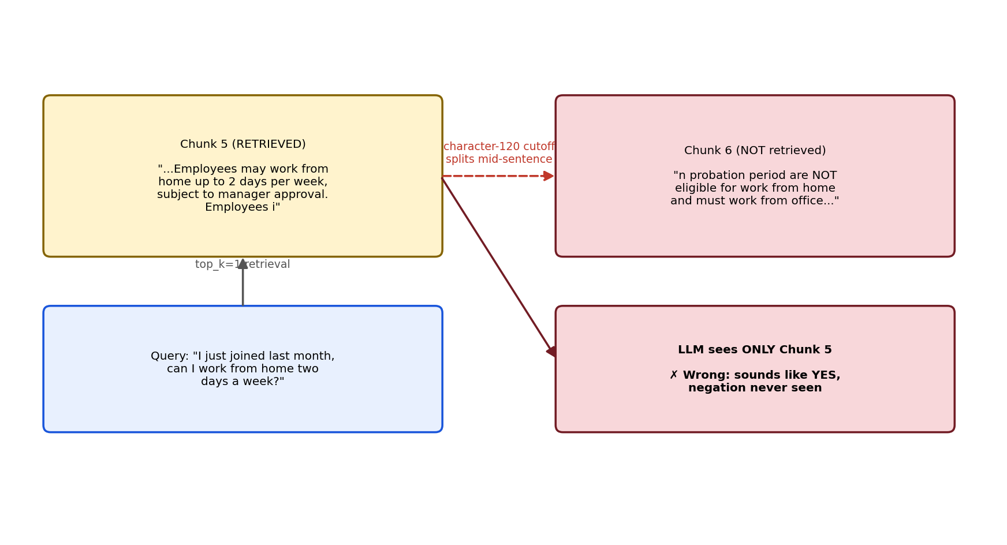
Figure 4: The negation clause ("NOT eligible") physically lives in the chunk that never gets retrieved. This is the exact bug both versions below will reproduce.

Version 1 of 2 — lab1_1_faiss_naive.py
"""
lab1_1_faiss_naive.py
=======================
Version 1 of 2 (FAISS). Naive fixed-size chunking + FAISS vector search.
Reproduces the negation-splitting bug.
"""

import numpy as np
import faiss
from sentence_transformers import SentenceTransformer
from lab1_1_common import DOCUMENT, naive_chunk, generate_answer, print_lab_output

if __name__ == "__main__":
embed_model = SentenceTransformer("all-MiniLM-L6-v2")

chunks = naive_chunk(DOCUMENT, chunk_size=120)

embeddings = embed_model.encode(chunks, normalize_embeddings=True)
index = faiss.IndexFlatIP(embeddings.shape[1])
index.add(np.array(embeddings, dtype="float32"))

# A realistic paraphrase that does NOT use the word "probation" --
# exactly how a real employee would actually ask this.
question = "I just joined last month, can I work from home two days a week?"
q_emb = embed_model.encode([question], normalize_embeddings=True)
scores, indices = index.search(np.array(q_emb, dtype="float32"), 1)
retrieved = [(chunks[i], float(scores[0][j])) for j, i in enumerate(indices[0])]

answer = generate_answer(retrieved[0][0], question)

print_lab_output(chunks, question, retrieved, answer)

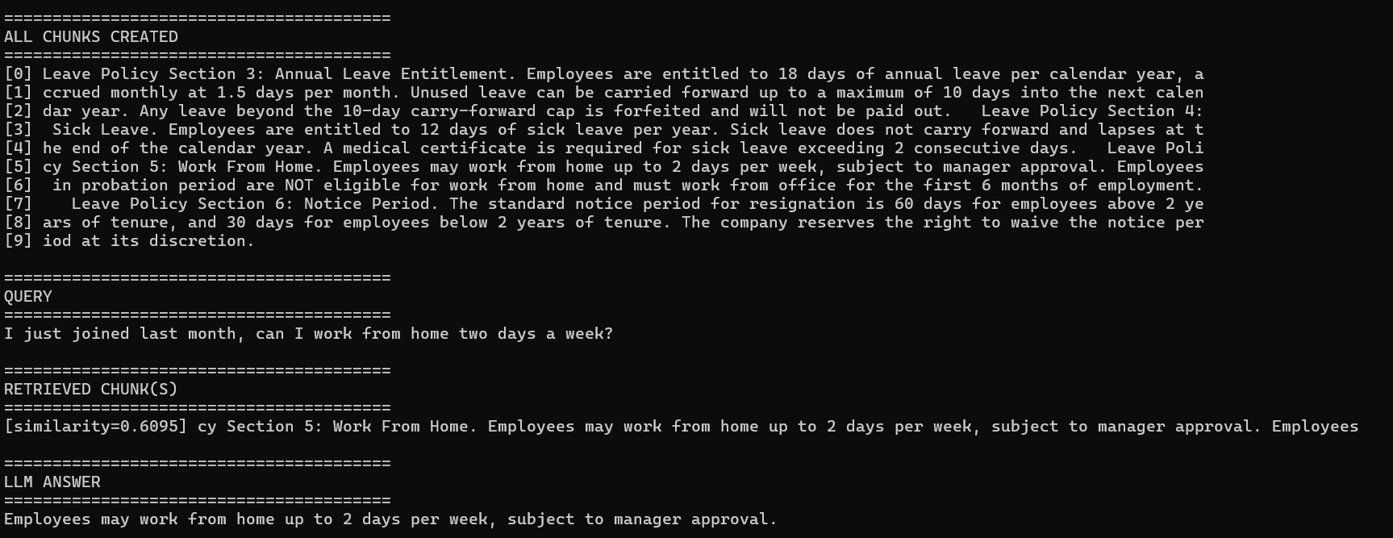

Version 2 of 2 — lab1_1_pgvector_naive.py
"""
lab1_1_pgvector_naive.py
==========================
Version 2 of 2 (pgvector). Naive fixed-size chunking + PostgreSQL/pgvector.
Reproduces the SAME negation-splitting bug as the FAISS version, proving
the bug is upstream in chunking, not the vector store.
"""

import os
import psycopg2
from pgvector.psycopg2 import register_vector
from sentence_transformers import SentenceTransformer
from dotenv import load_dotenv
from lab1_1_common import DOCUMENT, naive_chunk, generate_answer, print_lab_output

load_dotenv()

PG_CONFIG = {
"host": os.environ.get("PG_HOST", "localhost"),
"port": os.environ.get("PG_PORT", "5432"),
"dbname": os.environ.get("PG_DB", "rag_labs"),
"user": os.environ.get("PG_USER", "postgres"),
"password": os.environ.get("PG_PASSWORD"),
}
EMBED_DIM = 384 # all-MiniLM-L6-v2 output dimension

if __name__ == "__main__":
embed_model = SentenceTransformer("all-MiniLM-L6-v2")
conn = psycopg2.connect(**PG_CONFIG)
register_vector(conn)

# Drop and recreate each run so the lab is repeatable with no leftovers.
with conn.cursor() as cur:
cur.execute("CREATE EXTENSION IF NOT EXISTS vector;")
cur.execute("DROP TABLE IF EXISTS lab1_1_naive_chunks;")
cur.execute(f"""
CREATE TABLE lab1_1_naive_chunks (
id serial PRIMARY KEY,
chunk_text text,
embedding vector({EMBED_DIM})
);
""")
conn.commit()

chunks = naive_chunk(DOCUMENT, chunk_size=120)
embeddings = embed_model.encode(chunks, normalize_embeddings=True)
with conn.cursor() as cur:
for text, emb in zip(chunks, embeddings):
cur.execute(
"INSERT INTO lab1_1_naive_chunks (chunk_text, embedding) VALUES (%s, %s)",
(text, emb), # pass the numpy array directly -- NOT emb.tolist()
)
conn.commit()

question = "I just joined last month, can I work from home two days a week?"
q_emb = embed_model.encode([question], normalize_embeddings=True)[0]
with conn.cursor() as cur:
# <=> is pgvector's cosine DISTANCE operator (0 = identical).
# Converting to (1 - distance) makes it read the same as FAISS's score.
cur.execute(
"""
SELECT chunk_text, 1 - (embedding <=> %s) AS similarity
FROM lab1_1_naive_chunks
ORDER BY embedding <=> %s
LIMIT %s;
""",
(q_emb, q_emb, 1),
)
retrieved = cur.fetchall()

answer = generate_answer(retrieved[0][0], question)

print_lab_output(chunks, question, retrieved, answer)
conn.close()
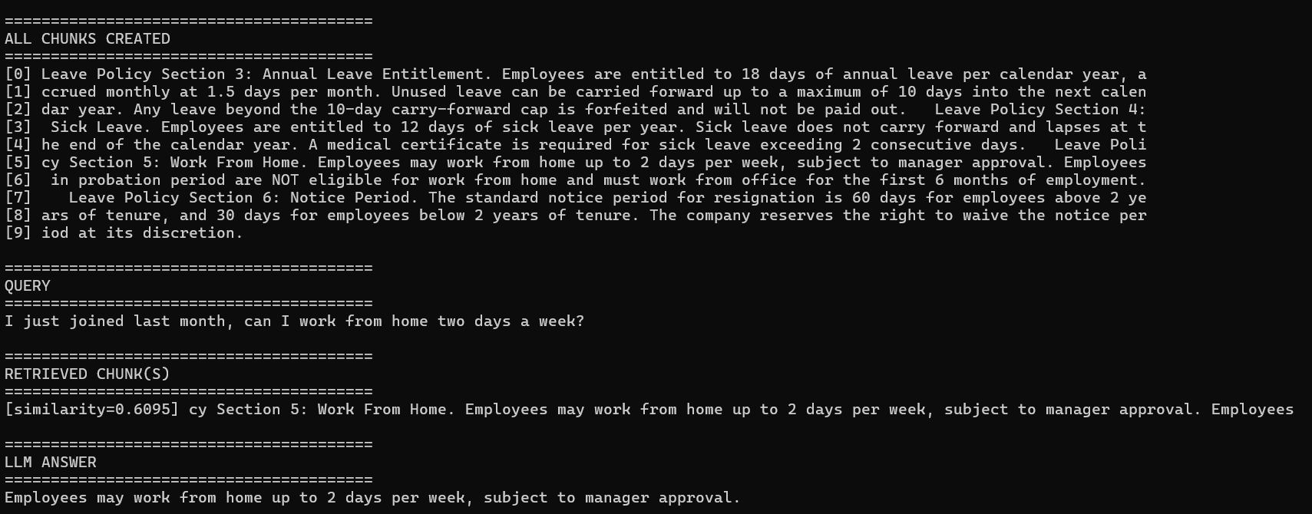
What to look for when you run both: the retrieved chunk in both versions should stop at "...Employees may work from home up to 2 days per week..." WITHOUT reaching the "NOT eligible during probation" clause. The similarity score is usually still reasonably high (0.4-0.6 range) in both versions, because "work from home" and "days per week" are still strong matches. A high similarity score does not mean the chunk contains the full answer — that's a distinct lesson worth stating explicitly in an interview, and the fact that it holds true on TWO different vector stores makes the point stronger, not weaker.

Part 4: The Fix — Sentence-Aware Chunking, Two Versions
Fixed-size chunking's only rule is "cut every N characters." The fix is to add a rule: never cut in the middle of a sentence.
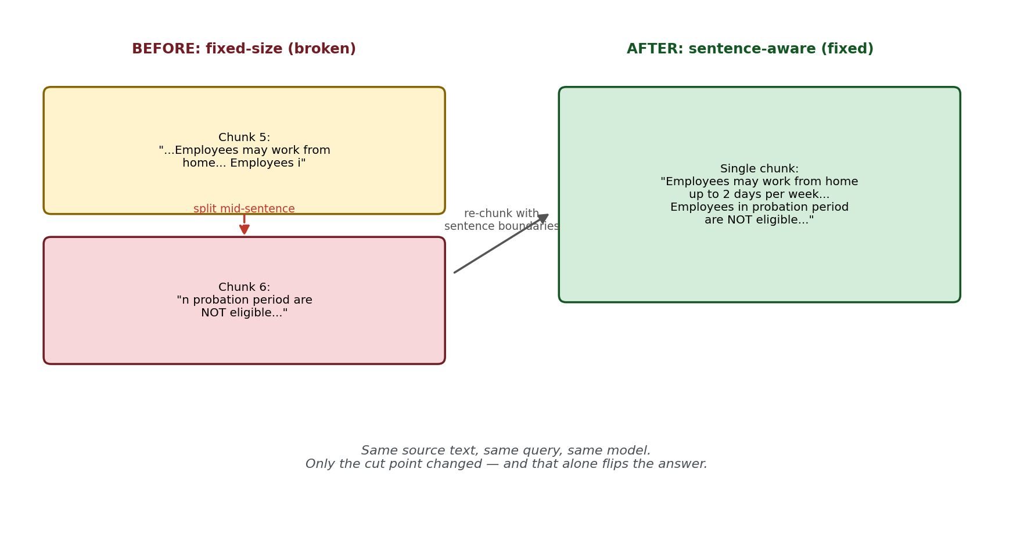
Figure 5: Same source text, same query, same model. The only change is where the cut happens — and that alone is enough to flip the LLM's answer from wrong to right, on both vector stores.

Version 1 of 2 — lab1_1_faiss_fixed.py
"""
lab1_1_faiss_fixed.py
=======================
Version 1 of 2 (FAISS). Sentence-aware chunking + FAISS vector search.
Fixes the negation-splitting bug from lab1_1_faiss_naive.py.
"""

import numpy as np
import faiss
from sentence_transformers import SentenceTransformer
from lab1_1_common import DOCUMENT, sentence_aware_chunk, generate_answer, print_lab_output

if __name__ == "__main__":
embed_model = SentenceTransformer("all-MiniLM-L6-v2")

chunks = sentence_aware_chunk(DOCUMENT, max_chars=250)

embeddings = embed_model.encode(chunks, normalize_embeddings=True)
index = faiss.IndexFlatIP(embeddings.shape[1])
index.add(np.array(embeddings, dtype="float32"))

question = "I just joined last month, can I work from home two days a week?"
q_emb = embed_model.encode([question], normalize_embeddings=True)
scores, indices = index.search(np.array(q_emb, dtype="float32"), 1)
retrieved = [(chunks[i], float(scores[0][j])) for j, i in enumerate(indices[0])]

answer = generate_answer(retrieved[0][0], question)

print_lab_output(chunks, question, retrieved, answer)

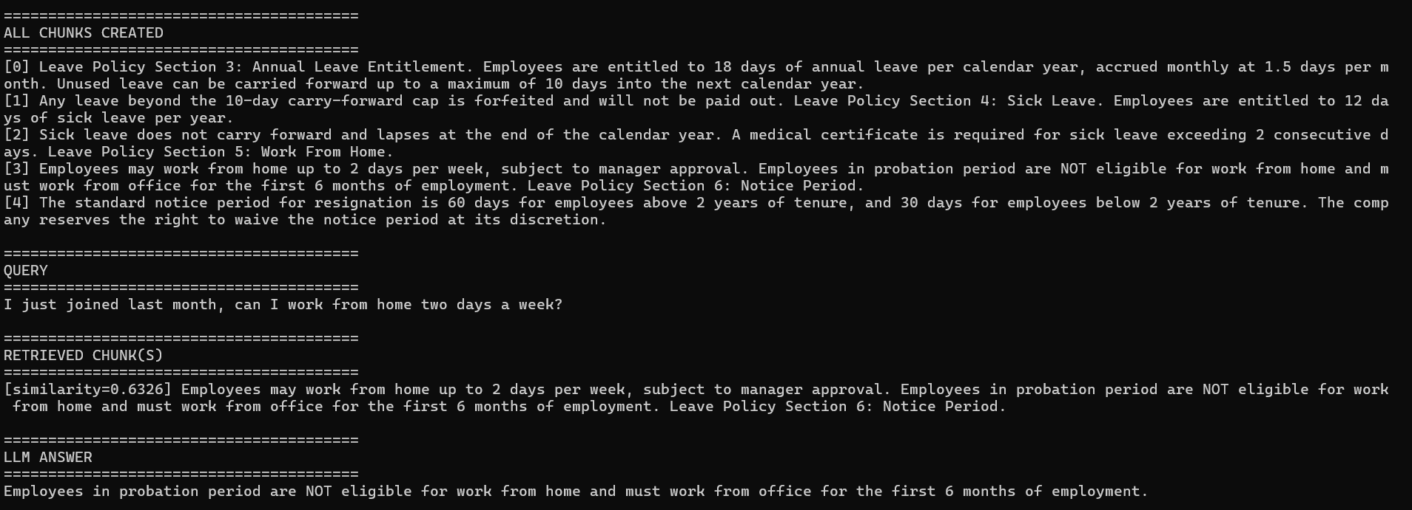

Version 2 of 2 — lab1_1_pgvector_fixed.py
"""
lab1_1_pgvector_fixed.py
==========================
Version 2 of 2 (pgvector). Sentence-aware chunking + PostgreSQL/pgvector.
"""

import os
import psycopg2
from pgvector.psycopg2 import register_vector
from sentence_transformers import SentenceTransformer
from dotenv import load_dotenv
from lab1_1_common import DOCUMENT, sentence_aware_chunk, generate_answer, print_lab_output

load_dotenv()

PG_CONFIG = {
"host": os.environ.get("PG_HOST", "localhost"),
"port": os.environ.get("PG_PORT", "5432"),
"dbname": os.environ.get("PG_DB", "rag_labs"),
"user": os.environ.get("PG_USER", "postgres"),
"password": os.environ.get("PG_PASSWORD"),
}
EMBED_DIM = 384

if __name__ == "__main__":
embed_model = SentenceTransformer("all-MiniLM-L6-v2")
conn = psycopg2.connect(**PG_CONFIG)
register_vector(conn)

with conn.cursor() as cur:
cur.execute("CREATE EXTENSION IF NOT EXISTS vector;")
cur.execute("DROP TABLE IF EXISTS lab1_1_fixed_chunks;")
cur.execute(f"""
CREATE TABLE lab1_1_fixed_chunks (
id serial PRIMARY KEY,
chunk_text text,
embedding vector({EMBED_DIM})
);
""")
conn.commit()

chunks = sentence_aware_chunk(DOCUMENT, max_chars=250)
embeddings = embed_model.encode(chunks, normalize_embeddings=True)
with conn.cursor() as cur:
for text, emb in zip(chunks, embeddings):
cur.execute(
"INSERT INTO lab1_1_fixed_chunks (chunk_text, embedding) VALUES (%s, %s)",
(text, emb),
)
conn.commit()

question = "I just joined last month, can I work from home two days a week?"
q_emb = embed_model.encode([question], normalize_embeddings=True)[0]
with conn.cursor() as cur:
cur.execute(
"""
SELECT chunk_text, 1 - (embedding <=> %s) AS similarity
FROM lab1_1_fixed_chunks
ORDER BY embedding <=> %s
LIMIT %s;
""",
(q_emb, q_emb, 1),
)
retrieved = cur.fetchall()

answer = generate_answer(retrieved[0][0], question)

print_lab_output(chunks, question, retrieved, answer)
conn.close()
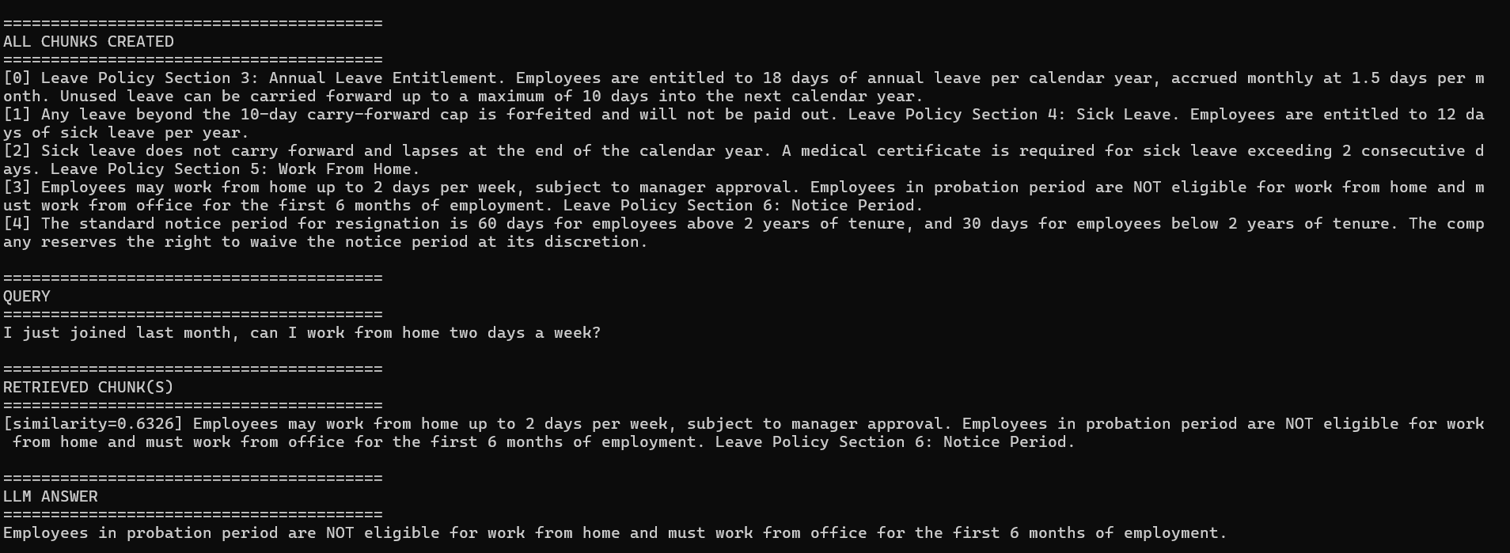
Run all four scripts from Part 3 and Part 4 and compare console output directly. Same model, same prompt template, same temperature — the only variables that change are (a) chunking strategy and (b) vector store. You should see the WRONG answer reproduce identically on both stores in Part 3, and the CORRECT answer reproduce identically on both stores in Part 4. That four-way comparison, from your own terminal output, is the strongest possible proof you can bring into an interview.

Version 1 of 2 — lab1_1_faiss_langchain.py
"""
lab1_1_faiss_langchain.py
============================
Version 1 of 2 (FAISS). Production-style chunking using LangChain's
RecursiveCharacterTextSplitter instead of the hand-rolled sentence_aware_chunk.
"""

import numpy as np
import faiss
from sentence_transformers import SentenceTransformer
from langchain_text_splitters import RecursiveCharacterTextSplitter
from lab1_1_common import DOCUMENT, generate_answer, print_lab_output

if __name__ == "__main__":
embed_model = SentenceTransformer("all-MiniLM-L6-v2")

# Tries paragraph breaks first, then sentence-ish breaks, then words,
# then raw characters as a last resort -- never fails to produce a
# valid chunk, unlike a custom regex written for one specific edge case.
splitter = RecursiveCharacterTextSplitter(
chunk_size=250,
chunk_overlap=30,
separators=["\n\n", "\n", ". ", " ", ""],
)
chunks = splitter.split_text(DOCUMENT)

embeddings = embed_model.encode(chunks, normalize_embeddings=True)
index = faiss.IndexFlatIP(embeddings.shape[1])
index.add(np.array(embeddings, dtype="float32"))

question = "I just joined last month, can I work from home two days a week?"
q_emb = embed_model.encode([question], normalize_embeddings=True)
scores, indices = index.search(np.array(q_emb, dtype="float32"), 1)
retrieved = [(chunks[i], float(scores[0][j])) for j, i in enumerate(indices[0])]

answer = generate_answer(retrieved[0][0], question)

print_lab_output(chunks, question, retrieved, answer)

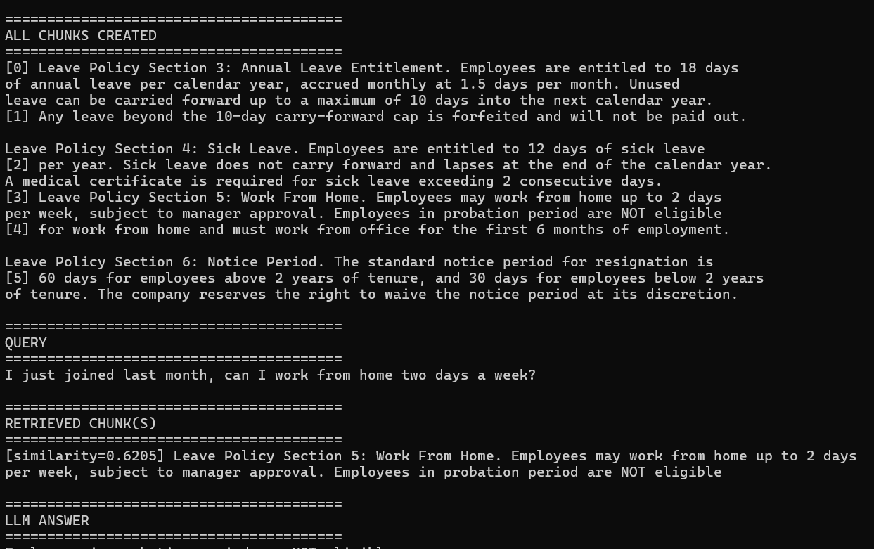

Version 1 of 2 — lab1_1_pgvector_langchain.py
"""
lab1_1_pgvector_langchain.py
===============================
Version 2 of 2 (pgvector). Same RecursiveCharacterTextSplitter chunking,
stored and retrieved via PostgreSQL/pgvector instead of FAISS.
"""

import os
import psycopg2
from pgvector.psycopg2 import register_vector
from sentence_transformers import SentenceTransformer
from dotenv import load_dotenv
from langchain_text_splitters import RecursiveCharacterTextSplitter
from lab1_1_common import DOCUMENT, generate_answer, print_lab_output

load_dotenv()

PG_CONFIG = {
"host": os.environ.get("PG_HOST", "localhost"),
"port": os.environ.get("PG_PORT", "5432"),
"dbname": os.environ.get("PG_DB", "rag_labs"),
"user": os.environ.get("PG_USER", "postgres"),
"password": os.environ.get("PG_PASSWORD"),
}
EMBED_DIM = 384

if __name__ == "__main__":
embed_model = SentenceTransformer("all-MiniLM-L6-v2")
conn = psycopg2.connect(**PG_CONFIG)
register_vector(conn)

with conn.cursor() as cur:
cur.execute("CREATE EXTENSION IF NOT EXISTS vector;")
cur.execute("DROP TABLE IF EXISTS lab1_1_langchain_chunks;")
cur.execute(f"""
CREATE TABLE lab1_1_langchain_chunks (
id serial PRIMARY KEY,
chunk_text text,
embedding vector({EMBED_DIM})
);
""")
conn.commit()

splitter = RecursiveCharacterTextSplitter(
chunk_size=250,
chunk_overlap=30,
separators=["\n\n", "\n", ". ", " ", ""],
)
chunks = splitter.split_text(DOCUMENT)

embeddings = embed_model.encode(chunks, normalize_embeddings=True)
with conn.cursor() as cur:
for text, emb in zip(chunks, embeddings):
cur.execute(
"INSERT INTO lab1_1_langchain_chunks (chunk_text, embedding) VALUES (%s, %s)",
(text, emb),
)
conn.commit()

question = "I just joined last month, can I work from home two days a week?"
q_emb = embed_model.encode([question], normalize_embeddings=True)[0]
with conn.cursor() as cur:
cur.execute(
"""
SELECT chunk_text, 1 - (embedding <=> %s) AS similarity
FROM lab1_1_langchain_chunks
ORDER BY embedding <=> %s
LIMIT %s;
""",
(q_emb, q_emb, 1),
)
retrieved = cur.fetchall()

answer = generate_answer(retrieved[0][0], question)

print_lab_output(chunks, question, retrieved, answer)
conn.close()
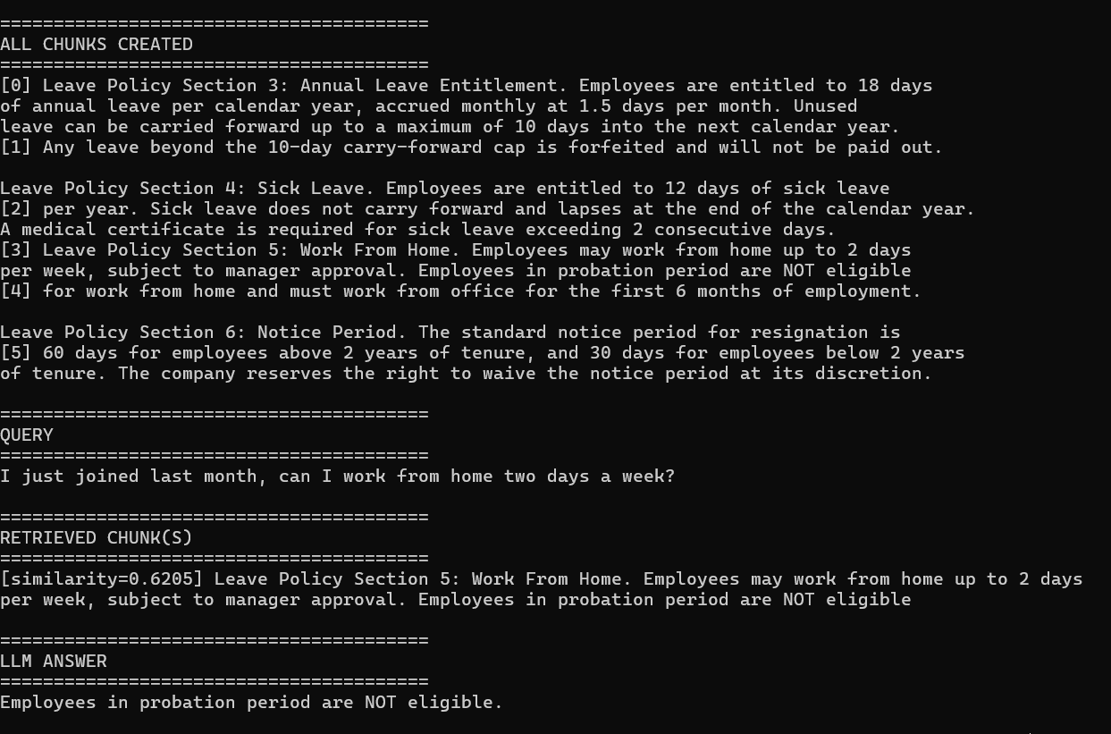

Part 5: Interview Cheat-Sheet (Reference Your Own Code)
Q: How does RAG actually work, end to end?
A: I built this myself -- index documents as chunks, embed them, store in a vector index. At query time, embed the question, retrieve the top-k most similar chunks, insert them into the prompt, and ask the LLM to answer using only that context. The whole discipline is really about making retrieval reliable, because generation quality is capped by what retrieval hands it.
Q: What's the biggest mistake people make with chunking?
A: Splitting purely by character count with no awareness of sentence boundaries. I reproduced this directly -- a policy document had a rule and its exception in the same sentence, fixed-size chunking split them into two different chunks, and the retrieved chunk-alone caused the LLM to give a wrong answer, even though the correct information existed in the document. The similarity score for the broken chunk was still reasonably high, which is the dangerous part -- a high score doesn't guarantee a complete answer.
Q: How did you fix it?
A: Switched to sentence-aware chunking -- group whole sentences up to a size limit instead of cutting by raw character count. I re-ran the identical question against the identical model and the answer flipped from wrong to correct, with chunking as the only variable changed. That's proof the fix works, not just a claim.
Q: Why not always use very large chunks to avoid this problem entirely?
A: Because that trades one failure mode for another -- bigger chunks dilute the embedding vector with irrelevant surrounding text, hurting retrieval precision, and they blow up your context window cost. The actual production answer to this trade-off is parent-child chunking, which I cover in the next lab -- small chunks for precise matching, larger parent context returned only when needed.
Q: What would you check first if a RAG system gave a wrong answer in production?
A: First isolate the layer: log the raw retrieved chunks for the failing query before they hit the LLM. If the correct information isn't in the retrieved chunks at all, it's upstream -- a chunking or embedding problem, exactly like what I reproduced. If the correct information is present but the LLM still got it wrong, that's a separate generation/grounding problem, not a retrieval one.
Q: Why did you test this on both FAISS and pgvector instead of just one?
A: To isolate the variable. I ran the identical broken chunking through both an in-memory library (FAISS) and a production-style database (PostgreSQL with pgvector) and got the identical wrong answer on both. Then I ran the identical fix through both and got the identical correct answer on both. That proves the bug and the fix live in chunking, not in the choice of vector store -- which is exactly the kind of claim you want to be able to back up with a real side-by-side run rather than just assert.

Part 6: Bonus — Graph RAG (a minimal working example)
Graph RAG retrieves over a knowledge graph (entities + relationships) instead of flat text chunks. It shines when the answer depends on a relationship between things, not just similarity to a blob of text -- for example, "who does the Notice Period policy apply differently to, and why?" requires connecting "Notice Period" -> "tenure" -> "2 years" as linked facts, not just finding the one paragraph that mentions notice period.
This example uses NetworkX (a pure-Python graph library) so it runs with no external graph database server -- good enough to learn the pattern, though production Graph RAG typically uses a real graph DB (Neo4j, Amazon Neptune) at scale.
Note on the FAISS/pgvector pattern: this lab is intentionally single-version, not a FAISS+pgvector pair. Graph RAG doesn't retrieve by vector similarity at all -- it retrieves by traversing relationships -- so there's no "FAISS version" of a graph walk to compare against. A true production pgvector-style twin here would require modeling entities and edges as relational tables and traversing them with recursive SQL, which is a bigger architectural exercise than a like-for-like swap. Worth naming this distinction explicitly if asked in an interview why Graph RAG doesn't fit the same two-version pattern as the rest of this lab.
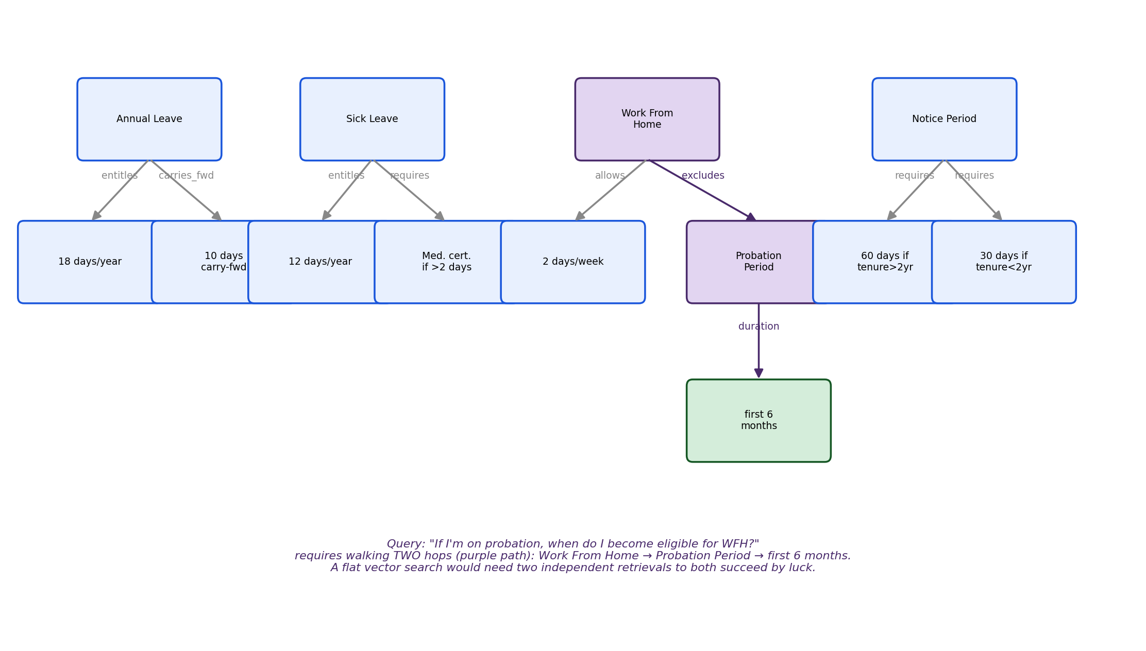
Figure 6: The query "if I'm on probation, when do I become eligible for WFH?" requires walking TWO hops. A flat vector search over text chunks has no concept of this connection -- a graph walk gets there by construction.

Setup
pip install networkx

lab1_1_graph_rag.py
"""
lab1_1_graph_rag.py
=====================
Minimal Graph RAG: build a small knowledge graph of entities and
relationships extracted from the leave policy, then retrieve by
traversing relationships instead of vector similarity.
"""

import networkx as nx
from lab1_1_common import generate_answer

# ---------------------------------------------------------------------------
# STEP 1: Build the knowledge graph manually.
# In a real system, an LLM extraction step would generate these
# (entity, relationship, entity) triples automatically from documents.
# We hand-build it here so the graph structure itself is easy to inspect.
# ---------------------------------------------------------------------------
graph = nx.DiGraph()

triples = [
("Annual Leave", "entitles", "18 days per year"),
("Annual Leave", "carries_forward_up_to", "10 days"),
("Sick Leave", "entitles", "12 days per year"),
("Sick Leave", "requires", "medical certificate if > 2 consecutive days"),
("Work From Home", "allows", "2 days per week"),
("Work From Home", "excludes", "employees in probation period"),
("Probation Period", "duration", "first 6 months of employment"),
("Notice Period", "requires", "60 days if tenure > 2 years"),
("Notice Period", "requires", "30 days if tenure < 2 years"),
]

for source, relation, target in triples:
graph.add_edge(source, target, relation=relation)

# ---------------------------------------------------------------------------
# STEP 2: "Retrieve" by traversing the graph from a matched entity,
# instead of embedding + cosine similarity over flat text.
# ---------------------------------------------------------------------------
def graph_retrieve(entity, max_hops=2):
"""Walk outward from `entity` up to max_hops, collecting every
relationship triple encountered. This is the graph-RAG equivalent
of 'retrieve the top-k similar chunks.'"""
if entity not in graph:
return []

visited_edges = []
frontier = [entity]
for _ in range(max_hops):
next_frontier = []
for node in frontier:
for _, target, data in graph.out_edges(node, data=True):
visited_edges.append((node, data["relation"], target))
next_frontier.append(target)
frontier = next_frontier
return visited_edges

def edges_to_context(edges):
return "\n".join(f"{s} {r} {t}." for s, r, t in edges)

if __name__ == "__main__":
# A question that genuinely needs a RELATIONSHIP, not just a text match:
# "Work From Home" alone doesn't answer this -- you must also traverse
# to "Probation Period" to get the duration of the exclusion.
question = "If I'm on probation, when do I become eligible for work from home?"

edges = graph_retrieve("Work From Home", max_hops=2)
print("Graph traversal result (this is what gets sent to the LLM instead of a text chunk):\n")
for s, r, t in edges:
print(f" {s} --[{r}]--> {t}")

context = edges_to_context(edges)
answer = generate_answer(context, question)
print(f"\nLLM ANSWER:\n{answer}")

print(f"\n>>> Notice the context passed to the LLM is a list of relationship")
print(f">>> triples, not a paragraph of text. This works because the graph")
print(f">>> traversal from 'Work From Home' automatically pulled in the")
print(f">>> connected 'Probation Period' -> 'first 6 months' fact, which a")
print(f">>> flat vector search over text chunks would need a SEPARATE lucky")
print(f">>> retrieval to find. That's the entire value proposition of Graph")
print(f">>> RAG: multi-hop facts become a graph walk instead of a gamble on")
print(f">>> whether two separate chunks both get retrieved together.")
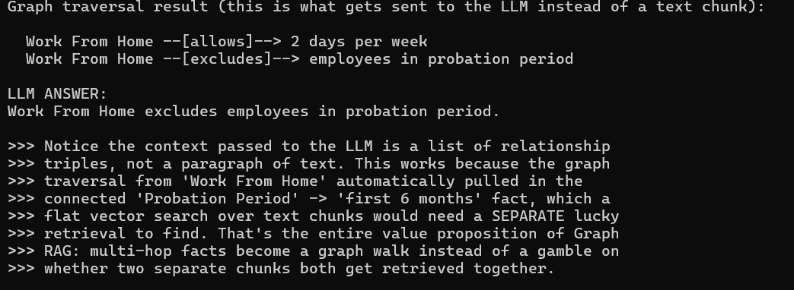
Q: When would you choose Graph RAG over standard vector RAG?
A: When the answer genuinely depends on a relationship between entities rather than similarity to a block of text -- org structures, dependency chains, or in my case, a policy exclusion that only makes sense combined with a separately-stated duration. I built a small example connecting 'Work From Home' to 'Probation Period' as a graph traversal, and the multi-hop fact came back reliably because it's a graph walk, not a gamble on two independent chunk retrievals both succeeding. The trade-off is Graph RAG needs upfront entity/relationship extraction -- usually an LLM extraction pass over your documents -- which is more ingestion engineering than just chunking and embedding.

Next: Lab 1.2 — Hybrid Search & Re-ranking.

