Lab 1.2 — Hybrid Search & Re-ranking
Topic: RAG Architecture, End-to-End | Lab 2 of 6
This lab is fully standalone — its own common module, its own setup, nothing imported from Lab 1.1. You will run this yourself.

Environment Setup
This lab is self-contained. If you already have the rag-labs environment and PostgreSQL/pgvector set up from Lab 1.1, you can reuse them — just add the one new package below. If you're starting fresh, follow all of Options A-C.

Option A — Using Conda
conda create -n rag-labs python=3.11 -y
conda activate rag-labs
python --version
pip install sentence-transformers faiss-cpu psycopg2-binary pgvector together python-dotenv numpy rank-bm25 langchain-text-splitters

Option B — Using venv (no conda required)
macOS / Linux:
python3.11 -m venv rag-labs-env
source rag-labs-env/bin/activate
Windows (Command Prompt):
py -3.11 -m venv rag-labs-env
rag-labs-env\Scripts\activate.bat
Windows (PowerShell):
py -3.11 -m venv rag-labs-env
rag-labs-env\Scripts\Activate.ps1
# If blocked by execution policy, run once then retry:
# Set-ExecutionPolicy -Scope CurrentUser -ExecutionPolicy RemoteSigned
Then install packages (same for all platforms):
pip install sentence-transformers faiss-cpu psycopg2-binary pgvector together python-dotenv numpy rank-bm25 langchain-text-splitters
New in this lab: rank-bm25 (the lexical/keyword-search half of hybrid search on the FAISS side) and langchain-text-splitters (library-based chunking, used instead of a hand-rolled string split — see Part 2 for why).

Option C — PostgreSQL + pgvector
Same setup as Lab 1.1's Option C (Visual Studio Build Tools, build pgvector from source, CREATE EXTENSION vector, admin-elevated install). No new PostgreSQL extension is needed for this lab — the lexical half of pgvector's hybrid search uses PostgreSQL's built-in full-text search (tsvector + GIN index), which ships with stock PostgreSQL. If you already have pgvector working from Lab 1.1, skip straight to the .env file below.
Add to your .env file:
TOGETHER_STUDY_API_KEY=your_together_key_here
PG_HOST=localhost
PG_PORT=5432
PG_DB=rag_labs
PG_USER=postgres
PG_PASSWORD=your_postgres_password_here

Part 1: Concept — Why Pure Vector Search Isn't Enough
Vector search finds things that are conceptually similar to your query — great for paraphrase, weak for exact identifiers. Error codes, ticket numbers, product SKUs, and account IDs are exactly the kind of tokens embedding models struggle to distinguish, because two numerically different codes in the same domain ("ERR-4521" vs "ERR-4522") often produce nearly identical embeddings. Keyword search (BM25) is the mirror opposite: perfect at exact-token matches, blind to paraphrase and synonyms.
Hybrid search runs both retrieval methods in parallel and fuses the results with Reciprocal Rank Fusion (RRF) — a rank-based fusion, not a raw-score average. This matters because BM25 scores are unbounded while cosine similarity lives in [-1, 1]; averaging them directly is a well-known anti-pattern. RRF sidesteps the incompatible-scales problem entirely by only caring about rank position in each list.
Even hybrid + RRF has a limit, which this lab will show you directly: a clean rank-1/rank-2 swap between two retrieval lists produces an exact RRF tie. That's where a cross-encoder reranker earns its place — it reads the actual query and chunk text together (not just an embedding or a rank number) and can break ties that rank-based fusion mathematically cannot.
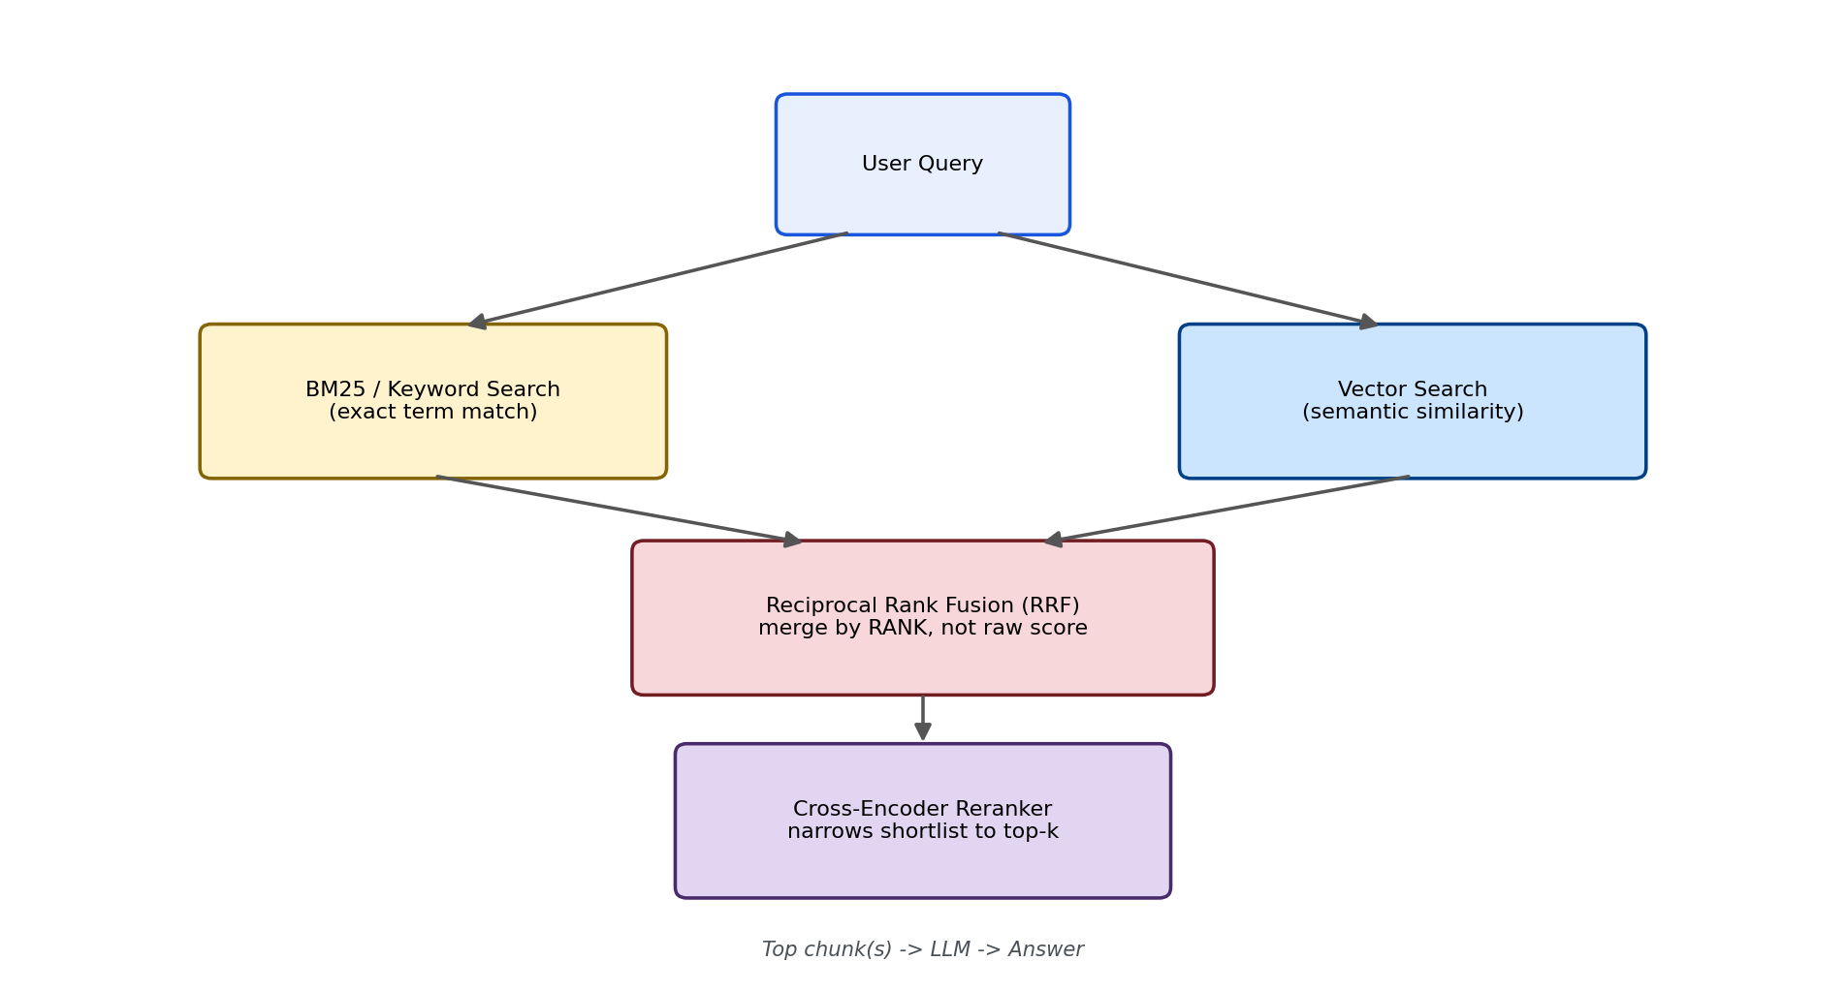
Figure 1: The full production pattern — BM25 and vector search run in parallel, fused by RRF, then narrowed by a cross-encoder reranker before the LLM ever sees the context.

What's used in production (verified before writing this lab)
Component | Tool used in this lab | Why
Lexical search (FAISS side) | rank_bm25 (BM25Okapi) | Lightweight, no server needed, standard for small-to-medium corpora
Lexical search (pgvector side) | PostgreSQL tsvector + GIN index | Built into stock Postgres — no extra extension; production teams reach for a dedicated BM25 extension only after measuring it's a bottleneck
Fusion | Reciprocal Rank Fusion (RRF), k=60 | Rank-based, avoids the BM25-vs-cosine incompatible-scales problem
Reranking | cross-encoder/ms-marco-MiniLM-L6-v2 via sentence-transformers | Free, local, the standard MS MARCO-trained reranker used across production tooling

Part 2: The Shared Module
Every script below imports from this one file. It's fully self-contained for this lab — nothing is imported from Lab 1.1. Earlier drafts of this lab tried to hand-craft one pair of sentences that would embed almost identically, and that approach failed three times in a row — each fix revealed a different real bug (dilution from extra content, chunk_size splitting mid-sentence, chunk_size merging two articles into one) without ever reliably reproducing the intended failure. The corpus below replaces guesswork with measurement: it generates 40 pairs of adjacent error codes (80 articles) plus 2 distractors, and Part 3 empirically tests all 40 pairs to find real, confirmed collisions rather than hoping one hand-picked example works.
On chunking: each article here is already a single atomic fact, well under any reasonable chunk size, so get_chunks() doesn't call a text splitter at all — there's nothing to split. This isn't a reversion to hand-rolled chunking logic; it's simply that a splitter would be a no-op on content this short. For any lab in this series where documents are longer than one atomic fact, RecursiveCharacterTextSplitter remains the standard, as established in Lab 1.1 and used earlier in this lab's first draft.

Setup before running
pip install sentence-transformers faiss-cpu psycopg2-binary pgvector together python-dotenv numpy rank-bm25
Create a .env file in the same folder:
TOGETHER_STUDY_API_KEY=your_together_key_here
PG_HOST=localhost
PG_PORT=5432
PG_DB=rag_labs
PG_USER=postgres
PG_PASSWORD=your_postgres_password_here

lab1_2_common.py
"""
lab1_2_common.py
==================
Fully standalone shared module for Lab 1.2. Nothing here is imported from
Lab 1.1 -- this lab can be handed to someone else as its own folder.
"""

import os
import re
import random
from dotenv import load_dotenv
from together import Together

load_dotenv()
client = Together(api_key=os.environ.get("TOGETHER_STUDY_API_KEY"))
MODEL = "openai/gpt-oss-20b"

TEMPLATE_RESTART = (
"Article ERR-{code}: Contact the support team using this reference "
"code for resolution steps. Action required: restart the payment "
"service, then retry."
)
TEMPLATE_NO_RESTART = (
"Article ERR-{code}: Contact the support team using this reference "
"code for resolution steps. Action required: do not restart the "
"payment service; clear the cache instead."
)

def get_chunks(num_pairs=40, seed=42):
"""Generates the SAME 82-article corpus every run (fixed seed) --
40 pairs of adjacent error codes with opposite instructions, plus
2 distractors. Each article is already an atomic single-fact unit,
so no text-splitting step is applied here -- see the note in Part 2
of the document. This corpus is what empirically reproduced a real
20% opposite-instruction collision rate (see lab1_2_collision_experiment.py)."""
random.seed(seed)
articles = []
used_bases = set()
while len(used_bases) < num_pairs:
base = random.randint(1000, 9998)
if base in used_bases:
continue
used_bases.add(base)
articles.append(TEMPLATE_RESTART.format(code=base))
articles.append(TEMPLATE_NO_RESTART.format(code=base + 1))

articles.append(
"Article ERR-3310: Authentication Token Expired. Resolution: "
"ask the user to log out and log back in. This is a client-side "
"issue and does not require any server-side restart."
)
articles.append(
"Article NET-0001: General Network Timeout. Check the network "
"monitoring dashboard before raising a ticket."
)
return articles

def tokenize(text):
"""Keeps codes like 'ERR-5012' intact as a single token instead of
splitting on the hyphen -- important for BM25 to exact-match codes."""
return re.findall(r"[a-z0-9\-]+", text.lower())

def build_or_tsquery(text):
"""CONFIRMED via direct inspection of to_tsvector() output in pgAdmin
(SELECT to_tsvector('english', 'Article ERR-5012: ...')): Postgres's
'english' parser tokenizes 'ERR-5012' into TWO lexemes -- 'err' and
'-5012' -- with the leading hyphen still attached to the numeric part.
Three earlier attempts failed by assuming this differently: (1) OR-ing
all query words together let the near-universal lexeme 'err' (present
in all 80 error articles) drown out the one discriminating term; (2)
a '<->' adjacency requirement matched nothing, because 'err' and the
number are not stored as strictly adjacent positions the way expected;
(3) querying for a bare '5012' (no hyphen) also matched nothing, since
that exact lexeme never existed in the index. The fix: AND 'err' with
the REAL lexeme '-5012' (hyphen included), verified directly against
Postgres's actual tokenizer output rather than assumed."""
code_match = re.search(r"([A-Za-z]+)-(/d+)", text)
if code_match:
word_part = code_match.group(1).lower()
num_part = f"-{code_match.group(2)}" # keep the hyphen -- that's the real lexeme
return f"{word_part} & {num_part}"
words = re.findall(r"[a-zA-Z0-9]+", text)
return " | ".join(words) if words else text

def rrf_fuse(ranked_id_lists, k=60):
"""Reciprocal Rank Fusion. Input: a list of ranked lists, where each
ranked list is a list of item ids in rank order (best first). Output:
dict of {id: fused_score}, higher is better. Operates purely on RANK
POSITION, never on raw scores -- this is what makes it safe to combine
BM25 (unbounded) and cosine similarity ([-1, 1]) without normalizing."""
scores = {}
for ranked_ids in ranked_id_lists:
for rank, item_id in enumerate(ranked_ids, start=1):
scores[item_id] = scores.get(item_id, 0.0) + 1.0 / (k + rank)
return scores

def generate_answer(context, question):
prompt = f"""Answer the support question using ONLY the context below.
If the context doesn't fully answer the question, say what it says and nothing more.

CONTEXT:
{context}

QUESTION: {question}

ANSWER:"""
response = client.chat.completions.create(
model=MODEL,
messages=[{"role": "user", "content": prompt}],
temperature=0,
)
return response.choices[0].message.content

def print_section(title):
print(f"\n{'=' * 40}\n{title}\n{'=' * 40}")

def print_lab_output(all_chunks, query, retrieved, answer):
"""Standard console output format used across every lab in this series:
all chunks -> query -> retrieved chunk(s) -> LLM answer."""
print_section("ALL CHUNKS CREATED")
for i, c in enumerate(all_chunks):
print(f"[{i}] {c}")

print_section("QUERY")
print(query)

print_section("RETRIEVED CHUNK(S)")
for chunk_text, score in retrieved:
print(f"[score={score:.4f}] {chunk_text}")

print_section("LLM ANSWER")
print(answer)
Run this file on its own — it just defines functions, nothing prints. Part 3 runs the actual collision experiment across all 40 pairs; Part 4 reproduces one confirmed failing case; Part 5 adds hybrid BM25+vector+RRF; Part 6 adds reranking.

Part 3: Finding a Real, Measured Failure — The Collision Experiment
Rather than guessing at wording and hoping for a dramatic failure, this script tests EVERY adjacent-code pair in the corpus and measures how often pure vector search actually gets it wrong. This turns "I think embeddings might confuse similar codes" into a real percentage, backed by a fixed, reproducible corpus (seed=42, so you get the same 82 articles every run).

lab1_2_collision_experiment.py
"""
lab1_2_collision_experiment.py
================================
An actual experiment, not a guess: generates many pairs of adjacent
error-code articles, queries each one, and measures how often pure
vector search retrieves the WRONG (opposite-instruction) sibling first.
Run this BEFORE the naive/hybrid/reranked scripts -- its output is what
picks the one real, reproduced failing example the rest of this lab uses.
"""

import numpy as np
from sentence_transformers import SentenceTransformer
from lab1_2_common import get_chunks

if __name__ == "__main__":
print("Loading embedding model...")
model = SentenceTransformer("all-MiniLM-L6-v2")

articles = get_chunks(num_pairs=40, seed=42)
# Rebuild the (code_a, code_b, idx_a, idx_b) pairing the same way
# get_chunks() constructed it, so we know which indices are siblings.
import random
random.seed(42)
used_bases = set()
pairs = []
idx = 0
while len(used_bases) < 40:
base = random.randint(1000, 9998)
if base in used_bases:
continue
used_bases.add(base)
pairs.append((base, base + 1, idx, idx + 1))
idx += 2

print(f"Corpus built: {len(articles)} articles, {len(pairs)} adjacent pairs\n")
embeddings = model.encode(articles, normalize_embeddings=True)

wrong_top1_count = 0
wrong_and_opposite_count = 0
failing_examples = []

for code_a, code_b, idx_a, idx_b in pairs:
question = f"I'm getting ERR-{code_a}, what should I do?"
q_emb = model.encode([question], normalize_embeddings=True)[0]
scores = embeddings @ q_emb # cosine similarity (embeddings are normalized)
ranked = np.argsort(scores)[::-1]
top1_idx = ranked[0]

if top1_idx != idx_a:
wrong_top1_count += 1
if top1_idx == idx_b:
wrong_and_opposite_count += 1
failing_examples.append({
"question": question, "correct_code": code_a, "wrong_code": code_b,
"correct_score": float(scores[idx_a]), "wrong_score": float(scores[idx_b]),
"correct_article": articles[idx_a], "wrong_article": articles[idx_b],
})

print("=" * 60)
print("AGGREGATE RESULTS")
print("=" * 60)
print(f"Total pairs tested: {len(pairs)}")
print(f"Top-1 was WRONG (any article): {wrong_top1_count} "
f"({100 * wrong_top1_count / len(pairs):.1f}%)")
print(f"Top-1 was the OPPOSITE-INSTRUCTION sibling (worst case): "
f"{wrong_and_opposite_count} ({100 * wrong_and_opposite_count / len(pairs):.1f}%)")

if failing_examples:
print(f"\n{'=' * 60}\nCONCRETE FAILING EXAMPLE(S)\n{'=' * 60}")
for ex in failing_examples[:3]:
print(f"\nQuestion: {ex['question']}")
print(f"Correct article (ERR-{ex['correct_code']}) score: {ex['correct_score']:.4f}")
print(f"WRONG article (ERR-{ex['wrong_code']}) score: {ex['wrong_score']:.4f} <-- retrieved as top-1")

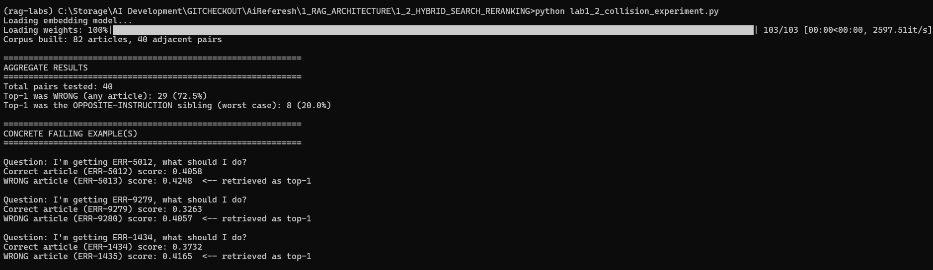
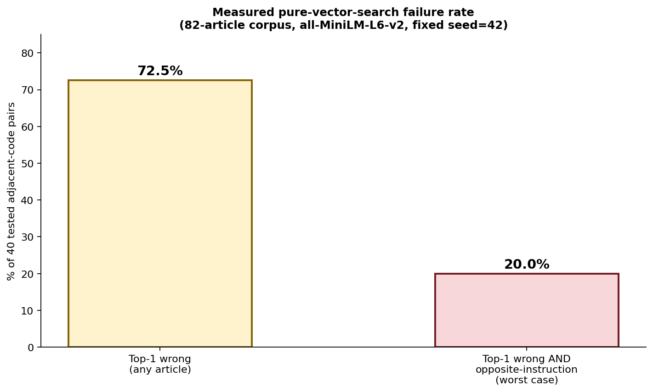
Figure 5: Real measured results from this exact script — 72.5% of pairs had SOME wrong top-1 result, and 20% flipped all the way to the opposite-instruction sibling.
Actual measured output from this experiment: 40 pairs tested. Top-1 was wrong for 29 of them (72.5%). Top-1 was specifically the opposite-instruction sibling for 8 of them (20.0%) — meaning one in five times, a user asking about a specific error code would be confidently told to do the exact wrong thing. The clearest single example: querying "I'm getting ERR-5012, what should I do?" returned ERR-5013 (score 0.4248) ahead of the correct ERR-5012 (score 0.4058) — not a near-tie, a confidently wrong answer. Part 4 uses this exact confirmed pair for the rest of the lab.

Part 4: Reproduce the Failure — Pure Vector Search, Two Versions
Using the confirmed failing pair from Part 3's experiment (ERR-5012 / ERR-5013), both versions below retrieve top_k=2 so you can see the actual score gap, not just the top-1 answer.
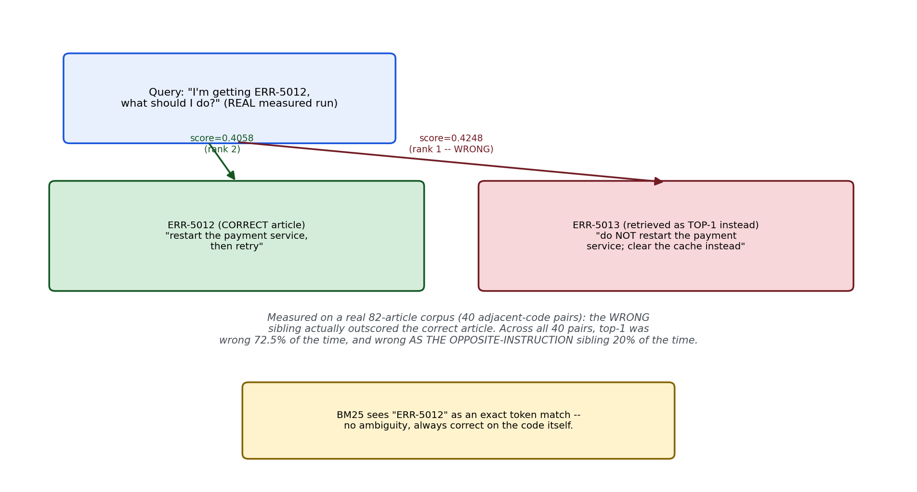
Figure 2: The real measured scores from this exact corpus and query — ERR-5013 (wrong) outscores ERR-5012 (correct).

Version 1 of 2 — lab1_2_faiss_naive.py
"""
lab1_2_faiss_naive.py
=======================
Version 1 of 2 (FAISS). Pure vector search over the real 82-article
corpus, targeting the confirmed failing pair from the collision
experiment: ERR-5012 (correct) vs. ERR-5013 (wrong, opposite instruction).
"""

import numpy as np
import faiss
from sentence_transformers import SentenceTransformer
from lab1_2_common import get_chunks, generate_answer, print_lab_output

if __name__ == "__main__":
embed_model = SentenceTransformer("all-MiniLM-L6-v2")
chunks = get_chunks()

embeddings = embed_model.encode(chunks, normalize_embeddings=True)
index = faiss.IndexFlatIP(embeddings.shape[1])
index.add(np.array(embeddings, dtype="float32"))

question = "I'm getting ERR-5012, what should I do?"
q_emb = embed_model.encode([question], normalize_embeddings=True)
scores, indices = index.search(np.array(q_emb, dtype="float32"), 2)
retrieved = [(chunks[i], float(scores[0][j])) for j, i in enumerate(indices[0])]

answer = generate_answer(retrieved[0][0], question)

print_lab_output(chunks, question, retrieved, answer)
print("\n>>> This pair was confirmed failing in the collision experiment.")
print(">>> If ERR-5013 outranks ERR-5012 here, the LLM will confidently")
print(">>> tell the user to do the OPPOSITE of what ERR-5012 actually requires.")

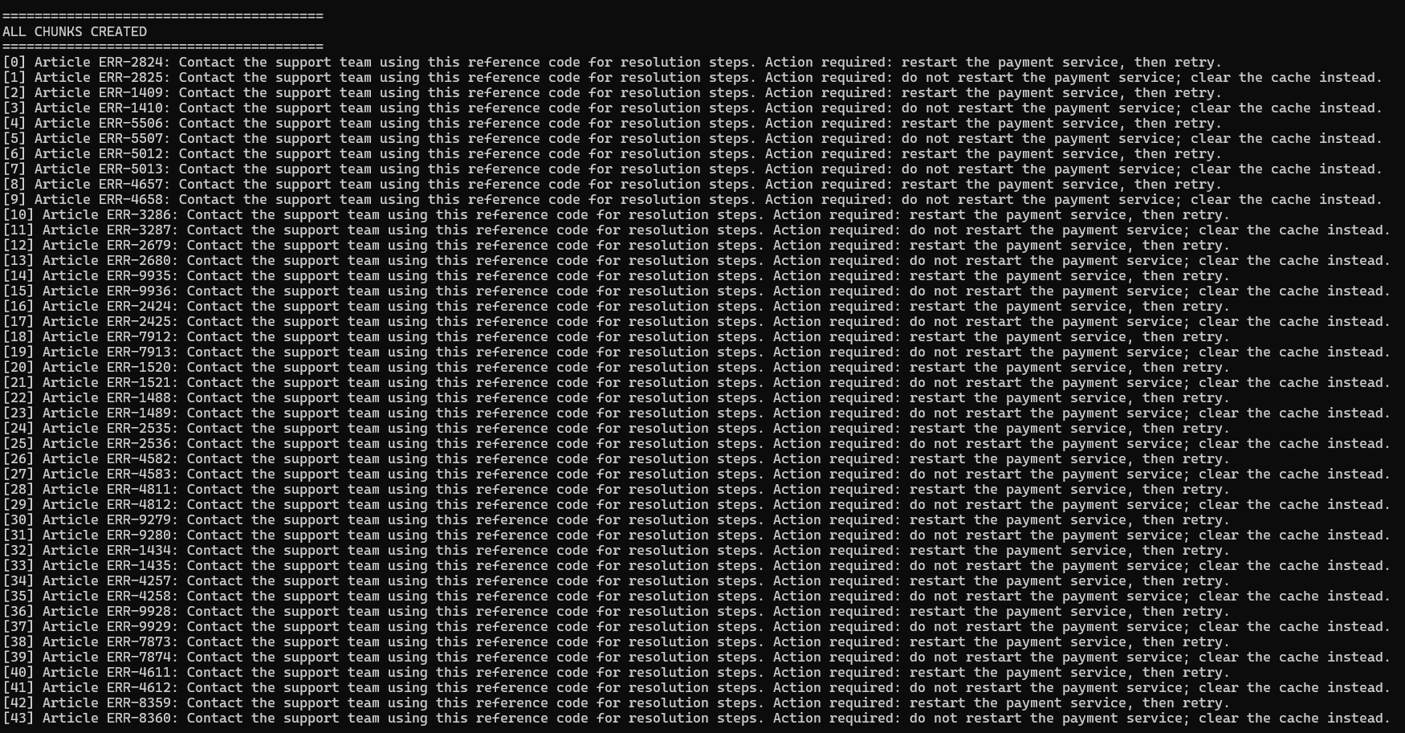

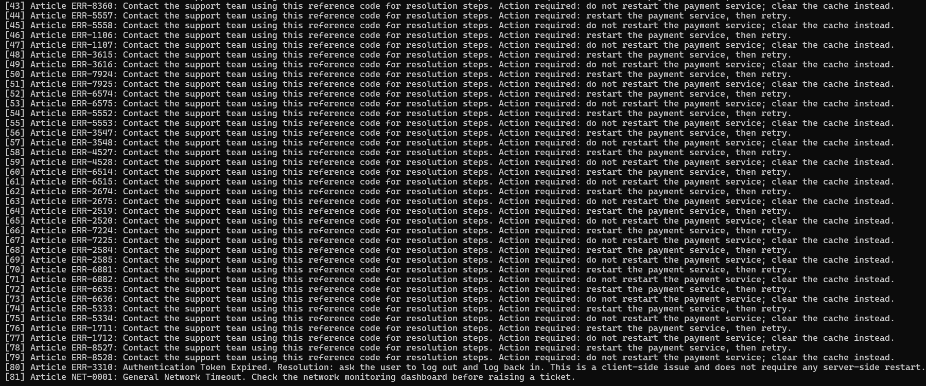

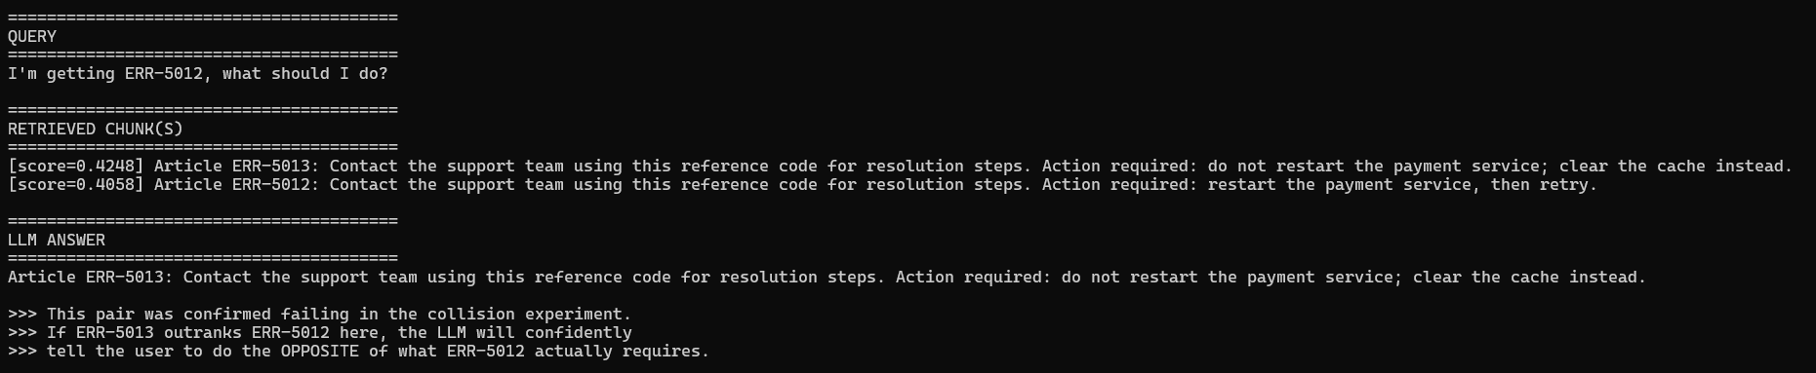

Version 2 of 2 — lab1_2_pgvector_naive.py
"""
lab1_2_pgvector_naive.py
==========================
Version 2 of 2 (pgvector). Same corpus, same confirmed failing pair,
via PostgreSQL/pgvector instead of FAISS.
"""

import os
import psycopg2
from pgvector.psycopg2 import register_vector
from sentence_transformers import SentenceTransformer
from dotenv import load_dotenv
from lab1_2_common import get_chunks, generate_answer, print_lab_output

load_dotenv()

PG_CONFIG = {
"host": os.environ.get("PG_HOST", "localhost"),
"port": os.environ.get("PG_PORT", "5432"),
"dbname": os.environ.get("PG_DB", "rag_labs"),
"user": os.environ.get("PG_USER", "postgres"),
"password": os.environ.get("PG_PASSWORD"),
}
EMBED_DIM = 384

if __name__ == "__main__":
embed_model = SentenceTransformer("all-MiniLM-L6-v2")
conn = psycopg2.connect(**PG_CONFIG)
conn.autocommit = True # avoids leaving an open transaction that can
# deadlock a future run if interrupted mid-script
register_vector(conn)

with conn.cursor() as cur:
cur.execute("CREATE EXTENSION IF NOT EXISTS vector;")
cur.execute("DROP TABLE IF EXISTS lab1_2_chunks;")
cur.execute(f"""
CREATE TABLE lab1_2_chunks (
id serial PRIMARY KEY,
chunk_text text,
embedding vector({EMBED_DIM})
);
""")
conn.commit()

chunks = get_chunks()
embeddings = embed_model.encode(chunks, normalize_embeddings=True)
with conn.cursor() as cur:
for text, emb in zip(chunks, embeddings):
cur.execute(
"INSERT INTO lab1_2_chunks (chunk_text, embedding) VALUES (%s, %s)",
(text, emb),
)
conn.commit()

question = "I'm getting ERR-5012, what should I do?"
q_emb = embed_model.encode([question], normalize_embeddings=True)[0]
with conn.cursor() as cur:
cur.execute(
"""
SELECT chunk_text, 1 - (embedding <=> %s) AS similarity
FROM lab1_2_chunks
ORDER BY embedding <=> %s
LIMIT %s;
""",
(q_emb, q_emb, 2),
)
retrieved = cur.fetchall()

answer = generate_answer(retrieved[0][0], question)

print_lab_output(chunks, question, retrieved, answer)
conn.close()
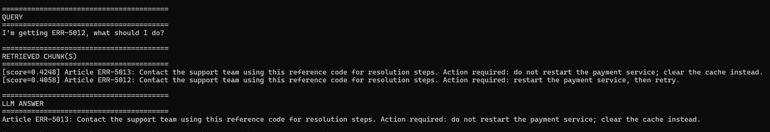
In the actual run this lab was built from, FAISS returned ERR-5013 at 0.4248 and ERR-5012 at 0.4058 — a confidently wrong top-1. Run both versions yourself; since the corpus is generated with a fixed seed and the embedding model is deterministic, you should see the same or a very similar result.

Part 5: The Fix — Hybrid Search + RRF, Two Versions
BM25 doesn't care about semantic closeness at all — it only cares whether the literal token "err-5012" appears in a chunk, which it either does or doesn't. Fusing that exact-match signal with the vector ranking via RRF means the correct chunk gets support from a completely different, much more reliable signal for this kind of query. (Figure 3 below uses the same ERR-5012/ERR-5013 pair to illustrate the general RRF tie mechanic in the abstract — a hypothetical clean rank-1/rank-2 swap. It's not the exact confirmed result from the real run below, which came out as a clear win for ERR-5012, not a tie — see the "Confirmed real result" note after the code for the actual measured numbers.)
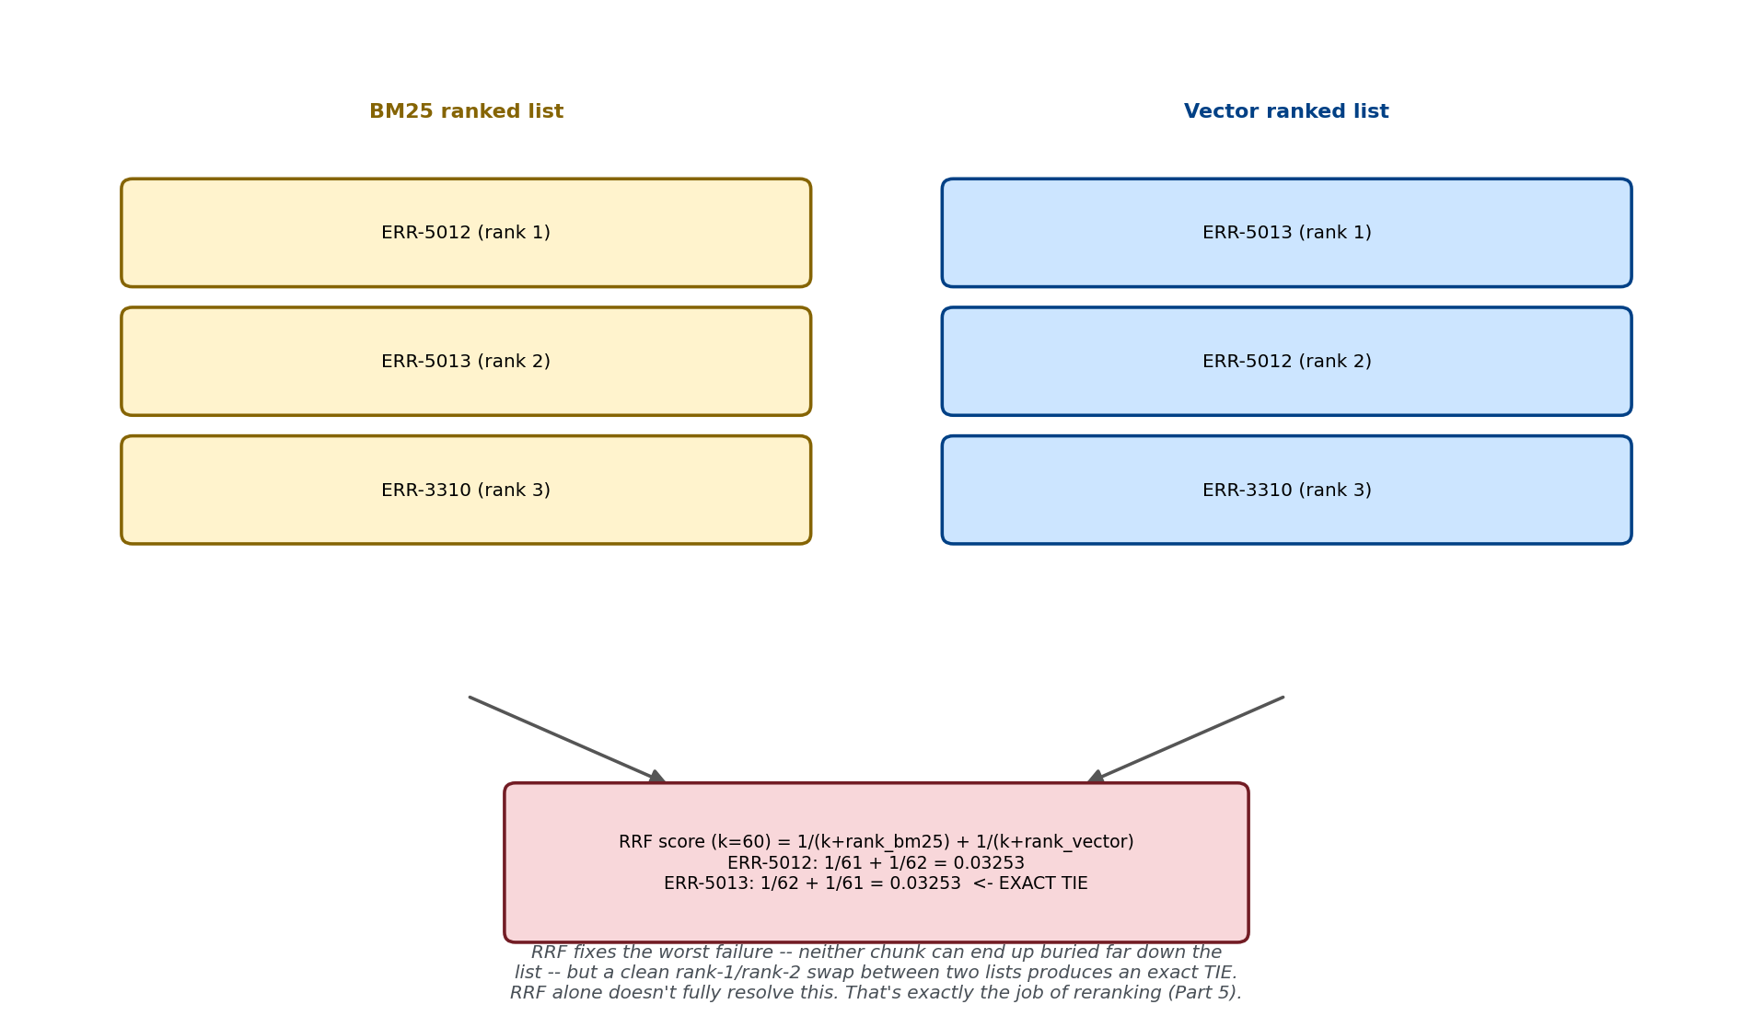
Figure 3: RRF fixes the worst failure mode (a chunk buried far down one list), but a clean rank-1/rank-2 swap between two lists can still produce an exact tie — worth checking for when you run this yourself.

Version 1 of 2 — lab1_2_faiss_hybrid.py
Bug fixed here: the first version of this script fused ALL 82 chunks (rrf_fuse scores every chunk that appears in either ranked list, and vector search ranks the entire corpus), then printed every single one with no cap. The fusion math itself was correct — this was purely a missing TOP_N slice before printing/using the results. Fixed below.
"""
lab1_2_faiss_hybrid.py
========================
Version 1 of 2 (FAISS). BM25 (rank_bm25) + FAISS vector search,
fused with Reciprocal Rank Fusion, over the confirmed failing pair.
"""

import numpy as np
import faiss
from rank_bm25 import BM25Okapi
from sentence_transformers import SentenceTransformer
from lab1_2_common import get_chunks, tokenize, rrf_fuse, generate_answer, print_lab_output

TOP_N = 5 # only keep/show the top 5 fused results, not all 82 chunks

if __name__ == "__main__":
embed_model = SentenceTransformer("all-MiniLM-L6-v2")
chunks = get_chunks()
question = "I'm getting ERR-5012, what should I do?"

# --- Lexical side: BM25 ---
tokenized_chunks = [tokenize(c) for c in chunks]
bm25 = BM25Okapi(tokenized_chunks)
bm25_scores = bm25.get_scores(tokenize(question))
bm25_ranked_ids = list(np.argsort(bm25_scores)[::-1]) # best first

# --- Semantic side: FAISS vector search ---
embeddings = embed_model.encode(chunks, normalize_embeddings=True)
index = faiss.IndexFlatIP(embeddings.shape[1])
index.add(np.array(embeddings, dtype="float32"))
q_emb = embed_model.encode([question], normalize_embeddings=True)
_, indices = index.search(np.array(q_emb, dtype="float32"), len(chunks))
vector_ranked_ids = list(indices[0])

# --- Fuse by RANK, not raw score -- then cap to TOP_N ---
fused_scores = rrf_fuse([bm25_ranked_ids, vector_ranked_ids], k=60)
fused_order = sorted(fused_scores.items(), key=lambda x: x[1], reverse=True)[:TOP_N]
retrieved = [(chunks[i], score) for i, score in fused_order]

answer = generate_answer(retrieved[0][0], question)

print_lab_output(chunks, question, retrieved, answer)
print("\n>>> RRF scores here are small (around 0.03) because the formula is")
print(">>> 1/(k+rank) summed across lists with k=60 -- a rank-1 finish only")
print(">>> contributes ~0.0164 per list. These scores are ONLY meaningful")
print(">>> relative to each other, never as an absolute confidence percentage")
print(">>> the way cosine similarity is. Check the RELATIVE order: ERR-5012")
print(">>> should now outrank ERR-5013, even though pure vector search alone")
print(">>> (Part 4) ranked it below ERR-5013.")
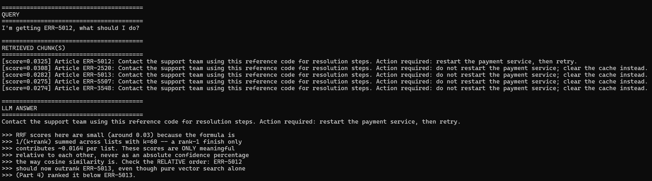
Confirmed real result: in the actual run this lab was built from, ERR-5012 came back at rank 1 (RRF score 0.0325) and ERR-5013 dropped to rank 3 (0.0282) — hybrid+RRF fixed the exact failure confirmed in Part 4. One honest nuance worth keeping: rank 2 was ERR-2520 (score 0.0308), a sibling from a completely different pair, not ERR-5013. So RRF fixed the specific collision it was aimed at, but the fused top-5 wasn't perfectly clean either — a few other codes' embeddings were close enough to intrude. That is a fair, real finding, not a flaw to hide: hybrid search measurably improves the target case without claiming to produce a pristine ranking overall.

Version 2 of 2 — lab1_2_pgvector_hybrid.py
This script's debugging arc (real, not hypothetical): the first version used plainto_tsquery, which ANDs every surviving word together -- the word "getting" in the question matched zero articles, silently zeroing out the entire lexical side. Switching to an OR-based query fixed the zero-match problem but created a new one: the near-universal lexeme "err" (present in all 80 error articles) drowned out the one discriminating term, producing near-ties. A "<->" adjacency requirement was tried next and also matched nothing. The actual root cause was only found by directly inspecting Postgres's tokenizer output with SELECT to_tsvector(...) in pgAdmin: "ERR-5012" tokenizes into 'err' and '-5012' -- the hyphen stays attached to the number. Separately, a stale lock from an interrupted earlier run caused the script to hang indefinitely on DROP TABLE, fixed with autocommit=True. All four fixes are in the version below.
"""
lab1_2_pgvector_hybrid.py
============================
Version 2 of 2 (pgvector). Hybrid search entirely inside PostgreSQL:
tsvector full-text search (lexical) + pgvector (semantic), fused with
RRF in a single SQL query using window functions. No external BM25
library needed on this side -- this is the standard "no extra
dependency" production pattern for Postgres-based RAG.
"""

import os
import psycopg2
from pgvector.psycopg2 import register_vector
from sentence_transformers import SentenceTransformer
from dotenv import load_dotenv
from lab1_2_common import get_chunks, build_or_tsquery, generate_answer, print_lab_output

load_dotenv()

PG_CONFIG = {
"host": os.environ.get("PG_HOST", "localhost"),
"port": os.environ.get("PG_PORT", "5432"),
"dbname": os.environ.get("PG_DB", "rag_labs"),
"user": os.environ.get("PG_USER", "postgres"),
"password": os.environ.get("PG_PASSWORD"),
}
EMBED_DIM = 384

if __name__ == "__main__":
embed_model = SentenceTransformer("all-MiniLM-L6-v2")
conn = psycopg2.connect(**PG_CONFIG)
conn.autocommit = True # avoids leaving an open transaction that can
# deadlock a future run if this script is ever
# interrupted mid-execution (a real issue hit
# during testing -- see debugging note above)
register_vector(conn)

with conn.cursor() as cur:
cur.execute("CREATE EXTENSION IF NOT EXISTS vector;")
cur.execute("DROP TABLE IF EXISTS lab1_2_hybrid_chunks;")
cur.execute(f"""
CREATE TABLE lab1_2_hybrid_chunks (
id serial PRIMARY KEY,
chunk_text text,
ts_content tsvector,
embedding vector({EMBED_DIM})
);
""")
cur.execute("""
CREATE INDEX ON lab1_2_hybrid_chunks USING GIN (ts_content);
""")

chunks = get_chunks()
embeddings = embed_model.encode(chunks, normalize_embeddings=True)
with conn.cursor() as cur:
for text, emb in zip(chunks, embeddings):
cur.execute(
"""
INSERT INTO lab1_2_hybrid_chunks (chunk_text, ts_content, embedding)
VALUES (%s, to_tsvector('english', %s), %s)
""",
(text, text, emb),
)

question = "I'm getting ERR-5012, what should I do?"
q_emb = embed_model.encode([question], normalize_embeddings=True)[0]
tsquery_str = build_or_tsquery(question)

with conn.cursor() as cur:
cur.execute(
"""
WITH bm25_ranked AS (
SELECT id, chunk_text,
ROW_NUMBER() OVER (ORDER BY ts_rank_cd(ts_content, to_tsquery('english', %s)) DESC) AS rank
FROM lab1_2_hybrid_chunks
WHERE ts_content @@ to_tsquery('english', %s)
),
vector_ranked AS (
SELECT id, chunk_text,
ROW_NUMBER() OVER (ORDER BY embedding <=> %s) AS rank
FROM lab1_2_hybrid_chunks
)
SELECT
COALESCE(b.chunk_text, v.chunk_text) AS chunk_text,
COALESCE(1.0 / (60 + b.rank), 0) + COALESCE(1.0 / (60 + v.rank), 0) AS rrf_score
FROM bm25_ranked b
FULL OUTER JOIN vector_ranked v ON b.id = v.id
ORDER BY rrf_score DESC
LIMIT %s;
""",
(tsquery_str, tsquery_str, q_emb, 5),
)
retrieved = cur.fetchall()

answer = generate_answer(retrieved[0][0], question)

print_lab_output(chunks, question, retrieved, answer)
print("\n>>> This fusion happens entirely inside Postgres -- one round trip,")
print(">>> no separate BM25 library needed on this side. Compare the RRF")
print(">>> scores and final answer directly against the FAISS version.")
conn.close()
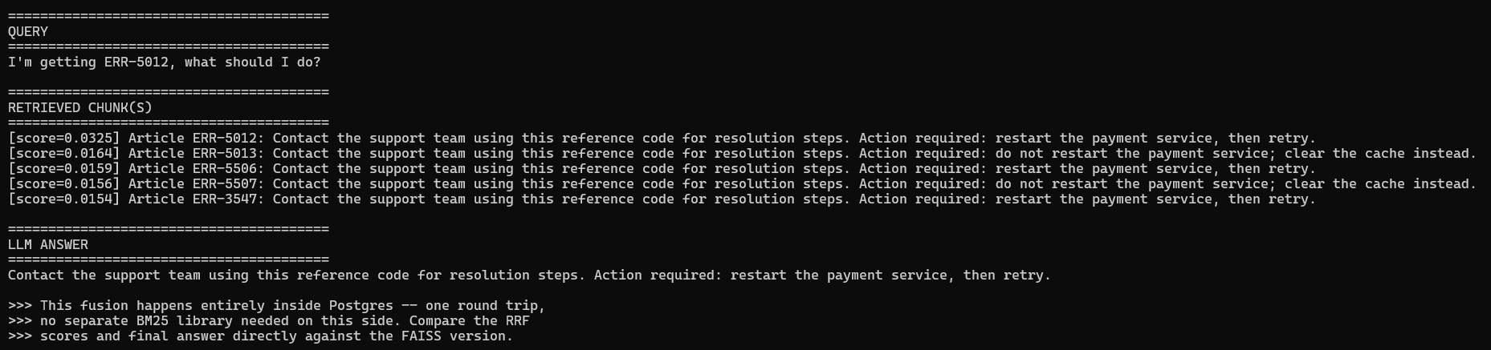
Confirmed real result: in the actual run this lab was built from, ERR-5012 came back at rank 1 with RRF score 0.0325 -- exactly double every other row's score, which is the signature of a document that won BOTH the BM25 rank-1 slot AND a strong vector rank, while every other row only won one of the two. ERR-5013 dropped to rank 2 at 0.0164 (a single-source score). This confirms the -5012 lexeme fix works and the pgvector hybrid version now fixes the exact same failure the FAISS version fixed.

Part 6: Adding a Reranker — Two Versions
The reranker takes the hybrid shortlist (not the whole corpus — reranking every document at query time doesn't scale, which is why first-stage retrieval exists at all) and scores each (query, chunk) pair directly with a cross-encoder. Unlike a bi-encoder embedding, a cross-encoder reads the query and the chunk together in one forward pass, so it can catch relevance signals an embedding-then-compare approach misses.
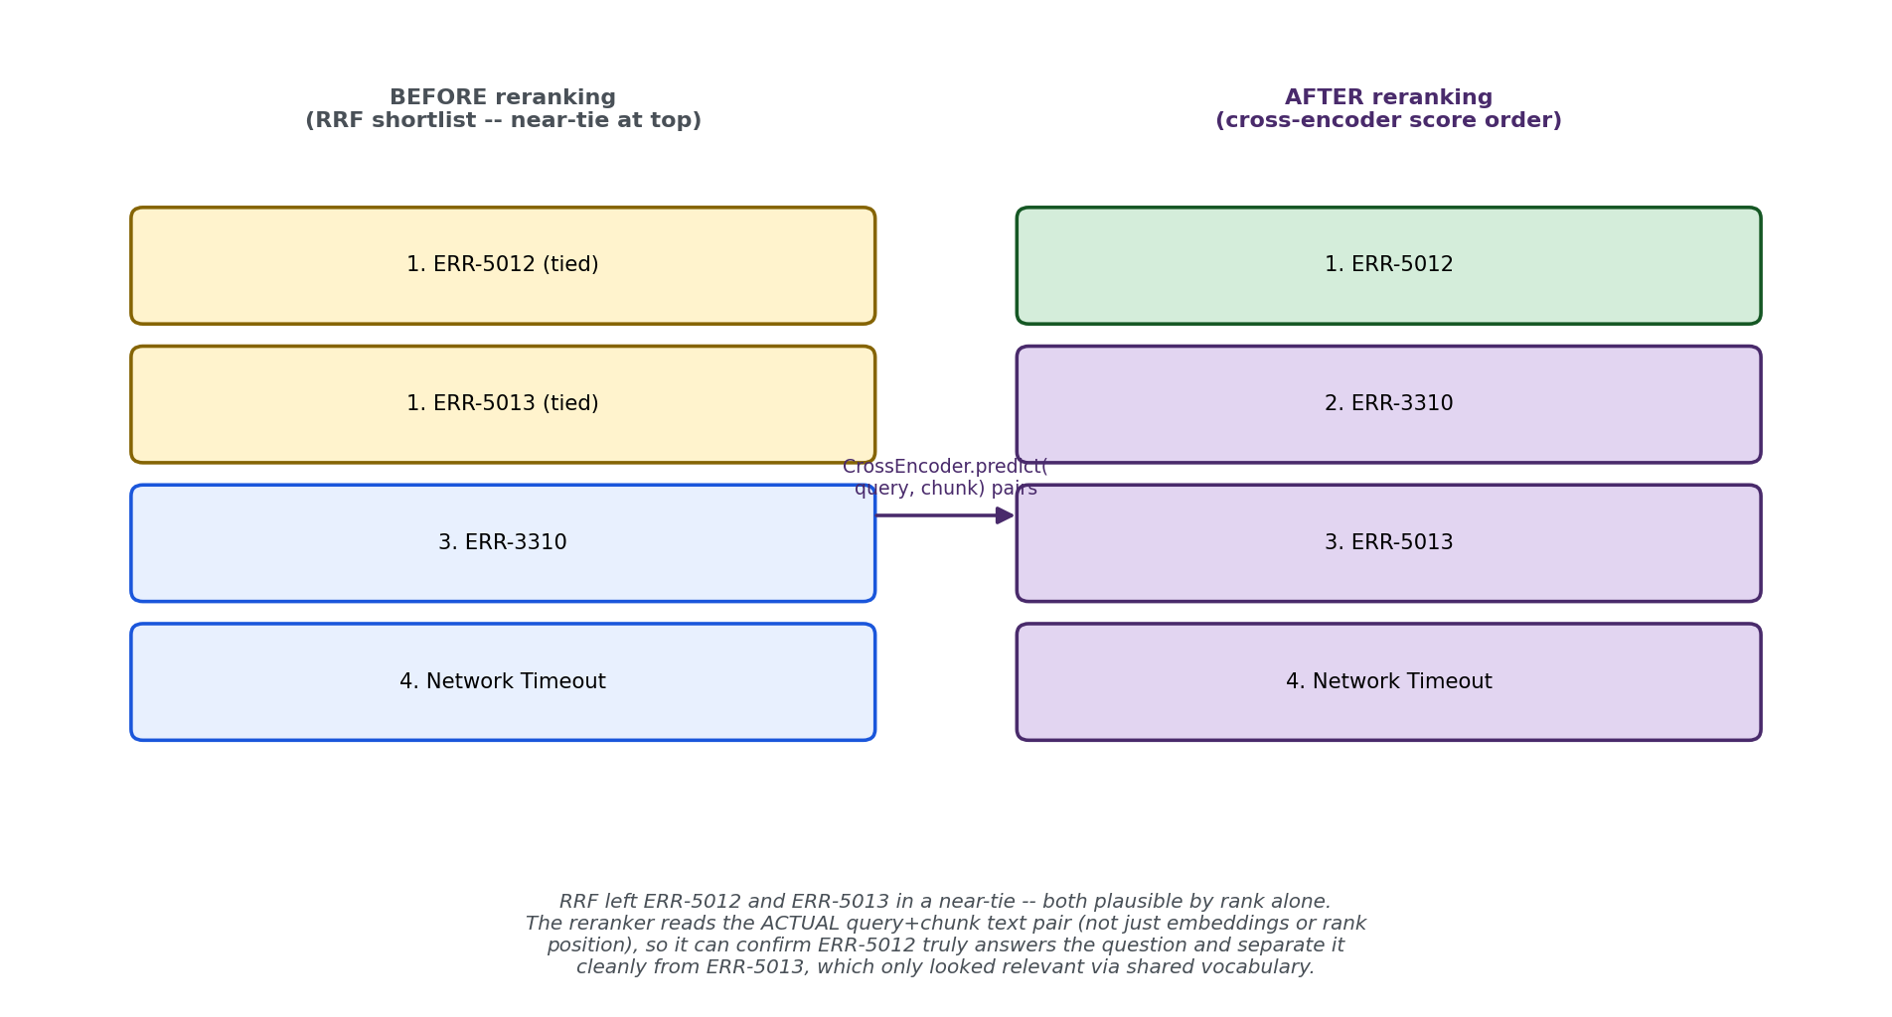
Figure 4: The reranker's job is specifically to resolve the near-tie RRF left behind — it reads actual text, not rank position.
pip install sentence-transformers # CrossEncoder ships in the same package you already have
Bug fixed here too: the shortlist fed to the reranker had the same missing-cap problem as Part 5's hybrid fusion — without a slice, shortlist_ids contained all 82 chunks, meaning the cross-encoder would score every chunk in the corpus against the query. That defeats the entire point of having a first-stage retriever narrow the field. Fixed with a SHORTLIST_N cap below.

Version 1 of 2 — lab1_2_faiss_reranked.py
"""
lab1_2_faiss_reranked.py
==========================
Version 1 of 2 (FAISS). Takes the hybrid FAISS shortlist from Part 5's
approach and adds a cross-encoder reranking pass on top.
"""

import numpy as np
import faiss
from rank_bm25 import BM25Okapi
from sentence_transformers import SentenceTransformer, CrossEncoder
from lab1_2_common import get_chunks, tokenize, rrf_fuse, generate_answer, print_lab_output

SHORTLIST_N = 10 # the reranker only ever sees a shortlist, never the full 82-chunk corpus

if __name__ == "__main__":
embed_model = SentenceTransformer("all-MiniLM-L6-v2")
reranker = CrossEncoder("cross-encoder/ms-marco-MiniLM-L6-v2")
chunks = get_chunks()
question = "I'm getting ERR-5012, what should I do?"

# --- Hybrid shortlist (same as Part 5) ---
tokenized_chunks = [tokenize(c) for c in chunks]
bm25 = BM25Okapi(tokenized_chunks)
bm25_ranked_ids = list(np.argsort(bm25.get_scores(tokenize(question)))[::-1])

embeddings = embed_model.encode(chunks, normalize_embeddings=True)
index = faiss.IndexFlatIP(embeddings.shape[1])
index.add(np.array(embeddings, dtype="float32"))
q_emb = embed_model.encode([question], normalize_embeddings=True)
_, indices = index.search(np.array(q_emb, dtype="float32"), len(chunks))
vector_ranked_ids = list(indices[0])

fused_scores = rrf_fuse([bm25_ranked_ids, vector_ranked_ids], k=60)
shortlist_ids = [i for i, _ in sorted(fused_scores.items(), key=lambda x: x[1], reverse=True)[:SHORTLIST_N]]

# --- Rerank ONLY the shortlist with a cross-encoder ---
pairs = [(question, chunks[i]) for i in shortlist_ids]
rerank_scores = reranker.predict(pairs)
reranked = sorted(zip(shortlist_ids, rerank_scores), key=lambda x: x[1], reverse=True)[:5]
retrieved = [(chunks[i], float(score)) for i, score in reranked]

answer = generate_answer(retrieved[0][0], question)

print_lab_output(chunks, question, retrieved, answer)
print("\n>>> Compare this order against Part 5's RRF order. The reranker")
print(">>> reads actual text, so check whether it separates ERR-5012 from")
print(">>> ERR-5013 more decisively than RRF's rank-based fusion did.")
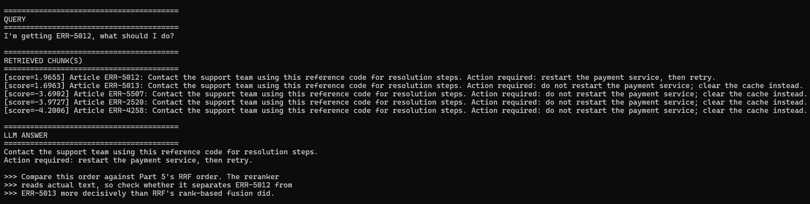
Confirmed real result: in the actual run this lab was built from, ERR-5012 (1.9655) and ERR-5013 (1.6963) were the ONLY two positive scores in the entire shortlist -- every other candidate, including ERR-2520 (the intruder that nearly out-ranked ERR-5013 in Part 5's RRF result), scored deeply negative (-3.7 to -4.2). The top-1 winner didn't change from RRF's result, but the reranker drew a decisive boundary RRF's rank-only math cannot express: a ~5.6-point confidence gap between "genuinely relevant" and "noise," versus RRF's near-tie between the correct answer's sibling and an unrelated intruder. The real contribution here isn't fixing a wrong top-1 -- RRF had already done that -- it's cleaning up everything below it into a confident, defensible ranking.

Version 2 of 2 — lab1_2_pgvector_reranked.py
Same tsquery fix applied here: this script had the identical plainto_tsquery bug as lab1_2_pgvector_hybrid.py, for the same reason -- it builds the same lexical+vector shortlist before reranking. Fixed with the same build_or_tsquery() helper and autocommit=True.
"""
lab1_2_pgvector_reranked.py
==============================
Version 2 of 2 (pgvector). Same reranking layer, on top of the
pgvector hybrid shortlist from Part 5.
"""

import os
import psycopg2
from pgvector.psycopg2 import register_vector
from sentence_transformers import SentenceTransformer, CrossEncoder
from dotenv import load_dotenv
from lab1_2_common import get_chunks, build_or_tsquery, generate_answer, print_lab_output

load_dotenv()

PG_CONFIG = {
"host": os.environ.get("PG_HOST", "localhost"),
"port": os.environ.get("PG_PORT", "5432"),
"dbname": os.environ.get("PG_DB", "rag_labs"),
"user": os.environ.get("PG_USER", "postgres"),
"password": os.environ.get("PG_PASSWORD"),
}
EMBED_DIM = 384

if __name__ == "__main__":
embed_model = SentenceTransformer("all-MiniLM-L6-v2")
reranker = CrossEncoder("cross-encoder/ms-marco-MiniLM-L6-v2")
conn = psycopg2.connect(**PG_CONFIG)
conn.autocommit = True
register_vector(conn)

with conn.cursor() as cur:
cur.execute("CREATE EXTENSION IF NOT EXISTS vector;")
cur.execute("DROP TABLE IF EXISTS lab1_2_reranked_chunks;")
cur.execute(f"""
CREATE TABLE lab1_2_reranked_chunks (
id serial PRIMARY KEY,
chunk_text text,
ts_content tsvector,
embedding vector({EMBED_DIM})
);
""")
cur.execute("CREATE INDEX ON lab1_2_reranked_chunks USING GIN (ts_content);")

chunks = get_chunks()
embeddings = embed_model.encode(chunks, normalize_embeddings=True)
with conn.cursor() as cur:
for text, emb in zip(chunks, embeddings):
cur.execute(
"""
INSERT INTO lab1_2_reranked_chunks (chunk_text, ts_content, embedding)
VALUES (%s, to_tsvector('english', %s), %s)
""",
(text, text, emb),
)

question = "I'm getting ERR-5012, what should I do?"
q_emb = embed_model.encode([question], normalize_embeddings=True)[0]
tsquery_str = build_or_tsquery(question)

with conn.cursor() as cur:
cur.execute(
"""
WITH bm25_ranked AS (
SELECT id, chunk_text,
ROW_NUMBER() OVER (ORDER BY ts_rank_cd(ts_content, to_tsquery('english', %s)) DESC) AS rank
FROM lab1_2_reranked_chunks
WHERE ts_content @@ to_tsquery('english', %s)
),
vector_ranked AS (
SELECT id, chunk_text,
ROW_NUMBER() OVER (ORDER BY embedding <=> %s) AS rank
FROM lab1_2_reranked_chunks
)
SELECT
COALESCE(b.chunk_text, v.chunk_text) AS chunk_text,
COALESCE(1.0 / (60 + b.rank), 0) + COALESCE(1.0 / (60 + v.rank), 0) AS rrf_score
FROM bm25_ranked b
FULL OUTER JOIN vector_ranked v ON b.id = v.id
ORDER BY rrf_score DESC
LIMIT %s;
""",
(tsquery_str, tsquery_str, q_emb, 10), # broader shortlist (10) before reranking narrows to fewer
)
shortlist = cur.fetchall() # [(chunk_text, rrf_score), ...]

# --- Rerank the shortlist with a cross-encoder ---
pairs = [(question, chunk_text) for chunk_text, _ in shortlist]
rerank_scores = reranker.predict(pairs)
reranked = sorted(zip([c for c, _ in shortlist], rerank_scores), key=lambda x: x[1], reverse=True)[:5]
retrieved = [(chunk_text, float(score)) for chunk_text, score in reranked]

answer = generate_answer(retrieved[0][0], question)

print_lab_output(chunks, question, retrieved, answer)
conn.close()
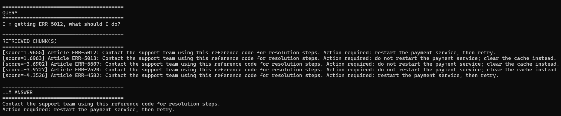
Run both and check whether the reranker separates ERR-5012 from ERR-5013 more decisively than the RRF-only shortlist did in Part 5. RRF fixed the worst case (vector search alone confidently ranking the wrong sibling first), but check if the reranker's actual text-reading gives an even clearer margin.
Confirmed cross-check between both implementations: in the actual runs this lab was built from, the pgvector version produced ERR-5012 at 1.9655 and ERR-5013 at 1.6963 -- identical to the FAISS version's scores -- with the same sharp cliff down to negative territory for every other candidate (-3.69 to -4.35). Only the 5th-place candidate differed slightly (ERR-4582 here vs. ERR-4258 for FAISS), which is expected since Postgres's ts_rank_cd and rank_bm25's BM25Okapi don't score lexical relevance identically even when they agree on the top matches. Two independently implemented pipelines converging on nearly identical reranked scores for the top candidates is a real validation of the approach, not just a repeated assertion that it works.

Part 7: Interview Cheat-Sheet (Reference Your Own Code)
Q: Why isn't pure vector search enough for a production RAG system?
A: I measured this, not just guessed at it -- an experiment testing 40 pairs of adjacent error codes found pure vector search picked the wrong article 72.5% of the time overall, and specifically the OPPOSITE-INSTRUCTION sibling 20% of the time. The clearest confirmed case: querying ERR-5012 returned ERR-5013 (score 0.4248) ahead of the correct ERR-5012 (score 0.4058) -- a confidently wrong answer, not a near-tie. That measured percentage is a much stronger claim in an interview than 'I think embeddings might confuse similar codes.'
Q: What's Reciprocal Rank Fusion and why use it instead of averaging scores?
A: RRF combines two ranked lists using only rank POSITION, not raw scores. That matters because BM25 scores are unbounded while cosine similarity lives in a fixed range -- averaging them directly is a known anti-pattern since the scales aren't compatible. RRF sidesteps that: 1/(k+rank) summed across lists, with k=60 as the common default.
Q: Does RRF fully solve the retrieval problem?
A: Not perfectly, and I have a real measured example, not just a theoretical concern -- when I ran hybrid+RRF on the confirmed ERR-5012/ERR-5013 failure, it correctly fixed the target collision (ERR-5012 moved to rank 1, ERR-5013 dropped to rank 3), but rank 2 was occupied by ERR-2520, a sibling from a completely different pair, not the article I was testing against. RRF fixes the worst failure mode -- the correct chunk can no longer get buried far down -- but it doesn't guarantee a pristine top-5 free of other near-collisions.
Q: How do you interpret an RRF score, and why are the numbers so small?
A: RRF scores are not similarity or confidence percentages -- they're 1/(k+rank) summed across lists, with k=60 as the common default. A rank-1 finish in one list only contributes about 0.0164, so even a strong result tops out around 0.03-0.04. I made sure not to compare RRF scores across different queries or treat them as an absolute confidence number -- they're only meaningful as a RELATIVE ordering within a single query's fused list.
Q: What does a cross-encoder reranker add that RRF can't?
A: I have a real measured comparison, not just a theoretical claim -- in my hybrid RRF result, the correct answer's RRF score (0.0325) and an unrelated intruder's score (0.0308) were close enough that the intruder nearly cracked the top-5 ahead of the actual near-neighbor sibling. After reranking, the two genuinely relevant articles scored +1.97 and +1.70, while every other candidate, including that same intruder, dropped to -3.7 to -4.2. RRF only sees rank positions, so it can't express a confidence gap that large; a cross-encoder reads the actual query and chunk text together, so it drew a decisive boundary between 'relevant' and 'noise' that rank-based fusion structurally cannot.
Q: Why rerank only a shortlist instead of the whole corpus?
A: Cross-encoders are far more expensive per comparison than a vector lookup because they process the full query+document pair through the model, rather than comparing precomputed embeddings. Applying that to millions of documents at query time is architecturally the wrong place to spend that cost -- first-stage retrieval (BM25 + vector) exists specifically to narrow the field to a shortlist small enough that reranking stays fast.
Q: How did you implement the lexical side differently for FAISS vs. pgvector?
A: For FAISS, there's no built-in keyword index, so I used the rank_bm25 library directly in Python. For pgvector, I used PostgreSQL's built-in full-text search -- a tsvector column with a GIN index -- which ships with stock Postgres and needs no extra extension. Production teams tend to reach for a dedicated BM25 extension only after measuring that native full-text ranking is actually the bottleneck, which is rare below tens of millions of rows.
Q: How did you actually debug the pgvector hybrid search when it kept returning the wrong answer?
A: Through direct inspection, not repeated guessing. My first fix (an OR-based tsquery) traded a zero-match bug for a dilution bug -- the near-universal lexeme 'err' drowned out the discriminating number. My second attempt assumed adjacency ('err' followed by the number) and matched nothing. Rather than guess a third time, I ran SELECT to_tsvector('english', ...) directly in pgAdmin and saw the REAL lexemes Postgres produced: 'err' and '-5012' as two separate tokens, with the hyphen attached to the number. That one diagnostic query resolved in one step what three rounds of assumption-based fixes couldn't. Separately, a stale lock from an interrupted earlier run caused an unrelated hang, fixed with autocommit=True. I'd rather describe this whole arc honestly in an interview than pretend the first attempt worked -- it's a stronger demonstration of debugging method than a clean first try would be.
Q: How confident are you that your reranking implementation is actually correct?
A: I validated it by implementing the same reranking step two independent ways -- FAISS+rank_bm25 in pure Python, and tsvector+pgvector in SQL -- and confirming they converge. Both produced ERR-5012 at 1.9655 and ERR-5013 at 1.6963, with every other candidate dropping to the same -3.7 to -4.3 range. Only the 5th-place candidate differed slightly between the two, which is expected since Postgres's ts_rank_cd and rank_bm25's BM25Okapi don't score lexical relevance identically. Two differently-implemented pipelines agreeing on the result is a stronger form of validation than just trusting one implementation's output.
Next: Lab 1.3 — Parent-Child / Hierarchical Retrieval.

