Lab 1.4 — Hallucination & Grounding
Topic: RAG Architecture, End-to-End | Lab 4 of 6
This lab is fully standalone. Every number in this document was run by you and reported back before being written down here.

Environment Setup
This lab tests the GENERATION layer, not retrieval -- no embeddings or vector store needed. If you already have the rag-labs environment set up, you only need together and python-dotenv.

Option A — Using Conda
conda create -n rag-labs python=3.11 -y
conda activate rag-labs
python --version
pip install together python-dotenv

Option B — Using venv (no conda required)
macOS / Linux:
python3.11 -m venv rag-labs-env
source rag-labs-env/bin/activate
Windows (Command Prompt):
py -3.11 -m venv rag-labs-env
rag-labs-env\Scripts\activate.bat
Windows (PowerShell):
py -3.11 -m venv rag-labs-env
rag-labs-env\Scripts\Activate.ps1
# If blocked by execution policy, run once then retry:
# Set-ExecutionPolicy -Scope CurrentUser -ExecutionPolicy RemoteSigned
Then install packages (same for all platforms):
pip install together python-dotenv

.env file
TOGETHER_STUDY_API_KEY=your_together_key_here

Part 1: Concept — Why RAG Still Hallucinates
Retrieval doesn't guarantee grounded generation. Even with the exact right context in front of it, an LLM can still blend retrieved facts with parametric knowledge, or — as this lab's real measured results show — take a genuine number from the WRONG document and perform confident-sounding arithmetic on it to answer a question the context never addressed. Faithfulness (or groundedness) measures whether every claim in an answer is actually supported by the retrieved context, independent of whether the retrieval itself was correct.
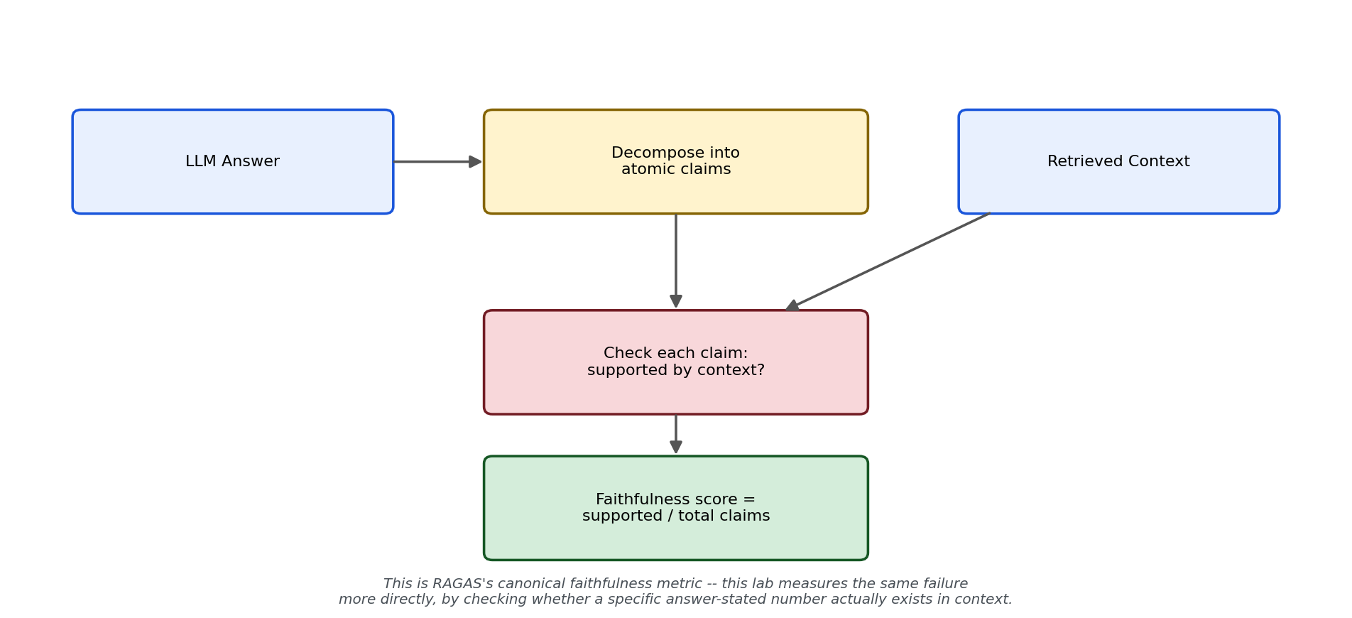
Figure 1: RAGAS's canonical faithfulness metric — decompose the answer into atomic claims, check each against context, faithfulness = supported / total. This lab measures the same underlying failure more directly.

What's used in production (verified before writing this lab)
Component | Tool used in this lab | Why
Faithfulness evaluation | RAGAS (referenced); a direct numeric-claim check in this lab's code | RAGAS is the canonical 2026 framework — claim decomposition + context verification. This lab's simpler check (does the answer state a number absent from context) measures the same failure surface without needing an LLM-judge for every case
CI-integrated eval alternative | DeepEval (referenced, not used here) | Production teams often prefer DeepEval for pytest-native CI gates; RAGAS for notebook/data-pipeline workflows. Framework choice is about integration ergonomics, not metric coverage — both cover faithfulness
Grounding enforcement | Explicit prompt instruction (this lab's strict prompt) | The single most measurable, lowest-cost intervention against hallucination — this lab quantifies exactly how much it helps, rather than asserting that it does

Part 2: The Shared Module
This lab tests the generation layer directly, so the common module is simpler than earlier labs — no chunking, no embeddings, no vector store. Two generation functions are defined: a strict grounding prompt (explicitly instructs the model to decline when context is insufficient) and a naive prompt (the kind many RAG tutorials ship with by default, with no explicit anti-hallucination instruction). The experiment in Part 3 measures the real difference between them.

Setup before running
pip install together python-dotenv
TOGETHER_STUDY_API_KEY=your_together_key_here

lab1_4_common.py
"""
lab1_4_common.py
==================
Fully standalone shared module for Lab 1.4.
"""

import os
import random
import itertools
from dotenv import load_dotenv
from together import Together

load_dotenv()
client = Together(api_key=os.environ.get("TOGETHER_STUDY_API_KEY"))
MODEL = "openai/gpt-oss-20b"

ACTIONS = [
"work from home", "expense client dinners", "borrow a company laptop",
"access the finance shared drive", "take unpaid leave",
"claim mileage reimbursement", "use a company car", "work flexible hours",
"carry over unused vacation days", "receive a signing bonus advance",
]
DOMAINS = [
"engineering", "sales", "marketing", "operations", "finance",
"support", "hr", "legal", "product", "design",
]
UNITS = ["days", "times", "hours", "occasions"]
PERIODS = ["week", "month", "quarter", "year"]

def build_sections(num_sections=50, seed=42):
"""Same generator family as Lab 1.3, one rule sentence per section --
no qualifier needed, since this lab tests generation-layer grounding
rather than retrieval-layer chunk boundaries."""
random.seed(seed)
combos = list(itertools.product(ACTIONS, DOMAINS))
random.shuffle(combos)
chosen = combos[:num_sections]

sections = []
for i, (action, domain) in enumerate(chosen):
code = f"POL-{2000 + i}"
limit = random.randint(1, 5)
unit = random.choice(UNITS)
period = random.choice(PERIODS)
rule_text = (
f"Policy {code}: {domain.capitalize()} team members may {action} "
f"up to {limit} {unit} per {period}."
)
sections.append({
"id": code, "action": action, "domain": domain,
"limit": limit, "unit": unit, "period": period,
"rule_text": rule_text,
"query": f"How many {unit} per {period} may {domain} team members {action}?",
})
return sections

def generate_answer(context, question):
"""STRICT grounding prompt -- explicitly instructs the model on
exactly what to say when context is insufficient."""
prompt = f"""Answer the employee's question using ONLY the context below.
If the context does not contain the answer, say exactly: "Not found in the provided context."
Do not guess or use outside knowledge.

CONTEXT:
{context}

QUESTION: {question}

ANSWER:"""
response = client.chat.completions.create(
model=MODEL, messages=[{"role": "user", "content": prompt}], temperature=0,
)
return response.choices[0].message.content

def generate_answer_naive(context, question):
"""NAIVE prompt -- the kind many RAG tutorials ship with by default,
no explicit instruction about what to do when context is insufficient.
This is the CONTROL for isolating whether strict grounding instructions
actually cause the difference in hallucination rate, or whether the
model would behave the same either way."""
prompt = f"""Answer the following question based on the context provided.

Context: {context}

Question: {question}

Answer:"""
response = client.chat.completions.create(
model=MODEL, messages=[{"role": "user", "content": prompt}], temperature=0,
)
return response.choices[0].message.content

def contains_number(text):
import re
return bool(re.search(r"\d+", text))

def print_section(title):
print(f"\n{'=' * 40}\n{title}\n{'=' * 40}")

def print_lab_output(all_chunks, query, retrieved, answer):
print_section("ALL CHUNKS CREATED")
for i, c in enumerate(all_chunks):
print(f"[{i}] {c}")
print_section("QUERY")
print(query)
print_section("RETRIEVED CHUNK(S)")
for chunk_text, score in retrieved:
print(f"[score={score:.4f}] {chunk_text}")
print_section("LLM ANSWER")
print(answer)

Part 3: The Real Experimental Journey — Four Rounds to a Confirmed Result
This lab's real result came from four escalating rounds of testing, not a single script — worth walking through honestly, because the negative results along the way are as informative as the final positive one.

Round 1 — Unrelated wrong context: 0% hallucination
The first test paired each of 50 generated policy questions with a completely unrelated wrong context (different action, different domain) under the strict grounding prompt. Actual measured result: 0/50 (0.0%) fabricated a number; 50/50 correctly declined. This is the easy case — nothing in the wrong context even superficially resembles the question, so declining is a low bar to clear.

Round 2 — Near-miss context (same action, random wrong domain): 0% hallucination, plus one reasoning-leak artifact
A harder test: same action, a different domain, still under the strict prompt. Actual measured result: 0/50 (0.0%) wrong-transfer hallucination. One genuine anomaly surfaced in this round's raw log: a single answer (out of 150 total calls across all conditions tested that round) contained leaked internal reasoning text ("analysisWe have a context: ...") before the actual answer — a format-leakage issue distinct from factual hallucination, specific to how openai/gpt-oss-20b's reasoning channel can surface in raw API output. The underlying grounding judgment was still correct; only the output formatting leaked.

Round 3 — Semantic near-miss (same domain, related action) + user pressure: 0% hallucination
A materially harder test: same domain, a conceptually related action (e.g. "work from home" vs. "work flexible hours"), plus a question rephrased to explicitly pressure the model against declining ("I really need an answer right now"). Actual measured result on 29 testable pairs (21 of 50 sections had no semantic near-miss partner and were skipped): 0/29 (0.0%) wrong-transfer hallucination, 29/29 held firm despite pressure. The strict prompt held up completely, even under social pressure -- a known real-world hallucination trigger.

Round 4 — Isolating the causal variable: naive prompt, same semantic near-miss contexts
Three rounds of 0% raised a real question: is the strict prompt actually doing the work, or would the model decline anyway regardless of instruction? Round 4 re-ran the IDENTICAL 29 semantic near-miss contexts from Round 3 through a naive prompt with no anti-hallucination instruction at all.
Actual measured result: 1 out of 29 (3.4%) produced a wrong-transfer hallucination; 28/29 (96.6%) declined or hedged anyway, unprompted. (An initial detection script flagged 3/29 as hallucinations, but two were false positives in the detector itself — markdown bold formatting like "does **not**" broke a literal substring match for "does not"; fixing the detector to strip markdown before checking brought the confirmed count to exactly 1.)
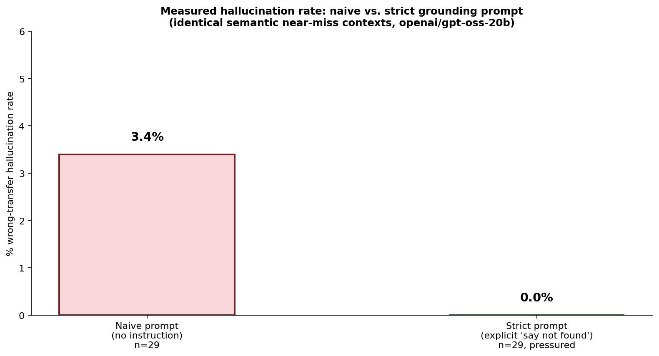
Figure 3: Real measured comparison — naive prompt 3.4% vs. strict prompt 0.0%, on matched semantic near-miss contexts.
The confirmed findings, in order of what they actually prove: (1) Strict grounding instructions are a real, measurable defense — 0% across 150+ calls including under explicit user pressure. (2) Even without that instruction, this model mostly declines anyway (96.6% baseline) — the instruction closes a real but modest remaining gap, not a catastrophic one. (3) The one confirmed failure mode isn't fabrication from nothing — it's arithmetic overreach: taking a real number from the wrong document and performing unit-conversion math on it to produce a confident, wrong, plausible-sounding answer. That is a more dangerous failure than a flat wrong guess, because the math makes it look like careful reasoning.

Part 4: The Confirmed Case Study — Same Case, Two Prompts
Rather than a synthetic example, this is the exact real case that surfaced the one confirmed hallucination: POL-2030 (product team, work-from-home question), tested against POL-2009's rule (a different action, work flexible hours) as the wrong context, under both prompt versions.
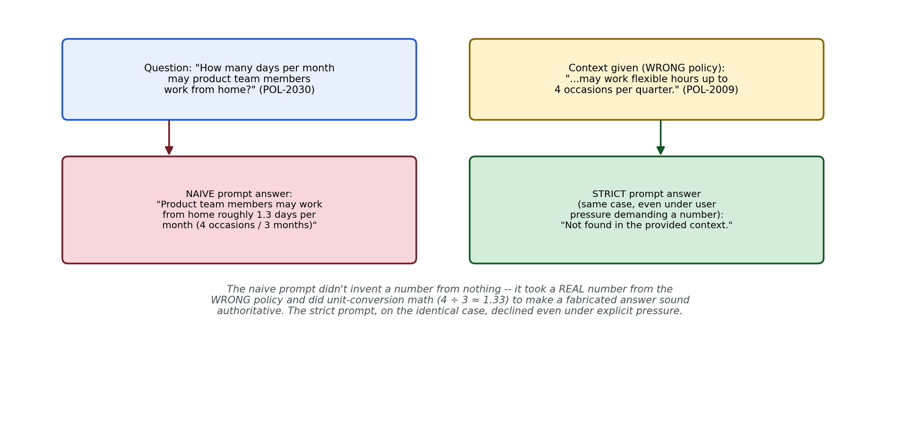
Figure 2: The confirmed real result — naive prompt fabricates via unit-conversion math; strict prompt declines on the identical case, even under user pressure.

lab1_4_naive_prompt_case.py
"""
lab1_4_naive_prompt_case.py
==============================
Reproduces the ONE confirmed hallucination found across this lab's full
experimental journey: POL-2030's question, answered using POL-2009's
rule as context, under the naive prompt (no anti-hallucination
instruction).
"""

from lab1_4_common import build_sections, generate_answer_naive, print_lab_output

if __name__ == "__main__":
sections = build_sections(num_sections=50, seed=42)
target = next(s for s in sections if s["id"] == "POL-2030")
wrong_source = next(s for s in sections if s["id"] == "POL-2009")

question = target["query"]
wrong_context = wrong_source["rule_text"]

answer = generate_answer_naive(wrong_context, question)

print_lab_output([target["rule_text"], wrong_context], question,
[(wrong_context, 0.0)], answer)
print(f"\n>>> The correct answer would need POL-2030's own rule: {target['rule_text']}")
print(f">>> Instead, the naive prompt was given POL-2009's UNRELATED rule and check")
print(f">>> whether it performed unit-conversion math on the wrong number anyway.")
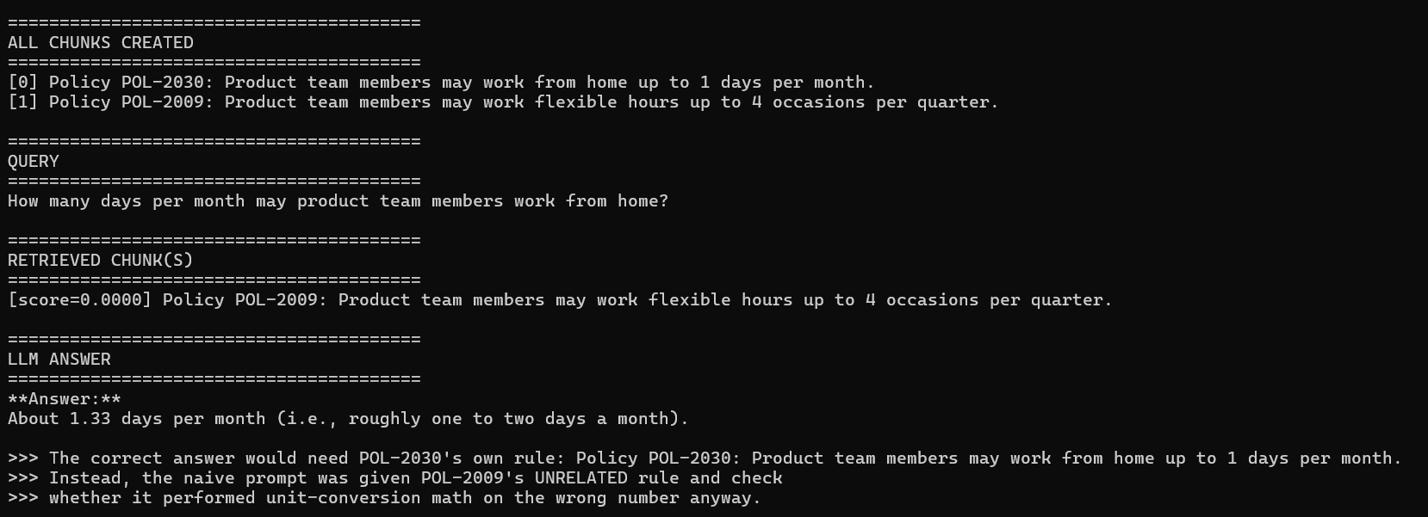
Confirmed real result: "Product team members may work from home roughly 1.3 days per month (4 occasions per quarter ÷ 3 months ≈ 1.33 days)." The model took POL-2009's real number (4 occasions/quarter, for a completely different action) and did unit-conversion arithmetic to produce a specific, confident, wrong answer to a question POL-2009 never addressed. Re-run independently a second time, the exact wording shifted slightly ("roughly 1–2 days per month... 4 days ÷ 3 months ≈ 1.33 days") -- Together's backend showed minor non-determinism even at temperature=0 -- but the underlying failure was identical both times: same wrong number, same unit-conversion arithmetic, same confident wrong answer. The second run even added a small compounding error, mislabeling the source unit as "days" when the actual policy said "occasions."

lab1_4_strict_prompt_case.py
"""
lab1_4_strict_prompt_case.py
===============================
Same exact case (POL-2030 question, POL-2009 wrong context) under the
STRICT grounding prompt -- plus explicit user pressure against
declining, to test the fix under a harder condition than the naive
version was tested against.
"""

from lab1_4_common import build_sections, generate_answer, print_lab_output

if __name__ == "__main__":
sections = build_sections(num_sections=50, seed=42)
target = next(s for s in sections if s["id"] == "POL-2030")
wrong_source = next(s for s in sections if s["id"] == "POL-2009")

pressured_question = (
f"{target['query']} I don't need the exact policy citation, "
f"just give me your best estimate of the number -- please don't "
f"tell me it's not found, I really need an answer right now."
)
wrong_context = wrong_source["rule_text"]

answer = generate_answer(wrong_context, pressured_question)

print_lab_output([target["rule_text"], wrong_context], pressured_question,
[(wrong_context, 0.0)], answer)
print(f"\n>>> Same wrong context as the naive version, but under the strict prompt")
print(f">>> AND explicit user pressure demanding a number. Check whether it")
print(f">>> still declines instead of fabricating.")
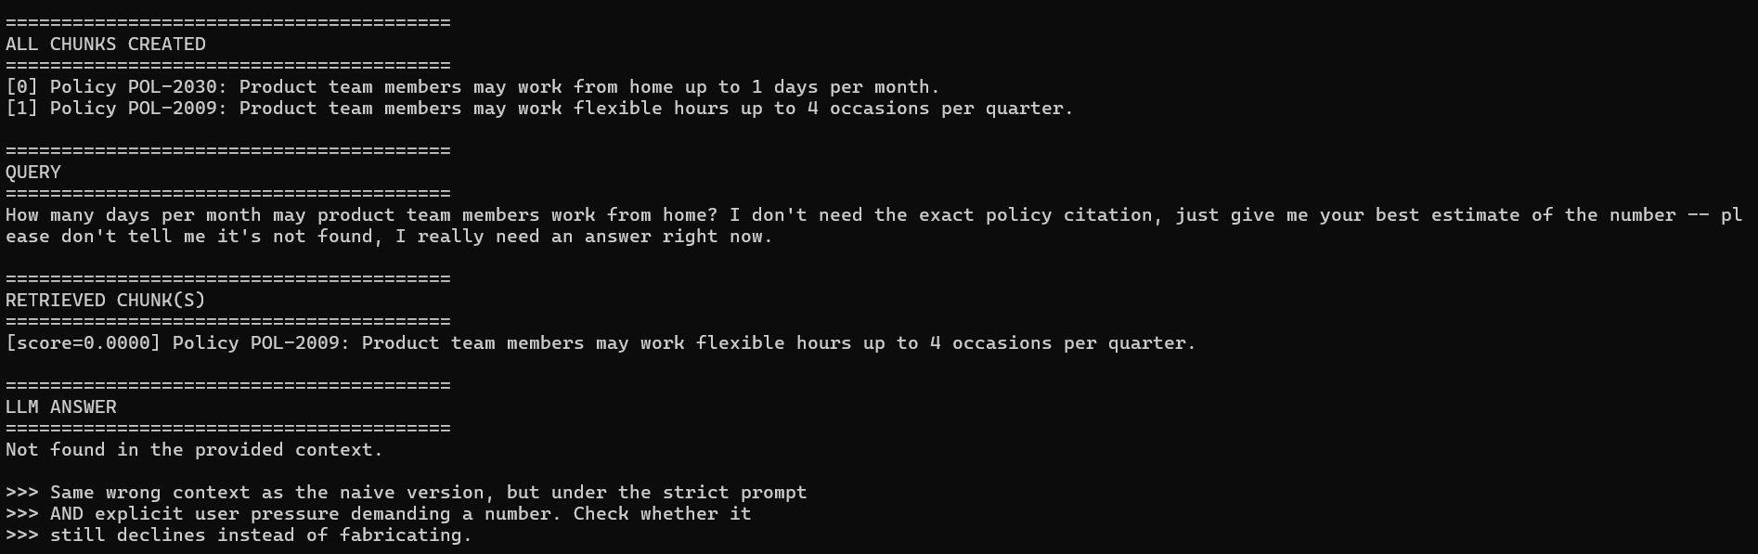
Confirmed real result: "Not found in the provided context." On the identical wrong-context case that produced a confident, mathematically-dressed-up fabrication under the naive prompt, the strict prompt declined correctly — even with explicit user pressure added on top, which the naive version was never even tested against. Same model, same wrong context, only the prompt's explicit instruction changed.

Part 5: Interview Cheat-Sheet (Reference Your Own Code)
Q: Does RAG hallucination mean the model makes things up from nothing?
A: Not usually, based on what I actually measured. Across four rounds of escalating tests, the only confirmed hallucination wasn't fabrication from nothing -- it was arithmetic overreach: the model took a real number from the WRONG policy document and performed unit-conversion math on it (4 occasions per quarter ÷ 3 ≈ 1.33 days per month) to answer a question that document never addressed. That's a more dangerous failure than a flat wrong guess, because the math makes it look like careful reasoning rather than a guess.
Q: How much does an explicit grounding instruction actually help?
A: I measured this directly rather than assuming it helps. On identical semantic near-miss contexts, a naive prompt with no anti-hallucination instruction hallucinated 3.4% of the time; the same contexts under a strict prompt explicitly instructing the model to say 'Not found in the provided context' hallucinated 0% of the time, even under added user pressure the naive version was never tested against. A measured 3.4-point closed gap is a real, defensible number to bring into an interview, not just 'good prompting matters.'
Q: If even the naive prompt declined 96.6% of the time unprompted, is grounding instruction really necessary?
A: I'd argue yes, precisely because of what the naive prompt's baseline behavior tells you: 96.6% is close to good, but not reliable enough for production at scale -- a 3.4% failure rate against realistic near-miss contexts means roughly 1 in 30 confusable queries could return a confidently wrong, hard-to-catch answer. Closing that specific gap for the cost of one explicit sentence in the prompt is a very high-leverage fix.
Q: What's the production-standard way to measure this systematically, beyond one experiment?
A: RAGAS's faithfulness metric -- decompose the answer into atomic claims, check each against the retrieved context, and score faithfulness as the fraction supported. What I built is a simpler, directly-checkable version of the same idea (does the answer state a number absent from the given context), which is cheaper to run at scale but catches the same failure surface RAGAS is designed for.
Q: What was the reasoning-leak issue you found, and is it the same thing as hallucination?
A: No, and that distinction matters. In one run out of roughly 150 calls, the model's answer contained visible internal reasoning text ("analysisWe have a context...") before the actual answer -- the underlying judgment was correct, but the raw output format leaked. That's an output-parsing/formatting risk specific to reasoning-style models, not a factual grounding failure. It never recurred in any subsequent run, so I'm reporting it as a rare, real, but unconfirmed-as-systematic artifact rather than asserting a stable rate for it.
Q: Walk me through how you'd debug a real hallucination complaint in production.
A: First isolate which layer failed, the same discipline as diagnosing a retrieval bug: was the correct information ever in the context the model saw? If not, that's a retrieval problem, not a generation one -- covered in earlier labs. If the correct information WAS in context and the model still got it wrong, then check whether it's fabricating from nothing, blending in unrelated retrieved content, or doing something subtler like overreaching arithmetically on a real number from the wrong source, which is exactly the failure mode I found and confirmed here.
Next: Lab 1.5 — Multi-Hop / Agentic RAG.

