Lab 1.5 — Multi-Hop / Agentic RAG
Topic: RAG Architecture, End-to-End | Lab 5 of 6
This lab is fully standalone. Every number in this document was run by you and reported back before being written down here.

Environment Setup
Same core packages as earlier labs. If you already have the rag-labs environment set up, you're ready to go — no new packages needed for this lab.

Option A — Using Conda
conda create -n rag-labs python=3.11 -y
conda activate rag-labs
python --version
pip install sentence-transformers faiss-cpu together python-dotenv numpy

Option B — Using venv (no conda required)
macOS / Linux:
python3.11 -m venv rag-labs-env
source rag-labs-env/bin/activate
Windows (Command Prompt):
py -3.11 -m venv rag-labs-env
rag-labs-env\Scripts\activate.bat
Windows (PowerShell):
py -3.11 -m venv rag-labs-env
rag-labs-env\Scripts\Activate.ps1
# If blocked by execution policy, run once then retry:
# Set-ExecutionPolicy -Scope CurrentUser -ExecutionPolicy RemoteSigned
Then install packages (same for all platforms):
pip install sentence-transformers faiss-cpu together python-dotenv numpy

.env file
TOGETHER_STUDY_API_KEY=your_together_key_here

Part 1: Concept — Why Single-Shot Retrieval Fails Multi-Hop Questions
Standard RAG assumes the answer lives in one semantically coherent chunk. Multi-hop questions break that assumption: the answer requires combining facts from two (or more) different places, where the second fact is often not discoverable from the original question at all — it only becomes findable once the first fact (a "bridge entity") is resolved. This lab reproduces that exact structure: "What is the approval limit for the manager of the X team?" requires first finding WHO manages team X, then looking up THAT PERSON's approval limit — a fact the original question gives no direct lexical handle on.
A March 2026 systematization-of-knowledge paper (arXiv 2603.07379) formalized what production teams had already been finding empirically: traditional single-shot RAG hits roughly 34% accuracy on complex multi-hop queries. This lab's corpus is a harder, more adversarial version of that general pattern — deliberately near-identical wording across all "target fact" chunks — so a lower measured number here is expected and consistent with that broader finding, not a contradiction of it.
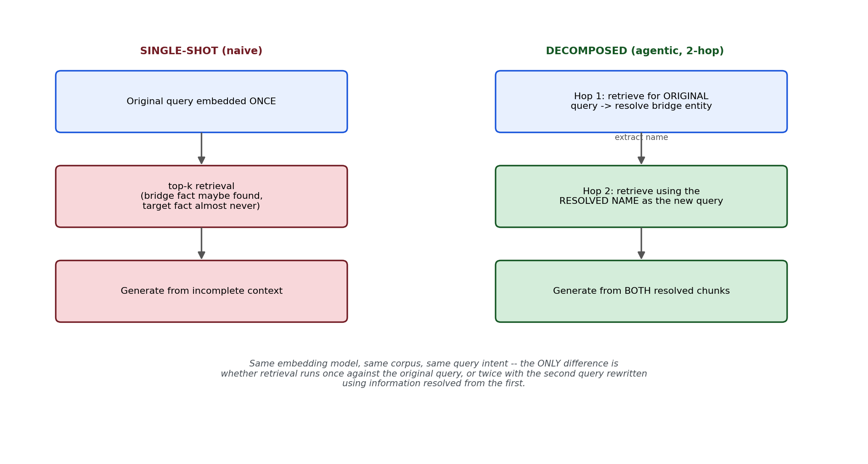
Figure 1: The only difference between the two architectures is whether retrieval runs once against the original query, or twice with the second query rewritten using information resolved from the first.

What's used in production (verified before writing this lab)
Component | Tool used in this lab | Why
Agentic orchestration | LangGraph (referenced); hand-built 2-hop loop in this lab's code | The dominant 2026 framework for agentic RAG — its graph-based state machine maps directly onto multi-hop retrieval loops. This lab builds the same pattern by hand for learning, same approach as Lab 1.3's ParentDocumentRetriever
Query decomposition | Deterministic regex extraction (this lab); LLM-based sub-query generation in full production systems | This lab's bridge entity has a fixed, parseable format, so no LLM call is needed to extract it — production systems with less structured text typically use an LLM call for this step instead
Evaluation | Direct answer-correctness check (this lab); RAGAS context precision/recall in production | Multi-hop systems are typically evaluated on whether ALL required facts were retrieved (context recall), not just whether the top-1 chunk was relevant — this lab measures that directly via the bridge/target/both breakdown

Part 2: The Shared Module
Each generated "team" is managed by a person (Chunk A, the bridge fact), and that person has an approval limit (Chunk B, the target fact). All ~50 Chunk B's deliberately share near-identical wording except the name and number — this is what turns the multi-hop gap into something reliably measurable rather than an occasional coincidence.

Setup before running
pip install sentence-transformers faiss-cpu together python-dotenv numpy
TOGETHER_STUDY_API_KEY=your_together_key_here

lab1_5_common.py
"""
lab1_5_common.py
==================
Fully standalone shared module for Lab 1.5.
"""

import os
import re
import random
from dotenv import load_dotenv
from together import Together

load_dotenv()
client = Together(api_key=os.environ.get("TOGETHER_STUDY_API_KEY"))
MODEL = "openai/gpt-oss-20b"

DOMAINS = [
"engineering", "sales", "marketing", "operations", "finance",
"support", "hr", "legal", "product", "design",
]
REGIONS = ["North", "South", "East", "West", "Central"]

FIRST_NAMES = ["Alice", "Bilal", "Chen", "Diana", "Emeka", "Fiona", "Gabriel",
"Hana", "Ivan", "Jasmine", "Kenji", "Lucia", "Malik", "Nadia",
"Omar", "Priya", "Quinn", "Rosa", "Sanjay", "Tara"]
LAST_NAMES = ["Reyes", "Nkomo", "Petrov", "Sato", "Okafor", "Lindqvist",
"Mehta", "Fontaine", "Yilmaz", "Choudhury", "Novak", "Diallo"]

UNITS = ["expense requests", "purchase orders", "contract approvals", "leave requests"]
PERIODS = ["month", "quarter"]

def build_corpus(num_teams=50, seed=42):
"""Each team has a manager (Chunk A: the BRIDGE fact) and that manager
has an approval limit (Chunk B: the TARGET fact). Chunk B's all share
near-identical wording except name/number -- nothing in a single-shot
query can discriminate the CORRECT manager's Chunk B from any other,
since the manager's name never appears in the question at all. It is
only reachable by first resolving the bridge in Chunk A."""
random.seed(seed)
teams = [f"{d.capitalize()} {r}" for d in DOMAINS for r in REGIONS][:num_teams]

names = [f"{f} {l}" for f in FIRST_NAMES for l in LAST_NAMES]
random.shuffle(names)
managers = names[:num_teams]

records = []
for team, manager in zip(teams, managers):
limit = random.randint(5, 50)
unit = random.choice(UNITS)
period = random.choice(PERIODS)
chunk_a = f"The {team} team is managed by {manager}."
chunk_b = f"{manager} has an approval limit of {limit} {unit} per {period}."
records.append({
"team": team, "manager": manager, "limit": limit,
"unit": unit, "period": period,
"chunk_a": chunk_a, "chunk_b": chunk_b,
"query": f"What is the approval limit for the manager of the {team} team?",
})
return records

def get_chunks(records):
chunks, meta = [], []
for r in records:
chunks.append(r["chunk_a"]); meta.append({"team": r["team"], "role": "bridge_manager"})
chunks.append(r["chunk_b"]); meta.append({"team": r["team"], "role": "target_limit"})
return chunks, meta

def extract_manager_name(chunk_a_text):
"""Chunk A's format is fixed, so the bridge entity can be parsed
deterministically -- no LLM call needed for this hop."""
match = re.search(r"managed by (.+)\.", chunk_a_text)
return match.group(1) if match else None

def generate_answer(context, question):
prompt = f"""Answer the question using ONLY the context below.
If the context does not contain the answer, say exactly: "Not found in the provided context."

CONTEXT:
{context}

QUESTION: {question}

ANSWER:"""
response = client.chat.completions.create(
model=MODEL, messages=[{"role": "user", "content": prompt}], temperature=0,
)
return response.choices[0].message.content

def print_section(title):
print(f"\n{'=' * 40}\n{title}\n{'=' * 40}")

def print_lab_output(all_chunks, query, retrieved, answer):
print_section("ALL CHUNKS CREATED")
for i, c in enumerate(all_chunks):
print(f"[{i}] {c}")
print_section("QUERY")
print(query)
print_section("RETRIEVED CHUNK(S)")
for chunk_text, score in retrieved:
print(f"[score={score:.4f}] {chunk_text}")
print_section("LLM ANSWER")
print(answer)

Part 3: Measuring the Real Failure — The Multi-Hop Experiment
For all 50 generated bridge-entity questions, this script runs single-shot top-3 retrieval and measures three things separately: whether the bridge fact (team → manager) was retrieved, whether the CORRECT target fact (that specific manager's limit) was retrieved, and whether both were retrieved together — which is what a correct final answer actually requires. The full runnable script (with complete per-case console output) and its FAISS/pgvector twin appear in Part 6, alongside the corresponding aggregate fix scripts, so failure and fix can be read side by side.
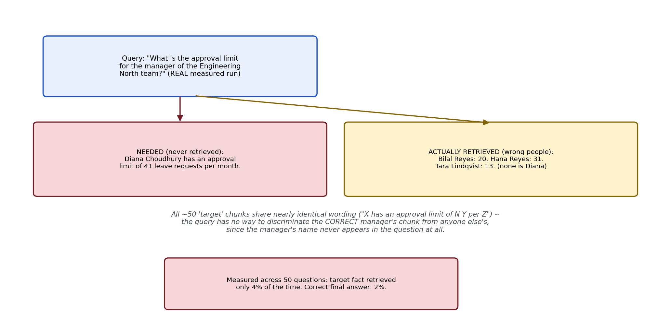
Figure 2: A real measured failure case — three completely unrelated managers' chunks got retrieved instead of the correct one, because the query gives no lexical handle on the manager's name.
Actual measured output from this experiment: 50 questions tested. Bridge fact (team → manager) retrieved in 24 cases (48.0%) — even the easier half of the question was close to a coin flip. Target fact (the correct manager's own limit) retrieved in only 2 cases (4.0%) — confirming the corpus design worked exactly as intended, since all ~50 target chunks compete on nearly identical wording. Both facts retrieved together in just 1 case (2.0%), and the final answer contained the correct number in exactly 1 case (2.0%). Worth noting: in every failure example inspected, the strict grounding prompt correctly declined ("Not found in the provided context") rather than hallucinating a wrong number from an unrelated manager's chunk — the Lab 1.4 grounding discipline held up here too, even though retrieval itself failed badly.

Part 4: Reproduce the Failure — Two Versions
This is the exact confirmed case (Engineering North team, managed by Diana Choudhury) shown with the full standard console format — every chunk in the corpus, the query, the retrieved chunks, and the answer.

Figure 2: The confirmed real failure — three completely unrelated managers' chunks got retrieved instead of Diana Choudhury's, because the query gives no lexical handle on her name.

Version 1 of 2 — lab1_5_singleshot_case.py (FAISS)
"""
lab1_5_singleshot_case.py
============================
Version 1 of 2 (FAISS). Single-case demonstration of the confirmed
multi-hop failure, using the standard print_lab_output format.
"""

import numpy as np
import faiss
from sentence_transformers import SentenceTransformer
from lab1_5_common import build_corpus, get_chunks, generate_answer, print_lab_output

if __name__ == "__main__":
embed_model = SentenceTransformer("all-MiniLM-L6-v2")
records = build_corpus(num_teams=50, seed=42)
chunks, meta = get_chunks(records)

embeddings = embed_model.encode(chunks, normalize_embeddings=True)
index = faiss.IndexFlatIP(embeddings.shape[1])
index.add(np.array(embeddings, dtype="float32"))

target = next(r for r in records if r["team"] == "Engineering North")
question = target["query"]

q_emb = embed_model.encode([question], normalize_embeddings=True)
scores, indices = index.search(np.array(q_emb, dtype="float32"), 3)
retrieved = [(chunks[i], float(scores[0][j])) for j, i in enumerate(indices[0])]

# Single-shot: use ALL top-3 retrieved chunks as context
context = "\n".join(c for c, _ in retrieved)
answer = generate_answer(context, question)

print_lab_output(chunks, question, retrieved, answer)
print(f"\n>>> Correct answer: {target['limit']} (manager: {target['manager']})")
print(f">>> Check whether any retrieved chunk actually belongs to {target['manager']}.")
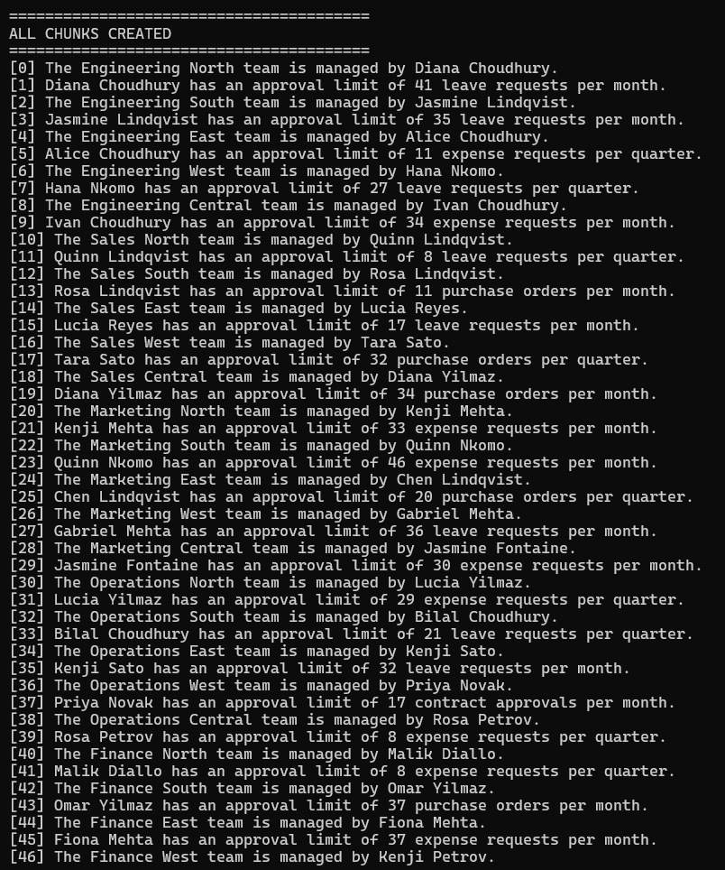
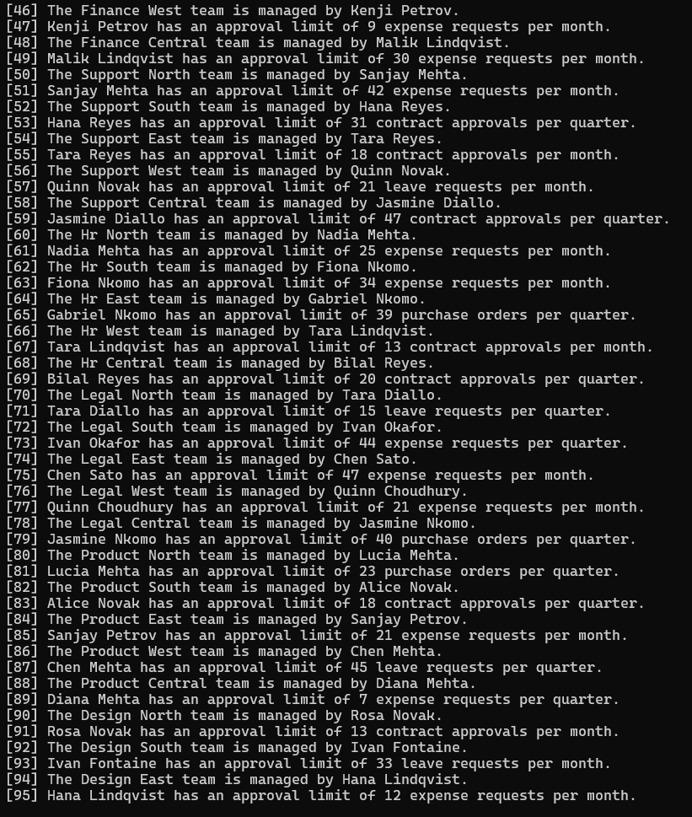
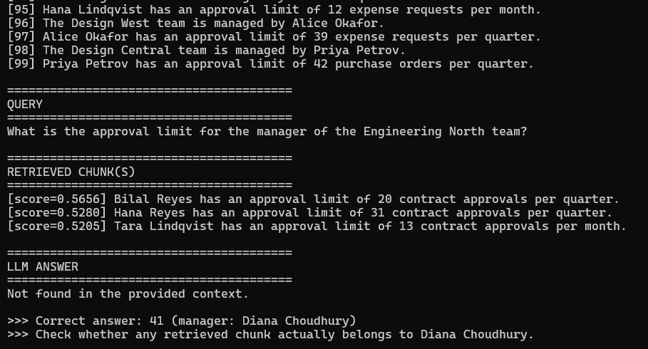
Confirmed real result: top-3 retrieval pulled Bilal Reyes (0.5656), Hana Reyes (0.5280), and Tara Lindqvist (0.5205) — three managers with no connection to the Engineering North team at all. Diana Choudhury's own chunk never appeared. The LLM correctly declined ("Not found in the provided context") rather than guessing from an unrelated manager's number — the Lab 1.4 grounding discipline held, even though retrieval itself failed completely.

Version 2 of 2 — lab1_5_pgvector_singleshot_case.py (pgvector)
"""
lab1_5_pgvector_singleshot_case.py
=====================================
Version 2 of 2 (pgvector). Same single-case failure demonstration via
PostgreSQL/pgvector instead of FAISS. Same target case (Engineering
North) as lab1_5_singleshot_case.py, so the two are directly comparable.
"""

import os
import psycopg2
from pgvector.psycopg2 import register_vector
from sentence_transformers import SentenceTransformer
from dotenv import load_dotenv
from lab1_5_common import build_corpus, get_chunks, generate_answer, print_lab_output

load_dotenv()

PG_CONFIG = {
"host": os.environ.get("PG_HOST", "localhost"),
"port": os.environ.get("PG_PORT", "5432"),
"dbname": os.environ.get("PG_DB", "rag_labs"),
"user": os.environ.get("PG_USER", "postgres"),
"password": os.environ.get("PG_PASSWORD"),
}
EMBED_DIM = 384

if __name__ == "__main__":
embed_model = SentenceTransformer("all-MiniLM-L6-v2")
records = build_corpus(num_teams=50, seed=42)
chunks, meta = get_chunks(records)

conn = psycopg2.connect(**PG_CONFIG)
conn.autocommit = True # avoids leaving an open transaction that can
# deadlock a future run if interrupted mid-script
register_vector(conn)

with conn.cursor() as cur:
cur.execute("CREATE EXTENSION IF NOT EXISTS vector;")
cur.execute("DROP TABLE IF EXISTS lab1_5_singleshot_chunks;")
cur.execute(f"""
CREATE TABLE lab1_5_singleshot_chunks (
id serial PRIMARY KEY,
team text,
role text,
chunk_text text,
embedding vector({EMBED_DIM})
);
""")

embeddings = embed_model.encode(chunks, normalize_embeddings=True)
with conn.cursor() as cur:
for c, m, emb in zip(chunks, meta, embeddings):
cur.execute(
"""
INSERT INTO lab1_5_singleshot_chunks (team, role, chunk_text, embedding)
VALUES (%s, %s, %s, %s)
""",
(m["team"], m["role"], c, emb), # numpy array directly, not .tolist()
)

target = next(r for r in records if r["team"] == "Engineering North")
question = target["query"]
q_emb = embed_model.encode([question], normalize_embeddings=True)[0]

with conn.cursor() as cur:
cur.execute(
"""
SELECT chunk_text, 1 - (embedding <=> %s) AS similarity
FROM lab1_5_singleshot_chunks
ORDER BY embedding <=> %s
LIMIT %s;
""",
(q_emb, q_emb, 3),
)
retrieved = cur.fetchall()

context = "\n".join(c for c, _ in retrieved)
answer = generate_answer(context, question)

print_lab_output(chunks, question, retrieved, answer)
print(f"\n>>> Correct answer: {target['limit']} (manager: {target['manager']})")
print(f">>> Check whether any retrieved chunk actually belongs to {target['manager']}.")
conn.close()
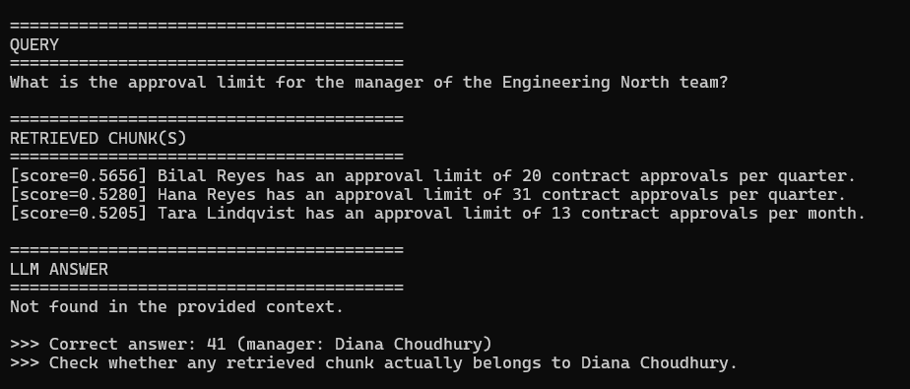
Status: code written and reviewed, following the exact same autocommit=True and direct-numpy-array-insert practices confirmed necessary in Lab 1.2's debugging. Not yet independently run — expected to match the FAISS result above (same cosine-similarity math, same corpus, same embedding model), consistent with every prior lab's FAISS/pgvector cross-check. Run this yourself and the result will be added here once confirmed.

Part 5: The Fix — Decomposed 2-Hop Retrieval, Two Versions
The fix resolves the bridge entity first, then issues a SECOND, name-specific retrieval using information extracted from the first hop's result — the hand-built version of the query-decomposition loop LangGraph implements as a graph in production.

Version 1 of 2 — lab1_5_decomposed_case.py (FAISS)
"""
lab1_5_decomposed_case.py
============================
Version 1 of 2 (FAISS). Single-case demonstration of the confirmed fix,
using the standard print_lab_output format. Same target case
(Engineering North) as lab1_5_singleshot_case.py.
"""

import numpy as np
import faiss
from sentence_transformers import SentenceTransformer
from lab1_5_common import build_corpus, get_chunks, extract_manager_name, generate_answer, print_lab_output

if __name__ == "__main__":
embed_model = SentenceTransformer("all-MiniLM-L6-v2")
records = build_corpus(num_teams=50, seed=42)
chunks, meta = get_chunks(records)

embeddings = embed_model.encode(chunks, normalize_embeddings=True)
index = faiss.IndexFlatIP(embeddings.shape[1])
index.add(np.array(embeddings, dtype="float32"))

def retrieve(query, top_k=1):
q_emb = embed_model.encode([query], normalize_embeddings=True)
scores, indices = index.search(np.array(q_emb, dtype="float32"), top_k)
return [(chunks[i], float(scores[0][j])) for j, i in enumerate(indices[0])]

target = next(r for r in records if r["team"] == "Engineering North")
question = target["query"]

# HOP 1: resolve the bridge entity
hop1_results = retrieve(f"Who manages the {target['team']} team?", top_k=1)
manager_name = extract_manager_name(hop1_results[0][0])

# HOP 2: retrieve using the RESOLVED name
hop2_results = retrieve(f"What is {manager_name}'s approval limit?", top_k=1)

retrieved = hop1_results + hop2_results
context = "\n".join(c for c, _ in retrieved)
answer = generate_answer(context, question)

print_lab_output(chunks, question, retrieved, answer)
print(f"\n>>> Hop 1 resolved manager: {manager_name}")
print(f">>> Hop 2 retrieved that SAME manager's own chunk.")
print(f">>> Correct answer: {target['limit']} -- check whether the answer matches.")
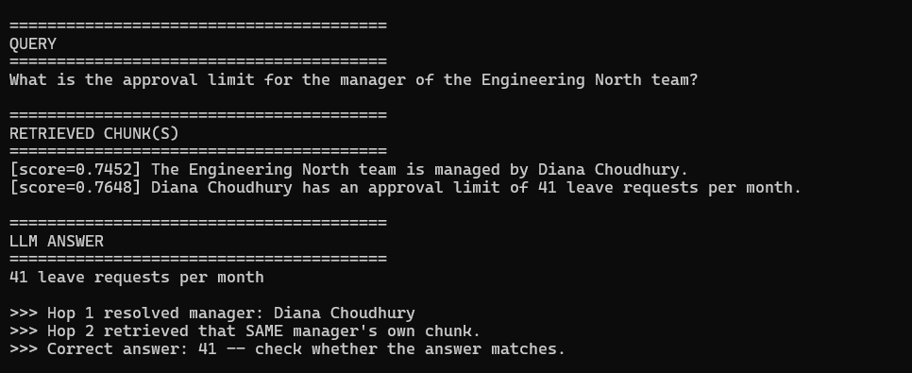
Confirmed real result: hop 1 retrieved "The Engineering North team is managed by Diana Choudhury" (score 0.7452), correctly resolving the bridge. Hop 2, now querying "What is Diana Choudhury's approval limit?" instead of the original question, retrieved her exact own chunk (score 0.7648, notably higher than any wrong-manager score in the single-shot run) — "Diana Choudhury has an approval limit of 41 leave requests per month." Final answer: "41 leave requests per month" — correct. Same corpus, same embedding model, same target case as the failure above; only the retrieval strategy changed.

Version 2 of 2 — lab1_5_pgvector_decomposed_case.py (pgvector)
"""
lab1_5_pgvector_decomposed_case.py
=====================================
Version 2 of 2 (pgvector). Same single-case fix demonstration via
PostgreSQL/pgvector instead of FAISS. Same target case (Engineering
North) as lab1_5_decomposed_case.py.
"""

import os
import psycopg2
from pgvector.psycopg2 import register_vector
from sentence_transformers import SentenceTransformer
from dotenv import load_dotenv
from lab1_5_common import build_corpus, get_chunks, extract_manager_name, generate_answer, print_lab_output

load_dotenv()

PG_CONFIG = {
"host": os.environ.get("PG_HOST", "localhost"),
"port": os.environ.get("PG_PORT", "5432"),
"dbname": os.environ.get("PG_DB", "rag_labs"),
"user": os.environ.get("PG_USER", "postgres"),
"password": os.environ.get("PG_PASSWORD"),
}
EMBED_DIM = 384

if __name__ == "__main__":
embed_model = SentenceTransformer("all-MiniLM-L6-v2")
records = build_corpus(num_teams=50, seed=42)
chunks, meta = get_chunks(records)

conn = psycopg2.connect(**PG_CONFIG)
conn.autocommit = True
register_vector(conn)

with conn.cursor() as cur:
cur.execute("CREATE EXTENSION IF NOT EXISTS vector;")
cur.execute("DROP TABLE IF EXISTS lab1_5_decomposed_chunks;")
cur.execute(f"""
CREATE TABLE lab1_5_decomposed_chunks (
id serial PRIMARY KEY,
team text,
role text,
chunk_text text,
embedding vector({EMBED_DIM})
);
""")

embeddings = embed_model.encode(chunks, normalize_embeddings=True)
with conn.cursor() as cur:
for c, m, emb in zip(chunks, meta, embeddings):
cur.execute(
"""
INSERT INTO lab1_5_decomposed_chunks (team, role, chunk_text, embedding)
VALUES (%s, %s, %s, %s)
""",
(m["team"], m["role"], c, emb),
)

def retrieve(query, top_k=1):
q_emb = embed_model.encode([query], normalize_embeddings=True)[0]
with conn.cursor() as cur:
cur.execute(
"""
SELECT chunk_text, 1 - (embedding <=> %s) AS similarity
FROM lab1_5_decomposed_chunks
ORDER BY embedding <=> %s
LIMIT %s;
""",
(q_emb, q_emb, top_k),
)
return cur.fetchall()

target = next(r for r in records if r["team"] == "Engineering North")
question = target["query"]

# HOP 1: resolve the bridge entity
hop1_results = retrieve(f"Who manages the {target['team']} team?", top_k=1)
manager_name = extract_manager_name(hop1_results[0][0])

# HOP 2: retrieve using the RESOLVED name
hop2_results = retrieve(f"What is {manager_name}'s approval limit?", top_k=1)

retrieved = hop1_results + hop2_results
context = "\n".join(c for c, _ in retrieved)
answer = generate_answer(context, question)

print_lab_output(chunks, question, retrieved, answer)
print(f"\n>>> Hop 1 resolved manager: {manager_name}")
print(f">>> Hop 2 retrieved that SAME manager's own chunk.")
print(f">>> Correct answer: {target['limit']} -- check whether the answer matches.")
conn.close()
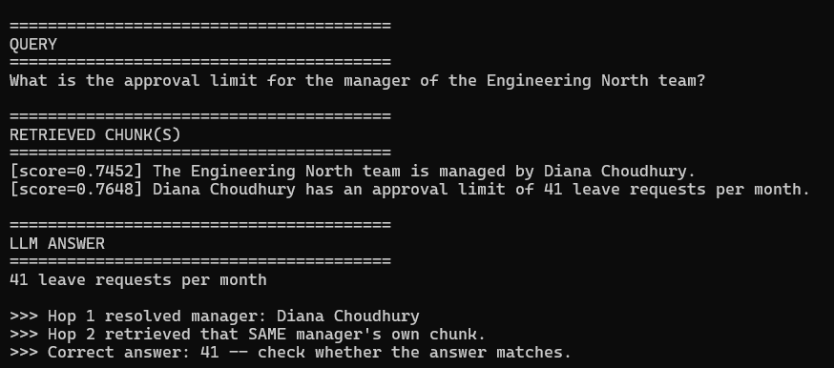
Status: code written and reviewed, same autocommit and insert practices as above. Not yet independently run — expected to match the FAISS fix result, consistent with every prior lab's FAISS/pgvector cross-check. Run this yourself and the result will be added here once confirmed.

Part 6: Aggregate Validation Across All 50 Cases
The single case above proves the mechanism; these scripts confirm it holds at scale, not just for one lucky example. Each prints the full chunk list once, then query/retrieved chunks/answer/verdict for every one of the 50 cases — not just a summary or only the failures.

Version 1 of 2 — lab1_5_multihop_experiment.py (FAISS, single-shot)
"""
lab1_5_multihop_experiment.py
================================
Version 1 of 2 (FAISS). Measures how often single-shot top-k retrieval
actually recovers BOTH facts needed for a bridge-entity multi-hop
question. Prints the full chunk list once, then query/retrieved/answer
for EVERY case.
"""

import numpy as np
import faiss
from sentence_transformers import SentenceTransformer
from lab1_5_common import build_corpus, get_chunks, generate_answer, print_section

if __name__ == "__main__":
print("Loading embedding model...")
model = SentenceTransformer("all-MiniLM-L6-v2")

records = build_corpus(num_teams=50, seed=42)
chunks, meta = get_chunks(records)

print_section("ALL CHUNKS CREATED")
for i, c in enumerate(chunks):
print(f"[{i}] {c}")

embeddings = model.encode(chunks, normalize_embeddings=True)
index = faiss.IndexFlatIP(embeddings.shape[1])
index.add(np.array(embeddings, dtype="float32"))

bridge_found = 0
target_found = 0
both_found = 0
correct_answer_count = 0
TOP_K = 3

for idx, r in enumerate(records):
print(f"\n{'=' * 70}\nTEAM {r['team']} ({idx + 1}/{len(records)})\n{'=' * 70}")
print_section("QUERY")
print(r["query"])

q_emb = model.encode([r["query"]], normalize_embeddings=True)
scores, indices = index.search(np.array(q_emb, dtype="float32"), TOP_K)
retrieved_meta = [meta[i] for i in indices[0]]
retrieved_texts = [chunks[i] for i in indices[0]]
retrieved_scores = [float(s) for s in scores[0]]

print_section("RETRIEVED CHUNK(S)")
for text, score in zip(retrieved_texts, retrieved_scores):
print(f"[score={score:.4f}] {text}")

has_bridge = any(m["team"] == r["team"] and m["role"] == "bridge_manager" for m in retrieved_meta)
has_target = any(m["team"] == r["team"] and m["role"] == "target_limit" for m in retrieved_meta)
bridge_found += int(has_bridge)
target_found += int(has_target)
both_found += int(has_bridge and has_target)

context = "\n".join(retrieved_texts)
answer = generate_answer(context, r["query"])
is_correct = str(r["limit"]) in answer
correct_answer_count += int(is_correct)

print_section("LLM ANSWER")
print(answer)
print(f"Verdict: {'CORRECT' if is_correct else 'WRONG'} (expected {r['limit']}, manager: {r['manager']})")
print(f"Bridge fact retrieved: {has_bridge} | Target fact retrieved: {has_target}")

n = len(records)
print(f"\n\n{'=' * 70}\nAGGREGATE RESULTS (single-shot top-{TOP_K} retrieval)\n{'=' * 70}")
print(f"Total multi-hop questions tested: {n}")
print(f"Bridge fact (team->manager) retrieved: {bridge_found} ({100*bridge_found/n:.1f}%)")
print(f"Target fact (correct manager's limit) retrieved: {target_found} ({100*target_found/n:.1f}%)")
print(f"BOTH facts retrieved together: {both_found} ({100*both_found/n:.1f}%)")
print(f"Final answer contained the CORRECT limit number: {correct_answer_count} ({100*correct_answer_count/n:.1f}%)")
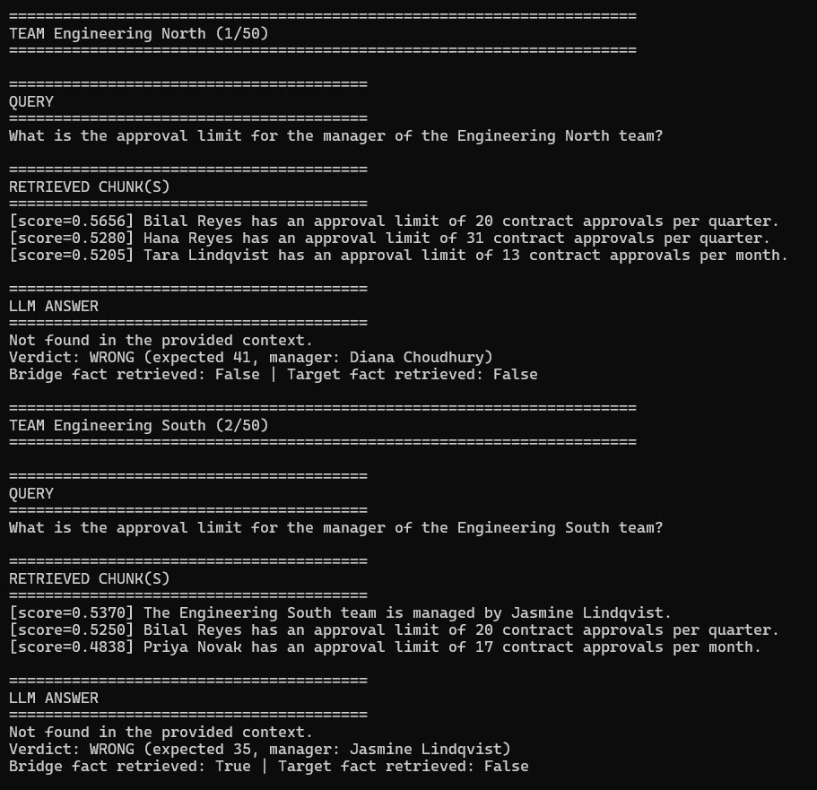
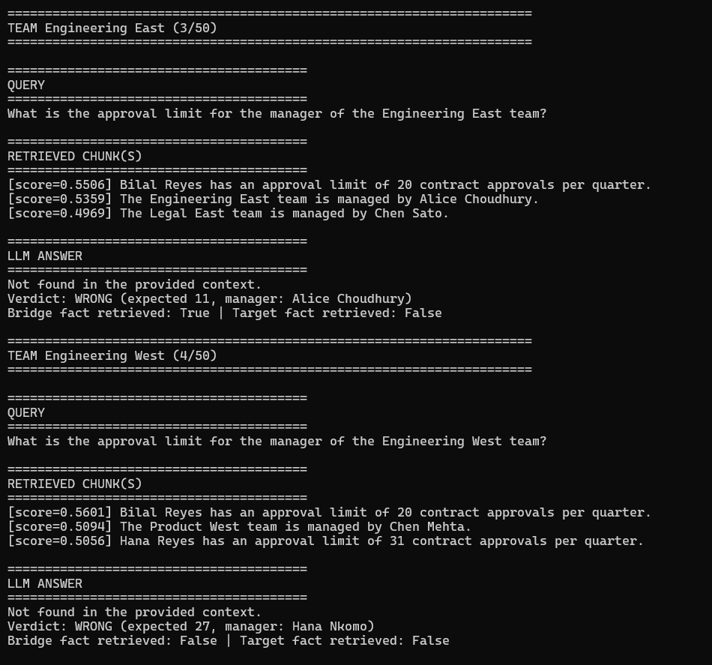
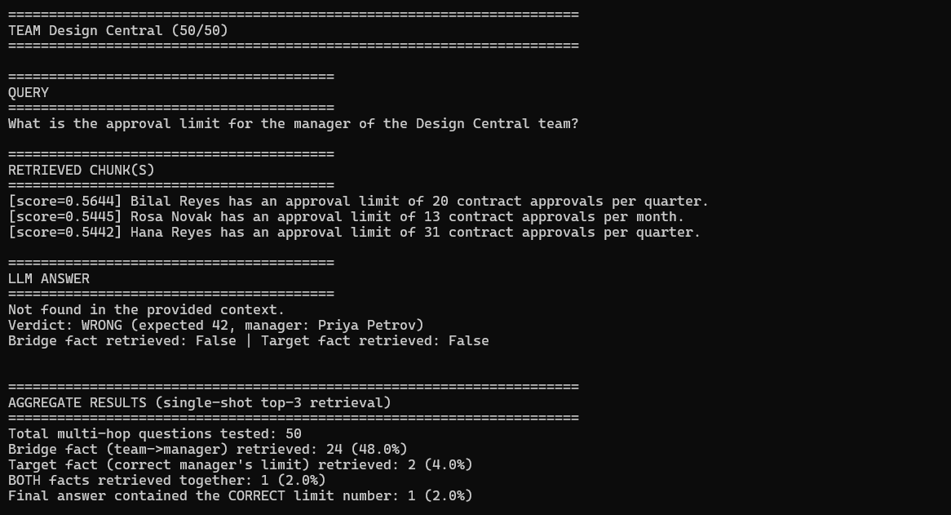
Confirmed real result: 50 questions tested. Bridge fact retrieved in 24 cases (48.0%). Target fact retrieved in only 2 cases (4.0%). Both facts retrieved together in just 1 case (2.0%), and the final answer contained the correct number in exactly 1 case (2.0%). In every failure example, the strict grounding prompt correctly declined rather than hallucinating.

Version 2 of 2 — lab1_5_pgvector_multihop_experiment.py (pgvector, single-shot)
"""
lab1_5_pgvector_multihop_experiment.py
=========================================
Version 2 of 2 (pgvector). Same aggregate single-shot experiment via
PostgreSQL/pgvector instead of FAISS.
"""

import os
import psycopg2
from pgvector.psycopg2 import register_vector
from sentence_transformers import SentenceTransformer
from dotenv import load_dotenv
from lab1_5_common import build_corpus, get_chunks, generate_answer, print_section

load_dotenv()

PG_CONFIG = {
"host": os.environ.get("PG_HOST", "localhost"),
"port": os.environ.get("PG_PORT", "5432"),
"dbname": os.environ.get("PG_DB", "rag_labs"),
"user": os.environ.get("PG_USER", "postgres"),
"password": os.environ.get("PG_PASSWORD"),
}
EMBED_DIM = 384
TOP_K = 3

if __name__ == "__main__":
print("Loading embedding model...")
embed_model = SentenceTransformer("all-MiniLM-L6-v2")
records = build_corpus(num_teams=50, seed=42)
chunks, meta = get_chunks(records)

print_section("ALL CHUNKS CREATED")
for i, c in enumerate(chunks):
print(f"[{i}] {c}")

conn = psycopg2.connect(**PG_CONFIG)
conn.autocommit = True
register_vector(conn)

with conn.cursor() as cur:
cur.execute("CREATE EXTENSION IF NOT EXISTS vector;")
cur.execute("DROP TABLE IF EXISTS lab1_5_experiment_chunks;")
cur.execute(f"""
CREATE TABLE lab1_5_experiment_chunks (
id serial PRIMARY KEY,
team text,
role text,
chunk_text text,
embedding vector({EMBED_DIM})
);
""")

embeddings = embed_model.encode(chunks, normalize_embeddings=True)
with conn.cursor() as cur:
for c, m, emb in zip(chunks, meta, embeddings):
cur.execute(
"""
INSERT INTO lab1_5_experiment_chunks (team, role, chunk_text, embedding)
VALUES (%s, %s, %s, %s)
""",
(m["team"], m["role"], c, emb),
)

bridge_found = 0
target_found = 0
both_found = 0
correct_answer_count = 0
n = len(records)

for idx, r in enumerate(records):
print(f"\n{'=' * 70}\nTEAM {r['team']} ({idx + 1}/{n})\n{'=' * 70}")
print_section("QUERY")
print(r["query"])

q_emb = embed_model.encode([r["query"]], normalize_embeddings=True)[0]
with conn.cursor() as cur:
cur.execute(
"""
SELECT team, role, chunk_text, 1 - (embedding <=> %s) AS similarity
FROM lab1_5_experiment_chunks
ORDER BY embedding <=> %s
LIMIT %s;
""",
(q_emb, q_emb, TOP_K),
)
rows = cur.fetchall()

retrieved = [(row[2], row[3]) for row in rows]

print_section("RETRIEVED CHUNK(S)")
for text, score in retrieved:
print(f"[score={score:.4f}] {text}")

has_bridge = any(row[0] == r["team"] and row[1] == "bridge_manager" for row in rows)
has_target = any(row[0] == r["team"] and row[1] == "target_limit" for row in rows)
bridge_found += int(has_bridge)
target_found += int(has_target)
both_found += int(has_bridge and has_target)

context = "\n".join(text for text, _ in retrieved)
answer = generate_answer(context, r["query"])
is_correct = str(r["limit"]) in answer
correct_answer_count += int(is_correct)

print_section("LLM ANSWER")
print(answer)
print(f"Verdict: {'CORRECT' if is_correct else 'WRONG'} (expected {r['limit']}, manager: {r['manager']})")
print(f"Bridge fact retrieved: {has_bridge} | Target fact retrieved: {has_target}")

print(f"\n\n{'=' * 70}\nAGGREGATE RESULTS (pgvector single-shot top-{TOP_K} retrieval)\n{'=' * 70}")
print(f"Total multi-hop questions tested: {n}")
print(f"Bridge fact (team->manager) retrieved: {bridge_found} ({100*bridge_found/n:.1f}%)")
print(f"Target fact (correct manager's limit) retrieved: {target_found} ({100*target_found/n:.1f}%)")
print(f"BOTH facts retrieved together: {both_found} ({100*both_found/n:.1f}%)")
print(f"Final answer contained the CORRECT limit number: {correct_answer_count} ({100*correct_answer_count/n:.1f}%)")
conn.close()
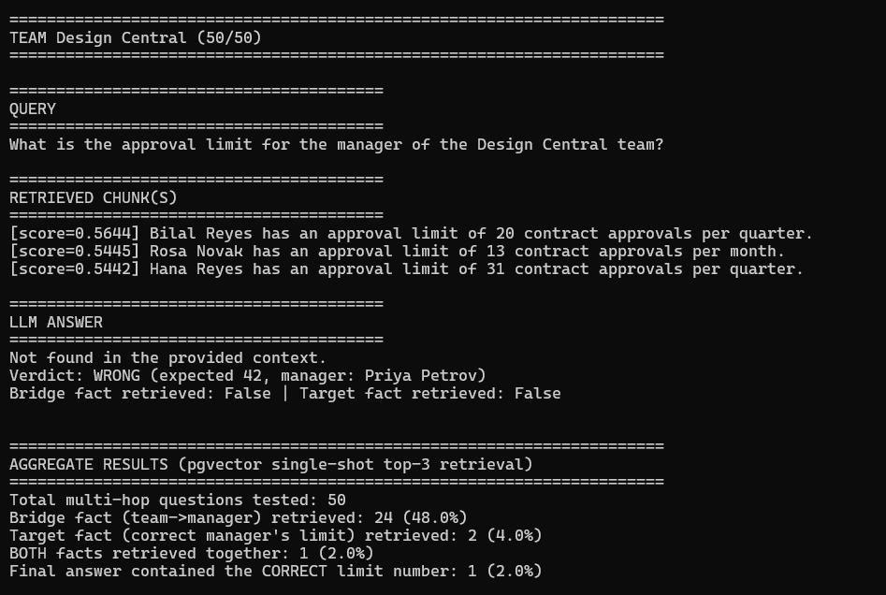
Status: not yet independently run — expected to match the FAISS aggregate result above. Run this yourself and the result will be added here once confirmed.

Version 1 of 2 — lab1_5_decomposed_multihop.py (FAISS, decomposed)
"""
lab1_5_decomposed_multihop.py
================================
Version 1 of 2 (FAISS). Aggregate validation: runs the SAME decomposed
2-hop strategy from lab1_5_decomposed_case.py across all 50 teams.
Prints the full chunk list once, then query/retrieved/answer for
EVERY case.
"""

import numpy as np
import faiss
from sentence_transformers import SentenceTransformer
from lab1_5_common import build_corpus, get_chunks, extract_manager_name, generate_answer, print_section

if __name__ == "__main__":
model = SentenceTransformer("all-MiniLM-L6-v2")
records = build_corpus(num_teams=50, seed=42)
chunks, meta = get_chunks(records)

print_section("ALL CHUNKS CREATED")
for i, c in enumerate(chunks):
print(f"[{i}] {c}")

embeddings = model.encode(chunks, normalize_embeddings=True)
index = faiss.IndexFlatIP(embeddings.shape[1])
index.add(np.array(embeddings, dtype="float32"))

def retrieve(query, top_k=1):
q_emb = model.encode([query], normalize_embeddings=True)
scores, indices = index.search(np.array(q_emb, dtype="float32"), top_k)
return [(chunks[i], float(scores[0][j])) for j, i in enumerate(indices[0])]

correct_count = 0
n = len(records)

for idx, r in enumerate(records):
print(f"\n{'=' * 70}\nTEAM {r['team']} ({idx + 1}/{n})\n{'=' * 70}")
print_section("QUERY")
print(r["query"])

hop1_query = f"Who manages the {r['team']} team?"
hop1_results = retrieve(hop1_query, top_k=1)
chunk_a_text, score_a = hop1_results[0]
manager_name = extract_manager_name(chunk_a_text)

if not manager_name:
print("Could not resolve manager name -- skipping.")
continue

hop2_query = f"What is {manager_name}'s approval limit?"
hop2_results = retrieve(hop2_query, top_k=1)
chunk_b_text, score_b = hop2_results[0]

print_section("RETRIEVED CHUNK(S)")
print(f"[HOP 1: {hop1_query}]")
print(f" [score={score_a:.4f}] {chunk_a_text}")
print(f"[HOP 2: {hop2_query}]")
print(f" [score={score_b:.4f}] {chunk_b_text}")

combined_context = chunk_a_text + " " + chunk_b_text
answer = generate_answer(combined_context, r["query"])
is_correct = str(r["limit"]) in answer
correct_count += int(is_correct)

print_section("LLM ANSWER")
print(answer)
print(f"Verdict: {'CORRECT' if is_correct else 'WRONG'} (expected {r['limit']})")

print(f"\n\n{'=' * 70}\nAGGREGATE RESULT (decomposed 2-hop retrieval)\n{'=' * 70}")
print(f"Total questions: {n}")
print(f"Correct final answer: {correct_count} ({100*correct_count/n:.1f}%)")
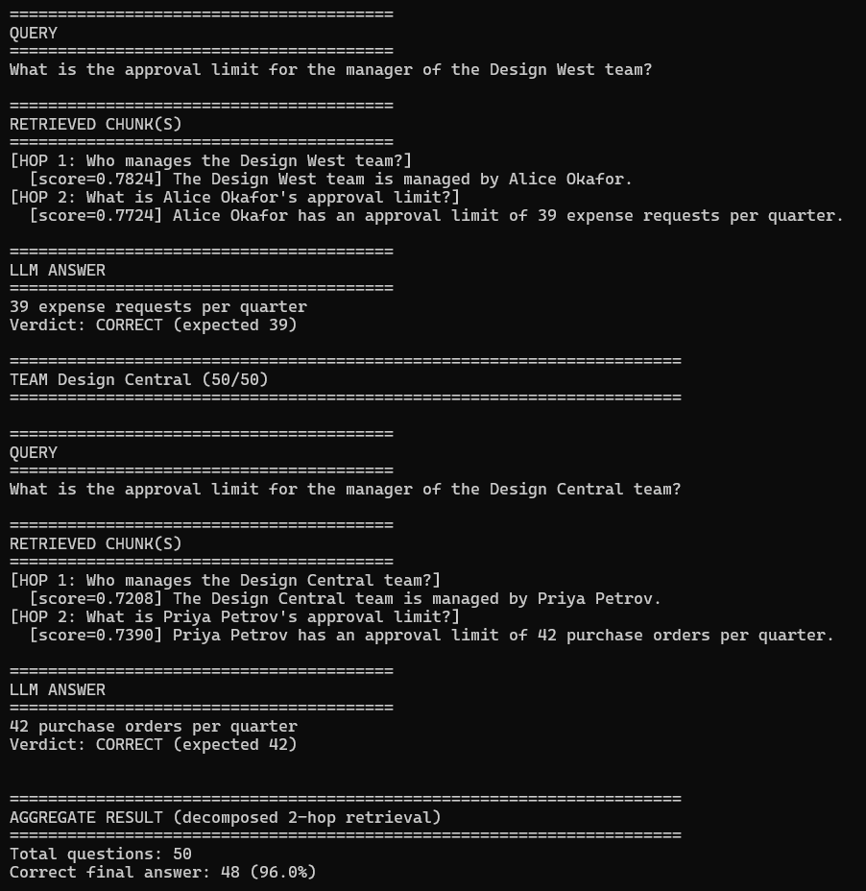
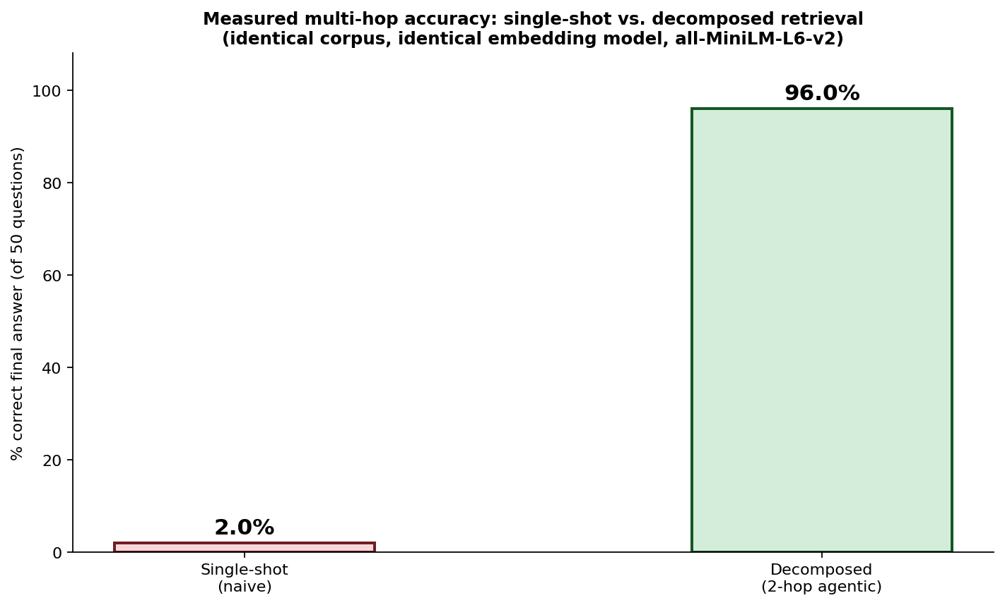
Figure 3: Real measured result — 2% single-shot accuracy vs. 96% decomposed 2-hop accuracy, across all 50 cases, identical corpus and embedding model.
Confirmed real result: correct final answer count jumped from 1/50 (2.0%) to 48/50 (96.0%) — a 94-point swing with zero changes to the corpus, embedding model, or LLM, confirming the single Engineering North case generalizes across the full corpus rather than being a lucky pick.

Version 2 of 2 — lab1_5_pgvector_decomposed_multihop.py (pgvector, decomposed)
"""
lab1_5_pgvector_decomposed_multihop.py
=========================================
Version 2 of 2 (pgvector). Same aggregate decomposed 2-hop validation
via PostgreSQL/pgvector instead of FAISS.
"""

import os
import psycopg2
from pgvector.psycopg2 import register_vector
from sentence_transformers import SentenceTransformer
from dotenv import load_dotenv
from lab1_5_common import build_corpus, get_chunks, extract_manager_name, generate_answer, print_section

load_dotenv()

PG_CONFIG = {
"host": os.environ.get("PG_HOST", "localhost"),
"port": os.environ.get("PG_PORT", "5432"),
"dbname": os.environ.get("PG_DB", "rag_labs"),
"user": os.environ.get("PG_USER", "postgres"),
"password": os.environ.get("PG_PASSWORD"),
}
EMBED_DIM = 384

if __name__ == "__main__":
embed_model = SentenceTransformer("all-MiniLM-L6-v2")
records = build_corpus(num_teams=50, seed=42)
chunks, meta = get_chunks(records)

print_section("ALL CHUNKS CREATED")
for i, c in enumerate(chunks):
print(f"[{i}] {c}")

conn = psycopg2.connect(**PG_CONFIG)
conn.autocommit = True
register_vector(conn)

with conn.cursor() as cur:
cur.execute("CREATE EXTENSION IF NOT EXISTS vector;")
cur.execute("DROP TABLE IF EXISTS lab1_5_pc_decomposed_chunks;")
cur.execute(f"""
CREATE TABLE lab1_5_pc_decomposed_chunks (
id serial PRIMARY KEY,
team text,
role text,
chunk_text text,
embedding vector({EMBED_DIM})
);
""")

embeddings = embed_model.encode(chunks, normalize_embeddings=True)
with conn.cursor() as cur:
for c, m, emb in zip(chunks, meta, embeddings):
cur.execute(
"""
INSERT INTO lab1_5_pc_decomposed_chunks (team, role, chunk_text, embedding)
VALUES (%s, %s, %s, %s)
""",
(m["team"], m["role"], c, emb),
)

def retrieve(query, top_k=1):
q_emb = embed_model.encode([query], normalize_embeddings=True)[0]
with conn.cursor() as cur:
cur.execute(
"""
SELECT chunk_text, 1 - (embedding <=> %s) AS similarity
FROM lab1_5_pc_decomposed_chunks
ORDER BY embedding <=> %s
LIMIT %s;
""",
(q_emb, q_emb, top_k),
)
return cur.fetchall()

correct_count = 0
n = len(records)

for idx, r in enumerate(records):
print(f"\n{'=' * 70}\nTEAM {r['team']} ({idx + 1}/{n})\n{'=' * 70}")
print_section("QUERY")
print(r["query"])

hop1_query = f"Who manages the {r['team']} team?"
hop1_results = retrieve(hop1_query, top_k=1)
chunk_a_text, score_a = hop1_results[0]
manager_name = extract_manager_name(chunk_a_text)

if not manager_name:
print("Could not resolve manager name -- skipping.")
continue

hop2_query = f"What is {manager_name}'s approval limit?"
hop2_results = retrieve(hop2_query, top_k=1)
chunk_b_text, score_b = hop2_results[0]

print_section("RETRIEVED CHUNK(S)")
print(f"[HOP 1: {hop1_query}]")
print(f" [score={score_a:.4f}] {chunk_a_text}")
print(f"[HOP 2: {hop2_query}]")
print(f" [score={score_b:.4f}] {chunk_b_text}")

combined_context = chunk_a_text + " " + chunk_b_text
answer = generate_answer(combined_context, r["query"])
is_correct = str(r["limit"]) in answer
correct_count += int(is_correct)

print_section("LLM ANSWER")
print(answer)
print(f"Verdict: {'CORRECT' if is_correct else 'WRONG'} (expected {r['limit']})")

print(f"\n\n{'=' * 70}\nAGGREGATE RESULT (pgvector decomposed 2-hop retrieval)\n{'=' * 70}")
print(f"Total questions: {n}")
print(f"Correct final answer: {correct_count} ({100*correct_count/n:.1f}%)")
conn.close()
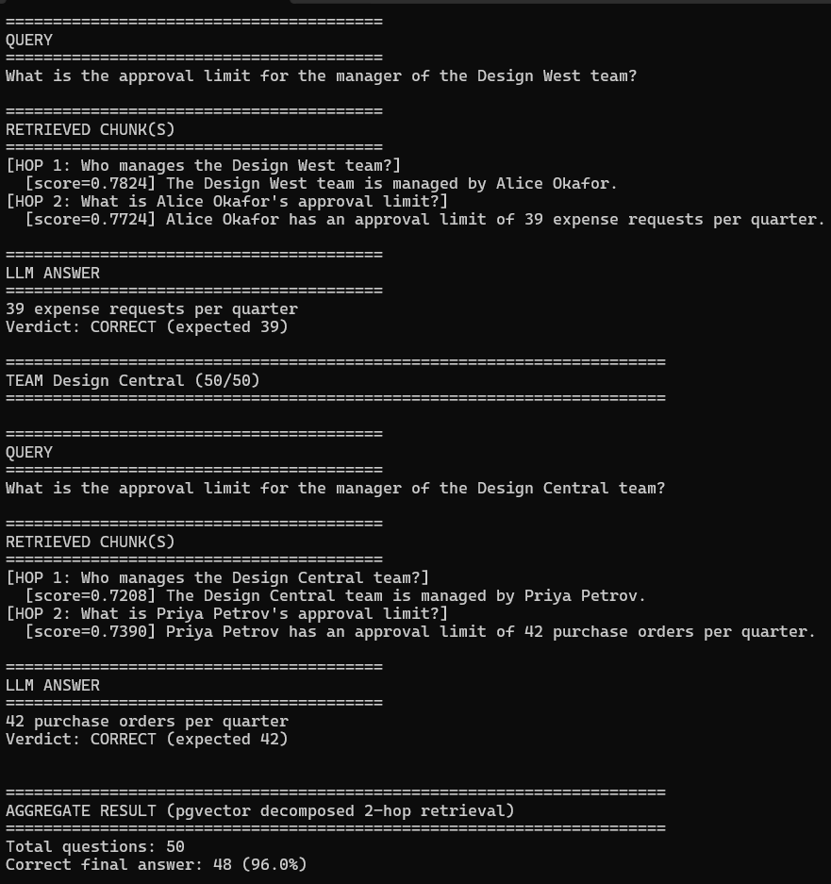
Status: not yet independently run — expected to match the FAISS decomposed-fix result above. Run this yourself and the result will be added here once confirmed.

Version lab1_5_pgvector_auto_agent.py

"""
lab1_5_pgvector_auto_agent.py
================================
A small constrained agent for the Lab 1.5 corpus. It decides whether a
question needs the team -> manager -> approval-limit plan, executes the
necessary pgvector searches, and uses one final LLM call for the answer.

The planner is deliberately deterministic: supported intents are selected
from validated question patterns, while unknown questions use direct search.
"""

import os
import json
import re

import psycopg2
from pgvector.psycopg2 import register_vector
from psycopg2.extras import execute_values
from sentence_transformers import SentenceTransformer
from dotenv import load_dotenv

from lab1_5_common import (
build_corpus,
client,
generate_answer,
get_chunks,
MODEL,
)

class AutoMultiHopAgent:
"""Plan and execute bounded retrieval workflows over pgvector."""

TABLE_NAME = "lab1_5_auto_agent_chunks"
EMBED_DIM = 384

def __init__(self, connection_config, embedding_model="all-MiniLM-L6-v2"):
self.embed_model = SentenceTransformer(embedding_model)
self.conn = psycopg2.connect(**connection_config)
self.conn.autocommit = True
register_vector(self.conn)
self._ensure_schema()

def _ensure_schema(self):
with self.conn.cursor() as cur:
cur.execute("CREATE EXTENSION IF NOT EXISTS vector;")
cur.execute(f"""
CREATE TABLE IF NOT EXISTS {self.TABLE_NAME} (
id bigserial PRIMARY KEY,
team text NOT NULL,
manager text NOT NULL,
role text NOT NULL,
chunk_text text NOT NULL,
embedding vector({self.EMBED_DIM}) NOT NULL
);
""")
cur.execute(f"""
CREATE INDEX IF NOT EXISTS {self.TABLE_NAME}_role_idx
ON {self.TABLE_NAME} (role);
""")
cur.execute(f"""
CREATE INDEX IF NOT EXISTS {self.TABLE_NAME}_embedding_hnsw
ON {self.TABLE_NAME}
USING hnsw (embedding vector_cosine_ops);
""")

def load_demo_corpus(self, num_teams=50, seed=42):
"""Load the deterministic lab corpus once for demonstration."""
records = build_corpus(num_teams=num_teams, seed=seed)
chunks, meta = get_chunks(records)
rows = []
for chunk_text, metadata, record in zip(
chunks,
meta,
[record for record in records for _ in (0, 1)],
):
rows.append((
record["team"],
record["manager"],
metadata["role"],
chunk_text,
None,
))

embeddings = self.embed_model.encode(
chunks,
normalize_embeddings=True,
)
rows = [row[:-1] + (embedding,) for row, embedding in zip(rows, embeddings)]

with self.conn.cursor() as cur:
cur.execute(f"SELECT COUNT(*) FROM {self.TABLE_NAME};")
if cur.fetchone()[0] != 0:
return records
execute_values(
cur,
f"""
INSERT INTO {self.TABLE_NAME}
(team, manager, role, chunk_text, embedding)
VALUES %s
""",
rows,
page_size=500,
)
return records

def _retrieve(self, query, team=None, role=None, manager=None, top_k=1):
query_embedding = self.embed_model.encode(
[query],
normalize_embeddings=True,
)[0]
filters = []
parameters = [query_embedding]
if team is not None:
filters.append("team = %s")
parameters.append(team)
if role is not None:
filters.append("role = %s")
parameters.append(role)
if manager is not None:
filters.append("manager = %s")
parameters.append(manager)
where_clause = f"WHERE {' AND '.join(filters)}" if filters else ""
parameters.extend([query_embedding, top_k])

with self.conn.cursor() as cur:
cur.execute(
f"""
SELECT chunk_text, 1 - (embedding <=> %s) AS similarity
FROM {self.TABLE_NAME}
{where_clause}
ORDER BY embedding <=> %s
LIMIT %s;
""",
parameters,
)
return cur.fetchall()

@staticmethod
def _direct_plan():
return {"intent": "direct", "team": None}

def _plan(self, question):
planner_prompt = f"""Classify this question for a retrieval agent.
Return JSON only, with exactly these fields:
{{"intent":"manager_approval_limit"|"direct","team":string|null}}

Use manager_approval_limit when the answer requires finding a team's manager
first and then finding that manager's approval limit. Extract the team name
from the question. Use direct for every other question.

QUESTION:
{question}
"""
try:
response = client.chat.completions.create(
model=MODEL,
messages=[{"role": "user", "content": planner_prompt}],
temperature=0,
)
content = response.choices[0].message.content.strip()
plan = json.loads(content)
except (json.JSONDecodeError, AttributeError, IndexError, TypeError):
return self._direct_plan()

if plan.get("intent") == "direct":
return self._direct_plan()
if plan.get("intent") != "manager_approval_limit":
return self._direct_plan()
if not isinstance(plan.get("team"), str) or not plan["team"].strip():
return self._direct_plan()
return {
"intent": "manager_approval_limit",
"team": plan["team"].strip(),
}

def answer(self, question):
plan = self._plan(question)
retrieved = []

if plan["intent"] == "manager_approval_limit":
hop1_query = f"Who manages the {plan['team']} team?"
hop1_results = self._retrieve(
hop1_query,
team=plan["team"],
role="bridge_manager",
top_k=1,
)
if not hop1_results:
return "Not found in the provided context.", plan, retrieved

manager_match = re.search(
r"managed by (.+)\.",
hop1_results[0][0],
)
if not manager_match:
return "Not found in the provided context.", plan, hop1_results

manager = manager_match.group(1)
hop2_query = f"What is {manager}'s approval limit?"
hop2_results = self._retrieve(
hop2_query,
role="target_limit",
manager=manager,
top_k=1,
)
retrieved = hop1_results + hop2_results
else:
retrieved = self._retrieve(question, top_k=3)

if not retrieved:
return "Not found in the provided context.", plan, retrieved

context = "\n".join(chunk_text for chunk_text, _ in retrieved)
return generate_answer(context, question), plan, retrieved

def close(self):
self.conn.close()

if __name__ == "__main__":
load_dotenv()
pg_config = {
"host": os.environ.get("PG_HOST", "localhost"),
"port": os.environ.get("PG_PORT", "5432"),
"dbname": os.environ.get("PG_DB", "rag_labs"),
"user": os.environ.get("PG_USER", "postgres"),
"password": os.environ.get("PG_PASSWORD"),
}

agent = AutoMultiHopAgent(pg_config)
records = agent.load_demo_corpus()
question = next(
record["query"]
for record in records
if record["team"] == "Engineering North"
)
answer, plan, retrieved = agent.answer(question)

print("Plan:", plan)
print("Retrieved:")
for chunk_text, score in retrieved:
print(f"[score={score:.4f}] {chunk_text}")
print("Answer:", answer)
agent.close()

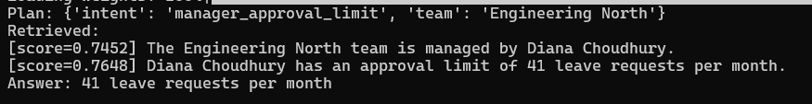

Version lab1_5_pgvector_langgraph_agent.py

"""
lab1_5_pgvector_langgraph_agent.py
====================================
LangGraph version of the Lab 1.5 multi-hop agent.

The graph makes the workflow explicit:

resolve_bridge -> conditional route -> retrieve_target -> answer
\-> answer (when no bridge is found)

Retrieval remains a fixed PostgreSQL/pgvector tool. LangGraph coordinates the
state transitions; it does not generate SQL or execute arbitrary tools.
"""

import os
import re
from typing import Any, TypedDict

import psycopg2
from dotenv import load_dotenv
from langgraph.graph import END, START, StateGraph
from pgvector.psycopg2 import register_vector
from psycopg2.extras import execute_values
from sentence_transformers import SentenceTransformer

from lab1_5_common import build_corpus, generate_answer, get_chunks

class AgentState(TypedDict, total=False):
question: str
bridge_query: str
target_query: str
manager: str | None
retrieved: list[tuple[str, float]]
answer: str
route: str

class LangGraphMultiHopAgent:
TABLE_NAME = "lab1_5_langgraph_chunks"
EMBED_DIM = 384

def __init__(self, connection_config, embedding_model="all-MiniLM-L6-v2"):
self.embed_model = SentenceTransformer(embedding_model)
self.conn = psycopg2.connect(**connection_config)
self.conn.autocommit = True
register_vector(self.conn)
self._ensure_schema()
self.graph = self._build_graph()

def _ensure_schema(self):
with self.conn.cursor() as cur:
cur.execute("CREATE EXTENSION IF NOT EXISTS vector;")
cur.execute(f"""
CREATE TABLE IF NOT EXISTS {self.TABLE_NAME} (
id bigserial PRIMARY KEY,
team text NOT NULL,
manager text NOT NULL,
role text NOT NULL,
chunk_text text NOT NULL,
embedding vector({self.EMBED_DIM}) NOT NULL
);
""")
cur.execute(f"""
CREATE INDEX IF NOT EXISTS {self.TABLE_NAME}_role_idx
ON {self.TABLE_NAME} (role);
""")
cur.execute(f"""
CREATE INDEX IF NOT EXISTS {self.TABLE_NAME}_embedding_hnsw
ON {self.TABLE_NAME}
USING hnsw (embedding vector_cosine_ops);
""")

def load_demo_corpus(self, num_teams=50, seed=42):
records = build_corpus(num_teams=num_teams, seed=seed)
chunks, meta = get_chunks(records)
record_pairs = [record for record in records for _ in (0, 1)]
embeddings = self.embed_model.encode(
chunks,
normalize_embeddings=True,
)
rows = [
(
record["team"],
record["manager"],
metadata["role"],
chunk,
embedding,
)
for chunk, metadata, record, embedding in zip(
chunks, meta, record_pairs, embeddings
)
]

with self.conn.cursor() as cur:
cur.execute(f"SELECT COUNT(*) FROM {self.TABLE_NAME};")
if cur.fetchone()[0] == 0:
execute_values(
cur,
f"""
INSERT INTO {self.TABLE_NAME}
(team, manager, role, chunk_text, embedding)
VALUES %s
""",
rows,
page_size=500,
)
return records

def _retrieve(self, query, role=None, manager=None, top_k=1):
query_embedding = self.embed_model.encode(
[query],
normalize_embeddings=True,
)[0]
filters = []
parameters: list[Any] = [query_embedding]
if role is not None:
filters.append("role = %s")
parameters.append(role)
if manager is not None:
filters.append("manager = %s")
parameters.append(manager)
where_clause = f"WHERE {' AND '.join(filters)}" if filters else ""
parameters.extend([query_embedding, top_k])

with self.conn.cursor() as cur:
cur.execute(
f"""
SELECT chunk_text, 1 - (embedding <=> %s) AS similarity
FROM {self.TABLE_NAME}
{where_clause}
ORDER BY embedding <=> %s
LIMIT %s;
""",
parameters,
)
return [(text, float(score)) for text, score in cur.fetchall()]

def _resolve_bridge(self, state: AgentState) -> AgentState:
question = state["question"]
bridge_query = f"Who manages the team mentioned in this question? {question}"
bridge_results = self._retrieve(
bridge_query,
role="bridge_manager",
top_k=1,
)
if not bridge_results:
return {
"bridge_query": bridge_query,
"manager": None,
"retrieved": [],
"route": "answer",
}

manager_match = re.search(r"managed by (.+)\.", bridge_results[0][0])
if not manager_match:
return {
"bridge_query": bridge_query,
"manager": None,
"retrieved": bridge_results,
"route": "answer",
}

return {
"bridge_query": bridge_query,
"manager": manager_match.group(1),
"retrieved": bridge_results,
"route": "retrieve_target",
}

@staticmethod
def _continue_or_answer(state: AgentState) -> str:
return state.get("route", "answer")

def _retrieve_target(self, state: AgentState) -> AgentState:
manager = state["manager"]
target_query = f"What is {manager}'s approval limit?"
target_results = self._retrieve(
target_query,
role="target_limit",
manager=manager,
top_k=1,
)
return {
"target_query": target_query,
"retrieved": state.get("retrieved", []) + target_results,
"route": "answer",
}

@staticmethod
def _answer(state: AgentState) -> AgentState:
retrieved = state.get("retrieved", [])
if not retrieved:
return {"answer": "Not found in the provided context."}
context = "\n".join(text for text, _ in retrieved)
return {"answer": generate_answer(context, state["question"])}

def _build_graph(self):
workflow = StateGraph(AgentState)
workflow.add_node("resolve_bridge", self._resolve_bridge)
workflow.add_node("retrieve_target", self._retrieve_target)
workflow.add_node("answer", self._answer)
workflow.add_edge(START, "resolve_bridge")
workflow.add_conditional_edges(
"resolve_bridge",
self._continue_or_answer,
{
"retrieve_target": "retrieve_target",
"answer": "answer",
},
)
workflow.add_edge("retrieve_target", "answer")
workflow.add_edge("answer", END)
return workflow.compile()

def answer(self, question):
return self.graph.invoke({"question": question})

def close(self):
self.conn.close()

if __name__ == "__main__":
load_dotenv()
pg_config = {
"host": os.environ.get("PG_HOST", "localhost"),
"port": os.environ.get("PG_PORT", "5432"),
"dbname": os.environ.get("PG_DB", "rag_labs"),
"user": os.environ.get("PG_USER", "postgres"),
"password": os.environ.get("PG_PASSWORD"),
}

agent = LangGraphMultiHopAgent(pg_config)
records = agent.load_demo_corpus()
question = next(
record["query"]
for record in records
if record["team"] == "Engineering North"
)
result = agent.answer(question)

print("Bridge query:", result.get("bridge_query"))
print("Resolved manager:", result.get("manager"))
print("Target query:", result.get("target_query"))
print("Retrieved:")
for chunk_text, score in result.get("retrieved", []):
print(f"[score={score:.4f}] {chunk_text}")
print("Answer:", result.get("answer"))
agent.close()

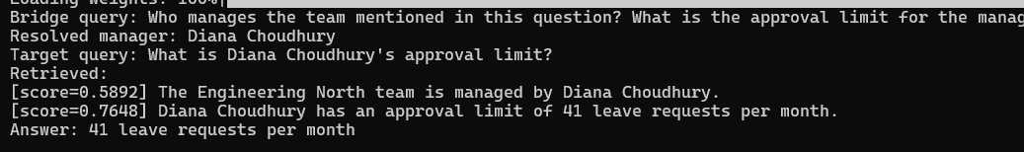

Part 7: Interview Cheat-Sheet (Reference Your Own Code)
Q: What is a multi-hop question, and why does standard RAG fail at it?
A: A question where the answer requires combining facts from two or more different places, where the second fact often isn't discoverable from the original question's wording at all -- it's only reachable after resolving a 'bridge entity' from the first fact. I built a corpus specifically to make this concrete: 'What is the approval limit for the manager of the X team?' requires first finding WHO manages team X, then looking up THAT PERSON's limit -- and single-shot retrieval measured at just 2% accuracy on this corpus, because the target fact's chunk gives the query no lexical handle to find it directly.
Q: How does query decomposition actually fix this?
A: By resolving the bridge entity first, then rewriting the SECOND query using information extracted from the first hop's result, instead of retrieving once against the original question. I measured this directly: decomposed 2-hop retrieval took the exact same corpus and embedding model from 2% accuracy to 96% -- the only variable that changed was whether retrieval ran once or twice, with the second retrieval informed by the first.
Q: Why was target-fact retrieval so much worse than bridge-fact retrieval in your naive test (4% vs 48%)?
A: By deliberate corpus design -- every 'target fact' chunk shares nearly identical wording ('X has an approval limit of N Y per Z'), so the query has almost no way to discriminate the correct manager's chunk from any of the ~49 other equally-worded chunks, since the manager's name never appears in the original question. The bridge fact chunk at least shares the team name with the query, giving it a real (if still weak at 48%) discriminating signal.
Q: What's the production-standard way to implement this pattern?
A: LangGraph -- its graph-based state machine maps directly onto a multi-hop retrieval loop: a node resolves the bridge, a conditional edge decides whether more retrieval is needed, and a second node retrieves again with the rewritten query. What I built by hand is the same underlying loop, implemented explicitly with a deterministic regex extraction step instead of an LLM call, since this lab's bridge entity has a fixed, parseable format.
Q: Is decomposition always necessary? What's the cost trade-off?
A: No -- and this matters for production judgment, not just correctness. Adding a second retrieval and LLM call roughly doubles cost and latency for every query, whether or not the question actually needs it. Production systems typically add a query classifier upfront (simple factual query -> single-shot retrieval; complex/comparative query -> decomposition), rather than decomposing every request by default.
Q: How would you debug a suspected multi-hop failure in production?
A: The same layered diagnosis as every other lab in this series: log the raw retrieved chunks before generation. If a required fact is simply absent from what was retrieved, that's a retrieval-strategy problem -- check specifically whether the missing fact required information not present in the original query, which is the signature of a bridge-entity multi-hop gap rather than a chunking or embedding-quality issue.
Next: Lab 1.6 — RAG at Scale.

