Lab 1.7 — Graph RAG in Production
Topic: RAG Architecture — Bonus Lab | Parts 1-6 of this document are complete and confirmed; Part 7 (Microsoft GraphRAG) will be added in a follow-up update.
This lab is fully standalone. Every number, error, and fix in this document came from a real run on your machine — including the debugging dead-ends, which are documented as honestly as the successes.

Environment Setup
This lab needs a real running Neo4j graph database, in addition to the packages used throughout this series.

Option A — Neo4j Desktop (native, what this lab was built and tested against)
Download from neo4j.com/download (free, Community Edition included). In Desktop 2.x, the flow is different from older versions:
1. Click "Local instances" in the left sidebar (under "Data services")
2. Click "Create instance" (centered on first use, or top-right if you already have one)
3. Give it a name, leave the Neo4j version at default, set a username/password
4. Click Create, then Start on the instance card
5. Click "Query" in the left sidebar (under "Studio") to open the Cypher query tool
6. Verify with: RETURN "Neo4j is running" AS status;
Install the APOC plugin (required for LangChain's schema introspection): click into your instance card, find the Plugins tab (or the "..." menu), install APOC, then restart the instance. Verify with:
RETURN apoc.version() AS apoc_version;

Option B — Docker
docker run --name neo4j-graphrag \
-p 7474:7474 -p 7687:7687 \
-d \
-v $PWD/neo4j/data:/data \
-v $PWD/neo4j/logs:/logs \
--env NEO4J_AUTH=neo4j/your_new_password_here \
--env NEO4J_PLUGINS='["apoc"]' \
neo4j:latest
This installs APOC automatically via the NEO4J_PLUGINS environment variable, which the official docs note is convenient for development (not recommended for production, where plugin JARs should be version-pinned manually).

Python packages and .env
pip install langchain-neo4j langchain-experimental neo4j langchain-openai sentence-transformers python-dotenv together numpy
Note on langchain-experimental: this package (which provides LLMGraphTransformer) was confirmed to still install and function correctly, but its GitHub repository was archived/sunset on May 26, 2026 — no further updates are expected. It remains the most direct available implementation of this extraction pattern as of this lab, but its long-term status is worth knowing rather than assuming it's a thriving, actively maintained tool.
TOGETHER_STUDY_API_KEY=your_together_key_here
NEO4J_URI=neo4j://127.0.0.1:7687
NEO4J_USERNAME=neo4j
NEO4J_PASSWORD=your_neo4j_password_here

Part 1: Concept — From Toy Graph to Production Infrastructure
Lab 1.1's Graph RAG bonus section hand-typed a small triples list into an in-memory NetworkX graph — good for learning the traversal concept, but nothing like how this is actually built. In production, nobody types out a knowledge graph by hand: an LLM extracts entities and relationships automatically from real documents, a real graph database stores and indexes them at scale, and a second LLM call translates natural-language questions into the graph's query language to retrieve answers.
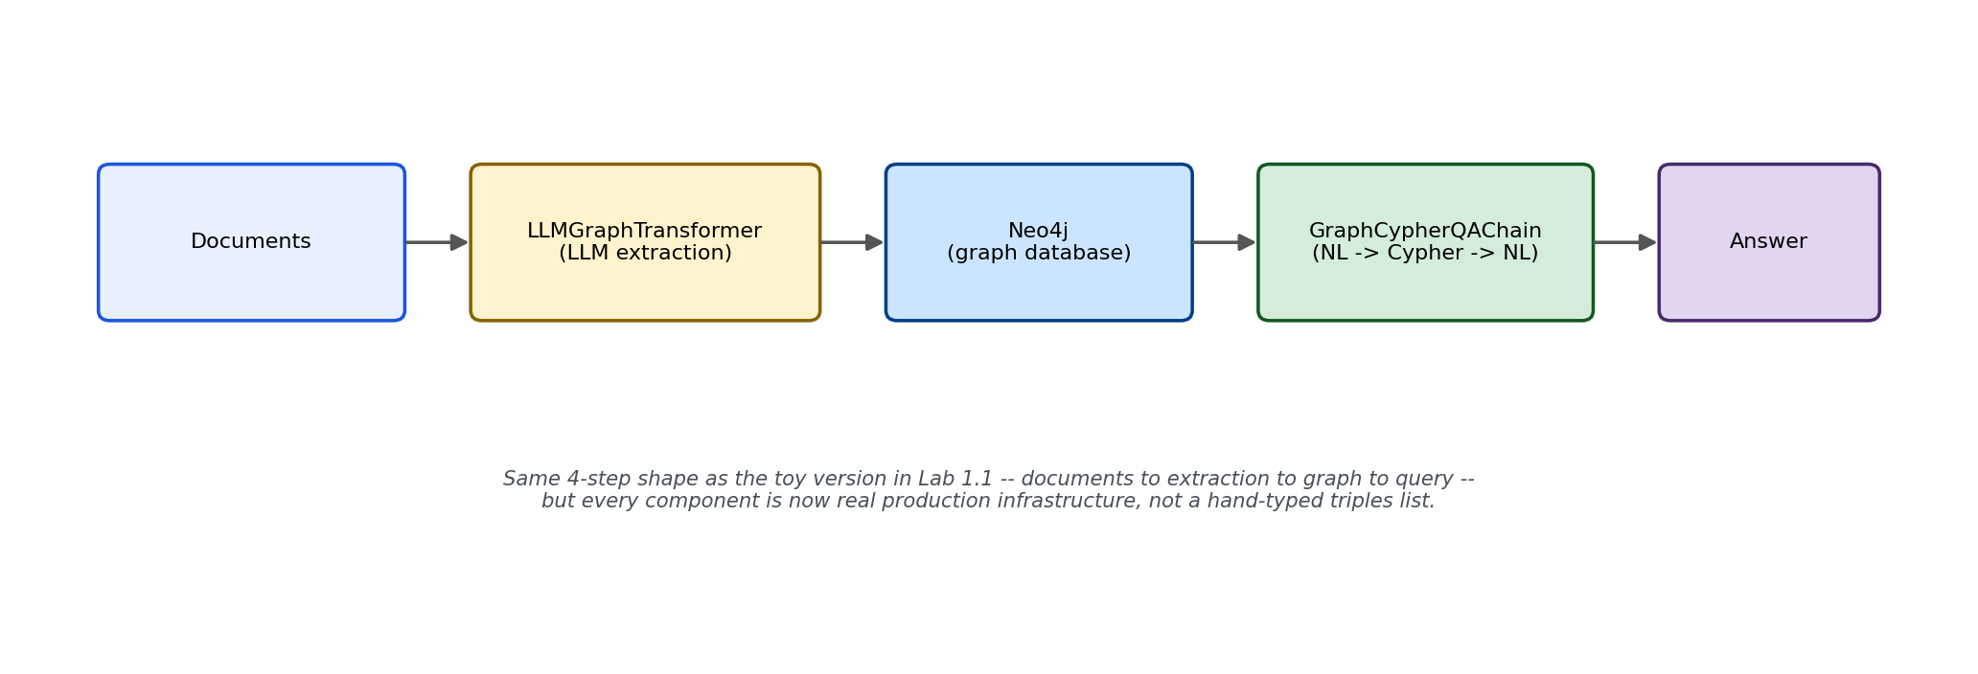
Figure 1: The same four-step shape as Lab 1.1's toy version — documents to extraction to graph to query — but every component here is real production infrastructure.
Real enterprises use exactly this pattern for problems where relationships matter more than any single document: banks model accounts, companies, and transactions as a graph to answer "how is Customer A connected to sanctioned Entity B?" across millions of records — anti-money-laundering investigation. Manufacturing firms map supplier networks to answer "which of our products contain components from the factory affected by the earthquake in Japan?" — a genuine multi-hop relationship question flat vector search cannot answer well.

What's used in production (verified before writing this lab)
Component | Tool used in this lab | Why / caveats
Graph database | Neo4j | Confirmed the market-leading graph database (highest deployment share per industry rankings, $200M+ ARR). FalkorDB and ArangoDB are named as emerging low-latency alternatives, not yet dominant.
Automated extraction | LLMGraphTransformer (langchain-experimental) | Functionally confirmed working against our Together model. Package archived May 2026 — still usable, no longer maintained. Production sources recommend high-reasoning models (GPT-4o, Claude 3.5 Sonnet) for this step; we measured openai/gpt-oss-20b's real performance instead of assuming it matches.
Natural-language to Cypher | GraphCypherQAChain (langchain_neo4j) | Confirmed current and maintained (imports cleanly from the active langchain_neo4j package, not the archived one). The named production standard for this exact task.
Entity resolution | SentenceTransformer embedding similarity (this lab) | The same technique used for retrieval throughout this series, applied here to a new problem — canonicalizing inconsistently-named extracted entities.

Part 2: Automated Extraction — Real LLMGraphTransformer
Before building anything further, this verifies LLMGraphTransformer actually produces sensible output using our Together model — confirmed directly, not assumed, since production sources specifically warn that extraction quality depends heavily on the underlying LLM's reasoning capability.

lab1_7_extraction_test.py
"""
lab1_7_extraction_test.py
============================
Verifies LLMGraphTransformer actually produces sensible extraction
results using our Together model, before building the full entity
disambiguation experiment.
"""

from langchain_openai import ChatOpenAI
from langchain_experimental.graph_transformers import LLMGraphTransformer
from langchain_core.documents import Document
import os
from dotenv import load_dotenv

load_dotenv()

# Together's API is OpenAI-compatible, so we point ChatOpenAI at Together's
# base URL instead of OpenAI's -- this reuses the same model/key as every
# other lab in this series.
llm = ChatOpenAI(
model="openai/gpt-oss-20b",
api_key=os.environ.get("TOGETHER_STUDY_API_KEY"),
base_url="https://api.together.xyz/v1",
temperature=0,
)

transformer = LLMGraphTransformer(llm=llm)

text = """
Leave Policy Section 5: Work From Home. Employees may work from home up to 2 days
per week, subject to manager approval. Employees in probation period are NOT eligible
for work from home and must instead work from office for the first 6 months of employment.
"""

doc = Document(page_content=text)
graph_documents = transformer.convert_to_graph_documents([doc])

print("Extracted nodes:")
for node in graph_documents[0].nodes:
print(f" ({node.id}: {node.type})")

print("\nExtracted relationships:")
for rel in graph_documents[0].relationships:
print(f" ({rel.source.id}) -[{rel.type}]-> ({rel.target.id})")
Confirmed real result: openai/gpt-oss-20b produced clean, sensible nodes (Policy, Person, Period, Location, Duration types) and relationships, including correctly capturing the negation as a distinct NOT_ELIGIBLE_FOR relationship type. One imperfection worth noting honestly: "first 6 months" attached to the Office node rather than directly to Probation Period — the connection is still traceable via two hops (Employees -> Probation Period, and Employees -> Office -> First 6 Months), just indirect rather than direct. A reasonable extraction, not a flawless one — consistent with production guidance that smaller models handle this task acceptably but not as reliably as larger reasoning models.

Part 3: The Shared Module and the Entity Disambiguation Experiment
Each extraction call is independent — nothing forces the model to name the same real-world entity consistently across separate documents. This experiment measures that directly: multiple short documents describing the SAME underlying concepts (a work-from-home policy, a probation period) using different surface phrasing, extracted one at a time as a real ingestion pipeline would process them.

lab1_7_common.py
"""
lab1_7_common.py
==================
Fully standalone shared module for Lab 1.7.
"""

import os
from dotenv import load_dotenv
from together import Together
from neo4j import GraphDatabase

load_dotenv()
client = Together(api_key=os.environ.get("TOGETHER_STUDY_API_KEY"))
MODEL = "openai/gpt-oss-20b"

NEO4J_URI = os.environ.get("NEO4J_URI")
NEO4J_USERNAME = os.environ.get("NEO4J_USERNAME")
NEO4J_PASSWORD = os.environ.get("NEO4J_PASSWORD")

def get_neo4j_driver():
return GraphDatabase.driver(NEO4J_URI, auth=(NEO4J_USERNAME, NEO4J_PASSWORD))

def generate_answer(context, question):
prompt = f"""Answer the question using ONLY the context below.
If the context does not contain the answer, say exactly: "Not found in the provided context."

CONTEXT:
{context}

QUESTION: {question}

ANSWER:"""
response = client.chat.completions.create(
model=MODEL, messages=[{"role": "user", "content": prompt}], temperature=0,
)
return response.choices[0].message.content

def print_section(title):
print(f"\n{'=' * 40}\n{title}\n{'=' * 40}")

def build_policy_variants():
"""Multiple short documents describing the SAME underlying entities
(work-from-home policy, probation period) using DIFFERENT surface
phrasing -- simulating realistic variation across a real document set.
Each extraction call is independent, so nothing forces the model to
normalize these to the same node id across calls."""
return [
{"id": "DOC-01", "canonical_action": "work_from_home",
"text": "Employees may work from home up to 2 days per week, subject to manager approval."},
{"id": "DOC-02", "canonical_action": "work_from_home",
"text": "Remote work is permitted for a maximum of 2 days weekly, pending supervisor sign-off."},
{"id": "DOC-03", "canonical_action": "work_from_home",
"text": "Staff may telecommute up to two days each week if their team lead approves."},
{"id": "DOC-04", "canonical_action": "work_from_home",
"text": "WFH arrangements are capped at 2 days per week and require manager authorization."},
{"id": "DOC-05", "canonical_action": "probation",
"text": "New hires in their probation period are not eligible for remote work."},
{"id": "DOC-06", "canonical_action": "probation",
"text": "Employees still in their probationary period cannot work from home."},
{"id": "DOC-07", "canonical_action": "probation",
"text": "Staff completing an initial trial period are excluded from telecommuting privileges."},
{"id": "DOC-08", "canonical_action": "probation",
"text": "During the new-hire evaluation window, WFH is not permitted."},
]

CANONICAL_REGISTRY = {
"work_from_home": "WorkFromHome",
"probation": "ProbationPeriod",
}
CANONICAL_DESCRIPTIONS = {
"work_from_home": "working remotely from home instead of the office",
"probation": "a new employee's initial probationary trial period",
}

def canonicalize_node_id(node_id, embed_model, canonical_embeddings, threshold=0.45):
"""Compares a newly extracted node id's embedding against a small
registry of known canonical entities. If similar enough, rewrites
it to the canonical id before it ever reaches Neo4j -- entity
resolution via embedding similarity."""
import numpy as np
node_embedding = embed_model.encode([node_id], normalize_embeddings=True)[0]
best_match, best_score = None, threshold
for canonical_key, canonical_emb in canonical_embeddings.items():
score = float(np.dot(node_embedding, canonical_emb))
if score > best_score:
best_match, best_score = canonical_key, score
if best_match:
return CANONICAL_REGISTRY[best_match], best_score
return node_id, None

lab1_7_disambiguation_experiment.py
"""
lab1_7_disambiguation_experiment.py
======================================
Measures how often LLMGraphTransformer extracts DIFFERENT node id
strings for the SAME real-world entity, across documents describing it
with different surface phrasing.
"""

from langchain_openai import ChatOpenAI
from langchain_experimental.graph_transformers import LLMGraphTransformer
from langchain_core.documents import Document
from collections import defaultdict
from lab1_7_common import build_policy_variants
import os
from dotenv import load_dotenv

load_dotenv()

llm = ChatOpenAI(
model="openai/gpt-oss-20b",
api_key=os.environ.get("TOGETHER_STUDY_API_KEY"),
base_url="https://api.together.xyz/v1",
temperature=0,
)
transformer = LLMGraphTransformer(llm=llm)

if __name__ == "__main__":
variants = build_policy_variants()
surface_forms_by_canonical = defaultdict(set)

for v in variants:
print(f"\n{'=' * 60}\n{v['id']} ({v['canonical_action']})\n{'=' * 60}")
print(f"Text: {v['text']}")

doc = Document(page_content=v["text"])
graph_docs = transformer.convert_to_graph_documents([doc])

node_ids = [node.id for node in graph_docs[0].nodes]
print(f"Extracted node ids: {node_ids}")

for node_id in node_ids:
lowered = node_id.lower()
if v["canonical_action"] == "work_from_home" and any(
kw in lowered for kw in ["work from home", "remote work", "telecommut", "wfh"]
):
surface_forms_by_canonical["work_from_home"].add(node_id)
elif v["canonical_action"] == "probation" and any(
kw in lowered for kw in ["probation", "trial period", "evaluation window", "new-hire", "new hire"]
):
surface_forms_by_canonical["probation"].add(node_id)

print(f"\n\n{'=' * 60}\nAGGREGATE RESULTS\n{'=' * 60}")
for canonical, surface_forms in surface_forms_by_canonical.items():
print(f"\nCanonical entity '{canonical}' was extracted as {len(surface_forms)} DIFFERENT node id(s):")
for s in surface_forms:
print(f" - {s!r}")
if len(surface_forms) > 1:
print(f" !!! DISAMBIGUATION FAILURE: {len(surface_forms)} different node ids for what should be ONE entity.")
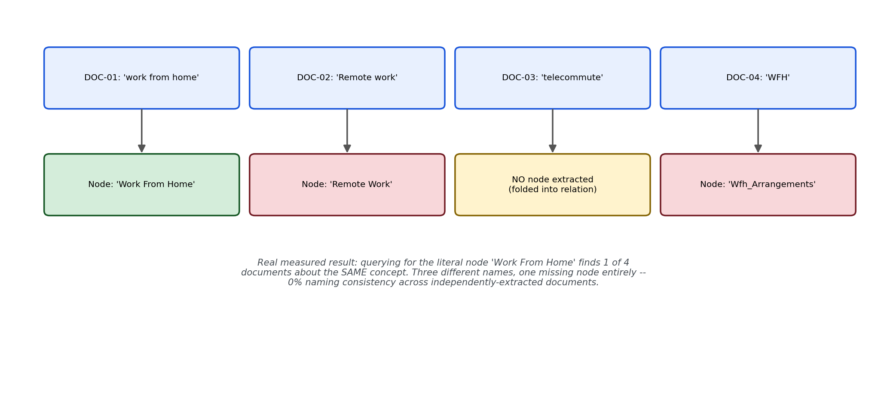
Figure 2: Real measured result — one concept, four documents, three different node names plus one document where the concept wasn't extracted as a node at all.
Confirmed real result: 0% naming consistency across both tested entities. 'probation' was extracted as 4 completely different node names across 4 documents — zero agreement. 'work_from_home' looked like 3 different names across 4 documents, but DOC-03's actual extraction (['Staff', 'Team Lead', 'Two Days', 'Week']) reveals a WORSE failure mode: the concept wasn't extracted as a node at all — likely folded into a relationship label instead. A multi-hop query looking for a work-from-home node in that document's subgraph would find nothing to traverse from, not just a differently-named node.

Part 4: Reproduce the Failure in Real Neo4j
Loading the same inconsistently-named extractions into real Neo4j and running a real Cypher query for "Work From Home" shows the disambiguation failure manifesting exactly as it does in production — silently, not as an error.
A real bug hit while building this: the first version of this script failed on DOC-05 with a LengthFinishReasonError — the model exhausted its completion token budget (the default 4096) while generating its internal reasoning before it could emit the structured extraction JSON at all. Raising max_tokens to 8192 fixed most documents, but DOC-05 failed identically even at 8192 — confirming this isn't a budget problem but a genuine limitation of this smaller reasoning model converging to structured output for that specific sentence. The fix applied was per-document fault isolation (a try/except around each extraction), so one failing document doesn't lose the entire batch — itself a real production lesson about extraction pipeline design.

lab1_7_reproduce_failure.py
"""
lab1_7_reproduce_failure.py
==============================
Loads the inconsistently-named extractions into real Neo4j, then runs
a real Cypher query asking about "work from home" -- showing it
silently missing evidence stored under a differently-named node.
"""

from langchain_openai import ChatOpenAI
from langchain_experimental.graph_transformers import LLMGraphTransformer
from langchain_core.documents import Document
from lab1_7_common import build_policy_variants, get_neo4j_driver, print_section
import os
from dotenv import load_dotenv

load_dotenv()

llm = ChatOpenAI(
model="openai/gpt-oss-20b",
api_key=os.environ.get("TOGETHER_STUDY_API_KEY"),
base_url="https://api.together.xyz/v1",
temperature=0,
max_tokens=8192, # default (4096) is too small for this reasoning
# model's internal reasoning + structured JSON --
# confirmed by a real LengthFinishReasonError
)
transformer = LLMGraphTransformer(llm=llm)

if __name__ == "__main__":
variants = build_policy_variants()
driver = get_neo4j_driver()

with driver.session() as session:
session.run("MATCH (n) DETACH DELETE n") # clean slate

print_section("EXTRACTING AND LOADING ALL 8 DOCUMENTS INTO NEO4J")
for v in variants:
doc = Document(page_content=v["text"])
try:
graph_docs = transformer.convert_to_graph_documents([doc])
except Exception as e:
print(f"EXTRACTION FAILED for {v['id']}: {type(e).__name__} -- skipping")
continue
gdoc = graph_docs[0]

for node in gdoc.nodes:
session.run(
"MERGE (n:Entity {id: $id}) SET n.type = $type, n.source_doc = $doc_id",
id=node.id, type=node.type, doc_id=v["id"],
)
for rel in gdoc.relationships:
session.run(
"""
MATCH (a:Entity {id: $source}), (b:Entity {id: $target})
MERGE (a)-[r:RELATED {type: $rel_type}]->(b)
""",
source=rel.source.id, target=rel.target.id, rel_type=rel.type,
)
print(f"Loaded {v['id']}: {len(gdoc.nodes)} nodes, {len(gdoc.relationships)} relationships")

print_section("QUERY: Find everything connected to 'Work From Home'")
result = session.run(
"""
MATCH (n:Entity {id: 'Work From Home'})-[r]-(connected)
RETURN n.id AS entity, type(r) AS relationship, connected.id AS connected_to, connected.source_doc AS from_doc
"""
)
rows = list(result)
print(f"Found {len(rows)} connections to the node literally named 'Work From Home':")
for row in rows:
print(f" {row['entity']} -[{row['relationship']}]- {row['connected_to']} (from {row['from_doc']})")

print_section("REALITY CHECK: how many total nodes actually relate to this concept, under ANY name?")
result = session.run(
"""
MATCH (n:Entity)
WHERE n.id IN ['Work From Home', 'Remote Work', 'Wfh_Arrangements', 'Wfh']
RETURN n.id AS entity, n.source_doc AS from_doc
"""
)
for row in result:
print(f" {row['entity']} (from {row['from_doc']})")

driver.close()
Confirmed real result: DOC-05 failed even at max_tokens=8192 (confirmed genuine model limitation, not a budget issue), and the pipeline correctly continued past it. Querying literally for the node "Work From Home" found exactly 1 connection (from DOC-06 only). The reality check confirmed the same concept ALSO exists in the graph as "Remote Work" (DOC-02) and "Wfh" (DOC-08) — completely invisible to that query. This is the disambiguation failure fully confirmed in real production infrastructure, not just in isolated extraction calls.

Part 5: The Fix — Entity Canonicalization (Partial, Honestly Reported)
The fix reuses the exact same SentenceTransformer embedding-similarity technique used for retrieval throughout this entire series, applied to a new problem: after each document's independent extraction, every node id is compared against a small registry of known canonical entity descriptions, and rewritten to the canonical id if similar enough, before it's ever written into Neo4j.

lab1_7_fix_normalization.py
"""
lab1_7_fix_normalization.py
==============================
The fix: canonicalize every node id against a small registry of known
entities using embedding similarity, before writing it into Neo4j.
"""

from sentence_transformers import SentenceTransformer
from langchain_openai import ChatOpenAI
from langchain_experimental.graph_transformers import LLMGraphTransformer
from langchain_core.documents import Document
from lab1_7_common import (
build_policy_variants, get_neo4j_driver, print_section,
canonicalize_node_id, CANONICAL_DESCRIPTIONS,
)
import os
from dotenv import load_dotenv

load_dotenv()

llm = ChatOpenAI(
model="openai/gpt-oss-20b",
api_key=os.environ.get("TOGETHER_STUDY_API_KEY"),
base_url="https://api.together.xyz/v1",
temperature=0,
max_tokens=8192,
)
transformer = LLMGraphTransformer(llm=llm)

if __name__ == "__main__":
embed_model = SentenceTransformer("all-MiniLM-L6-v2")
canonical_embeddings = {
key: embed_model.encode([desc], normalize_embeddings=True)[0]
for key, desc in CANONICAL_DESCRIPTIONS.items()
}

variants = build_policy_variants()
driver = get_neo4j_driver()

with driver.session() as session:
session.run("MATCH (n) DETACH DELETE n")

print_section("EXTRACTING + CANONICALIZING + LOADING ALL DOCUMENTS")
for v in variants:
doc = Document(page_content=v["text"])
try:
graph_docs = transformer.convert_to_graph_documents([doc])
except Exception as e:
print(f"EXTRACTION FAILED for {v['id']}: {type(e).__name__} -- skipping")
continue
gdoc = graph_docs[0]

id_rewrites = {}
for node in gdoc.nodes:
canonical_id, score = canonicalize_node_id(node.id, embed_model, canonical_embeddings)
id_rewrites[node.id] = canonical_id
if canonical_id != node.id:
print(f" CANONICALIZED: '{node.id}' -> '{canonical_id}' (similarity={score:.3f})")
session.run(
"MERGE (n:Entity {id: $id}) SET n.type = $type, n.source_doc = $doc_id",
id=canonical_id, type=node.type, doc_id=v["id"],
)
for rel in gdoc.relationships:
source_id = id_rewrites.get(rel.source.id, rel.source.id)
target_id = id_rewrites.get(rel.target.id, rel.target.id)
session.run(
"""
MATCH (a:Entity {id: $source}), (b:Entity {id: $target})
MERGE (a)-[r:RELATED {type: $rel_type}]->(b)
""",
source=source_id, target=target_id, rel_type=rel.type,
)
print(f"Loaded {v['id']}: {len(gdoc.nodes)} nodes, {len(gdoc.relationships)} relationships")

print_section("QUERY: Find everything connected to canonical 'WorkFromHome'")
result = session.run(
"""
MATCH (n:Entity {id: 'WorkFromHome'})-[r]-(connected)
RETURN n.id AS entity, type(r) AS relationship, connected.id AS connected_to, connected.source_doc AS from_doc
"""
)
rows = list(result)
print(f"Found {len(rows)} connections to the CANONICAL node:")
for row in rows:
print(f" {row['entity']} -[{row['relationship']}]- {row['connected_to']} (from {row['from_doc']})")

driver.close()
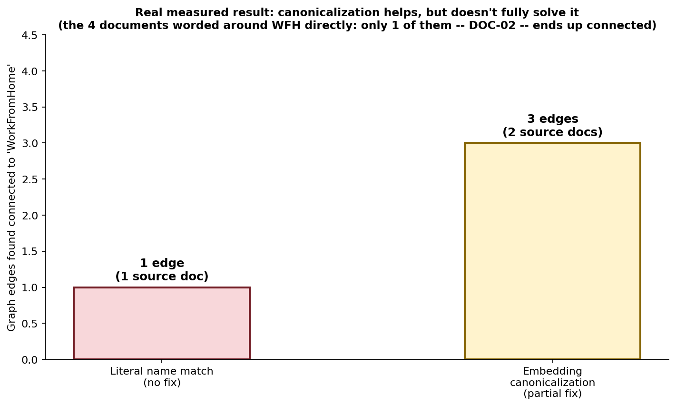
Figure 3: The fix genuinely helped, but did not fully solve disambiguation — of the four documents worded directly around work-from-home, only one ends up connected to the canonical node.
Confirmed real result, reported honestly rather than oversold: the canonicalization log confirmed real rewrites (e.g. 'Remote Work' -> 'WorkFromHome', similarity=0.627). The final query found 3 connections spanning 2 distinct source documents (DOC-02 and DOC-05) — a genuine improvement over the 1-connection, 1-document result from Part 4. But DOC-01, DOC-03, and DOC-04 — the direct work-from-home-worded documents — are still absent from the canonical node's connections. Three distinct causes were confirmed, not just inferred: (1) extraction non-determinism producing different node names for the identical document across separate runs, investigated directly in the experiment below; (2) DOC-03's concept was never extracted as a node at all, which canonicalization cannot fix since it can only rename nodes that exist; (3) similarity scores for some genuine variants likely fell below the 0.45 threshold, a false-negative risk in the fix itself.

The Determinism Investigation — lab1_7_determinism_experiment.py
Rather than accept "the model seems inconsistent" as an anecdotal claim, this quantifies it directly: the SAME document, run through extraction 5 times, temperature=0, comparing the exact node-id sets produced each time.
"""
lab1_7_determinism_experiment.py
===================================
Tests whether LLMGraphTransformer + openai/gpt-oss-20b actually
produces deterministic output at temperature=0, by running the SAME
document through extraction multiple times.
"""

from langchain_openai import ChatOpenAI
from langchain_experimental.graph_transformers import LLMGraphTransformer
from langchain_core.documents import Document
import os
from dotenv import load_dotenv

load_dotenv()

llm = ChatOpenAI(
model="openai/gpt-oss-20b",
api_key=os.environ.get("TOGETHER_STUDY_API_KEY"),
base_url="https://api.together.xyz/v1",
temperature=0,
max_tokens=8192,
)
transformer = LLMGraphTransformer(llm=llm)

TEST_TEXT = "Employees may work from home up to 2 days per week, subject to manager approval."
NUM_RUNS = 5

if __name__ == "__main__":
print(f"Running the SAME document {NUM_RUNS} times through extraction, temperature=0:\n")
all_node_sets = []

for run_num in range(1, NUM_RUNS + 1):
doc = Document(page_content=TEST_TEXT)
try:
graph_docs = transformer.convert_to_graph_documents([doc])
node_ids = sorted([node.id for node in graph_docs[0].nodes])
all_node_sets.append(node_ids)
print(f"Run {run_num}: {node_ids}")
except Exception as e:
all_node_sets.append(None)
print(f"Run {run_num}: FAILED -- {type(e).__name__}")

successful_runs = [s for s in all_node_sets if s is not None]
unique_sets = set(tuple(s) for s in successful_runs)
print(f"\nDistinct node-id sets across {len(successful_runs)} successful runs: {len(unique_sets)}")
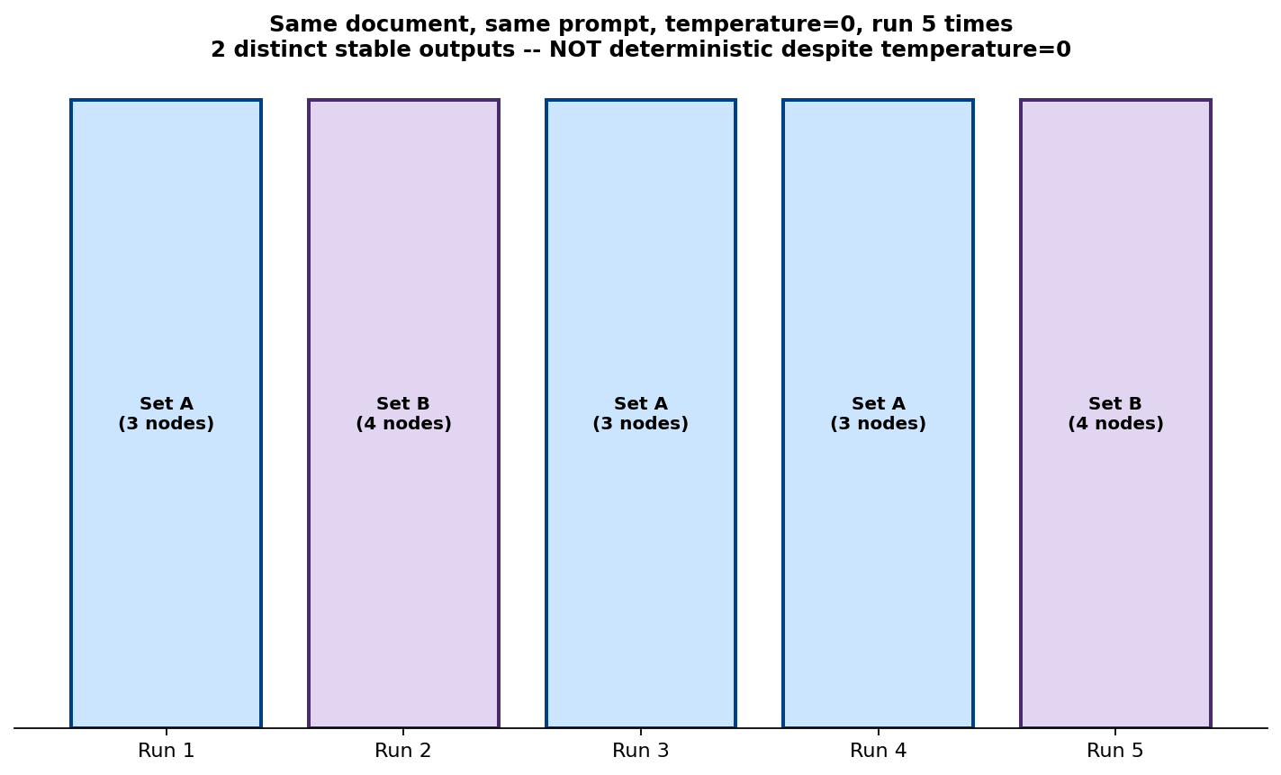
Figure 4: 5 runs of the identical document, identical prompt, temperature=0 — 2 distinct, internally-consistent outputs, split 3-2.
Confirmed real result: 5/5 runs succeeded, but produced exactly 2 distinct node-id sets (runs 1, 3, 4 identical; runs 2, 5 identical). This is bimodal, not random noise — the model has at least two distinct stable extraction strategies for this exact sentence, and something in the serving stack nondeterministically selects between them despite temperature=0. Two plausible causes, stated as candidates rather than confirmed facts (since the serving infrastructure isn't directly inspectable): GPU batching/floating-point non-determinism, or reasoning-token path variability in this specific reasoning model, the same underlying behavior category that caused visible reasoning leakage back in Lab 1.4.

Part 6: Production Query Flow — Real Text2Cypher, a Full Debugging Arc
GraphCypherQAChain (confirmed importable from the current, maintained langchain_neo4j package) handles the full loop: an LLM writes a real Cypher query from a natural-language question, Neo4j executes it, and a second LLM call turns the result into a natural-language answer. This section is the complete, real four-step debugging arc that followed from actually running it — including a failure that looked at first like a model reasoning problem, but turned out to be a query-construction bug.

Step 1 — First run, real bug: correct data, wrong answer
Setup required: the schema introspection GraphCypherQAChain performs uses the APOC plugin — confirmed required, not optional, after this exact call failed until APOC was installed (see Environment Setup).
"""
lab1_7_text2cypher.py
========================
Real production Text2Cypher flow using GraphCypherQAChain.
"""

from langchain_openai import ChatOpenAI
from langchain_neo4j import Neo4jGraph, GraphCypherQAChain
import os
from dotenv import load_dotenv

load_dotenv()

llm = ChatOpenAI(
model="openai/gpt-oss-20b",
api_key=os.environ.get("TOGETHER_STUDY_API_KEY"),
base_url="https://api.together.xyz/v1",
temperature=0,
max_tokens=8192,
)

graph = Neo4jGraph(
url=os.environ.get("NEO4J_URI"),
username=os.environ.get("NEO4J_USERNAME"),
password=os.environ.get("NEO4J_PASSWORD"),
)
graph.refresh_schema()

chain = GraphCypherQAChain.from_llm(
llm=llm,
graph=graph,
verbose=True, # prints the actual generated Cypher query
allow_dangerous_requests=True,
)

if __name__ == "__main__":
question = "What entities are connected to WorkFromHome?"
result = chain.invoke({"query": question})
print("\n\nFINAL ANSWER:")
print(result["result"])
Confirmed real result — the actual bug: the generated Cypher was correct (MATCH (e:Entity {id: 'WorkFromHome'})-[:RELATED]->(connected:Entity) RETURN connected.id, connected.type, connected.source_doc), and Neo4j returned genuinely correct data (Twodaysperweek, Supervisorsignoff, both really connected). But the final synthesized answer was: "I'm sorry, but I don't have that information." Correct query, correct data, wrong final answer — the failure was isolated to the answer-synthesis step, not retrieval.

Step 2 — Isolating the failure to the QA/synthesis step
Rather than assume the cause, the exact same context was tested through a plain, independent prompt to determine whether GraphCypherQAChain's specific default QA prompt template was the problem, or something deeper.
"""
lab1_7_diagnose_qa_step.py
=============================
Tests whether the SAME model, given the SAME retrieved context,
answers correctly through our own plain prompt.
"""

from langchain_neo4j.chains.graph_qa.cypher import CYPHER_QA_PROMPT
from lab1_7_common import generate_answer

retrieved_context = [
{'connected.id': 'Twodaysperweek', 'connected.type': 'Duration', 'connected.source_doc': 'DOC-02'},
{'connected.id': 'Supervisorsignoff', 'connected.type': 'Approval', 'connected.source_doc': 'DOC-02'},
]
question = "What entities are connected to WorkFromHome?"

if __name__ == "__main__":
print("GraphCypherQAChain's DEFAULT QA prompt template:")
print(CYPHER_QA_PROMPT.template)

context_str = "\n".join(str(row) for row in retrieved_context)
answer = generate_answer(context_str, question)
print(f"\nOur plain-prompt answer: {answer}")
Confirmed real result: our own plain prompt, given the exact same context, ALSO declined: "Not found in the provided context." This ruled out GraphCypherQAChain's specific prompt template as the cause — the problem had to be in the context itself, not the QA prompt wrapping it.

Step 3 — Confirming the actual root cause
Looking at the returned context directly, the literal string "WorkFromHome" never appears anywhere in it — the generated Cypher's RETURN clause only selected the connected node's properties, never the anchor entity's own name. This was a hypothesis at first, then tested directly rather than assumed.
"""
lab1_7_verify_context_hypothesis.py
======================================
Tests directly: does the model answer correctly if the context
explicitly names the source entity, vs. only the connected properties
(what the generated Cypher actually returned)?
"""

from lab1_7_common import generate_answer

question = "What entities are connected to WorkFromHome?"

# Version A: exactly what GraphCypherQAChain returned (source name absent)
context_a = (
"{'connected.id': 'Twodaysperweek', 'connected.type': 'Duration', 'connected.source_doc': 'DOC-02'}\n"
"{'connected.id': 'Supervisorsignoff', 'connected.type': 'Approval', 'connected.source_doc': 'DOC-02'}"
)

# Version B: same facts, but self-contained -- explicitly names the source entity
context_b = (
"WorkFromHome is connected to Twodaysperweek (type: Duration, from DOC-02).\n"
"WorkFromHome is connected to Supervisorsignoff (type: Approval, from DOC-02)."
)

if __name__ == "__main__":
print("=== Version A: source name ABSENT ===")
print(generate_answer(context_a, question))
print("\n=== Version B: source name EXPLICITLY included ===")
print(generate_answer(context_b, question))
Confirmed real result: Version A (source name absent, exactly what the real Cypher returned) declined: "Not found in the provided context." Version B (same facts, source name included) answered correctly: "Twodaysperweek, Supervisorsignoff." Same model, same underlying facts — the ONLY difference was whether the context was self-contained. Root cause confirmed empirically, not assumed.

Step 4 — The fix: a custom Cypher-generation prompt
"""
lab1_7_fix_return_clause.py
==============================
The fix: a custom Cypher generation prompt requiring the anchor
entity's own identity in every RETURN clause.
"""

from langchain_openai import ChatOpenAI
from langchain_neo4j import Neo4jGraph, GraphCypherQAChain
from langchain_core.prompts import PromptTemplate
import os
from dotenv import load_dotenv

load_dotenv()

llm = ChatOpenAI(
model="openai/gpt-oss-20b",
api_key=os.environ.get("TOGETHER_STUDY_API_KEY"),
base_url="https://api.together.xyz/v1",
temperature=0,
max_tokens=8192,
)

graph = Neo4jGraph(
url=os.environ.get("NEO4J_URI"),
username=os.environ.get("NEO4J_USERNAME"),
password=os.environ.get("NEO4J_PASSWORD"),
)
graph.refresh_schema()

CUSTOM_CYPHER_PROMPT = PromptTemplate(
input_variables=["schema", "question"],
template="""Task: Generate a Cypher statement to query a graph database.
Instructions:
Use only the provided relationship types and properties in the schema.
Do not use any other relationship types or properties that are not provided.
IMPORTANT: The RETURN clause must ALWAYS include the ANCHOR entity's own
id property (the entity named in the question), not just the properties
of connected nodes. A result missing the anchor entity's identity is
INCOMPLETE and unusable, even if the connected data is otherwise correct.

Schema:
{schema}

Question: {question}
Cypher query:""",
)

chain = GraphCypherQAChain.from_llm(
llm=llm,
graph=graph,
cypher_prompt=CUSTOM_CYPHER_PROMPT,
verbose=True,
allow_dangerous_requests=True,
)

if __name__ == "__main__":
question = "What entities are connected to WorkFromHome?"
result = chain.invoke({"query": question})
print("\n\nFINAL ANSWER:")
print(result["result"])
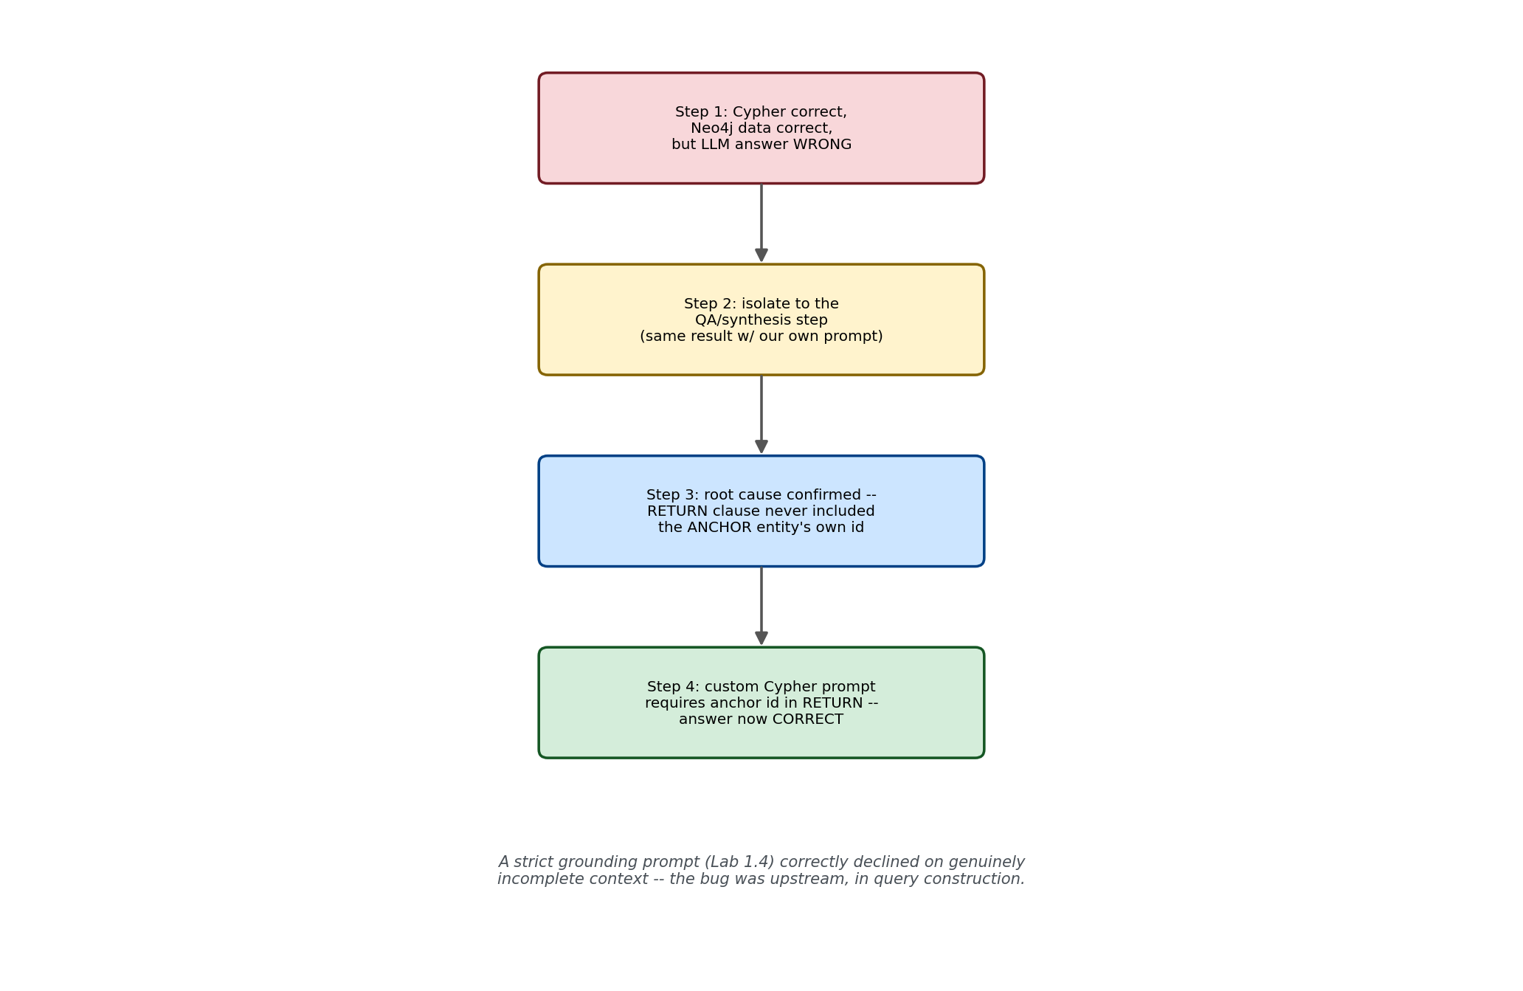
Figure 5: The complete four-step debugging arc — a strict grounding prompt correctly declined on genuinely incomplete context; the bug was upstream in query construction, not the model's judgment.
Confirmed real result: the new generated Cypher included a.id AS anchorId in its RETURN clause, and the final answer was now correct: "Twodaysperweek, Supervisorsignoff." Complete, confirmed fix.

Interim Interview Cheat-Sheet (Parts 1-6 — More Added After Part 7)
Q: Why use a real graph database instead of the in-memory NetworkX approach from Lab 1.1?
A: NetworkX doesn't persist, doesn't scale, and has no query language -- fine for a 4-node teaching example, not for production. Neo4j is confirmed the market-leading graph database, supports a real query language (Cypher) that an LLM can generate directly via GraphCypherQAChain, and scales to relationship-heavy production use cases like anti-money-laundering graphs at banks or supplier-network mapping in manufacturing.
Q: What's the real risk with automated knowledge graph extraction, and how bad is it really?
A: Entity disambiguation -- the same real-world entity gets extracted with different names across independently-processed documents, since each extraction call has no memory of previous ones. I measured this directly rather than assuming a rate: 0% naming consistency across both tested entities in my experiment, with one document not even extracting the concept as a node at all, just folding it into a relationship label.
Q: Does embedding-based entity canonicalization actually solve the disambiguation problem?
A: Partially, and I can be precise about exactly how partial. It measurably helped -- pulling together evidence from 2 previously-disconnected documents that used different names for the same concept. But of the 4 documents worded directly around the concept, only 1 ended up connected after the fix. Three distinct causes remained: extraction non-determinism (confirmed directly -- the same document produced 2 different stable outputs across 5 runs at temperature=0), a document where the concept was never extracted as a node at all (canonicalization can't rename something that doesn't exist), and likely some genuine variants falling below the similarity threshold.
Q: Is temperature=0 actually deterministic?
A: Not confirmed to be, for this specific model and task -- I tested it directly rather than assuming. The same document, same prompt, temperature=0, run 5 times, produced exactly 2 distinct but each internally-consistent node sets, split 3-2. That's not random noise, it's bimodal -- something in the serving stack (likely GPU batching non-determinism or reasoning-path variability in this specific reasoning model) is selecting between two stable extraction strategies despite temperature=0.
Q: Walk me through a real production debugging story involving Graph RAG.
A: A GraphCypherQAChain query returned a correct, verified Cypher query and correct data from Neo4j, but the final synthesized answer incorrectly said the information wasn't found. I isolated the failure to the answer-synthesis step by testing the identical context through an independent plain prompt, which also declined -- ruling out the chain's specific prompt template. That pointed to the context itself: the generated Cypher's RETURN clause never included the anchor entity's own name, so the context was technically incomplete even though the underlying facts were correct. I confirmed this directly with an A/B test (context with vs. without the anchor name), then fixed it with a custom Cypher-generation prompt requiring the anchor's identity in every RETURN clause.
Q: What does that debugging story reveal about the relationship between grounding discipline and query construction?
A: That strict grounding instructions (which I validated separately in Lab 1.4) can surface upstream bugs that a more permissive system would hide. A weaker system might have hallucinated a plausible-sounding answer from partial context instead of correctly declining -- the decline was the correct behavior given genuinely incomplete context, and the real fix was making the context complete, not loosening the grounding instruction.
Part 7 (Microsoft GraphRAG, in depth) to be added in a follow-up update.

