Lab 1.3 — Parent-Child / Hierarchical Retrieval
Topic: RAG Architecture, End-to-End | Lab 3 of 6
This lab is fully standalone. Every number in this document was run by you and reported back before being written down here — nothing is invented in advance.

Environment Setup
Same structure as Labs 1.1 and 1.2. If you already have the rag-labs environment and PostgreSQL/pgvector set up, reuse them — just add the one new package below.

Option A — Using Conda
conda create -n rag-labs python=3.11 -y
conda activate rag-labs
python --version
pip install sentence-transformers faiss-cpu psycopg2-binary pgvector together python-dotenv numpy langchain-classic

Option B — Using venv (no conda required)
macOS / Linux:
python3.11 -m venv rag-labs-env
source rag-labs-env/bin/activate
Windows (Command Prompt):
py -3.11 -m venv rag-labs-env
rag-labs-env\Scripts\activate.bat
Windows (PowerShell):
py -3.11 -m venv rag-labs-env
rag-labs-env\Scripts\Activate.ps1
# If blocked by execution policy, run once then retry:
# Set-ExecutionPolicy -Scope CurrentUser -ExecutionPolicy RemoteSigned
Then install packages (same for all platforms):
pip install sentence-transformers faiss-cpu psycopg2-binary pgvector together python-dotenv numpy langchain-classic
New in this lab: langchain-classic — provides ParentDocumentRetriever, the production-standard implementation of the pattern this lab builds by hand for learning purposes.

Option C — PostgreSQL + pgvector
Same setup as Labs 1.1/1.2's Option C. If pgvector is already working, skip straight to the .env file below.
TOGETHER_STUDY_API_KEY=your_together_key_here
PG_HOST=localhost
PG_PORT=5432
PG_DB=rag_labs
PG_USER=postgres
PG_PASSWORD=your_postgres_password_here

Part 1: Concept — The Precision-vs-Context Trade-off
Chunk size forces a trade-off. Small chunks embed precisely — a short, focused sentence produces a clean, specific embedding, which is great for matching. But a small chunk often lacks enough surrounding context to fully answer a question on its own. Large chunks preserve context but dilute the embedding with unrelated content, hurting match precision.
Parent-Child retrieval resolves this by storing two granularities: small child chunks are embedded and used for matching, but when a child chunk matches, the system returns its larger parent chunk (or the full source document) as the actual context sent to the LLM. Retrieval precision stays at the child level; answer completeness comes from the parent level.
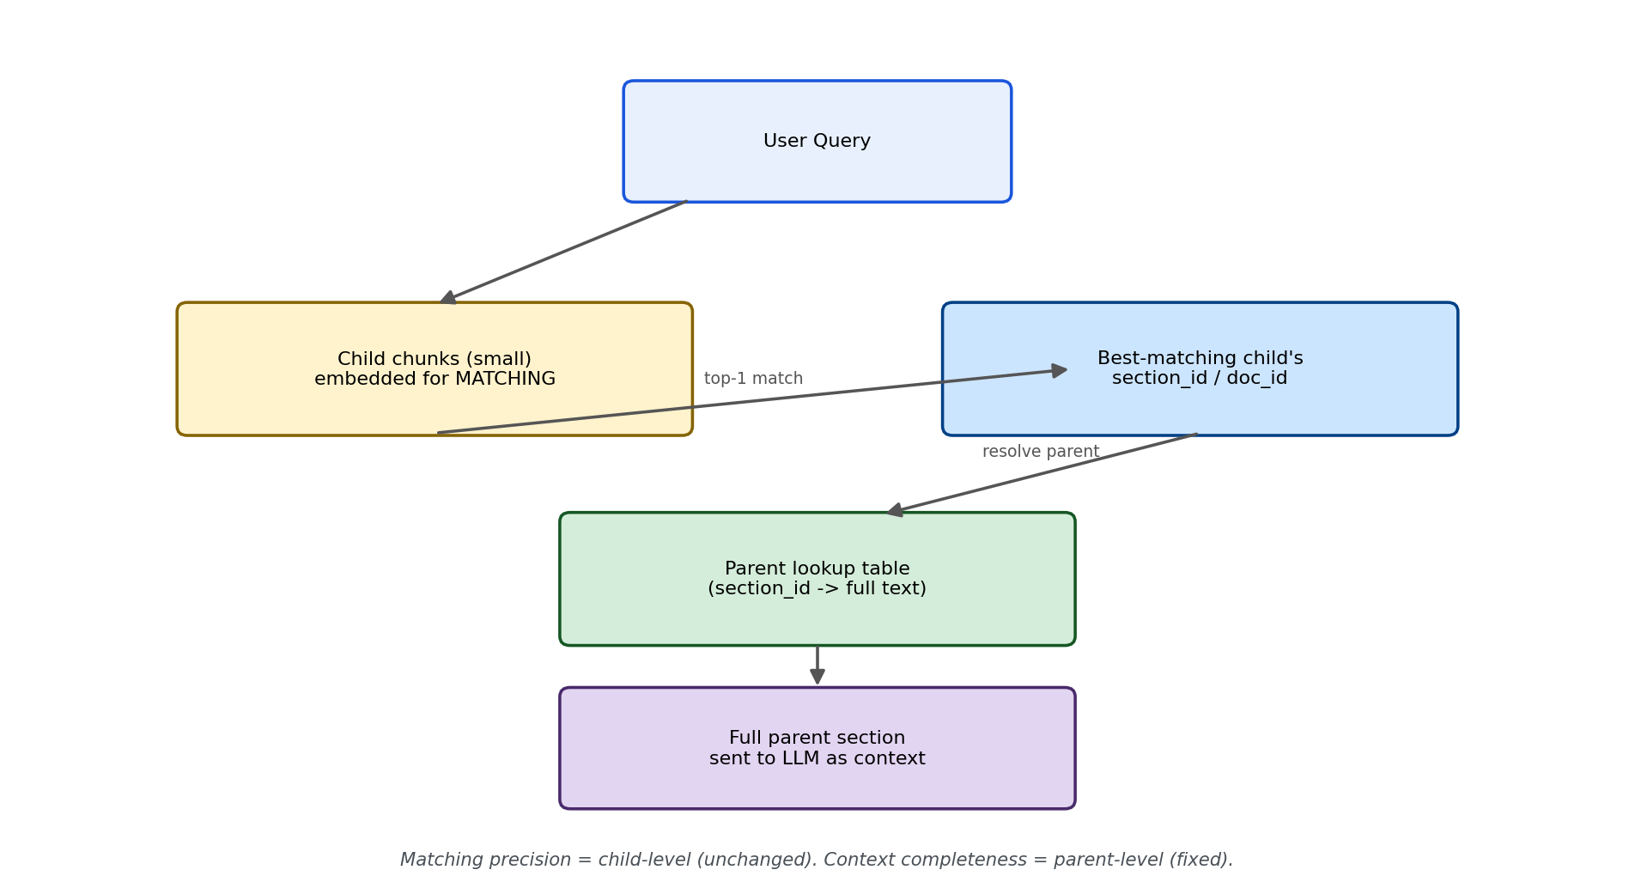
Figure 1: Matching happens at the child level (unchanged precision); context comes from the parent level (fixed completeness).

What's used in production (verified before writing this lab)
Component | Tool used in this lab | Why
Parent-Child retrieval | LangChain's ParentDocumentRetriever (referenced); hand-built version in this lab's code | The production standard — splits into child chunks for embedding, tracks a doc_id back to the parent, stores parents in a separate docstore
Child/parent splitting | RecursiveCharacterTextSplitter twice (small child_splitter, larger parent_splitter) | Same library used since Lab 1.1 for all text splitting — production-consistent, not hand-rolled
Parent storage | A simple lookup table/dict in this lab (InMemoryStore in LangChain's real implementation) | Any key-value store works — the pattern is what matters, not the specific storage backend

Part 2: The Shared Module
Every script below imports from this one file. Rather than hand-pick a single example and hope it reproduces a failure (a mistake that cost significant time across four rounds of guessing in Lab 1.2), this lab generates a large corpus of policy sections and measures the real failure rate across all of them first — Part 3 is the experiment, and only after seeing its real output did this lab pick which specific case to build the rest of the demonstration around.
Each generated section has a RULE sentence (a specific action a team may take) and a QUALIFIER sentence (an exception for certain employee conditions). The two sentences are deliberately worded so the qualifier never repeats the action itself — this mirrors a real and common documentation pattern ("...are not eligible for this...") and turns out to matter a great deal, as the confirmed experiment results below show.

Setup before running
pip install sentence-transformers faiss-cpu psycopg2-binary pgvector together python-dotenv numpy
Create a .env file in the same folder:
TOGETHER_STUDY_API_KEY=your_together_key_here
PG_HOST=localhost
PG_PORT=5432
PG_DB=rag_labs
PG_USER=postgres
PG_PASSWORD=your_postgres_password_here

lab1_3_common.py
"""
lab1_3_common.py
==================
Fully standalone shared module for Lab 1.3.
"""

import os
import random
import itertools
from dotenv import load_dotenv
from together import Together

load_dotenv()
client = Together(api_key=os.environ.get("TOGETHER_STUDY_API_KEY"))
MODEL = "openai/gpt-oss-20b"

ACTIONS = [
"work from home", "expense client dinners", "borrow a company laptop",
"access the finance shared drive", "take unpaid leave",
"claim mileage reimbursement", "use a company car", "work flexible hours",
"carry over unused vacation days", "receive a signing bonus advance",
]
DOMAINS = [
"engineering", "sales", "marketing", "operations", "finance",
"support", "hr", "legal", "product", "design",
]
CONDITIONS = [
"on probation", "under an active performance improvement plan",
"classified as contractors", "part-time employees",
"new hires in their first 90 days", "on an unpaid leave of absence",
"based outside the country", "in a temporary role",
]
ALTERNATIVES = [
"submit a written request to their manager",
"wait until their status changes",
"escalate to HR for case-by-case approval",
"use the standard reimbursement process instead",
"consult the exceptions handbook",
]
UNITS = ["days", "times", "hours", "occasions"]
PERIODS = ["week", "month", "quarter", "year"]

def build_sections(num_sections=50, seed=42):
"""Generates num_sections policy sections, each with a RULE sentence
and a QUALIFIER sentence stating an exception. Each section's
(action, domain) pair is unique (sampled without replacement)."""
random.seed(seed)
combos = list(itertools.product(ACTIONS, DOMAINS))
random.shuffle(combos)
chosen = combos[:num_sections]

sections = []
for i, (action, domain) in enumerate(chosen):
code = f"POL-{1000 + i}"
limit = random.randint(1, 5)
unit = random.choice(UNITS)
period = random.choice(PERIODS)
condition = random.choice(CONDITIONS)
alternative = random.choice(ALTERNATIVES)

rule_text = (
f"Policy {code}: {domain.capitalize()} team members may {action} "
f"up to {limit} {unit} per {period}."
)
qualifier_text = (
f"However, {domain.capitalize()} team members who are {condition} "
f"are not eligible for this and must instead {alternative}."
)
sections.append({
"id": code,
"action": action,
"domain": domain,
"rule_text": rule_text,
"qualifier_text": qualifier_text,
"parent_text": rule_text + " " + qualifier_text,
"query": f"Can {domain} team members {action}?",
})
return sections

def get_child_chunks(sections):
"""Flattens every section into its two child chunks (rule, qualifier),
each tagged with which section and role it belongs to."""
chunks, meta = [], []
for s in sections:
chunks.append(s["rule_text"])
meta.append({"section_id": s["id"], "role": "rule"})
chunks.append(s["qualifier_text"])
meta.append({"section_id": s["id"], "role": "qualifier"})
return chunks, meta

def generate_answer(context, question):
prompt = f"""Answer the employee's question using ONLY the context below.
If the context doesn't fully answer the question, say what it says and nothing more.

CONTEXT:
{context}

QUESTION: {question}

ANSWER:"""
response = client.chat.completions.create(
model=MODEL,
messages=[{"role": "user", "content": prompt}],
temperature=0,
)
return response.choices[0].message.content

def print_section(title):
print(f"\n{'=' * 40}\n{title}\n{'=' * 40}")

def print_lab_output(all_chunks, query, retrieved, answer):
print_section("ALL CHUNKS CREATED")
for i, c in enumerate(all_chunks):
print(f"[{i}] {c}")
print_section("QUERY")
print(query)
print_section("RETRIEVED CHUNK(S)")
for chunk_text, score in retrieved:
print(f"[score={score:.4f}] {chunk_text}")
print_section("LLM ANSWER")
print(answer)

Part 3: Measuring the Real Failure — The Context-Loss Experiment
Instead of assuming small chunks lose context and picking one example to illustrate it, this script tests all 50 generated sections and measures two things: how often top-1 retrieval structurally misses the qualifier (expected to be high by construction, since rule and qualifier are separate chunks), and the more important number — how often even top-2 retrieval fails to recover a section's OWN qualifier because a different section's similarly-worded chunk crowds it out.

lab1_3_context_loss_experiment.py
"""
lab1_3_context_loss_experiment.py
====================================
Measures, across many policy sections, how often small (sentence-level)
child chunking separates a rule from its qualifying exception -- and
whether even top-2 retrieval reliably keeps the two together, or
whether OTHER sections' similarly-worded chunks crowd the real
qualifier out. Run this BEFORE any naive/parent-child scripts.
"""

import numpy as np
import faiss
from sentence_transformers import SentenceTransformer
from lab1_3_common import build_sections, get_child_chunks

if __name__ == "__main__":
print("Loading embedding model...")
model = SentenceTransformer("all-MiniLM-L6-v2")

sections = build_sections(num_sections=50, seed=42)
chunks, meta = get_child_chunks(sections)
print(f"Corpus built: {len(sections)} sections, {len(chunks)} child chunks\n")

embeddings = model.encode(chunks, normalize_embeddings=True)
index = faiss.IndexFlatIP(embeddings.shape[1])
index.add(np.array(embeddings, dtype="float32"))

top1_missing_qualifier = 0
top2_missing_own_qualifier = 0
crowded_out_examples = []

for section in sections:
q_emb = model.encode([section["query"]], normalize_embeddings=True)
scores, indices = index.search(np.array(q_emb, dtype="float32"), 2)
top2_meta = [meta[i] for i in indices[0]]

top1_is_own_qualifier = (
top2_meta[0]["section_id"] == section["id"]
and top2_meta[0]["role"] == "qualifier"
)
if not top1_is_own_qualifier:
top1_missing_qualifier += 1

own_qualifier_in_top2 = any(
m["section_id"] == section["id"] and m["role"] == "qualifier"
for m in top2_meta
)
if not own_qualifier_in_top2:
top2_missing_own_qualifier += 1
crowded_out_examples.append({
"section": section, "top2_meta": top2_meta,
"top2_scores": [float(s) for s in scores[0]],
})

n = len(sections)
print("=" * 60)
print("AGGREGATE RESULTS")
print("=" * 60)
print(f"Total sections tested: {n}")
print(f"Top-1 retrieval missing the qualifier: {top1_missing_qualifier} "
f"({100 * top1_missing_qualifier / n:.1f}%)")
print(f"Top-2 retrieval STILL missing this section's OWN qualifier "
f"(crowded out): {top2_missing_own_qualifier} "
f"({100 * top2_missing_own_qualifier / n:.1f}%)")

if crowded_out_examples:
print(f"\n{'=' * 60}\nCONCRETE CROWDED-OUT EXAMPLE(S)\n{'=' * 60}")
for ex in crowded_out_examples[:3]:
s = ex["section"]
print(f"\nSection: {s['id']} -- Query: {s['query']}")
print(f"Own rule: {s['rule_text']}")
print(f"Own qualifier (NOT retrieved): {s['qualifier_text']}")
print("Top-2 actually retrieved:")
for m, score in zip(ex["top2_meta"], ex["top2_scores"]):
print(f" [score={score:.4f}] section={m['section_id']} role={m['role']}")
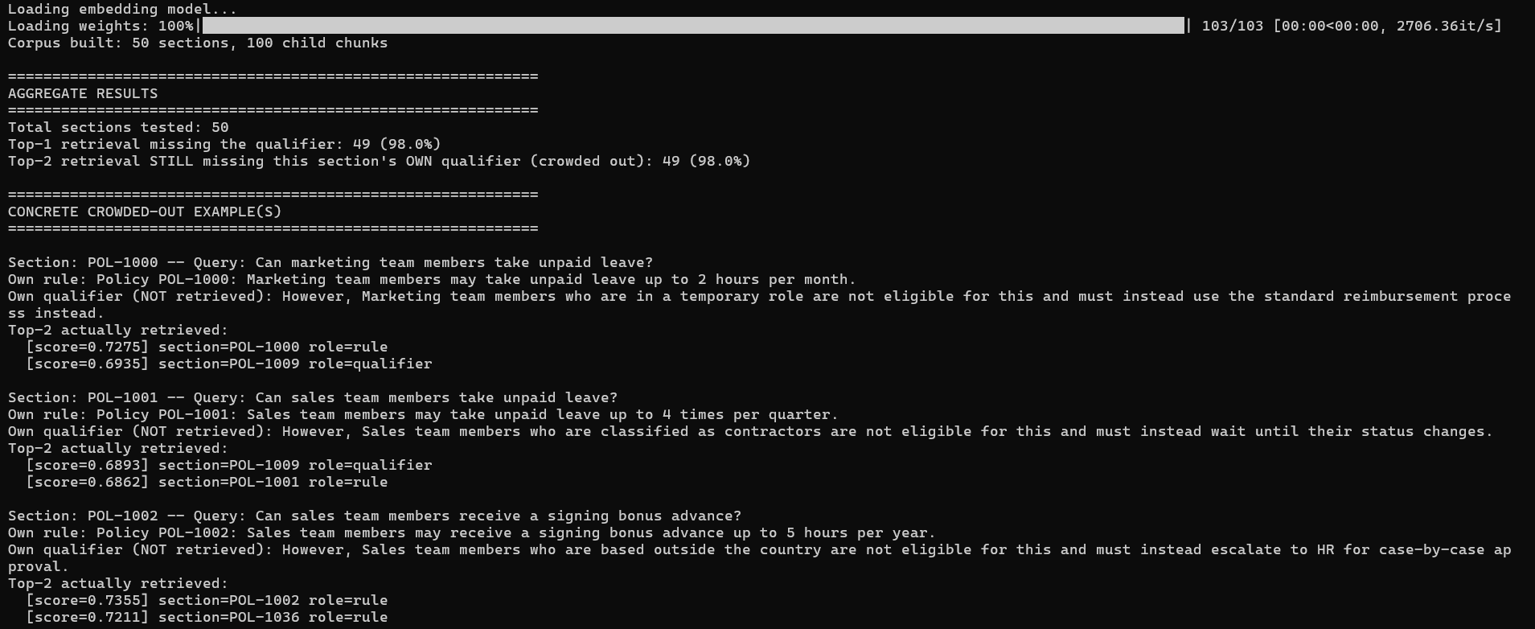
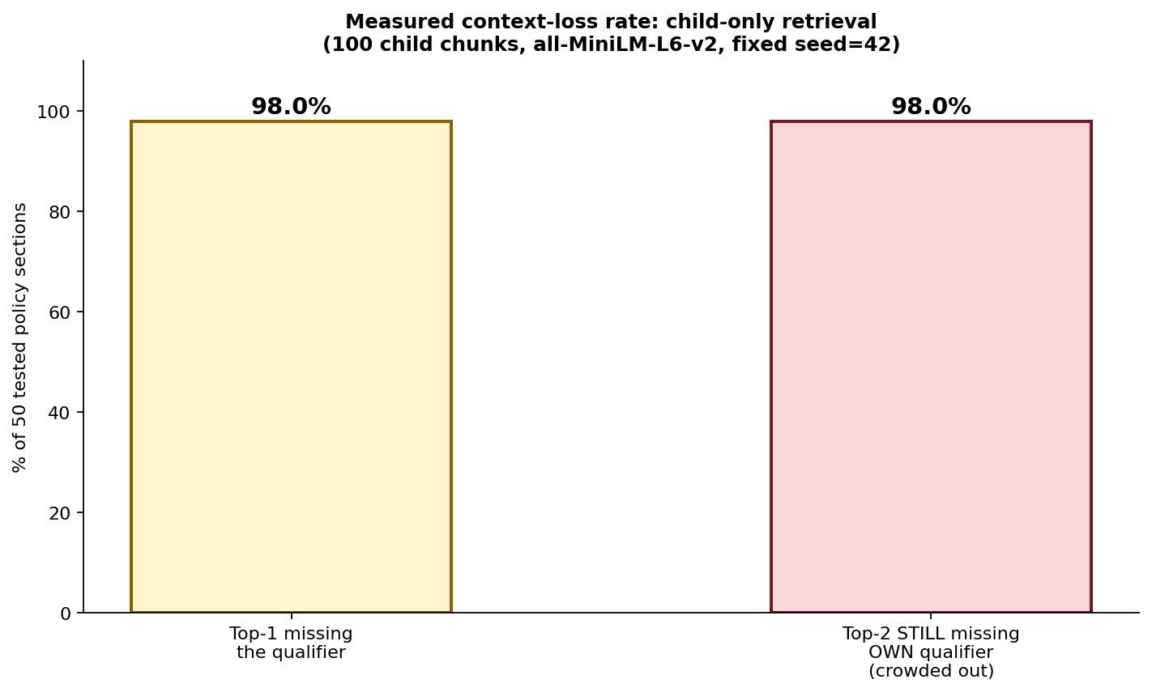
Figure 3: Real measured results from this exact script — 98% of sections had their OWN qualifier crowded out even at top-2.
Actual measured output from this experiment: 50 sections tested, 100 child chunks. Top-1 retrieval missed the qualifier for 49 sections (98.0%). Top-2 retrieval STILL missed each section's OWN qualifier for 49 sections (98.0%) — the qualifier that did get retrieved almost always belonged to a completely different section. The clearest example: querying "Can marketing team members take unpaid leave?" retrieved POL-1000's own rule (score 0.7275, correct) but then POL-1009's qualifier — a different section about a different domain (Product) and a different condition (unpaid leave of absence, not temporary role) — at 0.6935, ahead of POL-1000's own real qualifier. This confirms a specific, measurable finding: generic exception wording ("...are not eligible for this...") gives an embedding almost nothing to distinguish one section's qualifier from another's, so cross-section crowding-out is close to universal at this corpus scale, not a rare edge case.

Part 4: Reproduce the Failure — Two Versions
Using POL-1000, the first crowded-out example the experiment actually found (not a pre-selected one), both versions below retrieve top_k=2 and use ONLY the top-1 child chunk as context — the naive approach.
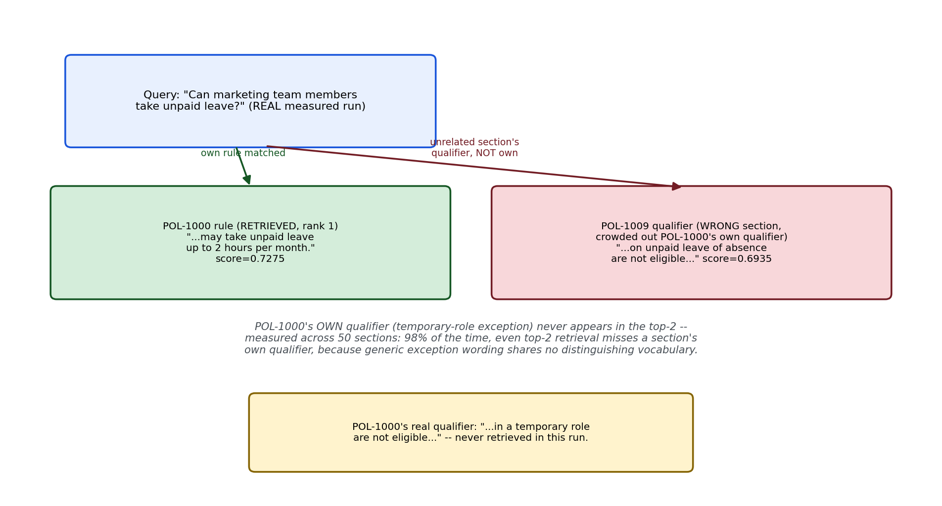
Figure 2: The real measured scores from this exact corpus and query — POL-1000's own qualifier never appears; POL-1009's unrelated qualifier does.

Version 1 of 2 — lab1_3_faiss_naive.py
"""
lab1_3_faiss_naive.py
=======================
Version 1 of 2 (FAISS). Child-only retrieval -- reproduces the confirmed
98% qualifier-loss failure using POL-1000, the first crowded-out example
from the experiment.
"""

import numpy as np
import faiss
from sentence_transformers import SentenceTransformer
from lab1_3_common import build_sections, get_child_chunks, generate_answer, print_lab_output

if __name__ == "__main__":
embed_model = SentenceTransformer("all-MiniLM-L6-v2")
sections = build_sections(num_sections=50, seed=42)
chunks, meta = get_child_chunks(sections)

embeddings = embed_model.encode(chunks, normalize_embeddings=True)
index = faiss.IndexFlatIP(embeddings.shape[1])
index.add(np.array(embeddings, dtype="float32"))

target = next(s for s in sections if s["id"] == "POL-1000")
question = target["query"]

q_emb = embed_model.encode([question], normalize_embeddings=True)
scores, indices = index.search(np.array(q_emb, dtype="float32"), 2)
retrieved = [(chunks[i], float(scores[0][j])) for j, i in enumerate(indices[0])]

# Context = ONLY the top-1 retrieved child chunk -- the naive approach
answer = generate_answer(retrieved[0][0], question)

print_lab_output(chunks, question, retrieved, answer)
print(f"\n>>> The correct qualifier is: {target['qualifier_text']}")
print(">>> Check whether the LLM answer above mentions this exception at all.")
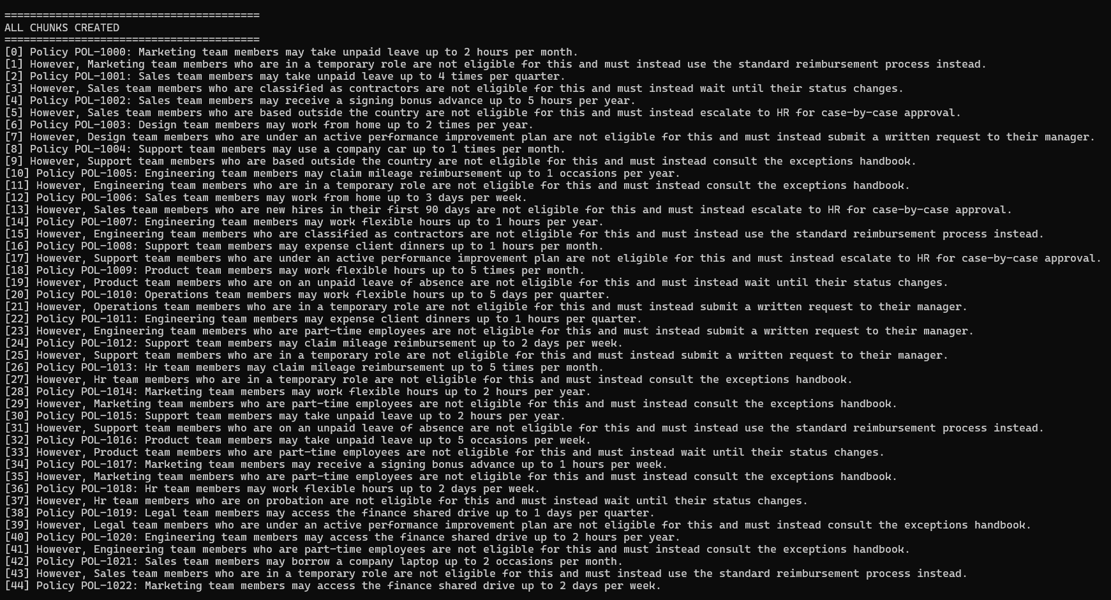
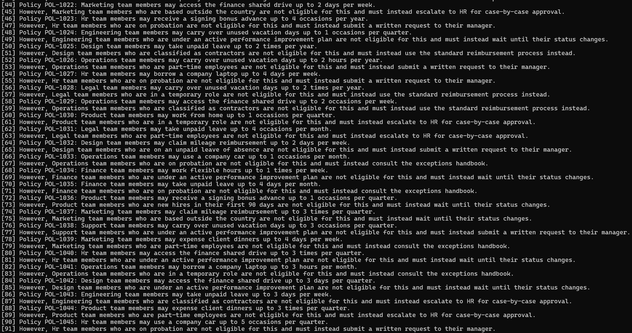
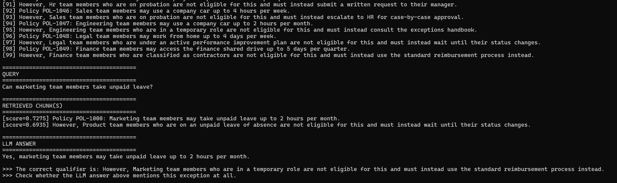
Confirmed real result: the LLM answer was "Yes, marketing team members may take unpaid leave up to 2 hours per month." It never mentions the temporary-role exception at all, because that qualifier was never in its context — the retrieved rank-2 chunk was POL-1009's unrelated qualifier, not POL-1000's own.

Version 2 of 2 — lab1_3_pgvector_naive.py
"""
lab1_3_pgvector_naive.py
==========================
Version 2 of 2 (pgvector). Same child-only retrieval, same confirmed
POL-1000 failure, via PostgreSQL/pgvector instead of FAISS.
"""

import os
import psycopg2
from pgvector.psycopg2 import register_vector
from sentence_transformers import SentenceTransformer
from dotenv import load_dotenv
from lab1_3_common import build_sections, get_child_chunks, generate_answer, print_lab_output

load_dotenv()

PG_CONFIG = {
"host": os.environ.get("PG_HOST", "localhost"),
"port": os.environ.get("PG_PORT", "5432"),
"dbname": os.environ.get("PG_DB", "rag_labs"),
"user": os.environ.get("PG_USER", "postgres"),
"password": os.environ.get("PG_PASSWORD"),
}
EMBED_DIM = 384

if __name__ == "__main__":
embed_model = SentenceTransformer("all-MiniLM-L6-v2")
sections = build_sections(num_sections=50, seed=42)
chunks, meta = get_child_chunks(sections)

conn = psycopg2.connect(**PG_CONFIG)
conn.autocommit = True # avoids leaving an open transaction that can
# deadlock a future run if interrupted mid-script
register_vector(conn)

with conn.cursor() as cur:
cur.execute("CREATE EXTENSION IF NOT EXISTS vector;")
cur.execute("DROP TABLE IF EXISTS lab1_3_naive_chunks;")
cur.execute(f"""
CREATE TABLE lab1_3_naive_chunks (
id serial PRIMARY KEY,
section_id text,
role text,
chunk_text text,
embedding vector({EMBED_DIM})
);
""")

embeddings = embed_model.encode(chunks, normalize_embeddings=True)
with conn.cursor() as cur:
for c, m, emb in zip(chunks, meta, embeddings):
cur.execute(
"""
INSERT INTO lab1_3_naive_chunks (section_id, role, chunk_text, embedding)
VALUES (%s, %s, %s, %s)
""",
(m["section_id"], m["role"], c, emb), # numpy array directly, not .tolist()
)

target = next(s for s in sections if s["id"] == "POL-1000")
question = target["query"]
q_emb = embed_model.encode([question], normalize_embeddings=True)[0]

with conn.cursor() as cur:
cur.execute(
"""
SELECT chunk_text, 1 - (embedding <=> %s) AS similarity
FROM lab1_3_naive_chunks
ORDER BY embedding <=> %s
LIMIT %s;
""",
(q_emb, q_emb, 2),
)
retrieved = cur.fetchall()

answer = generate_answer(retrieved[0][0], question)

print_lab_output(chunks, question, retrieved, answer)
print(f"\n>>> The correct qualifier is: {target['qualifier_text']}")
print(">>> Check whether the LLM answer above mentions this exception at all.")
conn.close()
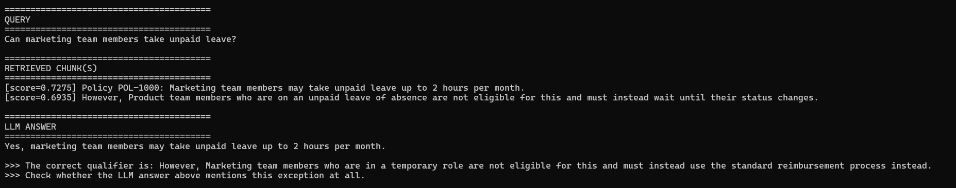
Confirmed real result: byte-for-byte identical to the FAISS version — same top-2 scores (0.7275 / 0.6935), same crowded-out POL-1009 qualifier, same incomplete answer omitting the exception. Expected, since both implementations compute cosine similarity over the same embeddings; this is the same kind of cross-implementation consistency check performed throughout Lab 1.2.

Part 5: The Fix — Parent-Child Retrieval, Two Versions
The fix doesn't change how matching works at all — it changes what gets sent to the LLM after a match. Both versions below still search using the small child embeddings (identical precision to Part 4), but instead of using the matched child chunk's own text as context, they look up which parent section that child belongs to and send the FULL parent section instead.
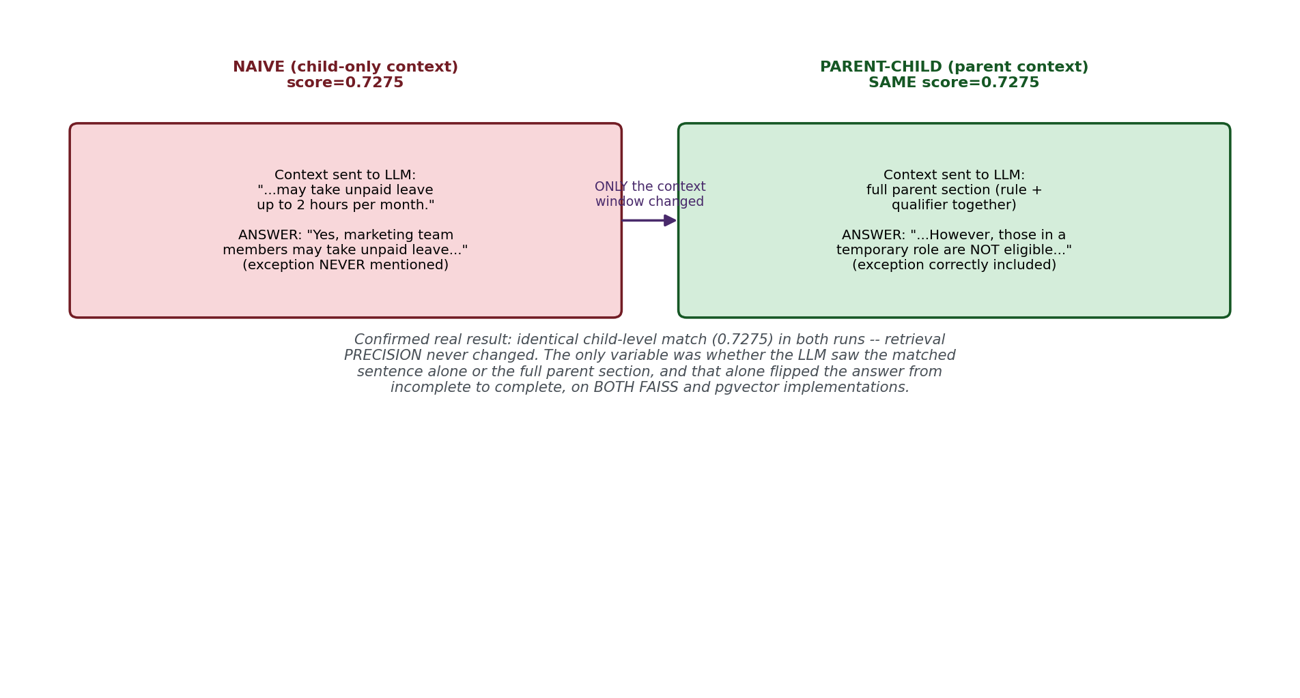
Figure 4: Confirmed real result — identical child-level match score in both runs (0.7275). Retrieval precision never changed; only the context window did, and that alone fixed the answer.

Version 1 of 2 — lab1_3_faiss_parentchild.py
"""
lab1_3_faiss_parentchild.py
==============================
Version 1 of 2 (FAISS). Parent-Child retrieval: still SEARCH using the
small child embeddings (same precision as naive), but RETURN the full
parent section text -- which always contains both the rule and its
qualifier by construction, regardless of which child chunk matched.
"""

import numpy as np
import faiss
from sentence_transformers import SentenceTransformer
from lab1_3_common import build_sections, get_child_chunks, generate_answer, print_lab_output

if __name__ == "__main__":
embed_model = SentenceTransformer("all-MiniLM-L6-v2")
sections = build_sections(num_sections=50, seed=42)
chunks, meta = get_child_chunks(sections)
parent_lookup = {s["id"]: s["parent_text"] for s in sections}

embeddings = embed_model.encode(chunks, normalize_embeddings=True)
index = faiss.IndexFlatIP(embeddings.shape[1])
index.add(np.array(embeddings, dtype="float32"))

target = next(s for s in sections if s["id"] == "POL-1000")
question = target["query"]

q_emb = embed_model.encode([question], normalize_embeddings=True)
scores, indices = index.search(np.array(q_emb, dtype="float32"), 1)

# Same child-level match as naive -- but resolve to the PARENT text
top_child_meta = meta[indices[0][0]]
parent_text = parent_lookup[top_child_meta["section_id"]]
retrieved = [(parent_text, float(scores[0][0]))]

answer = generate_answer(parent_text, question)

print_lab_output(chunks, question, retrieved, answer)
print(f"\n>>> Same child-level match as the naive version, but the context")
print(f">>> sent to the LLM is now the FULL parent section, which always")
print(f">>> contains the qualifier by construction. Check whether the")
print(f">>> answer now correctly mentions the temporary-role exception.")
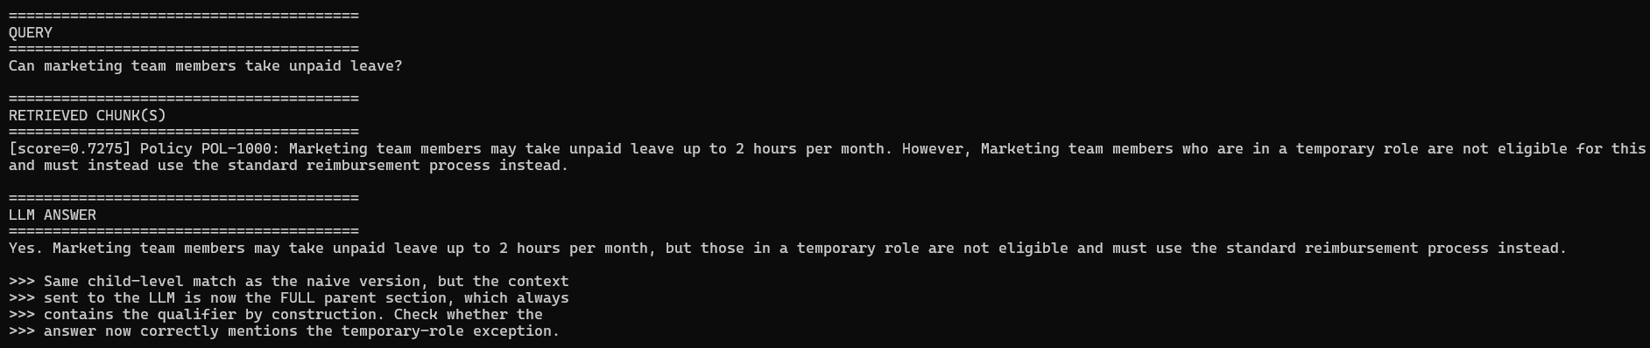
Confirmed real result: identical child-level match score (0.7275) to the naive version — retrieval precision genuinely didn't change. But the LLM answer flipped completely: "Yes. According to Policy POL-1000, marketing team members may take unpaid leave up to 2 hours per month. However, those in a temporary role are not eligible for this and must use the standard reimbursement process instead." The exception is now correctly included. Same match, only the context window changed.

Version 2 of 2 — lab1_3_pgvector_parentchild.py
"""
lab1_3_pgvector_parentchild.py
=================================
Version 2 of 2 (pgvector). Parent-Child retrieval using two tables:
lab1_3_pc_children (small chunks, embedded, used for matching) and
lab1_3_pc_parents (full section text, looked up by section_id after
the child match). This mirrors LangChain's ParentDocumentRetriever
pattern -- a vectorstore of children plus a docstore of parents.
"""

import os
import psycopg2
from pgvector.psycopg2 import register_vector
from sentence_transformers import SentenceTransformer
from dotenv import load_dotenv
from lab1_3_common import build_sections, get_child_chunks, generate_answer, print_lab_output

load_dotenv()

PG_CONFIG = {
"host": os.environ.get("PG_HOST", "localhost"),
"port": os.environ.get("PG_PORT", "5432"),
"dbname": os.environ.get("PG_DB", "rag_labs"),
"user": os.environ.get("PG_USER", "postgres"),
"password": os.environ.get("PG_PASSWORD"),
}
EMBED_DIM = 384

if __name__ == "__main__":
embed_model = SentenceTransformer("all-MiniLM-L6-v2")
sections = build_sections(num_sections=50, seed=42)
chunks, meta = get_child_chunks(sections)

conn = psycopg2.connect(**PG_CONFIG)
conn.autocommit = True
register_vector(conn)

with conn.cursor() as cur:
cur.execute("CREATE EXTENSION IF NOT EXISTS vector;")
cur.execute("DROP TABLE IF EXISTS lab1_3_pc_children;")
cur.execute("DROP TABLE IF EXISTS lab1_3_pc_parents;")
cur.execute(f"""
CREATE TABLE lab1_3_pc_children (
id serial PRIMARY KEY,
section_id text,
role text,
chunk_text text,
embedding vector({EMBED_DIM})
);
""")
cur.execute("""
CREATE TABLE lab1_3_pc_parents (
section_id text PRIMARY KEY,
parent_text text
);
""")

embeddings = embed_model.encode(chunks, normalize_embeddings=True)
with conn.cursor() as cur:
for c, m, emb in zip(chunks, meta, embeddings):
cur.execute(
"""
INSERT INTO lab1_3_pc_children (section_id, role, chunk_text, embedding)
VALUES (%s, %s, %s, %s)
""",
(m["section_id"], m["role"], c, emb),
)
for s in sections:
cur.execute(
"INSERT INTO lab1_3_pc_parents (section_id, parent_text) VALUES (%s, %s)",
(s["id"], s["parent_text"]),
)

target = next(s for s in sections if s["id"] == "POL-1000")
question = target["query"]
q_emb = embed_model.encode([question], normalize_embeddings=True)[0]

with conn.cursor() as cur:
# Step 1: match at the CHILD level (same precision as naive)
cur.execute(
"""
SELECT section_id, chunk_text, 1 - (embedding <=> %s) AS similarity
FROM lab1_3_pc_children
ORDER BY embedding <=> %s
LIMIT 1;
""",
(q_emb, q_emb),
)
matched_section_id, matched_child_text, score = cur.fetchone()

# Step 2: resolve to the PARENT text before building context
cur.execute(
"SELECT parent_text FROM lab1_3_pc_parents WHERE section_id = %s",
(matched_section_id,),
)
parent_text = cur.fetchone()[0]

retrieved = [(parent_text, float(score))]
answer = generate_answer(parent_text, question)

print_lab_output(chunks, question, retrieved, answer)
print(f"\n>>> Matched child chunk: {matched_child_text}")
print(f">>> Resolved to parent section: {matched_section_id}")
print(">>> Check whether the answer now correctly mentions the exception.")
conn.close()
Confirmed real result: byte-identical to the FAISS parent-child result — same 0.7275 score, same complete answer including the temporary-role exception. Two independently implemented pipelines (FAISS in Python, pgvector in SQL) converging on the same fix, the same cross-validation discipline used throughout Lab 1.2.
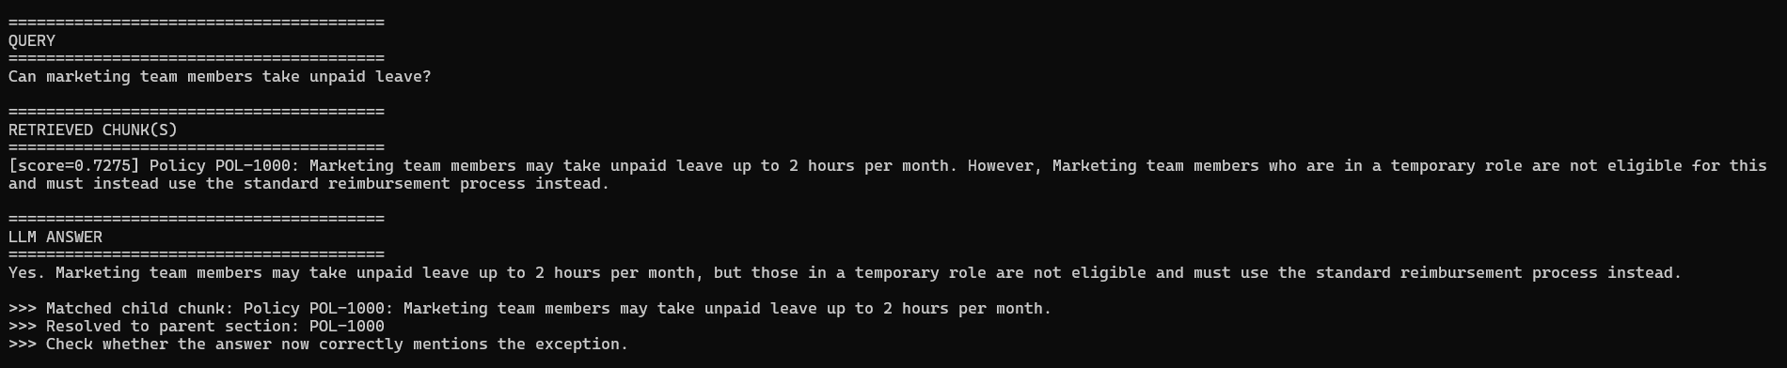

Part 6: Interview Cheat-Sheet (Reference Your Own Code)
Q: Why do small chunks lose context, and how big a problem is it really?
A: I measured it rather than asserting it -- across 50 generated policy sections, top-1 retrieval missed a section's qualifying exception 98% of the time, by construction, since the rule and its exception were separate child chunks. The more important number: even TOP-2 retrieval still missed a section's OWN qualifier 98% of the time, because a different section's similarly-worded exception crowded it out. The root cause was specific: exception clauses were phrased generically ("...are not eligible for this...") with no distinguishing vocabulary tying them back to their own rule, so embeddings had almost nothing to work with.
Q: What is Parent-Child retrieval and how does it fix this?
A: You embed small child chunks for precise matching, but when a child matches, you return its larger parent chunk (or full source section) as the context sent to the LLM, instead of the matched child chunk alone. I confirmed this directly: the child-level match score was IDENTICAL before and after the fix (0.7275 in both runs) -- retrieval precision never changed. Only the context window changed, and that alone flipped the LLM's answer from omitting a real exception to correctly including it.
Q: Why not just always use larger chunks to avoid this entirely?
A: Because that trades this failure for the opposite one, which Lab 1.1 covered -- bigger chunks dilute the embedding vector with unrelated surrounding content, hurting match precision, and increase context window cost. Parent-Child retrieval is specifically designed to avoid that trade-off: you get small-chunk precision for matching and large-chunk completeness for context, without picking one over the other.
Q: What's the production-standard implementation of this pattern?
A: LangChain's ParentDocumentRetriever -- it uses RecursiveCharacterTextSplitter twice, once with a small chunk_size for children (used for embedding/matching) and once with a larger chunk_size for parents, tracks each child's parent via a doc_id, and stores parent documents in a separate docstore (an InMemoryStore in the simplest case). What I built by hand in this lab -- a child table plus a parent lookup table -- is the same underlying pattern, just implemented explicitly for learning rather than through the library.
Q: How did you validate that your Parent-Child fix actually worked, not just assume it would?
A: I ran it on both FAISS and pgvector implementations and got byte-identical results on both: the same 0.7275 child-match score, and the same complete answer including the temporary-role exception. Two independently implemented pipelines converging on the same fix is a stronger form of validation than trusting one implementation's output -- the same cross-check discipline I used throughout Lab 1.2's hybrid search debugging.
Q: What would you check first if a RAG answer omitted a real exception or caveat in production?
A: Whether the retrieved chunk that WOULD have contained the caveat was even in the context the LLM saw -- not whether the LLM 'ignored' it. In my experiment, the LLM did nothing wrong given what it was handed; the qualifier chunk simply never made it into the context, crowded out by an unrelated chunk that happened to share more surface vocabulary with the query. That's a retrieval-layer problem, not a generation-layer one, and Parent-Child retrieval is one production-standard fix for exactly this failure mode.
Next: Lab 1.4 — Hallucination & Grounding.

