**Understanding and Handling Multicollinearity in Bivariate Data Analysis**

**1. Introduction to Multicollinearity**

Multicollinearity is a phenomenon in statistical modeling where two or more predictor variables in a regression model are highly correlated. This correlation implies that these variables contain similar information, which can lead to challenges in isolating the independent effect of each predictor on the dependent variable. In practice, multicollinearity causes issues in estimating regression coefficients, leading to inflated standard errors and making it difficult to determine the individual effect of each predictor. If not handled correctly, multicollinearity can undermine the reliability of the model’s interpretations and predictions.

**2. Detecting Multicollinearity**

To identify multicollinearity, we can employ various methods, including:

* **Correlation Matrix**: A simple approach is to create a correlation matrix of all predictor variables to observe pairwise correlations. A high correlation coefficient (close to +1 or -1) suggests multicollinearity. However, this approach only detects bivariate correlations and might miss cases where multicollinearity arises from combinations of three or more predictors.
* **Variance Inflation Factor (VIF)**: VIF is one of the most popular metrics for diagnosing multicollinearity. It quantifies how much the variance of a regression coefficient is inflated due to multicollinearity. A VIF value greater than 10 is commonly used as a threshold for high multicollinearity (though some studies suggest a threshold of 5). VIF can be calculated for each predictor variable as follows:

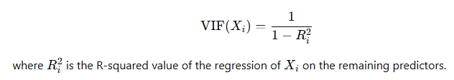

* **Tolerance**: Tolerance is the reciprocal of VIF. Low tolerance values (below 0.1) indicate high multicollinearity. This measure is especially useful in cross-validating findings from VIF analysis.

**3. Handling Multicollinearity**

Once multicollinearity is identified, several strategies can be employed to address it:

1. **Remove Highly Correlated Predictors**: If two or more variables have a very high correlation (close to 1 or -1), one of these variables can be removed from the model. For instance, if a dataset includes both *income* and *expenditure*, and these variables are highly correlated, we might choose to retain only one of them to avoid redundancy.
2. **Combine Predictors through Principal Component Analysis (PCA)**: PCA is a dimensionality reduction technique that can transform correlated variables into a smaller set of uncorrelated components, called principal components. By using these components instead of the original variables, we eliminate multicollinearity while preserving most of the variability in the data. For example, if *height*, *weight*, and *BMI* are highly correlated, PCA can combine them into a single component that captures their shared information.
3. **Regularization Techniques**:
   * **Ridge Regression**: Ridge regression introduces a penalty term to the least squares regression, shrinking the coefficient estimates. This method reduces the impact of multicollinear predictors without eliminating any. Ridge regression is particularly effective when we want to retain all variables but reduce their collinearity.
   * **Lasso Regression**: Similar to Ridge, Lasso also penalizes large coefficients. However, unlike Ridge, Lasso can shrink some coefficients to zero, effectively selecting a subset of predictors. This property makes Lasso useful in identifying key variables and handling multicollinearity simultaneously.
4. **Centering the Variables**: When working with interaction terms, mean-centering or standardizing predictor variables can help reduce multicollinearity. This process involves subtracting the mean or dividing by the standard deviation, reducing the correlation between the main and interaction terms.
5. **Using Domain Knowledge for Variable Selection**: Often, we can use domain knowledge to select the most relevant predictors, avoiding the inclusion of redundant or less meaningful variables. For instance, in a medical study, if both *blood pressure* and *heart rate* are correlated, we might choose the one more strongly related to the disease being studied.

**4. Example of Using VIF to Detect and Handle Multicollinearity**

Consider a regression model with three predictors: *A*, *B*, and *C*. After calculating the VIF values, we find the following results:

* VIF(A) = 4.5
* VIF(B) = 12.8
* VIF(C) = 15.2

Since both *B* and *C* have VIF values greater than 10, they exhibit high multicollinearity. To address this, we could:

* Remove either *B* or *C* if they are conceptually similar.
* Apply PCA to transform *A*, *B*, and *C* into principal components.
* Use Ridge or Lasso regression to reduce the impact of multicollinearity without eliminating predictors.

In summary, detecting and handling multicollinearity is crucial in ensuring model accuracy and interpretability. Techniques such as VIF, PCA, and regularization allow us to address multicollinearity while maintaining the strength and reliability of our regression models.

### ****5. Example Using Correlation Matrix and Tolerance****

#### **Scenario**

Let's say we have a dataset with four predictor variables: **X1**, **X2**, **X3**, and **X4**. We want to check for multicollinearity among these predictors before using them in a regression model.

#### **1. Correlation Matrix**

A correlation matrix helps us observe the pairwise correlations between each pair of variables:

|  | **X1** | **X2** | **X3** | **X4** |
| --- | --- | --- | --- | --- |
| **X1** | 1.00 | 0.85 | 0.20 | 0.10 |
| **X2** | 0.85 | 1.00 | 0.15 | 0.05 |
| **X3** | 0.20 | 0.15 | 1.00 | 0.60 |
| **X4** | 0.10 | 0.05 | 0.60 | 1.00 |

In this example:

* The correlation between **X1** and **X2** is **0.85**, indicating a strong positive correlation. This suggests potential multicollinearity between these variables.
* Other pairs, such as **X1** with **X3** (0.20) and **X1** with **X4** (0.10), have low correlations and are less of a concern.

**Interpretation**: Based on the correlation matrix, **X1** and **X2** are highly correlated. We might consider removing one of them or using further tests like VIF and tolerance to confirm if they contribute to multicollinearity.

#### **2. Tolerance Calculation**

Tolerance is calculated as the reciprocal of VIF and indicates the degree of multicollinearity. The formula for tolerance of a predictor Xi​ is:

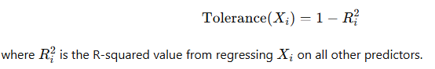

Let’s calculate tolerance values assuming the following R-squared values from regressing each predictor on the others:

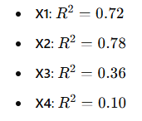

The tolerance values are as follows:

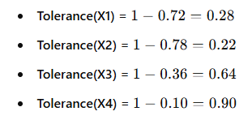

**Interpretation**:

* Low tolerance values (e.g., **0.28** for **X1** and **0.22** for **X2**) indicate potential multicollinearity, especially since they are below the common threshold of **0.1**.
* Higher tolerance values, such as for **X3** (0.64) and **X4** (0.90), suggest low multicollinearity for those variables.

**Conclusion**: From both the correlation matrix and tolerance values, **X1** and **X2** exhibit multicollinearity. Possible solutions include:

* Removing one of these variables from the model.
* Applying dimensionality reduction techniques like PCA.
* Using regularization methods such as Ridge or Lasso to handle their multicollinearity.