**Boxplot.**

A Seaborn boxplot is a visual representation of the distribution of a dataset that summarizes key statistics such as the median, quartiles, and potential outliers. It is used to understand data variability, detect outliers, and compare distributions across different categories.

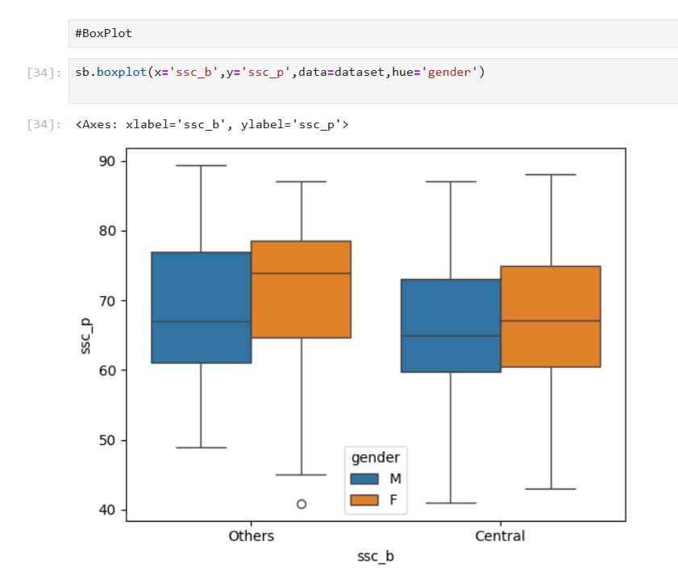

**Box:**

The box represents the interquartile range (IQR), which is the range between the 25th percentile (Q1) and the 75th percentile (Q3).

The line inside the box indicates the median (50th percentile).

**Outliers:**

Individual points plotted outside the whiskers indicate outliers.

**Hue (optional):**

Adding a hue parameter allows the data to be divided into subcategories, creating grouped boxplots.

**Use Cases:**

Compare groups: Compare distributions of a numeric variable across different categories.

Detect outliers: Identify values significantly different from the rest.

Summarize distributions: Quickly understand the central tendency and variability of the data.

**CatPlot(FactorPlot)**

The Seaborn catplot is a versatile function for creating categorical plots in Python. It provides a unified interface to multiple plot types for visualizing relationships between a categorical variable and one or more numerical variables.

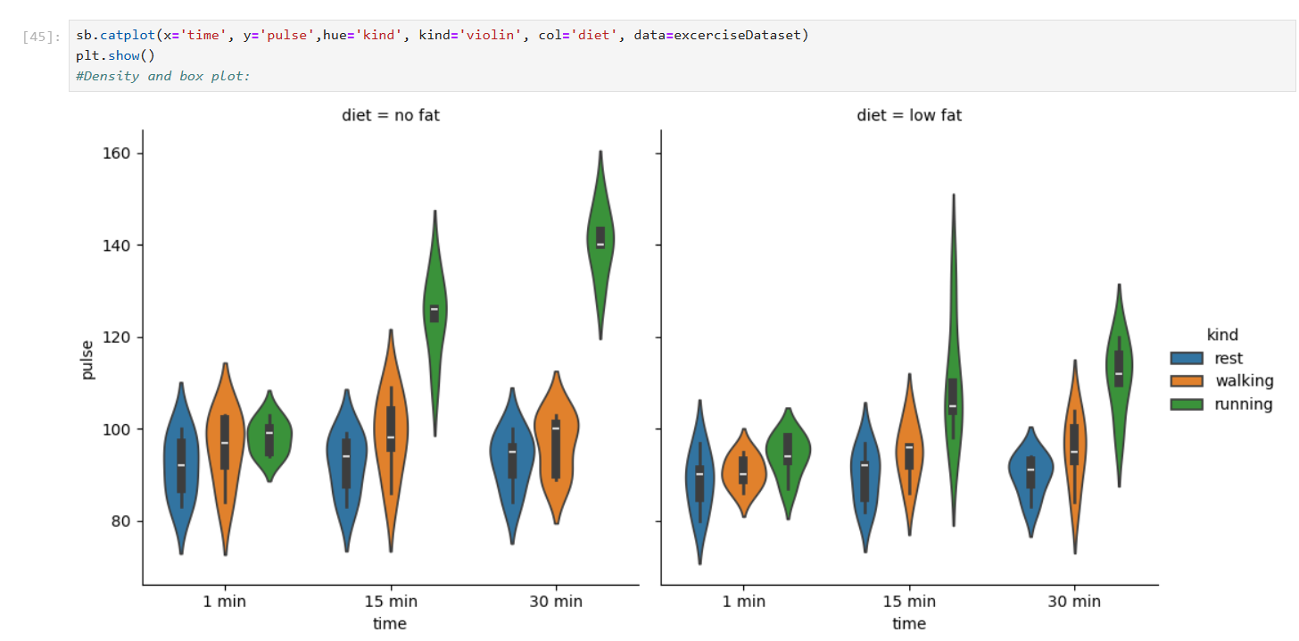

**Key Features of catplot**

**Flexibility:** Allows you to create several types of categorical plots like strip plots, swarm plots, box plots, violin plots, and bar plots.

**Faceting:** Supports splitting the data into subplots based on additional categorical variables (using col or row arguments).

**Aesthetics:** Offers customization options for colors, sizes, and orientations.

**Ease of Use:** Combines powerful defaults with intuitive customization.

**Key Parameters**

**data**: DataFrame containing the data.

**x, y**: Categorical and numeric variables to plot.

**hue**: Categorical variable for color encoding.

**kind**: Type of plot to draw:

'strip': Scatter plot with jittering (default).

'swarm': Scatter plot with non-overlapping points.

'box': Box plot.

'violin': Violin plot.

'boxen': Enhanced box plot for large datasets.

'point': Point plot.

'bar': Bar plot with confidence intervals.

'count': Histogram for categorical data.

**row, col**: Variables for faceting the plot into subplots.

**aspect and height**: Control the size and aspect ratio of the figure.

**Other parameters**: Options for styling and plotting specifics, like palette, order, dodge, etc.

**Usecases**

Comparing distributions across categories.

Visualizing differences in central tendency (mean, median) or spread.

Exploring categorical relationships in multi-dimensional datasets.

**Exercise Dataset Graph Explanation:**

**Dataset**

Dataset has the details about the different users diet plan and their pulse rate when they do different activities for specific timing.

We have 3 types of timing: 1 min, 15 min, 30 min

We have 2 types of diet: no fat, low fat

We have 3 kinds of activities: rest, walking, running

**Code:**

*sb.catplot(x='time', y='pulse',hue='kind', kind='violin', col='diet', data=excerciseDataset)*

This code will plot the chart for each diet, what is the pulse rate for the users when they rest, walking and running.

Barplot and violinplot used in the graph.

Violinplot display the density of the data.

Barplot displays the percentile.

**Summary: No fat diet people have more pulse rate than the low-fat diet people.**

**For diet=no flat**

When user taking rest for 1 min,

More people have the pulse rate between 80 to 100. Minimum 70 and maximum 110.

25% people pulse rate is 85

50% people pulse rate is 95

75% people pulse rate is 98

100% people pulse rate is 100

Median pulse rate is 95

When user taking rest for 15 min,

More people have the pulse rate between 90 to 95. Minimum 70 and maximum 110.

25% people pulse rate is 87

50% people pulse rate is 96

75% people pulse rate is 97

100% people pulse rate is 99

Median pulse rate is 96

When user taking rest for 30 min,

More people have the pulse rate 95. Minimum 70 and Maximum 110.

25% people pulse rate is 85

50% people pulse rate is 88

75% people pulse rate is 95

100% people pulse rate is 100

Median pulse rate is 88

When user walking for 1 min,

More people have the pulse rate between 90 to 100. Minimum 70 and maximum 115.

25% people pulse rate is 90

50% people pulse rate is 98

75% people pulse rate is 105

100% people pulse rate is 105

Median pulse rate is 98

When user walking for 15 min,

More people have the pulse rate between 95 to 105. Minimum 70 and maximum 120.

25% people pulse rate is 85

50% people pulse rate is 92

75% people pulse rate is 97

100% people pulse rate is 98

Median pulse rate is 92

When user walking for 30 min,

More people have the pulse rate between 85 to 100. Minimum 80 and Maximum 110.

25% people pulse rate is 85

50% people pulse rate is 93

75% people pulse rate is 95

100% people pulse rate is 100

Median pulse rate is 93

When user running for 1 min,

More people have the pulse rate between 95 to 100. Minimum 90 and maximum 105.

25% people pulse rate is 95

50% people pulse rate is 99

75% people pulse rate is 100

100% people pulse rate is 102

Median pulse rate is 99

When user running for 15 min,

More people have the pulse rate 120. Minimum 95 and maximum 145.

25% people pulse rate is 121

50% people pulse rate is 122

75% people pulse rate is 123

100% people pulse rate is 125

Median pulse rate is 122

When user running for 30 min,

More people have the pulse rate 140. Minimum 120 and Maximum 160.

25% people pulse rate is 140

50% people pulse rate is 142

75% people pulse rate is 145

100% people pulse rate is 145

Median pulse rate is 142

**For diet=Low flat**

When user taking rest for 1 min,

More people have the pulse rate 90. Minimum 60 and maximum 108.

25% people pulse rate is 84

50% people pulse rate is 90

75% people pulse rate is 92

100% people pulse rate is 98

Median pulse rate is 90

When user taking rest for 15 min,

More people have the pulse rate between 85 to 95. Minimum 70 and maximum 108.

25% people pulse rate is 84

50% people pulse rate is 92

75% people pulse rate is 93

100% people pulse rate is 98

Median pulse rate is 92

When user taking rest for 30 min,

More people have the pulse rate 90. Minimum 75 and Maximum 98.

25% people pulse rate is 89

50% people pulse rate is 90

75% people pulse rate is 95

100% people pulse rate is 95

Median pulse rate is 90

When user walking for 1 min,

More people have the pulse rate between 88 to 92. Minimum 82 and maximum 100.

25% people pulse rate is 85

50% people pulse rate is 90

75% people pulse rate is 95

100% people pulse rate is 96

Median pulse rate is 90

When user walking for 15 min,

More people have the pulse rate between 90 to 95. Minimum 78 and maximum 115.

25% people pulse rate is 92

50% people pulse rate is 96

75% people pulse rate is 97

100% people pulse rate is 97

Median pulse rate is 96

When user walking for 30 min,

More people have the pulse rate between 95 to 98. Minimum 70 and Maximum 115.

25% people pulse rate is 95

50% people pulse rate is 97

75% people pulse rate is 100

100% people pulse rate is 105

Median pulse rate is 97

When user running for 1 min,

More people have the pulse rate between 90 to 95. Minimum 82 and maximum 105.

25% people pulse rate is 95

50% people pulse rate is 96

75% people pulse rate is 99

100% people pulse rate is 99

Median pulse rate is 96

When user running for 15 min,

More people have the pulse rate between 95 to 108. Minimum 79 and maximum 150.

25% people pulse rate is 102

50% people pulse rate is 103

75% people pulse rate is 120

100% people pulse rate is 120

Median pulse rate is 103

When user running for 30 min,

More people have the pulse rate between 105 to 110. Minimum 88 and Maximum 128.

25% people pulse rate is 105

50% people pulse rate is 108

75% people pulse rate is 118

100% people pulse rate is 120

Median pulse rate is 108

**Swarmplot**

A Seaborn Swarmplot is a type of categorical scatter plot that visualizes data by plotting each data point in a way that avoids overlap. It’s particularly useful for showing distributions of small datasets or highlighting individual data points within categories.

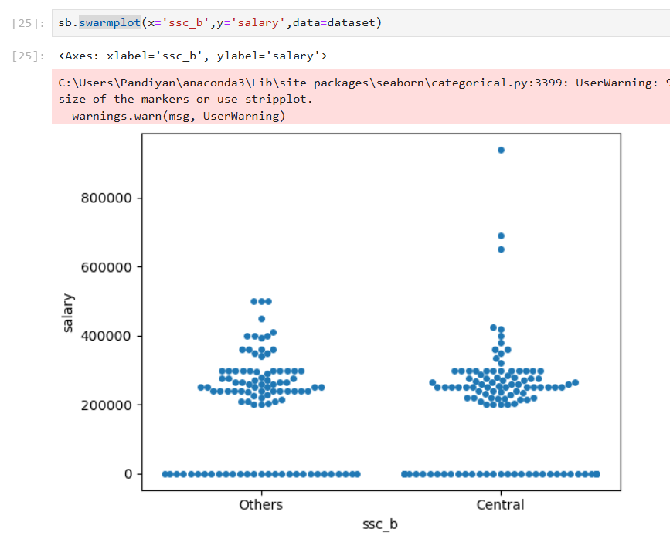

**Key Features**

**Avoids Overlap:** The swarmplot positions points along a categorical axis (e.g., "Category A", "Category B") and spreads them along the continuous axis (e.g., "Value") to prevent them from overlapping.

**Combination with Other Plots:** It works well in conjunction with other categorical plots like box plots or violin plots, providing a more detailed view of individual data points.

**Parameters**

**x, y**: Define the variables for the categorical and continuous axes.

**hue**: Splits the data further into subcategories by color.

**palette**: Specifies the color palette for the plot.

**size**: Sets the size of the points.

**dodge**: When using hue, separates the points for better clarity.

**orient**: Allows vertical ('v') or horizontal ('h') orientation of the plot.

**Usecases:**

Suppose you want to compare the sepal lengths of three species of flowers (setosa, versicolor, virginica). A swarmplot can show the individual sepal lengths within each species, highlighting any patterns or outliers.