Create environment
Activate Environment
Install Django
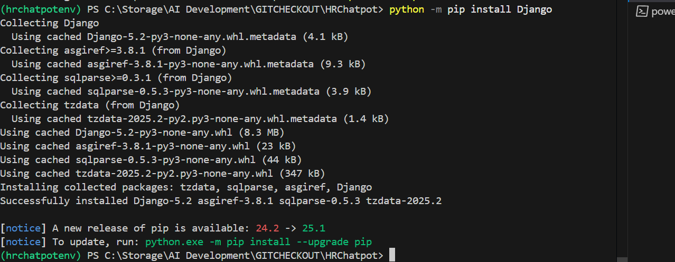
Start project
Error while activate
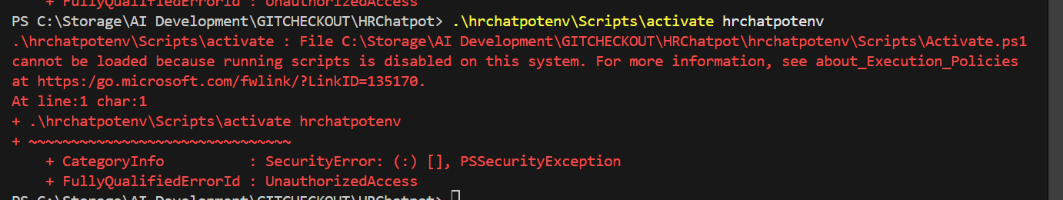
Run command toresolve
pip install django mysqlclient
pip install langchain
pip install sentence-transformers
pip install faiss-cpu
pip install PyMuPDF
python manage.py shell
>>> from chatpot.utils.embedding_loader import load_and_embed_policies
>>> load_and_embed_policies()

