**HSK**

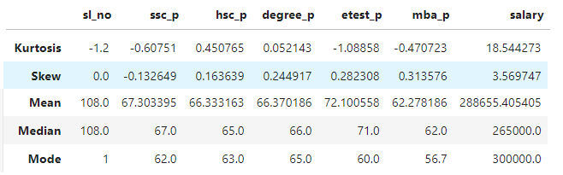

**Kurtosis:**

SSC Score: -0.60751

It is less than 3. Hence it is Playkurtic

HSC Score: 0.450765

It is less than 3. Hence it is Playkurtic

Degree Score: 0.052143

It is less than 3. Hence it is Playkurtic

Entrance Test Score: -1.08858

It is less than 3. Hence it is Playkurtic

MBA Score: -0.470723

It is less than 3. Hence it is Playkurtic

Salary: 18.544273

It is greater than 3. Hence it is lowkurtic.

**Skew:**

SSC Score: -0.132649

Mean(67.303395) > Median(67.0) > Mode(62.0).

HSC Score: 0.163639

Mean(66.333163) > Median(65.0) > Mode(63.0).

Degree Score: 0.244917

Mean(66.370186) > Median(66.0) > Mode(65.0).

Entrance Test Score: 0.282308

Mean(72.100558) > Median(71.0) > Mode(60.0).

MBA Score: 0.313576

Mean(62.278186) > Median(62.0) > Mode(56.7).

Salary: 3.569747

Mean(288655.405405) > Median(265000.0) < Mode(300000.0).