**Interquartile Range**

**Why 1.5 used in lesser and greater outlier?**

The value 1.5 in the outlier formula serves as a threshold to detect unusually small or large values that are far from the central portion of the data.

The Interquartile Range (IQR) measures the spread of the middle 50% of the data, from the first quartile (Q1) to the third quartile (Q3). The value 1.5 is used to extend this range both below Q1 and above Q3 to identify outliers, which are values that deviate significantly from the "normal" data distribution.

**Historical and empirical reasoning:** The value 1.5 has been found effective in many practical applications for detecting moderate outliers. It's large enough to flag unusual data points without being overly sensitive to minor deviations.

**Balance:** A multiplier of 1.5 strikes a balance between including normal variations and excluding extreme points. A smaller multiplier might classify too many points as outliers, while a larger multiplier would miss significant outliers.

|  |  |  |  |  |  |
| --- | --- | --- | --- | --- | --- |
|  | Minimum | Q1 | Median | Q3 | Maximum |
| Day | 32 | 56 | 74.5 | 82.5 | 99 |
| Night | 25.5 | 78 | 81 | 89 | 98 |

**a. Interquartile Range: Compare the two interquartile range.**

Day:

IQR= Q3-Q1 = 82.5 – 56 = 26.5

Night:

IQR=Q3-Q1=89 - 78 = 11

**b. Any outliers in either set?**

**Day:**

IQR= Q3-Q1 = 82.5 – 56 = 26.5

Lesser Outlier=Q1 – 1.5 x IQR = 56 – 1.5 x 26.5 = 56 – 39.75 = 16.25

Greater Outlier = Q3 + 1.5 x IQR = 82.5 + 1.5 x 26.5 = 82.5 + 39.75 = 122.25

There is no value less than lesser outlier (16.5) and there is no value greater than greater outlier (122.25). Hence no outlier available in Day.

**Night:**

IQR=Q3-Q1=89 - 78 = 11

Lesser Outlier = Q1 – 1.5 x IQR = 78 – 1.5 x 11 = 78 – 16.5 = 61.5

Greater Outlier = Q3 + 1.5 x IQR = 89 – 1.5 x 11 = 89 + 16.5 = 105.5

There is no value greater than greater outlier (105.5) But there is a value (25.5) less than lesser outlier (61.5). Hence, we have lesser outlier in Night.

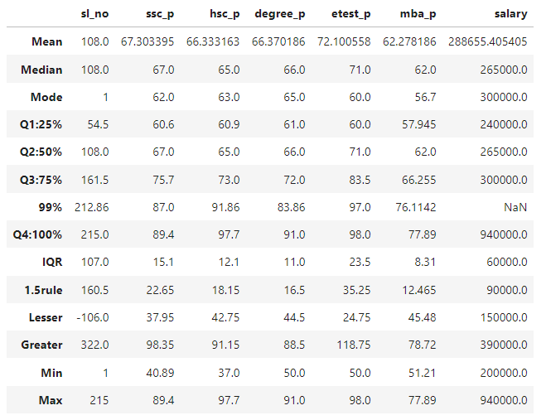

**SSC Score:**

IQR is 15.1

Lesser outlier is 37.95 and Greater outlier is 98.35.

There is no value less than lesser outlier and there is no value greater than greater outlier. Hence, there is no outlier in SSC Score.

**HSC Score:**

IQR is 12.1

Lesser outlier is 42.75 and Greater outlier is 91.15.

There is a value (37) is less than lesser outlier (42.75) and there is a value (97.7) greater than greater outlier (91.15). Hence, we have both lesser and greater outlier in HSC score.

**Degree Score:**

IQR is 11

Lesser outlier is 44.5 and Greater outlier is 88.5.

There is no value less than lesser outlier but there is a value (91) greater than greater outlier (88.5). Hence, we have greater outlier in HSC score.

**Entrance Test Score:**

IQR is 23.5

Lesser outlier is 24.75 and Greater outlier is 118.75.

There is no value less than lesser outlier and there is no value greater than greater outlier. Hence, there is no outlier in Entrance Test Score.

**MBA Score:**

IQR is 8.31

Lesser outlier is 45.48 and Greater outlier is 78.72.

There is no value less than lesser outlier and there is no value greater than greater outlier. Hence, there is no outlier in Entrance Test Score.

**Salary:**

IQR is 60000.

Lesser outlier is 150000 and Greater outlier is 390000.

There is no value less than lesser outlier but there is a value (940000) greater than greater outlier (390000). Hence, we have greater outlier in HSC score.

.