**Random Forest Classification**

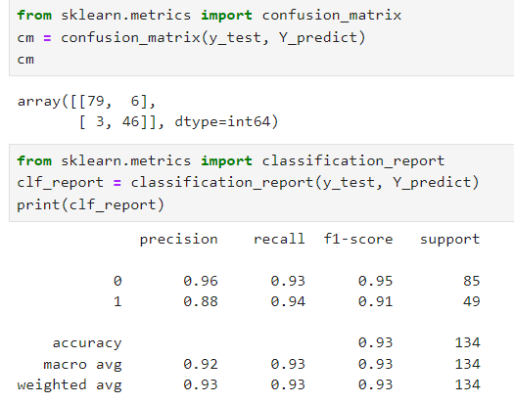

1. What is the percentage of correct classification of both (Purchased/Not Purchased) to the total input of the test set?

**Accuracy = 0.93**

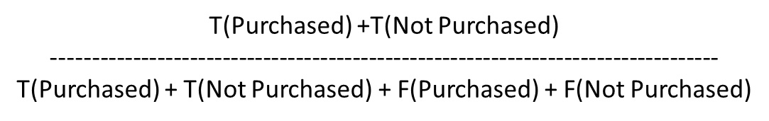

= 79+46 / 79+46+6+3

= 125 / 134

= 0.93

1. What is the percentage of correct classification of (Purchased) to the total input of (Purchased) in the test set?

**Recall of 0 = 0.93**

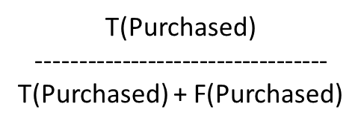

= 79 / 79+6

= 79 / 85

= 0.93

1. What is the percentage of correct classification of (Not Purchased) to the total input of(Not Purchased) in the test set?

**Recall of 1 = 0.94**

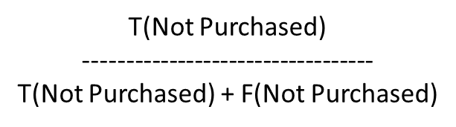

= 46 / 46+3

= 46 / 49

= 0.94

1. What is the percentage of correct classification of (Purchased) to sum of correctly classified as (Purchased) and wrongly classified as (Purchased) in the test set?

**Precision of 0 = 0.96**

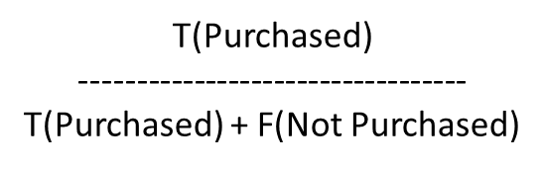

= 79 / 79 +3

= 79 / 82

= 0.96

1. What is the percentage of correct classification of (Not Purchased) to sum of correctly classified as (Not Purchased) and wrongly classified as (Not Purchased) in the test set?

**Precision of 1 = 0.88**

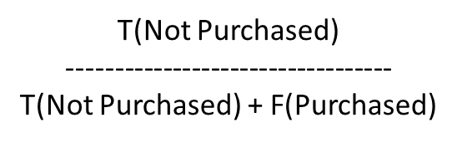

= 46 / 46+6

= 46 /52

= 0.88

1. What is the overall performance of the Purchased?

**F1 score of 0 = 0.95**

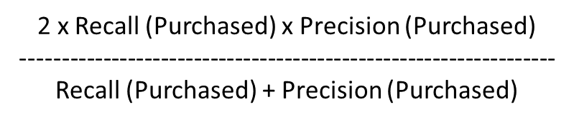

= 2 x 0.93 x 0.96 / (0.93+0.96)

= 1.7856 / 1.89

= 0.95

1. What is the overall performance of the Not Purchased?

**F1 score of 1 = 0.91**

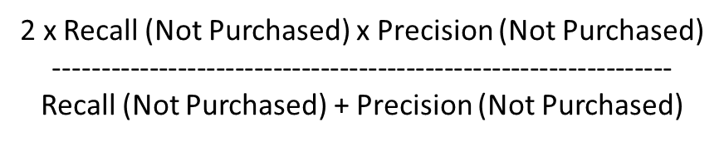

= 2 x 0.94 x 0.88 / 0.94+0.88

= 1.6544 / 1.82

= 0.91

1. What is the average performance of the precision correctly and wrongly classified?

**Macro Average of Precision = 0.92**

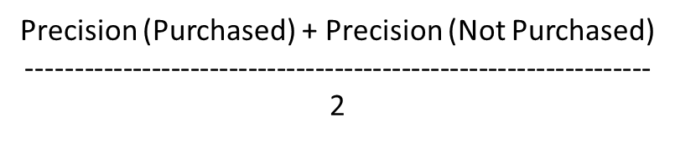

= 0.96+0.88 / 2

= 1.84 / 2

= 0.92

1. What is the average performance of recall (correctly classified)?

**Macro Average of Recall = 0.93**

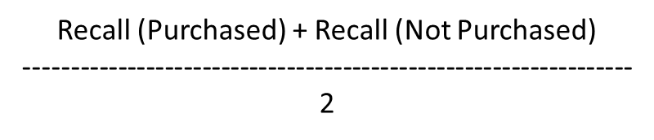

= 0.93+0.94 / 2

= 1.87 /2

= 0.93

1. What is the average performance of the F1 measure (overall performance)?

**Macro Average of F1 score = 0.93**

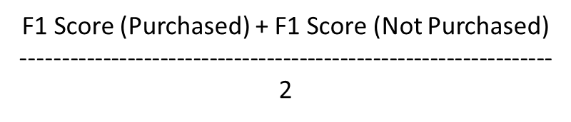

= 0.95+0.91 / 2

= 1.86 / 2

= 0.93

1. What is the sum of product of proportion rate(weight) of each class for precision calculation?

**Weighted Average of Precision = 0.93**



= 0.96x(85/134) + 0.88x(49/134)

= 0.608 + 0.321

= 0.93

1. What is the sum of product of proportion rate(weight) of each class for recall calculation?

**Weighted Average of Recall = 0.93**



= 0.93x(85/134) + 0.94x(49/134)

= 0.589 + 0.343

= 0.93

1. What is the sum of product of proportion rate(weight) of each class for f1 measure calculation?

**Weighted Average of Precision = 0.93**



= 0.95x(85/134) + 0.91x(49/134)

= 0.602 + 0.332

= 0.93