**Percentile**

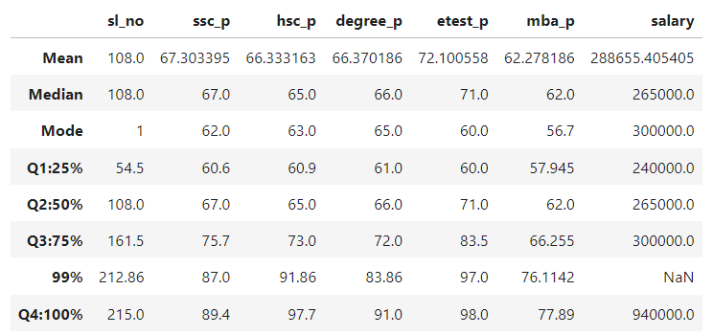

**SSC Score:**

25% of Students scored below 60.6.

50% of Students scored below 67.

75% of Students scored below 75.7.

All the students are scored below 89.4.

Difference between Q1 and Q2 is 6.1. 6.1 marks are increased in Q1.

Difference between Q2 and Q3 is 8.7. 8.7 marks are increased in Q2.

Difference between Q3 and Q4 is 13.7. 13.7 marks are increased in Q2.

Difference between 99% and 100% is 2.4.

**HSC Score:**

25% of Students scored below 60.9.

50% of Students scored below 65.

75% of Students scored below 73.

All the students are scored below 97.7.

Difference between Q1 and Q2 is 8. 8 marks are increased in Q1.

Difference between Q2 and Q3 is 8.7. 8.7 marks are increased in Q2.

Difference between Q3 and Q4 is 24.7. 24.7 marks are increased in Q2.

Difference between 99% and 100% is 5.84.

**Degree Score:**

25% of Students scored below 61.

50% of Students scored below 66.

75% of Students scored below 72.

All the students are scored below 83.86.

Difference between Q1 and Q2 is 5. 5 marks are increased in Q1.

Difference between Q2 and Q3 is 6. 6 marks are increased in Q2.

Difference between Q3 and Q4 is 17.86. 17.86 marks are increased in Q2.

Difference between 99% and 100% is 7.14.

**Entrance Test Score:**

25% of Students scored below 60.

50% of Students scored below 71.

75% of Students scored below 83.5.

All the students are scored below 98.

Difference between Q1 and Q2 is 11. 11 marks are increased in Q1.

Difference between Q2 and Q3 is 12.5. 12.5 marks are increased in Q2.

Difference between Q3 and Q4 is 14.5. 14.5 marks are increased in Q2.

Difference between 99% and 100% is 1.

**MBA Score:**

25% of Students scored below 57.945.

50% of Students scored below 62.

75% of Students scored below 66.255.

All the students are scored below 77.89.

Difference between Q1 and Q2 is 4.055. 4.055 marks are increased in Q1.

Difference between Q2 and Q3 is 4.255. 4.255 marks are increased in Q2.

Difference between Q3 and Q4 is 11.633. 11.633 marks are increased in Q2.

Difference between 99% and 100% is 1.778.

**Salary:**

25% of Students has salary below 240000.

50% of Students has salary below 265000.

75% of Students has salary below 300000.

All the students have salary below 940000.

Difference between Q1 and Q2 is 25000. 25000 of salary increased in Q1.

Difference between Q2 and Q3 is 35000. 35000 of salary increased in Q2.

Difference between Q3 and Q4 is 6,40,000. 6,40,000 of salary increased in Q2.