Random Forest Classification

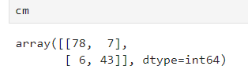

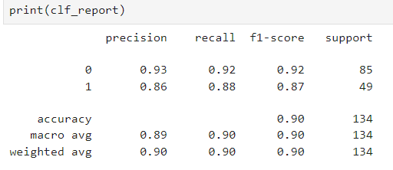

1. What is the percentage of correct classification of both (Purchased/Not Purchased) to the total input of the test set?

Accuracy = 0.90

1. What is the percentage of correct classification of (Purchased) to the total input of (Purchased) in the test set?

Recall of 1 = 0.88

1. What is the percentage of correct classification of (Not Purchased) to the total input of(Not Purchased) in the test set?

Recall of 0 = 0.92

1. What is the percentage of correct classification of (Purchased) to sum of correctly classified as (Purchased) and wrongly classified as (Purchased) in the test set?

Precision of 1 = 0.86

1. What is the percentage of correct classification of (Not Purchased) to sum of correctly classified as (Not Purchased) and wrongly classified as (Not Purchased) in the test set?

Precision of 0 = 0.93

1. What is the overall performance of the Purchased?

F1 score of 1 = 0.87

1. What is the overall performance of the Not Purchased?

F1 score of 0 = 0.92

1. What is the average performance of the precision correctly and wrongly classified?

Macro Average of Precision = 0.89

1. What is the average performance of recall (correctly classified)?

Macro Average of Recall = 0.90

1. What is the average performance of the F1 measure (overall performance)?

Macro Average of F1 score = 0.90

1. What is the sum of product of proportion rate(weight) of each class for precision calculation?

Weighted Average of Precision = 0.90

1. What is the sum of product of proportion rate(weight) of each class for recall calculation?

Weighted Average of Recall = 0.90

1. What is the sum of product of proportion rate(weight) of each class for f1 measure calculation?

Weighted Average of Precision = 0.90