**Sentiment Analyser**

**End Term Report**

By

|  |  |  |  |  |  |
| --- | --- | --- | --- | --- | --- |
| Sr. No. | Registration No | Name of Students | Roll No | Total Marks | Marks Obtained |
| 1 | 11804711 | E.Paramjit Reddy | A 20 |  |  |
| 2 | 11804302 | G.Ravi Teja | A-21 |  |  |



**Department of**

**School of Computer Science Engineering**

**Lovely Professional University, Jalandhar**

April-2020

**Student Declaration**

This is to declare that this report has been written by us. No part of the report is copied from other sources. All information included from other sources have been duly acknowledged. If any part of the report is found to be copied, we are shall take full responsibility for it.

E.Paramjit Reddy-20

G.Ravi Teja-21

**BONAFIDE CERTIFICATE**

Certified that this project report **“ Sentiment Analyser** ” is the bonafide work of “Ravi Teja,Paramjit” who carried out the project work under my supervision.

INT 404

Dr. Dhanpratap singh

Professor of Artificial Intelligence

Department of computer science

**Background and objectives**

**Motivation**

Mainly many people in the world with different type of mind-sets thinking of different things which is different from one another. Different people has different nature of mind as per the situation faced in their life. So, by analysing their moods,they can be controlled from any emotional situation..

**Concrete goals**

By this project, we sure that the mindset of the people can be identified. So that the application can suggest the content based on their current mood.

**8. implementation**

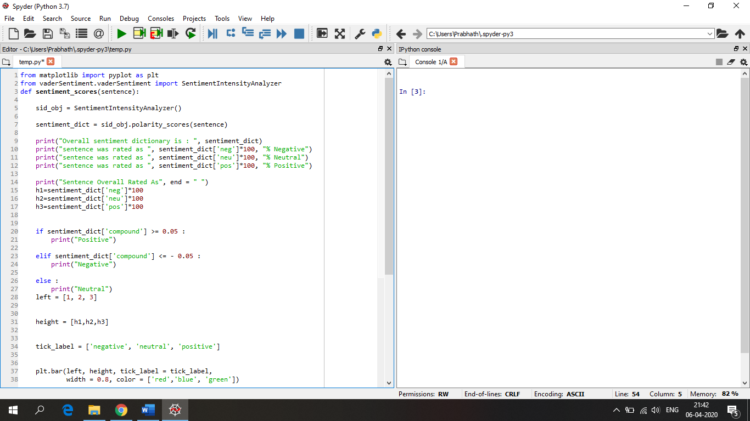

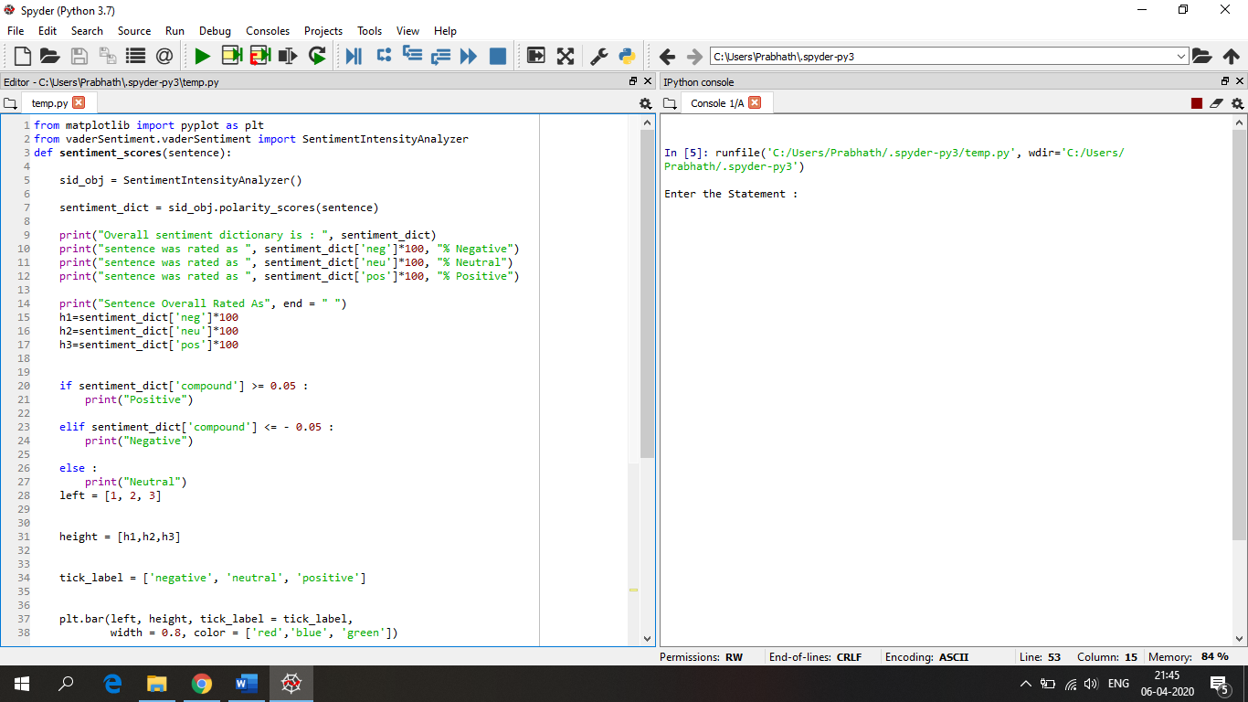

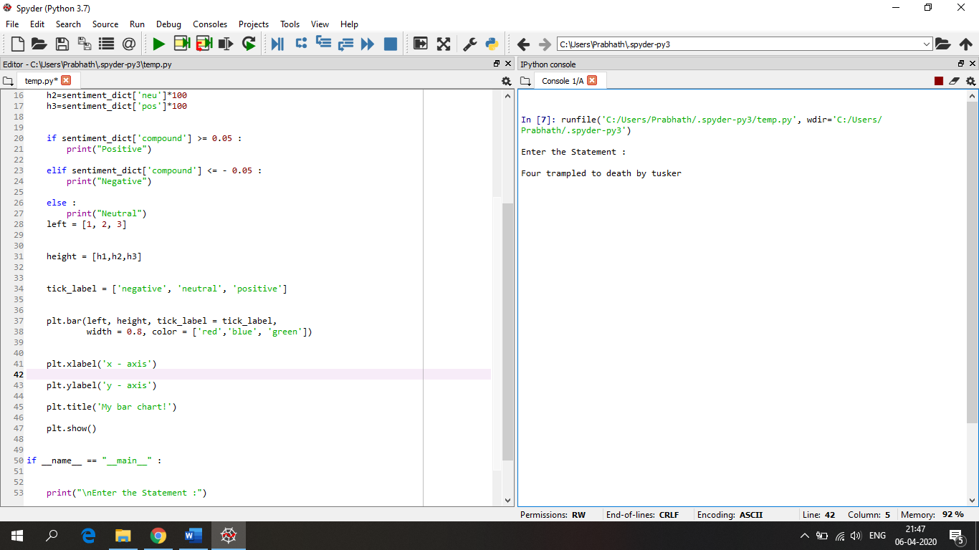

.

**9. Technologies and Framework**

In this we used Natural Language ToolKit. NLTK is a leading platform for building Python programs to work with human language data.

**10. Analysis in project**

**Strengths**

1. Quick analysis of the moods.
2. Aspect are identified easily.

**Weaknesses**

1. Completely dependent of dataset.

**Opportunities**

1. Hadoop framework can be used for processing Big data,
2. Easy access due to collaborated community nature.

**Threats**

1. False reviews can reduce performance.
2. Manupulation can make false reviews.